MANAV RACHNA UNIVERSITY
Department of CST
(Artificial Intelligence – CSH205 P)
(PT 1)
Name: HARSH MITTAL
Class: BTECH CSE 4B
Roll no: 2K19CSUN01082

- Define the purpose of using prolog in AI and also explain the concept of unification used in prolog.
Prolog is a declarative logic programming language and has an important role in artificial intelligence because core heart for both is logic being applied. We can declare facts and rules which can be used in AI to interpret a fact which is not given. It’s original intended field of use was natural language processing.
Unification in Prolog can be roughly defined as a technique it uses to make two called terms identical. Can be inferred as a very general form of matching technique.

- Implement your own Family Tree in PROLOG. Create basic facts and rules and check the same with appropriate goals.
Answer the following questions:
- Create a rule for uncle() and aunt().
- Create a rule for sister() and brother().
- Create a rule for father-in-law() and mother-in-law().
- Define mama(X,Y) in terms of relation parent() and sister().
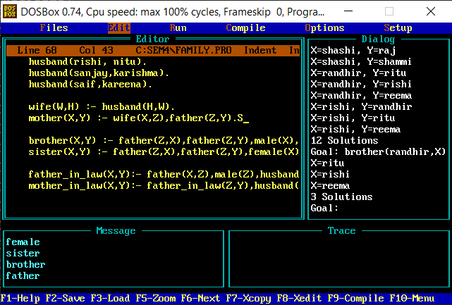
- To find name of a person having symptoms of malaria using rules.
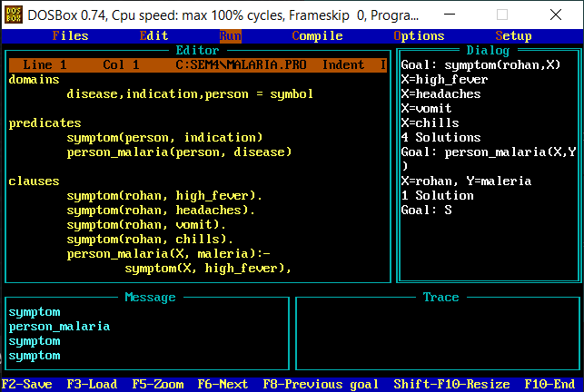
- Write a PROLOG program to find last member of a list.

