

**DEPARTMENT OF COMPUTER SCIENCE & TECHNOLOGY**

**Lab-1**

**HARSH MITTAL**

**2K19CSUN01082**

**CSE4B**

**Laboratory Objective:** To implement Basic system calls of UNIX Operating System

**Learning Outcome:** Familiarity with the use of basic calls of UNIX

Course Outcome: CO2

Blooms Taxonomy: BT1, BT2, BT3

Write programs using the following system calls of UNIX operating system

1. fork()

*#include* <stdio.h>

*#include* <sys/types.h>

*#include* <unistd.h>

int main()

{

fork();

printf("Hello world!\n");

*return* 0;

}



1. exec()

*#include* <stdio.h>

*#include* <stdlib.h>

*#include* <unistd.h>

int main()

{

char *args[] = {"./EXEC", NULL};

execvp(args[0], args);

printf("Ending-----");

*return* 0;

}

1. getpid()

*#include* <iostream>

*#include* <unistd.h>

using namespace std;

int main()

{

int pid;

pid = fork();

*if* (pid == 0)

{

cout << "\nParent Process id : "

<< getpid() << endl;

Scout << "\nChild Process with parent id : "

<< getppid() << endl;

}

*return* 0;

}

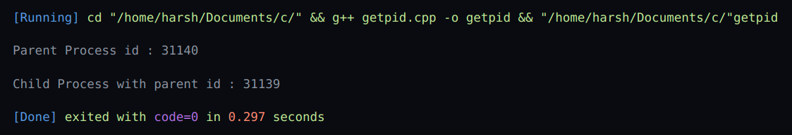

1. exit()

*#include* <bits/stdc++.h>

using namespace std;

void fun(void)

{

cout << "Exiting";

}

int main()

{

atexit(fun);

exit(10);

}



1. wait()

*#include* <stdio.h>

*#include* <stdlib.h>

*#include* <sys/wait.h>

*#include* <unistd.h>

int main()

{

pid_t cpid;

*if* (fork() == 0)

exit(0);

*else*

cpid = wait(NULL);

printf("Parent pid = %d\n", getpid());

printf("Child pid = %d\n", cpid);

*return* 0;

}

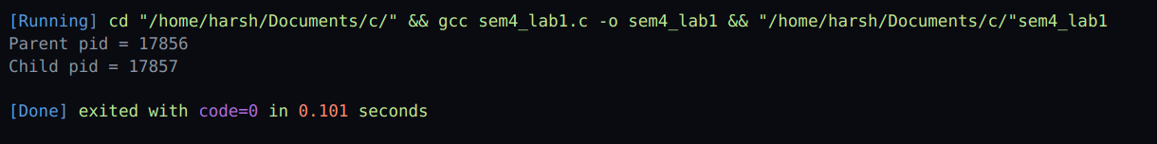

The **exec system call** is used to execute a file which is residing in an active process. When **exec** is called the previous executable file is replaced and new file is executed. More precisely, we can say that using **exec system call** will replace the old file or program from the process with a new file or program.

## 

**DEPARTMENT OF COMPUTER SCIENCE & TECHNOLOGY**

**Lab: 2**

**HARSH MITTAL**

**2K19CSUN01082**

**CSE4B**

**Laboratory Objective:** To implement System calls of UNIX

**Learning Outcome:** Handling system calls

Course Outcome: CO2

Blooms Taxonym: BT1, BT2, BT3

Write programs using the following system calls of UNIX operating system:

1. closedir()
2. opendir()
3. readdir()

*#include* <stdio.h>

*#include* <dirent.h>

int main(void)

{

struct dirent *de;

DIR *dr = opendir(".");

*if* (dr == NULL)

{

printf("Could not open current directory");

*return* 0;

}

*while* ((de = readdir(dr)) != NULL)

printf("%s\n", de->d_name);

closedir(dr);

*return* 0;

}

