Manav Rachna University

DBMS PROJECT

INVENTORY RECORD MANAGEMENT SYSTEM

**ER – Diagram**

**Queries**

CREATE DATABASE INVENTORY_M_SYSTEM;



USE INVENTORY_M_SYSTEM;



CREATE TABLE INVENTORY( InventoryID INT PRIMARY KEY, ItemID INT, QUANTITY INT);



CREATE TABLE STORAGE( SNO INT PRIMARY KEY, NAME VARCHAR(10), ItemID INT);



CREATE TABLE ITEMS( ItemNo INT PRIMARY KEY, ItemDesc VARCHAR(20), ItemID INT);



CREATE TABLE ORDERS( OrderNo INT PRIMARY KEY, ItemID INT, DATE_R DATE, DATE_C DATE);



CREATE TABLE SHIPMENTS( ShipmentNo INT PRIMARY KEY, OrderNo INT, SHIPMENT_DATE DATE);



SHOW TABLES;

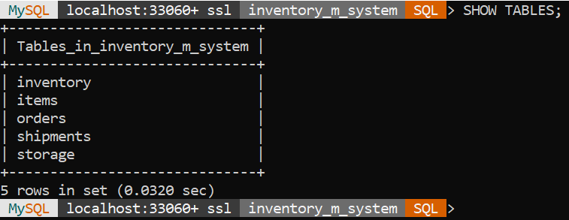

INSERT INTO INVENTORY VALUES ( 1,421,100);

INSERT INTO INVENTORY VALUES ( 2,201,121);

INSERT INTO INVENTORY VALUES ( 3,400,180);

INSERT INTO INVENTORY VALUES ( 4,901,98);

SELECT * FROM INVENTORY;

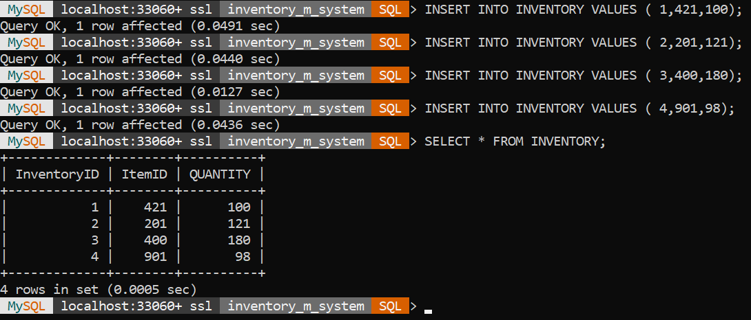

UPDATE INVENTORY SET QUANTITY=198 WHERE InventoryID=4;

DELETE FROM INVENTORY WHERE InventoryID=3;

SELECT * FROM INVENTORY;

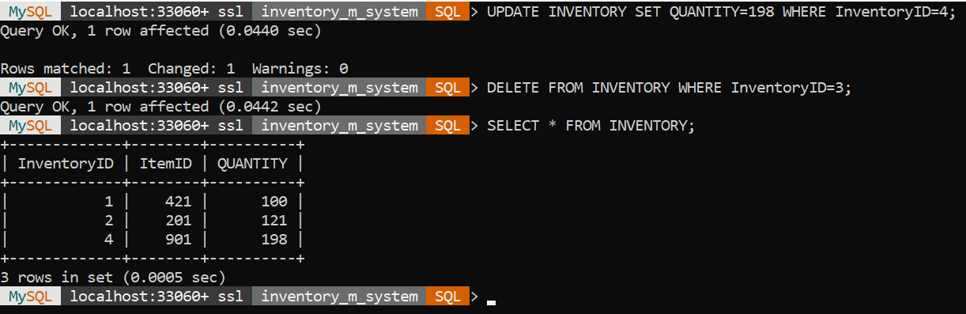

INSERT INTO STORAGE VALUES (1,’PENCIL’,201);

INSERT INTO STORAGE VALUES (2,’GLUE’,421);

INSERT INTO STORAGE VALUES (3,’PEN’,901);

SELECT * FROM STORAGE;

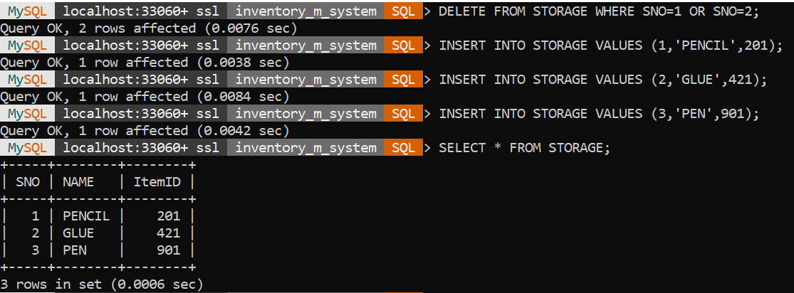

INSERT INTO ITEMS VALUES (1,’GRAPHITE PENCIL’,201);

INSERT INTO ITEMS VALUES (2,’HELP TO STICK THINGS’,421);

INSERT INTO ITEMS VALUES (3,’CONTAINS INK’,901);

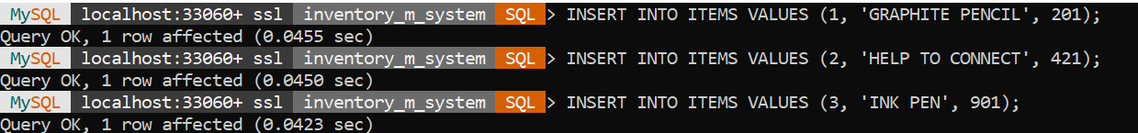

SELECT * FROM ITEMS;

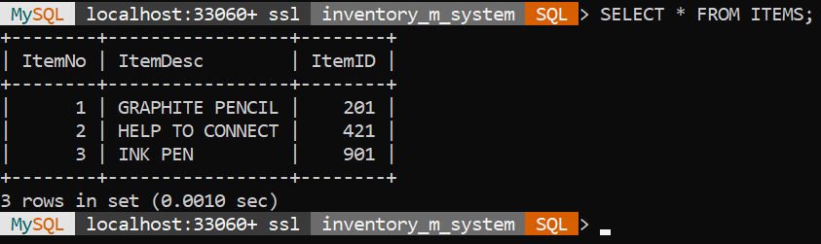

UPDATE ITEMS SET ItemDesc='ADHESIVE' WHERE ItemID=421;

SELECT * FROM ITEMS;

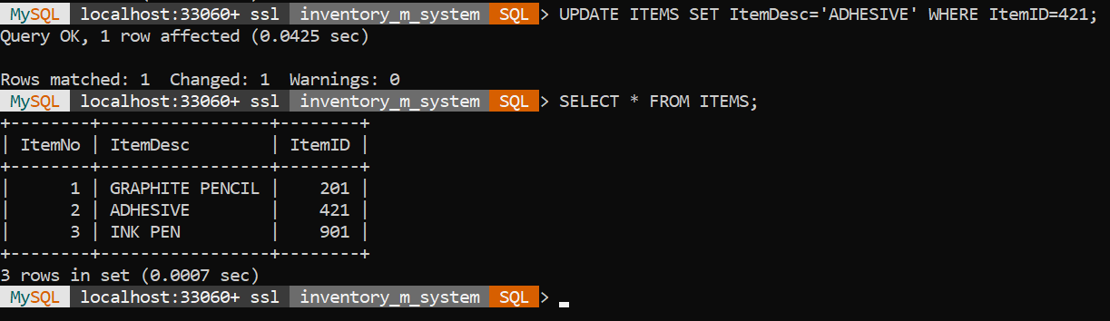

INSERT INTO ORDERS VALUES ( 1, 201, ‘2020-9-29’, ‘2020-9-28’);

INSERT INTO ORDERS VALUES ( 2, 201, ‘2020-9-25’, ‘2020-9-25’);

INSERT INTO ORDERS VALUES ( 3, 201, ‘2020-10-9’, ‘2020-10-8’);

INSERT INTO ORDERS VALUES ( 4, 421, ‘2020-8-15’, ‘2020-8-15’);

INSERT INTO ORDERS VALUES ( 5, 901, ‘2020-9-10’, ‘2020-9-10’);

SELECT * FROM ORDERS;

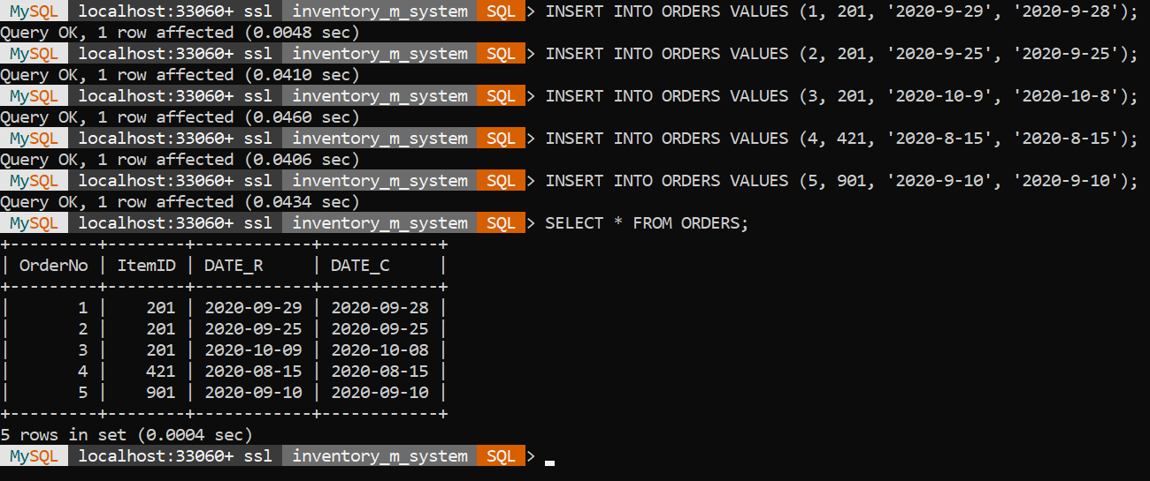

DELETE FROM ORDERS WHERE OrderNo=3 ;

SELECT * FROM ORDERS;

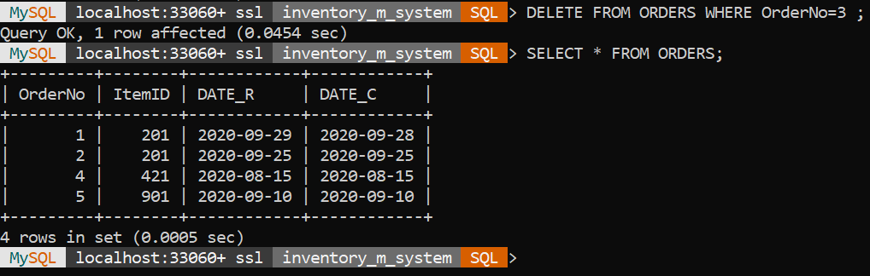

INSERT INTO SHIPMENTS VALUES ( 1, 1, ‘2020-9-27’);

INSERT INTO SHIPMENTS VALUES (2,2,'2020-9-23');

INSERT INTO SHIPMENTS VALUES (3,4,'2020-8-13');

INSERT INTO SHIPMENTS VALUES (4,5,'2020-9-8');

SELECT * FROM SHIPMENTS;

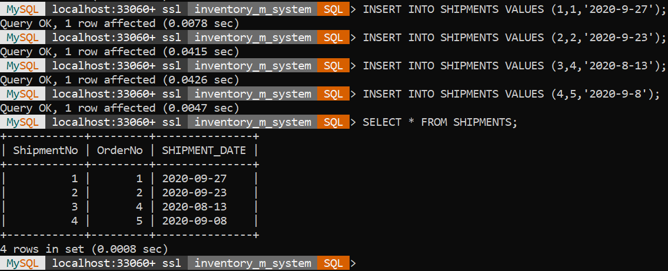

UPDATE SHIPMENTS SET SHIPMENT_DATE='2020-8-14' WHERE OrderNo=4;

SELECT * FROM SHIPMENTS;

