PT3 Instructions & Questions
NOTE: PT3 is for 3 hours. By 12:00 P.M you need to upload the pdf document with the snapshot of the following queries executed on MySQL. There are 2 sets for the PT3. Set 1 is for the students with odd rollno students and Set 2 for even rollno students.

KINDLY CREATE YOUR DATABASE AS “NAME_PT3”.
Do not crop

HARSH MITTAL
CSE3B
2K19CSUN01082
Create the following relations along with the constraints specified:

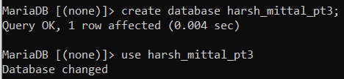
- Client (clno char(3), clname varchar(30), cladd varchar(40))
- PRIMARY KEY- clno
- clname can not be left blank

create table Client (clno char(3), clname varchar(30) NOT NULL , cladd varchar(40),Constraint pk1 PRIMARY KEY(clno))
-> ;

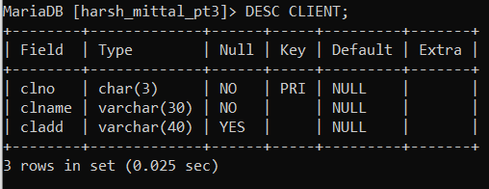
- Project (pno char(3), pname varchar(30), pstdate date, clno char(3))
- PRIMARY KEY- pno
- FOREIGN KEY – clno refers to Client relation
- pname can not be left blank

create table Project (pno char(3), pname varchar(30) NOT NULL , pstdate date, clno char(3),Constraint pk2 PRIMARY KEY(pno));

alter table project
-> add constraint fk2 foreign key (pno) references client(clno);
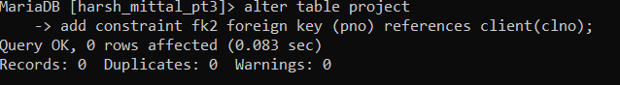

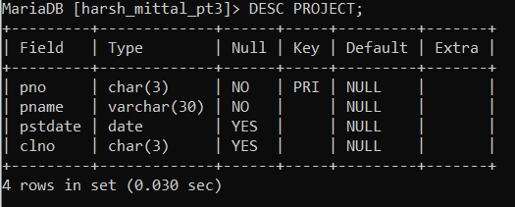

- Department (dno char(3), dname varchar(20), dloc varchar(20), dhead char(3))
- PRIMARY KEY – dno
- FOREIGN KEY – dhead refers to eno of Employee relation
- dname can not be left blank

create table department(dno char(3),dname varchar(20) not null,dloc varchar(20),dhead char(3),constraint pk1 primary key(dno));

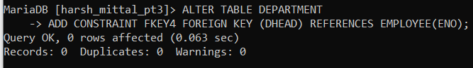

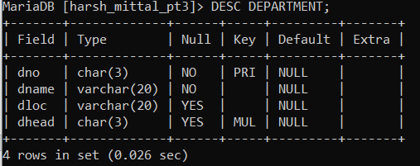
- Employee (eno char(3), ename varchar(20), eadd varchar(30), ephone char(8), esal int, grade char(1), edoj date, dno char(3))
- PRIMARY KEY – eno
- FOREIGN KEY – dno refers to Department relation
- ephone can have unique values only

create table Employee (eno char(3), ename varchar(20), eadd varchar(30), ephone char(8)UNIQUE , esal int, grade char(1), edoj date, dno char(3),CONSTRAINT PKEY2 PRIMARY KEY(ENO));

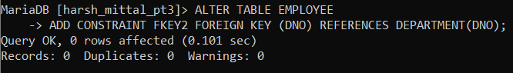

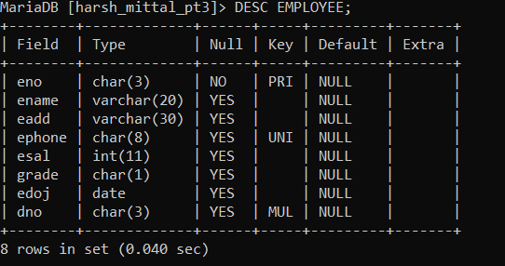

- Proj_alloc (eno char(3), pno char(3), hrs int)
- PRIMARY KEY – eno, pno
- FOREIGN KEY – eno refers to Employee relation

create table proj_alloc(eno char(3),pno char(3),hrs int);
Query OK, 0 rows affected (0.031 sec)

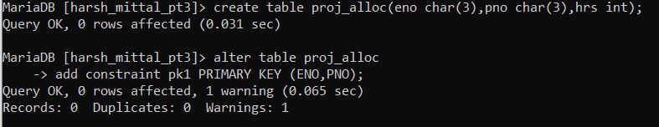

- Dependent (eno char(3), dpname varchar(20), dpdob datetime, dprelation varchar(20))
- PRIMARY KEY – eno, dpname
- FOREIGN KEY – eno refers to Employee relation
- Dprelation can have only one of the values {son,daughter,father,mother}
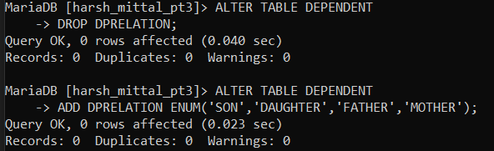

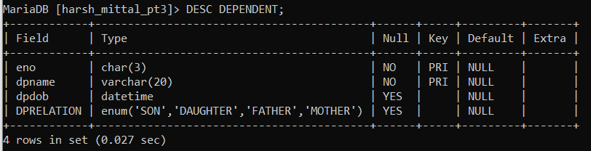

Insert the records in the following relations:

- Client (clno char(3), clname varchar(30), cladd varchar(40))

CLNO CLNAME CLADD
-------- ------------- -----------
c1 mnp Chd
c2 ghi Delhi
c3 fcb Mumbai

insert into client values
-> ('c1', 'mnp', 'Chd'),
-> ('c2', 'ghi', 'Delhi'),
-> ('c3', 'fcb', 'Mumbai');

- Project (pno char(3), pname varchar(30), pstdate date, clno char(3))

PNO PNAME PSTDATE CLNO
--- ------------ -------------- -------
p1 defo 01-MAR-20 c1
p2 ghmn 03-SEP-20 c2
p3 rspq 05-MAY-19 c3

insert into project values
-> ('p1', 'defo', '2020/03/01', 'c1'),
-> ('p2', 'ghmn', '2020/09/03', 'c2'),
-> ('p3', 'rspq', '2019/05/05', 'c3');

- Department (dno char(3), dname varchar(20), dloc varchar(20), dhead char(3))

DNO DNAME DLOC DHEAD
--- --------------- -------------------- --------
d1 sales Chd e1
d2 accounts Mumbai e2
d3 marketing Delhi e3

insert into department values
-> ('d1', 'sales', 'Chd', 'e1'),
-> ('d2', 'accounts', 'Mumbai', 'e2'),
-> ('d3', 'marketing', 'Delhi', 'e3');

- Employee (eno char(3), ename varchar(20), eadd varchar(30), ephone char(8), esal int, grade char(1), edoj date, dno char(3)
ENO ENAME EADD EPHONE ESAL GRADE EDOJ DNO
--- ---------- -------- ------- -------- ---------- ------ ------
e1 ht Delhi 4567382 50000 D 01-MAR-20 d1
e2 sm Chd 3215647 35000 A 02-APR-19 d2
e3 gk Mumbai 2578814 80000 C 08-FEB-20 d3

insert into employee values
-> ('e1', 'ht', 'Delhi', '4567382', 50000, 'D', '2020/03/01', 'd1'),
-> ('e2', 'sm', 'Chd', '3215647', 35000, 'A', '2019/04/02', 'd2'),
-> ('e3', 'gk', 'Mumbai', '2578814', 80000, 'C', '2020/02/08', 'd3');

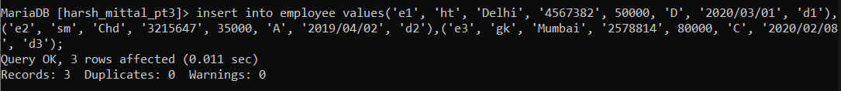

- Proj_alloc (eno char(3), pno char(3), hrs int)

ENO PNO HRS
--- --- ----------
e1 p 4
e2 p2 6
e3 p3 2

insert into proj_alloc(eno,pno,hrs)
-> values
-> ('e1','p',4),
-> ('e2','p2',6),
-> ('e3','p3',2);
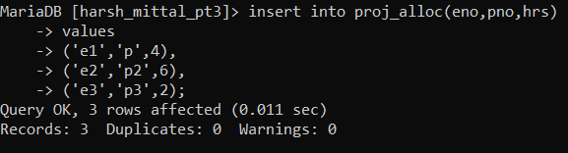
- Dependent (eno char(3), dpname varchar(20), dpdob date, dprelation varchar(20))
ENO DPNAME DPDOB DPRELATION
--- -------------- --------- --------------------
e2 ab 01-MAR-65 father
e3 bc 02-AUG-80 brother
e1 dc 02-JUL-89 son

insert into dependent(eno,dpname,dpdob,dprelation)
-> values
-> ('e2','ab','1965-03-01','father'),
-> ('e3','bc','1980-08-02','brother'),
-> ('e1','dc','1989-07-02','son');
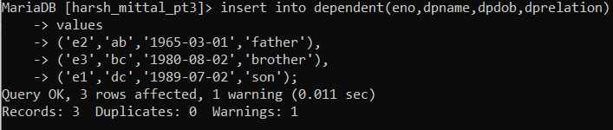

Set 2 (Even Rollno Students)
- Find the employee name for the employees who have salary more than 25000 and who do not live in ‘Delhi. (use set operation)

select ename from employee where
-> esal in (select esal from employee where esal>25000)
-> and eadd in (select eadd from employee where eadd!='Delhi');
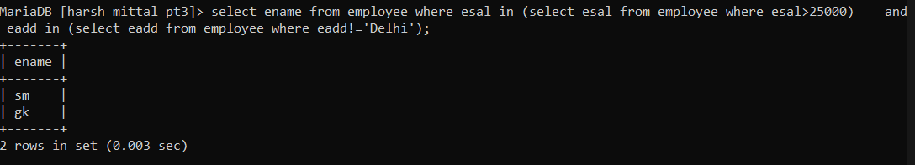

- Find the project name for the projects which have been ordered by client c2 and have employees living in Chd working on them.

select pname from project natural join employee natural join proj_alloc
-> where eadd='chd' or clno= 'c2';
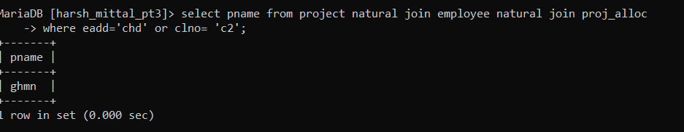

- Find the client names for the clients who have ordered more than 1 project.

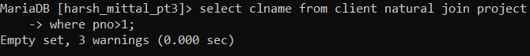

- Find the department names and their corresponding number of employees for the departments having more than one employees and having employees with salary equal to or more than 35000.
select dname ,eno from department natural join employee
-> where eno>1 or esal>=35000;
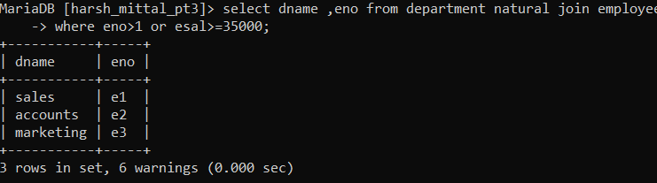

- Display details of employees whose salary is maximum. (use nesting)

select * from employee where esal in (select max(esal) from employee);
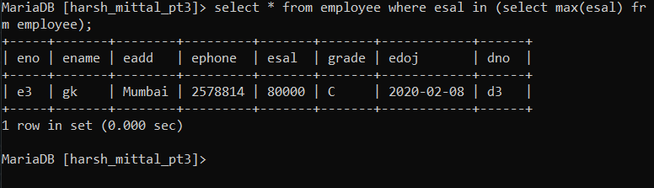
- Find the employee names for the employees who are working on any of the projects on which employee ‘e2’ is working. (use nesting)

SELECT ename FROM employee WHERE eno IN( SELECT eno FROM proj_alloc WHERE pno IN( SELECT pno FROM proj_alloc WHERE eno = 'e2' ));
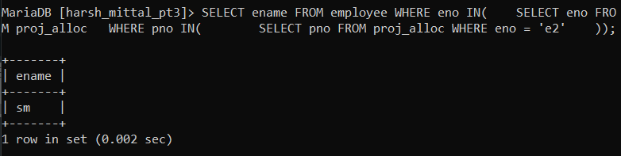

- Find the department names and their corresponding location under the heading
Department Name Department location
for the departments having head other than e3 and e1.

select dname,dloc from department natural join employee
-> where eno='e3' or eno= 'e1';
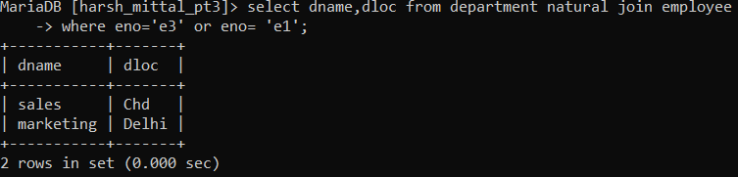
- Create a view that gives information about client number, client name and address with address ‘Delhi’ (with restriction of Delhi clients only). Also display the contents of the view created.
create view client_info as select clno, clname, cladd from client where cladd='Delhi';
Query OK, 0 rows affected (0.021 sec)

MariaDB [harsh_mittal_pt3]> select * from client_info;
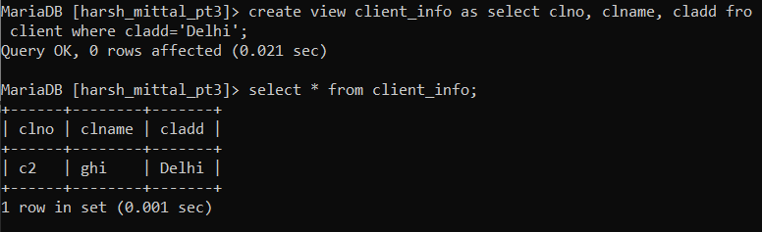

- List the names of managers who have at least one dependent. (using inner/natural/outer join)
select distinct e.ename from employee e natural join dependent d where e.eno = d.eno;

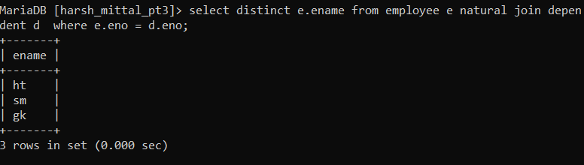

- For each department whose average employee salary is more than 10,000, retrieve the department name and the number of employees working for that department. (using inner/natural/outer join)
select dname,dno from employee natural join department
-> where esal>10000;

