MariaDB [(none)]> create database Student_Management;

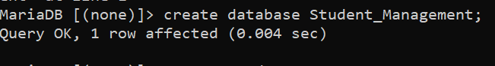

MariaDB [student_management]> create table admin

-> (admin_id char PRIMARY KEY,

-> A_name varchar(20) NOT NULL,

-> Password varchar(20),

-> register_no int,

-> region varchar(10));

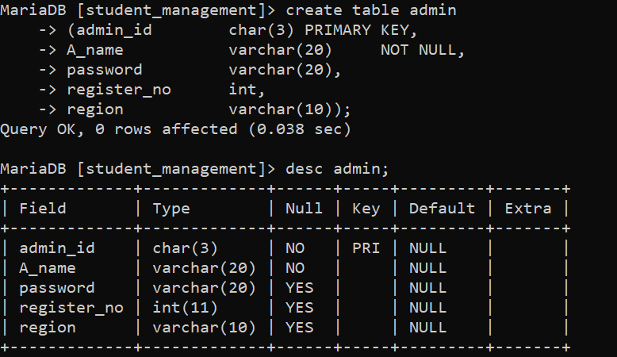

MariaDB [student_management]> create table student

-> (rollno varchar(10) PRIMARY KEY,

-> S_name varchar(20) NOT NULL,

-> Phn_no int,

-> reg_no int,

-> dob date,

-> year int,

-> semester int,

-> programme varchar(10));

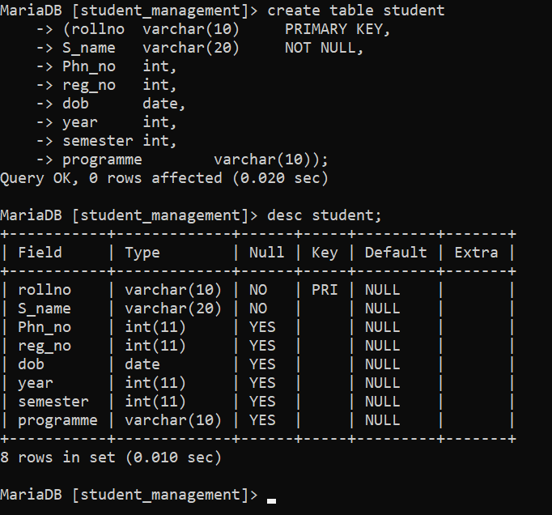

MariaDB [student_management]> create table fees

-> (rollno varchar(20),

-> amount int,

-> receipt varchar(10) PRIMARY KEY,

-> student_name varchar(20),

-> date_of_receipt date);

Query OK, 0 rows affected (0.020 sec)

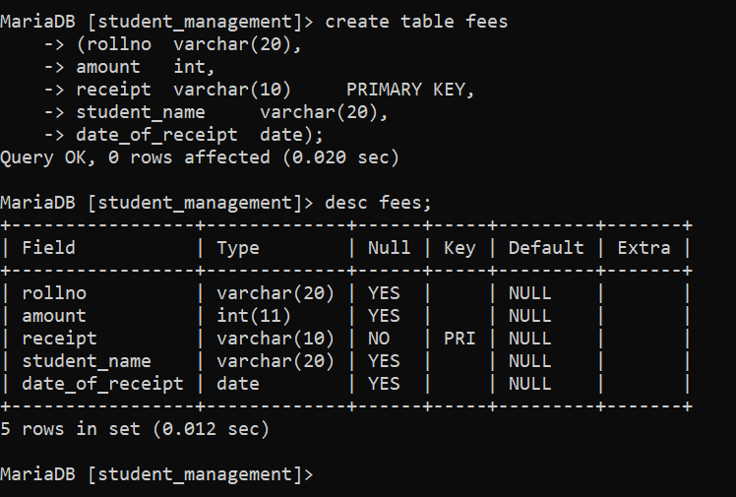

MariaDB [student_management]> create table faculty

-> (faculty_id char PRIMARY KEY,

-> fac_name varchar(20),

-> fac_address varchar(20),

-> age int,

-> salary int,

-> year int,

-> semester int);

Query OK, 0 rows affected (0.021 sec)

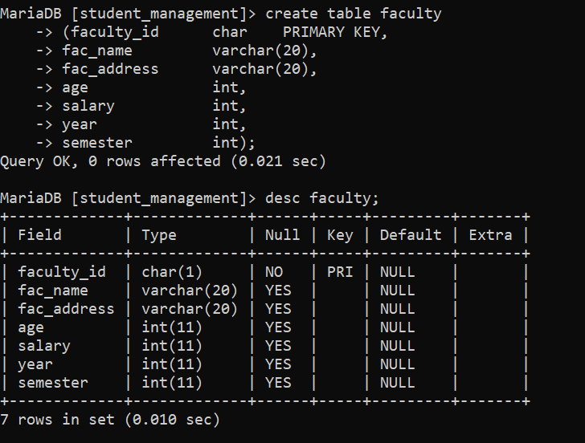

MariaDB [student_management]> create table course

-> (course_id char PRIMARY KEY,

-> course_name varchar(20),

-> credits int);

Query OK, 0 rows affected (0.021 sec)

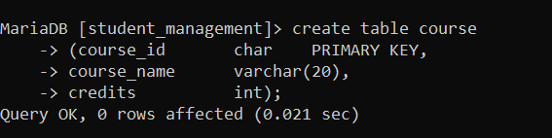

MariaDB [student_management]> create table department

-> (dept_id char PRIMARY KEY,

-> dept_name varchar(20),

-> location varchar(10)

-> );

Query OK, 0 rows affected (0.021 sec)

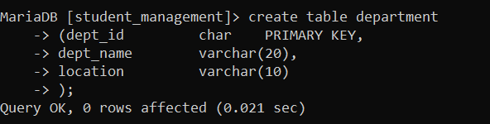

MariaDB [student_management]> create table exams

-> (exam_id char PRIMARY KEY,

-> exam_name varchar(20),

-> marks int,

-> student_rno varchar(10));

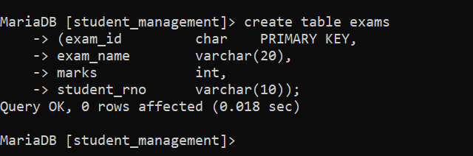

MariaDB [student_management]> show tables;

