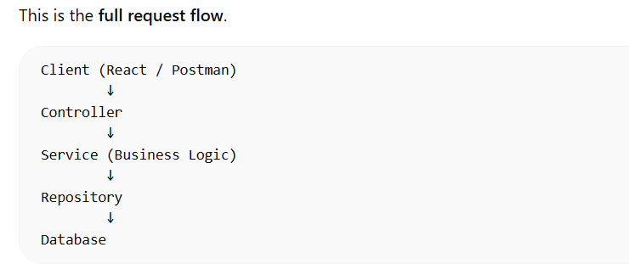
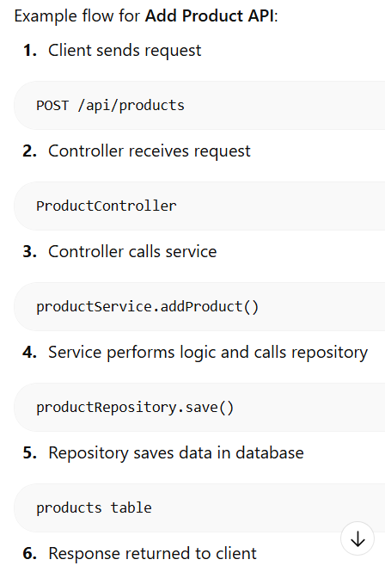
In our Spring Boot application we follow a layered architecture. The Entity layer represents database tables. The Repository layer handles database operations using Spring Data JPA. The Service layer contains business logic and validations. The Controller layer exposes REST APIs and handles HTTP requests from the client. This separation of concerns improves maintainability, scalability, and testability of the application.
1. What is CORS and why did you face this issue?

Question:- While integrating frontend and backend, did you face any CORS issues?

Answer
Yes. When integrating the React frontend with the Spring Boot backend, the browser blocked the request due to CORS (Cross-Origin Resource Sharing) policy.
CORS happens when the frontend and backend run on different origins.
Example:
Frontend: http://localhost:5173
Backend: http://localhost:8080
Since the ports are different, the browser treats them as different origins and blocks the request.

Error seen in browser
Access to XMLHttpRequest at 'http://localhost:8080/api/users/login'
from origin 'http://localhost:5173' has been blocked by CORS policy

Solution
We enabled CORS in the controller.
@CrossOrigin(origins = "http://localhost:5173")
@RestController
@RequestMapping("/api/users")
public class UserController {
}
Or globally:
@Configuration
public class CorsConfig {
@Bean
public WebMvcConfigurer corsConfigurer() {
return new WebMvcConfigurer() {
@Override
public void addCorsMappings(CorsRegistry registry) {
registry.addMapping("/**")
.allowedOrigins("http://localhost:5173")
.allowedMethods("*");
}};
}}

2. What is the purpose of a common API response class?

Question: Why did you create a common ApiResponse class?

Answer
Instead of returning raw objects from controllers, I used a wrapper response class to maintain a consistent API structure.
Example structure:
{
"success": true,
"message": "Login successful",
"data": { ... }
}
Benefits:
- Consistent responses across APIs
- Easier frontend integration
- Centralized success/error handling
- More readable APIs

3. What issue did you face with API response serialization?

Question: Did you encounter any issues with JSON responses?

Answer
Yes. While implementing the login API, the data field was not appearing in the response.
The issue was that the ApiResponse class did not have a getter for the data field.
Spring Boot uses Jackson to convert Java objects to JSON, and Jackson only serializes fields that have getters.
Original code:
private Object data;
But there was no getter.
After adding:
public Object getData() {
return data;
}
The response started returning the data correctly.

4. How does Spring Boot convert Java objects into JSON?

Answer:- Spring Boot uses the Jackson library for JSON serialization and deserialization.
Flow:
Controller returns Java Object
↓
Spring Boot detects @RestController
↓
Jackson converts object to JSON
↓
Response sent to client
Example Java response:
return new ApiResponse(true, "Login successful", user);
Converted JSON:
{
"success": true,
"message": "Login successful",
"data": {
"id": 1,
"name": "Harsh"
}
}

5. What debugging steps did you use when login was not working?

Question:- How do you debug frontend-backend integration issues?

Answer:- I followed a structured debugging process.
Step 1:- Check Network tab in browser.
Step 2:- Verify API response.
Step 3:- Add console logs.
console.log(res.data);
Step 4:- Check browser Local Storage.
Step 5:- Verify backend logs.
After checking the response and logs, we found the issue in response serialization.

6. What is ResponseEntity and why did you use it?

Answer
ResponseEntity allows us to control:
- HTTP status
- headers
- response body
Example:
return ResponseEntity.status(HttpStatus.CREATED)
.body(new ApiResponse(true, "Account created successfully"));
Advantages:
- Proper REST API design
- Better error handling
- Clear communication with frontend

7. Why did you use layered architecture?

Question:- Explain Controller-Service-Repository architecture.

Answer
We used layered architecture for separation of concerns.
Structure:
Controller → Handles HTTP requests
Service → Business logic
Repository → Database operations
Example flow:

React Frontend
↓
UserController
↓
UserService
↓
UserRepository
↓
Database
Benefits:
- Clean code
- Easier testing
- Better maintainability

8. How does login work in your backend?

Answer
Login flow:
- User sends email and password
- Controller receives request
- Service checks database
- If user exists → return success
- If not → return 401
Example:
@PostMapping("/login")
public ResponseEntity<ApiResponse> login(@RequestBody User user) {
User loggedInUser = userService.login(user.getEmail(), user.getPassword());
if (loggedInUser == null) {
return ResponseEntity.status(401)
.body(new ApiResponse(false, "Invalid credentials"));
}
return ResponseEntity.ok(
new ApiResponse(true, "Login successful", loggedInUser)
);
}

9. Why did you store the user in LocalStorage?

Answer:- After successful login, we store the user data in LocalStorage so the login session persists after page refresh.
Example:
localStorage.setItem("user", JSON.stringify(res.data.data));
This allows the application to display the logged-in user even after refreshing the page.
Example UI:
Hi, Harsh
Logout

10. What HTTP status codes did you use and why?

Answer:- We used standard REST API status codes.
Code | Meaning
200 | Request successful
201 | Resource created
401 | Unauthorized
404 | Resource not found
Example:
Register API → 201
ResponseEntity.status(HttpStatus.CREATED)
Login API → 200
Invalid login → 401

11. How does Spring Boot create tables automatically?
Answer:
Spring Boot uses Hibernate (JPA implementation). When the application starts, Hibernate scans classes annotated with @Entity and automatically generates database tables based on the fields.
12. Why do we use Optional in service?
Answer:
Optional is used to handle null values safely. Instead of returning null, it clearly indicates that a value may or may not be present, reducing the chances of NullPointerException.
Example:
Optional<Product> product = productRepository.findById(id);

