

**As a component of internal assessment method**

Assignment

Submitted to the

Department of ISE

**By**

**Name: Harsh Nautiyal**

**USN: 1NT17IS067**

**CLASS: 6th-A**

**Subject: Java Lab**

|  |  |
| --- | --- |
| **Maximum Marks** |  |
| **Marks Awarded** |  |

**Signature of the Faculty**

1. Develop a small java application, which accepts employee id from the command prompt and displays the details using arrays.

import java.util.Date;

import java.util.Stack;

public class Employee1

{

public static void main(String args[])

{

System.out.println("Enter Valid Employee ID : \n"); //enter an id from the specified list

int[] EmpId={1001,1002,1003,1004,1005,1006,1007}; //valid array of IDs

String[] EmpName={"Abc","Opqr","Ghi","Wxyz","Jklmn","Stuv","Def"}; //array of names according to the IDs respectively

String[] JoinDate={"01/04/2009","23/08/2012","12/11/2008","29/01/2013","16/07/2005","01/01/2000","12/06/2006"}; //array of joining dates according to the IDs respectively.

char[] DesigCode={'e','c','k','r','m','e','c'}; //array of designation codes according to the IDs respectively.

String[] Department={"R&D","PM","Acct","Front Desk","Engg","Manufacturing","PM"}; //array of department of the employees according the IDs respectively

double[] Basic={20000,30000,10000,12000,50000,23000,29000}; //array of basic salaries of employees.

double[] HRA={8000,12000,8000,6000,20000,9000,12000}; //array of hra of employees

double[] IT={3000,9000,1000,2000,20000,4400,10000}; //array of income tax of employees

char[] DesignationCode={'e','c','k','r','m'};

String[] Designation={"Engineer","Consultant","Clerk","Receptionist","Manager"}; //array of designations

double[] DA={20000,32000,12000,15000,40000}; //array of da of employees

int flag=0;

int id=Integer.parseInt(args[0]);

for(int i=0;i<EmpId.length;i++)

{

if(EmpId[i]==id)

{

flag=1;

System.out.println("Emp Id. Emp Name Department Designation DA"); //printing employee details of specified employee id

System.out.print(EmpId[i]+" "+EmpName[i]+" "+Department[i]);

for(int j=0;j<DesignationCode.length;j++)

{

if(DesigCode[i]==DesignationCode[j])

{ System.out.print(" "+Designation[j]+" ");

double sum=Basic[i]+HRA[i]+DA[j]-IT[i]; //calculating sum

System.out.print(sum);

}

}

}

}

if(flag==0)

System.out.println("There is no employee with EmpId : " +id); //prints this when an invalid employee ID is returned

}

}

**OUTPUT:**

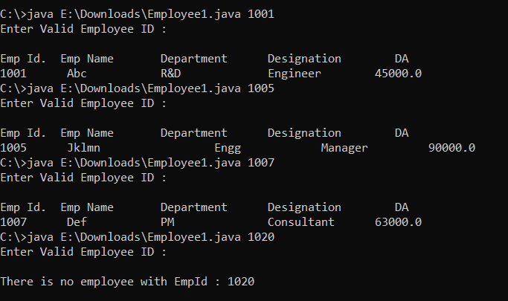

1. **Develop a small java application, which uses concepts of Multithreading**

package javalab;

import java.util.Date;

import java.util.*;

public class MultiThreading implements Runnable//thread creation by implementing the Runnable Interface

{

Thread t;

static int[] a=new int[51];//creates array a

static int sum=0;

MultiThreading(String name)

{

t=new Thread(this, name);//creates new thread t

System.out.println("childthread:"+t);

t.start();//starts thread t

}

public void run()

{

System.out.println(Thread.currentThread().getName());//prints the current running thread

if(Thread.currentThread().getName().compareTo("one")==0)

{

for(int i=0;i<10;i++)

{

sum=sum+a[i];

try

{

Thread.sleep(1000);// Let the thread sleep for a while.

}

catch (InterruptedException e)//exception thrown when thread is interrupted

{

e.printStackTrace();

}

System.out.println("Sum of 1-10 : " +sum);

}

//total=total+sum;

}

else if(Thread.currentThread().getName().compareTo("two")==0)

{

for(int j=10;j<20;j++)

{

sum=sum+a[j];

try

{

Thread.sleep(1000);// Let the thread sleep for a while.

}

catch (InterruptedException e)//exception thrown when thread is interrupted

{

// TODO Auto-generated catch block

e.printStackTrace();

}

System.out.println("Sum of 10-20 : " +sum);

}

//total=total+sum;

}

else if(Thread.currentThread().getName().compareTo("three")==0)

{

for(int k=20;k<30;k++)

{

sum=sum+a[k];

try

{

Thread.sleep(1000);// Let the thread sleep for a while.

}

catch (InterruptedException e)//exception thrown when thread is interrupted

{

e.printStackTrace();

}

System.out.println("Sum of 20-30 : " +sum);

}

//total=total+sum;

}

else if(Thread.currentThread().getName().compareTo("four")==0)

{

for(int l=30;l<40;l++)

{

sum=sum+a[l];

try{

Thread.sleep(1000);// Let the thread sleep for a while.

}catch (InterruptedException e)//exception thrown when thread is interrupted

{

// TODO Auto-generated catch block

e.printStackTrace();

}

System.out.println("Sum of 30-40 : " +sum);

}

//total=total+sum;

}

else if(Thread.currentThread().getName().compareTo("five")==0)

{

for(int m=40;m<50;m++)

{

sum=sum+a[m];

try

{

Thread.sleep(1000);// Let the thread sleep for a while.

}

catch (InterruptedException e)//exception thrown when thread is interrupted

{

e.printStackTrace();

}

System.out.println("Sum of 40-50 : " +sum);

//total=total+sum;

}

//System.out.println("Total sum is : " +total);

}

}

public static void main(String[] args)

{

for(int x=0;x<51;x++)

{

a[x]=x+1;

}

System.out.println(Thread.currentThread().getName());

MultiThreading ob1=new MultiThreading("one");

MultiThreading ob2=new MultiThreading("two");

MultiThreading ob3=new MultiThreading("three");

MultiThreading ob4=new MultiThreading("four");

MultiThreading ob5=new MultiThreading("five");

Date start=new Date();

System.out.println("First Thread is Alive? : " +ob1.t.isAlive());

System.out.println("Second Thread is Alive? : " +ob2.t.isAlive());

System.out.println("Third Thread is Alive? : " +ob3.t.isAlive());

System.out.println("Fourth Thread is Alive? : " +ob4.t.isAlive());

System.out.println("Fivth Thread is Alive? : " +ob5.t.isAlive());

try

{

System.out.println("waiting for Threads to complete");

ob1.t.join();

ob2.t.join();

ob3.t.join();

ob4.t.join();

ob5.t.join();

}

catch (InterruptedException e)

{

// TODO Auto-generated catch block

e.printStackTrace();

}

System.out.println("Total sum is : " +sum);

System.out.println("First Thread is Alive? :"+ob1.t.isAlive());

System.out.println("Second Thread is Alive? :"+ob2.t.isAlive());

System.out.println("Third Thread is Alive? :"+ob3.t.isAlive());

System.out.println("Fourth Thread is Alive? :"+ob4.t.isAlive());

System.out.println("Fivth Thread is Alive? :"+ob5.t.isAlive());

System.out.println("Main thread is interupted ");

Date end=new Date();

long difference=end.getTime()-start.getTime();//time taken for execution

System.out.println("Whole process took "+difference/1000 +" " +"seconds");

System.out.println("Main thread is exiting");

}

}

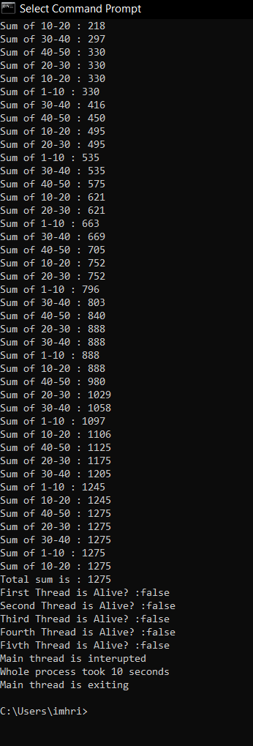**OUTPUT:**

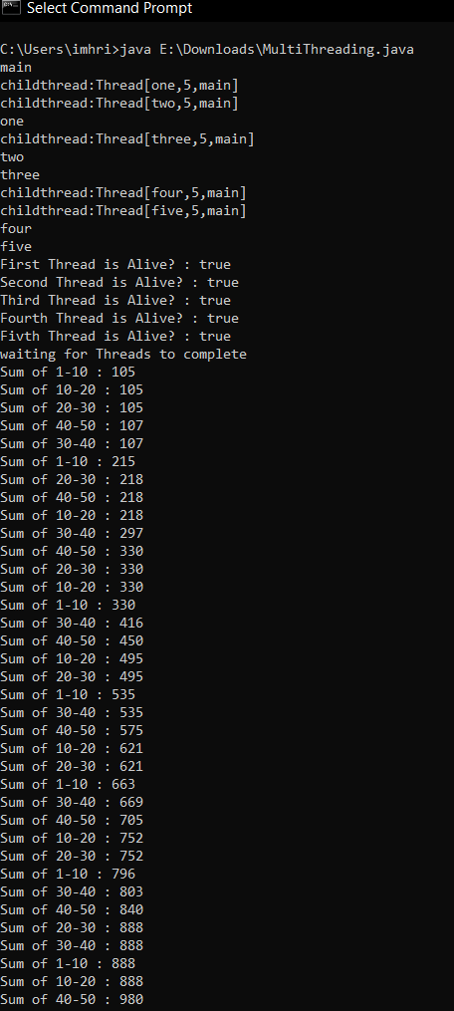

**3. Design and Implement GUI for managing Employee Details using concepts of Files.**

package javalab;

import java.awt.Color;

import java.awt.Dimension;

import java.awt.GridLayout;

import java.awt.event.ActionEvent;

import java.awt.event.ActionListener;

import java.io.File;

import java.io.FileWriter;

import java.io.IOException;

import javax.swing.*;

public class EmployeeFile

{

private static Color black;

public static void main(String[] args)

{

JFrame frameobj = new JFrame(); //creating frame

frameobj.setSize(500, 500); //declaring frame size

GridLayout g1=new GridLayout(5,2); // layout of the frame

frameobj.setLayout(g1); //layout is set to the frame created

JPanel p1=new JPanel(); //creating panels

JPanel p2=new JPanel();

JPanel p3=new JPanel();

JPanel p4=new JPanel();

JPanel p5=new JPanel();

JPanel p6=new JPanel();

JPanel p7=new JPanel();

JPanel p8=new JPanel();

JPanel p9=new JPanel();

JPanel p10=new JPanel();

JLabel l1=new JLabel("NAME"); //creating labels

JLabel l2=new JLabel("ID");

JLabel l3=new JLabel("DOJ");

JLabel l4=new JLabel("DOB");

JTextField f1=new JTextField(); //create object for text field

JTextField f2=new JTextField();

JTextField f3=new JTextField();

JTextField f4=new JTextField();

f1.setPreferredSize(new Dimension(200,30)); //size of text field

f2.setPreferredSize(new Dimension(200,30));

f3.setPreferredSize(new Dimension(200,30));

f4.setPreferredSize(new Dimension(200,30));

JButton b1=new JButton("SUBMIT");//create submit button

JButton b2=new JButton("RESET");//create reset button

b1.addActionListener(new ActionListener()//is notified whenever you click on the button or menu item

{

@Override

public void actionPerformed(ActionEvent e)//is invoked automatically whenever you click on the registered component

{

File fileobj=new File("E:\\Downloads\\File.txt");//file path

try

{

FileWriter fw=new FileWriter(fileobj.getAbsoluteFile(),true);

System.out.println("\n NAME : " +f1.getText() +"\n" +"ID : " +f2.getText() +"\n" +"DOJ : " +f3.getText() +"\n" +"DOB : "+f4.getText() +"\n");//prints details

fw.write("\n NAME : " +f1.getText() +"\n" +"ID : " +f2.getText() +"\n" +"DOJ : " +f3.getText() +"\n" +"DOB : "+f4.getText() +"\n");//writes details in file

fw.close();

}

catch (IOException e1)

{

e1.printStackTrace();

}

}

});

b2.addActionListener(new ActionListener()

{

@Override

public void actionPerformed(ActionEvent e)

{

f1.setText(" ");

f2.setText(null);

f3.setText(null);

f4.setText(null);

}

});

p1.add(l1); //add labels to panels where labels=name,id,doj,dob

p3.add(l2);

p5.add(l3);

p7.add(l4);

p2.add(f1); //add text field to panels where text field is user defined

p4.add(f2);

p6.add(f3);

p8.add(f4);

p9.add(b1); //add buttons to panel

p10.add(b2);

//l1.setBorder(BorderFactory.createLineBorder(Color.black));

l1.setBorder(BorderFactory.createLineBorder(black,10));

l2.setBorder(BorderFactory.createLineBorder(black,10));

l3.setBorder(BorderFactory.createLineBorder(black,10));

l4.setBorder(BorderFactory.createLineBorder(black,10));

frameobj.add(p1); //add panels to frames

frameobj.add(p2);

frameobj.add(p3);

frameobj.add(p4);

frameobj.add(p5);

frameobj.add(p6);

frameobj.add(p7);

frameobj.add(p8);

frameobj.add(p9);

frameobj.add(p10);

frameobj.setVisible(true);//shows the window

}

}

**OUTPUT:**

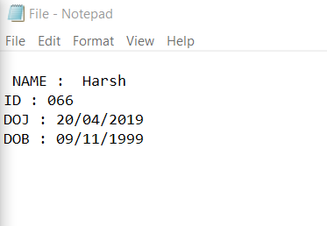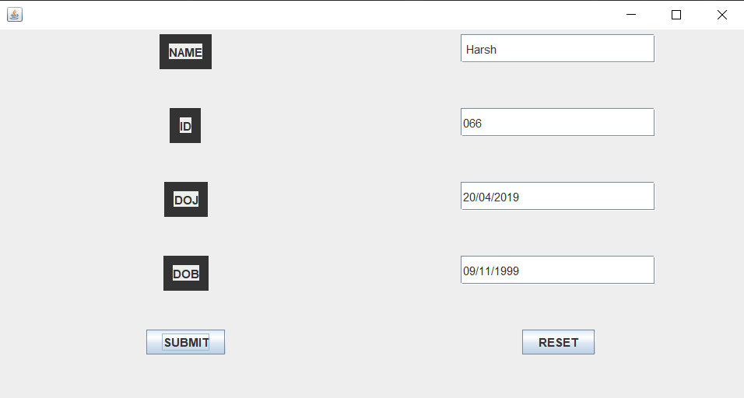

**4.Design and implement a simple inventory central system for a small video rental store using constructors and Object List.**

Video.java

package javalab;

public class Video

{

String mName;//movie name

boolean status;//status of return

double rating;//movie rating

public Video(String mName, boolean status, double rating)//constructor

{

super();

this.mName = mName;//set movie name

this.status = status;//set return status

this.rating = rating;//set movie rating

}

public String getmName()

{

return mName;//returns movie name

}

public void setmName(String mName)

{

this.mName = mName;//sets movie name

}

public boolean isStatus()

{

return status;//returns status

}

public void setStatus(boolean status)

{

this.status = status;//sets status

}

public double getRating()

{

return rating;//returns movie rating

}

public double setRating(double rating)

{

return this.rating = rating;//sets movie rating

}

}

VideoMethods.java

package javalab;

import java.util.List;

import java.util.Scanner;

import java.util.ArrayList;

public class VideoMethods

{

List<Video> MovieList = new ArrayList<Video>();//create list

public void AddMovies()//method to add movies into the list

{

Scanner in =new Scanner(System.in);

System.out.print("Enter the name of the movie:");

String mName=in.nextLine();

System.out.print("Enter the status of the movie(True/False):");

boolean status=in.nextBoolean();

System.out.print("Enter the ratings for the movie(0-5):");

double rating=in.nextDouble();

Video v= new Video(mName, status, rating);//calls constructor

MovieList.add(v);//inserts elements into list

System.out.println("Library Initialized");

}

public void DisplayAll()//method to display list

{

if(MovieList.isEmpty())//checks if list is empty

{

System.out.println("No movies in the library");

}

for(Video m : MovieList)//Iterates through whole loop

{

System.out.println("Movie : " +m.getmName()+" "+"Status : "+m.isStatus()+" "+"Rating "+m.getRating());

}

}

boolean RentOut(String name)//method to rent movies

{

for(Video m :MovieList)

{

if(m.getmName().equalsIgnoreCase(name))//checks if movie name is in the list

{

if(m.isStatus())

{

m.setStatus(false);

return true;

}

}

return false;

}

return false;

}

public void CollectIn(String name,double rat)//method to collect back rented movies

{

boolean flag=false;

for(Video m :MovieList)

{

if(m.getmName().equalsIgnoreCase(name))//checks if movie name is in the list

{

m.setStatus(true);

flag=true;

Math.round(m.setRating((m.getRating() + rat)/2));

}

}

if(!flag)//movie name is not rented

{

System.out.println("Requested Movie not rented out");

}

}

}

Videomain.java

package javalab;

import java.util.Scanner;

public class VideoMain

{

public static void main(String args[])

{

VideoMethods mm = new VideoMethods();// new object created

while(true)

{

System.out.println("%%%%%%%% VIDEO LIBRARY CENTER %%%%%%%%");

int n;//for choice

Scanner in = new Scanner(System.in);

System.out.println("1.ADD MOVIES");

System.out.println("2.DISPLAY MOVIES");

System.out.println("3.RENT OUT");

System.out.println("4.COLLECT BACK ");

System.out.println("PLEASE ENTER YOUR OPTION");

n = in.nextInt();

switch(n)

{

case 1:mm.AddMovies();

break;

case 2:mm.DisplayAll();

break;

case 3:System.out.print("Enter the movie you want to rent.");

in.nextLine();

if(mm.RentOut(in.nextLine()))//calling method RentOut

{

System.out.println("Rent out successfull");

}

else

{

System.out.println("Sorry!! Not Available");

}

break;

case 4:System.out.println("Enter the name and the ratings of the movie");

in.nextLine();

mm.CollectIn(in.nextLine(),in.nextDouble());//calling method CollectIn

break;

}

}

}

}

**OUTPUT:**

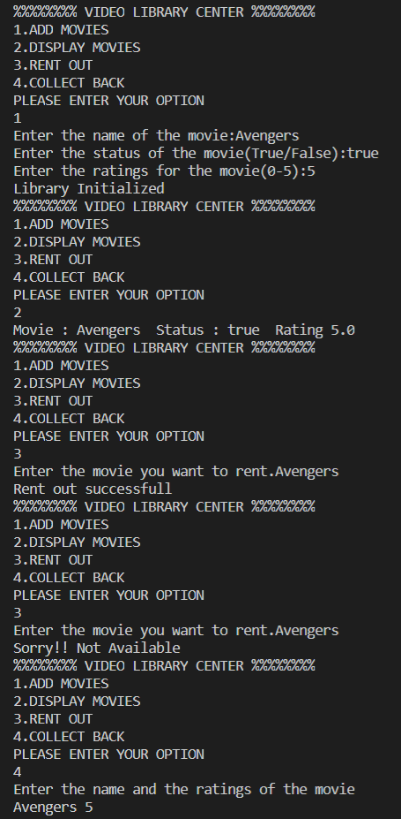

**5.Given the information about employees of an organization, develop a small java application, using JDBC.**

DBConnection.java

package javalab;

import java.sql.Connection;

import java.sql.DriverManager;

import java.sql.SQLException;

public class DBConnection

{

public Connection getDBconnection()

{

Connection conn=null;

try

{

Class.forName("com.mysql.jdbc.Driver");//registering mysql drivers

System.out.println("Registered successfully");

}

catch (ClassNotFoundException e)

{

e.printStackTrace();

}

try

{

conn=DriverManager.getConnection("jdbc:mysql://localhost:3306/EMP","root","");//connecting to database

System.out.println("Connection successfull\n");

}

catch (SQLException e)

{

e.printStackTrace();

}

return conn;

}

}

Employee.java

package javalab;

public class Employee

{

String name;

int age;

String dept;

double sal;

public String getName()

{

return name;//returns employee name

}

public void setName(String name)

{

this.name = name;//sets employee name

}

public int getAge()

{

return age;//returns employee age

}

public void setAge(int age)

{

this.age = age;//sets employee age

}

public String getDept()

{

return dept;//returns employee department

}

public void setDept(String dept)

{

this.dept = dept;//sets employee department

}

public double getSal()

{

return sal;//returns employee salary

}

public void setSal(double sal)

{

this.sal = sal;//sets employee salary

}

}

DAO.java

package javalab;

import java.sql.Connection;

import java.sql.PreparedStatement;

import java.sql.ResultSet;

import java.sql.SQLException;

public class DAO

{

public int insertemp(Employee e)//method to insert employee details

{

int r=0;

Connection conn=new DBConnection().getDBconnection();

try

{

PreparedStatement pst=conn.prepareStatement("insert into employee values(?,?,?,?)");//accepts input parameters at runtime

pst.setString(1, e.getName());//Sets the designated parameter to the given Java String value

pst.setInt(2, e.getAge());//Sets the designated parameter to the given Java int value

pst.setString(3, e.getDept());//Sets the designated parameter to the given Java String value

pst.setDouble(4, e.getSal());//Sets the designated parameter to the given Java double value

r=pst.executeUpdate();//Executes the SQL statement

}

catch (SQLException e1)

{

e1.printStackTrace();

}

return r;

}

public int deleteemp(String emp)//method to delete specific employee details

{

int s=0;

Connection conn=new DBConnection().getDBconnection();

try

{

PreparedStatement pst=conn.prepareStatement("delete from employee where name=?");//accepts parameters to delete details

pst.setString(1, emp);//Sets the designated parameter to the given Java String value

s=pst.executeUpdate();//Executes the SQL statement

}

catch (SQLException e1)

{

e1.printStackTrace();

}

return s;

}

public void displayname(String ename)//method to display specific employee details

{

Connection conn=new DBConnection().getDBconnection();

try

{

PreparedStatement pst = conn.prepareStatement("select * from employee where name=?");//accepts parameters to display details

pst.setString(1, ename);//Sets the designated parameter to the given Java String value

ResultSet rs=pst.executeQuery();//refers to the row and column data contained in a ResultSet object.

while(rs.next())

{

System.out.println("Name : " +rs.getString(1)+ "\t"+ "Age : " +rs.getInt(2)+ "\t"+ "Dept :" +rs.getString(3)+ "\t"+ "Salary :" +rs.getDouble(4));//displays details

}

}

catch (SQLException e)

{

e.printStackTrace();

}

}

public void displayall()////method to display all employee details

{

Connection conn=new DBConnection().getDBconnection();

try

{

PreparedStatement pst=conn.prepareStatement("select * from employee");

ResultSet rs=pst.executeQuery();//refers to the row and column data contained in a ResultSet object.

while(rs.next())

{

System.out.println("Name : " +rs.getString(1)+ "\t"+ "Age : " +rs.getInt(2)+"\t"+ "Dept :" +rs.getString(3)+"\t" + "Salary :" +rs.getDouble(4));;

}

}

catch (SQLException e1)

{

e1.printStackTrace();

}

}

}

FinalDBProgram.java

package javalab;

import java.util.Scanner;

public class FinalDBProgram

{

public static void main(String[] args)

{

for( ; ; )

{

Scanner in=new Scanner(System.in);

System.out.println("\n 1. Insert Emp \n 2. Delete Emp \n 3. Display Acc to Name \n 4. Display All \n 5. Exit \n");

System.out.println("Enter your choice");

int n=in.nextInt();

Employee e=new Employee();//object of class Employee

DAO d=new DAO();//object of class DAO

switch(n)

{

case 1:

System.out.println("Enter the Employee Name : ");

e.setName(in.next());

System.out.println("Enter the Age : ");

e.setAge(in.nextInt());

System.out.println("Enter the Dept : ");

e.setDept(in.next());

System.out.println("Enter the Salary : ");

e.setSal(in.nextDouble());

d.insertemp(e);

System.out.println("Employee added successfully");

break;

case 2:

System.out.println("Enter the employee name : ");

String Newname=in.next();

d.deleteemp(Newname);

System.out.println("Employee deleeted successfully");

break;

case 3:System.out.println("Enter the Employee name to display its attributes : ");

String ename=in.next();

System.out.println("Employee details...");

d.displayname(ename);

break;

case 4:System.out.println("Employee deatils are as follows...");

d.displayall();

break;

case 5:System.exit(0);

break;

default:

System.out.println("Please Choose Valid option \n");

break;

}

}

}

}

**OUTPUT:**

