Project

Feedback Recorder

**Group Members Details**

|  |  |
| --- | --- |
| **S. No.** | **Name** |
| **1.** | Harsh Negi |
| **2.** | Drishti Vashisth |
| **3.** | Rishab Kumar |
| **4.** | Harshil Golyan |

**About the project:**

1. This project is a GUI application written in python which will record the speech of the user and converts the recorded audio into speech and saves it into a .txt file
2. Along with the text conversion, the application also detects the sentiments (either positive, negative or neutral) and mentions in the file.
3. The generated file is saved into the system and also it is uploaded to online cloud service (Google Drive used for this purpose) to keep track of the recordings.



* **Output:**

1. When the Application Is Open, The User has option to save recording or convert into text

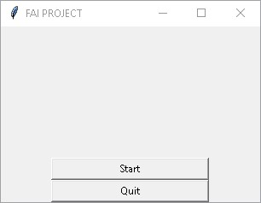 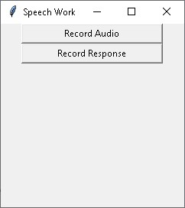

2. If the Person Chooses Record Audio Option, The Audio Gets Start Recording

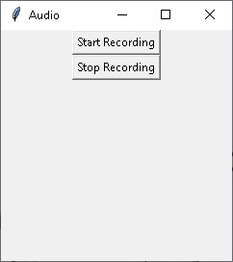 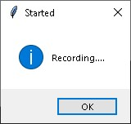

2.1 After the Users Press Stop Recording, The File Gets Saved and Asked User to Save the File Name.

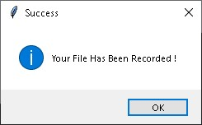 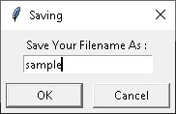

2.2 The file gets saved and the file gets uploaded to google drive

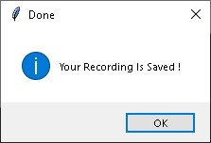 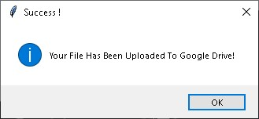

3. If the User Select Record Response, A New Window gets open and the audio gets start recording

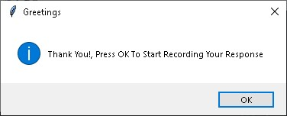

3.1 When the user stops saying something, the audio gets recorded, converts the audio into text and uploads the file into google drive

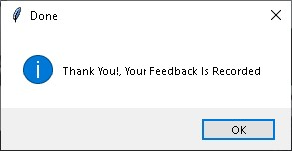 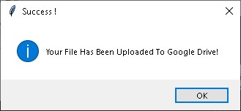

4. The Files Get Uploaded on Google Drive (sample3.wav, feedback_form_1.txt)

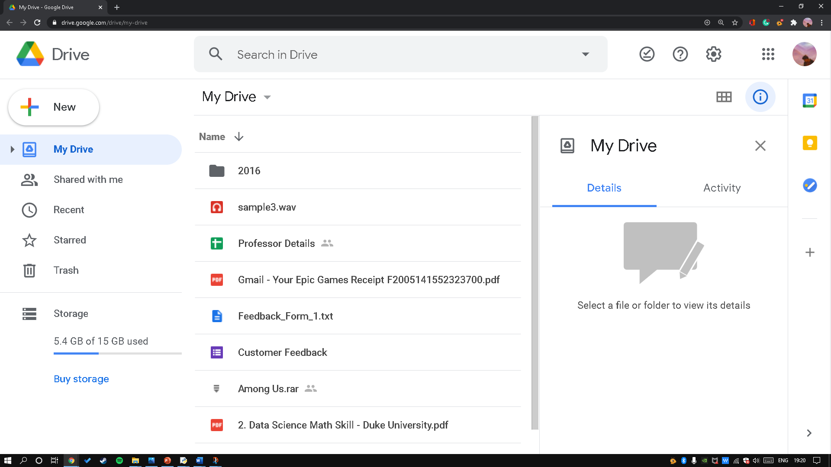

* **Limitations faced during creating the project:**

The only limitation faced during the project was to rewrite the API authorization link (to upload the file on google drive) as the authorization link expires within an hour. The way to solve is to arrange tokens which can be accessed by enabling drive API by Google Python QuickStart therefore can be used to request tokens to update authorization link every hour. However, the authorization link can be extracted every hour.

**THANK YOU!**