1. create all given tables

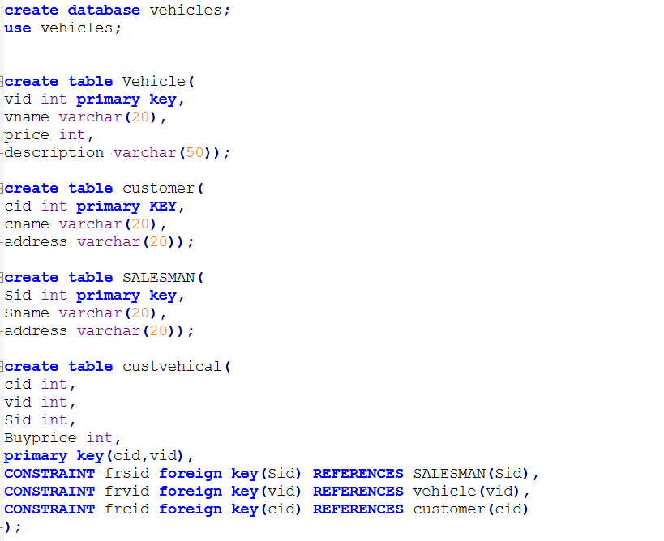

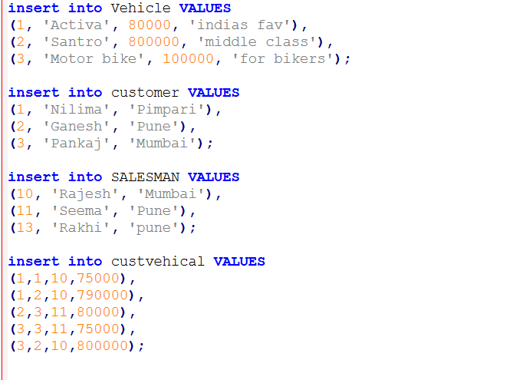

3 find all customer name,vehicle name, salesman name, discount earn by all customer

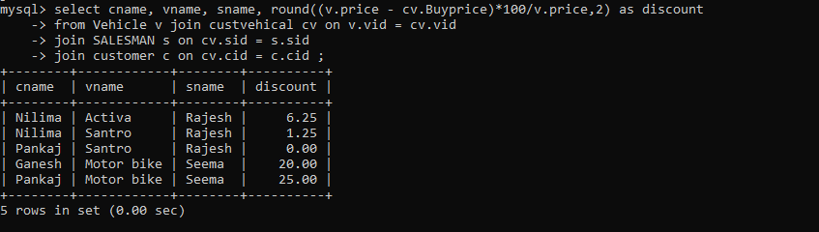

4 find all customer name,vehicle name,salesman name for all salesman who stays in pune

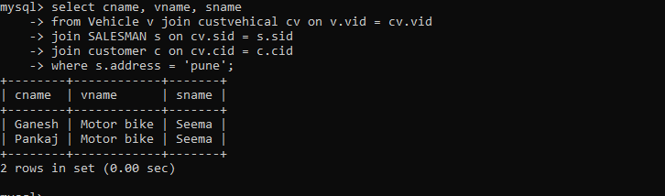

5 find how many customers bought motor bike

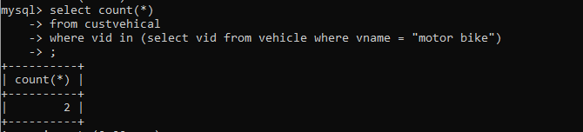

6 create a view find_discount which displays output

-------to create view

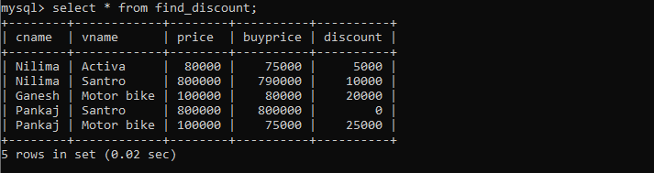

8 create view my_hr to display empno,ename,job,comm for all employees who earn Commission

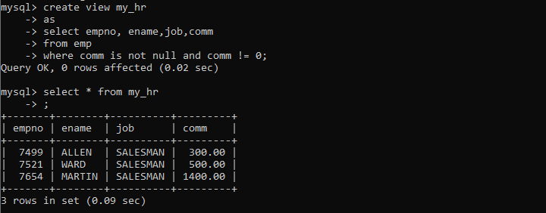

9 create view mgr30 to display all employees from department 30

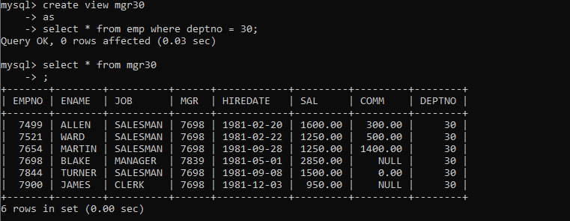

11

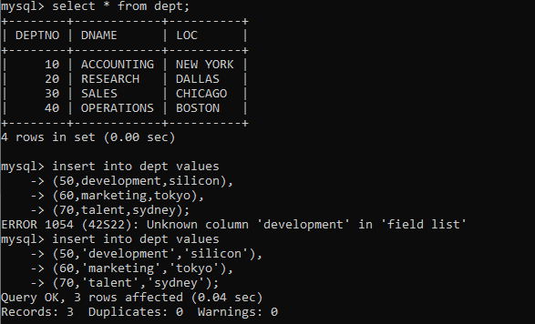

10 insert 3 employees in view mgr30 check whether insertion is possible

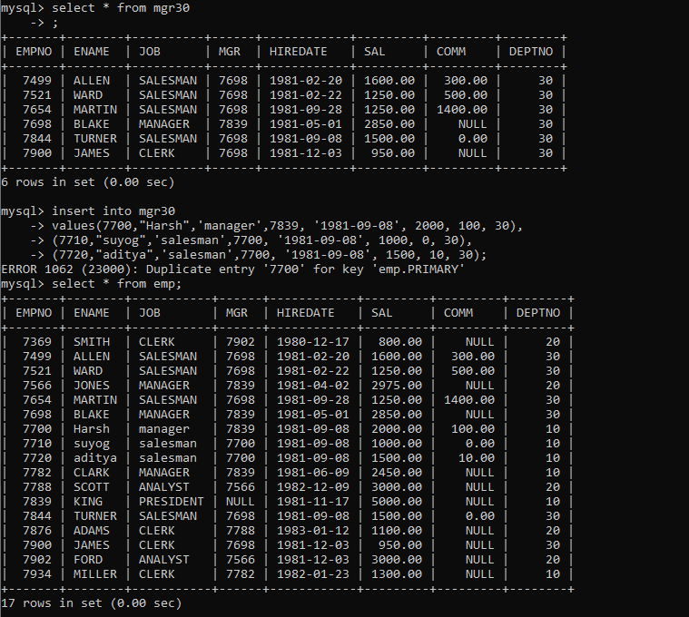

13 do the following

insert row in emp with empno 100

insert row in emp with empno 101

insert row in emp with empno 102

add savepoint A

insert row in emp with empno 103

insert row in emp with empno 104

insert row in emp with empno 105

add savepoint B

delete emp with empno 100

delete emp with emp no 104

rollback upto svaepoint B

check what all records will appear in employee table

rollback upto A

check what all records will appear in employee table

commit all changes

check what all records will appear in employee table

check whether you can roll back the contents.

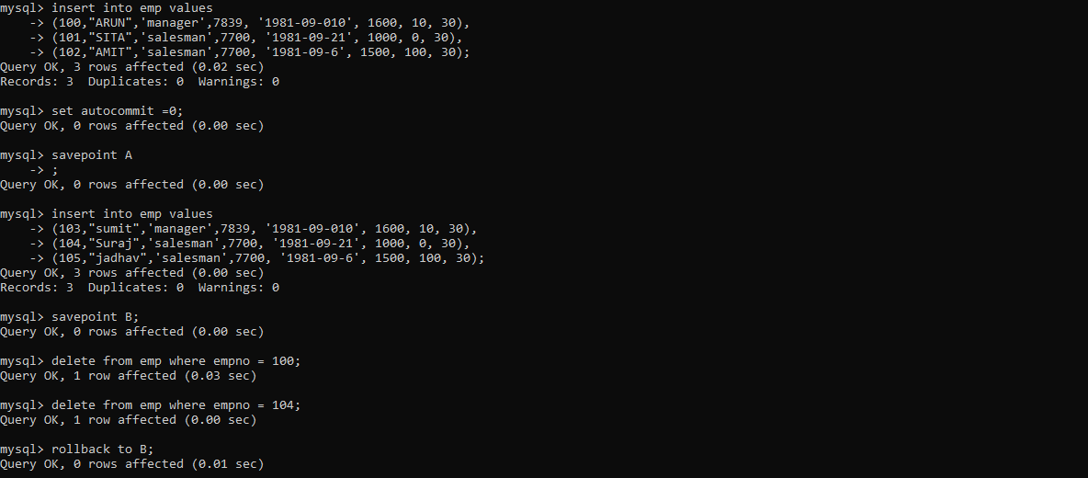

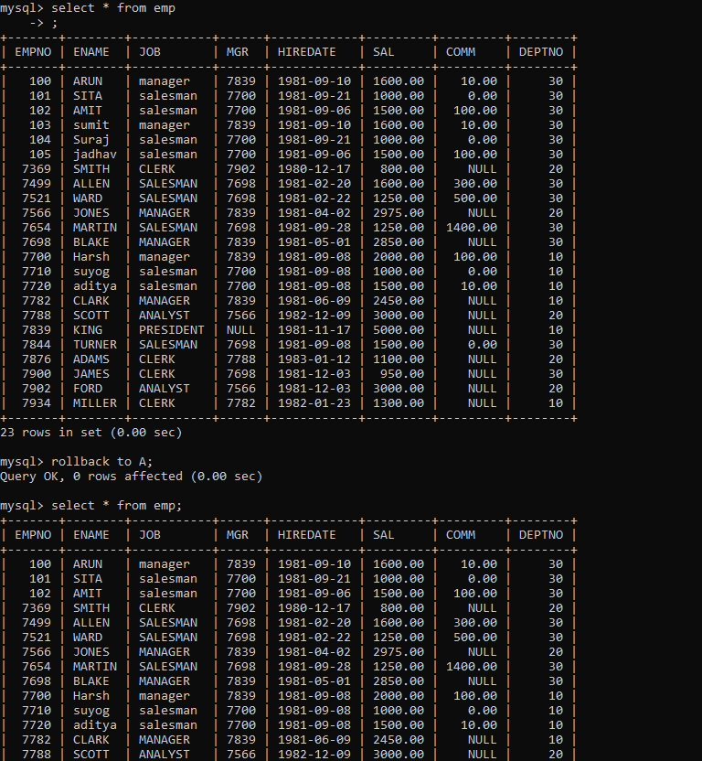

14 create a procedure getMin(deptno,minsal) to find minimum salary of given table.

