Q1. To list all records with sal > 2000 and comm>200

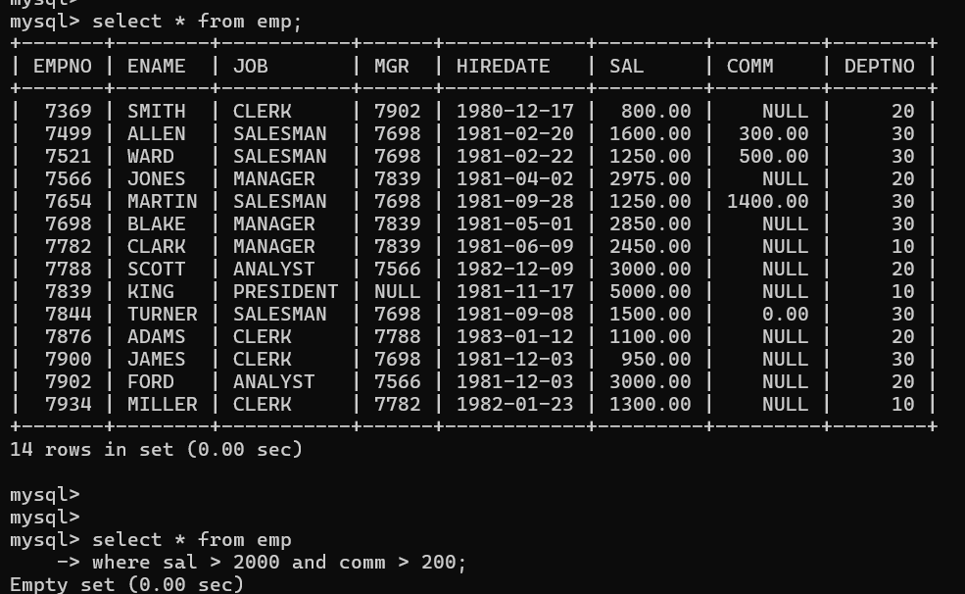

Q2 To list all record with job=’Clerk’ or sal>2000

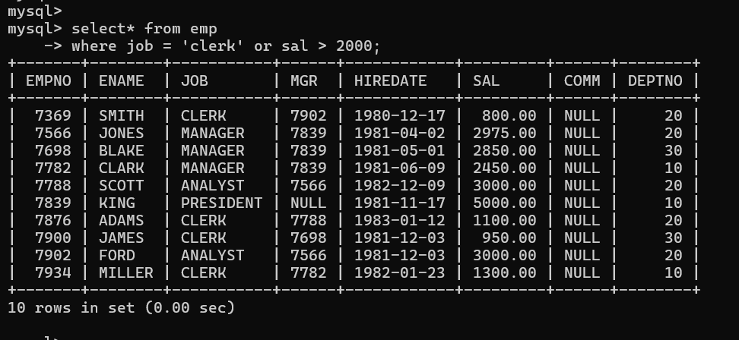

Q3. To list all the record with sal=1250 or 1100 or 2850

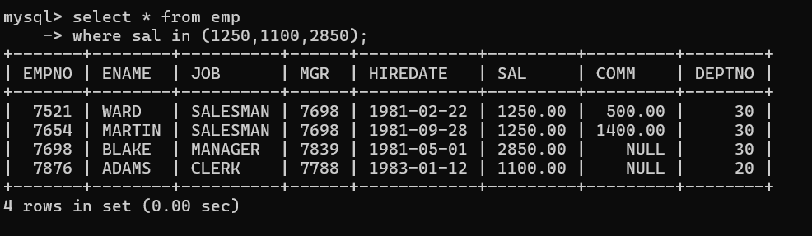

Q4. To list all employees with sal>1250 and <2850

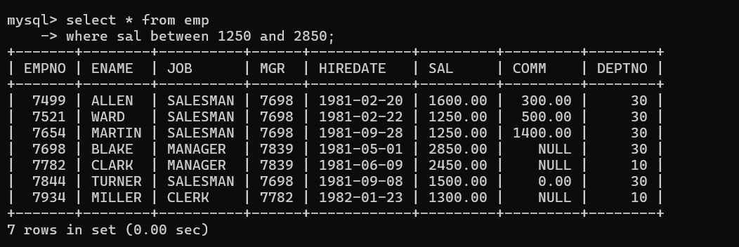

5 To list all employees with name ends with AS

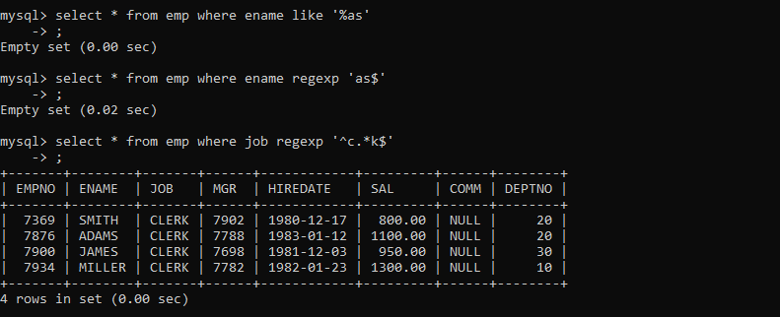

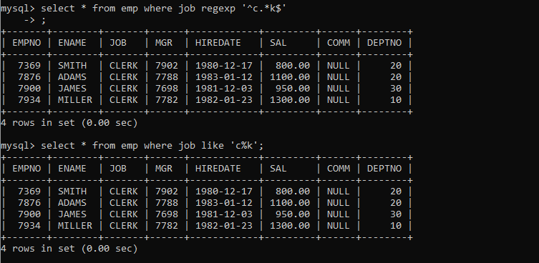2. To list all employees with job starts with C and ends with K

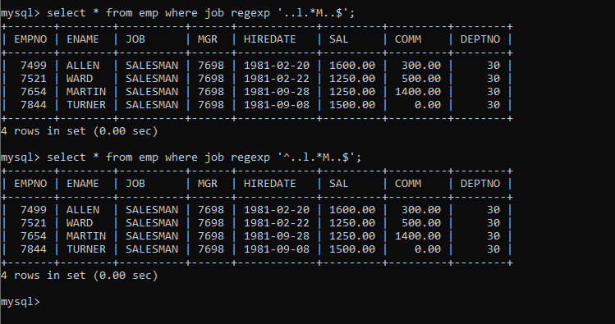3To list all employees with job contains L at third position and M at third last position

4 To list all employees with job starts with C , E at 3rd position and ends with K

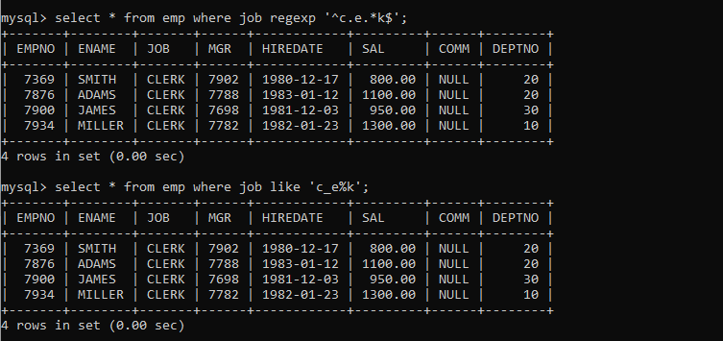

5To list all employees with sal is null and name starts with ‘S’

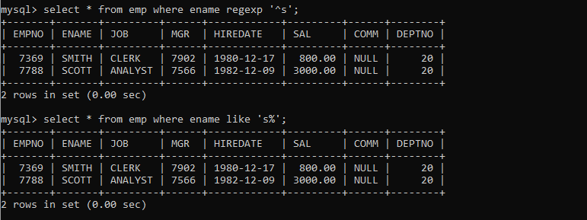

6 To list all employees with job contains 5 characters

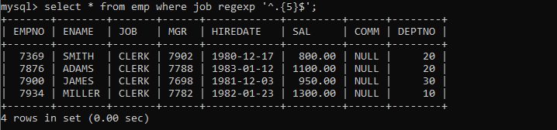

7 To list all employees with name contain ‘A’ at 1 position and job Contains 5 characters

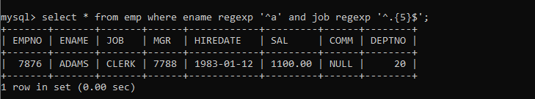

8 Display the employee details where the job contains word ‘AGE’ anywhere in the Job

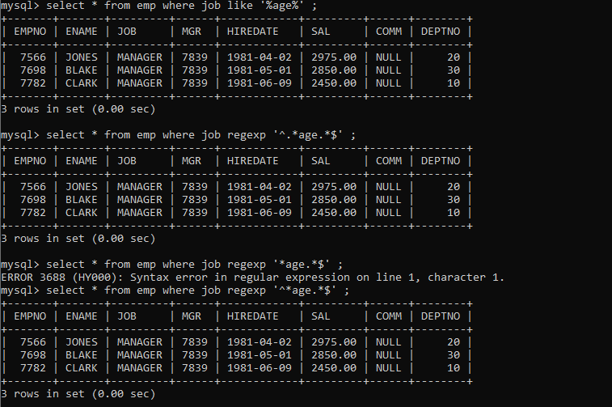

9 List the details of the employee , whose names start with ‘A’ and end with ‘S’ or whose names contains N as the second or third character, and ending with either ‘N’ or ‘S’.

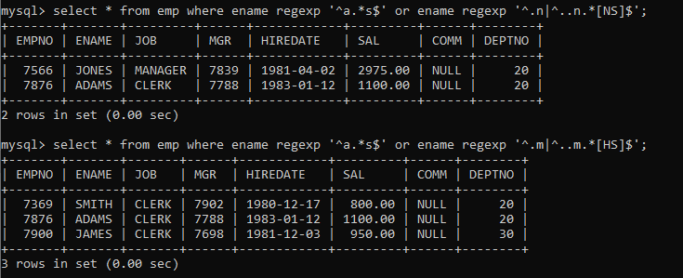

10 List the names of the emp having ‘_’ character in their name.

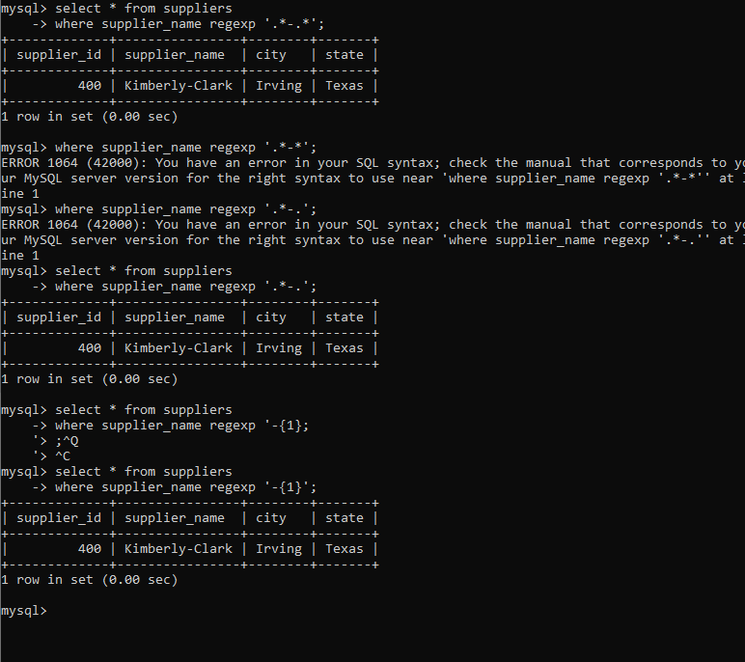

Singlerow_group

1 To list all employees and their email, to generate email use 2 to 5 characters from ename

Concat it with 2 to 4 characters in job and then concat it with ‘@mycompany.com’

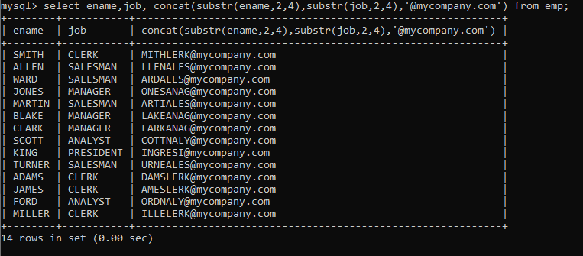

2 List all employees who joined in September.

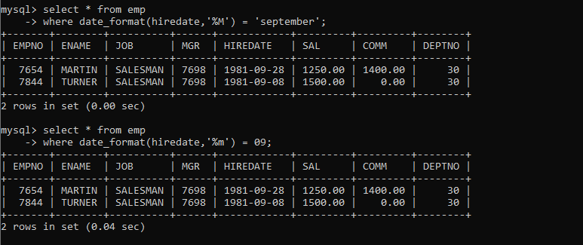

3 List the empno, name, and depart no of the emp who have experience of 18 or more years and sort on expr

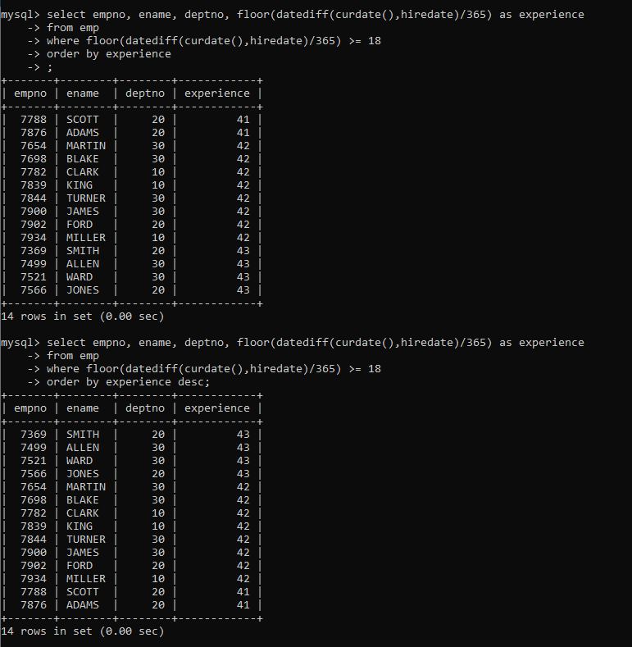

4 Display the employee details who joined on 3rd of any month or any year

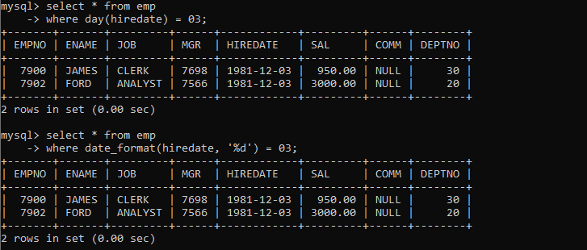

5 display all employees who joined between years 1981 to 1983.

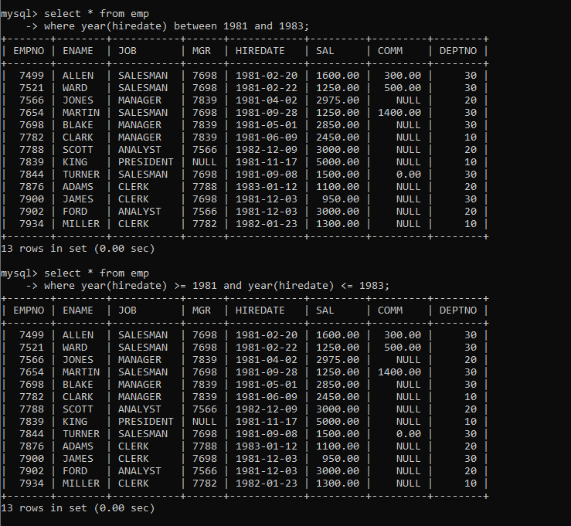

6. Display the Highest, Lowest, Total & Average salary of all employee. Label the columns Maximum, Minimum, Total and Average respectively for each Department. Also round the result to the nearest whole number.

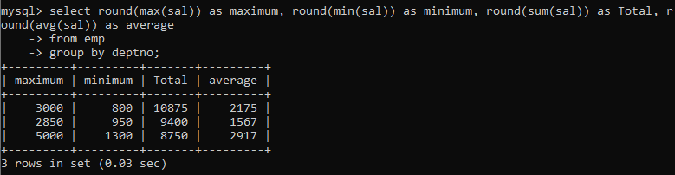

7. Display Department no and number of managers working in that department. Label the column as ‘Total Number of Managers’ for each department.

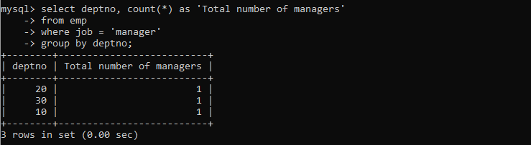

8 Get the Department number, and sum of Salary of all non managers where the sum is greater than 20000.

