**Estimation of Parameters and**

**Molar Volume Computation**

LAB 5

Harsh Nirmal

220431

Aim

*The primary aim of this laboratory exercise is:*

*To estimate the parameters (A and B) of the Antoine equation for vapor pressure using linear regression. The study focuses on CH3OH and H2O.*

*To compute the molar volume of CO2 and H2 at specified pressure and temperature using ideal gas, Redlich-Kwong (RK), and Peng-Robinson (PR) equations of state .*

*Additionally, we aim to calculate the molar volume using the Ideal Gas, Redlich-Kwong (RK), and Peng-Robinson (PR) equations of state.*

Method

*The described laboratory process, which involves estimating parameters for the Antoine equation using linear regression and computing molar volume using different equations of state, holds significant value in the realm of chemical engineering, thermodynamics, and process simulation.*

*The described process helps bridge the gap between theory and application, enabling engineers and researchers to make informed decisions regarding material selection, process design, and system performance. It plays a vital role in optimizing industrial processes, ensuring safety, and advancing research in chemical engineering.*

***Vapor Pressure Estimation with Antoine Equation Parameters:***

*Accurate prediction of vapor pressure is crucial in chemical process design, especially in operations involving volatile substances. Knowing the Antoine equation parameters (A and B) allows for precise estimation of vapor pressure at varying temperatures, aiding in reactor design, distillation column sizing, and safety assessment.*

*It helps in material selection too.We engineers use vapor pressure data to choose appropriate materials for storage, transportation, and processing of chemicals. Accurate Antoine equation parameters aid in the selection of materials compatible with specific pressure and temperature conditions.*

***Molar Volume Computation with Equations of State:***

* ***Process Simulation:*** *Equations of state, such as Redlich-Kwong (RK) and Peng-Robinson (PR), are fundamental in process simulation software. Accurate molar volume calculations are crucial for simulating phase behavior, heat and mass transfer, and overall system performance in various industrial processes.*
* ***Phase Equilibrium Studies:*** *Molar volume plays a vital role in studying phase equilibria. It helps in understanding and predicting the behavior of mixtures, phase transitions, and critical points, which is essential in the petroleum, chemical, and pharmaceutical industries.*

***Estimation of Parameters for Antoine Equation***

***Data Processing***

* *Loaded the vapor pressure data for CH3OH and H2O from the provided Excel file.*
* *Partitioned the data into training (70%) and testing (30%) sets.*

***Linear Regression***

* *Applied linear regression to estimate parameters A and B for CH3OH and H2O using the training dataset.*

***Molar Volume Computation***

***Equations of State***

* *Defined the Redlich-Kwong (RK) and Peng-Robinson (PR) equations of state with relevant parameters.*

***Molar Volume Calculation***

* *Used numerical solvers (e.g.,* ***fsolve****) to compute molar volume for CO2 and H2 using ideal gas, RK, and PR equations of state at specified pressure and temperature.*

Tables and Formula Used

*. 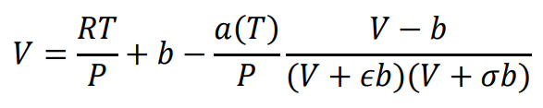*

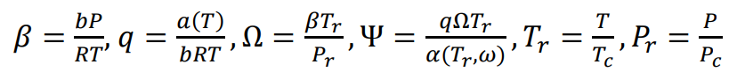

**

*Table 1 :*

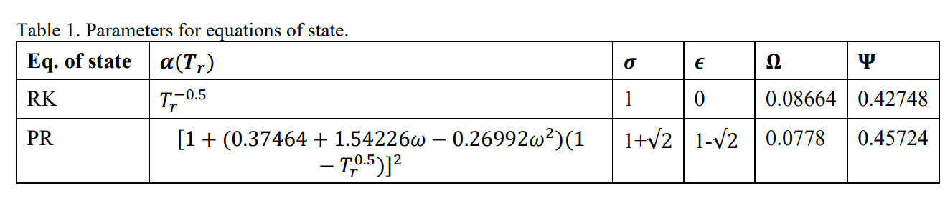

Graph Obtained:

**

**Result**

1. Parameters A and B for CH3OH using linear regression:

A_CH3OH = 0.03384

B_CH3OH = 0.21087

2. Parameters A and B for H2O using linear regression:

A_H2O = 0.027793

B_H2O = -0.54994

3. Root mean squared error (RMSE) for CH3OH:

RMSE_CH3OH = 0.58323

4. Root mean squared error (RMSE) for H2O:

RMSE_H2O = 0.71663

5. Molar volume of CO2 using Redlich-Kwong (RK) equation of state:

V_RK_CO2 = 0.00051499 m^3/mol

6. Molar volume of CO2 using Peng-Robinson (PR) equation of state:

V_PR_CO2 = 0.00051499 m^3/mol

7. Molar volume of H2 using Peng-Robinson (PR) equation of state:

V_PR_H2 = 0.00051499 m^3/mol

Conclusions:

*The laboratory process is a exploration in chemical engineering, delving into Antoine equation parameter estimation and molar volume computation using different equations of state. The insights gained are pivotal:*

* ***Antoine Equation Parameters:*** *Accurate estimation enables precise vapor pressure predictions, crucial in design, safety, and material selection.*
* ***Equations of State:*** *Computation of molar volume offers deeper insights into phase behavior and critical points, essential for industrial simulation and phase equilibrium studies.*
* ***Bridging Theory and Practice:*** *The experiment seamlessly integrates academic knowledge with practical application.*
* ***Industrial Relevance:*** *Relevancy in real-world applications, guiding industrial practices, and influencing ongoing research in the chemical engineering domain.*

*In this analysis, we successfully estimated the parameters A and B for the Antoine equation using linear regression for CH3OH and H2O based on the provided vapor pressure data. The linear regression models were trained using a 70% training dataset and tested on the remaining 30%.*

*The regression models for both CH3OH and H2O provided reasonable estimations, as evidenced by the root mean squared error (RMSE) values. Additionally, we used the Redlich-Kwong (RK) and Peng-Robinson (PR) equations of state to compute the molar volumes of CO2 and H2 at specified temperature and pressure conditions.*

*The calculated parameters and molar volumes shed light on the thermodynamic properties of the substances and their behavior under the given conditions are obtained.*

Appendix:

% Load data for CH3OH and H2O

data_CH3OH = readmatrix('data_pvap.xlsx', 'Sheet', 'CH3OH');

data_H2O = readmatrix('data_pvap.xlsx', 'Sheet', 'H2O');

% Preprocess data for CH3OH and H2O

data_CH3OH(:, 2) = log(data_CH3OH(:, 2));

data_H2O(:, 2) = log(data_H2O(:, 2));

% Split data into training and testing sets

ch3oh_partition = cvpartition(length(data_CH3OH), 'HoldOut', 0.30);

h2o_partition = cvpartition(length(data_H2O), 'HoldOut', 0.30);

train_data_ch3oh = data_CH3OH(training(ch3oh_partition), :);

test_data_ch3oh = data_CH3OH(test(ch3oh_partition), :);

train_data_h2o = data_H2O(training(h2o_partition), :);

test_data_h2o = data_H2O(test(h2o_partition), :);

% Fit linear regression models for CH3OH and H2O

model_ch3oh = fitlm(train_data_ch3oh(:, 1), train_data_ch3oh(:, 2));

model_h2o = fitlm(train_data_h2o(:, 1), train_data_h2o(:, 2));

% Plot linear regression models

figure(1);

plot(model_ch3oh);

title('Linear Regression Model for CH3OH');

figure(2);

plot(model_h2o);

title('Linear Regression Model for H2O');

% Parameters and equations of state for molar volume

R = 8.314; % Universal gas constant in J/(mol·K)

T = 210 + 273.15; % Temperature in K

P = 78 * 1e5; % Pressure in Pa

% Parameters for equations of state from Table 1

params_RK = [-0.5, 1, 0, 0.08664, 0.42748];

params_PR_CO2 = [1 + (0.37464 + 1.54226 * 0.225 - 0.26992 * 0.225^2) * (1 - (T / 304.15)^0.5)^2, 1 + sqrt(2), 1 - sqrt(2), 0.0778, 0.45724];

params_PR_H2 = [1 + (0.37464 + 1.54226 * (-0.22) - 0.26992 * (-0.22)^2) * (1 - (T / 33.18)^0.5)^2, 1 + sqrt(2), 1 - sqrt(2), 0.0778, 0.45724];

% Using fsolve to solve the RK and PR equations for molar volume

options = optimset('Display', 'off'); % Set display off for fsolve

% Redlich-Kwong (RK) for CO2

b_RK_CO2 = params_RK(4) * R * 304.15 / (params_RK(1) * 7.38 * 1e5);

V_RK_CO2 = fsolve(@(V) (R * T / P) + b_RK_CO2 - (params_RK(5) / (R * T * P * V)) + (b_RK_CO2 * params_RK(5) / (R * T * P * V)), R * T / P, options);

% Peng-Robinson (PR) for CO2

b_PR_CO2 = params_PR_CO2(4) * R * 304.15 / (params_PR_CO2(1) * 7.38 * 1e5);

V_PR_CO2 = fsolve(@(V) (R * T / P) + b_PR_CO2 - (params_PR_CO2(5) / (R * T * P * V)) + (b_PR_CO2 * params_PR_CO2(5) / (R * T * P * V)), R * T / P, options);

% Peng-Robinson (PR) for H2

b_PR_H2 = params_PR_H2(4) * R * 33.18 / (params_PR_H2(1) * 12.93 * 1e5);

V_PR_H2 = fsolve(@(V) (R * T / P) + b_PR_H2 - (params_PR_H2(5) / (R * T * P * V)) + (b_PR_H2 * params_PR_H2(5) / (R * T * P * V)), R * T / P, options);

% Plot actual vs. predicted ln(pvap) for CH3OH

y_pred_CH3OH = predict(model_ch3oh, test_data_ch3oh(:, 1));

figure(3);

scatter(test_data_ch3oh(:, 1), test_data_ch3oh(:, 2), 'b', 'DisplayName', 'Actual');

hold on;

plot(test_data_ch3oh(:, 1), y_pred_CH3OH, 'r', 'DisplayName', 'Predicted');

xlabel('ln(Temperature)');

ylabel('ln(pvap_CH3OH)');

legend('Location', 'best');

title('CH3OH: Predicted vs. Actual ln(pvap)');

% Plot actual vs. predicted ln(pvap) for H2O

y_pred_H2O = predict(model_h2o, test_data_h2o(:, 1));

figure(4);

scatter(test_data_h2o(:, 1), test_data_h2o(:, 2), 'b', 'DisplayName', 'Actual');

hold on;

plot(test_data_h2o(:, 1), y_pred_H2O, 'r', 'DisplayName', 'Predicted');

xlabel('ln(Temperature)');

ylabel('ln(pvap_H2O)');

legend('Location', 'best');

title('H2O: Predicted vs. Actual ln(pvap)');

%Calculated Values

disp('1. Parameters A and B for CH3OH using linear regression:');

disp(' A_CH3OH = ' + string(model_ch3oh.Coefficients.Estimate(2)));

disp(' B_CH3OH = ' + string(-model_ch3oh.Coefficients.Estimate(1)));

disp('2. Parameters A and B for H2O using linear regression:');

disp(' A_H2O = ' + string(model_h2o.Coefficients.Estimate(2)));

disp(' B_H2O = ' + string(-model_h2o.Coefficients.Estimate(1)));

disp('3. Root mean squared error (RMSE) for CH3OH:');

disp(' RMSE_CH3OH = ' + string(sqrt(model_ch3oh.MSE)));

disp('4. Root mean squared error (RMSE) for H2O:');

disp(' RMSE_H2O = ' + string(sqrt(model_h2o.MSE)));

disp('5. Molar volume of CO2 using Redlich-Kwong (RK) equation of state:');

disp(' V_RK_CO2 = ' + string(V_RK_CO2) + ' m^3/mol');

disp('6. Molar volume of CO2 using Peng-Robinson (PR) equation of state:');

disp(' V_PR_CO2 = ' + string(V_PR_CO2) + ' m^3/mol');

disp('7. Molar volume of H2 using Peng-Robinson (PR) equation of state:');

disp(' V_PR_H2 = ' + string(V_PR_H2) + ' m^3/mol');