OUR INDIA: A CIVIC ACCOUNTABILITY AND POLITICAL TRANSPARENCY PLATFORM
A PROJECT BASED LEARNING (PBL) REPORT
Submitted by
TEJAS KARPE
PRASAN PHADATARE
HARSH OSWAL
SHIVAM PATIL
in partial fulfillment for the award of the degree of
BACHELOR OF TECHNOLOGY
IN
COMPUTER SCIENCE & ENGINEERING (AIML)

KOLHAPUR INSTITUTE OF TECHNOLOGY'S
COLLEGE OF ENGINEERING KOLHAPUR
(EMPOWERED AUTONOMOUS)
OCTOBER 2026

KOLHAPUR INSTITUTE OF TECHNOLOGY'S
COLLEGE OF ENGINEERING KOLHAPUR
(EMPOWERED AUTONOMOUS)
CERTIFICATE
This is to certify that the Project report entitled, “OUR INDIA: A CIVIC ACCOUNTABILITY AND POLITICAL TRANSPARENCY PLATFORM” submitted by “TEJAS KARPE, PRASAN PHADATARE, HARSH OSWAL, SHIVAM PATIL” (Roll Nos. [ … ]), in partial fulfillment for the award of the degree of “BACHELOR OF TECHNOLOGY” in “COMPUTER SCIENCE & ENGINEERING (AIML)” at Kolhapur Institute of Technology's College of Engineering Kolhapur (Empowered Autonomous), Maharashtra, INDIA, is a record of their own work carried out under my / our supervision and guidance.

SIGNATURE  [ Name ]  SUPERVISOR  [ Academic Designation ]  Department of Computer Science & Engineering (AIML)  KIT's College of Engineering, Kolhapur | SIGNATURE  [ Name ]  HEAD OF THE DEPARTMENT  [ Academic Designation ]  Department of Computer Science & Engineering (AIML)  KIT's College of Engineering, Kolhapur

KOLHAPUR INSTITUTE OF TECHNOLOGY'S
COLLEGE OF ENGINEERING KOLHAPUR
(EMPOWERED AUTONOMOUS)
DECLARATION
We hereby declare that the Project entitled, “OUR INDIA: A CIVIC ACCOUNTABILITY AND POLITICAL TRANSPARENCY PLATFORM” submitted to Kolhapur Institute of Technology's College of Engineering Kolhapur (Empowered Autonomous), Maharashtra, INDIA in the partial fulfillment of the award of the Degree of “BACHELOR OF TECHNOLOGY” in “COMPUTER SCIENCE & ENGINEERING (AIML)” is a bonafide work carried out by us. The material contained in this Project has not been submitted to any University or Institution for the award of any degree.
NAME OF THE STUDENT | PRN | ROLL NO.
TEJAS KARPE | [ PRN ] | [ Roll No. ]
PRASAN PHADATARE | [ PRN ] | [ Roll No. ]
HARSH OSWAL | [ PRN ] | [ Roll No. ]
SHIVAM PATIL | [ PRN ] | [ Roll No. ]
Place: Kolhapur
Date:

KOLHAPUR INSTITUTE OF TECHNOLOGY'S
COLLEGE OF ENGINEERING KOLHAPUR
(EMPOWERED AUTONOMOUS)
ACKNOWLEDGEMENT
We express our sincere gratitude to our guide, [ Guide Name ], for valuable guidance, encouragement and timely feedback throughout this project.
We thank [ Name of the Head of the Department ], Head of the Department of Computer Science & Engineering (AIML), and the management of Kolhapur Institute of Technology's College of Engineering Kolhapur for providing the facilities and the opportunity to carry out this work.
We are also grateful to the maintainers of the open-source tools and public data sources this project depends on, including the Android and Jetpack Compose teams, MapLibre, Wikipedia contributors and the public directories of Maharashtra's municipal corporations.
Finally, we thank our families and friends for their constant support.
NAME OF THE STUDENT | PRN | ROLL NO.
TEJAS KARPE | [ PRN ] | [ Roll No. ]
PRASAN PHADATARE | [ PRN ] | [ Roll No. ]
HARSH OSWAL | [ PRN ] | [ Roll No. ]
SHIVAM PATIL | [ PRN ] | [ Roll No. ]
Place: Kolhapur
Date:

ABSTRACT
Citizens in India rarely have one place to see who holds party office in their area, or to raise a civic problem and follow it until it is fixed. Party leadership data is scattered across party websites, news reports and Wikipedia, and grievance portals give the public little visibility into whether issues are resolved.
Our India is an Android application that brings these together. Its Leaders module presents the organisation of 25 political parties, from national president down to district units, as an interactive orbit view, a hierarchical chart, a map of India and summary insights, with every named office-holder linked to the published source it was verified against. A background job re-checks national and state heads on Wikipedia every month and shows a change only when the page itself changes, marked as unverified.
Its NagrikVoice module lets citizens photograph a civic problem on the spot, uses GPS to route it to the responsible municipal corporation among 48 in the system, detects duplicate reports within 100 metres, and keeps a public status history and a ranking of corporations by unresolved complaints. An AI Lawyer, served through a cloud proxy to an open large language model, explains Indian law in plain language, drafts legal documents and maps old IPC sections to the Bharatiya Nyaya Sanhita.
The app is written in Kotlin with Jetpack Compose, Room, Hilt, WorkManager and MapLibre, and is supported by a Node.js service on Render and serverless functions on Vercel. It is covered by unit, Robolectric UI and Node tests, and every new version is built and published automatically through GitHub Actions. This report describes the design, the features delivered, the testing carried out and the remaining limitations.
Keywords: civic technology, political transparency, grievance redressal, Android, Jetpack Compose, large language models, Bharatiya Nyaya Sanhita

TABLE OF CONTENTS
ABSTRACT iv
CHAPTER 1 INTRODUCTION 1
1.1 General 1
1.2 Motivation 1
1.3 Problem Statement 1
1.4 Objectives 2
1.5 Scope 2
1.6 Organisation of the Report 3
CHAPTER 2 LITERATURE REVIEW 4
2.1 General 4
2.2 Existing Systems 4
2.3 Observations 4
CHAPTER 3 SYSTEM DESIGN 6
3.1 System Architecture 6
3.2 Technology Stack 6
3.3 Modules 7
3.4 Data Design 7
3.5 Data Integrity Rules 8
CHAPTER 4 IMPLEMENTATION AND FEATURES 9
4.1 General 9
4.2 Home: Civic Report Feed 9
4.3 Leaders: Party Organisations 9
4.4 Monthly Leader Check 12
4.5 Report: Civic Problem Reporting 12
4.6 Issues: Search, Filters and Ranking 12
4.7 AI Lawyer 13
4.8 Onboarding, Account and Reliability 16
4.9 App Icon, Website and Releases 16
CHAPTER 5 TESTING 18
5.1 Test Strategy 18
5.2 Defects Found and Fixed 19
5.3 Device Testing 19
CHAPTER 6 RESULTS AND DISCUSSION 20
6.1 Results 20
6.2 Limitations 20
6.3 Discussion 20
CHAPTER 7 CONCLUSION AND FUTURE SCOPE 21
7.1 Conclusion 21
7.2 Future Scope 21
REFERENCES 22
APPENDIX A: DEVELOPMENT TIMELINE 23

LIST OF FIGURES AND TABLES
Table 2.1 Comparison of existing systems 4
Figure 3.1 System architecture of Our India 6
Table 3.1 Technology stack 6
Figure 4.1 Orbit view of the BJP at overview zoom 10
Figure 4.2 Orbit view zoomed in, showing unit names 11
Figure 4.3 AI Lawyer, Ask tab with starter questions 14
Figure 4.4 AI Lawyer, Sections tab mapping IPC to BNS 15
Figure 4.5 AI Lawyer, Rights tab with helplines 16
Table 5.1 Automated test suites 18
Table 5.2 Notable defects found during development 19
Table A.1 Development milestones 23

CHAPTER 1
INTRODUCTION

1.1 General
India is a federal, multi-party democracy. Alongside the six national parties recognised by the Election Commission of India, dozens of state parties run organisations that reach down to districts, talukas and wards. Yet most citizens cannot easily find out who leads a party in their own state or district, because this information changes often and is spread across party websites, news coverage and encyclopaedias of uneven freshness.
Everyday civic problems such as potholes, broken street lights, leaking pipelines and uncollected garbage fall to municipal corporations. Existing grievance channels are largely private between the citizen and the department, so neighbours cannot see, support or track a common problem, and there is no public measure of how responsive each corporation is.
Legal awareness is a third gap. On 1 July 2024 the Bharatiya Nyaya Sanhita (BNS), the Bharatiya Nagarik Suraksha Sanhita (BNSS) and the Bharatiya Sakshya Adhiniyam (BSA) replaced the Indian Penal Code, the Code of Criminal Procedure and the Indian Evidence Act, so section numbers that citizens and news reports commonly cite have changed.

1.2 Motivation
Smartphones with GPS and cameras are now widespread, and open large language models can explain dense text in plain language. This project uses both to give citizens one app for political transparency, civic reporting and basic legal guidance, with a strict rule that every fact shown is traceable to its source and nothing is invented to fill a gap.

1.3 Problem Statement
There is no single, trustworthy mobile platform where an Indian citizen can see who holds party office in their area, with sources, and also report a local civic problem with verifiable evidence that is routed to the correct municipal corporation and tracked publicly until it is verified as fixed. Existing tools are limited to one city or one category of problem, keep complaint status private, cover election candidates rather than party organisations, or present unverified and stale data.

1.4 Objectives
- To design an Android application that presents party organisational hierarchies from national to district level, with every named office-holder linked to a verifiable public source.
- To implement phone-friendly visualisations of these hierarchies: an interactive orbit view, a hierarchical chart, a map of India and summary insights.
- To build a civic reporting workflow with on-the-spot photo evidence, GPS-based routing to the correct municipal corporation and department, and duplicate detection.
- To provide a public, auditable record of each complaint and a ranking of corporations based on delivered and verified-resolved complaints.
- To integrate an AI legal assistant for Indian law through a server-side proxy that keeps API keys out of the app.
- To keep data current with a monthly automated check against Wikipedia, and to distribute the app automatically through GitHub releases and a project website.

1.5 Scope

In scope
- Party organisation data for 25 parties with sources; orbit, chart, map and insights views.
- Monthly automatic check of national and state party heads against Wikipedia.
- Civic report feed; reporting with camera and GPS; duplicate detection; support, fix claims and abuse flags.
- City filter, department routing with official contacts, and a ranking of 48 municipal corporations and councils.
- AI Lawyer: questions, document drafting, IPC to BNS lookup, rights and helplines.
- First-run tutorial, location permission flow, accounts, project website and automated APK releases.

Out of scope
- iOS and web versions of the app.
- Real email delivery of complaints to corporations; delivery is simulated and labelled as such in this version.
- Complete district-level data for every party, and ward or booth-level posts.
- Publication on the Google Play Store.
- Professional legal advice; the AI Lawyer provides general information only.

1.6 Organisation of the Report
Chapter 2 reviews existing systems. Chapter 3 describes the architecture, technology stack, modules and data design. Chapter 4 documents every feature delivered. Chapter 5 covers testing and the defects found and fixed. Chapter 6 discusses results and limitations, and Chapter 7 concludes with future scope.

CHAPTER 2
LITERATURE REVIEW

2.1 General
Civic reporting, grievance redressal, political data and legal aid have each been addressed by separate systems. Five representative systems were studied for their approach, the data they use and the gap that remains.

2.2 Existing Systems
Table 2.1 Comparison of existing systems
System (Year) | Approach | Data Used | Findings / Limitations | Research Gap
FixMyStreet, mySociety (2007) | Map-based web and mobile reporting of street problems, forwarded to the responsible council. | Citizen reports with location and photos; UK council boundaries. | Open, public reporting works well, but it is built around UK councils, with no Indian municipal data or political context. | No routing to Indian municipal corporations; no link to who governs the area.
CPGRAMS, DARPG, Government of India (2007) | Centralised online grievance portal routed to ministries and departments. | Grievances lodged by citizens. | Nationwide reach, but department-centric; status is visible mainly to the complainant; photo and GPS evidence are not required. | No public, location-based feed where neighbours can support or follow an issue.
Swachhata-MoHUA app, MoHUA (2016) | Photo-based complaints routed to urban local bodies. | Geotagged photos of sanitation problems. | Photo evidence with location speeds up resolution, but the app covers sanitation only. | No coverage of roads, water, electricity or tax in one place; no public ranking.
MyNeta, Association for Democratic Reforms (ongoing) | Publishes election candidates' affidavit data. | Affidavits filed with the Election Commission of India. | Strong source for electoral candidates, but does not cover party organisational posts such as state or district presidents. | No view of party organisation hierarchies by place.
Tele-Law, Department of Justice (2017) | Pre-litigation legal advice from panel lawyers by video or phone. | Not applicable (advisory service). | Gives access to real lawyers, but needs an appointment and does not help draft documents or map IPC sections to BNS. | No instant, plain-language legal guidance inside a civic app.

2.3 Observations
Two further observations shaped the design. First, the open structured source Wikidata was found to be stale for party leadership: on 16 October 2026 it still listed J. P. Nadda as BJP national president, whereas the party had elected Nitin Nabin in January 2026, and only one of four sampled BJP state units recorded a head at all. Wikipedia infoboxes were current for 84 of 86 posts compared. Second, some data providers explicitly disallow automated access by AI agents in their robots.txt; such sources were respected and not scraped.
The research gap is therefore a single app that combines sourced party hierarchies by location, public and evidence-based civic reporting routed to the correct corporation, and plain-language legal guidance, while keeping data honest about its own uncertainty.

CHAPTER 3
SYSTEM DESIGN

3.1 System Architecture
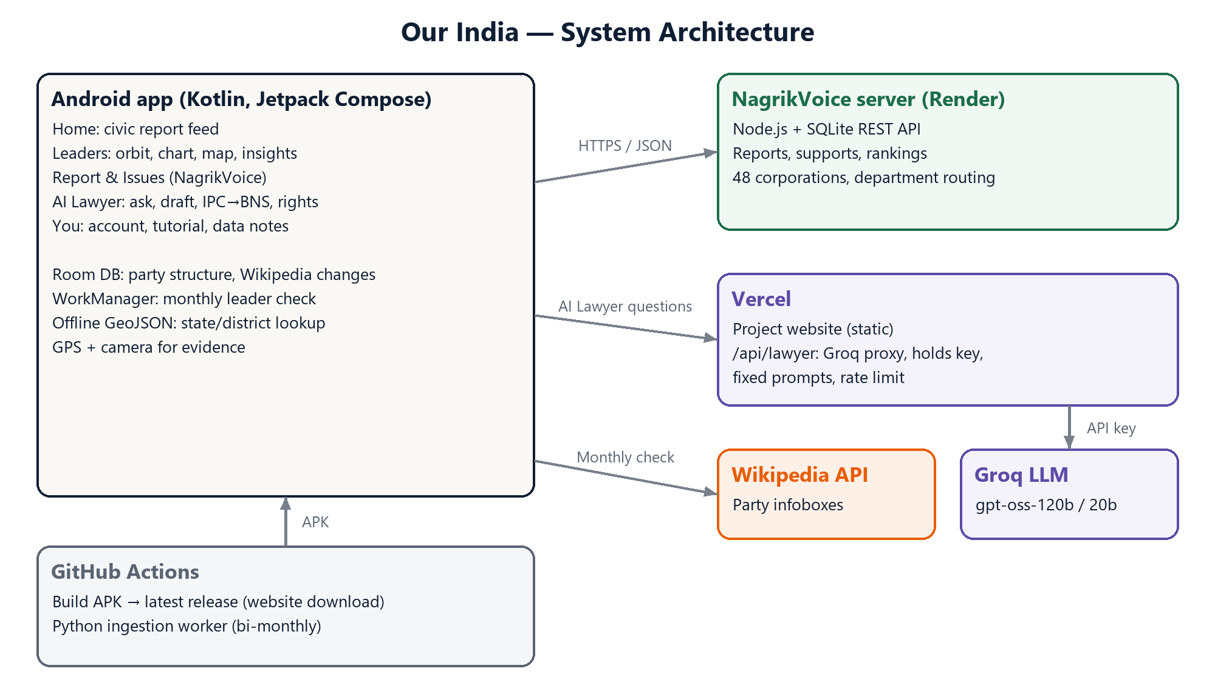
Figure 3.1 System architecture of Our India
The Android app is the centre of the system. It talks to three services over HTTPS: the NagrikVoice server on Render for reports, supports and rankings; a Vercel serverless function that forwards AI Lawyer questions to Groq while holding the API key; and the Wikipedia API for the monthly leader check. Party structures, recorded Wikipedia changes and state and district boundary files are stored on the device, so the Leaders section works offline. GitHub Actions builds every new version of the app and publishes it as a release, which the project website links to.

3.2 Technology Stack
Table 3.1 Technology stack
Layer | Technology
Android app | Kotlin 2.0, Jetpack Compose (Material 3), Hilt, Navigation Compose, Room, WorkManager, Retrofit and OkHttp, kotlinx.serialization, MapLibre Native, Coil
Civic server | Node.js with SQLite, hosted on Render (separate CitizenComplaint repository)
AI Lawyer proxy | Vercel serverless function (Node.js) calling Groq's gpt-oss-120b model, with gpt-oss-20b as fallback
Data and ingestion | Bundled sourced party data; Wikipedia MediaWiki API; Python ingestion worker scheduled on GitHub Actions
Website | Static HTML and CSS on Vercel
Build and test | Gradle, JUnit, Robolectric with Compose UI tests, Node test runner, GitHub Actions

3.3 Modules
- Party Structure (Leaders): bundled verified party data; orbit, chart, map and insights views; search and location focus.
- Leader Update: monthly Wikipedia infobox check stored in Room; applies only real changes, labelled as unverified.
- Civic Feed: home feed of reports with support, share, map, fix claim and report abuse.
- Civic Reporting: camera evidence, GPS and offline boundary lookup, corporation and department routing, duplicate check.
- Issues and Ranking: search and filters by city, department and status, and the corporation ranking.
- AI Lawyer: Ask, Draft, Sections (IPC to BNS) and Rights tabs, served through the Vercel proxy.
- Onboarding and Account: first-run tutorial, location permission flow, sign-in, profile and crash reporting.

3.4 Data Design
On the device, Room (schema version 3) stores the party structure as position nodes (party, level, parent, role title, holder, state, district and a version date) and, since version 3, a leader_updates table recording for each checked post the Wikipedia page title, the baseline value seen at the first check, the current value, the date it changed and the date it was last checked. The version 2 to 3 migration only adds this table, so it is safe to merge with other schema work.
On the civic server, the main entities are users, complaints (category, location, photo, authority, delivery and resolution status, support count), status history, supports and authorities (48 municipal corporations and councils with centre coordinates and department mappings). The app keeps only the login session and chosen city locally.

3.5 Data Integrity Rules
- Every named holder in the bundled data must carry a published source; a post that could not be confirmed is shown as “Not yet recorded”, never guessed.
- A Wikipedia value replaces bundled data only after it changes relative to the recorded baseline; a page that merely disagrees, or redirects to another page, is ignored.
- A civic report requires a photo taken in the app and a GPS location; a report from outside any covered area can only be sent as a clearly marked test report.
- A fix is counted only when it has been verified, and simulated email deliveries are labelled “demo delivery” throughout the app.

CHAPTER 4
IMPLEMENTATION AND FEATURES

4.1 General
This chapter documents every feature delivered, grouped by the app's tabs. The bottom navigation contains Home, Leaders, Report, Issues and You; the AI Lawyer opens from a floating button available on every tab.

4.2 Home: Civic Report Feed
- A full-width photo feed of civic reports, newest first, with infinite scrolling and pull-to-refresh.
- Double-tap a photo to support a report, with an animated confirmation; buttons to support, share, and open the location in a maps app.
- “Fixed?” lets a signed-in user claim a fix, which then awaits verification; an overflow menu lets anyone flag a post for moderation.
- Each post shows the corporation, locality, distance from the user and age, and the server's waking state is explained instead of showing a silent spinner.

4.3 Leaders: Party Organisations
The Leaders tab covers 25 parties with bundled, sourced structures (over 400 named posts and more than 200 district units at the time of writing), and lists the remaining parties of a 73-party catalogue with their head only. A party opens into four views.

4.3.1 Orbit view
The default view places a unit's head at the centre and its sub-units on rings around it. Rings are filled in proportion to their circumference so that no ring is crowded. Zooming is map-style: discs keep their size while zoom spreads them apart, showing state codes at overview (MH, MN, CG and so on, which never repeat within a ring), unit names when there is room and holder names when zoomed further. Pinch, drag and double-tap work anywhere, including on top of a disc, and +, − and fit buttons support one-handed use. Tapping a disc moves into that unit and the back button steps out.
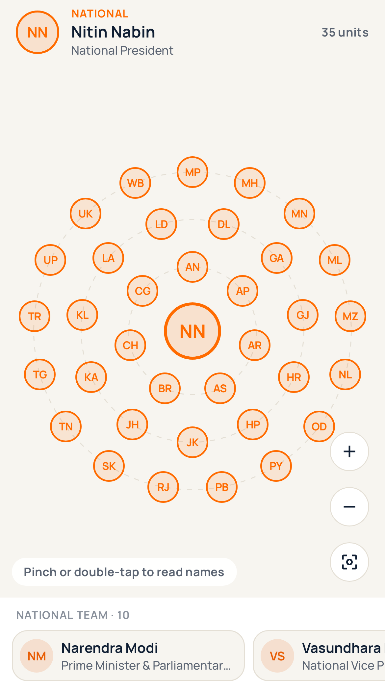
Figure 4.1 Orbit view of the BJP at overview zoom
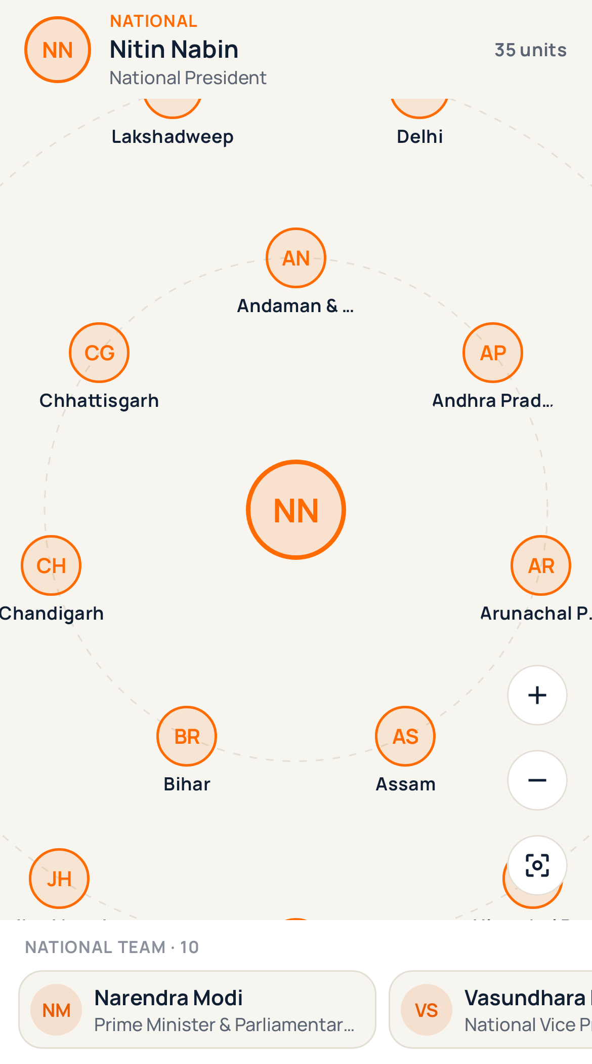
Figure 4.2 Orbit view zoomed in, showing unit names

4.3.2 Chart, map and insights
- Chart: a top-down organisation chart grouped into unit cards, with wrapped rows so that large parties stay readable, fling-scroll and focus on a searched post.
- Map: a MapLibre map of India with states and districts tinted by the party's presence, tap to select and long-press to set a location.
- Insights: counts by level and state, and coverage of the selected area.
- Search finds any post by name, role or place; “Use my location” focuses the orbit or chart on the user's state and district.
- Each person opens a detail sheet with the source article, and a profile with a career timeline for well-documented leaders.

4.4 Monthly Leader Check
A WorkManager job runs every 30 days and on demand from the sync button. It reads Wikipedia infoboxes for the national heads of 23 parties and the state presidents of the BJP and the Congress through the MediaWiki API, in batches of 50 pages. For each post it records the first value seen as a baseline and replaces the bundled holder only when Wikipedia changes from that baseline; the change is shown immediately, marked “not yet verified” and linked to the page. Redirects that land on a different page (for example, a state unit page that redirects to the national party page) are rejected. A comparison of 86 posts at launch found two genuine disagreements with Wikipedia, which were left for human review instead of being overwritten.

4.5 Report: Civic Problem Reporting
- Photo taken with the phone camera at the spot; gallery uploads are not accepted, the image is rotated correctly and compressed to about 350 KB, and the capture time is recorded.
- GPS location resolved offline to state, district and taluka, and to a neighbourhood name where the phone's geocoder can provide one.
- The nearest of 48 municipal corporations and councils within range is chosen automatically; near borders, other corporations in range are offered.
- Six department categories (public works, water, electricity, healthcare, property tax and disaster management) with the official department contacts of each Maharashtra corporation, compiled into an Excel dataset from public directories by the team.
- A duplicate check within 100 metres offers to support the existing report instead of creating a second one.
- A confirmation receipt shows the photo, place and the corporation the report was sent to.

4.6 Issues: Search, Filters and Ranking
- A city selector with search, a “near you” list and grouping by state, remembered across sessions.
- Sorting by latest, nearby, most supported or overdue, and filtering by category; search covers title, area, city and reference ID.
- A ranking of corporations by unresolved, delivered complaints, with resolution rate, overdue and failed deliveries; corporations without reports are listed compactly.
- An issue detail screen with the full status history, delivery state and retry, and the department contact.

4.7 AI Lawyer
A violet floating button, labelled “Ask a lawyer” until first used, opens the AI Lawyer from any tab. It has four tabs.
- Ask: a chat that explains a legal situation in plain words, citing BNS sections with the old IPC numbers and suggesting next steps and free legal aid.
- Draft: generates a first draft of a legal notice, cheque bounce notice, police complaint, RTI application or consumer complaint from the facts entered.
- Sections: an offline lookup of common IPC sections and their BNS equivalents, with punishment, bailability and the court that tries them.
- Rights: national helplines with one-tap dialling and know-your-rights cards on arrest, Zero FIR, traffic police, women in custody, tenancy and consumer rights.
Questions are sent to a Vercel function rather than directly to the AI provider. The function holds the Groq API key as an environment variable, applies fixed system prompts so that the endpoint cannot be used as a general-purpose chatbot, limits each address to 20 questions per ten minutes and caps message length. The legal reference data was checked against the new codes before release, which corrected several section numbers in the first draft.
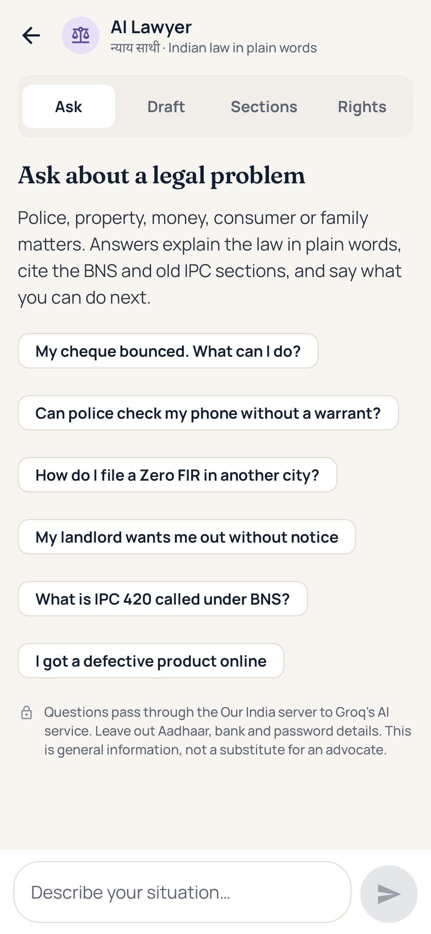
Figure 4.3 AI Lawyer, Ask tab with starter questions
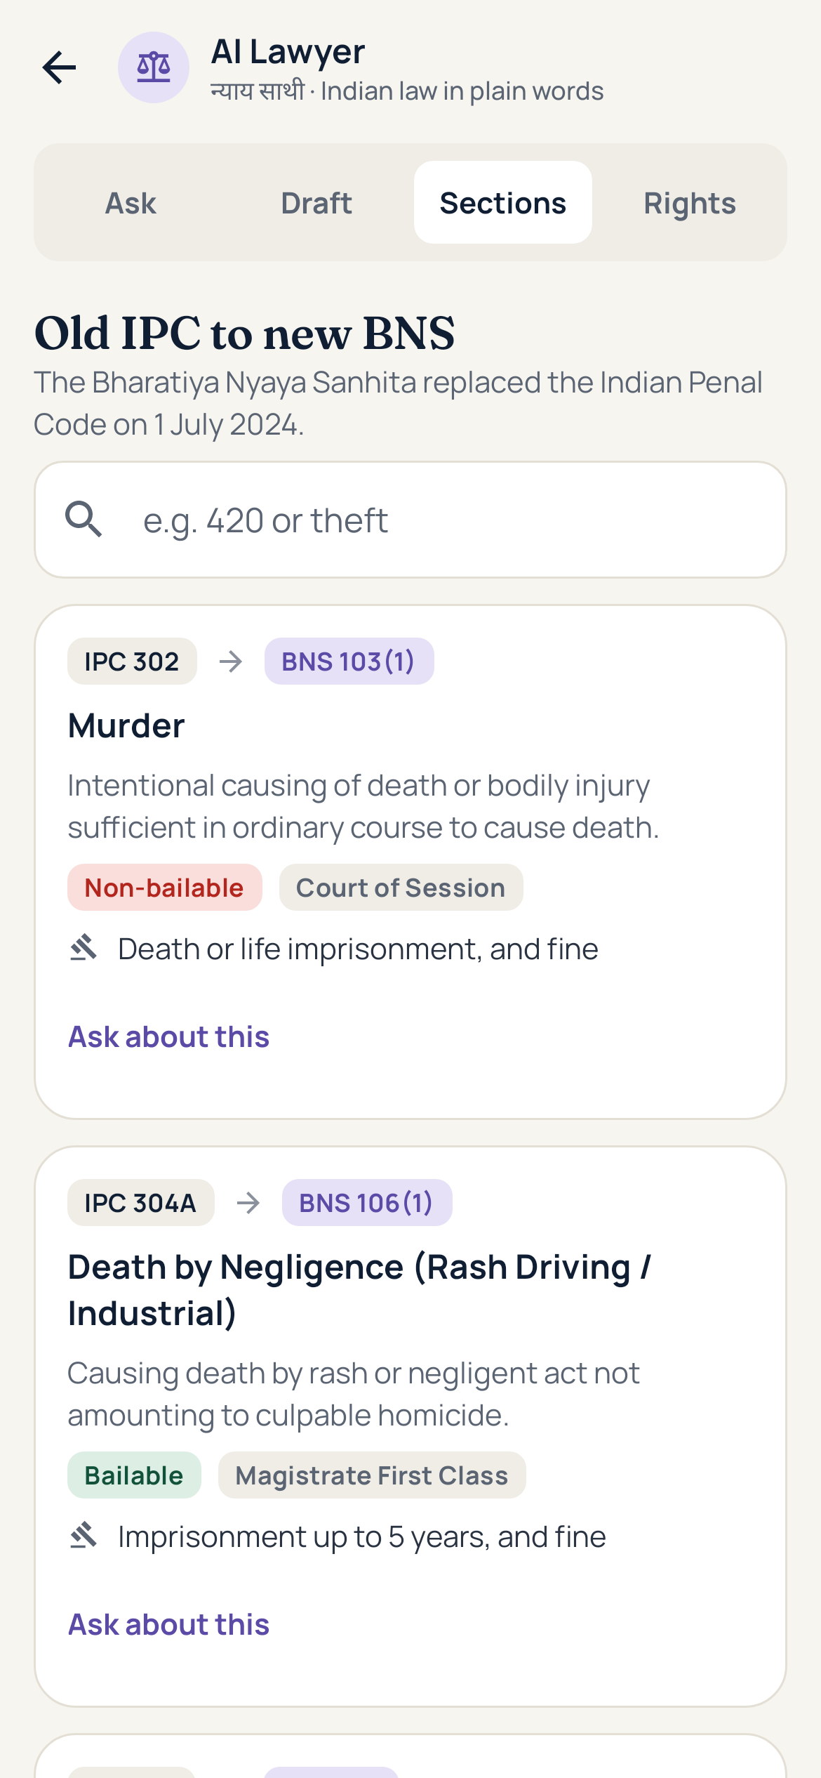
Figure 4.4 AI Lawyer, Sections tab mapping IPC to BNS
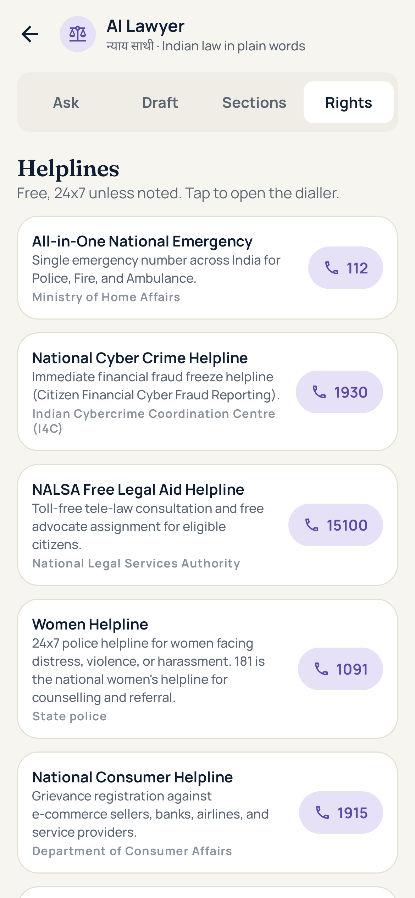
Figure 4.5 AI Lawyer, Rights tab with helplines

4.8 Onboarding, Account and Reliability
- A six-step first-launch tutorial in a floating card, replayable from the You tab, followed by the location permission request; if permission is refused, a reminder appears on later launches with options to allow, postpone or stop asking.
- Sign-in and registration; the You tab lists the user's own and supported reports and explains where the data comes from and when party data was last checked.
- A crash reporter saves the error and offers “Share report” on the next launch, which was used to diagnose a device-only crash during development.

4.9 App Icon, Website and Releases
- A vector adaptive launcher icon matching the website favicon, including a monochrome layer for themed icons.
- A responsive project website on Vercel describing the app, the data policy and the team, with a download button.
- A GitHub Actions workflow that builds the app on every change and publishes it as the latest release, signed with a shared debug key so that new versions install over old ones.
- A Python ingestion worker, scheduled twice a month on GitHub Actions, that scrapes official sources into a Supabase database; the app does not yet read from it.

CHAPTER 5
TESTING

5.1 Test Strategy
Logic that decides what users see, such as the Wikipedia change rules, coverage routing and status labels, is covered by plain unit tests. Screens are exercised with Robolectric and Compose UI tests that render the real composables on the JVM, which allowed screen-level testing without a physical device. The AI Lawyer proxy has its own Node tests with a mocked AI provider.
Table 5.1 Automated test suites
Suite | Tests | What it checks
CivicLogicTest | 5 | Server response parsing, honest status labels, coverage and routing, de-duplication of authorities, distance and time formatting
LeaderUpdatesTest | 5 | Infobox parsing, name matching, baseline-and-change rule, redirect rejection, orbit ring packing and unique disc codes
PartyStructureUnitTest | 4 | Party catalogue and tree building
HierarchyLayoutTest | 3 | Chart layout, unit grouping and row wrapping
PartySeedDataTest | 2 | Every catalogue party has a structure; every named holder is cited; trees are well formed
SeedGeographyTest | 1 | Seed state and district names match the boundary files
RegexPortabilityTest | 1 | No regular expression uses a bare brace or bracket that Android rejects
LawyerTest (Robolectric) | 3 | Markdown clean-up, legal data citations, every AI Lawyer tab opens
OrbitRenderTest (Robolectric) | 3 | Orbit renders for every party and every unit; drilling into a unit works
LeadersScreenTest (Robolectric) | 1 | Full Leaders flow with an in-memory database: open party, land on orbit, tap a state
lawyer-proxy.test.js (Node) | 5 | Server-owned prompts and model, fallback model, key errors, input limits, rate limit

On 23 October 2026 all 28 Android tests (21 unit tests and 7 Robolectric UI tests) and all 5 proxy tests passed.

5.2 Defects Found and Fixed
Table 5.2 Notable defects found during development
Defect | Cause | Fix
Leaders crashed on every phone when a party was opened | A regular expression with an unescaped “}” is accepted by the desktop JVM used for tests but rejected by Android's ICU engine. | Escaped the pattern, and added a test that scans every regular expression in the source for bare braces and brackets.
Chart vanished after the first touch | A gesture centroid became NaN when a finger lifted, poisoning the transform. | Ignored unspecified centroids and non-finite offsets.
Map blank and location always outside India | The Android build strips “.gz” from asset names, so compressed boundary files were never found. | The loader tries the plain name first, then the compressed one.
Reports from every city would be emailed to one corporation | New category codes were unknown to the server, which fell back to a single default address. | Separate display codes from server codes and translate on send.
AI Lawyer keyboard did not open | The question box was disabled when no key was configured. | The box always accepts typing; only sending depends on the server.
Stale or redirected Wikipedia pages could overwrite verified data | Comparing Wikipedia directly with bundled data treats every disagreement as news. | Baseline-and-change rule, and rejection of redirects to other pages.

5.3 Device Testing
The app was installed on an OPPO CPH1911 running Android 11. Crash reports collected through the in-app reporter identified the regular-expression defect above, which was then reproduced, fixed and covered by a test.

CHAPTER 6
RESULTS AND DISCUSSION

6.1 Results
- A working Android app (debug build of about 67 MB, Android 8.0 and newer) distributed from the project website through automated GitHub releases.
- Sourced organisation data for 25 parties, with 23 national heads and the BJP and Congress state presidents re-checked monthly.
- Civic reporting routed across 48 municipal corporations and councils, with department contacts for Maharashtra cities.
- An AI Lawyer that keeps its key on the server and offers drafting, offline section lookup and helplines.

6.2 Limitations
- Complaint emails to corporations are simulated; the app labels them as demo deliveries.
- The civic server runs on Render's free tier with an SQLite file, so data is lost when the server restarts and the first request after idle can take up to a minute. A persistent database is needed before public use.
- District-level data exists for some parties and states only, and is not covered by the monthly check.
- The rate limit on the AI proxy is approximate, as each serverless instance counts separately.
- Builds are debug builds, not Play Store releases.

6.3 Discussion
The most important design decision was to prefer honest gaps over plausible guesses: open posts are shown as open, simulated deliveries are labelled, and automated data is marked unverified until checked. Testing on the JVM proved valuable for coverage but also showed its limit, since the most serious defect appeared only on a real device; the in-app crash reporter closed that gap.

CHAPTER 7
CONCLUSION AND FUTURE SCOPE

7.1 Conclusion
Our India shows that political transparency, civic grievance tracking and legal awareness can be combined in one mobile app without sacrificing data integrity. Citizens can see who leads each party in their area with sources, report and follow civic problems publicly, and get plain-language legal guidance, while the system stays honest about what it does not yet know.

7.2 Future Scope
- Move the civic server to a persistent database such as PostgreSQL and enable real email delivery to corporations.
- Extend district and ward-level party data, with community-submitted corrections that require a source link.
- Add Hindi and Marathi interfaces.
- Publish signed release builds on the Google Play Store.
- Connect the ingestion pipeline's Supabase data to the app with the same verification rules.

REFERENCES
[1] mySociety, “FixMyStreet,” https://www.fixmystreet.com, Accessed on: 23 Oct 2026.
[2] Department of Administrative Reforms and Public Grievances, Government of India, “CPGRAMS,” https://pgportal.gov.in, Accessed on: 23 Oct 2026.
[3] Ministry of Housing and Urban Affairs, “Swachh Bharat Mission (Urban) and Swachhata-MoHUA app,” https://sbmurban.org, Accessed on: 23 Oct 2026.
[4] Association for Democratic Reforms, “MyNeta,” https://myneta.info, Accessed on: 23 Oct 2026.
[5] Department of Justice, Government of India, “Tele-Law,” https://www.tele-law.in, Accessed on: 23 Oct 2026.
[6] Government of India, The Bharatiya Nyaya Sanhita, 2023 (Act No. 45 of 2023), India Code, https://www.indiacode.nic.in, Accessed on: 23 Oct 2026.
[7] Wikimedia Foundation, “MediaWiki Action API,” https://www.mediawiki.org/wiki/API:Main_page, Accessed on: 23 Oct 2026.
[8] Google, “Jetpack Compose,” Android Developers, https://developer.android.com/compose, Accessed on: 23 Oct 2026.
[9] MapLibre, “MapLibre Native for Android,” https://maplibre.org, Accessed on: 23 Oct 2026.
[10] Groq, “GroqCloud documentation,” https://console.groq.com/docs, Accessed on: 23 Oct 2026.
[11] Robolectric, “Robolectric: fast and reliable Android unit tests,” https://robolectric.org, Accessed on: 23 Oct 2026.
[12] Project repository, “Our India,” https://github.com/harshoswal1/Our-India, Accessed on: 23 Oct 2026.

APPENDIX A: DEVELOPMENT TIMELINE
Key milestones from the project's version history.
Table A.1 Development milestones
Date | Author | Change
30 Jul 2026 | Harsh Oswal | Project started: native Android scaffold with Kotlin, Compose, Room and Hilt
28 Aug 2026 | Tejas Karpe | Python ingestion worker with official-source scrapers, Supabase storage and a scheduled GitHub Actions workflow
13 Oct 2026 | Prasan Phadatare | Party structure hierarchy, map explorer and politician profiles
14 Oct 2026 | Prasan Phadatare | Sourced party data, rebuilt chart and map, and the civic issues feed, reporting and detail screens (NagrikVoice merge)
14 Oct 2026 | Tejas Karpe | Catalogue of 67 regional parties
Oct 2026 | Shivam Patil | Gathered the official contact directory of Maharashtra municipal corporations and departments and provided it as an Excel dataset
16 Oct 2026 | Harsh Oswal | Official Maharashtra municipal data (from the Excel dataset), live location and department routing
16 Oct 2026 | Prasan Phadatare | Home feed, orbit view, monthly Wikipedia check, first-run tutorial and project website
17 Oct 2026 | Tejas Karpe | AI Lawyer: Groq integration, drafting, IPC to BNS converter and rights guide
17 Oct 2026 | Prasan Phadatare | AI Lawyer merged into the app with a Vercel proxy; orbit crash fixed; new app icon and automated APK releases
21 Oct 2026 | Harsh Oswal | NCP data, catalogue fallback nodes, build fixes and repository clean-up

