
K.I.T’s College of Engineering (Autonomous), Kolhapur
Department of Computer Science & Engineering (AIML)
A.Y. 2026-27
A MINI PROJECT SYNOPSIS ON
Our India: A Civic Accountability and Political Transparency Platform
Submitted in partial fulfilment of the requirements for the award of the degree of
BACHELOR OF ENGINEERING / TECHNOLOGY IN COMPUTER SCIENCE & ENGINEERING (AIML)
Submitted by
Tejas Karpe — [ Roll No. ]
Prasan Phadatare — [ Roll No. ]
Harsh Oswal — [ Roll No. ]
Shivam Patil — [ Roll No. ]
Under the Guidance of
[ Guide Name, Designation ]
B.Tech, Semester [III/V], Second Year/Third Year

CERTIFICATE
This is to certify that the mini project synopsis entitled
“Our India: A Civic Accountability and Political Transparency Platform” is submitted by Tejas Karpe, Prasan Phadatare, Harsh Oswal and Shivam Patil ([ Roll Nos. ]) in partial fulfilment of the requirements for the award of the degree of Bachelor of Engineering / Technology in Computer Science & Engineering (AIML), during the academic year 2026-2027.
The synopsis is a record of the work carried out by the student(s) under my/our guidance.
Guide: [ Name & Signature ]
Head of Department: [ Name & Signature ]

TABLE OF CONTENTS
(Right-click below and choose “Update Field” in Word to generate the contents list)
CERTIFICATE 2
TABLE OF CONTENTS 3
1. Abstract 4
2. Introduction 4
3. Problem Statement 5
4. Objectives 5
5. Literature Survey / Existing System 5
6. Proposed System 7
7. Scope of the Project 7
In Scope 7
Out of Scope 8
8. Methodology / System Design 8
Technology Stack 8
System Architecture 8
Modules 9
9. Hardware and Software Requirements 9
10. Expected Outcome 10
11. Applications 10
12. Timeline / Work Plan 10
13. References 11

1. Abstract
Citizens in India rarely have one place to see who holds party office in their area, or to raise a civic problem and follow it until it is fixed. Party leadership data is scattered across party websites, news reports and Wikipedia, and grievance portals give the public little visibility into whether issues are resolved. Our India is an Android application that brings these together. Its Leaders module shows the organisation of 25 political parties, from national president down to district units, as an interactive orbit view, a hierarchical chart and a map of India, with every named office-holder linked to the published source it was verified against; a background job re-checks national and state heads on Wikipedia every month and flags changes as unverified. Its NagrikVoice module lets citizens photograph a civic problem on the spot, uses GPS to route it to the responsible municipal corporation among 48 in the system, detects duplicate reports within 100 metres, and keeps a public status history and a ranking of corporations by unresolved complaints. An AI Lawyer, served through a secure cloud proxy to an open large language model, explains Indian law in plain language, drafts legal notices and maps old IPC sections to the new Bharatiya Nyaya Sanhita. The app is built in Kotlin with Jetpack Compose, Room, Hilt and MapLibre, backed by a Node.js service and Vercel serverless functions. The outcome is a working, open-source app that makes local political accountability and civic grievance tracking transparent and accessible.

2. Introduction
India is a federal, multi-party democracy: alongside the six national parties recognised by the Election Commission, dozens of state parties run organisations that reach down to districts, talukas and wards. Yet most citizens cannot easily find out who leads a party in their own state or district, because this information changes often and is spread across party websites, news coverage and encyclopaedias of uneven freshness.
At the same time, everyday civic problems such as potholes, broken street lights, leaking pipelines and uncollected garbage fall to municipal corporations. Existing grievance channels are largely private between the citizen and the department, so neighbours cannot see, support or track a common problem, and there is no public measure of how responsive each corporation is.
Legal awareness is a third gap. On 1 July 2024 the Bharatiya Nyaya Sanhita (BNS), Bharatiya Nagarik Suraksha Sanhita (BNSS) and Bharatiya Sakshya Adhiniyam (BSA) replaced the IPC, CrPC and Evidence Act, so section numbers that citizens and even news reports commonly cite have changed.
Smartphones with GPS and cameras are now widespread, and open large language models can explain text in plain language. This project uses both to give citizens one app for political transparency, civic reporting and basic legal guidance, while keeping every fact traceable to its source.

3. Problem Statement
There is no single, trustworthy mobile platform where an Indian citizen can see who holds party office in their area, with sources, and also report a local civic problem with verifiable evidence that is routed to the correct municipal corporation and tracked publicly until it is verified as fixed. Existing tools are either limited to one city or one category of problem, keep complaint status private, cover election candidates rather than party organisations, or present unverified and stale data.

4. Objectives
- To design an Android application that presents party organisational hierarchies from national to district level, with every named office-holder linked to a verifiable public source.
- To implement phone-friendly visualisations of these hierarchies: an interactive orbit view, a hierarchical chart, a map of India and summary insights.
- To build a civic reporting workflow with on-the-spot photo evidence, GPS-based routing to the correct municipal corporation and department, and duplicate detection.
- To provide a public, auditable record of each complaint and a ranking of corporations based on delivered and verified-resolved complaints.
- To integrate an AI legal assistant for Indian law (BNS, BNSS, BSA and civil statutes) through a secure server-side proxy that keeps API keys out of the app.
- To keep data current with a monthly automated check against Wikipedia, and to distribute the app automatically through GitHub releases and a project website.

5. Literature Survey / Existing System
Five existing systems that address parts of this problem are compared below, with the approach each uses and the gap that remains.
Research Paper (Published Year) | Approach / Method | Dataset / Data Used | Key Findings Limitations / | Research Gap
FixMyStreet, mySociety (2007) | Web and mobile reporting of street problems on a map; reports are forwarded to the responsible council. | Citizen reports with location and photos; UK council boundaries. | Open, public, map-based reporting works well, but it is built around UK councils and has no Indian municipal data or political context. | No routing to Indian municipal corporations; no link to who governs the area.
CPGRAMS, DARPG, Government of India (2007) | Centralised online grievance portal routed to central and state ministries and departments. | Grievances lodged by citizens. | Nationwide reach, but department-centric; status is visible mainly to the complainant and photo or GPS evidence is not required. | No public, location-based feed where neighbours can support or follow an issue.
Swachhata-MoHUA app, Ministry of Housing and Urban Affairs (2016) | Photo-based complaints routed to urban local bodies. | Geotagged photos of sanitation problems. | Shows that photo evidence with location speeds up resolution, but it covers sanitation only. | No coverage of roads, water, electricity or tax in one place; no public ranking for citizens.
MyNeta, Association for Democratic Reforms (ongoing) | Publishes election candidates' affidavit data: criminal cases, assets, education. | Affidavits filed with the Election Commission of India. | Strong source for electoral candidates, but does not cover party organisational posts such as state or district presidents. | No view of party organisation hierarchies by place.
Tele-Law, Department of Justice (2017) | Pre-litigation legal advice from panel lawyers over video or phone. | Not applicable (advisory service). | Gives citizens access to real lawyers, but needs an appointment and does not help draft documents or map old IPC sections to BNS. | No instant, plain-language legal guidance inside a civic app.

6. Proposed System
Our India combines political transparency, civic reporting and legal guidance in one Android app, and treats data honesty as a core requirement rather than an afterthought.
Leaders: party structures for 25 parties are bundled with the app and every named holder carries the article it was checked against; posts that could not be confirmed are shown as “Not yet recorded” instead of guessed. A monthly WorkManager job reads Wikipedia infoboxes for national and state heads and applies only a change after a recorded baseline, so a stale or redirected page cannot overwrite verified data. Structures are explored as an orbit (a unit's head in the centre with its units around it, map-style zoom), a chart, a choropleth map and insights, and can be focused on the user's location.
NagrikVoice: a photo must be taken on the spot; GPS and offline state and district boundaries identify the place and the nearest of 48 municipal corporations, and the user can change it near borders. Reports appear in a public feed where others can support, share and track them, duplicates within 100 metres are merged by support, and a fix counts only after verification.
AI Lawyer: questions are answered by an open model (gpt-oss) through a Vercel function that holds the API key, fixes the system prompt and rate-limits use; offline tabs cover IPC to BNS mapping, citizens' rights and helplines.

7. Scope of the Project

In Scope
- Party organisation data for 25 parties with sources, and orbit, chart, map and insights views.
- Monthly automatic check of national and state party heads against Wikipedia.
- Civic report feed, reporting with camera and GPS, duplicate detection, support, fix claims and abuse flags.
- City filter, department routing with official contacts, and a ranking of 48 municipal corporations.
- AI Lawyer: questions, document drafting, IPC to BNS lookup, rights and helplines.
- First-run tutorial, location permission flow, accounts, project website and automated APK releases.

Out of Scope
- iOS and web versions of the app.
- Real email delivery of complaints to corporations (simulated and clearly labelled in this version).
- Complete district-level data for every party, and ward or booth-level posts.
- Play Store publication; builds are distributed as debug APKs.
- Professional legal advice: the AI Lawyer gives general information only.

8. Methodology / System Design

Technology Stack
- Programming Language(s): Kotlin (Android app), JavaScript / Node.js (civic server and Vercel function), Python (data ingestion scripts)
- Framework(s): Jetpack Compose with Material 3, Hilt, Retrofit and OkHttp, WorkManager, MapLibre Native, Coil
- Database: Room (SQLite) on the device; SQLite on the NagrikVoice server
- Tools: Android Studio, Gradle, Git and GitHub, GitHub Actions, Vercel, Render, Groq API, JUnit and Robolectric

System Architecture
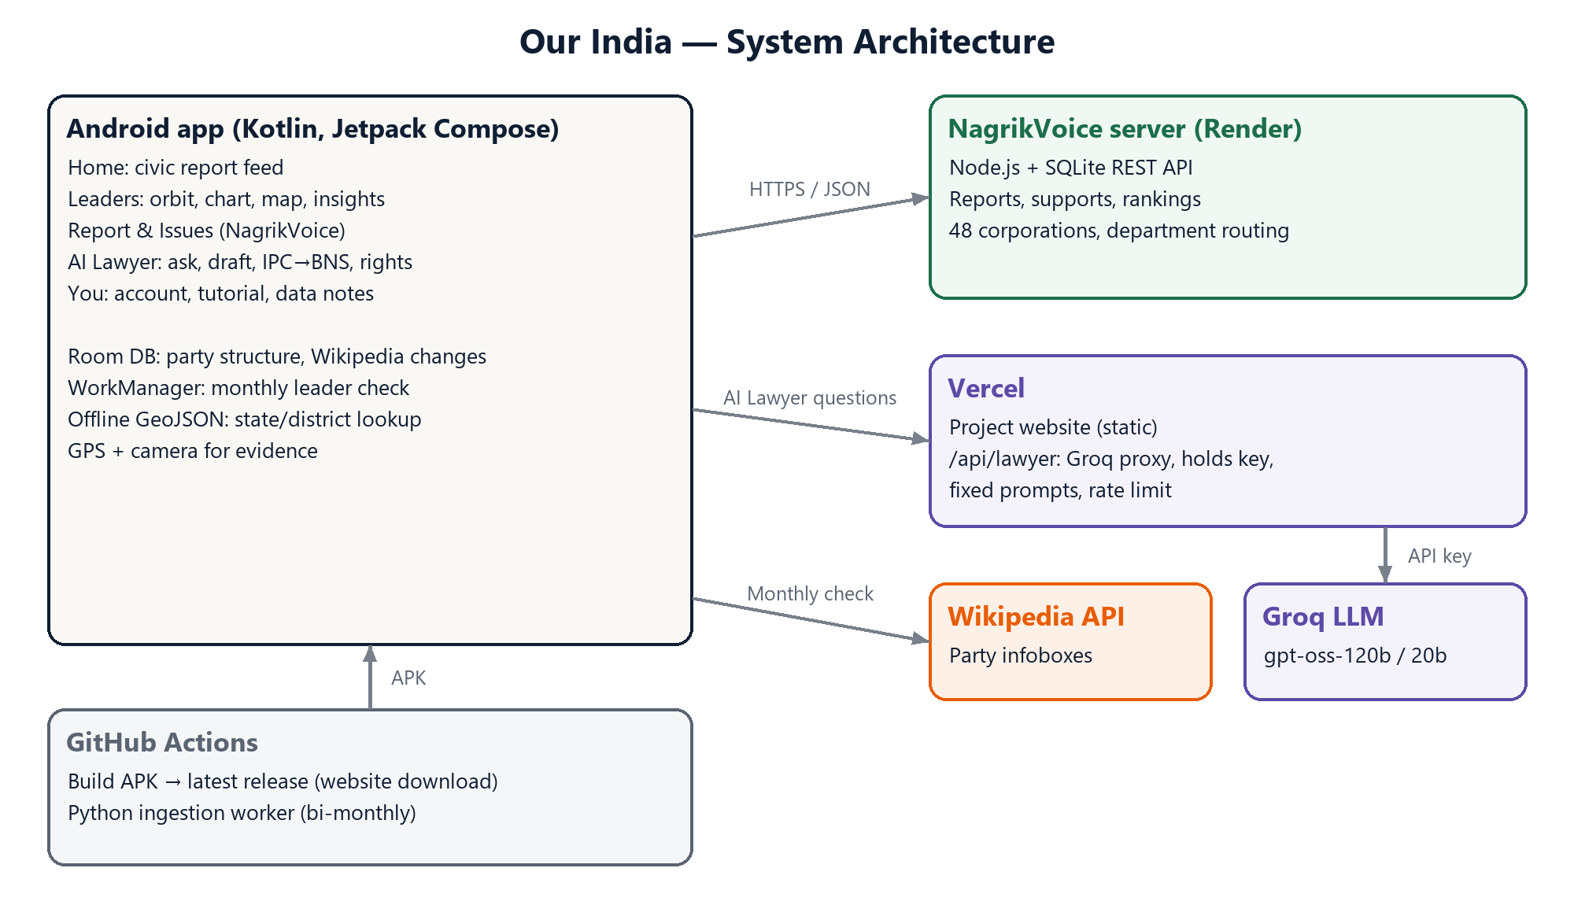
Figure 1. System architecture. The Android app talks to three services over HTTPS: the NagrikVoice server on Render for reports, supports and rankings; a Vercel function that forwards AI Lawyer questions to Groq while holding the API key; and the Wikipedia API for the monthly leader check. Party structures, Wikipedia changes and boundary files are stored on the device, so the Leaders section works offline. GitHub Actions builds each new version and publishes it for download from the website.

Modules
- Party Structure (Leaders) Module: bundled verified party data; orbit, chart, map and insights views; search and location focus.
- Leader Update Module: monthly Wikipedia infobox check stored in Room; applies only real changes, labelled as unverified.
- Civic Feed Module: home feed of reports with support, share, map, fix claim and report abuse.
- Civic Reporting Module: camera evidence, GPS and offline boundary lookup, corporation and department routing, duplicate check.
- Issues and Ranking Module: search and filters by city and department, and the corporation ranking.
- AI Lawyer Module: Ask, Draft, IPC to BNS lookup, Rights and helplines; Vercel proxy with fixed prompts and rate limiting.
- Onboarding and Account Module: first-run tutorial, location permission flow, sign-in and profile.

9. Hardware and Software Requirements
Hardware Requirements | Software Requirements
Processor: Intel Core i5 / AMD Ryzen 5 or above (development) | Operating System: Windows 10/11 or Linux (development); Android 8.0 or newer (users)
RAM: 8 GB minimum, 16 GB recommended for Android Studio | IDE: Android Studio, VS Code
Storage: 10 GB free for the Android SDK and builds | Languages: Kotlin, JavaScript (Node.js 20), Python 3.12
Android phone (Android 8.0+) with GPS, camera and internet | Database and services: Room / SQLite, Render, Vercel, Groq API, Wikipedia API

10. Expected Outcome
A working Android app, distributed as an APK from the project website, in which a user can: browse 25 parties' organisations with sources and find the party heads for their location; report a civic problem with a photo and have it routed to the right municipal corporation; follow and support reports in a public feed and see a ranking of corporations; and ask legal questions, draft documents and look up BNS sections. The codebase is open source, covered by automated unit and UI tests, and every new version is built and released automatically.

11. Applications
- Citizens finding out who leads each party in their state or district, with sources.
- Residents reporting and jointly tracking civic problems such as potholes, leaks and broken street lights.
- Journalists, researchers and civic groups comparing how responsive municipal corporations are.
- Legal awareness for citizens adapting to the new BNS, BNSS and BSA, and quick drafting of notices and RTI applications.
- Civic education in schools and colleges about how parties and local government are organised.

12. Timeline / Work Plan
Phase | Activity | Duration
Phase 1 | Requirement analysis & literature survey | Week 1-2
Phase 2 | System design & architecture | Week 3-4
Phase 3 | Implementation: party structure, maps, civic reporting, AI Lawyer | Week 5-9
Phase 4 | Testing & debugging: unit and UI tests, device testing | Week 10-11
Phase 5 | Documentation, website & final submission | Week 12

13. References
[1] mySociety, “FixMyStreet,” https://www.fixmystreet.com, Accessed on: 23 Oct 2026.
[2] Department of Administrative Reforms and Public Grievances, Government of India, “CPGRAMS,” https://pgportal.gov.in, Accessed on: 23 Oct 2026.
[3] Ministry of Housing and Urban Affairs, “Swachh Bharat Mission (Urban) and Swachhata-MoHUA app,” https://sbmurban.org, Accessed on: 23 Oct 2026.
[4] Association for Democratic Reforms, “MyNeta,” https://myneta.info, Accessed on: 23 Oct 2026.
[5] Department of Justice, Government of India, “Tele-Law,” https://www.tele-law.in, Accessed on: 23 Oct 2026.
[6] Government of India, The Bharatiya Nyaya Sanhita, 2023 (Act No. 45 of 2023), India Code, https://www.indiacode.nic.in, Accessed on: 23 Oct 2026.
[7] Wikimedia Foundation, “MediaWiki Action API,” https://www.mediawiki.org/wiki/API:Main_page, Accessed on: 23 Oct 2026.
[8] Google, “Jetpack Compose,” Android Developers, https://developer.android.com/compose, Accessed on: 23 Oct 2026.
[9] Groq, “GroqCloud documentation,” https://console.groq.com/docs, Accessed on: 23 Oct 2026.
[10] Project repository, “Our India,” https://github.com/harshoswal1/Our-India, Accessed on: 23 Oct 2026.

