**ESB STORE (ELECTRONIC STUDENT BOOK**

STORE)

# A PROJECT REPORT

**BACHELOR OF SCIENCE (INFORMATION TECHNOLOGY)**

# By

Mr. AADITYA GUPTA  
&  
Mr. ABHISHEK RAJBHAR   
SEAT NO :-IT305  
 :- IT319

Under the esteemed guidance of Prof. Mr. Mayur

&



# DEPARTMENT OF INFORMATION TECHNOLOGY

SHRI RAJASTHANI SEVA SANGH'S

Smt. PARMESHWARIDEVI DURGADUTT TIBREWALA LIONS JUHU COLLEGE OF ARTS, COMMERCE & SCIENCE

***(Affiliated to University of Mumbai)***

**J. B NAGAR, ANDHERI (E), MUMBAI-400059. MAHARASHTRA**

**2024-2025**



CERTIFICATE

This is to certify that the project entitled, "**ESB STORE (ELECTRONIC STUDENT BOOK STORE)**", is bonafied work of **Mr. ABHISHEK RAJBAHR** & **Mr. ADITYA GUPTA** bearing **Seat no :- 319&305**, submitted in partial fulfillment of the requirements for the award of degree of BACHELOR OF SCIENCE in INFORMATION TECHNOLOGY from University of Mumbai

**Internal Guide Co-ordinator**

**External Examiner**

Date: College Seal

# PROFOMA FOR THE APPROVAL PROPOSAL

PNR No:- 2022016401491166  
 2022016401487822 Seat No:-IT305  
 IT319

1. Name of the Students

# ABHISHEK RAJBHAR &AADITYA GUPTA

1. Title of the Project  
    **ESB STORE (ELECTRONIC STUDENT BOOK STORE)**

|  |  |  |  |
| --- | --- | --- | --- |
| 3. Name of the Guide |  | | |
| **Prof.Mr.Mayur**  4. Teaching experience of the Guide |  |  | **2.5Yrs** |
| 5. Is this your first submission? | Yes |  | No |

ABHISHEK RAJBHAR

ADITYA GUPTA

Signature of the Students Signature of the Guide

Date:- Date:-

Signature of the Coordinator Date:-

# Abstract

In today’s digital era, access to educational resources has become more important than ever. The availability of textbooks in digital format not only enhances learning opportunities but also provides students with flexibility and convenience.   
  
However, students often face challenges in finding PDF versions of their textbooks from 1st to 12th standard. They are required to navigate through multiple websites to find the correct book, which is time-consuming and frustrating.

This project, E-book Store, aims to address this issue by developing a single platform where users can easily search for and access free PDFs of textbooks from 1st to 12th standard. The platform will offer a simple, user-friendly interface that will allow students, parents, and teachers to quickly locate the textbooks they need without the hassle of browsing various websites.  
  
 The objective of the project is to make educational resources more accessible and to bridge the gap in availability of learning material across regions.

The website will incorporate search functionality that will allow users to search for books by subject, grade, and board of education.  
  
 The system will be built with the intention of providing open access to textbooks in a centralized manner, free of cost. This project will be implemented using modern web technologies to ensure a responsive and efficient platform.  
  
 It will provide a scalable solution that can grow to incorporate other resources in the future.

**ACKNOWLEDGEMENT**

First and foremost, I would like to express my sincere gratitude to **Mr. Mayur Tawade**, my project guide, for their continuous support, patience, and guidance throughout the entire duration of this project.   
  
Their invaluable insights and suggestions helped in shaping the project into its final form.

I would also like to thank the **Mumbai University** for providing me with the opportunity and resources to work on this project.  
  
 The tools, technology, and guidance offered by the institution have been pivotal in the successful completion of this project.

A special mention goes out to my family and friends, whose constant encouragement and understanding gave me the confidence to pursue and complete this project.

Lastly, I would like to acknowledge the valuable contributions of online communities, tutorials, and various educational resources that I relied on to gain the knowledge needed for this project. Without their generous sharing of information, I would not have been able to tackle the technical challenges.

Thank you all for your unwavering support and belief in me.

**DECLARATION**

I here by declare that the project entitled, “**ESB STORE (ELECTRONIC STUDENT BOOK STORE)**” done at **SMT. PARMESHWARIDEVI DURGADUTT TIBREWALA LIONS JUHU COLLEGEOF ARTS COMMERCE & SCIENCE**, has not been in any case duplicated to submit to any other university for the award of any degree. To the best of my knowledge other than me, no one has submitted to any other university.  
  
 The project is done in partial fulfillment of the requirements for the award of degree of **BACHELOR OF SCIENCE (INFORMATION TECHNOLOGY)** tobe submitted as final semester project as part of our curriculum.

**Name and Signature of the Students**

**TABLE OF CONTENTS**

|  |  |  |  |
| --- | --- | --- | --- |
|  | **Sr. No.** | **Contents** | **Page No.** |
| **Chapter** | **1** | **INTRODUCTION** | **10 - 12** |
|  | 1.1 | Background | 10 |
|  | 1.2 | Objectives | 10 |
|  | 1.3 | Purpose, Scope, and Applicability | 11 |
|  | 1.3.1 | Purpose | 11 |
|  | 1.3.2 | Scope | 11 |
|  | 1.3.3 | Applicability | 11 |
|  | 1.4 | Achievements | 11 |
|  | 1.5 | Organisation of Report | 11-12 |
| **Chapter** | **2** | **SURVEY OF TECHNOLOGIES** | **13** |
| **Chapter** | **3** | **REQUIREMENTS AND ANALYSIS** | **14-22** |
|  | 3.1 | Problem Definition | 14 |
|  | 3.2 | Requirements Specifications | 14-15-16 |
|  | 3.2.1 | Functional Requirements | 16-17 |
|  | 3.2.2 | Non Functional Requirements | 15-16 |
|  | 3.3 | Planning and Scheduling | 16-17 |
|  | 3.3.1 | Development Phases | 16 |
|  | 3.3.2 | Scheduling | 17 |
|  | 3.4 | Software and Hardware Requirements | 18 |
|  | 3.4.1 | Software Requirements | 18 |
|  | 3.4.2 | Hardware Requirements | 18 |
|  | 3.5 | Preliminary Product Description | 19 |

|  |  |  |  |
| --- | --- | --- | --- |
|  | 3.5.1 | Objectives of the System | 19 |
|  | 3.5.2 | Functions of the System | 19 |
|  | 3.5.3 | System Operation | 19 |
|  | 3.6 | Conceptual Models | 19-22 |
|  | 3.6.1 | System Architecture | 19 |
|  | 3.6.2 | User Interaction Flow | 20 |
|  | 3.6.3 | Data Flow | 21-22 |
| **Chapter** | **4** | **SYSTEM DESIGN** | **23-33** |
|  | 4.1 | Basic Modules | 23 |
|  | 4.2 | Data Design | 24-25 |
|  | 4.2.1 | Schema Design | 24 |
|  | 4.2.2 | Data Integrity and Constraints | 26-27 |
|  | 4.3 | Procedural Design | 28 |
|  | 4.3.1 | Logic Diagrams | 29 |
|  | 4.3.2 | Data Structure | 30 |
|  | 4.3.3 | Algorithms Design | 31 |
|  | 4.4 | User Interface Design | 31 |
|  | 4.5 | Security Issues | 32 |
|  | 4.6 | Test Cases Design | 33 |

**TABLE OF FIGURE**

|  |  |  |  |
| --- | --- | --- | --- |
|  | **Sr. No.** | **Contents** | **Page No.** |
| **Chapter** | **3** | **REQUIREMENTS AND ANALYSIS** | 1. **- 21** |
|  |  | Fig-3.3.2 Scheduling | 17 |
|  |  | Fig-3.6.1Use Case Diagram | 19 |
|  |  | Fig-3.6.2 Class Diagram | 20 |
|  |  | Fig- 3.6.3 Data Flow Diagram | 21 |
| **Chapter** | **4** | **SYSTEM DESIGN** | **23 - 33** |
|  |  | Fig-4.1.1 User Module | 23 |
|  |  | Fig-4.2.1 Database Schema | 24 |
|  |  | Fig-4.2.1.2 ER Model | 25 |
|  |  | Fig-4.2.2 Data Integrity and Constraints | 26-27 |
|  |  | Fig-4.3 Procedural Design | 28 |
|  |  | Fig-4.3.1 Logic Diagrams | 29 |
|  |  | Fig-4.3.2 Data Structures | 30 |
|  |  | Fig-4.4 User interface Design | 31 |
|  |  | Fig-4.5 Security Issues | 32 |
|  |  | Fig-4.6 Test Case DIagram | 33 |
|  |  |  |  |
|  |  |  |  |
|  |  |  |  |

**CHAPTER 1: INTRODUCTION**

**1.1 Background**

In the digital era, access to learning resources has become increasingly crucial for students across various educational levels.  
   
The internet is filled with abundant information, yet when it comes to finding textbooks for school students, there is often a challenge. Many students and educators spend valuable time searching for specific PDFs of textbooks on different platforms.  
  
 This often results in frustration due to fragmented sources, hidden fees, or unreliable links.

In response to this issue, the concept of an **E-book Store** emerges as a solution. The purpose of this project is to create a single website that offers free access to the PDFs of all textbooks from 1st to 12th standard.   
  
The website will provide an organized and centralized platform where students, teachers, and parents can easily search, download, and access the textbooks they need without any hassle or cost.

This project not only addresses the issue of accessibility but also supports the broader goals of digital literacy, enabling students from all backgrounds to have equal access to high-quality educational resources.

**1.2 Objectives**

The key objectives of the E-book Store project are:

* To provide a centralized platform where students from 1st to 12th standard can access their textbooks in PDF format.
* To ensure all textbooks are available free of cost, making education more accessible to students from economically weaker sections.
* To simplify the process of searching and downloading textbooks by offering a user-friendly interface that allows quick searches by class, subject, and board.
* To promote digital learning by offering easy access to digital versions of textbooks, contributing to environmental conservation by reducing paper usage.
* To ensure that the website is secure, reliable, and regularly updated with the latest editions of textbooks, ensuring that users always have access to accurate and up-to-date resources.

**1.3 Purpose, Scope, and Applicability**

The primary purpose of the E-book Store project is to provide free and convenient access to school textbooks, promoting educational inclusivity. With the increasing focus on e-learning and digital education, the project aims to eliminate the hurdles students face when searching for textbooks online.

**Scope:**

* **User Scope:** The website will cater to students, teachers, and parents who need access to textbooks for academic purposes.
* **Geographic Scope:** Although the primary focus is on textbooks from Indian education boards (SSC & HSC Board), the platform can be expanded in the future to include textbooks from other countries.
* **Content Scope:** The website will house digital versions (PDFs) of all textbooks from 1st to 12th standard, categorized by class and subject. The platform will be updated to include new editions as they are released.

**1.3.3 Applicability**

The website can be used by:

* Students from 1st to 12th standard who need easy access to textbooks.
* Teachers looking for free teaching material and resources.
* Parents who want to download educational materials for their children.
* Schools and educational institutions for distributing resources to students.

**1.4 Achievements**

This project will result in the creation of a well-organized, user-friendly website that offers:

* Access to textbooks in PDF format from a single platform.
* A highly efficient search and filtering system.
* Mobile responsiveness, ensuring that students can access textbooks on smartphones and tablets.
* Free and legal access to educational resources.

Additionally, the project contributes to bridging the digital divide by making textbooks accessible to students who may not be able to afford physical copies.

**1.5 Organisation of Report**

This report is structured as follows:

* **Chapter 2: Survey of Technologies**   
   A review of the technologies, platforms, and tools used in developing the E-book store.
* **Chapter 3: Requirements and Analysis**   
   Details the problem statement, requirements specifications, and project analysis, including   
   software and hardware needs.
* **Chapter 4: System Design**   
   Provides an in-depth look into the system architecture, data design, procedural design, and the user interface.
* **Chapter 5: Implementation**   
  Discusses the development process, the modules implemented, and the code functionality.
* **Chapter 6: Testing**   
   Describes the testing strategies, test cases, and results to ensure that the system functions as intended.
* **Chapter 7: Conclusion and Future Work**   
   Summarizes the outcomes of the project and outlines potential future enhancements.  
    
    
    
    
    
    
    
    
    
    
    
    
    
    
    
    
    
    
    
    
    
    
    
    
    
    
    
    
    
    
    
    
    
    
    
    
    
    
    
    
   **CHAPTER 2: SURVEY OF TECHNOLOGIES**

**1. Frontend Technologies:**

* **HTML5**: The foundation for structuring web pages. It's essential for building the layout of your e-book store, including forms, buttons, and navigation.
* **CSS3**: Enhances the visual appeal, providing responsive design, smooth transitions, and user-friendly interfaces. It ensures the site is visually appealing on any device.
* **JavaScript**: Adds interactivity to the website, allowing users to search, read books online, and manage orders smoothly. Frameworks like **React** can make the frontend dynamic.

**2. Backend Technologies:**

* **Node.js**: A JavaScript runtime for building scalable server-side applications. It handles user authentication, book storage, and order processing.
* **Express.js**: A backend web application framework for Node.js. It simplifies routing, middleware, and API development.
* **PHP** (Alternative): Another widely used server-side language, PHP can manage dynamic content and communicate with databases.

**3. Database:**

* **MySQL**: A relational database used to store user data, book information, and order history. It's widely used for structured data.
* **MongoDB** (NoSQL alternative): A NoSQL database that is flexible for handling large amounts of unstructured data, such as metadata for e-books.

**4. Book Reader Integration:**

* **PDF.js**: A JavaScript library that allows seamless online PDF viewing directly in the browser, offering a user-friendly reading experience.

**CHAPTER 3: REQUIREMENTS AND ANALYSIS**

**3.1 Problem Definition**

In today's digital age, the availability of academic resources online has grown exponentially, yet there remains a significant challenge for students in finding consolidated platforms where they can access textbooks. While there are various websites and repositories offering PDFs of textbooks, these resources are often scattered across multiple platforms, which makes it difficult for students to locate the exact books they need.  
   
The process of browsing through multiple websites wastes time and may lead to confusion or frustration.

For students from 1st to 12th grade, it is essential to have easy access to textbooks in order to supplement their learning and complete assignments efficiently. However, financial barriers and scattered resources online make it hard for all students to obtain these resources in one place, free of cost.  
   
Hence, there is a need for a user-friendly, organized website where students can access all the necessary textbooks from a single source.

The goal of this project is to develop an E-book store where students can easily search, download, and access PDFs of textbooks from 1st to 12th standard without the hassle of searching on different websites.  
  
 This website will provide free access to textbooks, making learning more accessible and inclusive for all students.

**3.2 Requirements Specification**

**3.2.1 Functional Requirements**:

1. **User Registration and Login**:  
   * The website should provide functionality for users to register with their email and password.
   * Users should be able to log in with their credentials to access the e-books.
2. **Textbook Search**:  
   * The system should allow users to search for textbooks by standard, subject, or book title.
   * Advanced filtering options (e.g., by author, publication year) should be provided for better search results.
3. **E-book Viewing and Downloading**:  
   * Users should be able to view the textbooks online using an integrated PDF viewer.
   * The system should allow users to download the textbook in PDF format for offline use.
4. **Categorization and Organization**:  
   * Textbooks should be organized by class (1st to 12th standard) and subject (e.g., Math, Science, Social Studies).
   * Each category should have a simple layout for easy navigation.
5. **User Feedback and Rating System**:  
   * Users should be able to provide feedback and rate the textbooks based on quality and ease of understanding.
6. **Admin Panel**:  
   * An admin panel should allow administrators to upload new textbooks, manage existing entries, and maintain the website.
   * Admins can handle user complaints and remove outdated or incorrect textbooks.

**3.2.2 Non-Functional Requirements**:

1. **Scalability**:  
   * The system should be designed to handle a large number of users simultaneously accessing the website.
2. **Security**:  
   * User data should be securely stored using encryption.
   * The system should prevent unauthorized access to textbooks by non-registered users.
3. **Usability**:  
   * The user interface should be simple and intuitive, catering to users of various age groups.
   * The website should have a responsive design for mobile, tablet, and desktop users.
4. **Performance**:  
   * The system should ensure fast loading times, especially while searching and downloading textbooks.
   * PDF files should be compressed to optimize performance without compromising quality  
       
     .
5. **Reliability**:  
   * The website should be highly available and able to handle unexpected downtimes or crashes with proper error handling.
6. **Compliance**:  
   * The system must comply with copyright laws and regulations regarding educational content and open-access publishing.

**3.3 Planning and Scheduling**

**3.3.1. Planning**

The project will be executed in several phases. Below is an outline of each phase, along with the corresponding deliverables:

* **Phase 1: Requirement Gathering and Analysis**:  
  + Conduct a detailed analysis of student needs and review existing platforms to identify gaps.
  + Gather all necessary requirements and validate them with stakeholders.
  + Deliverable: Requirements Specification Document.
* **Phase 2: System Design**:  
  + Create a blueprint for the website's architecture, database design, and user interface design.
  + Deliverable: System Architecture and Wireframes.
* **Phase 3: Development**:  
  + Develop the website backend (user authentication, textbook management, etc.).
  + Implement the search engine and PDF viewer functionality.
  + Deliverable: Basic Functional Website.
* **Phase 4: Testing**:  
  + Perform unit testing, integration testing, and user acceptance testing to ensure all features work as expected.
  + Deliverable: Test Results and Bug Reports.
* **Phase 5: Deployment and Maintenance**:  
  + Deploy the website on a server and make it available to users.
  + Regularly update the website and add new textbooks as needed.
  + Deliverable: Fully Functional E-book Store Website.
* **2. Scheduling:**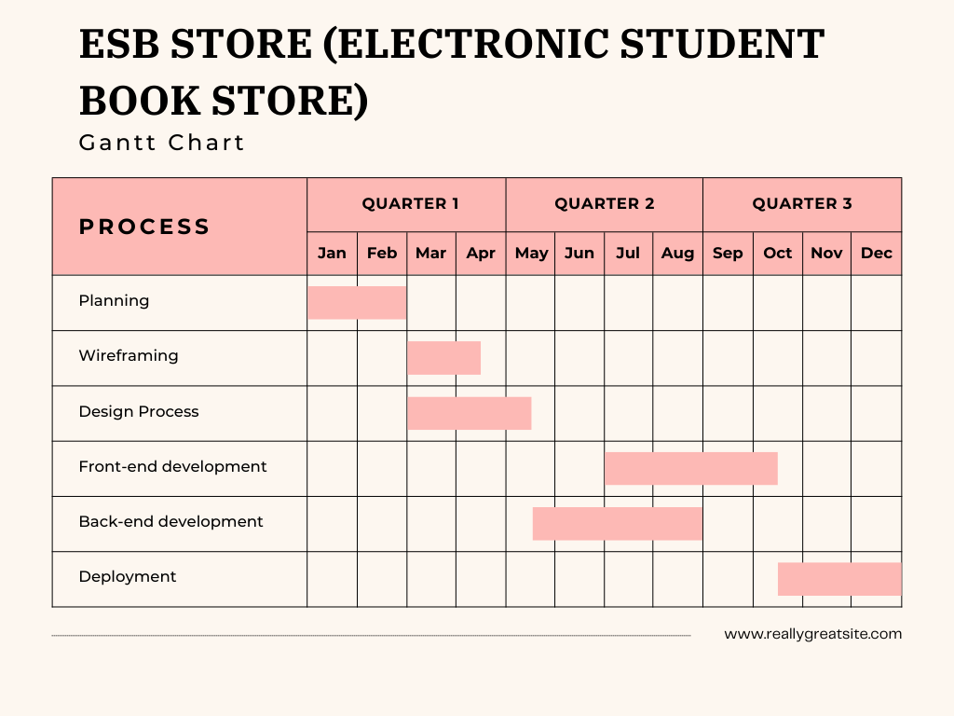 Fig-3.3.2 Scheduling

* The schedule allows for a total of 1 yrs to complete the project, with some flexibility to handle unexpected delays or adjustments. Each phase will be closely monitored to ensure it stays on track.

**3.4 Software and Hardware Requirements**

**3.4.1 Software Requirements**

1. **Frontend Technologies**
   * **HTML/CSS:** For structuring and styling the website.
   * **JavaScript:** To enhance user interactivity and provide dynamic content.
2. **Backend Technologies**
   * **Programming Language:**
     + **Node.js :** To handle server-side logic and database interactions.
   * **Database:**
     + **MySQL :** For storing user data, textbook information, and PDF file locations.
3. **File Management**
   * **PDF Handling Libraries:**
     + **PDF.js :** For displaying and managing PDF files.
4. **Web Hosting and Deployment**
   * **Web Server:**
     + **Apache :** To serve the web application.
5. **Version Control**
   * **Git:** For version control and collaboration.

**3.4.2 Hardware Requirements**

1. **Development Environment**
   * **Personal Computer:**
     + **Processor:** Intel core- i5
     + **RAM:** 8 GB or higher.
     + **Storage:** Minimum of 256 GB SSD for faster performance.

**3.5 Preliminary Product Description**

The "E-book Store" is an online platform that provides free access to PDFs of textbooks for students from 1st to 12th standard.  
  
 The platform aims to simplify the process of finding educational resources by aggregating links to textbooks across different subjects and grades into a single, user-friendly website. Key features include:

* **User Registration and Login:** Allows users to create accounts to save favorite textbooks and access personalized recommendations.
* **Search Functionality:** Users can easily search for textbooks by subject, grade, or title.
* **PDF Viewer:** Users can view textbooks directly on the website without needing to download them.
* **Feedback System:** Users can submit feedback or request textbooks not available on the platform.

**User Journey:**

1. Users visit the website.
2. They can register or log in.
3. Users can search for specific textbooks.
4. Once found, they can view or download the PDFs.

**3.6 Conceptual Models**

**3.6.1 Use Case Diagram**

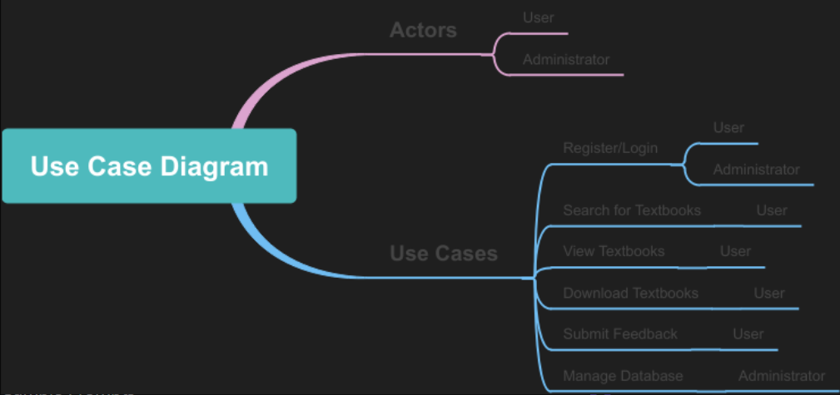 **Fig-3.6.1Use Case Diagram**

**3.6.2 Class Diagram  
  
  
  
  
  
  
  
  
  
  
  
  
  
  
  
  
  
  
  
  
  
  
  
  
  
  
  
  
  
  
  
  
  
  
  
  
  
  
   
 Fig-3.6.2 Class Diagram  
   
  
  
  
  
  
  
  
  
  
3.6.3 Data Flow Diagram (DFD)**

* **Processes:**
  + User Registration
  + Textbook Search
  + PDF Retrieval
* **Data Stores:**
  + User Database
  + Textbook Database

**Fig- 3.6.3 Data Flow Diagram  
  
  
3.6.4 Wireframes**

* **Homepage:**   
   Search bar, categories (1st-12th standard), featured textbooks.
* **Textbook Page:** Title, author, view/download button, related textbooks.
* **User Dashboard:**  User profile, saved textbooks, feedback section.

**Chapter 4: System Design**

**4.1 Basic Modules**

**4.1.1 User Module**

* **Description**:  
   This module allows users to register, log in, and manage their profiles. Users can search for textbooks by grade, subject, or title.

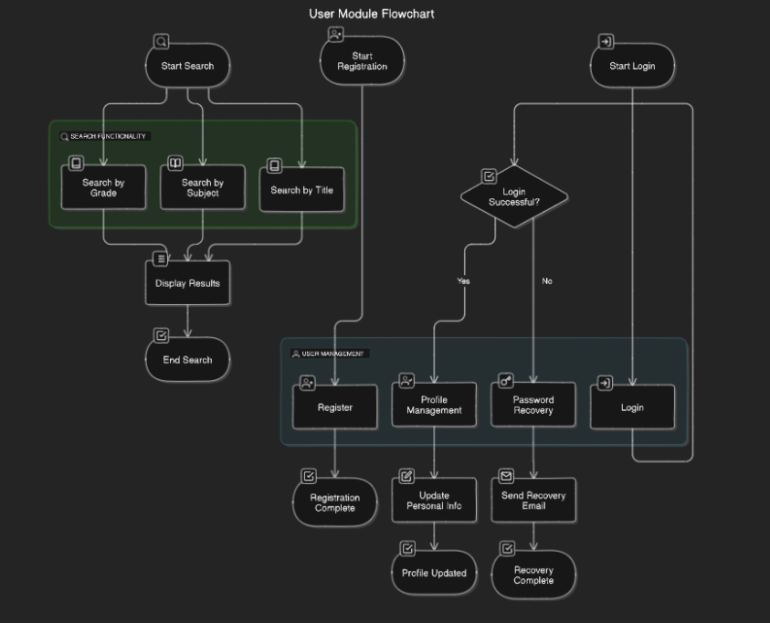

**Fig-4.1.1 User Module**

**4.2 Data Design**

**4.2.1 Database Schema**

* **Overview**:  
   The database will use a relational database model to store and manage data efficiently. It will consist of several tables, including Users, Textbooks, Downloads, and Feedback.

**Fig-4.2.1 Database Schema**

**ER Model**The ER Model outlines the entities, attributes, and relationships within the

ESB STORE (ELECTRONIC STUDENT BOOK STORE  
  
 **Fig-4.2.1.2 ER Model  
  
  
  
4.2.2 Data Integrity and Constraints** To ensure data integrity within **ESB STORE (ELECTRONIC STUDENT BOOK STORE)** , several constraints are implemented across different tables. The following table outlines the entities, their attributes, and the constraints applied to maintain data integrity **Fig-4.2.2 Data Integrity and Constraints**

|  |  |  |  |  |  |
| --- | --- | --- | --- | --- | --- |
| **Entity** | |  | | --- | | **Attribute** |  |  | | --- | |  | | **Constraint** | **Description** |
| **User** | User_ID | PRIMARY KEY, NOT NULL, AUTO_INCREMENT | Unique identifier for each user**.** |
|  | Email | UNIQUE, NOT NULL | Ensures each user has a unique and valid email address for login. |
|  | Password | NOT NULL | Users must have a password to ensure secure access. Passwords should also be encrypted. |
|  | Role | NOT NULL | Limits the role of the user to one of the predefined values (Student, Teacher, Admin). |
| **Book** | Book_ID | PRIMARY KEY, NOT NULL, AUTO_INCREMENT | Unique identifier for each book in the system. |
|  | Title | NOT NULL | Title of the textbook; must be provided for every book. |
|  | Class | CHECK (Class BETWEEN 1 AND 12), NOT NULL | Ensures the class value is between 1st and 12th standard. |
|  | Subject | NOT NULL | Specifies the subject of the textbook. |
|  | File_Link | NOT NULL, UNIQUE | Link to the PDF file for free reading; must be unique for each book. |
| **Category** | Category_ID | PRIMARY KEY, NOT NULL, AUTO_INCREMENT | Unique identifier for each category (class level, e.g., 1st grade). |
|  | Category_Name | NOT NULL, UNIQUE | The name of the category, such as '1st Grade', '2nd Grade', etc. Ensures no duplicates. |
| **Read_Log** | Log_ID | PRIMARY KEY, NOT NULL, AUTO_INCREMENT | Unique identifier for each reading log entry. |
|  | User_ID | FOREIGN KEY (User_ID) REFERENCES User(User_ID) ON DELETE CASCADE, NOT NULL | Ensures each log entry is associated with a valid user and cascades on delete to remove logs when a user is deleted. |
|  | Book_ID | FOREIGN KEY (Book_ID) REFERENCES Book(Book_ID) ON DELETE CASCADE, NOT NULL | Ensures each log entry is associated with a valid book and cascades on delete to remove logs when a book is deleted. |
|  | Start_Date | NOT NULL | Start date of the reading session. |
|  | Feedback_ID | PRIMARY KEY, NOT NULL, AUTO_INCREMENT | Unique identifier for each feedback entry. |
|  | User_ID | FOREIGN KEY (User_ID) REFERENCES User(User_ID) ON DELETE CASCADE, NOT NULL | Ensures feedback is associated with a valid user and cascades on delete to remove feedback when the user is deleted. |
|  | Book_ID | FOREIGN KEY (Book_ID) REFERENCES Book(Book_ID) ON DELETE CASCADE, NOT NULL | Ensures feedback is associated with a valid book and cascades on delete to remove feedback when the book is deleted. |
|  | Comments |  | Optional comments provided by users for feedback. |
|  | Rating | CHECK (Rating BETWEEN 1 AND 5), NOT NULL | Rating must be between 1 (lowest) and 5 (highest). |

**4.3 Procedural Design  
  
 Objective:** Ensure that only authorized users (user registration , user login process/ user registration) can access the platform and its functionalities

* + 1. 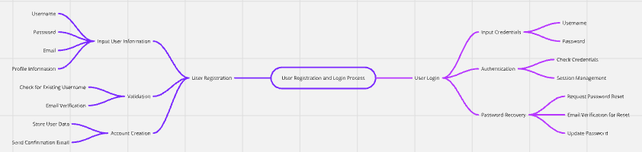  
        **Fig-4.3 Procedural Design**  
        **4.3.1 Logic** **Diagrams  
         
         
         
       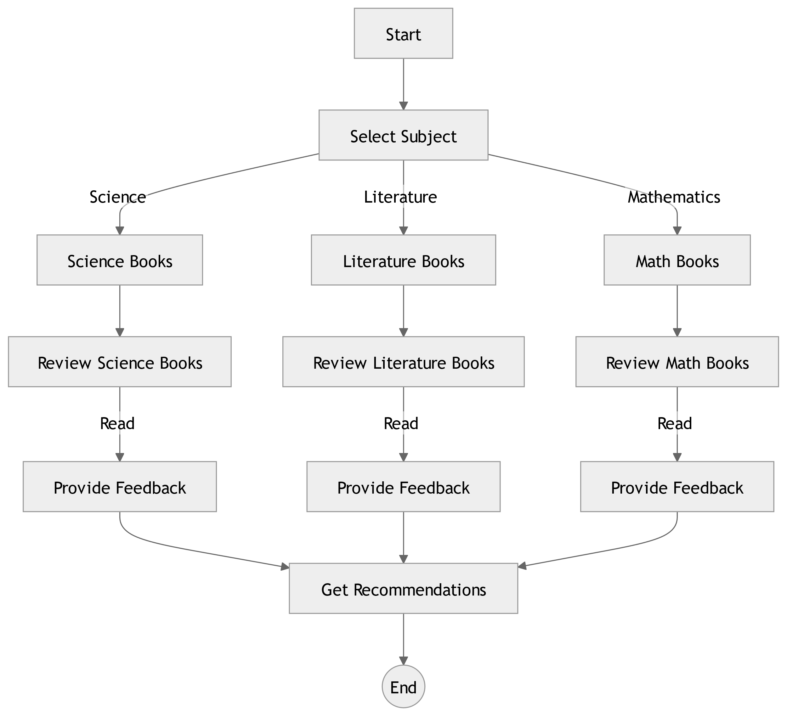  
         
         
       Fig-4.3.1 Logic Diagrams  
         
         
         
         
         
         
         
         
         
         
         
         
         
         
        4.3.2 Data Structures  
         
       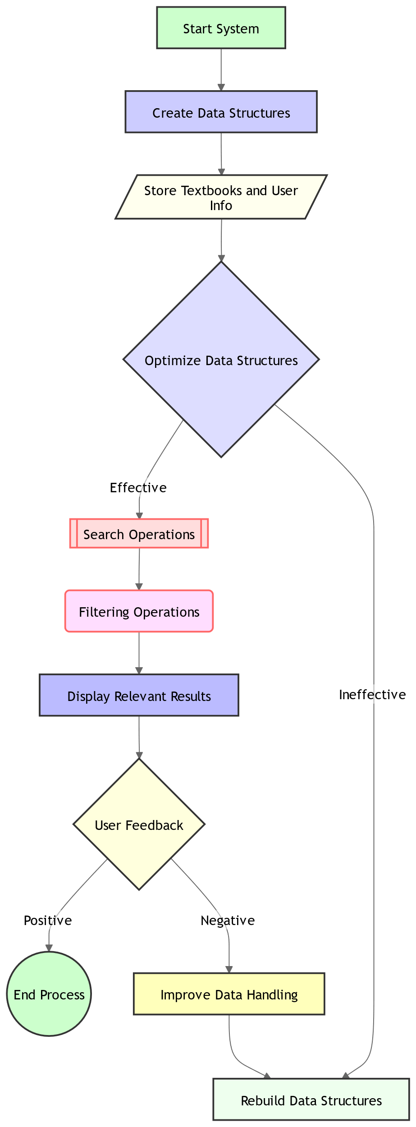  
        Fig-4.3.2 Data Structures**

### **4.3.3 Algorithms Design** The algorithms implemented in the system handle operations such as searching for Textbooks . The Textbooks search algorithm is optimized to filter items based on name, Class, or Author based. **4.4 User interface Design** The user interface is designed to be intuitive and user-friendly. Wireframes are created to demonstrate the layout of the login page, Textbook browsing, Reading, and admin management dashboardfor uploading Recent data Related to students

**Fig-4.4 User interface Design  
  
  
  
  
  
  
4.5 Security Issues   
  
  
1. Data Privacy and Protection:**

* **User Information:**If the website collects user data (e.g., name, email), it must ensure that this information is stored securely using encryption and secure databases to prevent data breaches.
* **Compliance with Laws:** Follow privacy laws like GDPR to ensure user data is handled appropriately.

**2. Unauthorized Access:**

* **User Authentication:** Implement secure login mechanisms (e.g., strong password policies, two-factor authentication) to prevent unauthorized access to user accounts.
* **Admin Access Control:** Ensure that only authorized admin users can upload, edit, or remove textbooks from the website.

**3. PDF File Security:**

* **File Tampering:** PDFs hosted on the website could be modified or replaced by malicious actors if proper security measures (like file integrity checks) are not in place.
* **Malware in PDFs**:   
  Ensure that uploaded PDF files are scanned for viruses or malware to avoid infecting users' devices.

**5. Piracy and Copyright Issues:**

* Although offering textbooks for free reading might be educational, ensure that the website is not violating copyright laws. Unauthorized distribution of copyrighted content can lead to legal consequences.  
    
    
    
    
    
    
    
    
    
    
    
    
    
    
    
    
    
    
    
   **Fig-4.5 Security Issues**  
  **4.6 Test Case Design**

• **User Login**

* **Input**: Username, Password
* **Output**: Access granted to the website

• **Search or Browse Books**

* **Input**: Keywords, Class, Subject
* **Output**: Display relevant textbook lis  
  t

• **Open PDF for Reading**

* **Input**: Selected Book
* **Output**: Open PDF viewer for reading

• **Feedback/Issues** (Optional)

* **Input**: User comments, rating
* **Output**: Feedback stored for future reference

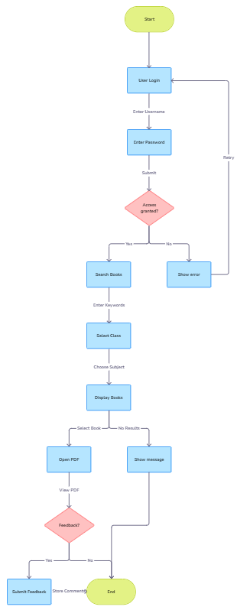Fig-4.6 Test Case DIagram