SQL DATA ANALYSIS REPORT
Hospital Management System
A SQL Server (T-SQL) case study analyzing patients, doctors, appointments, admissions, billing and hospital operations across a 14-table relational schema.
Prepared by: Harsh Pandey
Role: Data Analyst | BI Analyst | AI Analyst
Portfolio: github.com/harshpandey97
Date: September 2026
40  Patients | 25  Doctors | 60  Appointments | ₹305K  Billed Revenue

Table of Contents
- 1. Executive Summary
- 2. Project Background & Objectives
- 3. Database Schema Overview
- 4. Tools & Methodology
- 5. Analysis — Care Team & Operations (Q1, Q2, Q12)
- 6. Analysis — Financial & Revenue (Q3, Q4, Q7, Q10, Q15)
- 7. Analysis — Clinical Operations (Q5, Q6, Q13, Q14)
- 8. Analysis — Patient & Facility (Q8, Q9, Q11)
- 9. Additional Quality Metrics
- 10. Reusable KPI Views
- 11. Conclusion & Key Takeaways

1. Executive Summary
This report documents a complete SQL Server (T-SQL) data analysis project built around a realistic Hospital Management System. Starting from a 14-table relational schema and a ~40-rows-per-table sample dataset, 15 business questions were answered using joins, aggregations, conditional logic, date functions, and window functions, then packaged into 3 reusable KPI views.
Overall, the hospital served 40 patients through 25 doctors and 40 nurses, logging 60 appointments and 20 admissions. Total billed revenue across the sample period reached ₹304,504.43, of which ₹113,524.5 was successfully collected. 65% of appointments were completed, 18.3% remain scheduled, and 16.7% were cancelled.
The analysis surfaces concrete operational signals: Orthopedics is the most heavily staffed department yet the least expensive per consultation; ICU and Semi-Private rooms see the heaviest use; June and October are the year's peak revenue and appointment months respectively; and roughly a third of all payments fail to settle on the first attempt, pointing to a collections process worth tightening.
8  Departments | 40  Rooms Tracked | 57.5%  Room Occupancy | 6.21 days  Avg. Hospital Stay

2. Project Background & Objectives
A mid-size hospital tracks its patients, staff, appointments, admissions, treatments, prescriptions, lab work, and billing across separate operational systems — but has no consolidated reporting layer to help management make decisions. The objective of this project was to design a realistic relational dataset and write production-style T-SQL to answer the operational and financial questions hospital administrators would genuinely ask, such as:
- Which departments and doctors carry the heaviest workload?
- Where is the hospital generating (and losing) revenue?
- How efficiently are rooms, medicines and lab resources being used?
- Where do patients come from, and how reliable is the appointment pipeline?
Each answer needed to hold up as a query a working analyst could hand to a stakeholder — not just a syntactically correct SELECT statement.

3. Database Schema Overview
The schema is organized into four functional groups spanning 14 tables, linked through foreign keys such as department_id, doctor_id, patient_id, room_id, and bill_id.
Group | Tables | Purpose
People & Care Teams | Departments, Doctors, Nurses, Patients | Who delivers and receives care
Clinical Activity | Appointments, Admissions, Treatments, LabTests, TestResults | What happens during a visit or stay
Resources | Rooms, Medicines, Prescriptions | What gets consumed or occupied
Finance | Billing, Payments | What gets charged and collected

Sample data was generated at roughly 40 rows per table — enough variation to produce meaningful rankings and trends, while staying small enough to trace every result back to individual rows during testing.

4. Tools & Methodology
Technique | Where it's used
Multi-table JOINs | Linking Doctors → Departments → Treatments for cost breakdowns (Q7)
Aggregate functions (SUM, AVG, COUNT) | Revenue totals, average fees, occupancy counts (Q3, Q4, Q8)
Window functions — RANK(), DENSE_RANK() | Ranking doctors by appointments and unique patients (Q2, Q12)
Date functions — YEAR, MONTH, DATEDIFF, FORMAT | Monthly trends and average stay duration (Q3, Q11, Q13)
Conditional aggregation — CASE WHEN | Room occupancy percentage calculations (Q8)
Reusable views — CREATE OR ALTER VIEW | Turning ad-hoc queries into stable KPIs (Section 10)
Platform: Microsoft SQL Server (T-SQL). All 15 queries and 3 views run directly against the HospitalManagementSystem sample database referenced throughout this report.

5. Analysis — Care Team & Operations
This section looks at staffing distribution and how workload is spread across doctors — both by raw appointment count and by unique patients served.

Q1. Which department has the most doctors?
SELECT TOP 1 d.department_name, COUNT(doc.doctor_id) AS doctor_count
FROM Departments d
JOIN Doctors doc ON doc.department_id = d.department_id
GROUP BY d.department_id, d.department_name
ORDER BY doctor_count DESC;

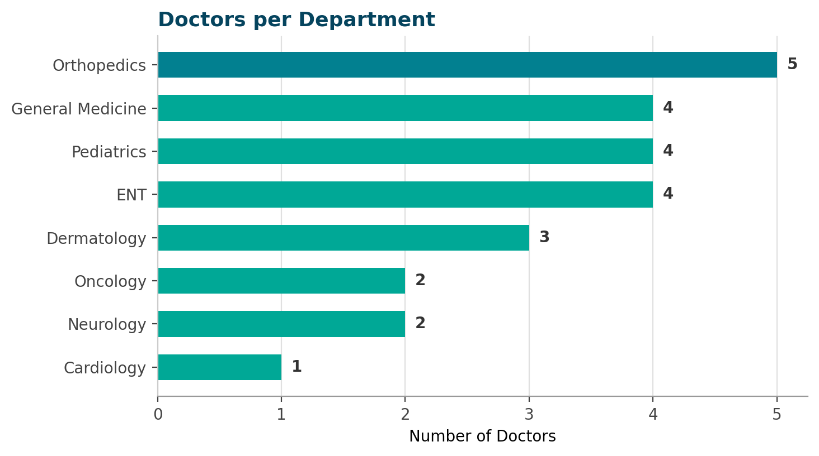
KEY INSIGHT — Orthopedics leads staffing
Orthopedics fields 5 doctors — the largest specialist bench of any department. General Medicine, Pediatrics and ENT are tied at 4 doctors each, while Cardiology has just 1 doctor despite carrying the highest average consultation fee (₹1,000) — a potential capacity gap worth reviewing.

Q2. Which doctor sees the most patients?
SELECT TOP 5 doc.doctor_id, doc.first_name + ' ' + doc.last_name AS doctor_name,
COUNT(a.appointment_id) AS total_appointments,
RANK() OVER (ORDER BY COUNT(a.appointment_id) DESC) AS doctor_rank
FROM Doctors doc
JOIN Appointments a ON a.doctor_id = doc.doctor_id
GROUP BY doc.doctor_id, doc.first_name, doc.last_name
ORDER BY total_appointments DESC;

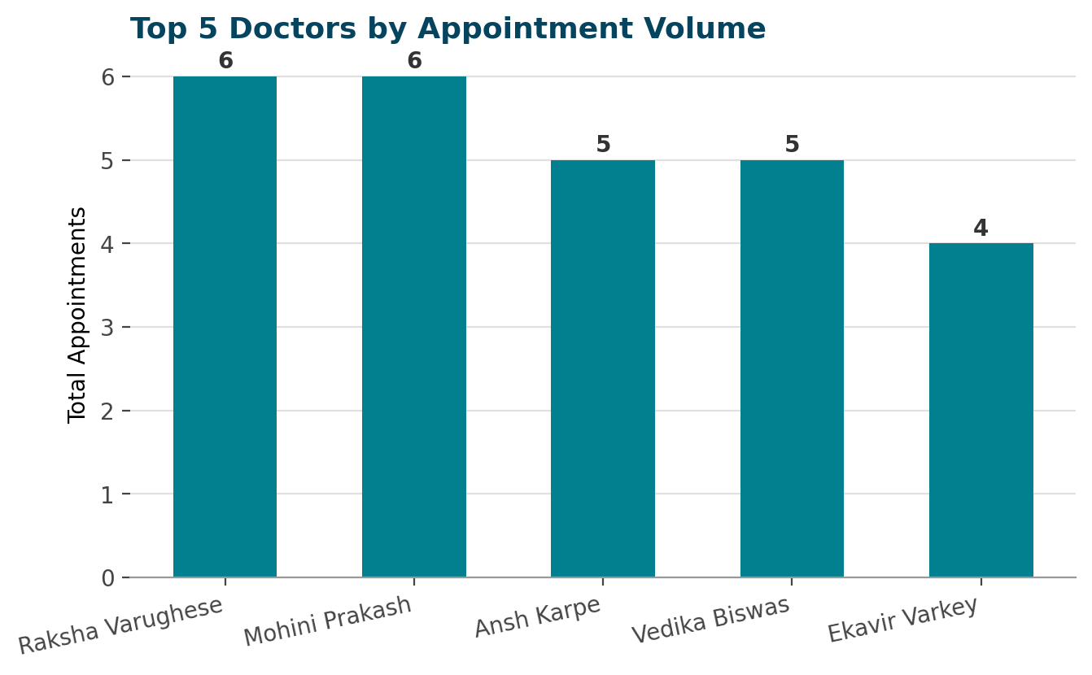
KEY INSIGHT — Two doctors tie for busiest
Dr. Raksha Varughese and Dr. Mohini Prakash each logged 6 appointments — the highest of any doctor. General Physicians and Orthopedic Surgeons dominate the top 5 by volume. RANK() is used deliberately so tied doctors share the same position rather than being arbitrarily ordered.

Q12. Which doctors reach the most unique patients?
SELECT TOP 5 doc.doctor_id, doc.first_name + ' ' + doc.last_name AS doctor_name,
COUNT(DISTINCT a.patient_id) AS unique_patients,
DENSE_RANK() OVER (ORDER BY COUNT(DISTINCT a.patient_id) DESC) AS patient_rank
FROM Doctors doc
JOIN Appointments a ON a.doctor_id = doc.doctor_id
GROUP BY doc.doctor_id, doc.first_name, doc.last_name
ORDER BY unique_patients DESC;

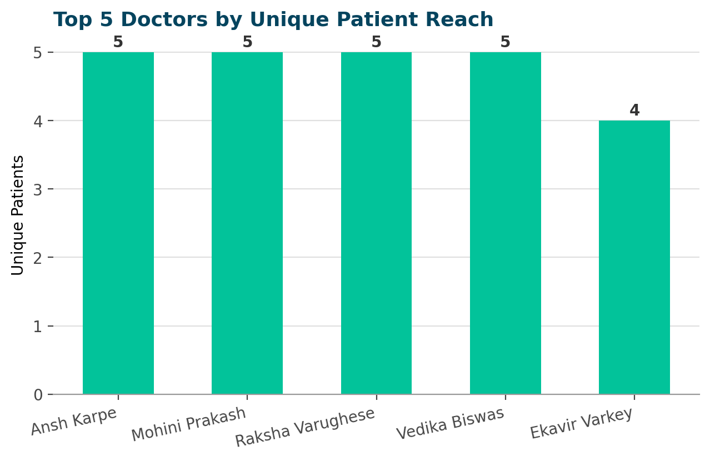
KEY INSIGHT — Volume and reach tell different stories
Four different doctors each treated 5 distinct patients — a broader reach than raw appointment counts alone suggest. COUNT(DISTINCT patient_id) reveals doctors serving more unique people rather than repeat visits from the same few, which is a better read on patient-facing coverage than appointment volume alone.

6. Analysis — Financial & Revenue
This section covers where the hospital's money comes from — by month, department, treatment type and payment channel — and where collection is breaking down.

Q3. What is the monthly revenue trend?
SELECT YEAR(bill_date) AS bill_year, MONTH(bill_date) AS bill_month,
FORMAT(bill_date, 'MMMM yyyy') AS month_label,
SUM(total_amount) AS monthly_revenue
FROM Billing
GROUP BY YEAR(bill_date), MONTH(bill_date), FORMAT(bill_date, 'MMMM yyyy')
ORDER BY bill_year, bill_month;

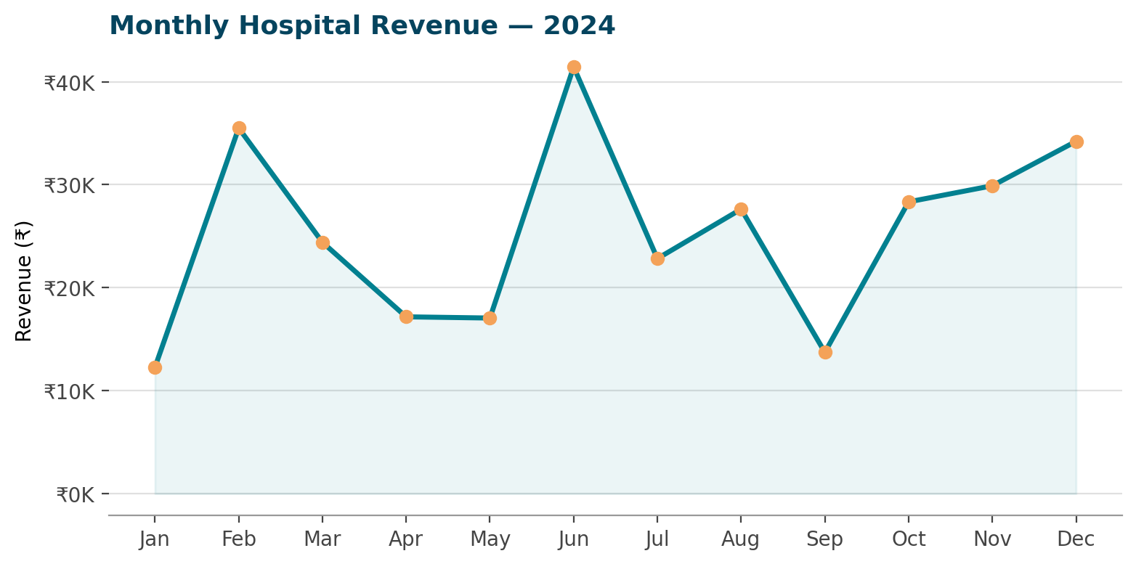
KEY INSIGHT — June is the peak month
June generated ₹41.4K — the hospital's highest month — followed by a February spike of ₹35.5K. September dipped to the year's lowest at ₹13.7K before revenue recovered steadily from September through December, closing the year strong at ₹34.2K.

Q4. What is the average consultation fee by department?
SELECT d.department_name, AVG(doc.consultation_fee) AS avg_consultation_fee
FROM Departments d
JOIN Doctors doc ON doc.department_id = d.department_id
GROUP BY d.department_name
ORDER BY avg_consultation_fee DESC;

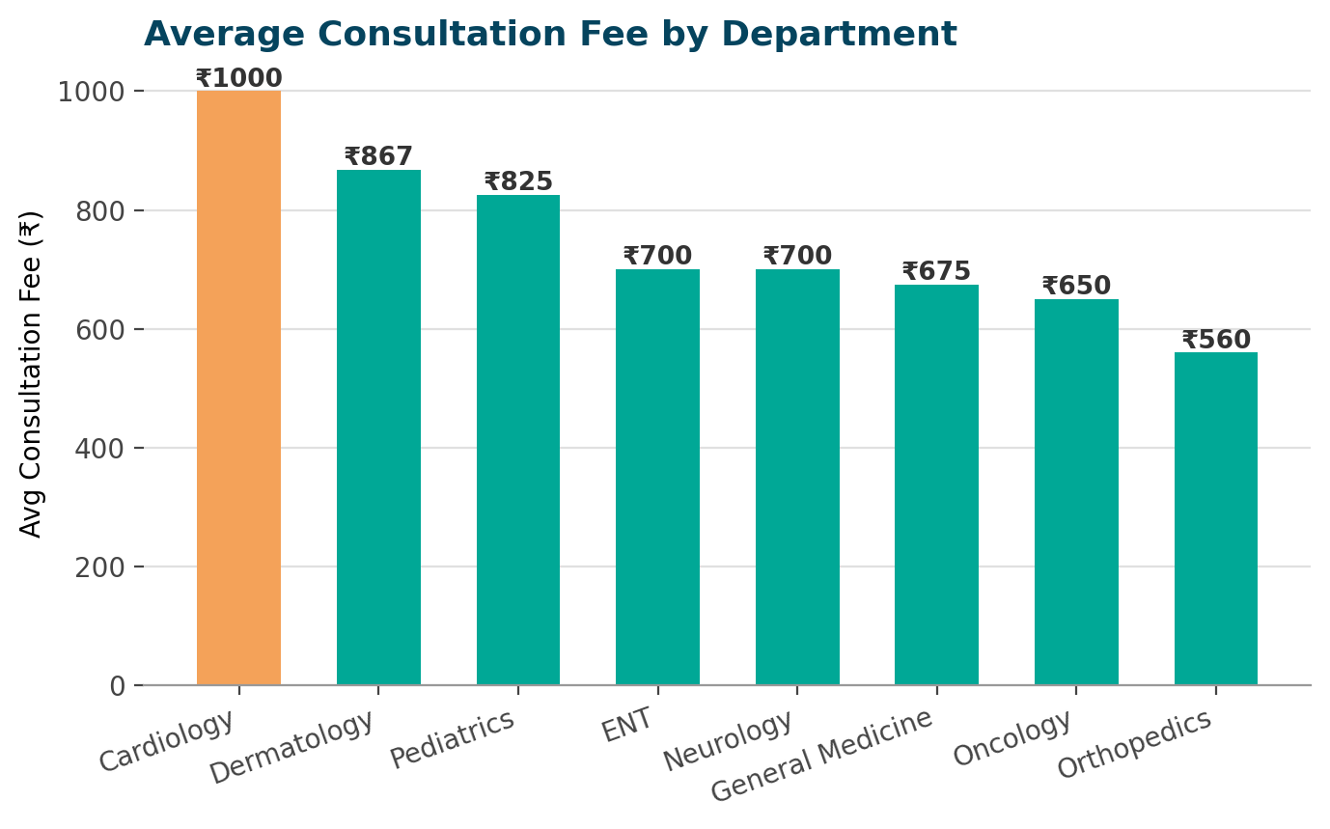
KEY INSIGHT — Cardiology commands the premium
Cardiology charges an average ₹1,000 per consult — the highest of all 8 departments — followed by Dermatology (₹867) and Pediatrics (₹825). Orthopedics is the most affordable at ₹560 despite having the largest doctor headcount, suggesting fee levels are set by specialty scarcity rather than staffing.

Q7. What is the average treatment cost by department?
SELECT d.department_name, AVG(t.treatment_cost) AS avg_treatment_cost,
COUNT(t.treatment_id) AS total_treatments
FROM Treatments t
JOIN Doctors doc ON doc.doctor_id = t.doctor_id
JOIN Departments d ON d.department_id = doc.department_id
GROUP BY d.department_name
ORDER BY avg_treatment_cost DESC;

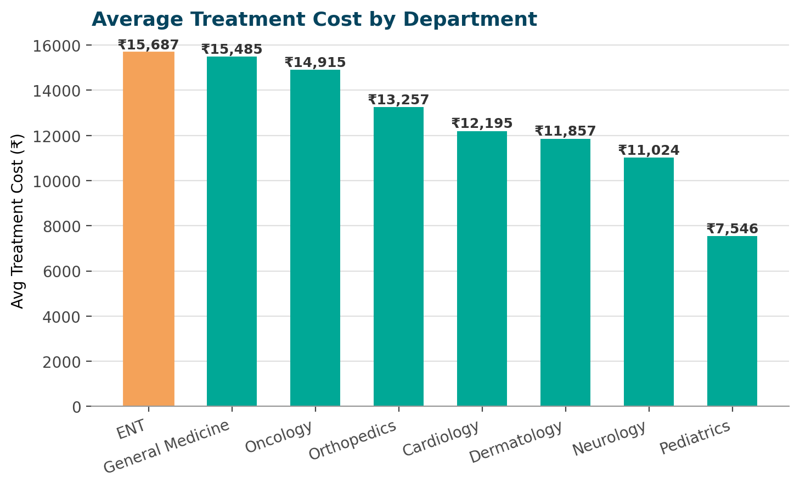
KEY INSIGHT — ENT treatments cost the most
ENT treatments average ₹15,687 per procedure — the highest of any department, across 9 recorded treatments. Pediatrics is the least costly on average at ₹7,546. Notably, cost and consultation fee don't move together: Cardiology has the priciest consults but not the priciest treatments.

Q10. How much revenue comes through each payment method?
SELECT payment_method, COUNT(*) AS total_payments, SUM(amount) AS total_revenue
FROM Payments
WHERE payment_status = 'Paid'
GROUP BY payment_method
ORDER BY total_revenue DESC;

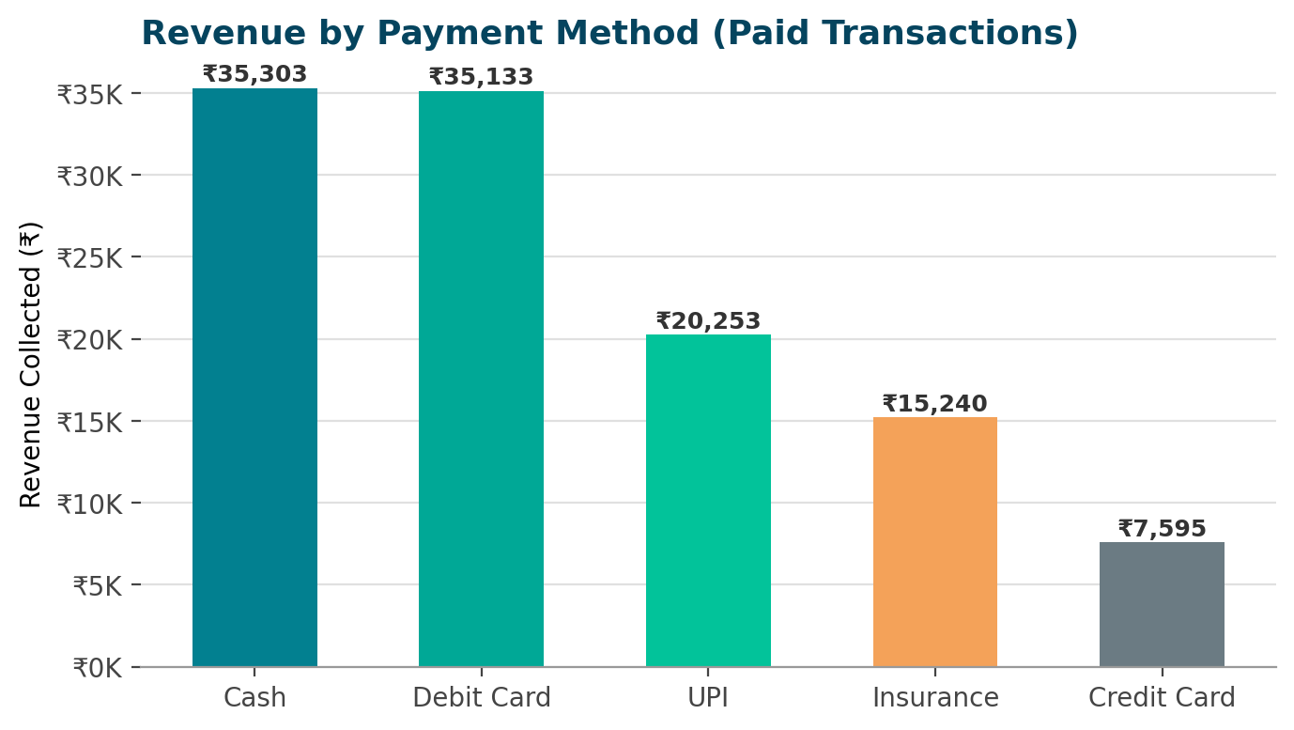
KEY INSIGHT — Cash and card lead collections
Cash (₹35.3K) and Debit Card (₹35.1K) are the top two channels among successfully paid bills. Insurance settlements lag despite frequent use, pointing to slower claim-processing cycles that management may want to follow up on.

Q15. How does Insurance compare with Cash payments?
SELECT payment_method, COUNT(*) AS payment_count, SUM(amount) AS total_revenue,
AVG(amount) AS avg_payment_amount
FROM Payments
WHERE payment_method IN ('Insurance', 'Cash')
GROUP BY payment_method;

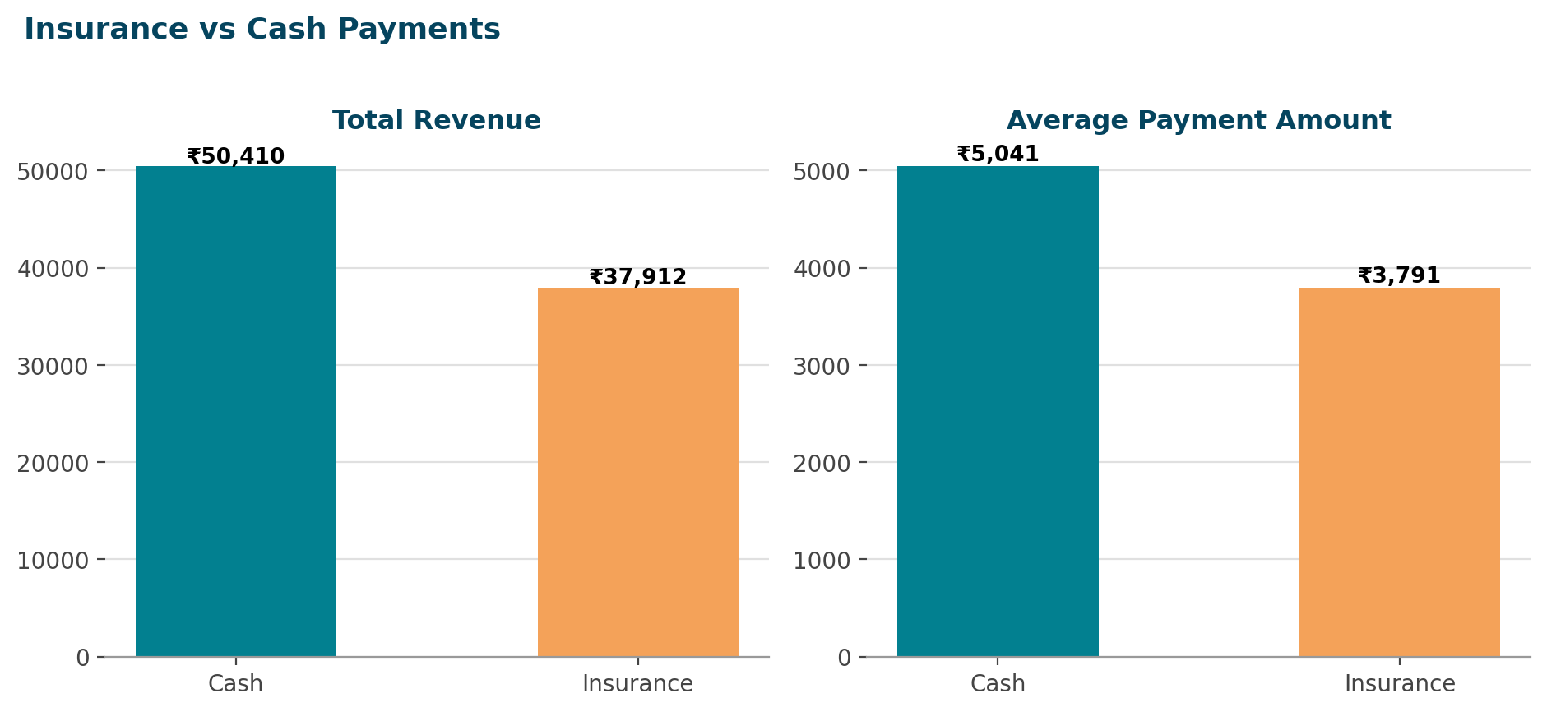
KEY INSIGHT — Cash outperforms insurance
Cash generated ₹50.4K in total revenue versus ₹37.9K for insurance, from the same 10 transactions each. The average cash payment (₹5,041) is roughly 33% higher than the average insurance payout (₹3,791) — a sign that insurance claims may be settling at a discount to the billed amount.

A note on collections risk
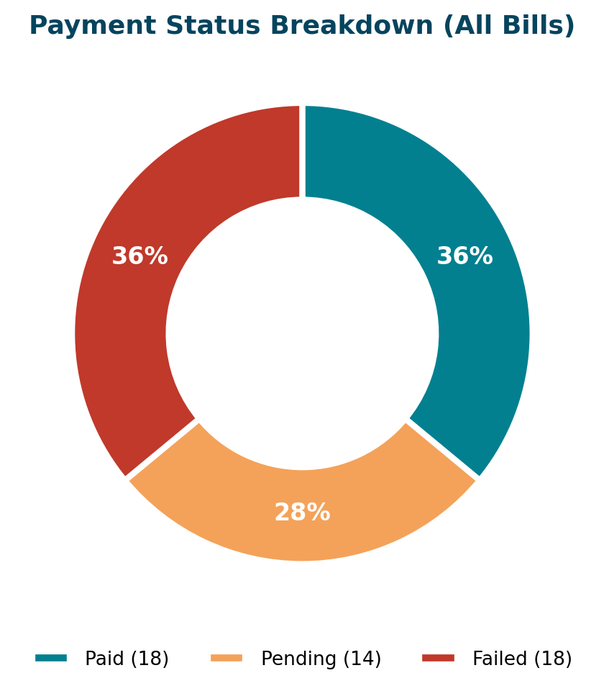
KEY INSIGHT — 1 in 3 payments fails
Of all 50 recorded payments, only 36% are marked 'Paid' — an equal 36% are 'Failed', and the remaining 28% sit 'Pending'. This is a meaningful collections bottleneck and a natural candidate for its own tracked KPI.

7. Analysis — Clinical Operations
This section examines medicine usage, lab test demand, length of stay, and room-type utilization during admissions.

Q5. Which medicines are prescribed most often?
SELECT TOP 10 m.medicine_id, m.medicine_name, COUNT(p.prescription_id) AS times_prescribed
FROM Medicines m
JOIN Prescriptions p ON p.medicine_id = m.medicine_id
GROUP BY m.medicine_id, m.medicine_name
ORDER BY times_prescribed DESC;

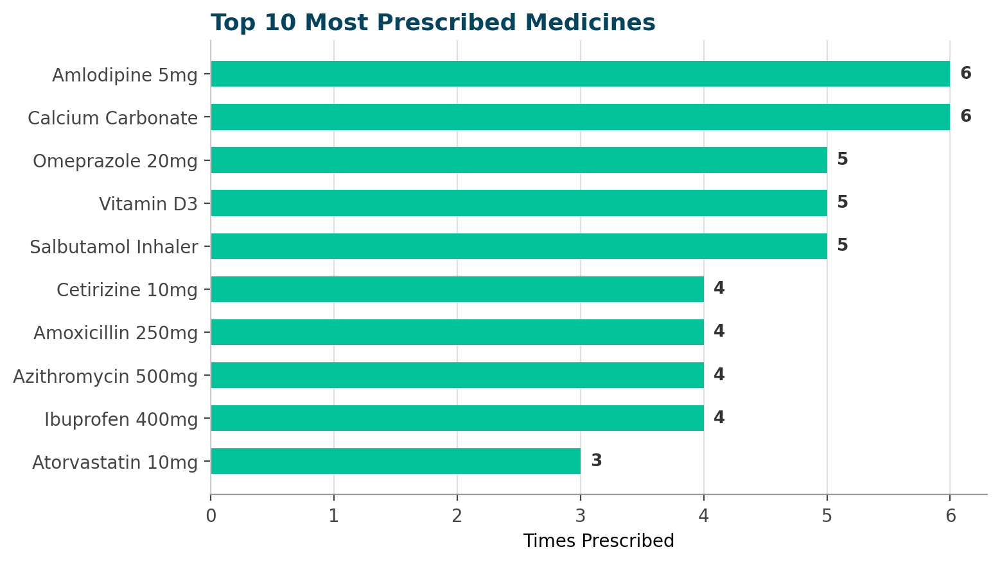
KEY INSIGHT — Chronic-care drugs top the list
Amlodipine 5mg and Calcium Carbonate are each prescribed 6 times — the most of any medicine — with Omeprazole, Vitamin D3 and Salbutamol Inhaler close behind at 5 each. Grouping batch variants of the same drug (e.g. 'Amlodipine 5mg (Batch 24)') reveals true demand by active medicine rather than by inventory lot.

Q6. What are the most common lab tests?
SELECT TOP 10 test_name, COUNT(*) AS times_performed
FROM LabTests
GROUP BY test_name
ORDER BY times_performed DESC;

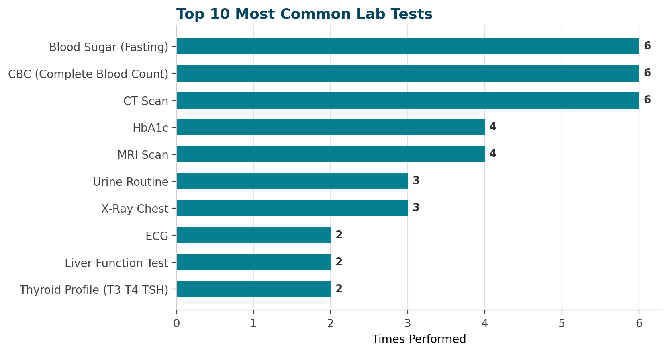
KEY INSIGHT — Routine screens dominate volume
Blood Sugar (Fasting), CBC and CT Scan are tied as the most-ordered tests, each performed 6 times. MRI Scan and HbA1c follow at 4 each, reflecting steady diabetes and neurology workups. CT and MRI scans are both high-frequency and high-cost — a good candidate for a turnaround-time KPI.

Q13. What is the average hospital stay duration?
SELECT AVG(DATEDIFF(DAY, admission_date, discharge_date)) AS avg_stay_days
FROM Admissions
WHERE discharge_date IS NOT NULL;

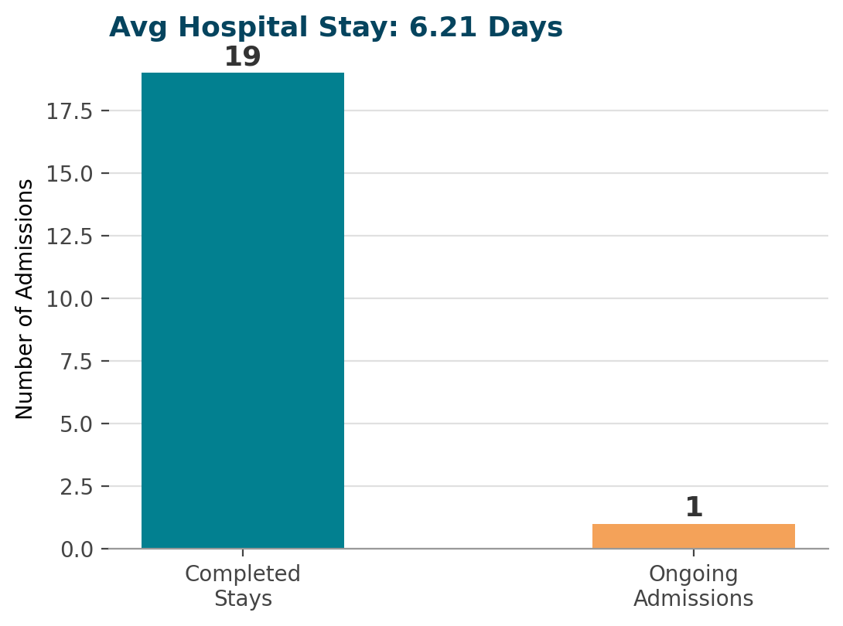
KEY INSIGHT — Stays average just over 6 days
Completed admissions last an average of 6.21 days from admission to discharge. 19 of 20 admissions have a recorded discharge date; 1 patient remains admitted (cardiac observation) and is correctly excluded from the average via the discharge_date IS NOT NULL filter.

Q14. Which room type is used most often?
SELECT TOP 1 r.room_type, COUNT(ad.admission_id) AS times_used
FROM Rooms r
JOIN Admissions ad ON ad.room_id = r.room_id
GROUP BY r.room_type
ORDER BY times_used DESC;

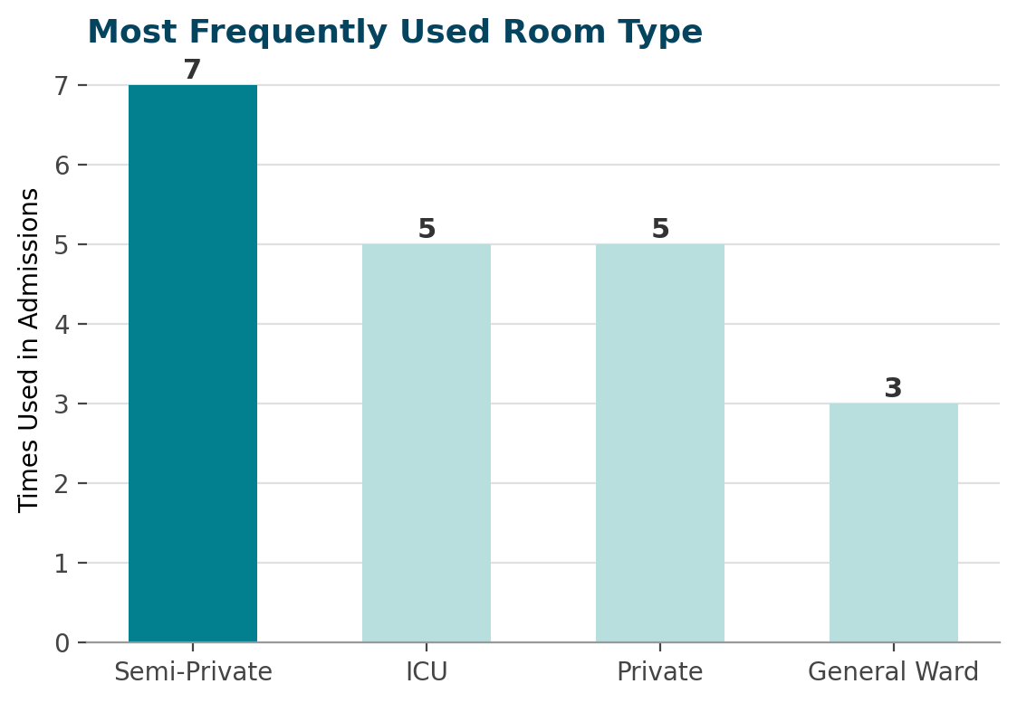
KEY INSIGHT — Semi-Private rooms see the most turnover
Semi-Private rooms were used in 7 admissions — more than any other type. ICU and Private rooms tie at 5 admissions each, reflecting a steady stream of critical cases. General Ward sees the least admission activity at 3, despite being the cheapest option — occupancy is driven by clinical need, not price.

8. Analysis — Patient & Facility
This section looks at how full the hospital runs, where patients travel from, and how appointment demand moves through the year.

Q8. What is the current room occupancy rate?
SELECT COUNT(*) AS total_rooms,
SUM(CASE WHEN availability = 'Occupied' THEN 1 ELSE 0 END) AS occupied_rooms,
SUM(CASE WHEN availability = 'Available' THEN 1 ELSE 0 END) AS available_rooms,
CAST(SUM(CASE WHEN availability = 'Occupied' THEN 1 ELSE 0 END) AS DECIMAL(10,2))
* 100.0 / COUNT(*) AS occupancy_pct
FROM Rooms;

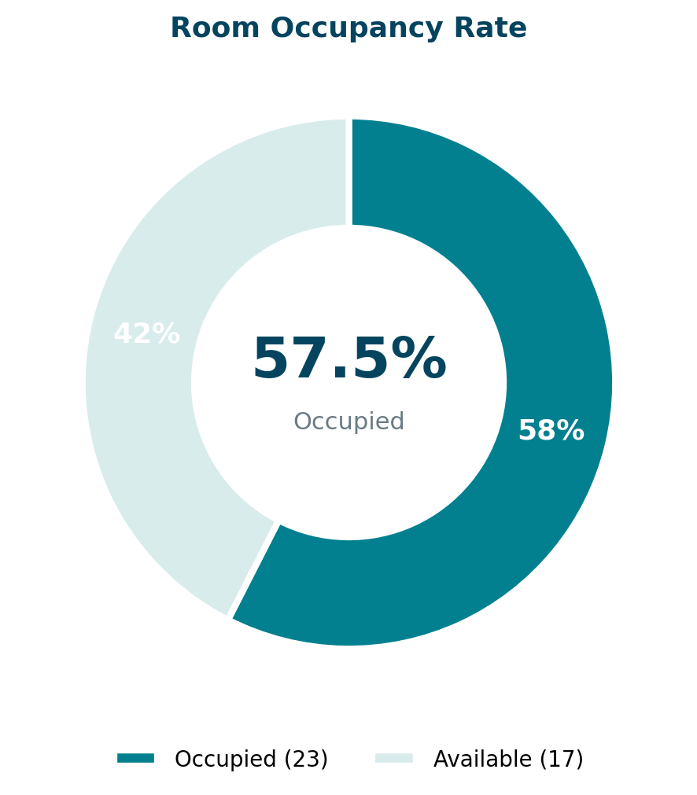
KEY INSIGHT — Over half the hospital is full
57.5% of all 40 rooms are currently Occupied — 23 rooms in use against 17 available. That leaves meaningful headroom overall, but ICU and Deluxe rooms trend toward being the tightest categories. A live version of this query would flag when occupancy nears a safety threshold.

Q9. How are patients distributed by city?
SELECT city, COUNT(*) AS patient_count
FROM Patients
GROUP BY city
ORDER BY patient_count DESC;

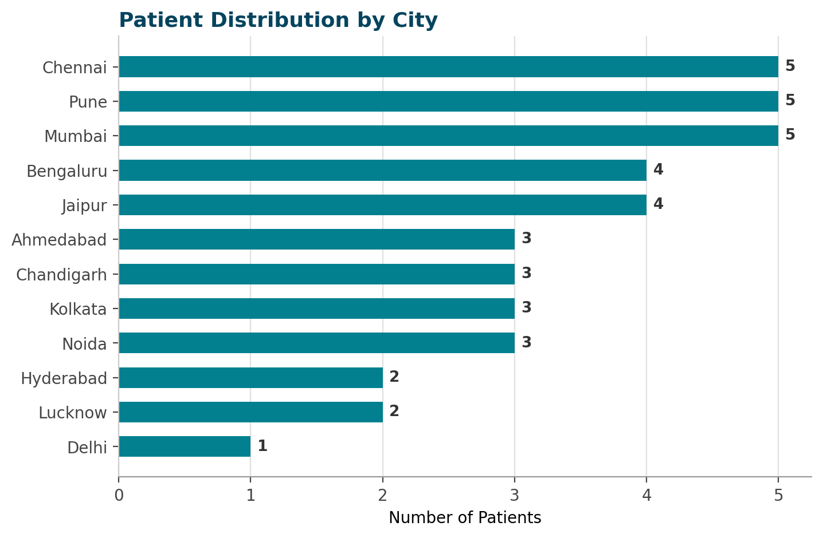
KEY INSIGHT — Metro hubs lead patient volume
Chennai, Pune and Mumbai each contribute 5 patients — the top three source cities — followed by Bengaluru and Jaipur with 4 apiece. Patients span 12 cities across India in this sample, suggesting a referral base that reaches beyond the immediate metro area.

Q11. What is the daily/monthly appointment trend?
SELECT appointment_date, COUNT(*) AS appointment_count
FROM Appointments
GROUP BY appointment_date
ORDER BY appointment_date;

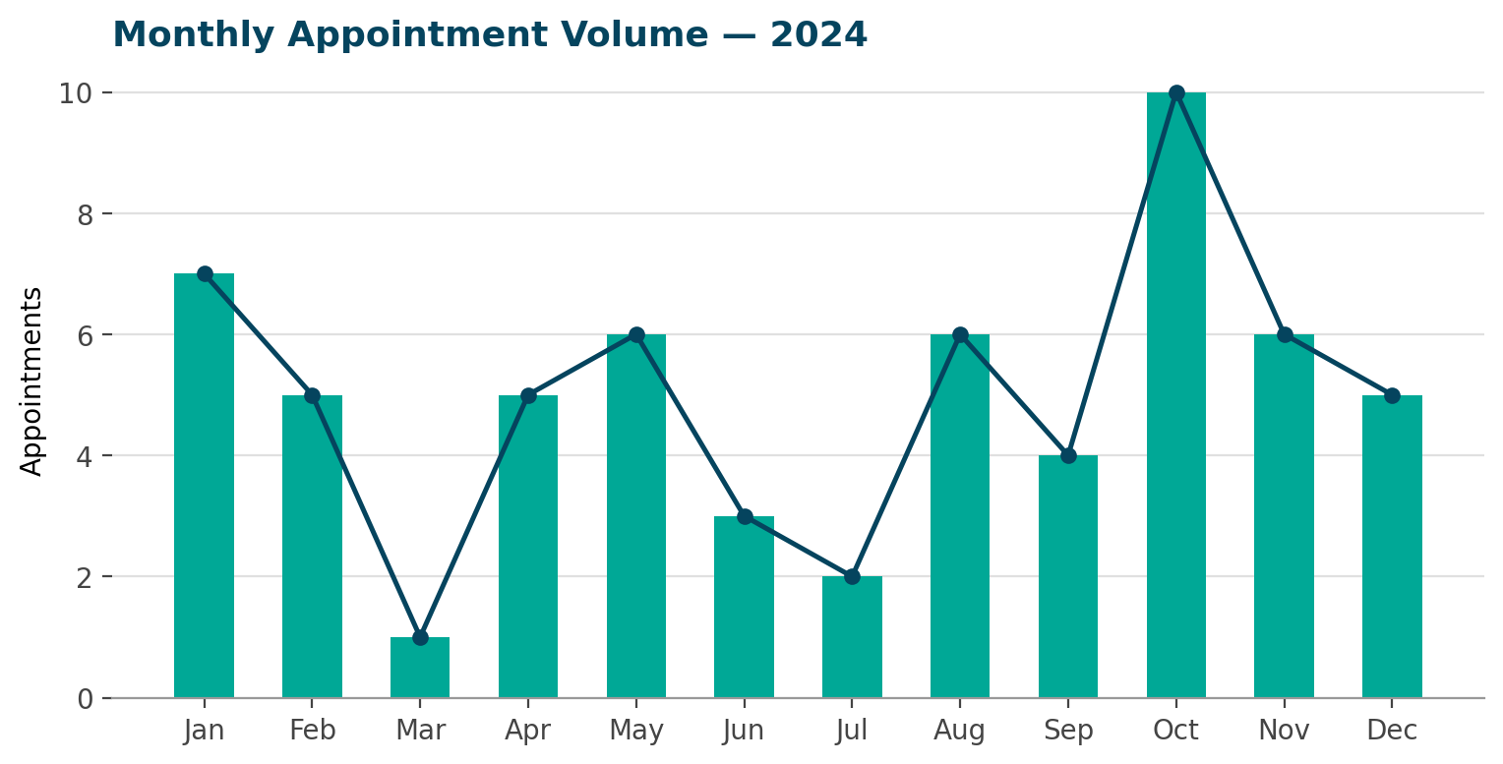
KEY INSIGHT — October is the busiest month for visits
October recorded 10 appointments — the year's peak — while March saw just 1. Demand is uneven month to month with no obvious seasonal pattern in this sample. Pairing this with the Q3 revenue trend shows that visit volume and revenue don't always move together.

9. Additional Quality Metrics
Beyond the 15 core questions, two supporting breakdowns round out the picture of appointment reliability and lab result quality.
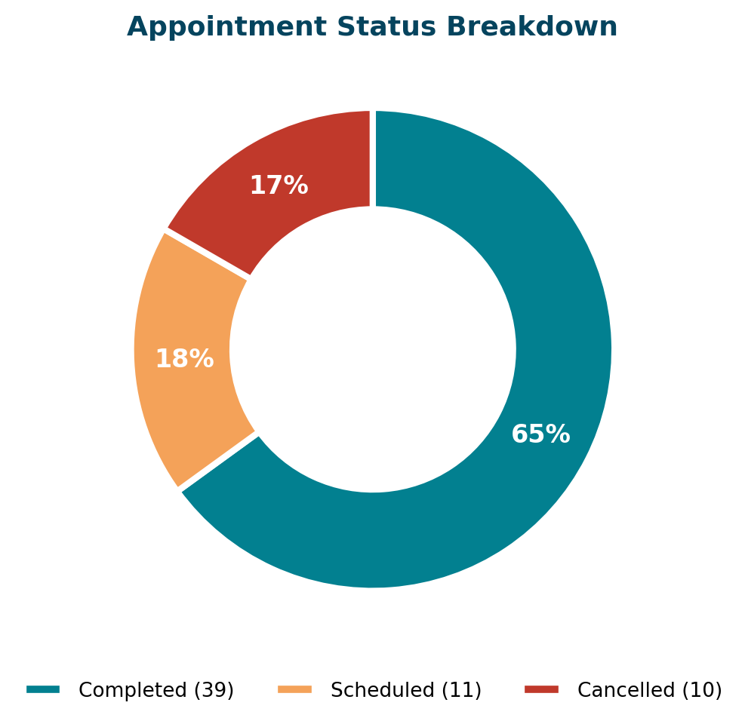
KEY INSIGHT — Two-thirds of appointments complete
39 of 60 appointments (65%) were completed as scheduled. 10 were cancelled (17%) and 11 remain scheduled (18%) at the time of this snapshot.
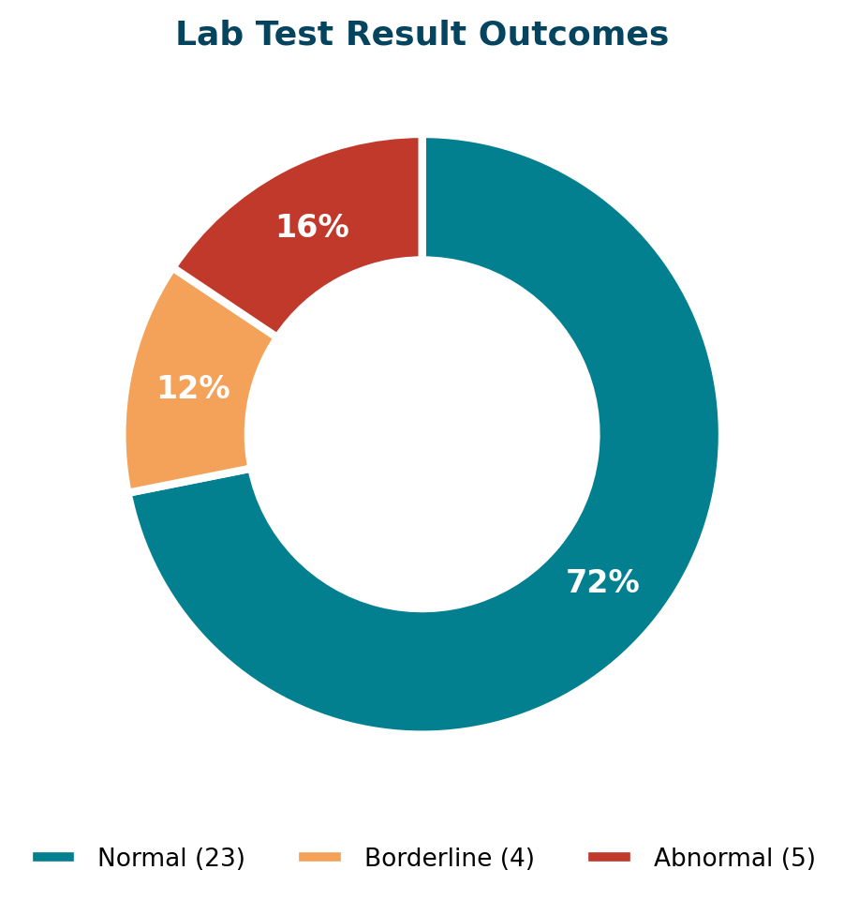
KEY INSIGHT — Most lab results come back normal
Of the 80% of lab tests with a result on file, 72% came back Normal, 12% Borderline, and 16% Abnormal — a healthy baseline distribution for monitoring purposes.

10. Reusable KPI Views
Every recurring question was wrapped in a SQL View, so stakeholders can query a stable name instead of re-writing the underlying logic each time a report is needed.

vw_MonthlyRevenue
Aggregates the Billing table by year and month for trend reporting and dashboards.
CREATE OR ALTER VIEW vw_MonthlyRevenue AS
SELECT YEAR(bill_date) AS bill_year, MONTH(bill_date) AS bill_month,
SUM(total_amount) AS monthly_revenue
FROM Billing
GROUP BY YEAR(bill_date), MONTH(bill_date);

vw_DoctorPerformance
Ranks every doctor by appointment volume and unique patients served, joined to department.
CREATE OR ALTER VIEW vw_DoctorPerformance AS
SELECT doc.doctor_id, doc.first_name + ' ' + doc.last_name AS doctor_name,
d.department_name,
COUNT(DISTINCT a.appointment_id) AS total_appointments,
COUNT(DISTINCT a.patient_id) AS unique_patients,
RANK() OVER (ORDER BY COUNT(DISTINCT a.appointment_id) DESC) AS appointment_rank
FROM Doctors doc
JOIN Departments d ON d.department_id = doc.department_id
LEFT JOIN Appointments a ON a.doctor_id = doc.doctor_id
GROUP BY doc.doctor_id, doc.first_name, doc.last_name, d.department_name;

vw_RoomOccupancy
Live occupancy percentage by room type — the same logic behind the Q8 donut chart.
CREATE OR ALTER VIEW vw_RoomOccupancy AS
SELECT room_type, COUNT(*) AS total_rooms,
SUM(CASE WHEN availability = 'Occupied' THEN 1 ELSE 0 END) AS occupied,
CAST(SUM(CASE WHEN availability = 'Occupied' THEN 1 ELSE 0 END) AS DECIMAL(10,2))
* 100.0 / COUNT(*) AS occupancy_pct
FROM Rooms
GROUP BY room_type;
Usage examples:
SELECT * FROM vw_MonthlyRevenue ORDER BY bill_year, bill_month;
SELECT * FROM vw_DoctorPerformance ORDER BY appointment_rank;
SELECT * FROM vw_RoomOccupancy ORDER BY occupancy_pct DESC;

11. Conclusion & Key Takeaways
This project turned a raw 14-table hospital dataset into a structured, decision-ready analysis using pure T-SQL. Four things stand out about the approach:
Relational thinking: Modeled 14 interlinked tables spanning clinical, resource and financial data with clean foreign-key relationships.
Analytical SQL: Joins, aggregation, CASE logic, DATEDIFF and window functions (RANK / DENSE_RANK) were used purposefully to answer specific business questions, not just to demonstrate syntax.
Business framing: Every query maps to a real hospital-management decision — staffing levels, pricing, room capacity, or payment collections.
Production habits: Reusable views (vw_MonthlyRevenue, vw_DoctorPerformance, vw_RoomOccupancy) turn one-off analysis into stable, dashboard-ready building blocks.
Taken together, the 15 queries and 3 views form a lightweight but genuinely useful reporting layer — the kind of foundation a BI or analytics team would build on top of with a dashboard tool such as Power BI.

Harsh Pandey | Data Analyst / BI Analyst / AI Analyst | github.com/harshpandey97

