India Unemployment Rate Analysis (2020)
State-wise & Zone-wise Trends, COVID-19 Impact, and Policy Recommendations
Prepared by Harsh Pandey | Data Analyst / AI Analyst Portfolio Project

Executive Summary
This report analyzes monthly unemployment data across 27 Indian states and union territories from January to November 2020, a period that captures the full economic shock of the COVID-19 lockdown. The analysis combines national trend tracking, state and zone-level comparisons, and a labour-participation correlation check to surface where joblessness hit hardest and how quickly different regions recovered.
Metric | Value | Context
National Peak Unemployment | 23.24% | May 2020, during lockdown
Pre-COVID Baseline | ~9.2% | Jan–Feb 2020
Highest-Hit State | Haryana (27.5% avg) | Followed by Tripura, Jharkhand, Bihar, Delhi
Lowest-Hit State | Meghalaya (3.9% avg) | Followed by Assam, Gujarat, Odisha
Highest Zone | North (15.9% avg) | Lowest: West (8.2% avg)

1. National Trend: The COVID-19 Shock
The national average unemployment rate stayed near 9% in January and February 2020, then rose sharply as the nationwide lockdown took effect in late March. It peaked at 23.24% in May 2020 before falling steadily through the second half of the year as restrictions eased and economic activity resumed.
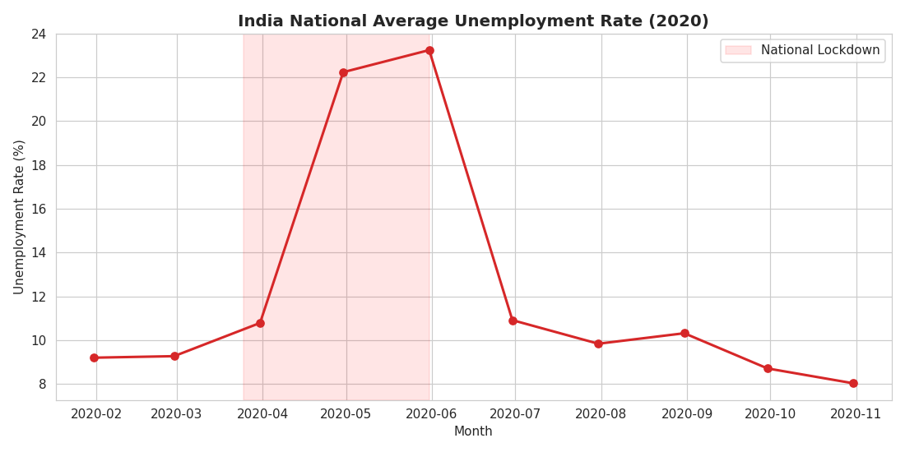

2. State-wise Disparities
Unemployment impact was highly uneven across states. Haryana and Tripura recorded the highest average rates for the year, both exceeding 25%, while Meghalaya, Assam, and Gujarat stayed under 7%. Notably, Delhi ranked in the top five most-affected regions, relevant given its role as a major employment hub for migrant and informal-sector workers.
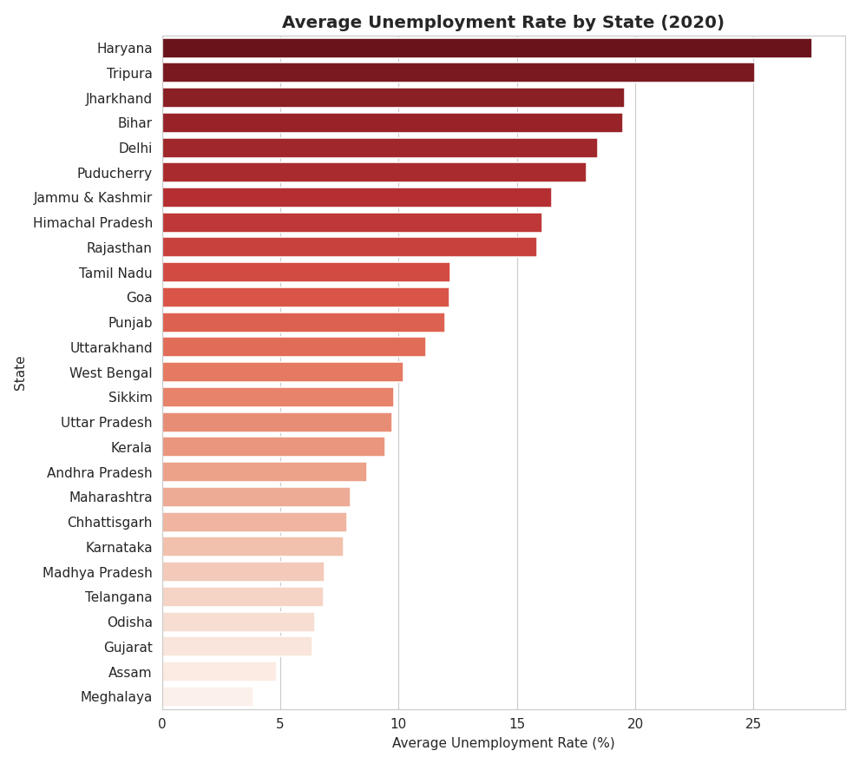

3. Zone-wise Patterns
Grouping states into North, South, East, West, and Northeast zones shows the North zone (Haryana, Delhi, Punjab, Rajasthan, J&K, Himachal Pradesh) was the worst-affected region on average, while the West zone (Maharashtra, Gujarat) recovered fastest and stayed most stable throughout the year.
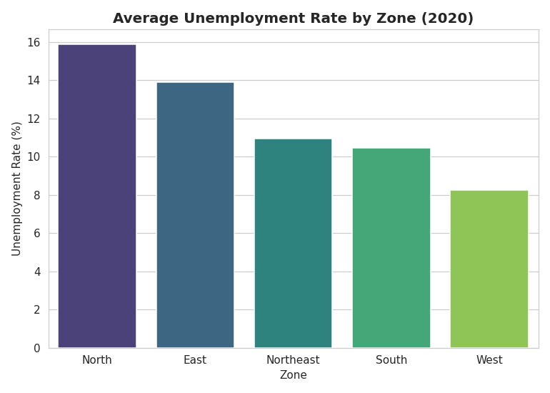

4. Labour Participation vs Unemployment
A correlation check between labour participation rate and unemployment rate returned a near-zero coefficient (-0.07), indicating no strong linear relationship in this dataset. This suggests unemployment spikes during the lockdown were driven primarily by an external shock (forced business closures) rather than by structural shifts in who was seeking work.
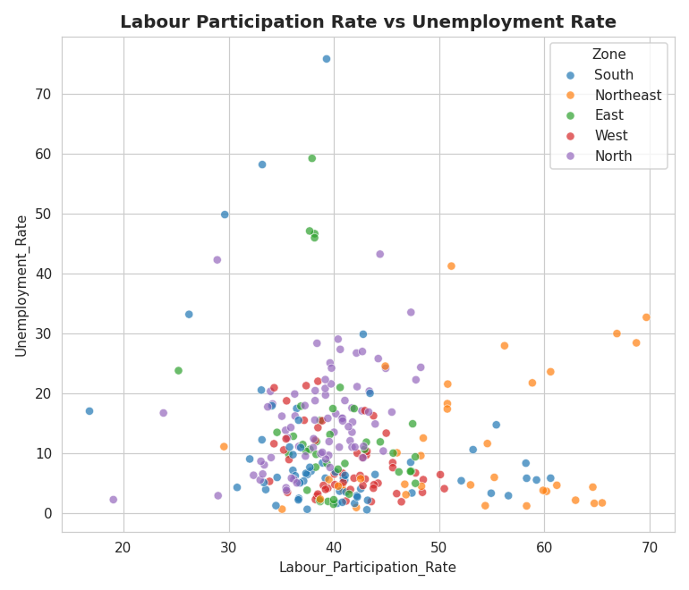

5. Monthly Heatmap: State x Month
The heatmap below highlights exactly when and where the crisis was most severe. Puducherry and Jharkhand show the most extreme localized spikes in April-May 2020, while several Northeastern and Western states show consistently lighter shading throughout the year.
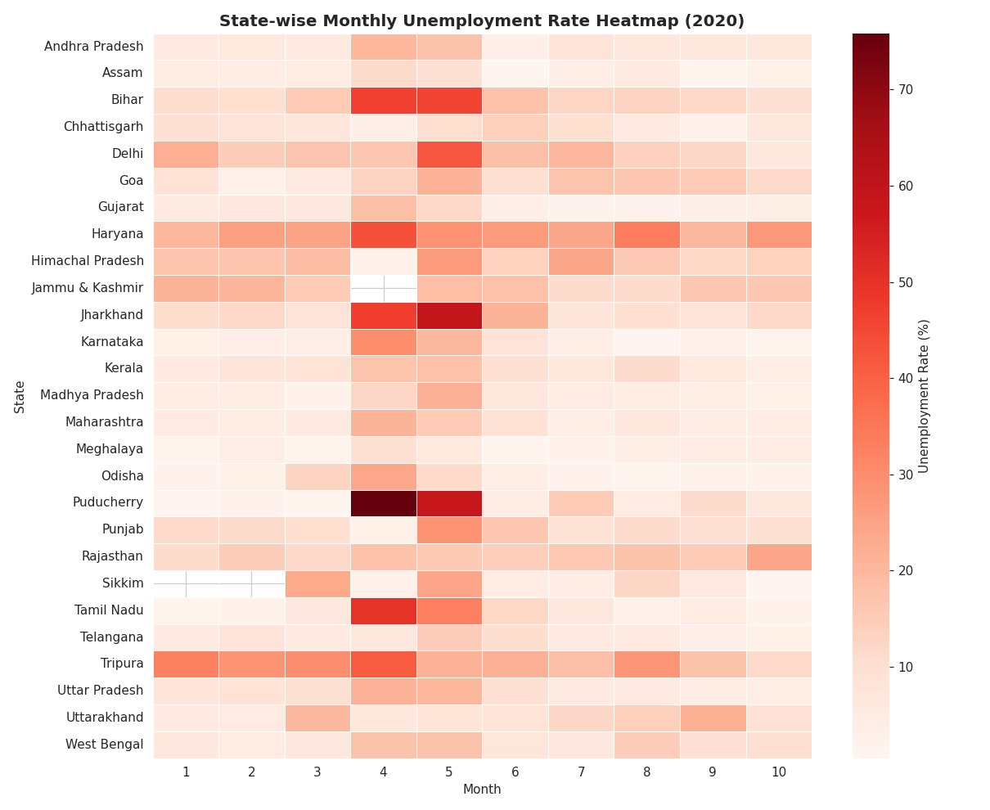

6. Key Insights
- The lockdown shock was sharp but temporary at the national level — unemployment more than doubled in two months but fell back to near pre-COVID levels by October 2020.
- Regional resilience varied widely: industrial/service-heavy states with large informal and migrant workforces (Haryana, Delhi, Bihar, Jharkhand) suffered disproportionately, while agriculture-driven Northeastern and Western states were comparatively insulated.
- Labour participation rate is not a reliable predictor of unemployment rate in this dataset, reinforcing that the spike was supply-shock driven, not motivation/participation driven.

7. Recommendations
- Prioritize emergency employment safety nets (wage subsidies, MGNREGA-style urban schemes) in high-volatility states like Haryana, Delhi, and Bihar during future economic shocks.
- Build sector-specific contingency plans for states with large informal/migrant workforces, since these groups bore the brunt of the 2020 spike.
- Use early-warning monitoring (monthly state-level tracking) to detect localized spikes — as seen in Puducherry and Jharkhand — before they compound nationally.

8. Methodology & Tools
Data source: State-wise monthly unemployment statistics (Centre for Monitoring Indian Economy, via public Kaggle dataset), Jan–Nov 2020. Tools used: Python (Pandas for cleaning and aggregation, Matplotlib/Seaborn for visualization), Excel/Power BI for the interactive dashboard. Full code, cleaned dataset, and dashboard file are included alongside this report.

