## 



AFSG

(**Assurant Framework Step Generator**)

**User Manual**

Prepared for

AEB, Kansas

Table of Contents

Section 1: About This Document 4

Section2: Step Generator Artifacts 5

Overview 5

Types of Artifacts 5

Folder Structure 7

Section3. Software 8

Prerequisites 8

Browser Settings 8

Section4.Using Step Generator... 11

4.1Prerequisites 11

4.2 Login to Step Generator 11

4.3 Application Maintenance 12

4.3.1 Select Application 12

4.3.2 Add Application 12

4.3.3 Edit Application 13

4.3.4 Delete Application 13

4.4 Object Repository Management 15

4.4.1 Adding Objects in Object Repository 15

4.4.2 Editing Objects in Object Repository 17

4.4.3 Deleting Objects in Object Repository 19

4.5 Action Management 21

4.5.1 Adding Actions in Step Generator 21

4.5.2 Editing Actions in Step Generator 23

4.5.3 Deleting Actions in Step Generator 25

4.6 Function Library Management 27

4.6.1 Adding Function Library in Step Generator 27

4.6.2 Editing Function Library path in Step Generator 29

4.6.3 Deleting Function Library in Step Generator 31

4.7 Selecting existing Test Case (.xml) 33

4.8 Starting with new Test Case 35

4.9 Add Step Tab 36

4.9.1 Writing Test Case 36

4.9.1.1 Using the GUI 36

4.9.1.2 Using the Web-Table 37

4.9.1.3 Re-Usable Scripts 39

4.9.1.4 User Defined Functions 39

4.9.2 Deleting Test Steps 40

4.9.2.1 Deleting Single Test Step 40

4.9.2.2 Deleting multiple steps from Test Case 40

4.9.2.3 Deleting all steps from Test Case 41

4.9.3 Saving Test Case 42

4.9.3.1 Saving to temp File 42

4.9.3.2 Saving to custom folder 42

4.9.4 Exporting Test Case (In Excel) 43

4.10 Execute Script Tab 44

4.10.1 Understanding Execute Script Tab 44

4.10.2 Executing Script 45

4.10.2.1 Selecting the Excel file 45

4.10.2.2 Executing after writing script in Utility 47

4.10.3 Analyzing results 48

# Section 1: About This Document

The Framework Step Generator User Manual is designed with a purview of answering the most frequently asked question – “*How does Step Generator –Work?”*

*The document highlights* *on step generator utility usage and its advantages. The document also speaks about to usage of the Step Generator to create; update and deletion of test steps in automation script along with object management and script execution.*

Back to Index…

# Section2: Step Generator Artifacts

## Overview

The framework step generator uses different types of test artifacts to create; update and deletion of objects and test steps for new test scripts. They are Admin login, Step Creation, Add Object and Delete/Update Object. All these artifacts are ***stored*** in i-ASTG folder.

## Types of Artifacts

| **Test Artifacts** | **Description** | **Location** | **Can be modified?** |
| --- | --- | --- | --- |
| **Login** | The main page where user uses his/her LAN ID and password to login to the application | *T:\Test Services\Offshore Folder\Final_VI\HTML PRoj/Login.html* | Yes. Only user having access to QC Project: AEB_AUTOMATION and Domain: Web_Automation can login. |
| **Index Page**   * Select Application * Add Application * Update Application * Delete Application | This page contains “Select Applications, object Repository and Test Script Path browse button” i.e. Available Applications for automation along with Application Object Repository path and Test Script Path (XML). | *E.g.:*  *Application Name: SAS*  *Application OR Path: T:\Test Services\Offshore Folder\Final_VI\HTML PRoj\XML\Application OR\SAS\SAS.xml*  *Test Script Path: T:\Test Services\Offshore Folder\Final_VI\HTML PRoj\lr1385\temp\temp.xml* | Yes. Select Application and Test Script path can be modified. |
| **Framework Page**  Back to Index…  Back to Index…   * Add Step * Object Repository * Action Management * Function Library Management * Execute Script | **Add Step** tab contains Test Case details i.e. Test Case Id, objects details and its respective action list and data parameter. |  | Yes. Add Step for automation can be added and it can be modified. |
| **Object Repository** tab contains the list of the properties to be added in to the object. |  | Yes. Adding the objects with different properties can be achieved. |
| **Action Management** tab is to manage actions i.e. new keywords to add or to change the name of the existing actions. |  | Yes. Adding the actions can be achieved. |
| **Function Library Management** tab is to manage the paths of function library. |  | Yes. Adding the function libraries along with paths can be achieved. |
| **Execute Script** tab is to execute scripts. |  | Yes. User can execute script from this tab by passing the Test Case ID. |
| **Config.txt** | This Properties file can be accessed using notepad and configure the settings for the paths of the different files. | //config.txt | Yes. We need to make sure that all the settings in this file are valid before executing a test case.  Values can be changed by opening file from the login Page. |
| **Temp.xml** | This XML contains the temporary test case of the test cases to be executed. | \\Users\ <User Name>\ Temp\ temp.xml  e.g. For ***lr1385*** application:  *\\Users\lr1385\Temp\temp.xml* | No. |
| **Actions.XML** | This XML contains the set of actions. | [XML\Actions.xml](XML/Actions.xml) | Yes. From application itself. |
| **ApplicationsList.XML** | This XML contains the set of Applications. | [XML\ ApplicationsList.xml](XML/ApplicationsList.xml) | Yes. From application itself. |
| **Class.XML** | This XML contains the set of Classes and classID. | [XML\ Class.xml](XML/Class.xml) | Yes. From application itself. |
| **FunctionLibraries.XML** | This XML contains the set of Function Libraries and path of Function Libraries. | [XML\ FunctionLibraries.xml](XML/Class.xml) | Yes. From application itself. |

## Folder Structure

Back to Index…

Back to Index…

**Main Folder** \\StepGenerator

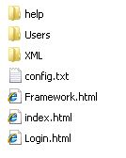

**User Folder** \\ StepGenerator \Users

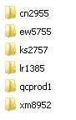

**User Folder** \\ StepGenerator \Users\lr1385



**Results Folder** \\ StepGenerator \Users\lr1385\Results

Back to Index…

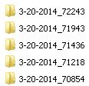

**Result File** \\ StepGenerator \Users\lr1385\Results\



**Temp Folder** \\ StepGenerator \Users\lr1385\temp\

Back to Index…



|  |  |
| --- | --- |
| **Folder** | **Description** |
| **Users** | * Individual user level folder. * Used to manage files for user level. |
| **Results** | * Used to store execution results. Date and Time stamp is used to differentiate. * Ex: 3-20-2014_72243 |
| **Temp** | * Temporary folder to save the current xml and xls. * Contains temp.xml and teml.xls |

# Section3. Software

## Prerequisites

* + 1. Windows XP/ windows 7
    2. HP QTP
    3. HP QC Credentials
    4. Internet Explorer Version 8
    5. Access to “\\T Drive”

## Browser Settings

**Note:** **Supported Browsers**: IE8. Following settings are related to IE8

Step 1: Go to Tools ->Internet Options.

Step2: Click on the **Local internet** symbol and click on Custom Level button

Back to Index…

Back to Index…

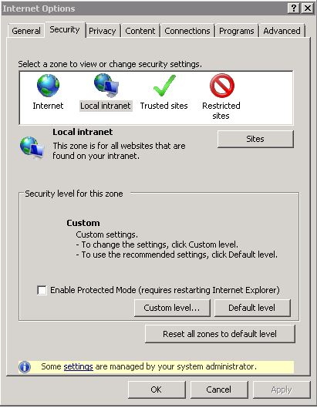

Step 3: In the **ActiveX controls and plug-ins** options mark everything “**enabled**”.

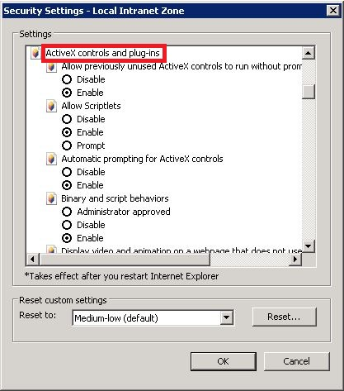

Back to Index…

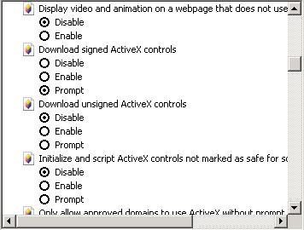

Select **Enable** up to Script ActiveX controls marked safe for scripting*

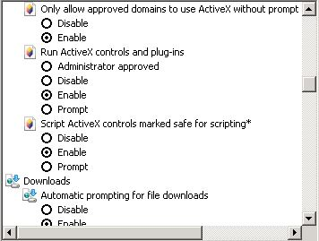

Step 4: Scroll down to Miscellaneous Options, Select **Enable** for “Access data sources across domains”. Step 4: Click on “OK” button and then if it throws a warning message, click on Yes

Back to Index…

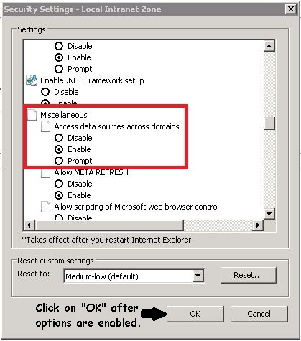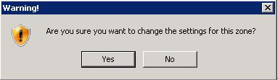

Step 6: Make sure that Zoom is set to 100% in IE.

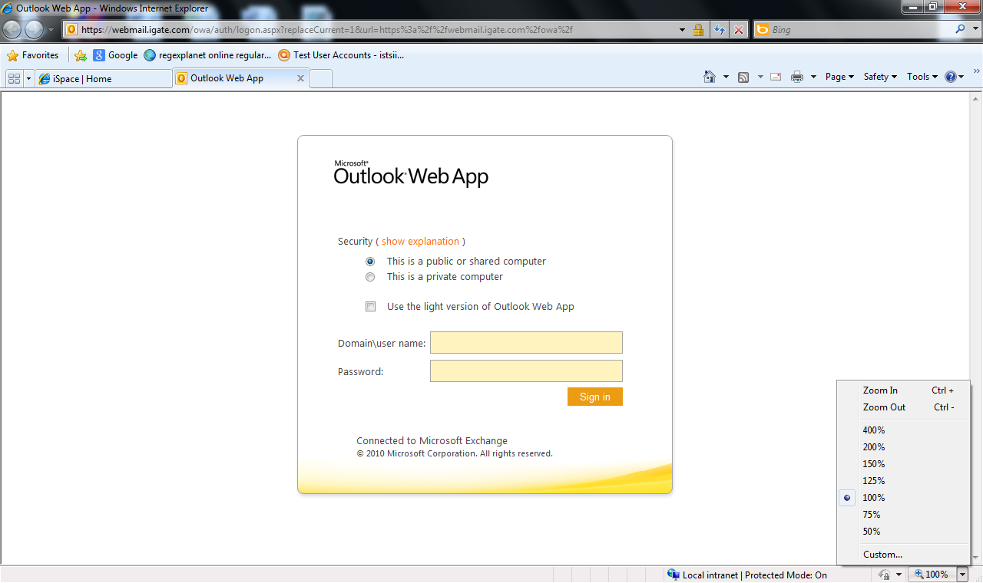

Step 7: Install IE.reg from the home folder. This is required to avoid unnecessary script prompts.

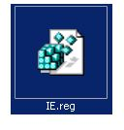

Back to Index…

Back to Index…

# Section4.Using Step Generator...

## 4.1Prerequisites

* + **HP Quality Center credentials** should be available.
  + Browser setting should set prior to launch the login file.

## 4.2 Login to Step Generator

Step 1: Open ‘Login.html’ placed in the ‘Step Generator’ folder.

Back to Index…

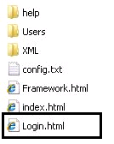

Step 2: Change the **config** settings if required from the link available on the Login Page (Right Bottom of the page).

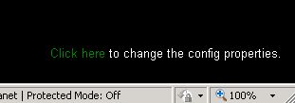

Step 3: Enter credentials (Quality Center) and click on login button.

Back to Index…

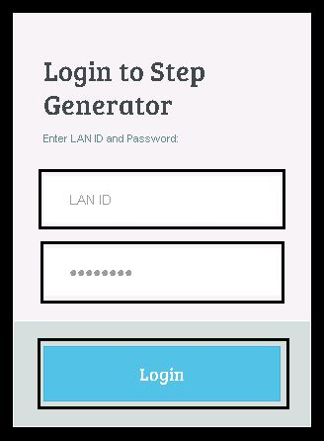

## 4.3 Application Maintenance

## 4.3.1 Select Application

This tab is used to select the application available from the list.

**Application Name**: Drop Down with all available applications.

**Application OR Path**: Not editable. This box shows the path of Application Object Repository Path.

**XML Script Path**: To select the existing Test file (in xml format).

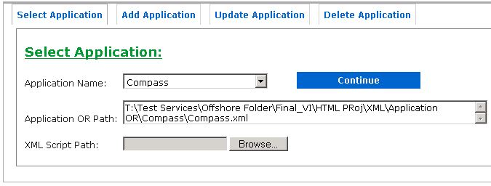

## 4.3.2 Add Application

This tab is used to add new application.

Step 1: On Step Generator Home Page, click on “**Add Application**” tab.

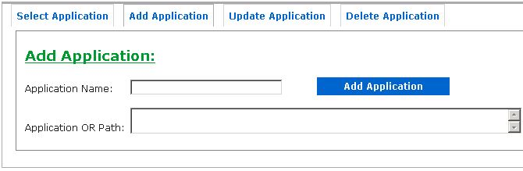

Step 2: Enter Name of the application and path of the Object Repository in XML format of the new application.

**Example**:

Application Name: “TestApplication”

Application OR Path: “T:\Test Folder\TestApplication.xml”

Back to Index…

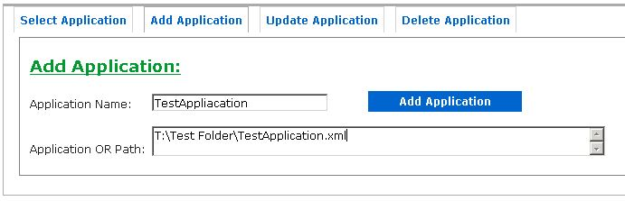

Step 3: Click on **Add Application** button. Click “**OK**” on the message box.

Back to Index…

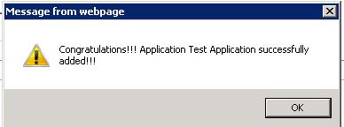

## 4.3.3 Edit Application

This tab is used to update the **Application OR Path**.

Step 1: On Step Generator Home Page, click on “**Update Application**” tab.

Back to Index…

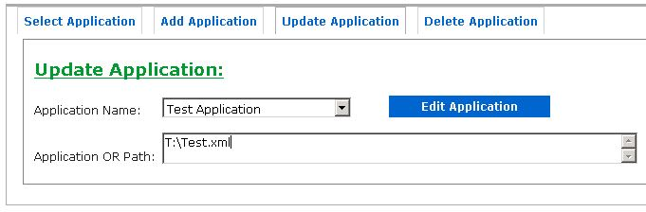

Step 2: Enter Name of the application and path of the Object Repository in XML format of the new application.

**Example**:

Application Name: “TestApplication”

Application OR Path: “T:\TestApplication.xml”

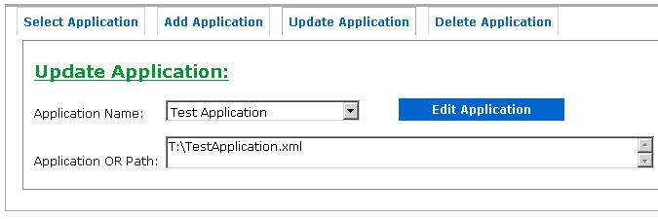

Step 3: Click on **Edit Application** button. Click “**OK**” on the message box.

Back to Index…

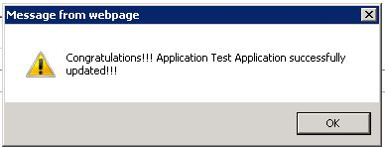

## 4.3.4 Delete Application

This tab is used to delete the **Application**.

Step 1: On Step Generator Home Page, click on “**Update Application**” tab.

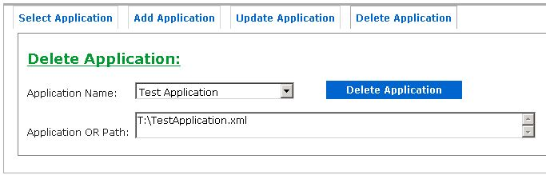

Step 2: Select Application from the list.

**Example**:

Application Name: “TestApplication”



Step 3: Click on **Delete Application** button. Click “**OK**” on the message box.

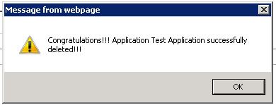

## 4.4 Object Repository Management

Back to Index…

Back to Index…

## 4.4.1 Adding Objects in Object Repository

Adding TestObject in object Repository

In this example, TestObject is WebEdit and its parent object is WebPage which is AEB_Page which in turn is child of Browser named AEB_Browser.

i.e. Hierarchy is like:

**AEB_Browser().AEB_Page().TestObject()**

Step 1: Select Application from the list.

Example: SAS

Back to Index…

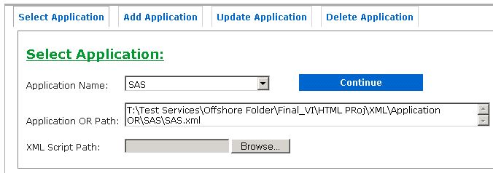

Step 2: Click on “**Continue**” button.

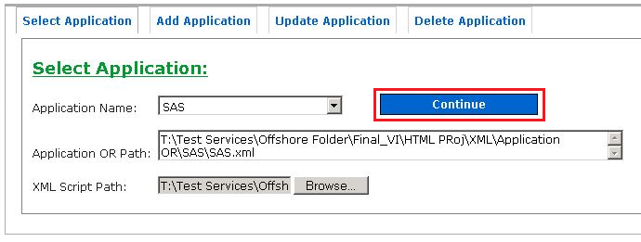

Step 3: Click on “**Object Repository**” Tab.

Back to Index…

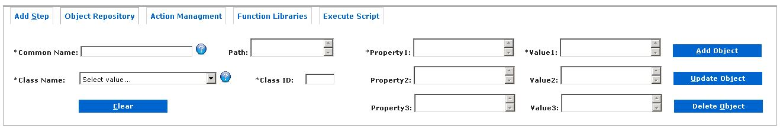

Step 4: Enter Common Name; it should be unique and not used before.

Example: TestObject (WebEdit)

Enter Path. Hierarchy to parent objects.

Example: AEB_Browser.AEB_Page

Select Class Name, Class ID will be populated automatically.

Example: WedEdit

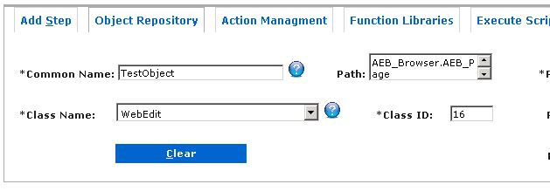

Step 5: Using QTP “**Object Spy**”, get the object properties and add them.

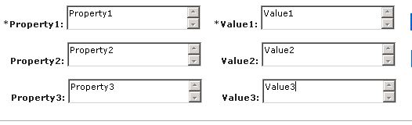

Step 6: Click on “**Add Object**”. Click on Ok Button on message box.

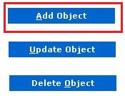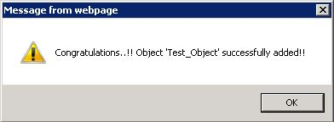

## 4.4.2 Editing Objects in Object Repository

Back to Index…

Back to Index…

Editing TestObject in object Repository

In this example, TestObject is WebEdit and its parent object is WebPage which is AEB_Page which in turn is child of Browser named AEB_Browser.

i.e. Hierarchy is like:

**AEB_Browser().AEB_Page().TestObject()**

Step 1: Select Application from the list.

Back to Index…

Example: SAS



Step 2: Click on “**Continue**” button.



Step 3: Click on “**Object Repository**” Tab.



Step 4: Enter Common Name and press “**Tab**”, this will load the properties

Example: TestObject (WebEdit)

Back to Index…

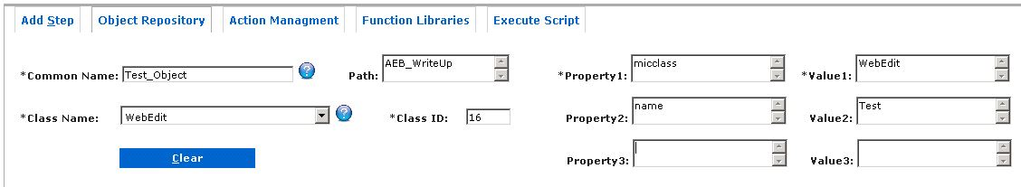

Step 5: Using QTP “**Object Spy**”, get the object properties and update the required ones or add new property if available. User can also update Path and Class.

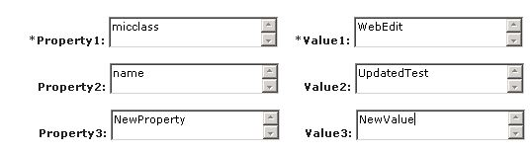

Step 6: Click on “**Update Object**”.

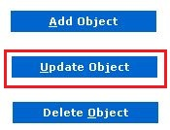

Step 7: Click on Ok Button on message box to update the object.

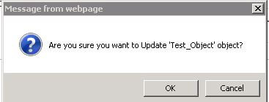

Step 8: Click on OK box once again. Verify the properties of the updated object.

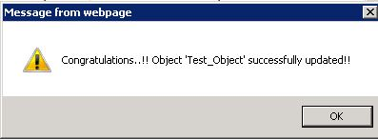

## 4.4.3 Deleting Objects in Object Repository

Back to Index…

Back to Index…

Deleting TestObject in object Repository

Back to Index…

Step 1: Select Application from the list.

Example: SAS



Step 2: Click on “**Continue**” button.



Step 3: Click on “**Object Repository**” Tab.



Step 4: Enter Common Name and press “**Tab**”, this will load the properties

Example: TestObject (WebEdit)

Back to Index…



Step 5: Click on “**Delete Object**”.

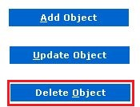

Step 6: Click on Ok Button on message box to delete the object.

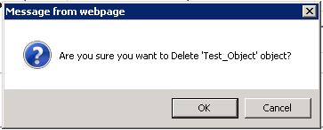

Step 7: Click on OK box once again.

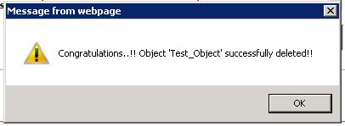

## 4.5 Action Management

Back to Index…

Back to Index…

This tab is used to manage actions.

Whenever new keyword is added in the function library (in QTP) we need to add the corresponding action name also. This task is achieved from Action Management tab.

Also , sometimes we also need to update or delete the action, same thing can also be done from Action Management tab.

Back to Index…

## 4.5.1 Adding Actions in Step Generator

Below are the steps for adding action in the utility.

Step 1: Select Application from the list.

Example: SAS



Step 2: Click on “**Continue**” button.

Back to Index…



Step 3: Click on “**Action Management**” Tab.

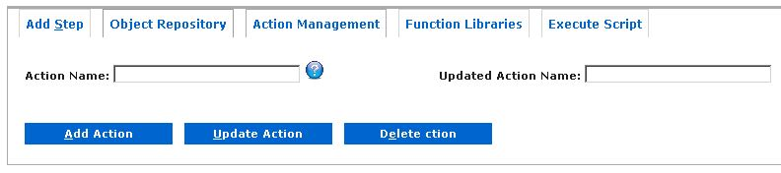

Step 4: Enter the name of the action.

Example: “Test_Action”

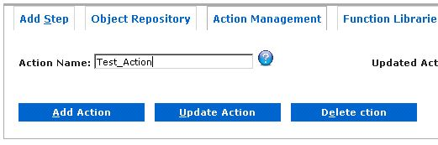

Step 5: Click on “**Add Action**” Button. Click on “**OK**” button on the alert box.

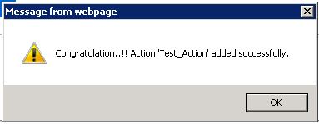

## 4.5.2 Editing Actions in Step Generator

Back to Index…

Back to Index…

Back to Index…

Below are the steps for editing action in the utility.

Step 1: Select Application from the list.

Example: SAS



Step 2: Click on “**Continue**” button.



Step 3: Click on “**Action Management**” Tab.

Back to Index…



Step 4: Enter the name of the action and **Updated Action Name** to change the name.

Example: Action Name: “Test_Action”

Updated Action Name: “Test_Action_Updated”

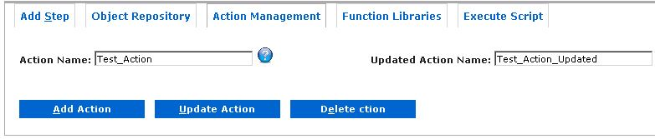

Step 5: Click on “**Update Action**” Button. Click on “**OK**” button on the alert box.

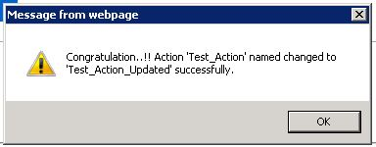

## 4.5.3 Deleting Actions in Step Generator

Back to Index…

Back to Index…

Below are the steps for deleting action in the utility.

Back to Index…

Step 1: Select Application from the list.

Example: SAS



Step 2: Click on “**Continue**” button.



Step 3: Click on “**Action Management**” Tab.

Back to Index…



Step 4: Enter the name of the action to delete.

Example: Action Name: “Test_Action_Updated”

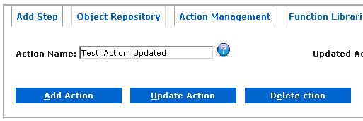

Step 5: Click on “**Delete Action**” Button. Click on “**OK**” button on the alert box.

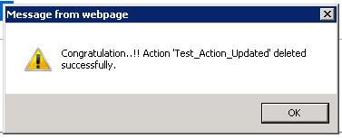

## 4.6 Function Library Management

Back to Index…

Back to Index…

Back to Index…

This tab is used to manage Function Library.

Whenever new Function Library is added (in QTP) we need to add the corresponding Function Library name also. This task is achieved from Function Libraries tab.

Also , sometimes we also need to update or delete the Function Library, same thing can also be done from Function Libraries tab.

## 4.6.1 Adding Function Library in Step Generator

Below are the steps for adding Function Library in the utility.

Step 1: Select Application from the list.

Example: SAS



Step 2: Click on “**Continue**” button.

Back to Index…



Step 3: Click on “**Function Libraries**” Tab.

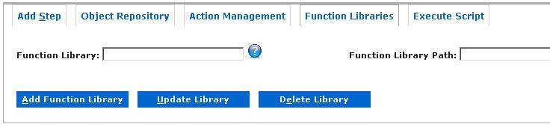

Step 4: Enter the name of the Function Library.

Example: Function Library: “Test_Func_Lib”

Function Library Path: “T:\Test.qfl”

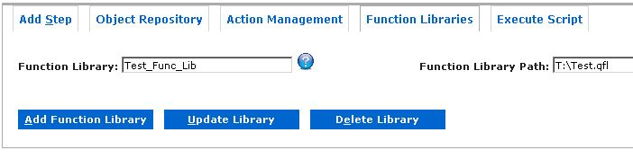

Step 5: Click on “**Add Function Library**” Button. Click on “**OK**” button on the alert box.

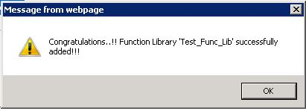

## 4.6.2 Editing Function Library path in Step Generator

Back to Index…

Back to Index…

Below are the steps for editing action in the utility.

Step 1: Select Application from the list.

Example: SAS



Step 2: Click on “**Continue**” button.

Back to Index…



Step 3: Click on “**Function Libraries**” Tab.



Step 4: Select Function Name and Enter **Updated** Action Name to change the path.

Example: Function Library: “Test_Action”

Function Library Path: “T:\Test_Updated_Path.qfl”

Back to Index…

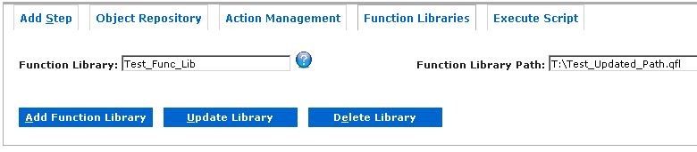

Step 5: Click on “**Update Action**” Button. Click on “**OK**” button on the alert box.

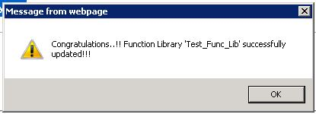

## 4.6.3 Deleting Function Library in Step Generator

Back to Index…

Back to Index…

Below are the steps for deleting Function Library in the utility.

Back to Index…

Step 1: Select Application from the list.

Example: SAS



Step 2: Click on “**Continue**” button.



Step 3: Click on “**Function Libraries**” Tab.



Step 4: Enter the name of the Function Library to delete.

Back to Index…

Example: Function Library: “Test_Func_Lib”



Step 5: Click on “**Delete Action**” Button. Click on “**OK**” button on the alert box.

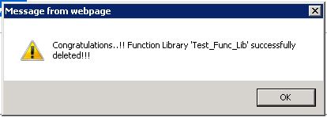

## 4.7 Selecting existing Test Case (.xml)

Back to Index…

Back to Index…

Step 1: Select Application from the list.

Example: SAS



Step 2: Click on Browse and select the xml file.

Back to Index…

Back to Index…

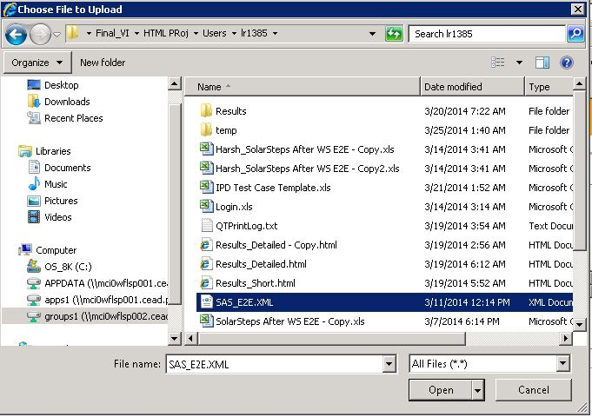

**Example**: SAS_E2E.XML

**NOTE:** Only *.xml files are allowed to select.

Step 3: Click on “**Continue**” button.

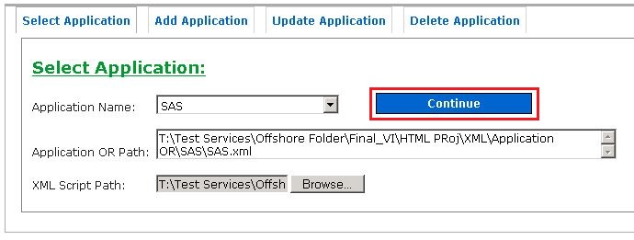

Step 4: Verify Table in the bottom section of the **Framework Utility** Page.

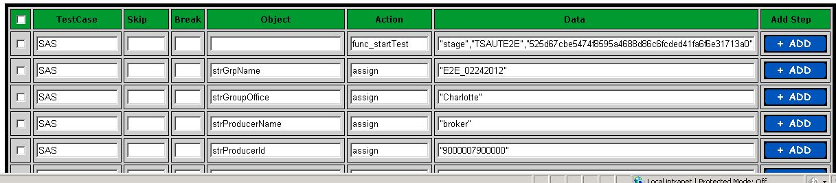

## 4.8 Starting with new Test Case

Back to Index…

Back to Index…

Step 1: Select Application from the list.

Example: SAS



Step 2: Click on “**Continue**” button.



## 4.9 Add Step Tab

Back to Index…

Back to Index…

## 4.9.1 Writing Test Case

There are two ways of writing test cases using Step Generator

1. Using the GUI available in the top section.
2. Directly writing in the web-table.

## 4.9.1.1 Using the GUI

Understanding GUI:

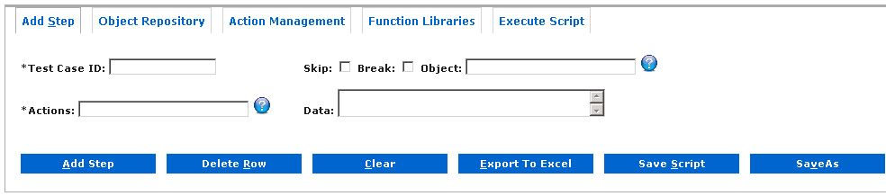

| **Field Name** | **Description** |
| --- | --- |
| **Test Case ID** | Mandatory field. Test Case ID of the test Script Example “**TC01**” |
| **Skip** | Check Box. Check to skip the step. |
| **Break**  Back to Index… | Check Box. Check to have a break during execution on the step (For debugging). |
| **Object** | Textbox. Object Name. Fetched from object repository. |
| **Actions** | Mandatory field. Action Name or “**keyword**”. |
| **Data** | Textbox. For entering data of the step. |

Below are the steps for writing test case.

Back to Index…

Step 1: Select Application from the list.

Example: SAS



Step 2: Click on “**Continue**” button.

Back to Index…



Step 3: Enter details in Add Step Tab for

* Test Case ID : “**TC01**”
* Skip: “**Uncheck**”
* Break: “**Check**”
* Object: “**AEB_WriteUp**”
* Action: “**msgbox**”
* Data: “**This is a test step**”

Back to Index…

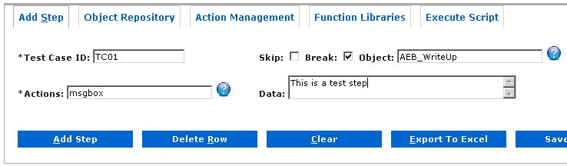

Step 4: Click on “**Add Step**” button. Verify Step in the Table below the tab.

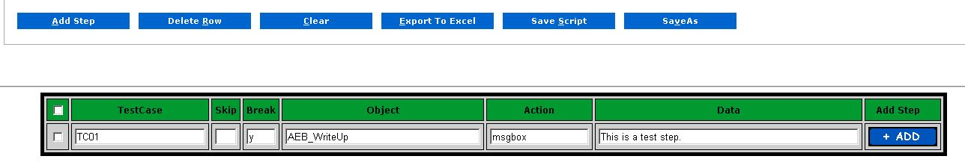

## 4.9.1.2 Using the Web-Table

We can directly use the web table (Only after first step is added from the GUI).

Below are the steps for writing test case.

Step 1: Select Application from the list.

Example: SAS



Step 2: Click on “**Continue**” button.



Step 3: Enter details in Add Step Tab for

* Test Case ID : “**TC01**”
* Skip: “**Uncheck**”
* Break: “**Check**”
* Object: “**AEB_WriteUp**”
* Action: “**msgbox**”
* Data: “**This is a test step**”



Step 4: Click on “**Add Step**” button. Verify Step in the Table below the tab.

Back to Index…



Step 5: Click on “**+** **Add**” button in the last column of the Web-Table. Test Case will automatically be populated.

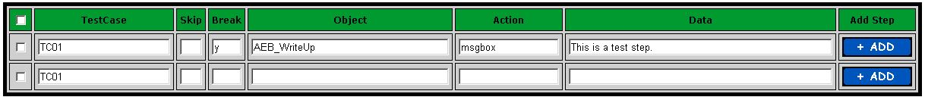

Step 6: Enter the details same as required.

* Test Case ID : “**TC01**”
* Skip: “**Uncheck**”
* Break: “**Uncheck**”

Back to Index…

* Object: “**AEB_WriteUp**”
* Action: “**msgbox**”
* Data: “**This is a second test step**”

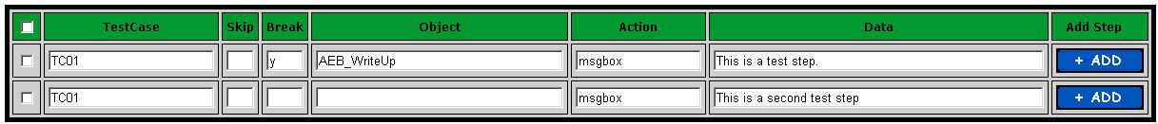

## 4.9.1.3 Re-Usable Scripts

Step Generator can also handle Re-usable scripts.

Syntax: **mod_**

Use mod_ in action to along with some prefix (for eg: mod_Test1, mod_Test2 etc.)

In Data column enter the path of the xls file you want to use.

For example: If Login is the file (**Location**: T:\Test Services\Offshore Folder\Final_VI\HTML PRoj\Users\lr1385\Harsh Temp\Login.xls) which we want to use in our Test Script then we will write:

Action: mod_Login

Data: T:\Test Services\Offshore Folder\Final_VI\HTML PRoj\Users\lr1385\Harsh Temp\Login.xls

Similarly if we want to use Logout File (**Location**: T:\Test Services\Offshore Folder\Final_VI\HTML PRoj\Users\lr1385\Harsh Temp\Logout.xls ) than we will write:

Action: mod_Logout

Data: T:\Test Services\Offshore Folder\Final_VI\HTML PRoj\Users\lr1385\Harsh Temp\Logout.xls

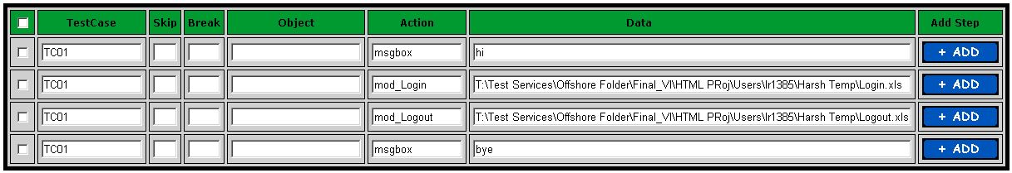

## 4.9.1.4 User Defined Functions

For using function we have a keyword/ prefix called **func_**

Similar to mod functionality, for function also we will add “**func_**” as the prefix before the function name. Like: func_FunctionName.

In Data we will write the input parameters for the function

“Parameter1”, “Paramter2”

Suppose we want to use a custom function named “FormatDateinMMDDYYYFormat” in our test case then we will write:

Action: func_FormatDateinMMDDYYYFormat



## 4.9.2 Deleting Test Steps

Back to Index…

Back to Index…

Deleting test steps can be performed on:

1. Individual Step
2. Multiple random steps
3. All the test steps.

User need to click “**Delete**” button.

## 4.9.2.1 Deleting Single Test Step

Step 1: Mark/Check the checkbox in first column

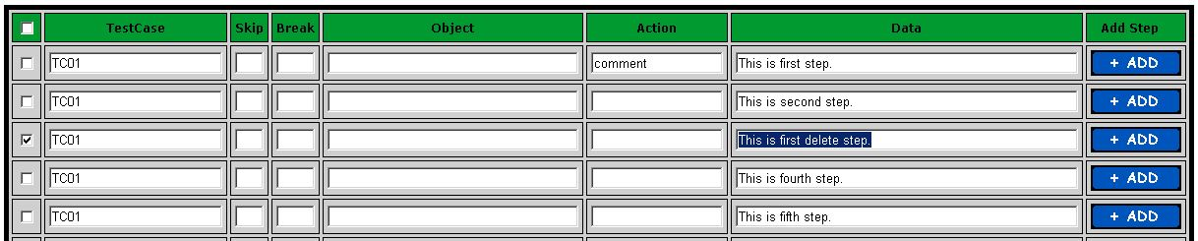

Step2: Click on “**Delete Row**” button.



Step3: Click on “**OK**” button in the pop-up box.

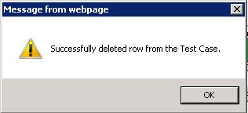

Step4: Step is deleted:

Back to Index…

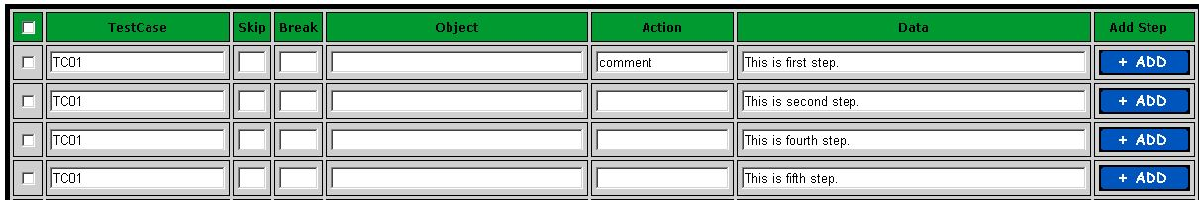

## 4.9.2.2 Deleting multiple steps from Test Case

Step 1: Mark/Check the checkbox in first column against the steps to delete

Back to Index…

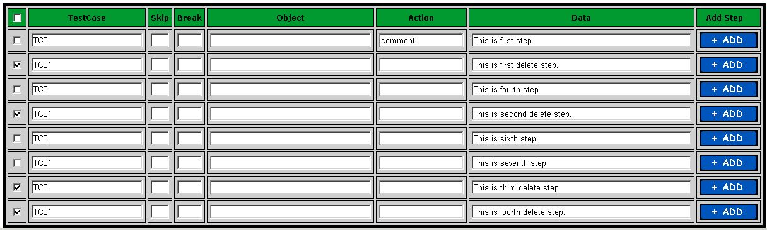

Step2: Click on “**Delete Row**” button.



Step3: Click on “**OK**” button in the pop-up box.



Step4: Mark steps are deleted:

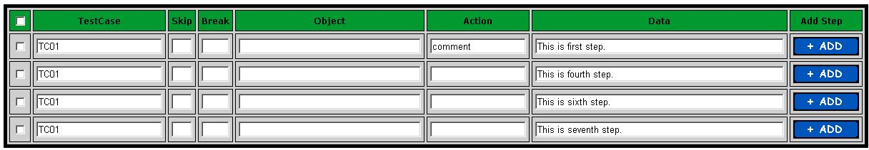

## 4.9.2.3 Deleting all steps from Test Case

Step 1: Mark/Check the checkbox in header row.

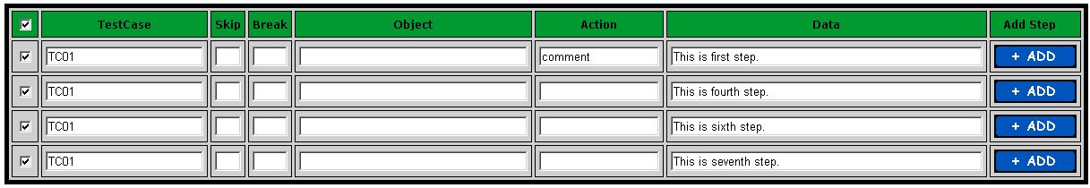

Step2: Click on “**Delete Row**” button.



Step3: Click on “**OK**” button in the pop-up box.

Back to Index…

Back to Index…



Step4: Mark steps are deleted:



## 4.9.3 Saving Test Case

Saving xml can be done in two ways:

1. Saving to temp File (Save Script)
2. Saving to custom folder (Save As Script)



## 4.9.3.1 Saving to temp File

Click on “**Save Script**” button to save directly to the temp file which is saved in the temp folder of the logged in user.



## 4.9.3.2 Saving to custom folder

Steps to save the script to custom folder.

Step 1: Click on “**SaveAs**” button.



Step2: Enter the path to save file. Click on “**OK**” button.

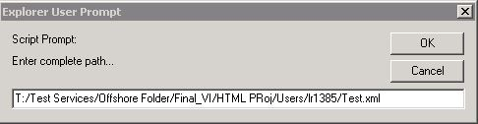

Step3: Click on “**OK**” button in the pop-up box.

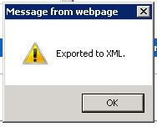

## 4.9.4 Exporting Test Case (In Excel)

Back to Index…

Back to Index…

Steps to export test script in to excel.

Step 1: Click on “**Export To Excel**” button.



Step 2: Enter the path to save file. Click on “**OK**” button.

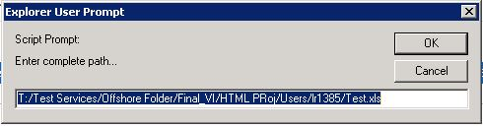

Step3: Wait for pop-up box and click on “**OK**” button in the pop-up box.

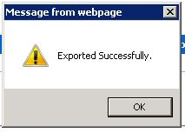

Back to Index…

Back to Index…

## 4.10 Execute Script Tab

## 4.10.1 Understanding Execute Script Tab

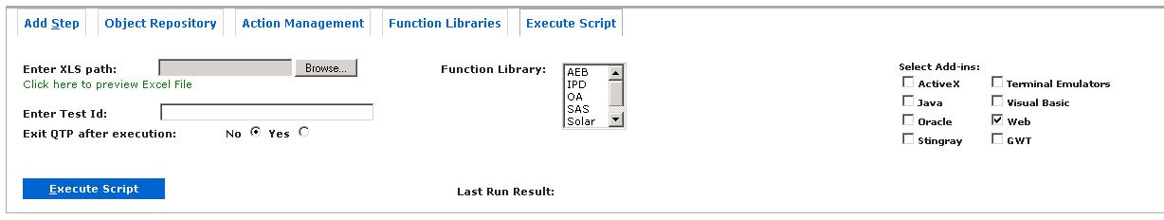

| **Field Name** | **Description** |
| --- | --- |
| **Enter XLS Path** | This field is optional. If user wants to execute any excel test case he can execute by selecting excel file. |
| **Click here to preview Excel File** | Link which gives preview of the selected excel file in “Enter XLS Path” field. |
| **Enter Test ID** | Mandatory Field. It will execute the rows having the same value as mentioned in the box.  Example: **TC01** |
| **Exit QTP after execution** | Radio Button.  Determines whether to exit QTP or not after execution. |
| **Exit QTP after execution** | Mandatory field. Action Name or “**keyword**”. |
| **Function Library** | Web List.  Select the function libraries that are applicable for the test script execution. |
| **Last Run Result** | Shows the result for the last run. Possible values:  Fail, Pass, Stopped, Done. |
| **Select Add-ins** | Checkboxes.  Allows user to select the QTP Add-ins which are applicable for the particular test script. |

## 4.10.2 Executing Script

Back to Index…

Back to Index…

Scripts can be executed from utility in two ways:

1. Selecting the Excel script.
2. Executing the script written from the step generator.

Mandatory Fields:

* Test Case ID
* QTP Add-ins
* Function Library if applicable.

## 4.10.2.1 Selecting the Excel file

Back to Index…

User can select Excel file and can execute the script.

Step 1: Click on “**Browse**” button and select the excel file.

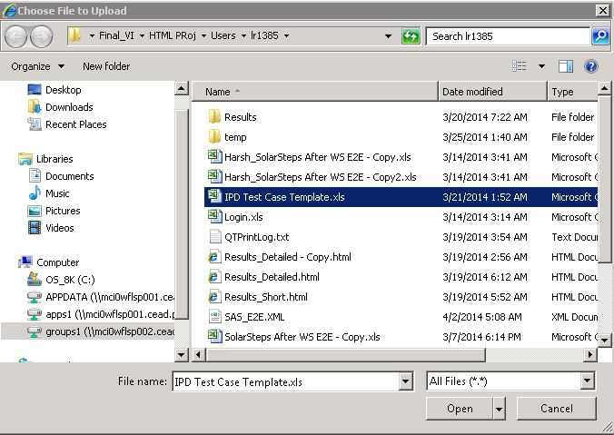

Step 2: Click on “**Click here to preview Excel File**” link to cross verify if the selected file is correct or not.

NOTE: User might get some warning for “**ADO Security**” Click on “**OK**” button.

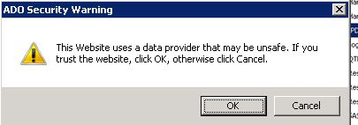

Once the file is loaded the preview will be like:

Back to Index…

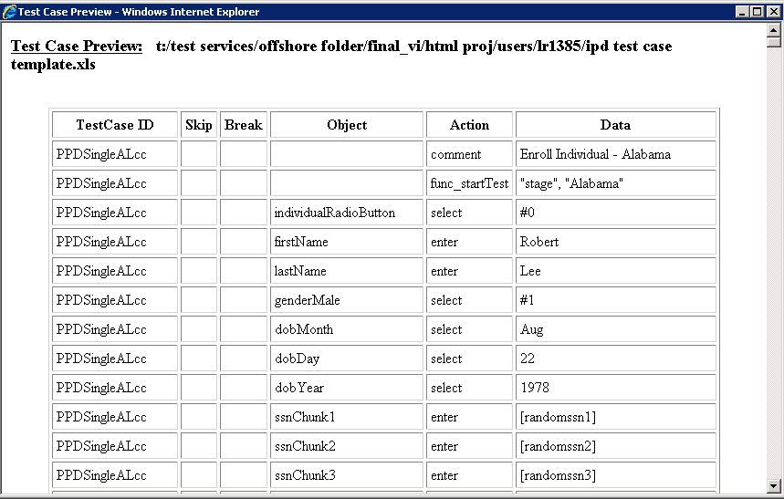

Step 3: Close the preview window and

Enter Test Case ID:

Example: **PPDSingleALcc**

Select Function Libraries:

Example: **IPD**

Select Add-ins:

Example: **Web**

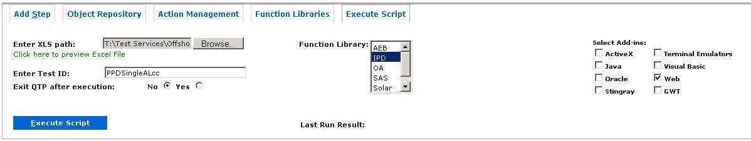

Step 4: Click on “**Execute Script**” button.

Wait for QTP to complete the execution.

Step 5: Get the **Last Run Result**.

Back to Index…



## 4.10.2.2 Executing after writing script in Utility

Back to Index…

User can execute the script which he/she has written in the utility

Step 1: Write test steps using Utility.



Step 2: Enter details for:

Enter Test Case ID:

Example: **TC01**

Select Function Libraries:

Example: **IPD**

Select Add-ins:

Example: **Web**

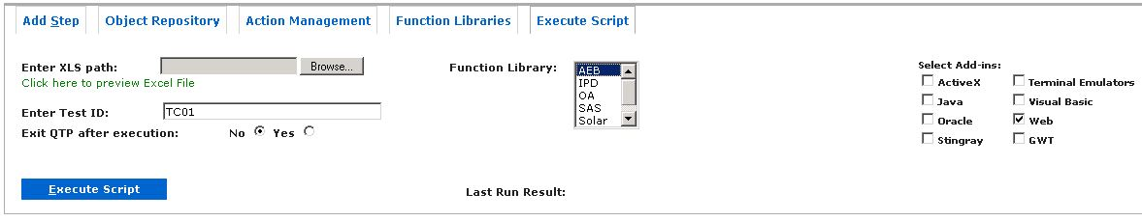

Step 3: Click on “**Execute Script**” button.

Wait for QTP to complete the execution.

Step 4: Get the **Last Run Result**.



Back to Index…

Back to Index…

## 4.10.3 Analyzing results

User can analyze the results by clicking on the status of the result i.e. “Fail”, “Passed”, etc.

Result will be opened in a new window.

Click on result status:



New Window with detailed result:

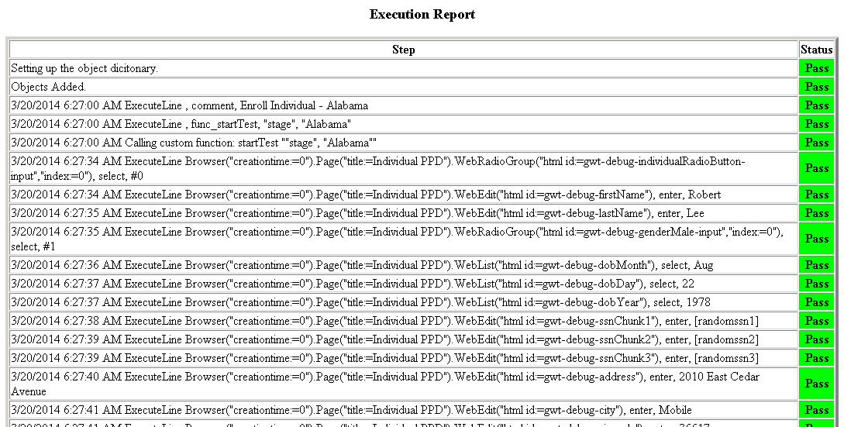

Back to Index…

Back to Index…