- Open Instagram's home page in Chrome, right-click on a post image, and use Inspect Element to find the exact HTML tag and CSS class used for the image container. Write down the tag name and class.

- Create a simple HTML file named myprofile.html that displays your name, a short bio, and a profile picture using appropriate HTML tags (h1, p, img). Open it in your browser and view the result.

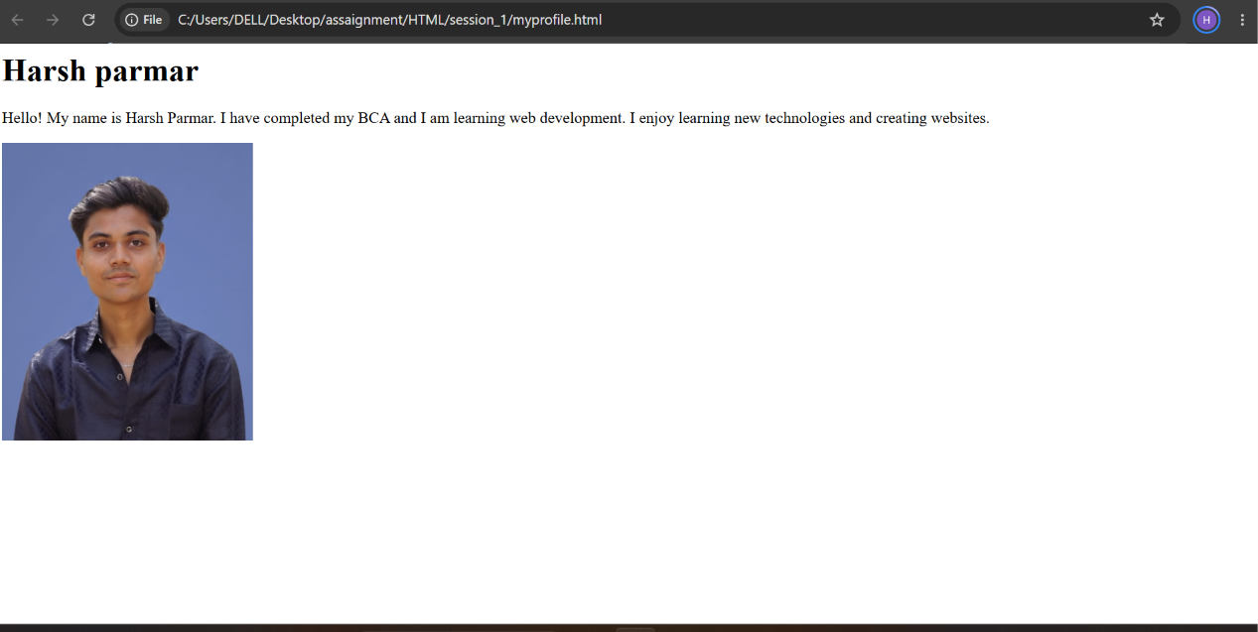

- Use Chrome DevTools to change the background color of your name (in myprofile.html) to any color you like, live in the browser, without editing the HTML file.

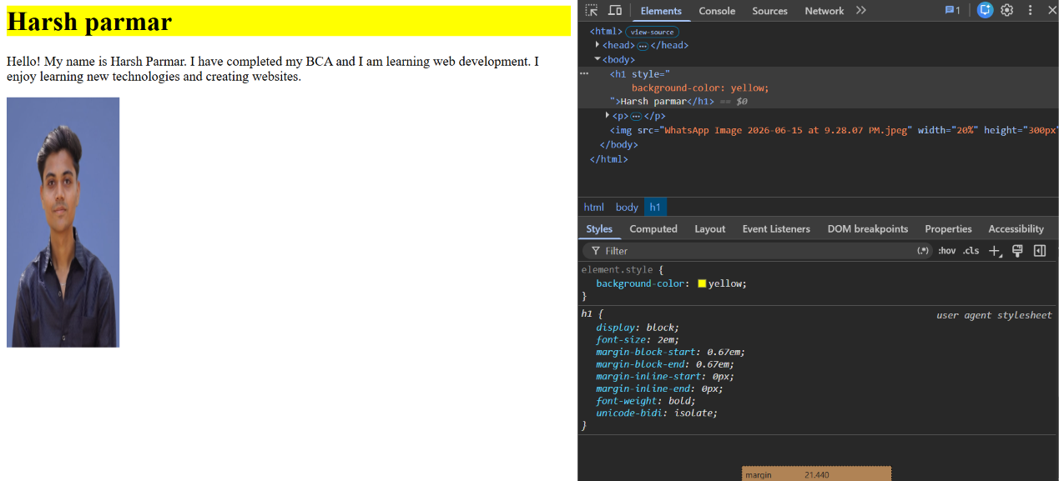
- Draw a diagram or write a list showing the DOM structure (parent-child relationships) of your myprofile.html page. Include at least 3 levels (html > body > your content).

html
├── head
│ └── title
│ └── "My Profile"
│
└── body
├── h1
│ └── "Harsh Parmar"
│
├── p
│ └── "Hello! My name is Harsh Parmar.
│ I have completed my BCA and I am
│ learning web development."
│
└── img
├── src="img/profile.jpg"
├── alt="My Profile Picture"
└── width="200"

