- Create a table called Playlist with columns: id, song_name, artist, genre, and play_count. Insert at least 5 sample records representing your favorite songs from Spotify.

CREATE TABLE Playlist (

id INT,
song_name VARCHAR(20),
artist VARCHAR(20),
genre VARCHAR(20),
play_count INT

);

INSERT INTO Playlist (id, song_name, artist, genre, play_count)
VALUES
(1, 'Drip or Drown', 'Gunna', 'Trap', 120),
(2, 'Burning Bridges', 'Drake', 'Hip-Hop', 150),
(3, 'Call Out My Name', 'The Weeknd', 'R&B', 180),
(4, 'Lil Demon', 'Future', 'Hip-Hop', 100),
(5, 'Until I Found You', 'Stephen Sanchez', 'Melody', 115);

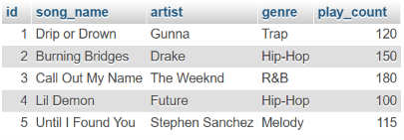

- Write a SELECT query to display only the song_name and artist from the Playlist table, but show the artist column as 'Singer' using an alias.

SELECT song_name, artist AS Singer FROM Playlist;

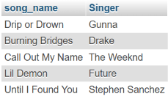

- Write a SELECT query to find all songs in the Playlist table where the genre is 'Hip-Hop' and play_count is greater than 100. Sort the results by play_count in descending order.

SELECT * FROM Playlist
WHERE genre = 'Hip-Hop' AND play_count > 100
ORDER BY play_count DESC;

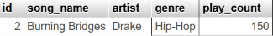
- Use the COUNT aggregate function to find out how many songs in your Playlist table belong to the genre 'Hip-Hop'.

SELECT COUNT(*) AS total_songs
FROM Playlist
WHERE genre = ‘Hip-Hop’;

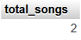

- Write a SELECT query that shows the total number of plays (SUM of play_count) for each genre in your Playlist table, grouped by genre.<br><br><em><strong>Hint:</strong> Use GROUP BY with the SUM function to aggregate play counts by genre.</em>

SELECT genre, SUM(play_count) AS total_plays
FROM Playlist
GROUP BY genre;

