- Install MySQL Workbench on your computer, connect to the local MySQL server, and take a screenshot of the default databases shown in the Schemas panel.

- Create a new database called InstaClone in MySQL Workbench, then create a table named Users with columns: user_id (INT, primary key), username (VARCHAR), email (VARCHAR), and followers_count (INT).

CREATE DATABASE InstaClone;

CREATE TABLE Users (

user_id INT PRIMARY KEY AUTO_INCREMENT,
username VARCHAR(100),
email VARCHAR(150),
followers_count INT

);

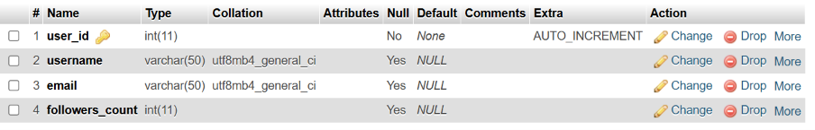

- Insert 3 sample users into the Users table you created, using realistic Instagram-style usernames and follower counts.

INSERT INTO Users (username, email, followers_count)
VALUES
('harsh.parmar', 'harsh@gmail.com', 100),
('rahul_solanki, ‘rahul@gmail.com', 500),
('priya20’, ‘p20@gmail.com', 250);

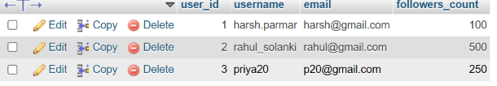

- Create another table in the InstaClone database called Posts with columns: post_id (INT, primary key), user_id (INT), caption (VARCHAR), and post_date (DATE). Add a foreign key from Posts.user_id to Users.user_id to establish a relationship.

CREATE TABLE Posts (

post_id INT PRIMARY KEY,
user_id INT,
caption VARCHAR(100),
post_date DATE,
FOREIGN KEY (user_id) REFERENCES Users(user_id)

);

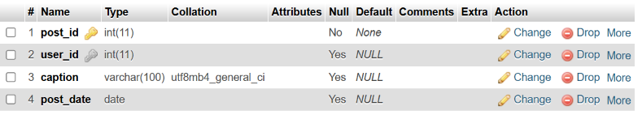

- Write a short comparison (3-4 lines each) of MySQL, PostgreSQL, Oracle, and SQLite, focusing on where each one is commonly used (for example: web apps, mobile apps, enterprise systems, etc.).

Database | Used For | Comparison
MySQL | Web applications, websites, e-commerce, CMS | Easy to use and widely supported.  It works well with PHP and other web technologies.  It is popular for small to large web applications.
PostgreSQL | Web applications, analytics, and data-heavy systems | It provides advanced SQL features and strong data integrity.  It is suitable for complex queries and large datasets.  It is highly customizable and reliable.
Oracle | Banking, finance, government, and large enterprises | It is designed for large-scale enterprise applications.  It provides strong security, reliability, and transaction management.  It is powerful but generally more expensive.
SQLite | Mobile apps, desktop apps, and embedded systems | It is lightweight and does not require a separate server. The entire database is stored in a single file.  It is best for small to medium-sized applications.

