- Create a table called Restaurant with columns: id, name, location, and cuisine. Apply NOT NULL constraint to name and location, and make id the PRIMARY KEY.

CREATE TABLE Restaurant (

Id INT PRIMARY KEY,
name VARCHAR(50) NOT NULL,
location VARCHAR(100) NOT NULL,
cuisine VARCHAR(50)

);

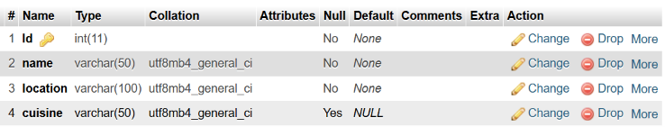

- Create a table called FoodOrder with columns: order_id, restaurant_id, user_id, and order_total. Set order_id as PRIMARY KEY, and add a FOREIGN KEY constraint on restaurant_id referencing Restaurant(id).

CREATE TABLE FoodOrder (

order_id INT PRIMARY KEY,
restaurant_id INT,
user_id INT,
order_total INT,
FOREIGN KEY (restaurant_id) REFERENCES Restaurant (id)

);

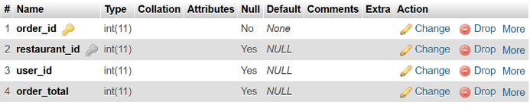
- Insert 6 rows into a table called SpotifyUser with columns: user_id, username, email, and subscription_type. Ensure that username is UNIQUE and email is NOT NULL.<br><br><em><strong>Hint:</strong> Use the UNIQUE and NOT NULL constraints when creating the table.</em>

CREATE TABLE SpotifyUser (

user_id INT,
username VARCHAR(50) UNIQUE,
email VARCHAR(50) NOT NULL,
subscription_type VARCHAR(50)

);

INSERT INTO SpotifyUser (user_id, username, email, subscription_type)
VALUES
(1, 'harsh123', 'harsh@gmail.com', 'Premium'),
(2, 'rahul456', 'rahul@gmail.com', 'Free'),
(3, 'priya789', 'priya@gmail.com', 'Premium'),
(4, 'amit101', 'amit@gmail.com', 'Free'),
(5, 'neha202', 'neha@gmail.com', 'Family'),
(6, 'jay303', 'jay@gmail.com', 'Student');

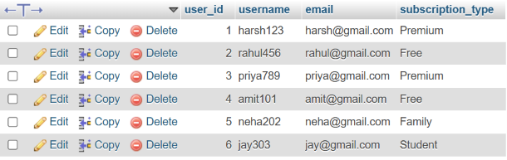

- Create a VIEW named TopSpendersView that shows usernames and order_total from a FoodOrder table where order_total is greater than 1000.

CREATE VIEW TopSpendersView AS
SELECT usernames, order_total
FROM FoodOrder
WHERE order_total >1000;

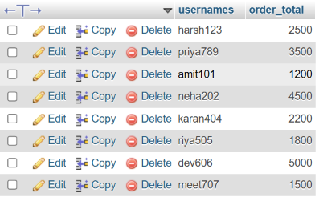

- Write a SQL query to list all users from the TopSpendersView who have spent more than 2000, sorted by order_total descending. <br><br><em> <strong>Constraint:</strong>Only use the TopSpendersView for your query, not the original FoodOrder table.</em>

SELECT username, order_total
FROM TopSpendersView
WHERE order_total > 2000
ORDER BY order_total DESC;

