- Create a MySQL table called playlists to store Spotify-style music playlists, with columns: playlist_id (primary key), user_id (foreign key), name (varchar), and created_at (datetime). Write the CREATE TABLE statement.

CREATE TABLE playlists (
playlist_id INT PRIMARY KEY AUTO_INCREMENT,
user_id INT,
name VARCHAR(100),
created_at DATETIME,
FOREIGN KEY (user_id) REFERENCES users(user_id)
);

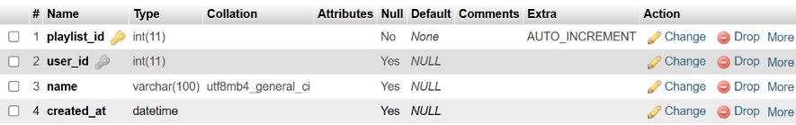

- Insert three sample records into the playlists table: one for a user with a 'Workout Mix', one with a 'Chill Vibes', and one with a 'Top Hits' playlist. Use realistic data for each field.

INSERT INTO playlists (user_id, name, created_at)
VALUES
(1, 'Workout Mix', '2026-10-18 10:00:00'),
(2, 'Chill Vibes', '2026-10-18 11:30:00'),
(3, 'Top Hits', '2026-10-18 15:00:00');

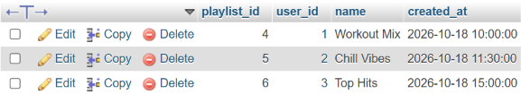
- Write an SQL UPDATE statement to rename the 'Chill Vibes' playlist to 'Evening Chill' for a specific user_id.

UPDATE playlists
SET name = 'Evening Chill'
WHERE user_id = 2;

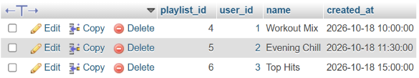

- Write a DELETE statement to remove a playlist named 'Workout Mix' for a given user_id from the playlists table.<br><br><em><strong>Hint:</strong> Make sure your WHERE clause targets only the intended row.</em>

DELETE FROM playlists
WHERE name = 'Workout Mix'
AND user_id = 1;

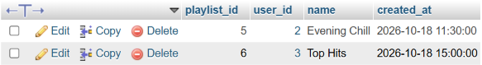

- Create a stored procedure named GetMonthlyPlaylistCount that takes a user_id and a month (as an integer) as input, and returns the total number of playlists the user created in that month.<br><br><em><strong>Hint:</strong> Use the MONTH() function in your WHERE clause.</em>

DELIMITER $$

CREATE PROCEDURE GetMonthlyPlaylistCount(
IN p_user_id INT,
IN p_month INT
)
BEGIN
SELECT COUNT(*) AS total_playlists
FROM playlists
WHERE user_id = p_user_id
AND MONTH(created_at) = p_month;
END $$

DELIMITER ;

CALL GetMonthlyPlaylistCount(2, 10);

