SECTION A - Concept Application

Question 1 : Justify your constraint choices for at least three columns across two tables. What data integrity problems would arise if these constraints were not applied?
Answer :
1. PRIMARY KEY - restaurant_id
The restaurant_id column in the Restaurants table should be a PRIMARY KEY because every restaurant must have a unique identifier. Without it, duplicate or indistinguishable restaurant records could exist.
2. NOT NULL - restaurant_name
The restaurant_name column should have a NOT NULL constraint because every restaurant must have a name. Without this constraint, a restaurant record could be created without a name.
3. FOREIGN KEY - restaurant_id in the MenuItems table
The restaurant_id column in the MenuItems table should be a FOREIGN KEY referencing the Restaurants table. It ensures that every menu item belongs to an existing restaurant. Without this constraint, menu items could reference restaurants that do not exist, creating invalid or orphan records.

Question 2 : Explain why the WHERE clause is essential in each DML statement. What could go wrong with an UPDATE or DELETE executed without a proper WHERE condition?
Answer :
The WHERE clause is used in SQL to specify which records should be updated or deleted.
In the given scenario, the UPDATE statement changes the status of orders placed more than 7 days ago that are still marked as 'Pending' to 'Cancelled'. The DELETE statement removes menu items marked as 'Unavailable' from restaurants that have closed.
The WHERE clause is essential because it ensures that only the records matching the specified conditions are affected.
Example 1: UPDATE statement
UPDATE orders
SET status = 'Cancelled'
WHERE order_date < CURRENT_DATE - INTERVAL 7 DAY
AND status = 'Pending';
Example 2: DELETE statement
DELETE FROM menu_items
WHERE status = 'Unavailable';
What can go wrong without a WHERE clause?
- An UPDATE statement without a WHERE clause may change the status of every order in the table.
- A DELETE statement without a WHERE clause may permanently delete all records from the table.
- It can cause data loss, incorrect information, and serious database management problems.
Conclusion:
The WHERE clause is important because it restricts DML operations to the intended records and prevents accidental changes or deletion of unnecessary data.

Question 3 : Which SQL clauses and aggregate functions would you use to produce this report? Explain why HAVING must be used here rather than WHERE to filter by aggregate results.
Answer :
To generate the revenue report, we use aggregate functions such as SUM(), AVG(), and COUNT() along with the GROUP BY clause.
- SUM(): Calculates the total revenue of each restaurant.
- AVG(): Calculates the average order value of each restaurant.
- COUNT(): Calculates the total number of orders processed by each restaurant.
- GROUP BY: Groups orders according to each restaurant.
- HAVING: Filters restaurants that have processed more than 20 orders in the current month.
- WHERE: Filters orders placed during the current month before grouping.
SQL Query:
SELECT
restaurant_id,
SUM(total_amount) AS total_revenue,
AVG(total_amount) AS average_order_value,
COUNT(order_id) AS total_orders
FROM orders
WHERE MONTH(order_date) = MONTH(CURRENT_DATE)
AND YEAR(order_date) = YEAR(CURRENT_DATE)
GROUP BY restaurant_id
HAVING COUNT(order_id) > 20;
Why is HAVING used instead of WHERE?
The WHERE clause filters individual rows before grouping, whereas the HAVING clause filters groups after aggregate functions are calculated.
Since the condition requires restaurants to have processed more than 20 orders, HAVING is used with COUNT(order_id).
Conclusion:
SUM(), AVG(), and COUNT() calculate the required revenue statistics, GROUP BY generates restaurant-wise summaries, WHERE filters orders from the current month, and HAVING displays only restaurants with more than 20 orders.
Question 4 : Compare INNER JOIN and LEFT JOIN for this query. Which would you use and why? Describe what each join type does to records that have no match in the other table.
Answer :
INNER JOIN and LEFT JOIN are used to combine data from two or more tables based on a related column.
In the given scenario, the orders table contains order_id, customer_id, restaurant_id, and total_amount, while the restaurants table contains restaurant_id and name.
1. INNER JOIN:
INNER JOIN returns only those orders that have a matching restaurant record in the restaurants table. If a restaurant does not exist in the restaurants table, its order will not appear in the result.
Example:
SELECT
o.order_id,
r.name AS restaurant_name,
o.total_amount
FROM orders o
INNER JOIN restaurants r
ON o.restaurant_id = r.restaurant_id;
2. LEFT JOIN:
LEFT JOIN returns all records from the left table (orders), including orders that do not have a matching restaurant record. If no matching restaurant is found, the restaurant name will be NULL.
Example:
SELECT
o.order_id,
r.name AS restaurant_name,
o.total_amount
FROM orders o
LEFT JOIN restaurants r
ON o.restaurant_id = r.restaurant_id;
Comparison:
- INNER JOIN returns only matching records from both tables.
- LEFT JOIN returns all records from the left table and matching records from the right table.
- When a restaurant record is missing, INNER JOIN excludes that order, whereas LEFT JOIN displays the order with NULL restaurant details.
Conclusion:
LEFT JOIN is the correct choice for this scenario because the order history page must display every order, including orders that reference a restaurant no longer present in the restaurants table.

Question 5 : Justify why a VIEW is preferred over direct table access here. What are two limitations the front-end developer should be aware of when working with this VIEW?
Answer :
A VIEW is a virtual table created using an SQL query. It displays selected data from one or more tables without storing the complete result as a separate physical table.
In the given scenario, a VIEW named top_restaurants is created to display the restaurant name, total orders, and average rating while hiding raw ID columns from the front-end team.
Example:
CREATE VIEW top_restaurants AS
SELECT
r.name AS restaurant_name,
COUNT(o.order_id) AS total_orders,
AVG(o.rating) AS average_rating
FROM restaurants r
LEFT JOIN orders o
ON r.restaurant_id = o.restaurant_id
GROUP BY r.restaurant_id, r.name;

Why is a VIEW preferred over direct table access?
- Data Security: A VIEW can hide sensitive columns, such as raw IDs, and expose only the required information to the front-end team.
- Simplicity: It simplifies complex queries by allowing developers to retrieve summarized information without writing the same JOIN and aggregate queries repeatedly.

Two Limitations of a VIEW:
- Limited Update Operations: Views containing aggregate functions, GROUP BY, or JOINs may not support direct INSERT, UPDATE, or DELETE operations.
- Dependency on Base Tables: If the underlying tables are modified or deleted in ways that affect the VIEW, the VIEW may stop working correctly or require modification.
Conclusion:
A VIEW improves security, simplifies data access, and provides a consistent representation of information. However, developers should understand its update limitations and dependency on the underlying tables.

Question 6 : Which database mechanism should have prevented this inconsistency? Explain how COMMIT, ROLLBACK, and SAVEPOINT work together to ensure both operations succeed or neither takes effect.
Answer :
The database mechanism that should have prevented the inconsistency is a Transaction. A transaction ensures that related database operations are treated as a single logical unit of work.
In the given scenario, deducting money from the customer's wallet and inserting the payment record must succeed together. If either operation fails, the transaction should be rolled back to maintain data consistency.
1. COMMIT:
COMMIT permanently saves all changes made during a transaction.

2. ROLLBACK:
ROLLBACK cancels the changes made during a transaction if an error occurs. For example, if the payment record insertion fails, the wallet deduction can be undone.
3. SAVEPOINT:
SAVEPOINT creates a temporary point within a transaction to which the database can roll back without cancelling the entire transaction.
Example:
START TRANSACTION;

UPDATE customers
SET wallet_balance = wallet_balance - 500
WHERE customer_id = 1;

SAVEPOINT wallet_deducted;

INSERT INTO payments (customer_id, amount, payment_status)
VALUES (1, 500, 'Success');

COMMIT;
If the payment insertion fails, the application should execute:
ROLLBACK;
This undoes the wallet deduction and any other uncommitted changes in the transaction.
How these mechanisms work together:
- START TRANSACTION begins the transaction.
- The wallet balance is deducted.
- SAVEPOINT marks a point within the transaction.
- The payment record is inserted.
- COMMIT saves both operations if everything succeeds.
- ROLLBACK undoes the uncommitted changes if an error occurs.

Conclusion:
Transactions, along with COMMIT and ROLLBACK, ensure that wallet deduction and payment recording succeed or fail together. SAVEPOINT allows partial rollback when needed. These mechanisms help maintain database consistency and prevent incorrect wallet balances.

Section B - Practical Coding Tasks

Task 1 : Design and Populate a Restaurant Database.
-- Step 1: Create Database
CREATE DATABASE foodapp_db;

-- Step 2: Select Database
USE foodapp_db;

-- Step 3: Create restaurants Table
CREATE TABLE restaurants (
restaurant_id INT AUTO_INCREMENT PRIMARY KEY,
name VARCHAR(100) NOT NULL,
city VARCHAR(50),
cuisine_type VARCHAR(50),
rating DECIMAL(3,1)
);

-- Step 4: Insert at least 6 Restaurant Records
INSERT INTO restaurants (name, city, cuisine_type, rating)
VALUES
('Spice Garden', 'Ahmedabad', 'Indian', 4.2),
('Pizza Point', 'Surat', 'Italian', 3.9),
('Royal Dine', 'Vadodara', 'Indian', 4.5),
('Burger Hub', 'Ahmedabad', 'Fast Food', 4.0),
('Dragon House', 'Rajkot', 'Chinese', 4.1),
('Tasty Bites', 'Surat', 'Fast Food', 3.7);

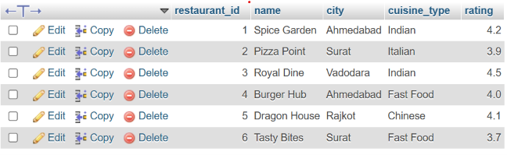

-- Step 5: Update One Restaurant Rating

UPDATE restaurants
SET rating = 4.8
WHERE restaurant_id = 2;

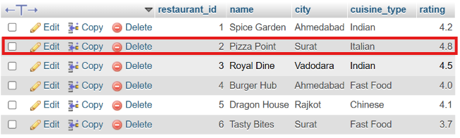

-- Step 6: Delete One Restaurant Record

DELETE FROM restaurants
WHERE restaurant_id = 6;

-- Step 7: Display All Restaurants
-- Sorted by Rating in Descending Order

SELECT *
FROM restaurants
ORDER BY rating DESC;

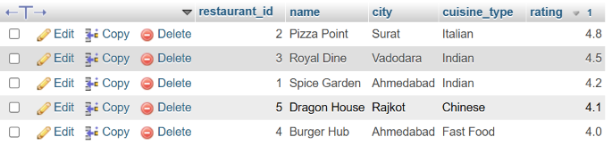

Task 2 : Aggregate Revenue Reporting on Orders.
-- Step 1: Select Database
USE foodapp_db;

-- Step 2: Create Orders Table
CREATE TABLE orders (
order_id INT AUTO_INCREMENT PRIMARY KEY,
restaurant_id INT,
customer_name VARCHAR(100),
total_amount DECIMAL(10,2),
order_date DATE
);

-- Step 3: Insert 12 Orders
-- Distributed across 4 restaurants

INSERT INTO orders
(restaurant_id, customer_name, total_amount, order_date)
VALUES
(1, 'Amit', 1200.00, '2026-10-10'),
(1, 'Rahul', 1800.00, '2026-10-12'),
(1, 'Neha', 1500.00, '2026-10-15'),

(2, 'Priya', 2200.00, '2026-10-11'),
(2, 'Karan', 1900.00, '2026-10-14'),
(2, 'Riya', 2500.00, '2026-10-18'),

(3, 'Jay', 3000.00, '2026-10-13'),
(3, 'Pooja', 2800.00, '2026-10-16'),
(3, 'Mehul', 1500.00, '2026-10-19'),

(4, 'Ankit', 1000.00, '2026-10-09'),
(4, 'Simran', 1200.00, '2026-10-17'),
(4, 'Vikas', 1400.00, '2026-10-20');

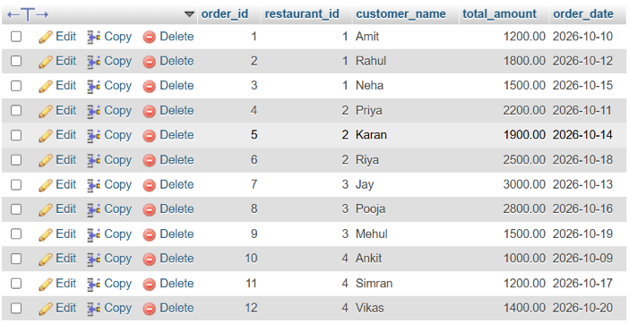

-- Step 4: Total Revenue and Average Order Value
-- Per Restaurant

SELECT
restaurant_id,
SUM(total_amount) AS total_revenue,
AVG(total_amount) AS average_order_value
FROM orders
GROUP BY restaurant_id;

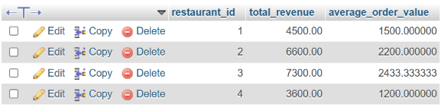

-- Step 5: Restaurants with Revenue Above Rs 5,000

SELECT
restaurant_id,
SUM(total_amount) AS total_revenue
FROM orders
GROUP BY restaurant_id
HAVING SUM(total_amount) > 5000;

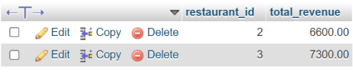
-- Step 6: Get the 5 Most Recent Orders

SELECT *
FROM orders
ORDER BY order_date DESC, order_id DESC
LIMIT 5;
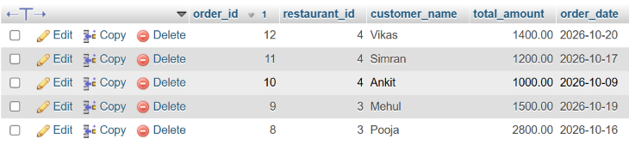

Task 3 : Multi-Table JOINs and Menu Summary View.
CREATE TABLE menu_items (
item_id INT AUTO_INCREMENT PRIMARY KEY,
restaurant_id INT,
item_name VARCHAR(100),
price DECIMAL(10,2),
category VARCHAR(50),
FOREIGN KEY (restaurant_id)
REFERENCES restaurants(restaurant_id)
);

INSERT INTO menu_items
(restaurant_id, item_name, price, category)
VALUES
(1, 'Paneer Tikka', 250.00, 'Starter'),
(1, 'Butter Paneer', 320.00, 'Main Course'),
(1, 'Veg Biryani', 220.00, 'Rice'),
(2, 'Margherita Pizza', 280.00, 'Pizza'),
(2, 'Farmhouse Pizza', 380.00, 'Pizza'),
(2, 'Garlic Bread', 150.00, 'Starter'),
(3, 'Gujarati Thali', 300.00, 'Thali'),
(3, 'Paneer Handi', 350.00, 'Main Course'),
(3, 'Masala Dosa', 180.00, 'South Indian'),
(4, 'Veg Burger', 120.00, 'Burger'),
(4, 'Cheese Burger', 180.00, 'Burger'),
(4, 'French Fries', 100.00, 'Sides');
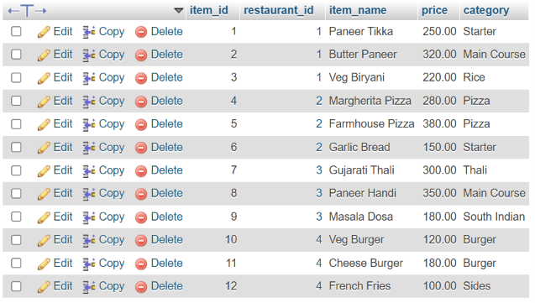

SELECT
restaurants.name AS restaurant_name,
menu_items.item_name,
menu_items.price
FROM restaurants
INNER JOIN menu_items
ON restaurants.restaurant_id = menu_items.restaurant_id;

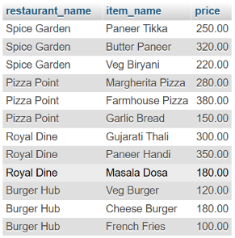

SELECT
restaurants.name AS restaurant_name,
menu_items.item_name,
menu_items.price,
menu_items.category
FROM restaurants
LEFT JOIN menu_items
ON restaurants.restaurant_id = menu_items.restaurant_id;

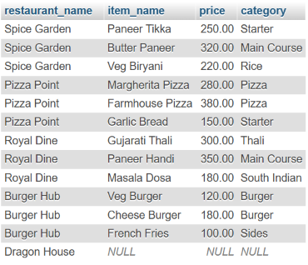

CREATE VIEW restaurant_menu_summary AS
SELECT
restaurants.name AS restaurant_name,
COUNT(menu_items.item_id) AS total_menu_items,
AVG(menu_items.price) AS average_item_price
FROM restaurants
LEFT JOIN menu_items
ON restaurants.restaurant_id = menu_items.restaurant_id
GROUP BY restaurants.restaurant_id, restaurants.name;

SELECT * FROM restaurant_menu_summary;

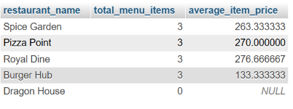

Task 4 : PL/SQL Order Placement Procedure.

USE foodapp_db;

DROP PROCEDURE IF EXISTS place_order;

DELIMITER //

CREATE PROCEDURE place_order(
IN p_customer_id INT,
IN p_restaurant_id INT,
IN p_amount DECIMAL(10,2)
)
BEGIN
DECLARE v_rows INT DEFAULT 0;

START TRANSACTION;

UPDATE customers
SET wallet_balance = wallet_balance - p_amount
WHERE customer_id = p_customer_id
AND wallet_balance >= p_amount;

SET v_rows = ROW_COUNT();

IF v_rows = 0 THEN
ROLLBACK;

SELECT 'Failed: Insufficient balance or customer not found'
AS result;
ELSE
INSERT INTO orders
(restaurant_id, customer_name, total_amount,
order_date, customer_id)
SELECT
p_restaurant_id, c.customer_name, p_amount,
NOW(), p_customer_id
FROM customers c
WHERE c.customer_id = p_customer_id;

COMMIT;

SELECT 'Success: Order placed successfully'
AS result;
END IF;
END //

DELIMITER ;

CALL place_order(1, 1, 500.00);



CALL place_order(2, 1, 5000.00);

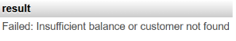

Section C – Mini capstone project

- Create three tables: restaurants (restaurant_id, name, city, cuisine_type, created_at), menu_items (item_id, restaurant_id, item_name, price, category) with a FOREIGN KEY on restaurant_id, and orders (order_id, customer_name, restaurant_id, item_id, quantity, total_amount, order_date) with a FOREIGN KEY on restaurant_id — all with appropriate PRIMARY KEY and NOT NULL constraints.

CREATE DATABASE food_delivery_db;
USE food_delivery_db;
CREATE TABLE menu_items (
item_id INT PRIMARY KEY AUTO_INCREMENT,
restaurant_id INT NOT NULL,
item_name VARCHAR(100) NOT NULL,
price DECIMAL(10,2) NOT NULL,
category VARCHAR(50) NOT NULL,
FOREIGN KEY (restaurant_id)
REFERENCES restaurants(restaurant_id)
);
INSERT INTO menu_items
(restaurant_id, item_name, price, category)
VALUES
(1, 'Paneer Tikka', 220, 'Starter'),
(1, 'Veg Biryani', 180, 'Main Course'),
(1, 'Gulab Jamun', 80, 'Dessert'),
(1, 'Masala Chaas', 50, 'Beverage'),
(1, 'Dal Fry', 160, 'Main Course'),
(2, 'Margherita Pizza', 250, 'Main Course'),
(2, 'Garlic Bread', 120, 'Starter'),
(2, 'Chocolate Brownie', 100, 'Dessert'),
(2, 'Cold Coffee', 90, 'Beverage'),
(2, 'Farmhouse Pizza', 320, 'Main Course'),
(3, 'Veg Manchurian', 170, 'Starter'),
(3, 'Hakka Noodles', 190, 'Main Course'),
(3, 'Ice Cream', 70, 'Dessert'),
(3, 'Lemon Soda', 60, 'Beverage'),
(3, 'Fried Rice', 180, 'Main Course');

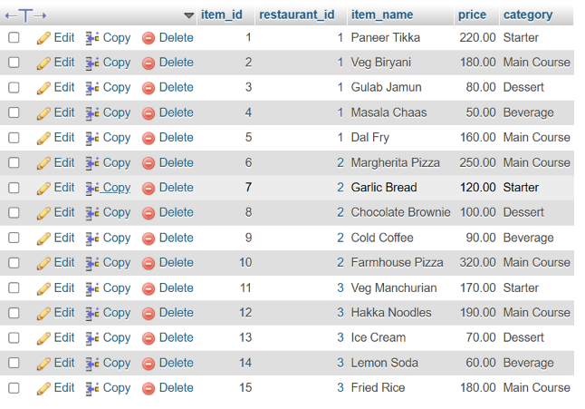

CREATE TABLE restaurants (
restaurant_id INT PRIMARY KEY AUTO_INCREMENT,
name VARCHAR(100) NOT NULL,
city VARCHAR(50) NOT NULL,
cuisine_type VARCHAR(50) NOT NULL,
created_at TIMESTAMP DEFAULT CURRENT_TIMESTAMP
);
INSERT INTO restaurants
(name, city, cuisine_type)
VALUES
('Spice Hub', 'Ahmedabad', 'Indian'),
('Pizza Palace', 'Ahmedabad', 'Italian'),
('Dragon Bowl', 'Surat', 'Chinese');

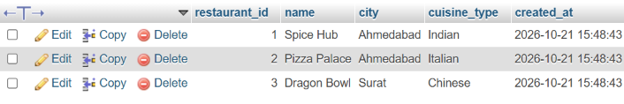

CREATE TABLE orders (
order_id INT PRIMARY KEY AUTO_INCREMENT,
customer_name VARCHAR(100) NOT NULL,
restaurant_id INT NOT NULL,
item_id INT NOT NULL,
quantity INT NOT NULL,
total_amount DECIMAL(10,2) NOT NULL,
order_date TIMESTAMP DEFAULT CURRENT_TIMESTAMP,
FOREIGN KEY (restaurant_id)
REFERENCES restaurants(restaurant_id),
FOREIGN KEY (item_id)
REFERENCES menu_items(item_id)
);

INSERT INTO orders
(customer_name, restaurant_id, item_id, quantity, total_amount)
VALUES
('Amit', 1, 1, 2, 440),
('Neha', 1, 2, 1, 180),
('Rahul', 1, 3, 3, 240),
('Priya', 1, 4, 2, 100),
('Karan', 1, 5, 1, 160),
('Riya', 2, 6, 1, 250),
('Jay', 2, 7, 2, 240),
('Meera', 2, 8, 1, 100),
('Dev', 2, 9, 2, 180),
('Pooja', 2, 10, 1, 320),
('Arjun', 3, 11, 2, 340),
('Diya', 3, 12, 1, 190),
('Krish', 3, 13, 2, 140),
('Anjali', 3, 14, 3, 180),
('Vivek', 3, 15, 2, 360);

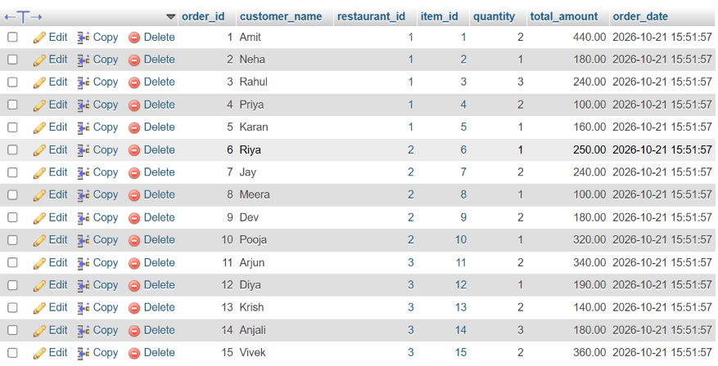

- Create a VIEW named restaurant_sales_summary showing restaurant name, total number of orders, and total revenue grouped by restaurant.

CREATE VIEW restaurant_sales_summary AS
SELECT
r.name AS restaurant_name,
COUNT(o.order_id) AS total_orders,
COALESCE(SUM(o.total_amount), 0) AS total_revenue
FROM restaurants r
LEFT JOIN orders o
ON r.restaurant_id = o.restaurant_id
GROUP BY r.restaurant_id, r.name;
SELECT * FROM restaurant_sales_summary;
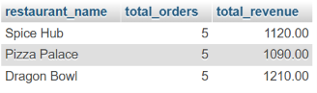

- Write a stored procedure named add_order that accepts customer_name, restaurant_id, item_id, and quantity, calculates total_amount from the menu item price, validates the restaurant exists (ROLLBACK if not), and inserts the order record.

DROP PROCEDURE IF EXISTS add_order;
DELIMITER //
CREATE PROCEDURE add_order(
IN p_customer_name VARCHAR(100),
IN p_restaurant_id INT,
IN p_item_id INT,
IN p_quantity INT
)
BEGIN
DECLARE v_price DECIMAL(10,2) DEFAULT NULL;
DECLARE v_total DECIMAL(10,2);
DECLARE v_restaurant_count INT DEFAULT 0;
DECLARE v_item_count INT DEFAULT 0;
DECLARE EXIT HANDLER FOR SQLEXCEPTION
BEGIN
ROLLBACK;
RESIGNAL;
END;

START TRANSACTION;

SELECT COUNT(*)
INTO v_restaurant_count
FROM restaurants
WHERE restaurant_id = p_restaurant_id;

IF v_restaurant_count = 0 THEN
ROLLBACK;
SIGNAL SQLSTATE '45000'
SET MESSAGE_TEXT = 'Restaurant does not exist';
END IF;

SELECT COUNT(*)
INTO v_item_count
FROM menu_items
WHERE item_id = p_item_id
AND restaurant_id = p_restaurant_id;

IF v_item_count = 0 THEN
SIGNAL SQLSTATE '45000'
SET MESSAGE_TEXT = 'Menu item does not exist for this restaurant';
END IF;

SELECT price
INTO v_price
FROM menu_items
WHERE item_id = p_item_id
AND restaurant_id = p_restaurant_id;

IF p_quantity <= 0 THEN
SIGNAL SQLSTATE '45000'
SET MESSAGE_TEXT = 'Quantity must be greater than zero';
END IF;

SET v_total = v_price * p_quantity;

INSERT INTO orders (
customer_name,
restaurant_id,
item_id,
quantity,
total_amount
)
VALUES (
p_customer_name,
p_restaurant_id,
p_item_id,
p_quantity,
v_total
);

COMMIT;
END //
DELIMITER ;

CALL add_order('Harsh', 1, 1, 2);
SELECT * FROM orders
ORDER BY order_id DESC
LIMIT 1;

CALL add_order('Harsh', 999, 1, 2);
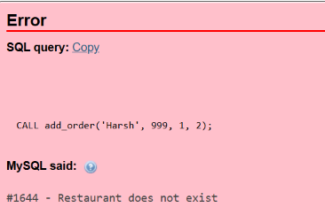

- Write a TRIGGER named after_order_insert that logs a record into an order_audit table (order_id, restaurant_id, action='INSERT', log_time=NOW()) immediately after every new order is created

CREATE TABLE IF NOT EXISTS order_audit (
audit_id INT AUTO_INCREMENT PRIMARY KEY,
order_id INT NOT NULL,
restaurant_id INT NOT NULL,
action VARCHAR(20) NOT NULL,
log_time DATETIME NOT NULL
);

DROP TRIGGER IF EXISTS after_order_insert;
DELIMITER //
CREATE TRIGGER after_order_insert
AFTER INSERT ON orders
FOR EACH ROW
BEGIN
INSERT INTO order_audit
(order_id, restaurant_id, action, log_time)
VALUES
(NEW.order_id, NEW.restaurant_id, 'INSERT', NOW());
END //
DELIMITER ;

CALL add_order('Harsh', 1, 1, 2);

Section D – Ai Augmented Lerning
Step – 1 : BUILD WITH AI
Original Ai’s genreted stored procedural code
DROP PROCEDURE IF EXISTS GetMonthlyRestaurantSummary;
DELIMITER //
CREATE PROCEDURE GetMonthlyRestaurantSummary(
IN p_restaurant_id INT,
IN p_month INT
)
BEGIN
IF p_month < 1 OR p_month > 12 THEN
SELECT 'Invalid month. Enter a month from 1 to 12.' AS message;
ELSE
SELECT
p_restaurant_id AS restaurant_id,
p_month AS order_month,
COUNT(*) AS total_orders,
SUM(total_amount) AS total_revenue,
AVG(total_amount) AS average_order_value
FROM orders
WHERE restaurant_id = p_restaurant_id
AND MONTH(order_date) = p_month
GROUP BY restaurant_id, MONTH(order_date);
IF ROW_COUNT() = 0 THEN
SELECT
'No orders found for this restaurant in the selected month.'
AS message;
END IF;
END IF;
END //
DELIMITER ;

Test - 1 : CALL GetMonthlyRestaurantSummary(1, 10);

Test -2 : CALL GetMonthlyRestaurantSummary(2, 10);

Step – 2 : TEST & DEBUG (WITHOUT AI)

CALL GetMonthlyRestaurantSummary(1, 1);
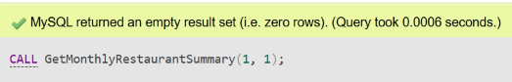

- Bug Identified and Fixed
The original procedure used ROW_COUNT() to check whether orders existed after a SELECT query. This did not correctly handle the no-orders case and resulted in an empty output.
I fixed the issue by using COUNT(*) and storing the result in the variable v_order_count. If no matching orders exist, the procedure now displays a meaningful message instead of an empty result.

Exact Prompt Given to AI :
Create a stored procedure named GetMonthlyRestaurantSummary for MySQL. It should accept restaurant_id and a month number (1–12) as input parameters. The procedure must return the total number of orders, total revenue, and average order value for the specified restaurant and month using aggregate functions and GROUP BY. It should validate the month input and display a meaningful message if no orders exist for the selected restaurant and month. Provide the complete SQL code using the correct delimiter syntax and include test queries for two different restaurant IDs and month combinations.

- Corrected Stored Procedure Code :
DROP PROCEDURE IF EXISTS GetMonthlyRestaurantSummary;
DELIMITER //
CREATE PROCEDURE GetMonthlyRestaurantSummary(
IN p_restaurant_id INT,
IN p_month INT
)
BEGIN
DECLARE v_order_count INT DEFAULT 0;
IF p_month < 1 OR p_month > 12 THEN
SELECT 'Invalid month. Enter a month from 1 to 12.' AS message;
ELSE
SELECT COUNT(*)
INTO v_order_count
FROM orders
WHERE restaurant_id = p_restaurant_id
AND MONTH(order_date) = p_month;
IF v_order_count = 0 THEN
SELECT
'No orders found for this restaurant in the selected month.' AS message;
ELSE
SELECT
p_restaurant_id AS restaurant_id,
p_month AS order_month,
COUNT(*) AS total_orders,
SUM(total_amount) AS total_revenue,
AVG(total_amount) AS average_order_value
FROM orders
WHERE restaurant_id = p_restaurant_id
AND MONTH(order_date) = p_month
GROUP BY restaurant_id, MONTH(order_date);
END IF;
END IF;
END //
DELIMITER ;

I executed the same test again after updating the procedure :

CALL GetMonthlyRestaurantSummary(1, 1);



- Note on Changes and Improvements :
The original AI-generated procedure used ROW_COUNT() to check whether orders existed, but it did not correctly handle the no-orders case and returned an empty result. I replaced it with COUNT(*) and stored the result in the variable v_order_count. The procedure now checks whether the count is zero and displays a meaningful message if no orders are found. This improvement makes the procedure more reliable and handles empty results correctly.

