- Create a SQL script to insert a new order into an Orders table, then use COMMIT to save the transaction and verify that the new order persists after reconnecting to the database.

START TRANSACTION;

INSERT INTO orders(`user_id`, `order_date`, `total_amount`, `order_status`, `payment_method`)
VALUES
('105','18-10-2026','9000','pending','COD');

COMMIT;

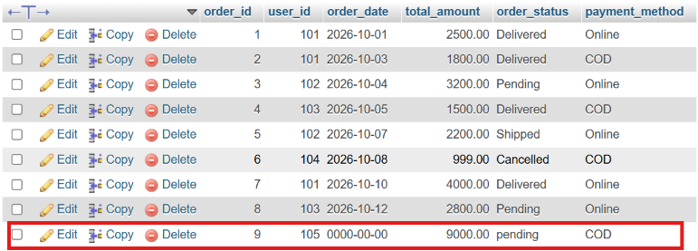

- Simulate a Zomato-style food order process: insert two new items into an OrderItems table, then use ROLLBACK to undo the changes before committing. Check that no new items remain in the table after rollback.

START TRANSACTION;

INSERT INTO `orderitems`(`item_id`, `order_id`, `product_name`, `price`)
VALUES ('4','4','shirt','1999');

INSERT INTO `orderitems`(`item_id`, `order_id`, `product_name`, `price`)
VALUES ('5','5','jeans','2999');

SELECT * FROM orderitems;

ROLLBACK;

- In a Flipkart-like shopping cart scenario, use SAVEPOINT to mark a point after adding a product to the Cart table, add another product, then use ROLLBACK TO SAVEPOINT to undo only the last addition. Show the final contents of the Cart table.

START TRANSACTION;

INSERT INTO `Cart`(`cart_id`, `user_id`, `product_name`, `price`)
VALUES (3,3,'jeans','1999');

SAVEPOINT s1;

INSERT INTO `Cart`(`cart_id`, `user_id`, `product_name`, `price`)
VALUES (4,4,'shirt','1500');

ROLLBACK TO SAVEPOINT s1;

SELECT * FROM cart;

COMMIT;

- Write a trigger on a Wallet table that automatically deducts the purchase amount from the user's balance whenever a new transaction is inserted, similar to how Paytm updates wallet balance after a payment.

- Use ChatGPT to generate a SQL test scenario where a trigger incorrectly updates a user's balance after an expense entry. Paste the scenario and your corrected trigger code, explaining how you fixed the error.<br><br><em><strong>Hint:</strong> Ask ChatGPT for a buggy trigger example and a test case that exposes the bug.</em>

