- Declare variables for a Flipkart product: productName (as a string), price (float), and rating (double). Assign sample values and print each variable with its data type.

Code:
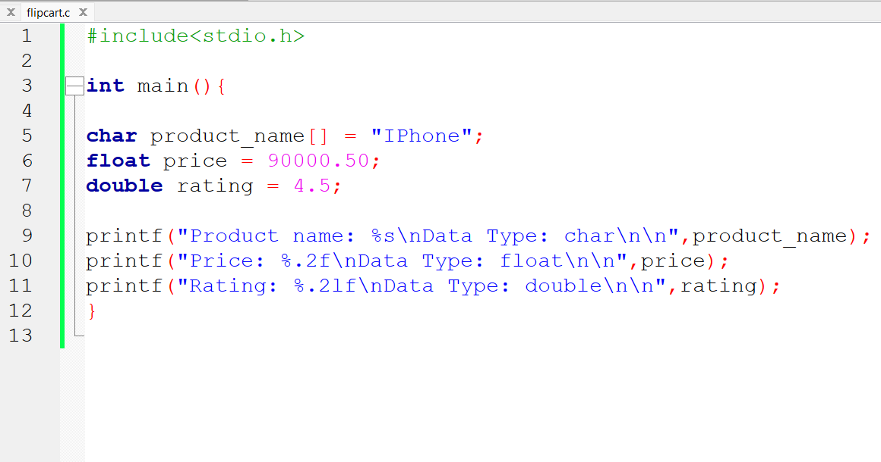

Output:
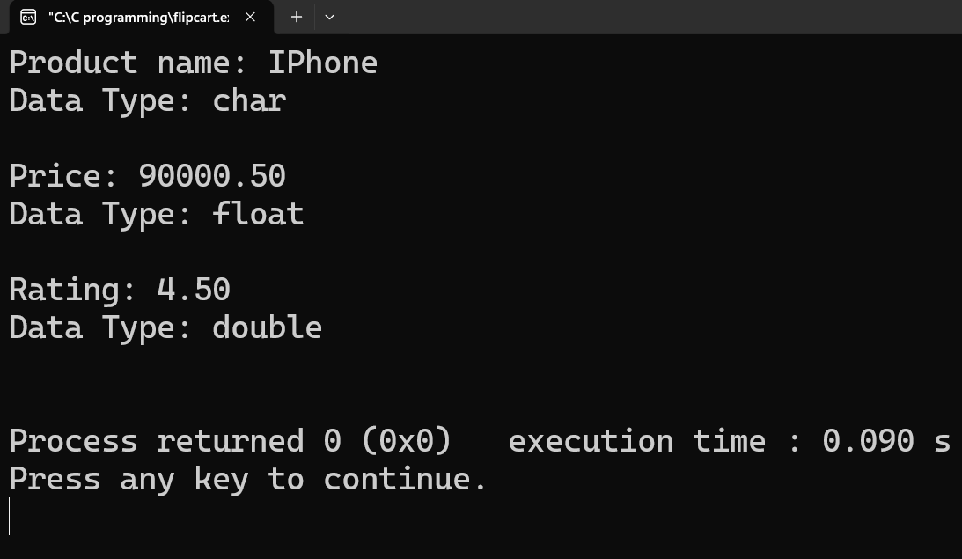

- Create a constant variable to store the GST rate (for example, 18%) and use it to calculate the final price of a Zomato order with a given base price. Constraint The GST rate must not be changeable after its initial assignment.

Code:
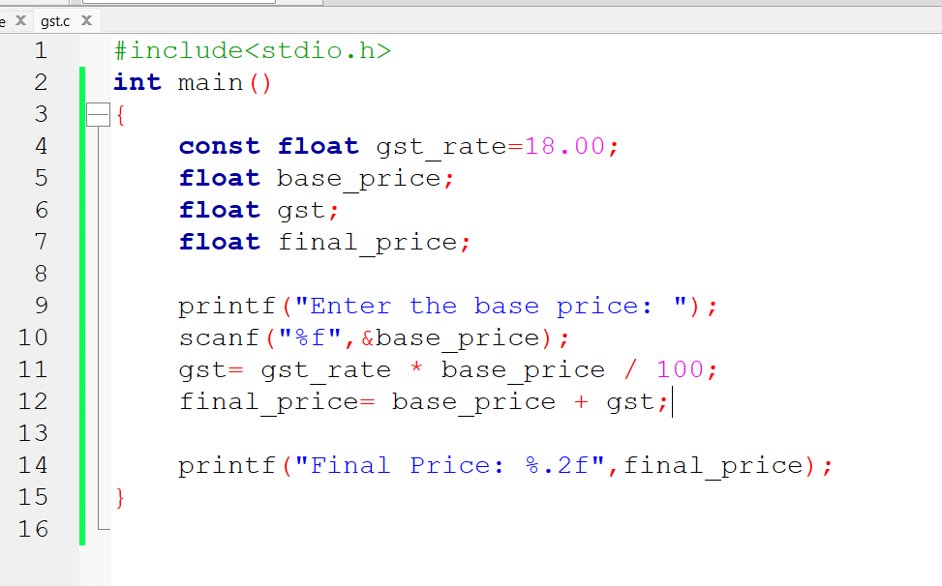

Output:
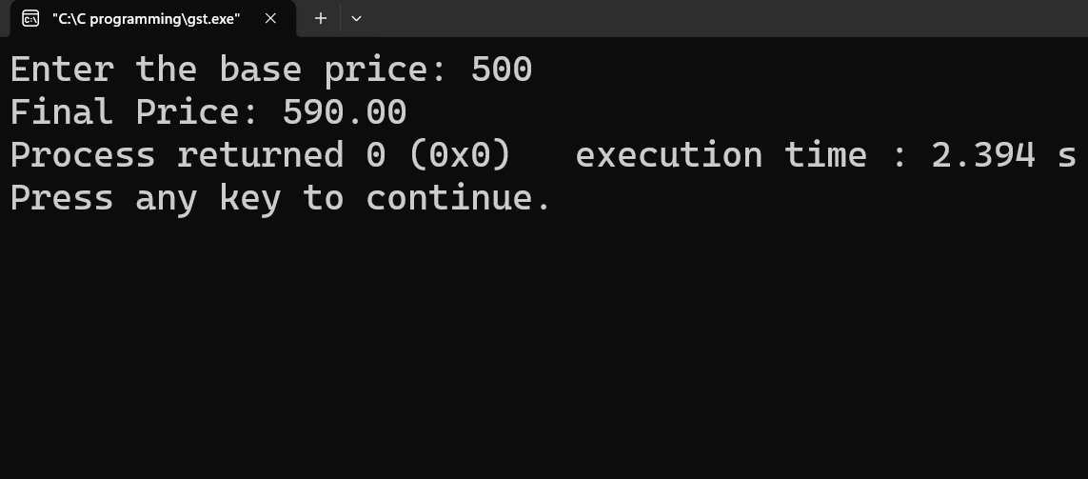

- Write a program that stores your favorite Spotify playlist's name (string), total number of songs (int), and average song duration in minutes (float). Print all values in a single formatted sentence.

Code:
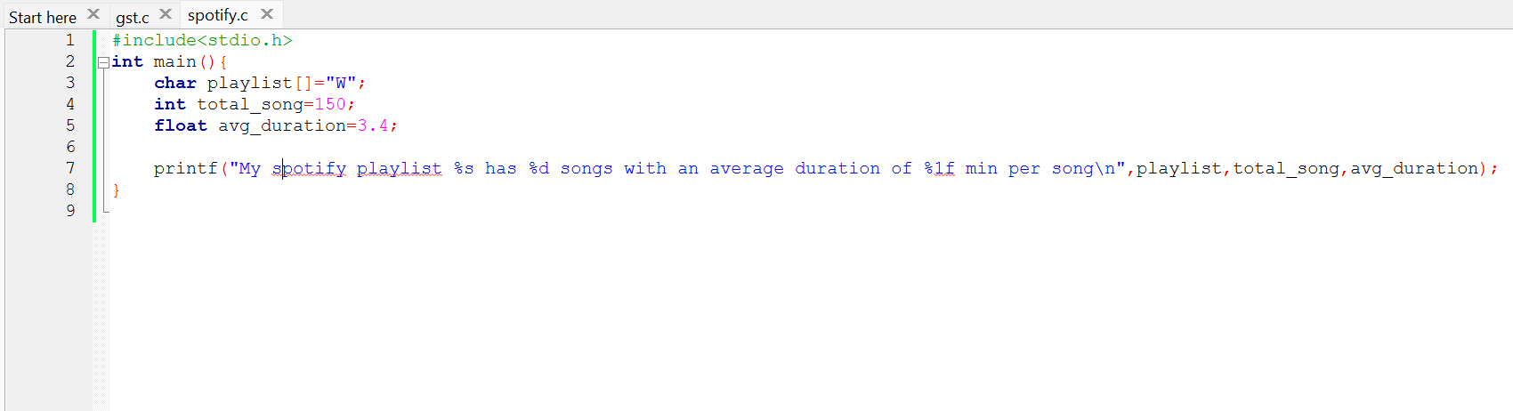

Output:
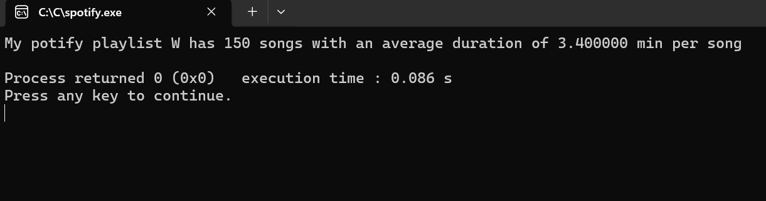

- Identify and correct the invalid variable names from this list: 1stPlayer, player_age, $score, total-marks, userName. Hint: Apply standard variable naming rules for your programming language.

Variable name | Valid/Invalid | Correction
1stPlayer | Invalid | firstPlayer
Player_age | Valid | player_age
$score | Invalid | score
total-marks | Invalid | total_marks
userName | Valid | userName

