B U S I N E S S I N T E L L I G E N C E R E P O R T

Vendor Performance Analysis
Identifying Pricing, Inventory & Vendor-Risk Opportunities from Purchase & Sales Data
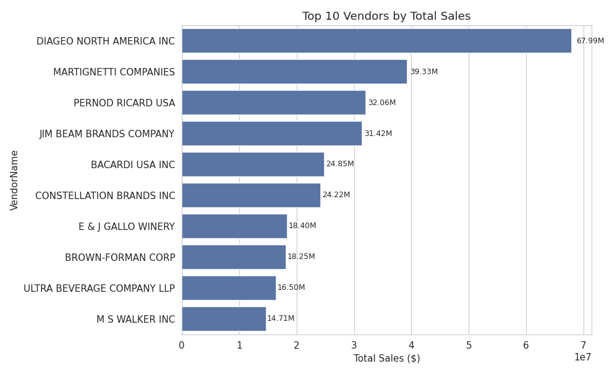
DATASET | 10,692 vendor–brand records
METHOD | SQL aggregation · Python (pandas / seaborn) · hypothesis testing
TOOLS | SQLite · Python · Power BI
PREPARED BY | Harshkumar Patel · Data & Analytics
DATE | July 2026

Contents
Business Problem 3
Approach 3
Data Overview 3
1. Brands for Promotional or Pricing Adjustments 5
2. Top Vendors by Sales & Purchase Contribution 6
3. Impact of Bulk Purchasing on Unit Cost 7
4. Vendors with Low Inventory Turnover 8
5. Profit Margin: High vs. Low-Performing Vendors 9
Final Recommendations 10
Limitations & Next Steps 10

Business Problem
Effective inventory and vendor management directly affects profitability in retail and wholesale distribution. This analysis works through purchase, sales, and freight data for one distributor to answer five practical questions that inform pricing, purchasing, and vendor-relationship decisions.
- Which brands would benefit from a pricing or promotion push?
- Which vendors contribute the most to sales and purchases?
- Does buying in bulk actually lower unit cost?
- Which vendors are sitting on slow-moving inventory?
- Is the profitability gap between high- and low-volume vendors real, or just noise?

Approach
Raw purchase, sales, and freight tables were joined and aggregated into a single vendor_sales_summary table using SQL, producing one row per vendor–brand pair. The result was cleaned — data types corrected, gaps filled, loss-making and zero-sale rows removed — and then analyzed in Python. Where a claim needed statistical backing rather than a simple average, a confidence interval and a hypothesis test were used instead of eyeballing the numbers.

Data Overview
10,692 vendor-brand records were reviewed. Before filtering, a few things stood out:
- Gross profit ranged as low as −$52,000 — some products are sold at a loss.
- Profit margin hit −∞ where a product had $0 in sales but a nonzero cost.
- Some products had zero sales — purchased but never sold.
These are not data errors — they reflect real situations such as returns, dead stock, and promotional giveaways — but they would distort averages if left in the profitability analysis. Rows with zero or negative gross profit or margin, and zero sales quantity, were filtered out before answering the questions below, reducing the working set from 10,692 to 8,565 rows.
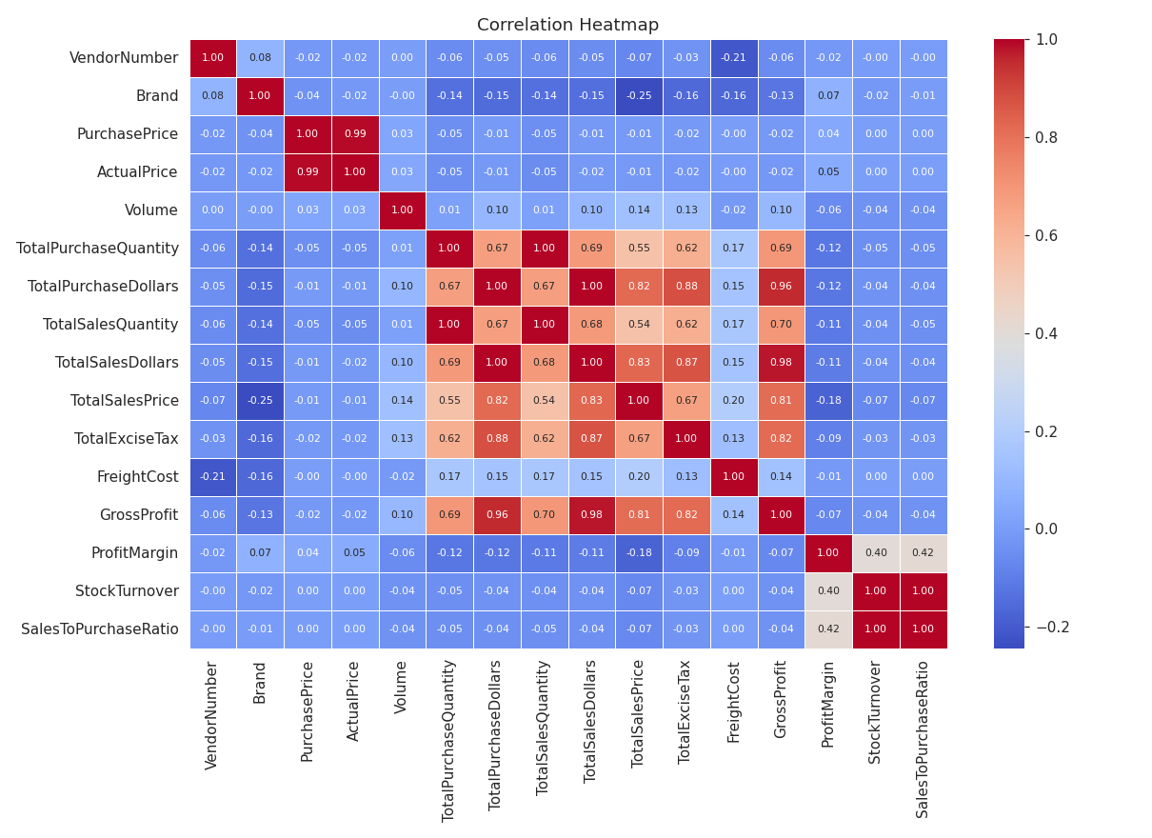
Figure 1 — Correlation heatmap across all numeric fields, post-filtering.
Takeaway: Purchase price barely correlates with sales or profit (≈ −0.01) — higher-priced products aren't inherently more profitable. Purchase and sales quantity move almost perfectly together in aggregate (0.999), even though specific vendors carry excess stock.

1. Brands for Promotional or Pricing Adjustments
Brands were grouped by total sales and average profit margin. Those in the bottom 15% of sales but the top 15% of margin were flagged as brands that are already profitable but simply aren't moving much volume.
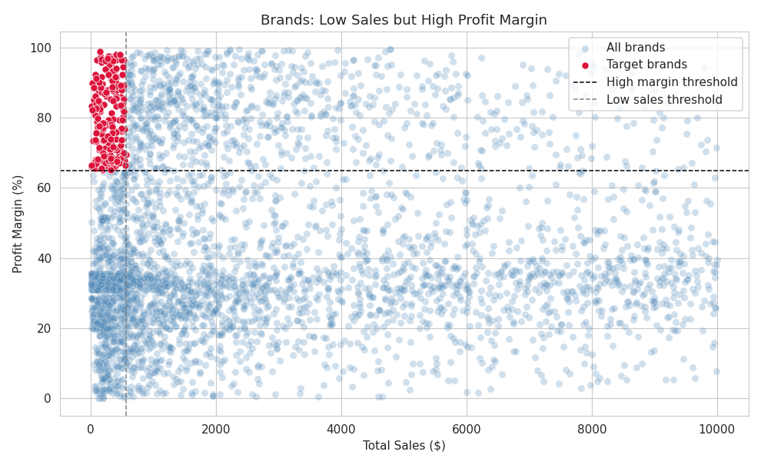
Figure 2 — Brands with low sales but high profit margin (red: target list for promotion).
Takeaway: 198 brands fit this pattern. Their margin is already proven — a promotional push or better shelf placement is a lower-risk way to grow revenue than launching new products.

2. Top Vendors by Sales & Purchase Contribution
Share of total purchase dollars by vendor:
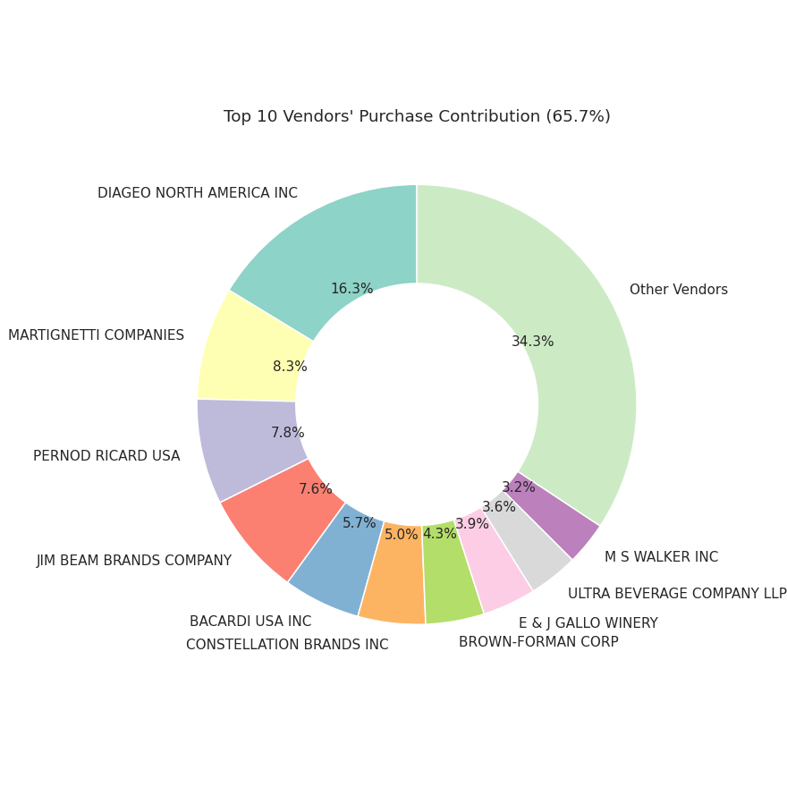
Figure 3 — Top 10 vendors' purchase contribution (65.7% of total).

Figure 4 — Top 10 vendors ranked by total sales dollars.
Takeaway: The top 10 vendors account for 65.7% of all purchases; the rest is spread thin. That's a real supply-chain concentration risk — losing one top vendor would hurt far more than losing any single smaller one.

3. Impact of Bulk Purchasing on Unit Cost
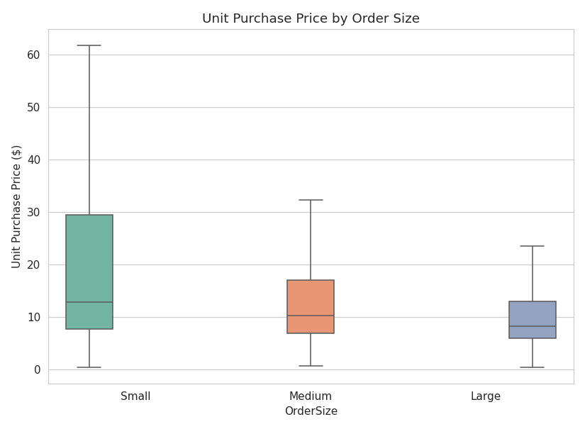
Figure 5 — Unit purchase price by order size (Small / Medium / Large, by purchase quantity tercile).
Order Size | Avg. Unit Purchase Price
Small | $39.06
Medium | $15.49
Large | $10.78

Takeaway: Large orders cost 72% less per unit than small orders ($10.78 vs. $39.06). Bulk buying is clearly worth it — provided the resulting stock actually sells (see next section).

4. Vendors with Low Inventory Turnover
Total capital currently tied up in unsold inventory: $2.71M.
Top vendors by unsold inventory value:
Vendor | Unsold Inventory Value
Diageo North America Inc | $722.21K
Jim Beam Brands Company | $554.67K
Pernod Ricard USA | $470.63K
William Grant & Sons Inc | $401.96K
E & J Gallo Winery | $228.28K

Takeaway: The vendors with the most locked-up capital are largely the same ones with the largest order volumes — unsurprising, but it means bulk-buying savings need to be paired with a demand forecast, or the savings get eaten by holding costs.

5. Profit Margin: High vs. Low-Performing Vendors
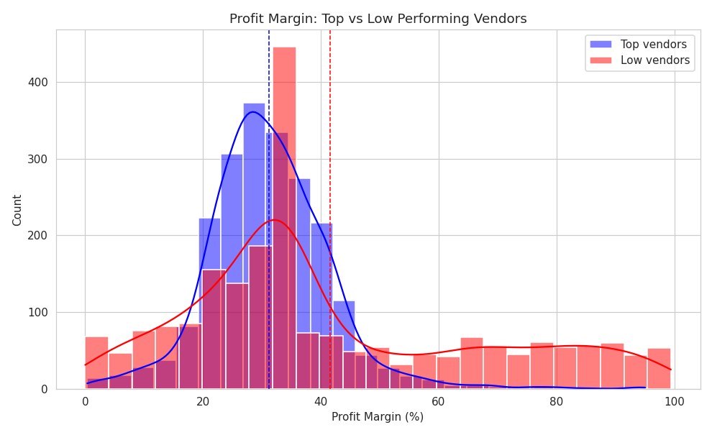
Figure 6 — Distribution of profit margin: top-quartile vendors (by sales) vs. bottom-quartile vendors.
Group | 95% Confidence Interval | Mean
Top vendors | 30.74% – 31.61% | 31.17%
Low vendors | 40.48% – 42.62% | 41.55%

Hypothesis Test
- H₀ (null): no real difference in mean profit margin between top and low vendors.
- H₁ (alternative): a real difference exists.
Result: Welch's t-test, t = −17.64, p < 0.001 — the null hypothesis is rejected.
Takeaway: The confidence intervals don't overlap and the gap is large (≈10 points). This isn't random noise — top-selling vendors and low-volume vendors are running on genuinely different pricing strategies (volume vs. margin).

Final Recommendations
- Promote, don't discount, the 198 low-sales/high-margin brands — the profitability is already there.
- Diversify the vendor base. A 65.7% purchase concentration in 10 vendors is a real supply-chain risk.
- Keep buying in bulk, but pair it with demand forecasting so the 72% unit-cost saving doesn't add to the $2.71M dead-stock problem.
- Run a targeted clearance for the specific low-turnover vendors identified, instead of a blanket discount.
- Revisit pricing for top vendors. Their margins run ~10 points thinner than low-volume vendors; a small, targeted adjustment on best sellers could recover profit without hurting volume.

Limitations & Next Steps
- No date field in the summary table — trends over time (seasonality, growth) aren't visible yet. Adding a monthly grain would unlock this.
- “Performance” is judged mainly on margin and volume; adding delivery lead-time data would round out the vendor-risk picture.
- Thresholds (15th/85th percentile, quartiles) are reasonable defaults, not tuned — worth a sensitivity check.
- Filtered-out rows (losses, dead stock) deserve their own follow-up analysis rather than being discarded.
- A vendor segmentation model (clustering on margin, volume, and turnover) would turn this from descriptive into predictive analysis.

