PROJECT DOCUMENTATION
GESTURE-CONTROLLED
ROBOT CAR

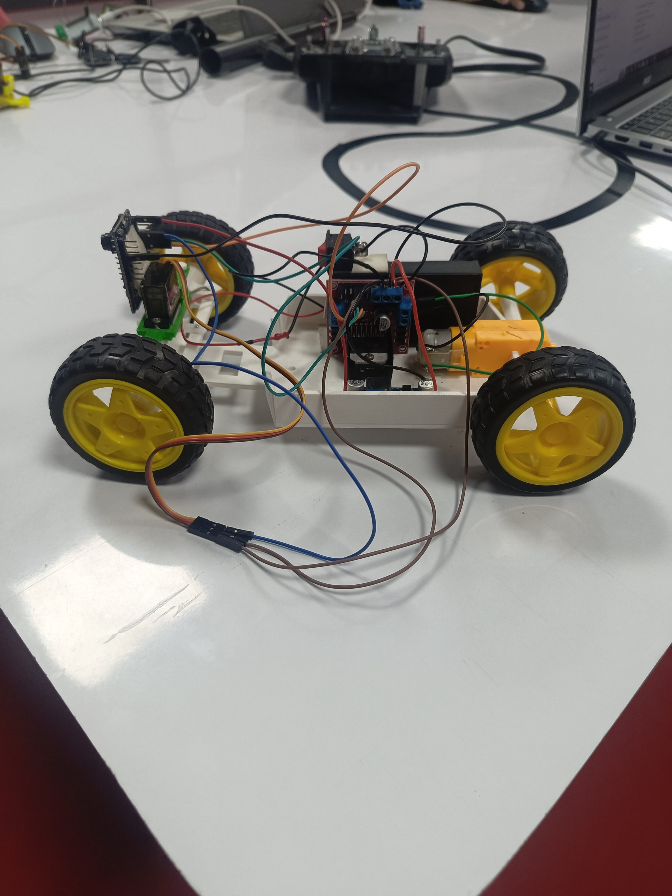
The gesture-controlled robot car build
AI-Thinker ESP32-CAM • L298N Motor Driver • Servo Motor • Gesture Control
Repository: gesture-controlled-car

Table of Contents
1. Project Overview 3
2. Project Objectives 4
3. Components 5
4. How the Project Works 6
5. Wiring 7
6. Power System 9
7. L298N Motor Driver 10
8. Servo 11
9. Buck Converter 12
10. Building the Robot 13
11. Programming the ESP32-CAM 14
12. Software Overview 16
13. Testing 17
14. Troubleshooting 18
15. Safety 19
16. Current Project Media 20
17. GitHub Repository Structure 21
18. Future Improvements 22
19. Final Summary 23

1. Project Overview
The Gesture-Controlled Robot Car is a small wheeled robot that is driven by hand gestures instead of a joystick, buttons, or a smartphone app. A camera mounted on the robot watches the operator's hand, and the movements it sees are turned into driving commands that are sent to the robot's motor and steering hardware in real time.
At the heart of the system is an AI-Thinker ESP32-CAM module. This single board combines a small camera with a Wi-Fi-capable microcontroller, which lets it act as both the "eyes" of the system and the main controller that decides how the robot should move. The ESP32-CAM communicates its movement decisions to an L298N motor driver board, which supplies the correct amount of power to a single DC motor that drives the robot forward, backward, or turns it.
In addition to driving the wheels, the ESP32-CAM also controls a servo motor. The servo can be used to rotate or reposition a mounted component, such as the camera itself, a sensor, or an indicator — giving the robot an extra degree of controlled movement beyond simple forward-and-back driving. Because the ESP32-CAM has a built-in camera, it can also stream a live video view, which allows an operator to see what the robot sees while driving it remotely.

Basic Concept
HAND GESTURE
↓
AI-THINKER ESP32-CAM
↓
CONTROL SIGNAL
↓
L298N MOTOR DRIVER
↓
ONE DC MOTOR
↓
ROBOT MOVEMENT
In simple terms: the operator makes a hand gesture in front of the camera, the ESP32-CAM interprets that gesture and converts it into a control signal, the L298N motor driver receives that signal and powers the DC motor accordingly, and the robot moves.
Not specified — verify with the final hardware/code.
The exact gesture-recognition algorithm running on or alongside the ESP32-CAM is not documented here.
The exact wireless communication protocol used to send commands to the robot is not documented here.
Refer to the source code in the code/ folder of this repository for the current implementation details.

2. Project Objectives
This project was built to bring together several areas of embedded systems and robotics into one working platform. Its main objectives are:
- Demonstrate gesture-based control of a physical robot
- Gain practical experience programming the ESP32-CAM module
- Implement motor control using a standard H-bridge driver (L298N)
- Implement servo control for positional movement
- Provide a remote camera view for driving the robot out of direct line of sight
- Explore wireless robotics as a control method
- Design a stable power-management scheme for mixed voltage components
- Combine hardware and software into a single, working, testable system

3. Components
The table below lists every component currently used in the build, along with the role each one plays.
Component | Purpose
AI-Thinker ESP32-CAM | Main controller and camera. Reads gesture input, makes movement decisions, and drives the motor and servo control signals.
L298N Motor Driver | Receives low-power control signals from the ESP32-CAM and switches higher-current power to the DC motor.
One DC Motor | Drives the robot. This build currently uses a single motor rather than one motor per wheel.
Servo Motor | Provides controlled rotation or positioning of a mounted component, driven directly from the ESP32-CAM.
Battery | Main power source for the whole system, supplying the L298N driver.
DC-DC Buck Converter | Steps the battery voltage down to a regulated supply suitable for powering the ESP32-CAM.
Robot Chassis | The frame that all other components are mounted to.
Wheels | Attach to the chassis and allow the robot to move across a surface.
Jumper Wires | Provide the electrical connections between all boards and components.
USB-to-Serial Programmer | Connects the ESP32-CAM to a computer so code can be uploaded, since the module has no built-in USB port.
Computer | Used to write, compile, and upload the project's code.
For anyone new to electronics: the ESP32-CAM is the "brain" of the robot, the L298N is a switch that is strong enough to handle the motor's power while being controlled by the ESP32-CAM's much smaller signals, the buck converter is a voltage regulator that protects the ESP32-CAM from being damaged by the battery's higher voltage, and everything else is mechanical support or wiring.

4. How the Project Works
The overall system operates through the following sequence of steps:
- The ESP32-CAM captures and interprets the hand-gesture input from its camera feed.
- The onboard program determines which movement the recognized gesture corresponds to.
- GPIO14 and GPIO15 on the ESP32-CAM send the motor-control signals for that movement.
- The L298N motor driver receives those control signals on its IN1 and IN2 inputs.
- The L298N switches power to drive the single DC motor accordingly.
- GPIO13 on the ESP32-CAM sends a separate servo control signal.
- The servo moves to the position instructed by the program.
- The ESP32-CAM's camera continues to provide a live remote visual view throughout operation.

Power, Control, and Data — What's the Difference?
It is worth being clear about four different things that travel through this circuit, because they are easy to confuse when starting out:
- Power — the 12 V from the battery and the regulated 5 V from the buck converter and the L298N. This is the electrical energy that runs every board and motor. It flows through thicker wiring.
- Control signals — the small GPIO14/GPIO15 signals from the ESP32-CAM to the L298N's IN1/IN2 inputs. These do not power the motor; they only tell the L298N which direction to switch the motor's power.
- Motor output — the higher-current power that the L298N itself switches out to the DC motor through OUT1/OUT2. This is derived from the battery power, not from the ESP32-CAM.
- Servo signal — the GPIO13 pulse signal that tells the servo what position to move to. Like the motor control signals, this is a small signal, separate from the servo's own power supply.
- Camera data — the video feed captured by the ESP32-CAM and transmitted for remote viewing. This is data, not electrical power, and travels over the wireless connection rather than through the wiring described above.

5. Wiring
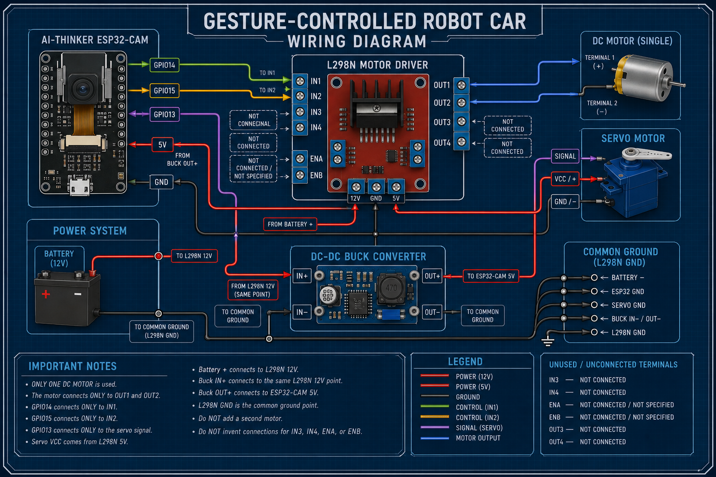
Figure 1 — Robot Car Wiring Diagram
The diagram above is the project's current wiring reference. It shows every connection currently used in the build. The exact connections are documented section by section below.

Motor
This build uses only one DC motor.
- L298N OUT1 → DC Motor terminal 1
- L298N OUT2 → DC Motor terminal 2
There is no second motor in this build, and none should be assumed.

Motor Control
- ESP32-CAM GPIO14 → L298N IN1
- ESP32-CAM GPIO15 → L298N IN2
The L298N's IN3, IN4, ENA, and ENB terminals are not connected in this build.

Servo
- ESP32-CAM GPIO13 → Servo Signal
- L298N 5V → Servo VCC (+)
- Servo GND → L298N GND

Power
- Battery + → L298N 12V
- L298N 12V → Buck Converter IN+
- L298N 5V → Servo VCC
- Buck Converter OUT+ → ESP32-CAM 5V

Common Ground
The L298N GND terminal is the common-ground point for the whole system. Every ground connection in the build ties back to it:
- Battery − → L298N GND
- ESP32-CAM GND → L298N GND
- Servo GND → L298N GND
If the buck converter used in the final build has a separate negative terminal for its input and/or output, that terminal should also be tied into this same common-ground point so that every board shares one consistent 0 V reference.

6. Power System
The robot is powered from a single battery, and that battery voltage is distributed to different boards at the correct level for each of them.
BATTERY +
↓
L298N 12V
↓
BUCK CONVERTER IN+
↓
BUCK CONVERTER OUT+
↓
ESP32-CAM 5V
Separately, the L298N also provides a 5 V output that supplies the servo:
- L298N 5V → Servo VCC
And every ground in the system is tied together at one shared reference point:
- Battery − + ESP32-CAM GND + Servo GND → L298N GND
A buck converter is used because the ESP32-CAM is a 5 V device, while the battery supplies a higher 12 V. Feeding 12 V directly into the ESP32-CAM's 5 V pin would overpower and likely destroy the board. The buck converter steps the voltage down to a safe, regulated level before it reaches the ESP32-CAM.
IMPORTANT
Always verify the buck converter's actual output voltage with a multimeter before connecting it to the ESP32-CAM's 5V pin. Adjustable buck converters can be set incorrectly and can output far more than 5V if left unchecked, which can permanently damage the ESP32-CAM.

7. L298N Motor Driver
The L298N is a motor driver board built around an H-bridge integrated circuit. Its job is to take the small, low-current control signals produced by a microcontroller like the ESP32-CAM and use them to switch a much larger current from the battery to a motor. A microcontroller's GPIO pins cannot safely drive a motor directly — they are only designed for small signal-level currents — so a driver board like the L298N sits in between as an electrically isolated "switch."
The terminals used in this project are:
Terminal | Function
12V | Main power input from the battery.
GND | Ground / common reference for the whole system.
5V | Regulated 5V output, used here to power the servo.
IN1 | Control input from ESP32-CAM GPIO14.
IN2 | Control input from ESP32-CAM GPIO15.
OUT1 | Motor output, connected to DC motor terminal 1.
OUT2 | Motor output, connected to DC motor terminal 2.
This project currently uses a single DC motor, connected only to OUT1 and OUT2. The L298N's second channel (IN3, IN4, OUT3, OUT4) and its enable pins (ENA, ENB) are not used and are not connected. No connections should be added to these terminals unless the design is deliberately extended to a second motor.

8. Servo
A typical hobby servo motor has three wires:
- VCC — power supply for the servo's internal motor and electronics
- GND — ground / return path for the power supply
- Signal — a control line that tells the servo what position to move to
In this project, the servo is wired as follows:
- Servo VCC → L298N 5V
- Servo GND → L298N GND
- Servo Signal → ESP32-CAM GPIO13
A servo is controlled differently from the DC motor. Instead of simply switching power on or off, the ESP32-CAM sends a repeating pulse on the signal wire. The width of each pulse tells the servo which angle to move to and hold. This is a standard method used across almost all hobby servos and is handled by the servo library used in the project's code.

9. Buck Converter
A buck converter is a small voltage-regulator circuit that takes a higher input voltage and steps it down to a lower, stable output voltage. It is more efficient than a simple resistive voltage drop and is the standard way to power a 5V device such as the ESP32-CAM from a higher-voltage battery.
The relevant terminals are:
- IN+ — positive voltage input, connected to the battery/L298N 12V rail
- IN− — negative input, tied to the common ground
- OUT+ — the regulated positive output, connected to the ESP32-CAM's 5V pin
- OUT− — the regulated negative output, tied to the common ground
In this project, the buck converter takes the battery's 12 V supply and converts it into a regulated voltage suitable for the ESP32-CAM, which requires 5 V.
IMPORTANT
Verify the buck converter output voltage before connecting it to the ESP32-CAM 5V pin.

10. Building the Robot
This section assumes the chassis, motor mounting, wheels, and general assembly are already handled by the builder — that part is left to individual preference and available parts. What matters for this project is mounting the ESP32-CAM, L298N, servo, battery, and buck converter somewhere accessible, and then making the electrical connections correctly. Once the boards are mounted anywhere sensible on the chassis, wire them up as follows:
- Motor → L298N OUT1 / OUT2 (see Section 5 — Wiring)
- ESP32-CAM GPIO14 → L298N IN1
- ESP32-CAM GPIO15 → L298N IN2
- ESP32-CAM GPIO13 → Servo Signal
- Battery, buck converter, and L298N power wiring → see Section 6 — Power System
- All grounds (battery −, ESP32-CAM GND, servo GND, buck converter GND) → L298N GND
Double-check every connection against Section 5 — Wiring and Figure 1 before applying power for the first time. Once wiring is confirmed, upload the code (Section 11) and work through the staged tests (Section 13) before running the robot freely.

11. Programming the ESP32-CAM
Code is uploaded to the ESP32-CAM using the Arduino IDE. Because the ESP32-CAM has no built-in USB port, an external USB-to-serial programmer is required to connect it to a computer.
1. Install Arduino IDE. Download and install the Arduino IDE on the computer that will be used for programming.
2. Install the ESP32 board package. Add ESP32 support to the Arduino IDE through the Boards Manager so it recognizes ESP32-based boards.
3. Select AI-Thinker ESP32-CAM. In the IDE's board list, choose the AI-Thinker ESP32-CAM entry so the correct pin mapping and settings are used.
4. Connect the USB-to-serial programmer. Wire the programmer to the ESP32-CAM's serial pins (TX, RX, GND, and the appropriate voltage) and plug it into the computer.
5. Select the correct COM/serial port. In the IDE, choose the port that corresponds to the connected USB-to-serial programmer.
6. Open the .ino file. Open the project's main Arduino sketch file in the IDE.
7. Check GPIO assignments. Confirm the GPIO pins used in the code match GPIO14, GPIO15, and GPIO13 as documented in this project.
8. Compile / verify. Use the IDE's Verify function to compile the code and check for errors before uploading.
9. Enter programming mode if required. Some ESP32-CAM boards need GPIO0 held to ground and the board reset to enter upload mode.
10. Upload. Use the IDE's Upload function to transfer the compiled program onto the ESP32-CAM.
11. Reset. Press the board's reset button, or power-cycle it, once the upload finishes.
12. Return to normal boot mode if required. If GPIO0 was grounded for programming, disconnect that connection so the board boots normally.
13. Test. Confirm the ESP32-CAM starts up and runs the uploaded program as expected.

Recommended Programmer Boards
The ESP32-CAM has no built-in USB port, so a separate USB-to-serial programmer is required. Any of the following work well for this project:
- FTDI FT232RL USB-to-TTL adapter — a reliable, widely-used choice; make sure its voltage-select jumper is set correctly before connecting it.
- CP2102 USB-to-UART board — a common, inexpensive alternative to the FTDI adapter with the same wiring approach.
- ESP32-CAM-MB programming shield — plugs directly onto the ESP32-CAM's pins and includes a CH340C USB-to-serial chip plus RESET and BOOT buttons, which removes most of the manual wiring and button-pressing needed with a plain FTDI/CP2102 adapter.
- Arduino Uno as a programmer — useful if no dedicated FTDI/CP2102/MB board is available; the Arduino Uno's own microcontroller is bypassed (or its RESET pin is tied to GND) so it acts purely as a USB-to-serial bridge for the ESP32-CAM.

Helpful Video Tutorials
The following videos walk through the upload process visually and can help alongside the written steps above:
- ESP32-CAM-MB programmer walkthrough — youtube.com/watch?v=z67mfL63e2M
- FTDI programmer walkthrough — youtube.com/watch?v=lVRYdDcngCg
- Uploading using an Arduino Uno as the programmer — youtube.com/watch?v=7-3piBHV1W0
Video content and third-party channels may change over time; if a link stops working, search for "program ESP32-CAM AI-Thinker Arduino IDE" to find an up-to-date equivalent.

Beginner Terms
Term | Meaning
GPIO | General Purpose Input/Output — a pin on the microcontroller that can be used to send or receive simple electrical signals.
Compile | The process of translating written code into a form the microcontroller can run.
Upload | Transferring the compiled program from the computer onto the microcontroller's memory.
Serial port | The communication channel (here, over the USB-to-serial programmer) used between the computer and the board.
Reset | Restarting the microcontroller so it begins running its program from the start.
Programming mode | A special startup state some ESP32 boards must be placed in before they will accept a new upload.

12. Software Overview
At a high level, the software running on the ESP32-CAM is responsible for:
- Starting up the ESP32-CAM and initializing its peripherals
- Handling the onboard camera
- Handling hand-gesture input captured by the camera
- Converting recognized gestures into movement commands
- Driving GPIO14 and GPIO15 to control the DC motor through the L298N
- Driving the servo through GPIO13
- Providing the camera / remote-view functionality for the operator
Not specified — verify with the final hardware/code.
The precise gesture-recognition method, thresholds, and any supporting software (for example, a companion app or computer-side processing) are implementation details of the code itself.
Refer directly to the source files in the code/ folder of this repository for the current, authoritative implementation.

13. Testing
Testing should be carried out in stages, confirming each subsystem individually before testing the complete robot.

Test 1 — Power
Check the power system and common ground. Confirm the battery, L298N, buck converter, and all ground connections are correct before powering on any board.

Test 2 — ESP32-CAM
Verify that the ESP32-CAM starts up correctly once powered.

Test 3 — Servo
Test GPIO13 and confirm the servo moves as expected.

Test 4 — Motor
Test the single motor through OUT1 and OUT2, ideally with the robot's wheels lifted off the ground.

Test 5 — Gesture control
Test that recognized hand gestures produce the correct movement commands.

Test 6 — Camera
Test the camera and confirm the remote view is working.

Test 7 — Full system
With all previous tests passed, test the complete robot together under normal operating conditions.

14. Troubleshooting
The table below lists common issues, their likely causes, and what to check first.
Problem | Possible Cause | What to Check
ESP32-CAM won't upload | Board not in programming mode, or wrong port selected | GPIO0-to-ground connection, board selection, and COM port in the IDE
ESP32-CAM doesn't start | No power reaching the board, or incorrect voltage | Buck converter output voltage and the 5V/GND connections to the ESP32-CAM
ESP32 keeps restarting | Insufficient or unstable power supply | Buck converter capacity and wiring; power draw from the camera and Wi-Fi radio
Servo doesn't move | No signal or no power reaching the servo | GPIO13 connection and the servo's VCC/GND wiring to the L298N
Servo moves incorrectly | Wrong signal timing or wiring mix-up | Signal wire connection and the code's servo position values
Motor doesn't move | No power reaching OUT1/OUT2, or a wiring fault | L298N power input, IN1/IN2 signal wiring, and the motor's own connections
Motor moves in the wrong direction | Motor wires reversed, or IN1/IN2 swapped | OUT1/OUT2-to-motor wiring and the GPIO14/GPIO15-to-IN1/IN2 wiring
Camera doesn't work | Camera module not seated, or code/board mismatch | Camera ribbon cable seating and that AI-Thinker ESP32-CAM is selected in the IDE
Gesture control doesn't respond | Poor camera view, lighting, or gesture out of range | Camera positioning, lighting conditions, and that the ESP32-CAM is running correctly
L298N becomes hot | Motor drawing excess current, or a wiring/stall issue | Motor for jams or stalls, and confirm current draw is within the L298N's rated limits
ESP32 becomes unstable when motor starts | Voltage dip caused by motor start-up current | Whether the ESP32-CAM and motor share a clean, sufficiently separated power supply and common ground

15. Safety
Follow these precautions at every stage of building and testing
Disconnect battery power before changing any wiring.
Check polarity before powering the system.
Never short the battery terminals.
Verify the buck converter output voltage before connecting the ESP32-CAM.
Keep wires away from moving parts, including wheels and the motor shaft.
Secure the battery so it cannot shift or come loose.
Test the motor with the robot lifted off the ground initially.
Stop testing immediately if a component becomes unusually hot or behaves unexpectedly.

16. Current Project Media
The repository currently contains two pieces of project media: a photo of the physical build, and a wiring diagram.

Robot Photo

Figure 2 — Current robot build

Circuit Diagram
The circuit diagram is shown as Figure 1 in Section 5 — Wiring, and is captioned there as "Current wiring diagram." It is not repeated here to avoid duplicating the same figure twice in this document.

17. GitHub Repository Structure
The repository is organized as follows:
gesture-controlled-car/
│
├── images/
│ ├── robot.jpg
│ └── circuit-diagram.png
│
├── code/
│ └── car-controller.ino
│
├── documentation/
│ └── gesture-controlled-car-documentation.pdf
│
└── README.md
This document
documentation/gesture-controlled-car-documentation.pdf is THIS document. It is authored as a Word file and exported to PDF for storage in the documentation folder, where it serves as the project's full technical and build reference.

Folder Overview
- images/ — contains the robot photo and the circuit diagram used throughout this document.
- code/ — contains the project's source code (the Arduino sketch uploaded to the ESP32-CAM).
- documentation/ — contains this document.
- README.md — provides a short overview of the project on the repository's main page.
No folders are included for media that does not currently exist in the project.

18. Future Improvements
The items below are potential directions for extending the project. None of these are implemented in the current build; they are listed here purely as future work.
- Add a second motor for independent left/right drive control
- Improve gesture recognition accuracy and reliability
- Add support for more gesture commands
- Improve camera streaming quality and latency
- Add camera pan/tilt using additional servos
- Add obstacle detection to prevent collisions
- Improve the chassis design for better stability
- Improve overall power management and battery life

19. Final Summary
The Gesture-Controlled Robot Car uses an AI-Thinker ESP32-CAM to read hand gestures through its camera and convert them into driving commands. Those commands are sent as control signals on GPIO14 and GPIO15 to an L298N motor driver, which powers a single DC motor connected to OUT1 and OUT2, driving the robot. A servo, controlled separately through GPIO13, provides controlled rotation or positioning of a mounted component, and the ESP32-CAM's onboard camera also provides a live remote view of the robot's surroundings.
Power for the system comes from a single battery. The L298N takes the full battery voltage directly, while a DC-DC buck converter steps that voltage down to a safe, regulated level for the ESP32-CAM, and the L298N's own 5V output separately powers the servo. Every ground in the system — battery negative, ESP32-CAM ground, servo ground, and the buck converter's ground — is tied back to the L298N's GND terminal as one shared common-ground point.
Code is written and uploaded to the ESP32-CAM using the Arduino IDE together with a USB-to-serial programmer, with the AI-Thinker ESP32-CAM board selected in the IDE. Before regular use, the system should be tested in stages — power, ESP32-CAM start-up, servo, motor, gesture control, camera, and finally the full system together — following the safety precautions in Section 15.
Within the project's GitHub repository, the robot photo and wiring diagram are stored in images/, the source code is stored in code/, and this document is stored in documentation/ as the project's complete technical and build reference.

