Module (Bootstrap Basic & Advanced)-6

1.What are the advantages of Bootstrap?

Ans. Bootstrap is a popular front-end framework for developing responsive and mobile-first websites.

Responsive Design:Its grid system and flexible layout options allow websites to adjust seamlessly to different screen sizes and devices.

Pre-designed Components:These components can be easily customized and integrated into projects, speeding up development time.

Consistency: Using Bootstrap ensures a consistent look and feel across different parts of a website.

Cross-browser Compatibility: Bootstrap is tested and compatible with all major browsers, ensuring that web applications look and function correctly across different platforms.

Customizable:Developers can override styles or use Bootstrap’s customization options to tailor the framework to their specific needs.

Community Support:This community support means that developers can find numerous resources, tutorials, and plugins to extend Bootstrap's capabilities.

Integration with JavaScript Libraries: Bootstrap includes built-in support for JavaScript components such as carousels, modals, and tooltips, which can enhance the functionality of a website without requiring additional JavaScript coding.

Speed and Efficiency: By using Bootstrap, developers can reduce the time required to create a fully functional and responsive website, as they can leverage pre-built components and styles.

2.What is a Bootstrap Container, and how does it work?

Ans.The container is used to center and horizontally pad your site's content. It serves as the outermost element within which you can place rows and columns to layout your page.

Types of Bootstrap Containers

Bootstrap provides three types of containers:

.container: This is a responsive, fixed-width container. It changes its width according to the current breakpoint

Extra small : 100% wide until it hits the small (sm) breakpoint

Small : 540px max width

Medium : 720px max width

Large : 960px max width

Extra large : 1140px max width

.container-fluid: This container is always 100% wide, spanning the entire width of the viewport, regardless of the screen size.

.container-{breakpoint}: Bootstrap 4 and newer versions introduce this class to create containers that are responsive to a specific breakpoint.

It works:

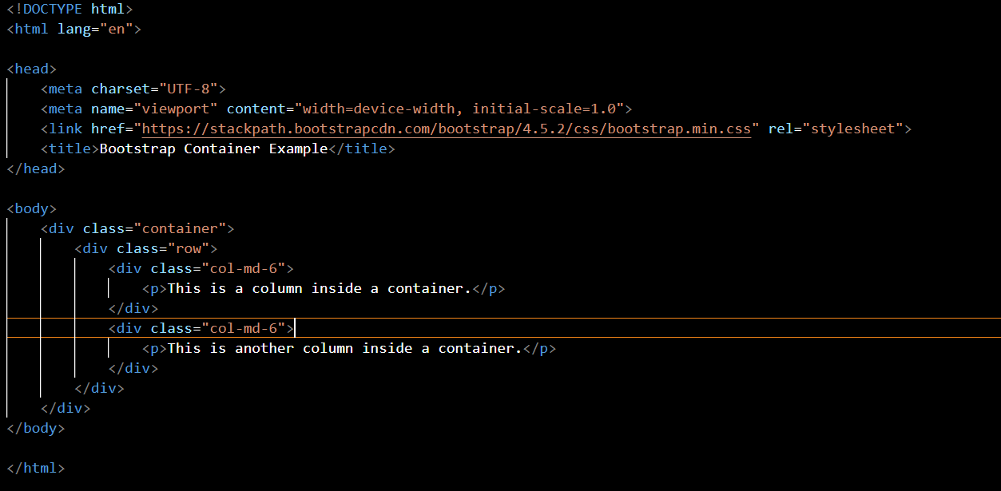

3.What are the default Bootstrap text settings?

Ans. Typography

- Font Family: Bootstrap uses font-family: "Helvetica Neue", Helvetica, Arial, sans-serif; for its body text.

Font Size: The default font size is 16px.

Line Height: The default line height is 1.5.

Font Weight: The default font weight is 400 (normal).

Color: The default text color is #212529, which is a dark gray to ensure readability.

Headings: h1 - h6 have specific font sizes and margins.

Text Utilities

Bootstrap provides several text utilities to help style text easily:

Text Alignment: Classes like .text-start, .text-center, .text-end for aligning text.

Text Transform: Classes like .text-lowercase, .text-uppercase, .text-capitalize for text transformation.

Font Weight: Classes like .fw-light, .fw-normal, .fw-bold for changing font weight.

Font Style: Use .fst-italic for italic text and .fst-normal to reset it.

Text Color: Utilities such as .text-primary, .text-secondary, .text-success, etc., for changing text color.

Text Decoration: Use .text-decoration-none to remove underlines from links.

Responsive Font Sizes

Bootstrap uses responsive font sizes (RFS) to adjust text size based on the viewport. This ensures text remains legible across various device sizes.

These defaults can be easily customized using Bootstrap's SASS variables or by overriding the CSS in your stylesheets.

4.What do you know about the Bootstrap Grid System?

Ans.Responsive Design: The grid system is designed to create layouts that adapt to different screen sizes, ensuring that web pages look good on devices ranging from mobile phones to desktop computers.

Column System: The grid is based on a 12-column layout, which allows developers to divide the page into up to 12 equal parts.

Container Classes: The grid system uses container classes to wrap the grid content. The two main types are .container for fixed-width layouts and .container-fluid for full-width layouts that stretch across the entire screen.

Rows and Columns: The grid system uses .row classes to create horizontal groups of columns

Breakpoints: Bootstrap includes several responsive breakpoints that allow developers to control the layout for different device sizes.

Nesting: Columns can be nested within other columns, allowing for complex layouts within a single grid system.

Auto Layout: The grid system can automatically adjust column sizes based on the content or screen size, allowing for more flexible layouts without specifying exact column widths.

5.What is the difference between Bootstrap 4 and bootstrap?

Ans.Flexbox Layout: Bootstrap 4 uses Flexbox for its grid system, which provides more flexibility and control over the layout compared to the float-based layout of previous versions.

Improved Grid System: Bootstrap 4 offers more responsive breakpoints and a more powerful grid system, making it easier to create complex layouts.

Customizable with SASS: Bootstrap 4 uses SASS for its stylesheets, allowing for easier customization and theming compared to LESS used in Bootstrap 3.

Cards Component: The introduction of the "cards" component in Bootstrap 4 replaces several older components like panels, thumbnails, and wells, providing a more flexible and extensible component for displaying content.

Dropped Support for Older Browsers: Bootstrap 4 dropped support for older versions of Internet Explorer, which allowed it to leverage newer CSS and JavaScript features.

Reboot CSS: Bootstrap 4 includes a new CSS reset called "Reboot," which builds on Normalize.css to provide more consistent styling across browsers.

Utility Classes: There is a greater emphasis on utility classes in Bootstrap 4, which allows for more precise and reusable styling without needing to write custom CSS.

6.What is a Button Group, and what is the class for a basic Button Group?

Ans. In web development, particularly when using frameworks like Bootstrap, a \*Button Group\* is a component that groups a series of buttons together on a single line.

Basic Button Group Classes

btn-group

html

<div class="btn-group" role="group" aria-label="Basic example">

<button type="button" class="btn btn-primary">Left</button>

<button type="button" class="btn btn-primary">Middle</button>

<button type="button" class="btn btn-primary">Right</button>

</div>

2.btn-group-vertical

html

<div class="btn-group-vertical" role="group" aria-label="Vertical button group">

<button type="button" class="btn btn-primary">Top</button>

<button type="button" class="btn btn-primary">Middle</button>

<button type="button" class="btn btn-primary">Bottom</button>

</div>

7.How can you use Bootstrap to make thumbnails?

Ans.

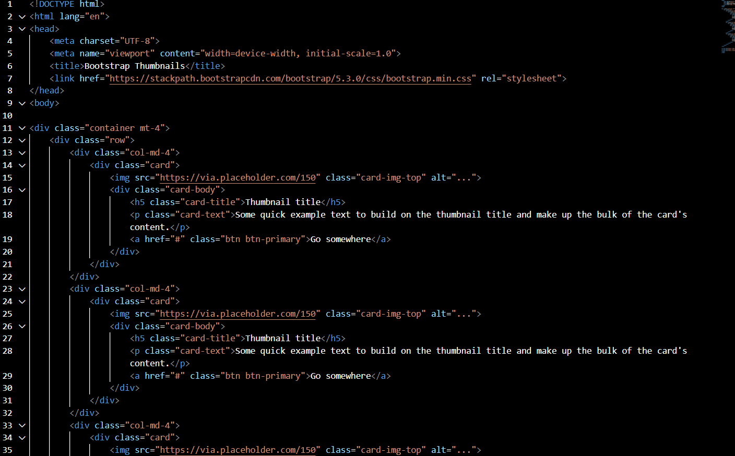

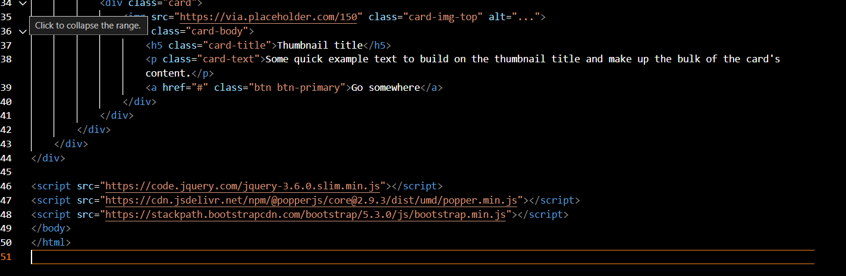

Explanation

Container: The container class centers your content and provides some padding.

Row: The row class creates a horizontal group of columns.

Customization

Images: Replace the src attribute with the URL of your image.

Text: Update the card-title and card-text with your own content.

Button: Customize the button with your desired link and text.

8.In Bootstrap 4, what is flexbox?

Ans.Flexbox in Bootstrap 4:

Flex Container: The parent element becomes a flex container when you apply the d-flex class. This enables flex properties for its direct children.

Flex Items: The direct children of a flex container become flex items, and they can be controlled using various flexbox properties.

Direction: You can control the direction of the flex items using the flex-direction property with values such as row, row-reverse, column, and column-reverse.

Alignment: Flexbox provides several classes to align items

Wrap: The flex-wrap property allows flex items to wrap onto multiple lines if needed (e.g., flex-wrap, flex-nowrap, flex-wrap-reverse).

Order: You can change the visual order of flex items using the order class.

Grow and Shrink: Control how items grow and shrink within a container using flex-grow, flex-shrink, and flex-basis.

9.How can one create an alert in Bootstrap?

Ans. 1. Include Bootstrap in Your Project

First, ensure that you have included Bootstrap's CSS and JavaScript files in your project. You can either download Bootstrap or use a CDN.

2. Create a Basic Alert

To create a basic alert, you can use the .alert class along with a contextual class to specify the alert type.

3. Adding a Dismiss Button

To make the alert dismissible, add the .alert-dismissible class and a close button

4. Using JavaScript to Trigger Alerts

Bootstrap alerts can also be triggered using JavaScript for more dynamic behavior. Here's an example using JavaScript to add an alert dynamically

5. Customizing Alerts

You can customize alerts by adding additional classes or styles. You can also use Bootstrap's utility classes to change padding, margins, and more.

10.What is a bootstrap card and how would you create one?

Ans.