Module (JQuery Basic, Effects & Advanced)-5

1.What is jQuery?

Ans. jQuery is a fast, small, and feature-rich JavaScript library designed to simplify the client-side scripting of HTML.Here are some key features and benefits of jQuery:

Simplifies HTML Document Traversal and Manipulation: jQuery provides a simplified syntax for selecting and manipulating HTML elements.

Event Handling:This includes handling user interactions like clicks, form submissions, and more.

AJAX Support: jQuery simplifies the process of making asynchronous HTTP requests to load data from a server without refreshing the page, using its AJAX functions.

Animation and Effects: It provides methods for creating animations and effects, making it easy to create visually appealing transitions and interactions.

Cross-Browser Compatibility: jQuery handles many of the inconsistencies and issues between different web browsers, allowing developers to write code that works seamlessly across all major browsers.

Plugins: jQuery has a large ecosystem of plugins that extend its functionality. Developers can use these plugins to add features like sliders, date pickers, and more to their websites.

Lightweight: Despite its capabilities, jQuery is lightweight, making it efficient in terms of load times and performance.

2.How to Apply CSS Using JQuery, How to Add Class and Remove Class in Jquery, Jquery Animation?

Ans.CSS Using JQuery

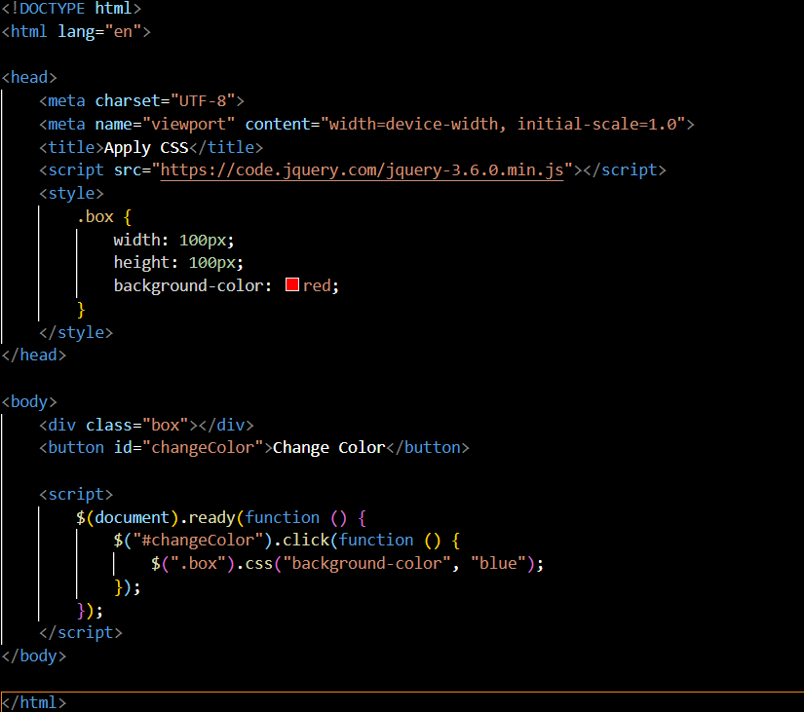

Add and Remove Classes Using jQuery:

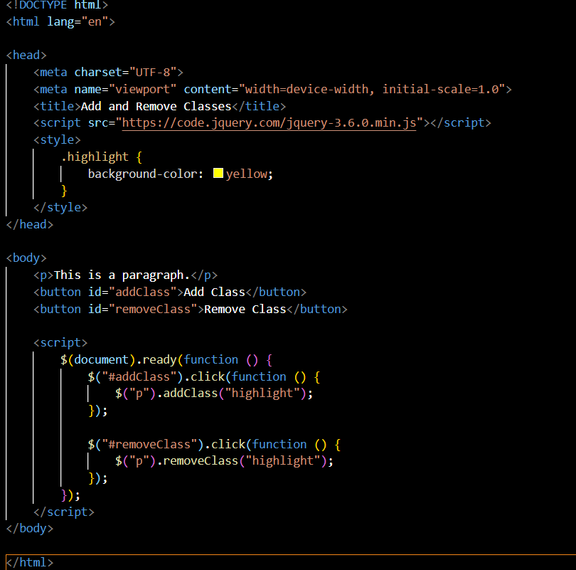

jQuery Animation:



3.How to create slider with animation?

Ans.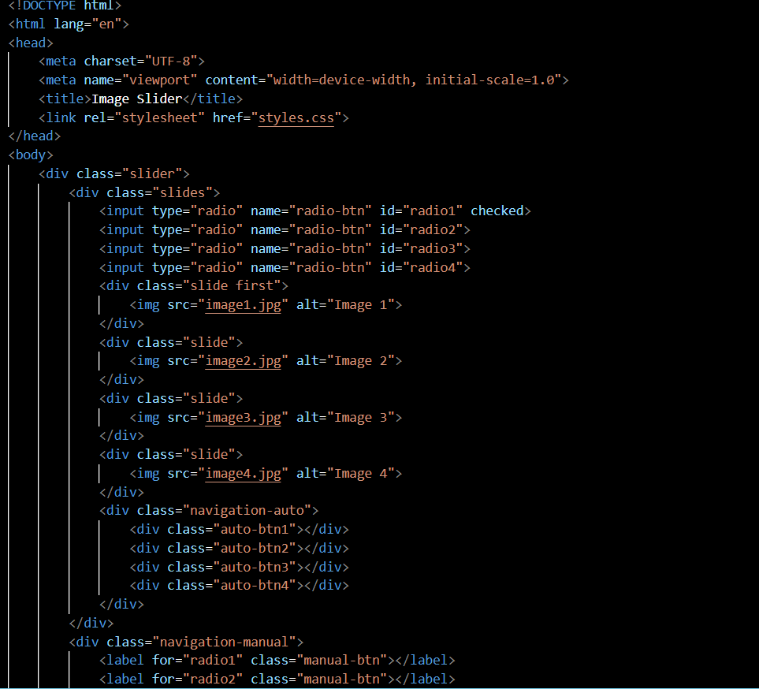

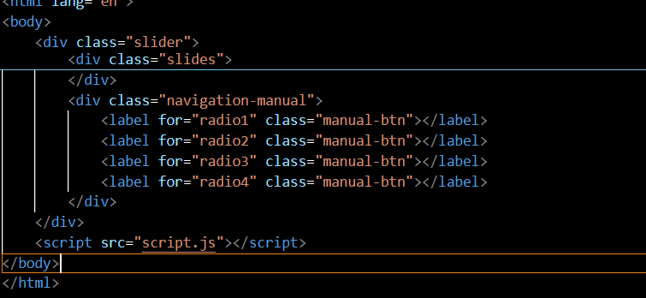Css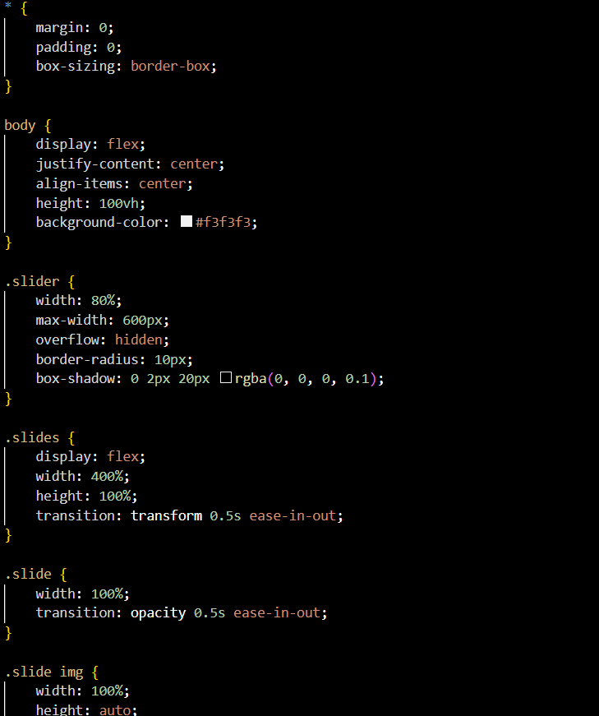

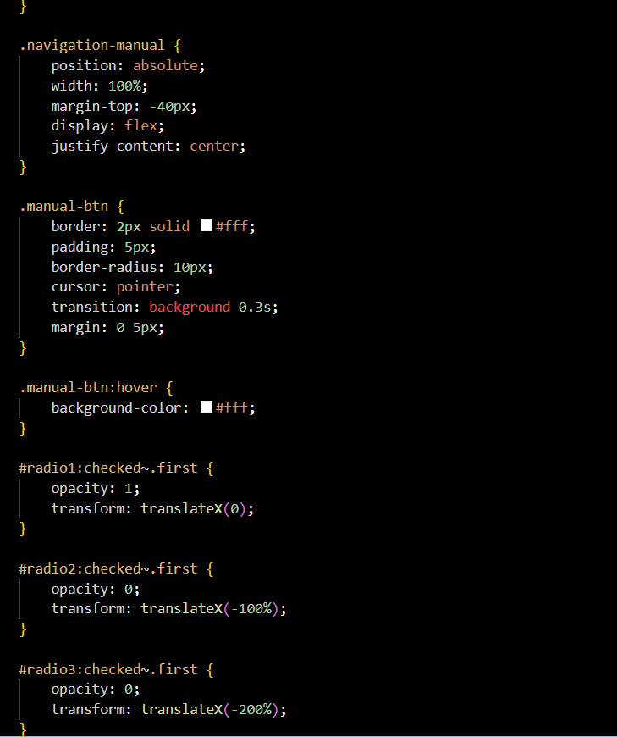

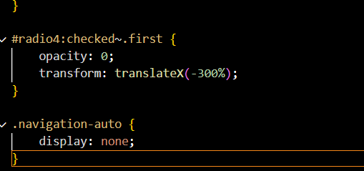

Javascript

