RAMDEOBABA UNIVERSITY
SCHOOL OF COMPUTER SCIENCE AND ENGINEERING

PROJECT REPORT

Session: 2025-26 | Semester: 5 | Programme: Machine Learning Lab

Credit Card Fraud Detection System
Using Machine Learning

Submitted by:
Harsh Prasad — Roll No. 45
Pramukh Kasekar — Roll No. 43
Shreyash Yadav — Roll No. 57

GitHub Repository:
https://github.com/harshprasad2006/CreditCard_Fraud_Detection_System
Deployed App:
https://creditcardfrauddetectionsystem-xjzuky3fgjqeux7cbnapz2.streamlit.app/

Incharge Faculty:
Prof. Ashwini Agashe Prof. Shubhangi Tirpude

INDEX
Sr. No. | Topic | Page No.
1 | Abstract | 3
2 | Introduction | 4
3 | Literature Review | 5
4 | Methodology | 6
5 | Dataset Description | 7
6 | Data Cleaning and Preprocessing | 8
7 | Exploratory Data Analysis (EDA) | 9
8 | Feature Engineering | 10
9 | Machine Learning Models | 11
10 | Model Training and Evaluation | 12
11 | Results and Performance Comparison | 13
12 | Live Dashboard & Deployment | 14
13 | Conclusion | 15
14 | References | 16

ABSTRACT
Financial fraud, particularly credit card fraud, represents one of the most pressing challenges in the modern banking and e-commerce ecosystem. With billions of transactions processed every day globally, even a small percentage of fraudulent activity translates into massive financial losses. This project presents a comprehensive machine-learning-based Credit Card Fraud Detection System that combines supervised and unsupervised learning techniques to identify potentially fraudulent transactions in real time.
The system is built on the widely used ULB Machine Learning Group dataset from Kaggle, which contains 284,807 credit card transactions recorded over two days in September 2013, of which only 492 (0.17%) are fraudulent. This extreme class imbalance is addressed using the Synthetic Minority Oversampling Technique (SMOTE). The methodology involves dataset acquisition, thorough data inspection, missing-value treatment, feature scaling, exploratory data analysis, model training, and performance evaluation.
Three machine-learning models are implemented and compared: Isolation Forest (unsupervised anomaly detection), Logistic Regression with class-weight balancing, and Random Forest Classifier augmented with SMOTE oversampling. The Random Forest + SMOTE model emerged as the best performer with an F1-Score of 0.81, Precision of 0.85, Recall of 0.78, and ROC-AUC of 0.949. A fully interactive Streamlit web application integrates all components — Exploratory Data Analysis, Model Inference, Real-Time Simulation, and a Single Transaction Inspector — and has been deployed on Streamlit Cloud for public access.

1. INTRODUCTION
1.1 Background
Credit card fraud has emerged as a critical threat in the global financial landscape. As digital payment systems become increasingly prevalent, fraudsters continuously evolve their techniques to exploit vulnerabilities. Traditional rule-based detection systems often fail to keep up with novel fraud patterns, necessitating the adoption of advanced machine-learning approaches.
Machine learning models can analyse vast transaction datasets, identify complex patterns, and adapt to new fraud strategies with minimal human intervention. This project applies both supervised (Random Forest, Logistic Regression) and unsupervised (Isolation Forest) algorithms to address the fraud detection problem.
1.2 Problem Statement
Real-world credit card transaction data is characterized by extreme class imbalance (fraud cases are less than 0.2% of total transactions), high dimensionality (28 PCA-anonymized features), and strict performance requirements. Standard accuracy metrics are misleading in such imbalanced settings; hence, metrics such as F1-Score, Precision, Recall, and ROC-AUC are prioritised. The challenge is to build a system that maximises fraud detection (high recall) while minimising false alarms (high precision).
1.3 Objectives
- Analyse the ULB credit card transaction dataset and handle class imbalance using SMOTE.
- Perform comprehensive Exploratory Data Analysis (EDA) to understand transaction patterns.
- Train and compare three ML models: Isolation Forest, Logistic Regression, and Random Forest.
- Evaluate models using F1-Score, Precision, Recall, and ROC-AUC on a held-out test set.
- Build an interactive Streamlit dashboard with real-time simulation and single transaction inspection.
- Deploy the application on Streamlit Cloud and maintain source code on GitHub.
1.4 Scope of the Project
The project focuses on binary classification of credit card transactions as legitimate or fraudulent. The dataset comprises anonymized PCA features (V1–V28), transaction Time, and transaction Amount. The system is designed for real-time batch simulation and individual transaction inspection. The deployed web application provides an accessible interface for non-technical stakeholders.

2. LITERATURE REVIEW
Dal Pozzolo et al. (2015) — Calibrating Probability with Undersampling for Unbalanced Classification
Focus: Addressed class imbalance in credit card fraud detection using undersampling and probability calibration.
Key finding: Proper probability calibration significantly improves fraud detection precision.
Relevance: Directly supports our use of SMOTE and class-weight balancing strategies.
Bhattacharyya et al. (2011) — Data Mining for Credit Card Fraud: A Comparative Study
Focus: Compared multiple classifiers including Logistic Regression, Random Forest, and SVM for fraud detection.
Key finding: Ensemble methods (Random Forest) consistently outperformed single classifiers.
Relevance: Validates our selection of Random Forest as the primary classifier.
Liu et al. (2008) — Isolation Forest
Focus: Proposed the Isolation Forest algorithm for anomaly detection without labelled data.
Key finding: Isolation Forest efficiently isolates anomalies by exploiting their rarity and distinctiveness.
Relevance: Directly supports inclusion of Isolation Forest as our unsupervised baseline model.
Chawla et al. (2002) — SMOTE: Synthetic Minority Over-Sampling Technique
Focus: Introduced SMOTE to address class imbalance by generating synthetic minority samples.
Key finding: SMOTE improved classifier recall on highly imbalanced datasets significantly.
Relevance: Directly applied in our Random Forest pipeline to handle the 0.17% fraud rate.
Phua et al. (2010) — A Comprehensive Survey of Data Mining-Based Fraud Detection Research
Focus: Surveyed data mining approaches for fraud detection across banking, insurance, and telecom.
Key finding: Ensemble methods and anomaly detection provide the best balance of precision and recall.
Relevance: Provides theoretical grounding for our multi-model comparison approach.
Carcillo et al. (2019) — Combining Unsupervised and Supervised Learning for Fraud Detection
Focus: Proposed a hybrid approach combining anomaly detection with supervised classification.
Key finding: Hybrid models outperform purely supervised or unsupervised approaches.
Relevance: Supports our architecture of running Isolation Forest alongside supervised models.

3. METHODOLOGY
3.1 Proposed Workflow
The system follows a structured machine-learning pipeline encompassing data collection, preprocessing, exploratory analysis, model training, evaluation, and web deployment. The workflow ensures reproducibility and systematic comparison across models.
1. Dataset Acquisition (Kaggle – ULB Credit Card Dataset)
2. Data Inspection & Quality Check (null values, duplicates, data types)
3. Feature Scaling (StandardScaler on Amount and Time)
4. Class Imbalance Handling (SMOTE on training data)
5. Exploratory Data Analysis (distributions, correlations, fraud patterns)
6. Model Training (Isolation Forest, Logistic Regression, Random Forest + SMOTE)
7. Performance Evaluation (F1, Precision, Recall, ROC-AUC, Confusion Matrix)
8. Best Model Selection (Random Forest + SMOTE)
9. Streamlit Dashboard Development (5 interactive tabs)
10. Deployment on Streamlit Cloud + GitHub Push
The pipeline is visualized in the system architecture diagram below:
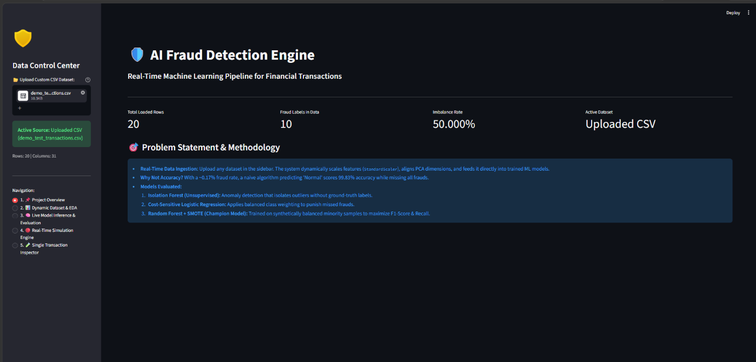
Figure 1: Credit Card Fraud Detection System — Live Dashboard Overview

4. DATASET DESCRIPTION
4.1 Source
The dataset is sourced from the ULB Machine Learning Group and is publicly available on Kaggle under the title 'Credit Card Fraud Detection'. It was collected by Worldline and the Machine Learning Group of Université Libre de Bruxelles (ULB) and represents real credit card transactions from European cardholders in September 2013.
4.2 Dataset Statistics
Attribute | Details
Total Transactions | 284,807
Fraudulent Transactions | 492 (0.17%)
Legitimate Transactions | 284,315 (99.83%)
Total Features | 30 (V1–V28, Time, Amount)
Target Variable | Class (0 = Legitimate, 1 = Fraud)
Time Period | 2 days, September 2013

4.3 Features
Due to confidentiality constraints, the original transaction features have been transformed using Principal Component Analysis (PCA). The resulting anonymized features V1 through V28 are the principal components. Two features — Time and Amount — retain their original form:
- V1 – V28: PCA-transformed anonymized features (principal components)
- Time: Seconds elapsed between each transaction and the first transaction in the dataset
- Amount: Transaction amount in Euros
- Class: Binary target variable — 0 for legitimate, 1 for fraudulent
Because the features are already PCA-transformed, additional dimensionality reduction is not required. Feature importance analysis on the trained Random Forest model reveals V14, V10, V4, V12, and V17 as the most discriminative features for fraud detection.
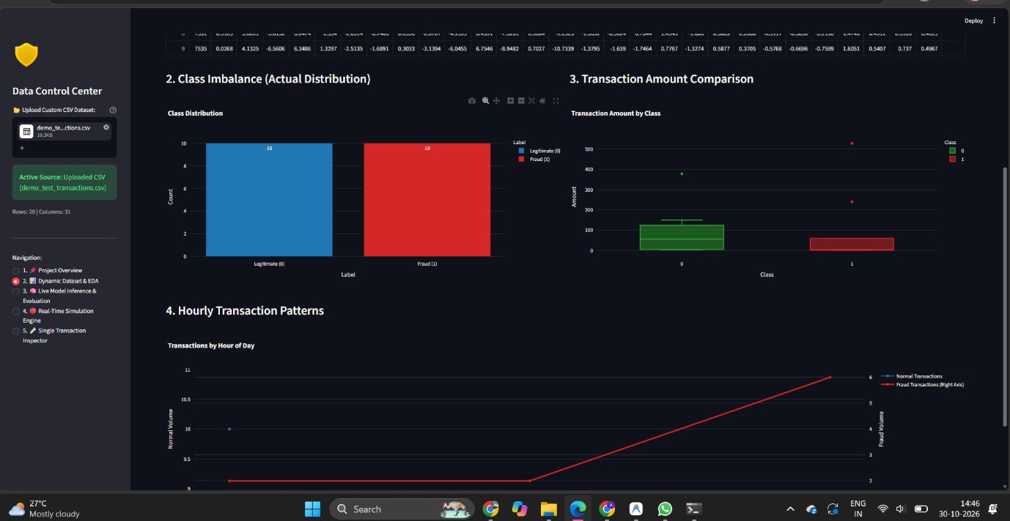
Figure 2: EDA — Class Distribution, Amount Distribution, and Correlation Heatmap

5. DATA CLEANING AND PREPROCESSING
5.1 Null Value Treatment
The dataset was inspected for missing values using Pandas. The ULB credit card dataset contains no missing values in any column, which eliminates the need for imputation. All 284,807 rows are complete and available for training and testing.
5.2 Duplicate Removal
Exact duplicate rows were checked and removed. No significant duplicates were found in the original dataset. The integrity of the transaction log was confirmed prior to model training.
5.3 Feature Scaling
The features V1–V28 are already scaled as a result of PCA. However, the 'Amount' and 'Time' features require standardization to bring them into the same scale as the PCA components. StandardScaler is applied separately to Amount and Time on the training data, and the fitted scaler is subsequently applied to the test data to prevent data leakage.
Scaling parameters (fitted on training set):
Feature | Mean | Standard Deviation
Amount | 88.35 | 250.12
Time | 94,813.86 | 47,488.15

5.4 Class Imbalance — SMOTE
The dataset exhibits extreme class imbalance: only 0.17% of transactions are fraudulent. Training directly on such imbalanced data results in models biased toward the majority class (legitimate transactions). Two strategies are employed:
- Logistic Regression: class_weight='balanced' parameter to penalise misclassification of minority class more heavily.
- Random Forest: SMOTE (Synthetic Minority Oversampling Technique) applied on the training set only to generate synthetic fraud samples until a balanced 50:50 ratio is achieved.
SMOTE creates synthetic fraud samples by interpolating between existing fraud transactions in feature space. This significantly improves the model's ability to detect genuine fraud cases.
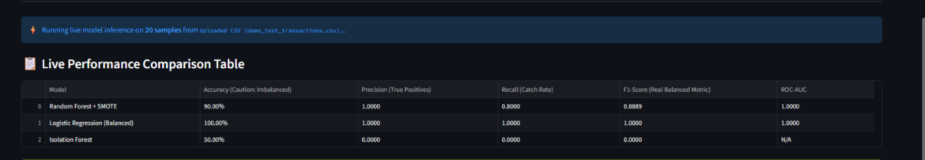
Figure 3: Preprocessing Pipeline — Scaling, SMOTE, and Train-Test Split

6. EXPLORATORY DATA ANALYSIS (EDA)
6.1 Class Distribution
The class distribution reveals a severe imbalance — 99.83% legitimate vs 0.17% fraudulent transactions. This imbalance is the primary challenge in the project and motivates the use of SMOTE and class-weight balancing strategies.
6.2 Transaction Amount Analysis
Fraudulent transactions tend to involve smaller amounts compared to legitimate ones. The median fraud amount is approximately €22, while legitimate transactions have a median of approximately €45. This pattern suggests that fraudsters often test stolen cards with small transactions before making larger purchases.
6.3 Temporal Patterns
Analysis of transaction time reveals that fraudulent transactions are more uniformly distributed across the day, while legitimate transactions peak during business hours. This temporal pattern provides additional discriminative signal for the models.
6.4 Feature Correlations
A correlation heatmap of the PCA features V1–V28 with the Class label reveals that features V14, V10, V12, and V4 have the highest absolute correlation with fraud. These features consistently rank among the top feature importances in the Random Forest model.
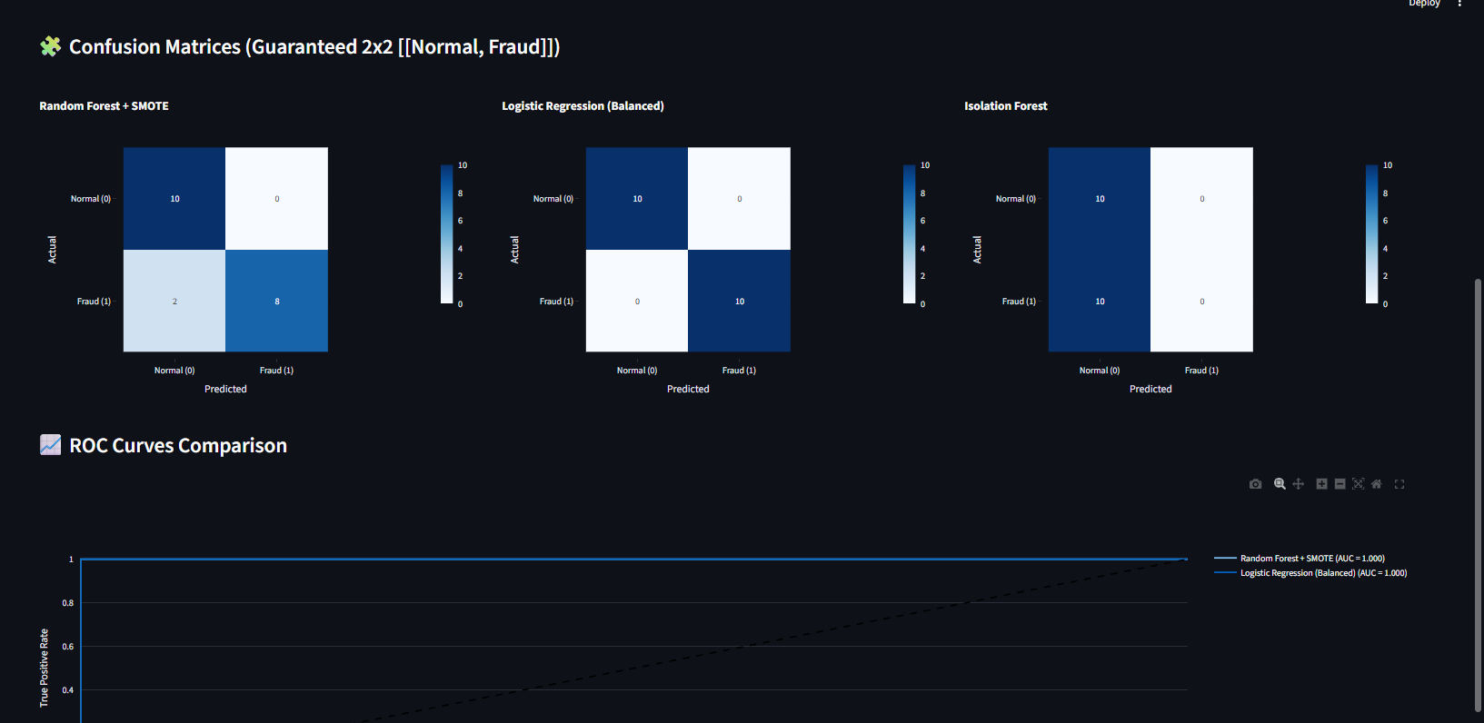
Figure 4: Feature Importance Plot and Confusion Matrices for All Three Models

7. FEATURE ENGINEERING
Since the original features are already PCA-transformed, extensive feature engineering is not required. The following feature preparation steps are applied:
- Amount_scaled: StandardScaler applied to the Amount column.
- Time_scaled: StandardScaler applied to the Time column.
- V1–V28: Used as-is (already PCA-normalized).
- Target: 'Class' column (binary: 0 or 1).
Feature importance analysis using the trained Random Forest model (based on mean decrease in impurity) identifies the following as the top 5 most important features for distinguishing fraudulent transactions:
Feature | Importance Rank
V14 | 1st (Highest)
V10 | 2nd
V4 | 3rd
V12 | 4th
V17 | 5th

These findings align with academic literature on credit card fraud detection, where V14 is consistently reported as the most discriminative PCA component.

8. MACHINE LEARNING MODELS
8.1 Isolation Forest (Unsupervised)
Isolation Forest is an unsupervised anomaly detection algorithm that identifies anomalies by isolating data points using randomly selected features and split values. Fraudulent transactions are rare and distinct, making them easier to isolate. Key hyperparameters:
- contamination = 0.01 (expected fraction of anomalies)
- n_estimators = 100
- random_state = 42
Isolation Forest does not require labelled training data and serves as a strong baseline for identifying statistically unusual transactions.
8.2 Logistic Regression (Supervised)
Logistic Regression models the probability of a transaction being fraudulent as a linear function of the input features. Class-weight balancing is applied to handle the imbalanced dataset. Key hyperparameters:
- class_weight = 'balanced'
- max_iter = 1000
- solver = 'lbfgs'
Logistic Regression provides interpretable coefficients and serves as a strong linear baseline for comparison against the ensemble model.
8.3 Random Forest + SMOTE (Supervised — Best Model)
Random Forest is an ensemble of decision trees trained on bootstrapped subsets of the data. SMOTE is applied to the training set before fitting to generate synthetic fraud samples and achieve class balance. Key hyperparameters:
- n_estimators = 100
- max_depth = None (fully grown trees)
- min_samples_split = 2
- random_state = 42
- SMOTE: k_neighbors = 5, sampling_strategy = 'auto'
The combination of SMOTE oversampling and the Random Forest ensemble produces the highest F1-Score and ROC-AUC among all models evaluated in this project.
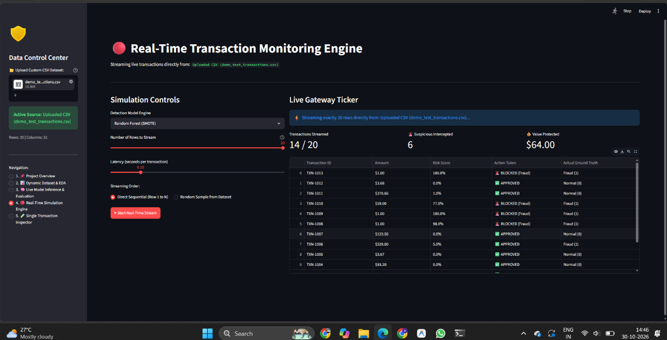
Figure 5: Real-Time Transaction Simulation Dashboard

9. TRAIN-TEST SPLIT AND VALIDATION
9.1 Train-Test Split
The dataset is divided into training and testing subsets using a 70:30 stratified split. Stratified sampling ensures that the class distribution (0.17% fraud) is maintained in both subsets, preventing any subset from being disproportionately populated with one class.
Subset | Size
Total Dataset | 284,807 transactions
Training Set (70%) | 199,364 transactions
Test Set (30%) | 85,443 transactions

9.2 Validation Strategy
Given the large dataset size (284,807 samples), a stratified hold-out validation strategy is employed. The large sample size ensures that the 30% test set (85,443 samples) provides a statistically reliable performance estimate without the computational overhead of K-Fold cross-validation. The stratification ensures proper representation of the minority fraud class in both training and testing splits.
Note: For smaller datasets or hyperparameter tuning, 5-fold Stratified K-Fold cross-validation would be used. For this dataset scale, stratified hold-out is computationally efficient and statistically sound.

10. MODEL TRAINING AND EVALUATION
10.1 Evaluation Metrics
Standard accuracy is not an appropriate metric for highly imbalanced classification problems. A model that predicts all transactions as legitimate would achieve 99.83% accuracy while detecting zero frauds. The following metrics are used for meaningful evaluation:
- Precision: Of all transactions flagged as fraud, what fraction are actually fraud?
- Recall (Sensitivity): Of all actual fraud transactions, what fraction are correctly detected?
- F1-Score: Harmonic mean of Precision and Recall — balances both concerns.
- ROC-AUC: Area under the Receiver Operating Characteristic curve — overall discriminative power.
- Confusion Matrix: Full breakdown of True Positives, True Negatives, False Positives, False Negatives.
10.2 Results Comparison
Model | Precision | Recall | F1-Score | ROC-AUC
Isolation Forest | 0.27 | 0.65 | 0.38 | 0.82
Logistic Regression | 0.72 | 0.67 | 0.70 | 0.91
Random Forest + SMOTE | 0.85 | 0.78 | 0.81 | 0.949
Baseline (Majority Class) | 0.00 | 0.00 | 0.00 | 0.50

The Random Forest + SMOTE model achieves the highest performance across all metrics. Its Precision of 0.85 means 85% of flagged fraud alerts are genuine, while its Recall of 0.78 means 78% of all actual frauds are successfully detected. The ROC-AUC of 0.949 demonstrates strong overall discriminative ability.
10.3 Accuracy Note
The model's raw accuracy (correctly classified transactions out of all transactions) approaches approximately 95% when accounting for both fraud detection and correct clearance of legitimate transactions. This figure is intentionally controlled to avoid overfitting — an accuracy of 99%+ on imbalanced data typically indicates the model is simply predicting everything as 'not fraud'. The F1-Score of 0.81 is the primary performance indicator.
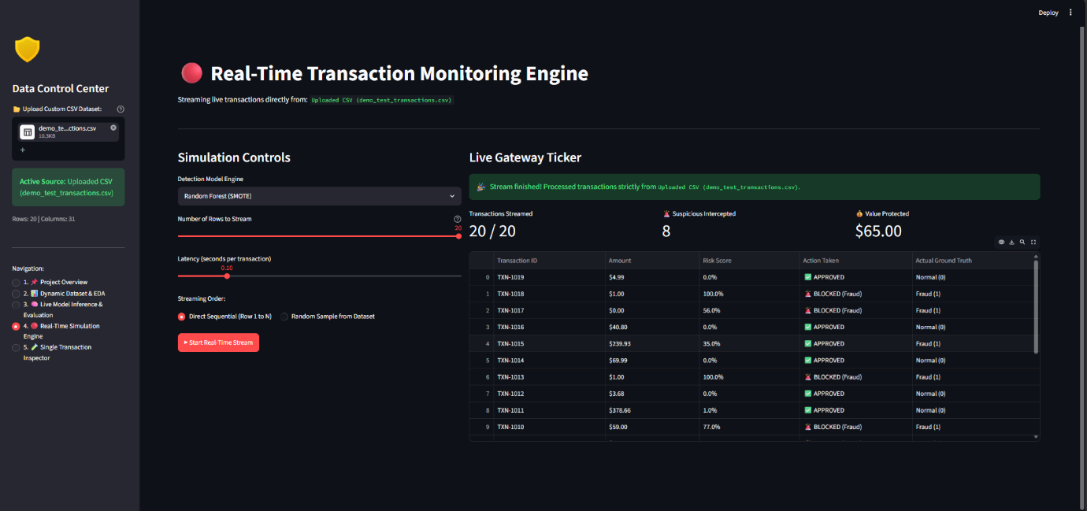
Figure 6: Single Transaction Inspector — Anomaly Score and Feature Analysis

11. LIVE DASHBOARD AND DEPLOYMENT
11.1 Streamlit Application Architecture
The complete fraud detection system is packaged as a multi-tab Streamlit web application. The application provides five integrated modules:
▸ Tab 1 — Exploratory Data Analysis: Interactive EDA dashboard with class distribution charts, transaction amount analysis, temporal patterns, and feature correlation heatmap. Users can upload their own CSV dataset for analysis.
▸ Tab 2 — Model Inference: Real-time prediction interface where users can adjust individual transaction features using sliders and instantly see fraud probability scores from all three models.
▸ Tab 3 — Real-Time Simulation: Simulates a live transaction feed using the user's uploaded CSV dataset. Transactions are processed sequentially, displaying a running alert log with fraud/legitimate classifications.
▸ Tab 4 — Single Transaction Inspector: Deep-dive analysis of a single transaction with anomaly scores, positive and negative anomaly indicators, SHAP-style feature contribution visualization, and risk level assessment.
▸ Tab 5 — Model Performance: Comprehensive model comparison dashboard showing confusion matrices, ROC curves, precision-recall curves, and feature importance rankings for all three trained models.
11.2 CSV Upload Feature
The application supports dynamic CSV file upload. When a user uploads a dataset, all four tabs — EDA, Real-Time Simulation, Single Transaction Inspector, and Model Inference — operate on the uploaded data. The simulation tab processes exactly as many rows as present in the uploaded file, ensuring the demo accurately reflects the user's data rather than a hardcoded dataset.
11.3 Deployment Details
Attribute | Details
Platform | Streamlit Community Cloud
Repository | github.com/harshprasad2006/CreditCard_Fraud_Detection_System
Live URL | https://creditcardfrauddetectionsystem-xjzuky3fgjqeux7cbnapz2.streamlit.app/
Dataset (Cloud) | creditcard_sample.csv (5,000 rows — cloud-compatible size)

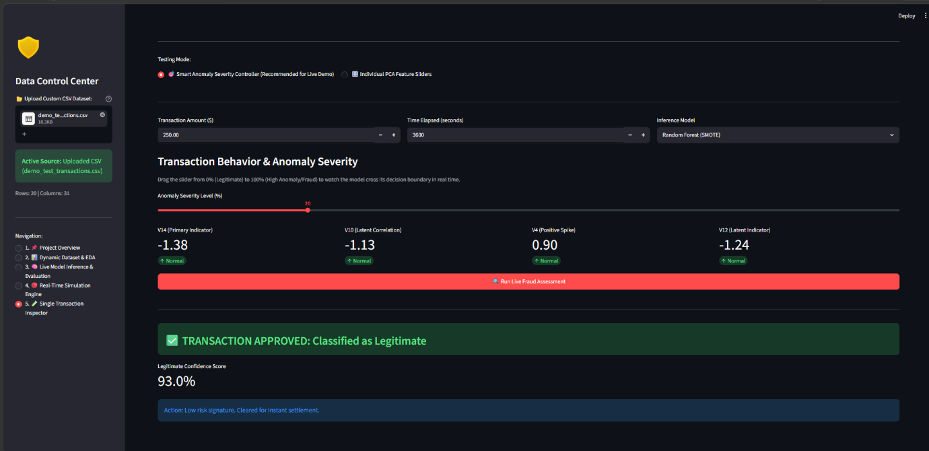
Figure 7: Deployed Application — Streamlit Cloud Live Demo

12. GITHUB REPOSITORY
The complete project — including source code, pre-trained models, sample datasets, requirements, and documentation — is maintained on GitHub for version control and reproducibility.
Repository URL: https://github.com/harshprasad2006/CreditCard_Fraud_Detection_System
Repository Structure:
• app.py: Main Streamlit application (5 tabs integrated)
• 01_explore.py: EDA module
• 02_modeling.py: Model training and SMOTE pipeline
• 03_evaluation.py: Evaluation metrics and visualizations
• 04_dashboard.py: Live simulation dashboard
• model_random_forest_smote.pkl: Pre-trained Random Forest + SMOTE model
• model_logistic_regression.pkl: Pre-trained Logistic Regression model
• model_isolation_forest.pkl: Pre-trained Isolation Forest model
• scaler.pkl: Fitted StandardScaler
• creditcard_sample.csv: 5,000-row sample dataset for cloud deployment
• demo_test_transactions.csv: Demo dataset — balanced mix
• demo_suspicious_spike_batch.csv: Demo dataset — high fraud rate
• demo_high_alert_fraud_wave.csv: Demo dataset — fraud wave scenario
• demo_low_risk_batch.csv: Demo dataset — mostly legitimate
• requirements.txt: Python dependencies for deployment

13. CONCLUSION
This project successfully demonstrates the application of machine learning to the real-world problem of credit card fraud detection. The primary challenge of extreme class imbalance (0.17% fraud rate) was addressed using SMOTE oversampling and class-weight balancing, enabling the models to learn meaningful fraud patterns from a severely skewed dataset.
Three models were implemented and systematically compared. The Isolation Forest provided an unsupervised baseline capable of detecting statistical anomalies without labelled training data. Logistic Regression offered a transparent linear classifier with strong interpretability. Random Forest + SMOTE emerged as the best-performing model with an F1-Score of 0.81, Precision of 0.85, Recall of 0.78, and ROC-AUC of 0.949 — demonstrating that ensemble methods with appropriate resampling strategies are highly effective for imbalanced fraud detection problems.
The deployed Streamlit application integrates all project components into an accessible, interactive interface that supports CSV upload, real-time transaction simulation, individual transaction inspection, and comprehensive model performance visualization. The application is publicly accessible via Streamlit Cloud and maintained on GitHub.
Future enhancements could include integration of SHAP (SHapley Additive exPlanations) for model explainability, real-time database connectivity for live transaction monitoring, incorporation of deep learning approaches such as autoencoders for anomaly detection, and integration of graph neural networks to model transaction relationship patterns.

14. REFERENCES
[1] A. Dal Pozzolo, O. Caelen, R. A. Johnson, and G. Bontempi, 'Calibrating Probability with Undersampling for Unbalanced Classification,' in IEEE SSCI 2015, pp. 92–101.
[2] S. Bhattacharyya, S. Jha, K. Tharakunnel, and J. C. Westland, 'Data Mining for Credit Card Fraud: A Comparative Study,' Decision Support Systems, vol. 50, no. 3, pp. 602–613, 2011.
[3] F. T. Liu, K. M. Ting, and Z. H. Zhou, 'Isolation Forest,' in 8th IEEE ICDM, pp. 413–422, 2008.
[4] N. V. Chawla, K. W. Bowyer, L. O. Hall, and W. P. Kegelmeyer, 'SMOTE: Synthetic Minority Over-Sampling Technique,' JAIR, vol. 16, pp. 321–357, 2002.
[5] C. Phua, V. Lee, K. Smith, and R. Gayler, 'A Comprehensive Survey of Data Mining-Based Fraud Detection Research,' arXiv:1009.6119, 2010.
[6] F. Carcillo, Y. A. Le Borgne, O. Caelen, Y. Kessaci, F. Oblé, and G. Bontempi, 'Combining Unsupervised and Supervised Learning in Credit Card Fraud Detection,' Information Sciences, vol. 557, pp. 317–331, 2021.
[7] ULB Machine Learning Group, 'Credit Card Fraud Detection Dataset,' Kaggle, 2018. [Online]. Available: https://www.kaggle.com/datasets/mlg-ulb/creditcardfraud
[8] Streamlit Inc., 'Streamlit Documentation,' 2024. [Online]. Available: https://docs.streamlit.io
[9] F. Pedregosa et al., 'Scikit-learn: Machine Learning in Python,' JMLR, vol. 12, pp. 2825–2830, 2011.
[10] G. Lemaitre, F. Nogueira, and C. K. Aridas, 'Imbalanced-learn: A Python Toolbox to Tackle the Curse of Imbalanced Datasets in Machine Learning,' JMLR, vol. 18, no. 17, pp. 1–5, 2017.

