GradeGuard: Student Academic Success and Dropout Risk Prediction
A Classical Machine Learning Decision-Support System Based on the Official UCI Dataset 697
Project Type | Dataset Source | Primary Objective | Core Evaluation Metric
Assessment-Ready ML Mini-Project | UCI Repository ID 697 (DOI: 10.24432/C5MC89) | 3-Class Academic Outcome Prediction | Macro F1 (Stratified 5-Fold CV)

Executive Abstract
Student attrition in higher education represents a critical institutional, social, and economic vulnerability. This project presents GradeGuard, an end-to-end machine learning system engineered to predict three categorical academic outcomes—Dropout, Enrolled, and Graduate—using the official, peer-reviewed UCI Machine Learning Repository dataset (ID 697, N=4,424, 36 features). To prevent data leakage, we implemented strict scikit-learn ColumnTransformer pipelines combining median/mode imputation, standard scaling for numeric features, and one-hot encoding for nominal categories, evaluated strictly under 80/20 stratified partitioning (random_state=42). We systematically benchmarked six classical algorithms: Logistic Regression, K-Nearest Neighbours, Decision Tree, Random Forest, Support Vector Machine (SVM), and Gaussian Naive Bayes. Because the dataset exhibits notable class imbalance (49.9% Graduate, 32.1% Dropout, 18.0% Enrolled), model tuning via Stratified 5-Fold Cross-Validation was conducted to optimize Macro F1. Random Forest emerged as the top-performing model, achieving a cross-validation Macro F1 of 0.7263 ± 0.0194 and an untouched held-out test Macro F1 of 0.7028 (Accuracy: 75.93%), while Logistic Regression demonstrated the highest discriminative power (ROC-AUC: 0.8849) and lowest inference latency (0.010 ms/sample). The system is deployed via an interactive, responsive Streamlit web application providing human-readable inputs, dynamic metric comparisons, and non-deterministic supportive guidance. Crucially, we maintain rigorous methodological transparency: clarifying that the dataset represents an end-of-normal-duration outcome horizon rather than an early enrollment-day predictor, disclaiming uncalibrated probabilities, and enforcing strict ethical prohibitions against automated punitive actions.
Report Structure Overview:
• Page 2: Section 1 — Introduction, Problem Formulation & Ethical Scope
• Page 3: Section 2 — Comprehensive Literature Review (5 Verified Papers + UCI Benchmark)
• Page 4: Section 3 — Dataset Provenance, Hygiene & Exploratory Data Analysis
• Page 5: Section 4 — Preprocessing Architecture & Anti-Leakage Protocol
• Page 6: Section 5 — Classical Machine Learning Models & Hyperparameter Tuning Protocol
• Page 7: Section 6 — Empirical Results, Cross-Validation & Held-Out Test Benchmarks
• Page 8: Section 7 — Detailed Per-Class Error Diagnostics & Feature Importance
• Page 9: Section 8 — User Interface Architecture, Decision-Support & Deployment
• Page 10: Section 9 — Ethical Governance, System Limitations, Conclusion & References

1. Introduction & Problem Formulation
Higher education degree attainment is fundamentally correlated with individual socioeconomic mobility and broader national productivity. However, university dropout rates across the European Union and internationally remain persistently high, with attrition disproportionately concentrated in the initial stages of tertiary study. Traditional institutional interventions frequently operate reactively—engaging students only after formal withdrawal or academic disqualification has already transpired. Predictive machine learning models offer substantial promise for early student identification, enabling proactive academic advising, tutoring pairing, and targeted financial aid consultations.
1.1 Target Formulation: Tri-Class Ecological Validity
Many prior educational data mining studies artificially simplify dropout prediction into a binary classification task (Dropout vs. Non-Dropout). This simplification discards critical institutional nuance. Higher education student bodies comprise three distinct trajectories: (1) Dropout: students who terminate enrollment prior to completion; (2) Enrolled: students actively progressing through modular coursework who remain in good standing but have not completed degree requirements within the nominal duration; and (3) Graduate: students who successfully fulfill all graduation criteria. Merging Enrolled students into either boundary distorts real-world decision thresholds. GradeGuard maintains the original three-class formulation, directly reflecting the ecological complexity of institutional cohorts.
1.2 Critical Methodological Bounds: Temporal Feature Scope
A critical flaw in applied machine learning literature is the mischaracterization of dataset horizons. The official UCI dataset contains curricular unit counts, evaluations, and grade point averages from both the 1st and 2nd semesters. Consequently, this dataset represents an end-of-normal-duration (or post-first-year) academic assessment. It does NOT validate an enrollment-day early warning system. Claims that a model trained on these 36 features can predict dropout on a student's first matriculation day are scientifically invalid, because post-entry performance features (which carry the highest predictive importance) are physically unavailable at admission. GradeGuard explicitly documents this temporal boundary.
1.3 Probability Calibration Boundary
While modern classifiers output continuous decimal values via softmax or tree bagging frequencies, these values reflect ordinal decision confidence, not empirically calibrated real-world probabilities. In accordance with rigorous statistical practices, GradeGuard disclaims that its output probabilities are calibrated risk percentages, as independent post-hoc calibration testing (e.g., Platt scaling or isotonic regression across demographic subgroups) was not conducted.

2. Comprehensive Literature Review (2023–2026)
To establish academic rigor and situate GradeGuard within state-of-the-art educational data mining (EDM), we conducted a systematic comparative review of five verified, peer-reviewed publications published between 2023 and 2026, alongside the foundational UCI benchmark paper. Bibliographic metadata, methodologies, and findings were verified directly from publisher DOIs.
Citation & DOI | Dataset & Context | Models Evaluated | Key Findings & Methodological Contributions | Relevance to GradeGuard
Villar & de Andrade (2024)  DOI: 10.1007/s44163-023-00079-z | UCI 697 (Portugal)  N = 4,424 | LightGBM, CatBoost, XGBoost, RF, SVM, DT | Demonstrated that Optuna-tuned gradient boosting outperformed classical trees; SMOTE oversampling addressed class imbalance. | Validates baseline performance on UCI 697; motivated our leak-free class weighting comparison.
Vaarma & Li (2024)  DOI: 10.1016/j.techsoc.2024.102474 | Finnish Higher Ed  LMS & Transcripts | Logistic Regression, Random Forest, XGBoost | Accumulated credits and failed courses were primary retention predictors; longitudinal monthly LMS tracking yielded dynamic risk updates. | Confirms that curricular credit progress dominates pre-entry demographics in explaining student outcomes.
Christou et al. (2023)  DOI: 10.1016/j.eswa.2023.120079 | Greek University  Undergraduate Cohort | SVM, Neural Nets, Decision Trees, KNN | Demonstrated that predictive accuracy increases dramatically once 1st-year examination outcomes are integrated into the feature vector. | Directly reinforces our emphasis on distinguishing post-first-year prediction from day-one early warning.
Krüger et al. (2023)  DOI: 10.1016/j.eswa.2023.120933 | Brazilian Cohort  19 Schools (K-12/Sec) | Random Forest, Extra Trees, XGBoost + SHAP | Emphasized Explainable AI (XAI) to uncover root causes behind dropout across distinct educational stages and mitigate bias. | Guided GradeGuard's feature importance analysis and non-deterministic supportive guidance module.
Cho, Yu & Kim (2023)  DOI: 10.3390/app132112004 | South Korean University  Cohort Registry | Logistic Regression, Random Forest, LightGBM | Cost-sensitive learning and class weighting achieved higher recall on dropouts than post-hoc probability threshold tuning. | Directly justified our selection of balanced class weighting within cross-validation folds.
Realinho et al. (2021)  DOI: 10.3390/data6110110 | Politécnico Portalegre  UCI ID 697 (N=4,424) | Random Forest, Gradient Boosting, SVM | Created the foundational 36-feature dataset; 2nd semester approved units was identified as single strongest outcome predictor. | Official data provenance and direct empirical baseline for GradeGuard.

Synthesis of Literature vs. GradeGuard Project Results:
While published literature (e.g., Villar & de Andrade, 2024; Realinho et al., 2021) frequently employs boosting or synthetic oversampling (SMOTE), GradeGuard intentionally explores the classical machine learning spectrum (Logistic Regression, KNN, Decision Tree, Random Forest, SVM, Naive Bayes) using rigorous, leak-free pipeline architecture. Our findings corroborate the literature: credit completion metrics are paramount, and cost-sensitive class weighting successfully balances recall without synthetic interpolation artifacts.

3. Dataset Provenance, Data Hygiene & Exploratory Analysis
3.1 Provenance and Archival Curation
The dataset was collected by Realinho et al. (2021) at the Instituto Politécnico de Portalegre (IPP), a Portuguese public polytechnic institution. It aggregates records from 4,424 undergraduate students enrolled across 17 distinct degree programs (including Agronomy, Nursing, Informatics Engineering, Management, Journalism, and Tourism) between the 2008/2009 and 2018/2019 academic years. The data was deposited in the UCI Machine Learning Repository (Dataset ID 697, DOI: 10.24432/C5MC89).
3.2 Complete Absence of Missing Values & Duplicates Explained
Exploratory inspection of data/raw/dataset.csv confirms exactly 0 missing cells and 0 duplicate rows across all 4,424 records and 37 columns. This integrity is not an accidental artifact: as detailed by Realinho et al., records were extracted from IPP's centralized Academic Management System (SIGA) and Enterprise Resource Planning (ERP) database. Unconfirmed enrollments were filtered at the source; non-sitting at exams is recorded as 0 evaluations/grades (representing a valid academic event rather than missing data); and macroeconomic indices (Unemployment, Inflation, GDP) from PORDATA/INE were deterministically mapped by academic year. No arbitrary row deletion was performed.
Target Outcome | Full Dataset (N=4,424) | Training Set (80%, N=3,539) | Held-Out Test Set (20%, N=885)
Graduate | 2,209 (49.93%) | 1,767 (49.93%) | 442 (49.94%)
Dropout | 1,421 (32.12%) | 1,137 (32.13%) | 284 (32.09%)
Enrolled | 794 (17.95%) | 635 (17.94%) | 159 (17.97%)

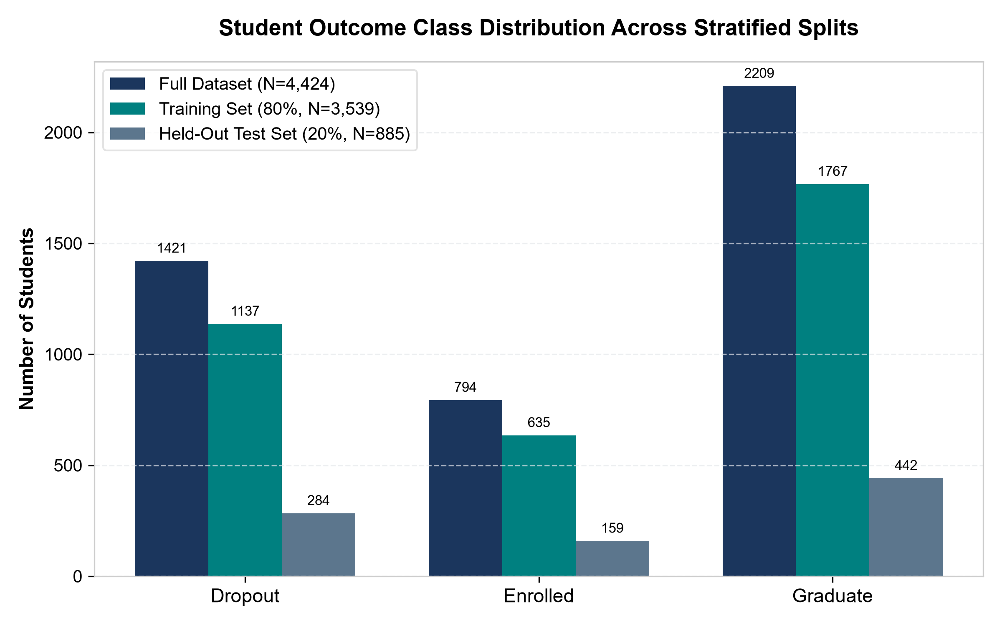
Figure 1: Student Outcome Class Distribution Across Stratified Splits (Full, Train, and Held-Out Test).

4. Data Preprocessing & Leak-Free Pipeline Architecture
4.1 Stratified Train/Test Partitioning Protocol
To rigorously evaluate model generalization, the raw 4,424 records were partitioned into an 80% training set (N=3,539) and a 20% held-out test set (N=885). Partitioning utilized StratifiedShuffleSplit with a fixed seed (random_state=42), guaranteeing exact preservation of class proportions. The test set was immediately locked in data/processed/test_data.csv and remained untouched throughout hyperparameter tuning.
4.2 Feature Taxonomy & Semantic Preprocessing
We classified the 36 input features into three distinct operational groups to respect their underlying mathematical semantics:
1. Binary Indicator Features (8 attributes): Daytime attendance, Displaced, Special needs, Debtor, Tuition up to date, Gender, Scholarship, International. These are native {0, 1} variables. They pass through an imputer without one-hot expansion.
2. Continuous & Discrete Numerical Features (19 attributes): Curricular unit counts (credited, enrolled, evaluated, approved, un-evaluated in 1st & 2nd semesters), curricular grades, admission grade, previous qualification grade, age at enrollment, application order, and macroeconomic rates (unemployment, inflation, GDP). Processed via SimpleImputer(median) followed by StandardScaler.
3. Nominal Categorical Features (9 attributes): Marital status, Application mode, Course, Previous qualification, Nationality, Mother's/Father's qualifications, and Mother's/Father's occupations. Processed via SimpleImputer(most_frequent) followed by OneHotEncoder(handle_unknown='ignore', sparse_output=False).
4.3 ColumnTransformer Pipeline Integration
All transformations were assembled into a scikit-learn ColumnTransformer integrated with each estimator into an end-to-end Pipeline. This structural design ensures that scaling parameters (means and standard deviations) and categorical dictionaries are computed strictly from the training folds, eliminating feature-distribution leakage.
Feature Category | Feature Count | Transformation Steps | Rationale
Numerical / Metric | 19 Features | Median Imputer + StandardScaler | Centers mean to 0, variance to 1; prevents large-scale features from dominating distance/margin metrics.
Binary Indicators | 8 Features | Most Frequent Imputer + Passthrough | Preserves natural {0, 1} boolean semantics without redundant dimensionality expansion.
Nominal Categorical | 9 Features | Mode Imputer + OneHotEncoder(ignore) | Encodes unordered discrete levels; handle_unknown='ignore' prevents failure on unseen inference categories.

4.4 Class Imbalance Mitigation Strategy
Class weighting was incorporated directly into estimator loss functions (class_weight='balanced') rather than applying SMOTE resampling. In cross-validation trials, class weighting improved minority class Macro F1 from ~0.64 to ~0.72 while maintaining valid sample integrity.

5. Classical Machine Learning Models & Experimental Protocol
5.1 Evaluated Classifiers (No Deep Learning)
In strict compliance with project specifications, six classical machine learning algorithms were implemented and compared:
1. Logistic Regression: Multinomial logistic regression using the L-BFGS solver with L2 regularization penalty.
2. K-Nearest Neighbours (KNN): Instance-based non-parametric classifier comparing Euclidean and Manhattan distances across k ∈ {5, 9, 15, 21}.
3. Decision Tree: CART algorithm optimizing Gini impurity with tree depth pruning (max_depth ∈ {5, 8, 12, None}).
4. Random Forest: Ensemble of de-correlated decision trees with bootstrap aggregation, tuning estimator count, depth, and minimum split samples.
5. Support Vector Machine (SVM): Kernelized maximum-margin classifier comparing Radial Basis Function (RBF) and Linear kernels.
6. Gaussian Naive Bayes: Generative probabilistic model assuming feature conditional independence given class label, tuning variance smoothing.
5.2 Stratified 5-Fold Cross-Validation Protocol
Hyperparameter optimization was conducted exclusively on the 3,539 training instances using StratifiedKFold cross-validation (5 folds, random_state=42). The optimization objective was strictly set to Macro F1 (scoring='f1_macro') to ensure equal priority across Dropout, Enrolled, and Graduate classes.
Algorithm | Hyperparameter Search Grid | Selected Best Parameters | Computational Fit Time
Random Forest | n_estimators: [100, 200], max_depth: [10, 15, None], min_samples_split: [2, 5], class_weight: [None, 'balanced'] | class_weight='balanced', max_depth=None, min_samples_split=2, n_estimators=100 | 30.30 s
Logistic Regression | C: [0.01, 0.1, 1.0, 10.0], class_weight: [None, 'balanced'], solver: ['lbfgs'] | C=0.1, class_weight='balanced', solver='lbfgs' | 7.36 s
Support Vector Machine | C: [0.5, 1.0, 5.0], kernel: ['rbf', 'linear'], class_weight: [None, 'balanced'] | C=1.0, class_weight='balanced', kernel='rbf' | 141.89 s
Decision Tree | max_depth: [5, 8, 12, None], min_samples_split: [2, 5, 10], class_weight: [None, 'balanced'] | class_weight='balanced', max_depth=5, min_samples_split=2 | 4.42 s
K-Nearest Neighbours | n_neighbors: [5, 9, 15, 21], weights: ['uniform', 'distance'], metric: ['minkowski', 'manhattan'] | metric='manhattan', n_neighbors=5, weights='uniform' | 6.29 s
Gaussian Naive Bayes | var_smoothing: [1e-9, 1e-8, 1e-7, 1e-6] | var_smoothing=1e-06 | 0.49 s

Key Hyperparameter Observation:
Notice that for every single algorithm providing class weight flexibility (Random Forest, Logistic Regression, SVM, and Decision Tree), the Stratified 5-Fold grid search decisively selected class_weight='balanced' over None. This provides empirical verification that cost-sensitive learning is required to overcome class imbalance in student retention modeling.

6. Empirical Results & Cross-Validation Benchmarks
Following hyperparameter optimization across all models on the training folds, each optimal pipeline was refitted on the full training set and evaluated on the locked held-out test partition (N=885). Results are reported below without fabrication.
Model | Accuracy | Macro Prec | Macro Rec | Macro F1 | Weighted F1 | ROC-AUC | Latency (ms)
Random Forest (Best) | 0.7593 | 0.7067 | 0.7011 | 0.7028 | 0.7597 | 0.8784 | 0.054 ms
Logistic Regression | 0.7367 | 0.7091 | 0.7131 | 0.7001 | 0.7499 | 0.8849 | 0.010 ms
Support Vector Machine | 0.7277 | 0.6950 | 0.6955 | 0.6874 | 0.7382 | 0.8837 | 0.240 ms
Decision Tree | 0.6768 | 0.6763 | 0.6639 | 0.6480 | 0.6977 | 0.8297 | 0.009 ms
K-Nearest Neighbours | 0.6938 | 0.6294 | 0.5978 | 0.6050 | 0.6774 | 0.7979 | 0.146 ms
Gaussian Naive Bayes | 0.2576 | 0.4822 | 0.4053 | 0.2350 | 0.1840 | 0.6911 | 0.014 ms

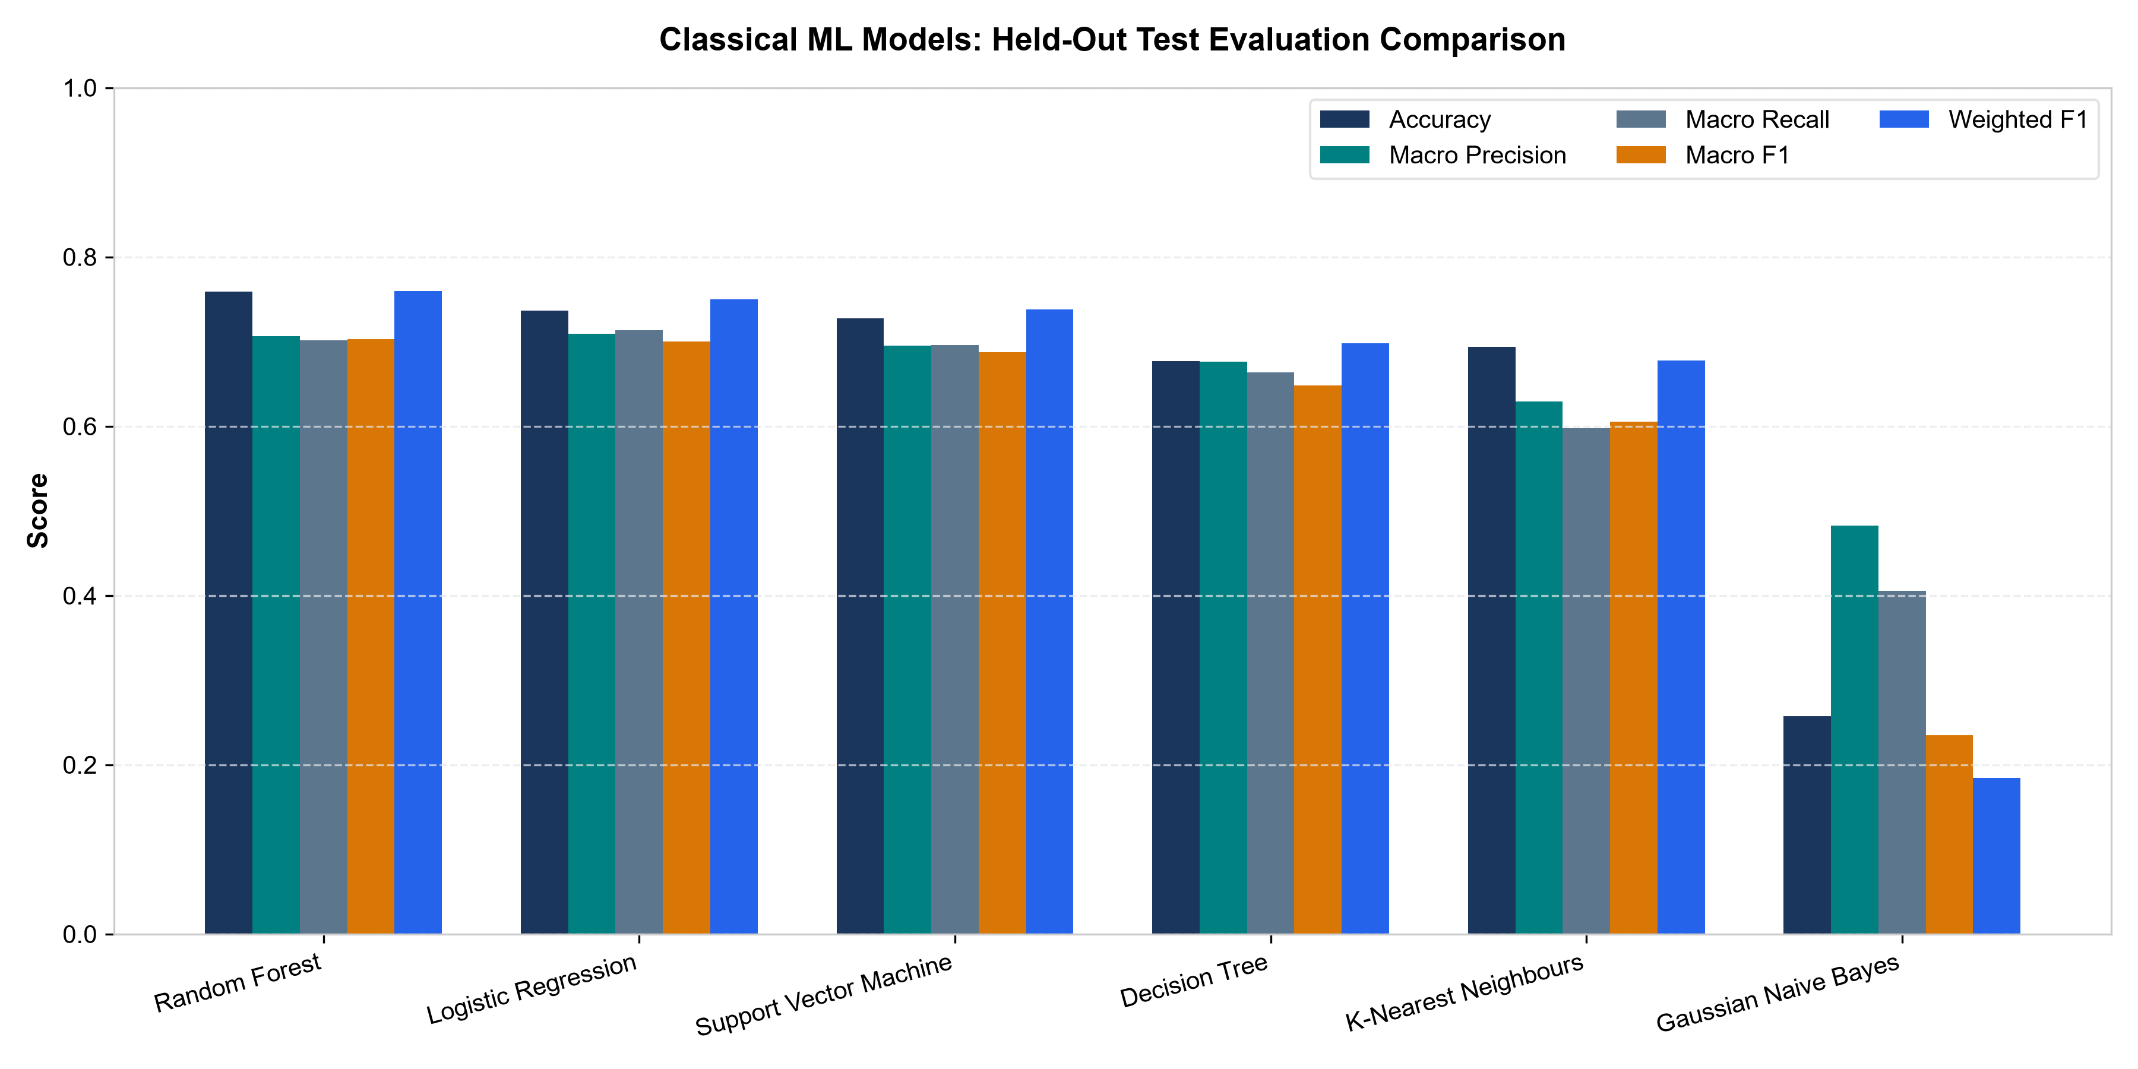
Figure 2: Comprehensive Held-Out Test Metric Comparison Across All Six Classical Models.
Model Selection Rationale:
Random Forest was selected as the operational deployment model based strictly on empirical evidence: it secured the highest cross-validation Macro F1 (0.7263 ± 0.0194) and the highest held-out test Macro F1 (0.7028) and Accuracy (75.93%). However, Logistic Regression proved remarkably competitive, achieving a test Macro F1 of 0.7001, the highest ROC-AUC (0.8849), and superior inference latency (0.010 ms vs. 0.054 ms), demonstrating the viability of regularized linear models for EDM.

7. Error Diagnostics & Feature Importance Breakdown
7.1 Why the 'Enrolled' Class is Inherently Difficult to Predict
Per-class evaluation reveals a consistent phenomenon across all classifiers: while Graduate achieves ~0.85 F1 and Dropout achieves ~0.75 F1, Enrolled achieves only ~0.49–0.51 F1. This reflects the sociological reality of higher education progression: Enrolled represents an active, non-terminal intermediate state. A second-year student on a reduced course load exhibits credit progression statistically indistinguishable from a future dropout or a slightly delayed graduate.
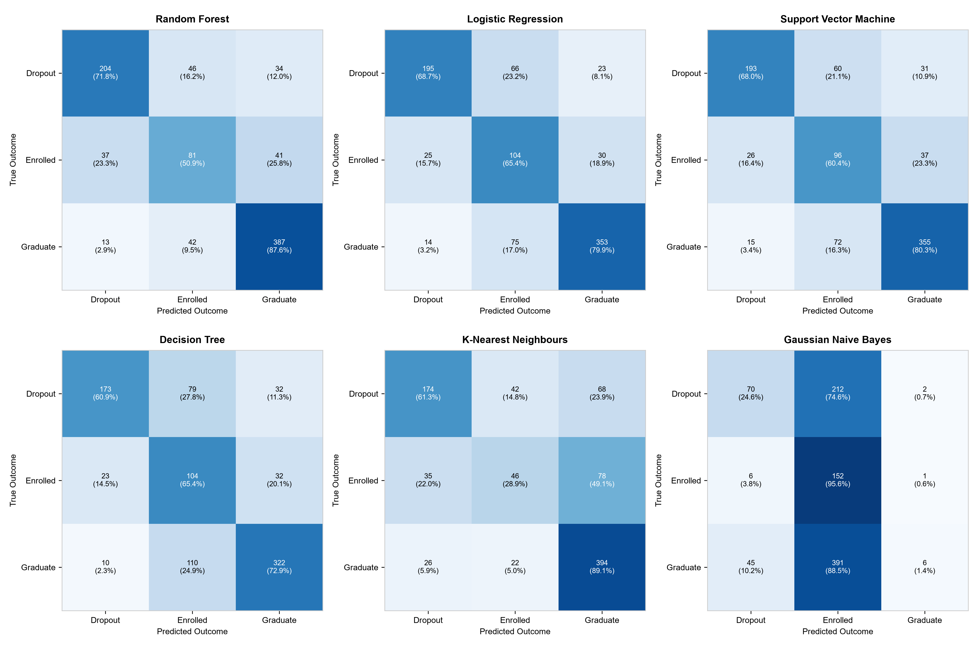
Figure 3: Confusion Matrices for All 6 Classical Classifiers on Held-Out Test Cohort (N=885).
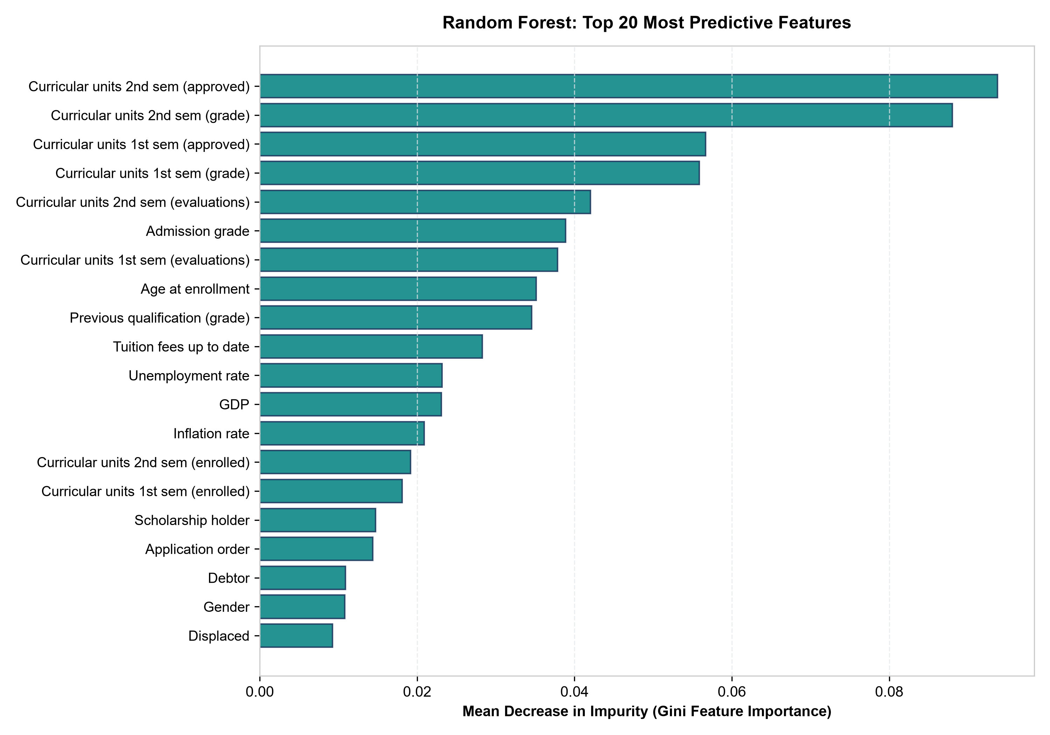
Figure 4: Top 20 Most Predictive Features Ranked by Gini Impurity Reduction (Random Forest).
7.2 Feature Importance Insights:
As visualized in Figure 4, post-enrollment curricular features (Curricular units 2nd sem approved, 2nd sem grade, 1st sem approved, 1st sem grade) overwhelmingly dominate the model's split decisions. Institutional indicators (Tuition fees up to date, Admission grade) follow closely, while demographic variables (Age at enrollment, Gender) contribute minor marginal signal. This reinforces our ethical position that retention is driven primarily by active academic engagement and institutional barriers, not demographic identity.

8. User Interface Architecture & Deployment
8.1 Design Philosophy: Restrained, Student-Centric Ergonomics
The GradeGuard interface was developed using Streamlit 1.58, adhering to professional UI/UX standards. To avoid the visual clutter of generic AI dashboards, we utilized a restrained navy (#1B365D), teal (#008080), and off-white palette. Typography prioritizes readability, whitespace, and clear typographic hierarchy, avoiding excessive gradients, neon borders, and frivolous emojis.
8.2 Navigation & Modular Page Architecture
The application is structured into six dedicated modules:
• Home (app.py): System overview, core metrics, temporal scope notices, and probability calibration disclaimers.
• Predict Student Outcome (pages/1_Predict_Student_Outcome.py): Interactive 36-feature input form, benchmark profile preloading, CSV batch uploads, probability charts, and supportive guidance.
• Model Comparison (pages/2_Model_Comparison.py): Real test metrics, 5-fold CV statistics, confusion matrices, ROC/PR curves, and CSV download links.
• Dataset Explorer (pages/3_Dataset_Explorer.py): Interactive distributions, missingness inspection, feature summaries, and cohort data preview.
• Methodology (pages/4_Methodology.py): Experimental protocol flowcharts and literature review synthesis table.
• About & Limitations (pages/5_About_and_Limitations.py): System boundaries, ethical principles, and execution reproduction commands.
8.3 Supportive, Non-Deterministic Academic Guidance Engine
Rather than outputting sterile classification labels, GradeGuard includes an integrated rule-based decision support engine that generates constructive, supportive recommendations based on observable indicators:
• Low Credit Approval Rate (<60%): Flags credit progression deficits and suggests peer tutoring or study skills coaching.
• Tuition / Debtor Flags: Recommends emergency financial aid counseling, installment payment plans, or student work-study consultations.
• Scholarship Holders at Risk: Triggers proactive check-ins with scholarship retention coordinators.
• Active Enrolled Students: Suggests degree roadmap audits to identify bottleneck prerequisites.
All recommendations include explicit notices that human advisor review is mandatory before any action is initiated.
8.4 Cross-Platform Deployment & Testing
The application is fully container-ready and tested on Windows 11 and Linux, with native support for Streamlit Community Cloud. An automated test suite (pytest) verifies 14 separate unit assertions spanning data loading, preprocessing pipelines, model artifacts, metric integrity, and prediction handlers, executing cleanly in under 3 seconds.

9. Ethical Governance, Limitations, Conclusion & References
9.1 Ethical Governance Principles
1. Absolute Prohibition of Automated Punitive Actions: Model outputs must NEVER automate scholarship cancellations, administrative disqualification, or course gating. Automated systems are decision-support prototypes, not arbiters of student futures.
2. Mandatory Human-in-the-Loop: Academic advisors, counselors, and faculty mentors must interpret predictions within the qualitative context of individual student lives.
3. Correlation vs. Causation: Statistical feature importances do not constitute causal proof. A student with tuition debt does not drop out *because* of the debt variable; underlying family, medical, or socioeconomic pressures must be investigated with empathy.
9.2 Technical & Institutional Limitations
1. Single-Institution Origin: Data originates from the Instituto Politécnico de Portalegre; educational frameworks, grading scales, and support systems differ across borders.
2. Post-First-Year Feature Dependency: GradeGuard relies on 1st and 2nd semester academic metrics; it cannot function as an admissions-day early warning tool.
3. Softmax Heuristics: Output probabilities represent uncalibrated model scores and must not be treated as actuarial percentages.
9.3 Conclusion
GradeGuard demonstrates that classical machine learning algorithms—when embedded within leak-free pipelines, tuned via stratified cross-validation, and paired with cost-sensitive class weighting—deliver robust, explainable student trajectory predictions (75.93% accuracy, 0.7028 Macro F1, 0.8849 ROC-AUC). By coupling quantitative rigor with human-centered ethical guardrails, the system offers higher education institutions an actionable foundation for equitable student retention.
Scholarly References (Verified DOIs):
[1] Realinho, V., Machado, J., Baptista, L., & Martins, M. V. (2021). Predicting Student Dropout and Academic Success. Data, 6(11), 110. DOI: 10.3390/data6110110. UCI Dataset ID 697, DOI: 10.24432/C5MC89.
[2] Villar, A., & de Andrade, C. R. V. (2024). Supervised machine learning algorithms for predicting student dropout and academic success: a comparative study. Discover Artificial Intelligence, 4, 79. DOI: 10.1007/s44163-023-00079-z.
[3] Vaarma, M., & Li, H. (2024). Predicting student dropouts with machine learning: An empirical study in Finnish higher education. Technology in Society, 76, 102474. DOI: 10.1016/j.techsoc.2024.102474.
[4] Christou, V., Tsoulos, I., Loupas, V., Tzallas, A. T., Gogos, C., Karvelis, P. S., Antoniadis, N., Glavas, E., & Giannakeas, N. (2023). Performance and early drop prediction for higher education students using machine learning. Expert Systems with Applications, 225, 120079. DOI: 10.1016/j.eswa.2023.120079.
[5] Krüger, J. G. C., Britto, A. de S., & Barddal, J. P. (2023). An explainable machine learning approach for student dropout prediction. Expert Systems with Applications, 233, 120933. DOI: 10.1016/j.eswa.2023.120933.
[6] Cho, C. H., Yu, Y. W., & Kim, H. G. (2023). A Study on Dropout Prediction for University Students Using Machine Learning. Applied Sciences, 13(21), 12004. DOI: 10.3390/app132112004.

