**LAB 2**

**Aim:** Installation of HortonWorks Sandbox on Virtual Machine

**Procedure:**

1. Visit the following link and download the Virtual Appliance file for HortonWorks Sandbox.

https://archive.cloudera.com/hwx-sandbox/hdp/hdp-2.6.5/HDP_2.6.5_virtualbox_180626.ova

2. Open VirtualBox and click on File -> Import Appliance.

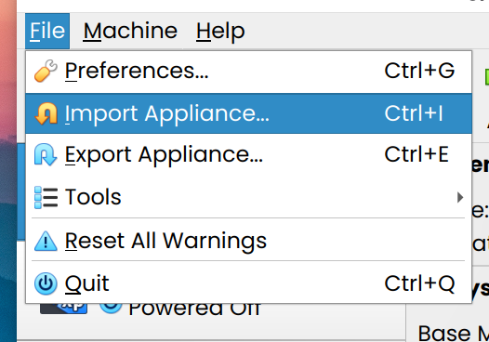

3. Select the location of recently downloaded file.

4. Select the machine base folder where the machine should be saved and review the settings.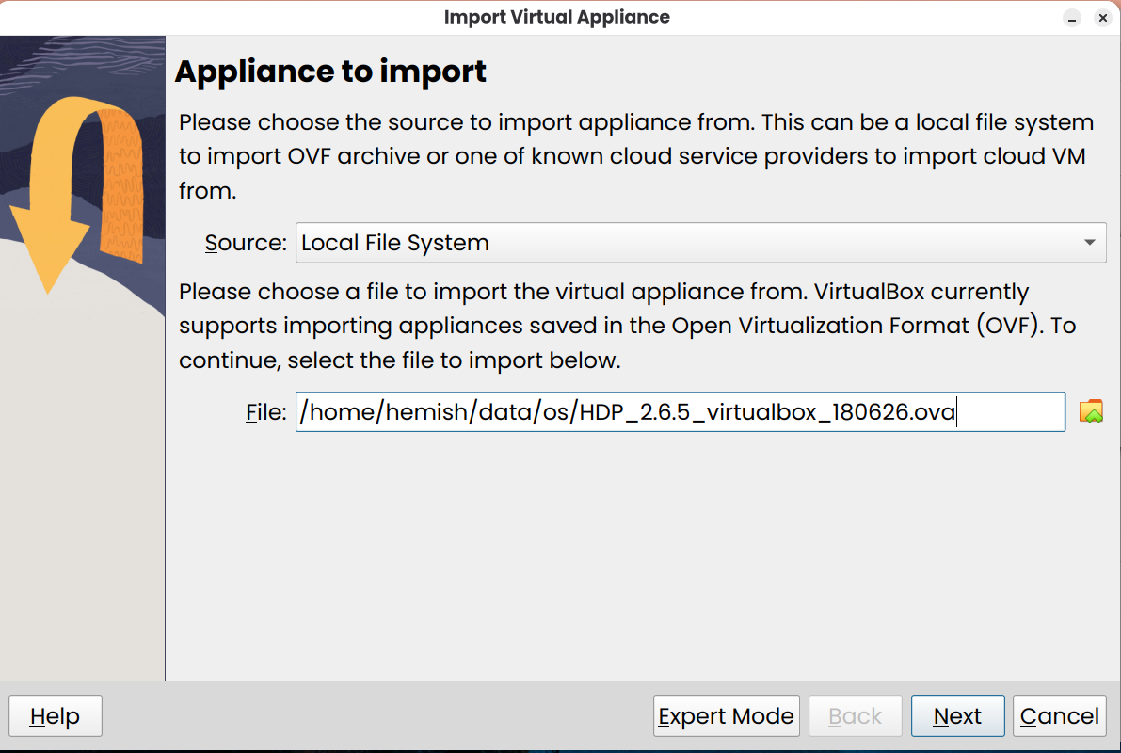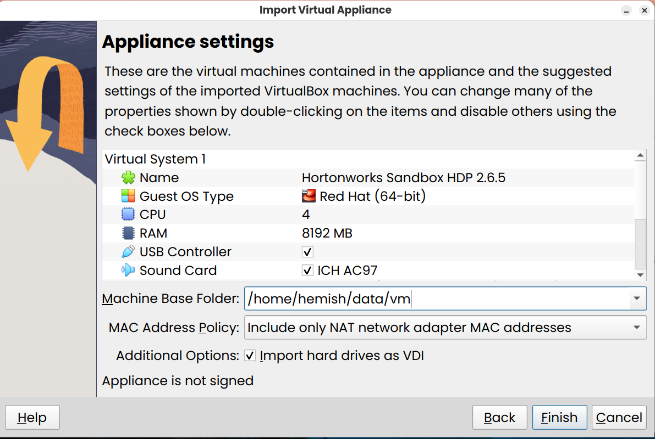

5. Wait till the appliance gets imported.

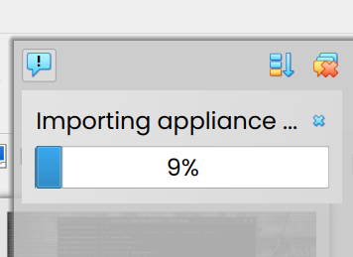

6. The machine would appear in VirtualBox. Double click on it to launch it.

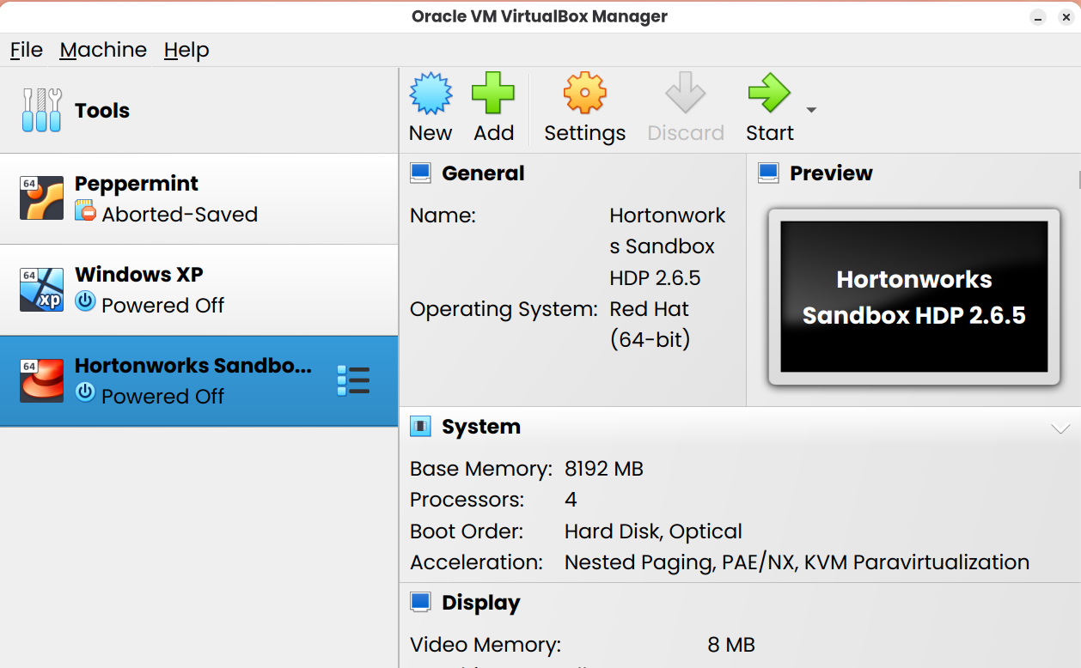

7. Wait till the OS extracts.

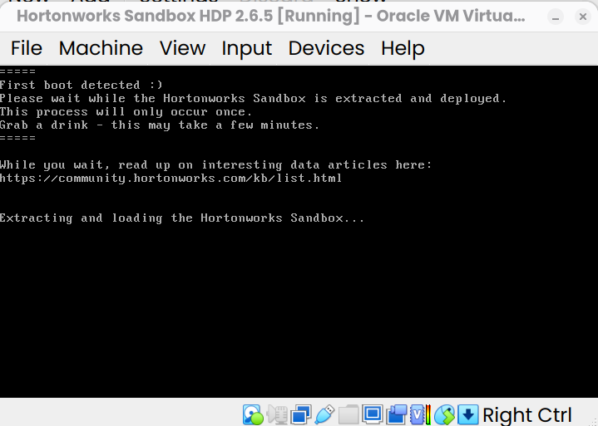

8. After the extraction process is complete, it shows the IP address of machine.

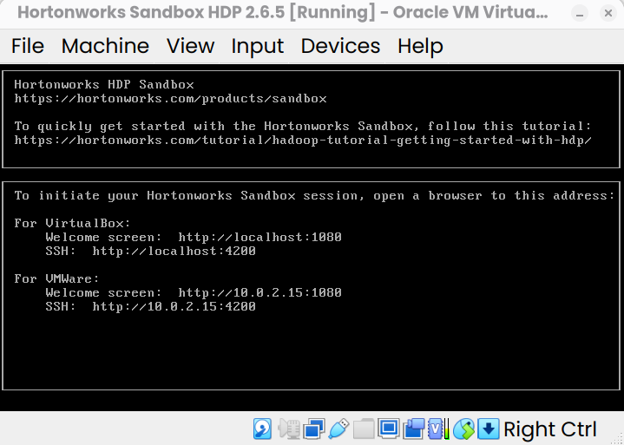

9. Navigate to [http://localhost:1080](http://localhost:1080/)

10. Use the username and password: maria_dev to login.

