MediBook
Doctor Appointment Booking & Clinic Management System
(MERN Stack Web Application)

A Project Report submitted in partial fulfilment of the
requirements for the award of the degree of
Bachelor of ______________ (____________)

Submitted by
Student Name: __________________________
Roll No. / Enrollment No.: __________________________

Under the guidance of
Guide / Supervisor: __________________________

Department: __________________________
College / Institute Name: __________________________
University: __________________________
Academic Year: __________________________

Certificate
This is to certify that the project report entitled “MediBook — Doctor Appointment Booking & Clinic Management System” is a bonafide record of the project work carried out by ________________________ (Roll No. ________________) under my supervision and guidance, in partial fulfilment of the requirements for the award of the degree of ________________________ during the academic year ____________.
To the best of my knowledge, the work presented in this report is original and has not been submitted, in part or full, for the award of any other degree or diploma.

____________________________ ____________________________
Signature of Guide Signature of H.O.D.

____________________________
Signature of External Examiner

Declaration
I hereby declare that the project work entitled “MediBook — Doctor Appointment Booking & Clinic Management System”, submitted in partial fulfilment of the requirements for the award of the degree of ________________________, is my own work carried out under the guidance of ________________________.
I further declare that the material contained in this report has not been copied from any source without proper acknowledgement, and that the results embodied in this report have not been submitted to any other university or institute for the award of any degree or diploma.

Place: __________________
Date: __________________

________________________
Signature of Student

Acknowledgement
I take this opportunity to express my sincere gratitude to all those who supported me throughout the course of this project. I am deeply thankful to my guide, ________________________, for their invaluable guidance, constant encouragement and constructive feedback that shaped this work.
I extend my thanks to the Head of the Department, ________________________, and to all the faculty members of the Department of ________________________ for providing the necessary facilities and a conducive environment for learning.
I am also grateful to my family and friends for their motivation and support. Finally, I acknowledge the vast open-source community whose tools and documentation made this project possible.

________________________
(Student Name)

Abstract
Booking a doctor’s appointment through traditional channels is often slow, opaque and frustrating — patients call clinics repeatedly, wait in long queues with no visibility, and manage paper prescriptions and reports. Clinics, in turn, struggle with manual scheduling, fragmented records and limited operational insight.
MediBook is a full-stack web application built on the MERN stack (MongoDB, Express, React, Node.js) that digitises the complete clinic workflow for four distinct roles — Patient, Doctor, Receptionist and Administrator. Patients can search doctors using a rich set of filters, use an AI symptom checker to find the right specialist, pay online, and track their position in a live queue. Doctors manage availability, consult patients and issue digital prescriptions. Receptionists run the front desk and live token board, while administrators oversee doctors, users, payments and audit logs through analytics dashboards.
A distinctive engineering feature of the system is its pluggable storage layer: the same repository interface transparently supports a zero-configuration file-based JSON database for development and MongoDB/Atlas for production, switchable through a single environment flag. The application also demonstrates JWT-based authentication with role-based access control, request validation, a rule-based AI triage engine, a simulated payment gateway with GST invoicing, real-time queue management, and a fully responsive, multilingual (English/Hindi) user interface.
This report documents the analysis, design, implementation and testing of the system, including complete data-flow, entity-relationship, class, sequence and use-case diagrams, database schema, and a comprehensive set of screenshots covering every screen of the application.
Keywords: MERN, healthcare, appointment scheduling, role-based access control, REST API, AI symptom checker, live queue, EHR, responsive web application.

Table of Contents

(In Microsoft Word, right-click the table above and choose “Update Field” to populate page numbers.)

Chapter 1: Introduction

1.1 Overview
The healthcare sector is increasingly moving towards digital-first patient experiences. Yet, for a large number of small and mid-sized clinics, appointment scheduling, billing, prescription management and record-keeping remain manual or spread across disconnected tools. MediBook addresses this gap with a single, cohesive platform that connects patients with clinics and gives each stakeholder a purpose-built workspace.
The system is delivered as a modern single-page application (SPA) backed by a RESTful API. It supports the full lifecycle of a clinic visit — discovery, booking, payment, consultation, prescription, records and follow-up — with real-time visibility into queues and appointment status.

1.2 Problem Statement
Existing appointment processes suffer from several problems: (a) patients cannot easily discover the right specialist; (b) there is no transparency about waiting time; (c) payments and invoices are handled manually; (d) prescriptions and reports are paper-based and easily lost; and (e) clinic administrators lack consolidated operational and financial insight. There is a need for an integrated, secure and easy-to-use system that solves these issues end-to-end.

1.3 Objectives
- To design and develop a role-based web application for patients, doctors, receptionists and administrators.
- To enable smart doctor discovery with multi-criteria search and an AI-assisted symptom checker.
- To implement real-time slot generation, pay-first booking, and a live queue/token system.
- To provide digital prescriptions, an electronic health record (EHR) vault, and vitals tracking.
- To offer administrators analytics dashboards, payment/billing management and an audit trail.
- To engineer a storage-agnostic backend that runs on a file store or MongoDB without code changes.

1.4 Scope of the Project
The project covers the complete front-end and back-end of the application, including authentication, authorisation, all four role workspaces, the pluggable database layer, a simulated payment workflow with GST invoices, and a responsive multilingual interface. Third-party integrations such as a real payment gateway, SMS/e-mail delivery and production OCR are simulated or stubbed to keep the project self-contained, while being architected so that they can be integrated with minimal changes.

1.5 Organisation of the Report
Chapter 2 presents the system analysis and feasibility study. Chapter 3 lists the functional and non-functional requirements along with the technology stack. Chapter 4 details the system design with all UML and data diagrams and the database schema. Chapter 5 describes the implementation. Chapter 6 presents the user interface through screenshots. Chapter 7 covers testing, and Chapter 8 discusses results, limitations and future scope, followed by the conclusion, references and appendix.

Chapter 2: System Analysis

2.1 Existing System
In most clinics today, appointments are booked over the phone or in person. A receptionist maintains a register or spreadsheet, patients wait without knowing their turn, bills are written manually, and prescriptions and reports are handed over on paper. Any reporting for management is compiled by hand.

2.1.1 Limitations of the Existing System
- No self-service discovery or online booking for patients.
- No visibility into queue position or estimated waiting time.
- Manual, error-prone billing without consolidated records.
- Paper prescriptions and reports that are easily lost.
- No consolidated analytics for administrators.

2.2 Proposed System
The proposed system, MediBook, digitises the entire workflow. Patients discover doctors and book/pay online; doctors and receptionists manage a live queue; prescriptions and records are stored digitally; and administrators get real-time dashboards. Role-based access ensures each user sees only what is relevant to them.

2.2.1 Advantages of the Proposed System
- 24×7 self-service booking with real-time slot availability and conflict prevention.
- AI symptom checker guides patients to the right specialist.
- Live queue and token board with estimated waiting time.
- Secure online payments with automatically generated GST invoices.
- Digital prescriptions, EHR vault and vitals tracking.
- Analytics, payments ledger and audit logs for administrators.

2.3 Feasibility Study

2.3.1 Technical Feasibility
The system is built with widely-adopted, well-documented open-source technologies (React, Node.js, Express). The pluggable storage layer means it can run with zero external dependencies during development and scale to MongoDB in production. Hence the project is technically feasible.

2.3.2 Economic Feasibility
All core technologies are free and open-source. The application can be hosted on low-cost or free tiers of modern cloud platforms. Development requires only a standard computer. Therefore the project is economically feasible.

2.3.3 Operational Feasibility
The interface follows familiar, enterprise-grade design patterns and is fully responsive, making it easy for non-technical users (patients, front-desk staff) to operate with minimal training. The project is thus operationally feasible.

Chapter 3: System Requirements

3.1 Functional Requirements

3.1.1 Patient Module
- Register/login; manage profile and profile photo.
- Search doctors by name, disease, specialty, city, gender, language, insurance, fee and rating.
- Use the AI symptom checker and receive doctor recommendations.
- Book appointments (regular/emergency) with pay-first checkout and GST invoice.
- Track live queue position; view/cancel appointments; review completed visits.
- View prescriptions, manage EHR records, track vitals, view billing and notifications.

3.1.2 Doctor Module
- Manage weekly availability, breaks and leave; publish public profile.
- View appointments and a live queue; consult patients (view reports/history).
- Write and digitally sign prescriptions; mark appointment status.

3.1.3 Receptionist Module
- Manage the live queue and token board; check-in and advance patients.
- View all appointments; upload/view patient records; approve doctor leaves.

3.1.4 Administrator Module
- Approve/activate doctors; manage users and receptionists.
- View analytics dashboards, payments ledger and audit logs.

3.2 Non-Functional Requirements
- Security: JWT authentication, hashed passwords (bcrypt), role-based authorisation, request validation, rate limiting and Helmet headers.
- Performance: server-side filtering, pagination and lightweight payloads.
- Usability: responsive, accessible, multilingual (English/Hindi) interface.
- Reliability: input validation and consistent error handling.
- Maintainability: modular, layered architecture with reusable components.
- Portability: storage-agnostic backend (file store or MongoDB).

3.3 Hardware Requirements
Component | Minimum | Recommended
Processor | Dual-core 2.0 GHz | Quad-core 2.5 GHz+
RAM | 4 GB | 8 GB or more
Storage | 2 GB free | 5 GB free (SSD)
Display | 1366 × 768 | 1920 × 1080
Network | Broadband | Broadband

3.4 Software Requirements
Component | Specification
Operating System | Windows / macOS / Linux
Runtime | Node.js 18 or higher, npm
Database | File JSON store (default) or MongoDB 6+/Atlas
Browser | Chrome / Edge / Firefox (latest)
IDE | Visual Studio Code (recommended)

3.5 Technology Stack
Layer | Technologies
Front-end | React 18, React Router, Vite, Axios, custom CSS design system
Back-end | Node.js, Express, JWT, bcryptjs, Zod, Multer, Helmet
Database | Pluggable: File JSON store or MongoDB (Mongoose driver)
Charts/UI | Dependency-free SVG charts, responsive components
Tooling | Nodemon, Concurrently, ESLint

Chapter 4: System Design

4.1 System Architecture
MediBook follows a classic three-tier architecture. The presentation tier is a React single-page application; the application tier is a stateless Express REST API secured with JWT; and the data tier is accessed through a repository/adapter layer that can target either a file-based JSON store or MongoDB. This separation keeps the business logic independent of the storage technology.
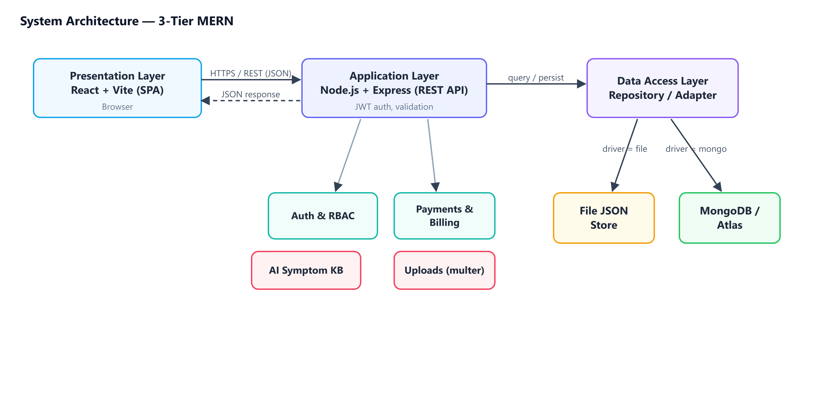
Fig 4.1 System Architecture (3-tier MERN)

4.2 Use Case Diagram
The use case diagram identifies the four actors and their interactions with the system. Patients focus on discovery, booking and health management; doctors on consultation; receptionists on the front desk; and administrators on governance.
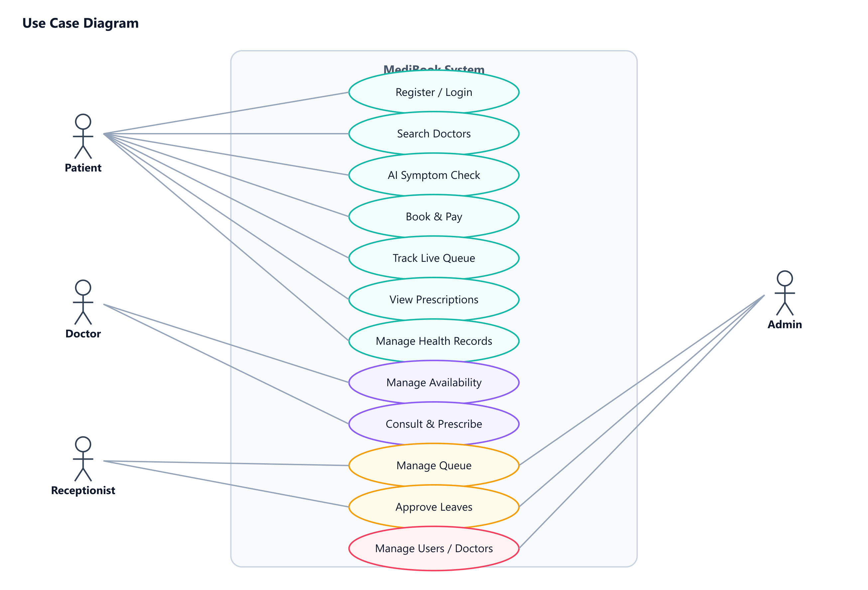
Fig 4.2 Use Case Diagram

4.3 Entity–Relationship Diagram
The ER diagram captures the primary entities and their relationships. A User may be a patient or doctor; a Doctor is linked to a User; Appointments connect patients and doctors and are associated one-to-one with a Payment and one-to-many with Prescriptions. Patients own Records, Vitals and Reviews.
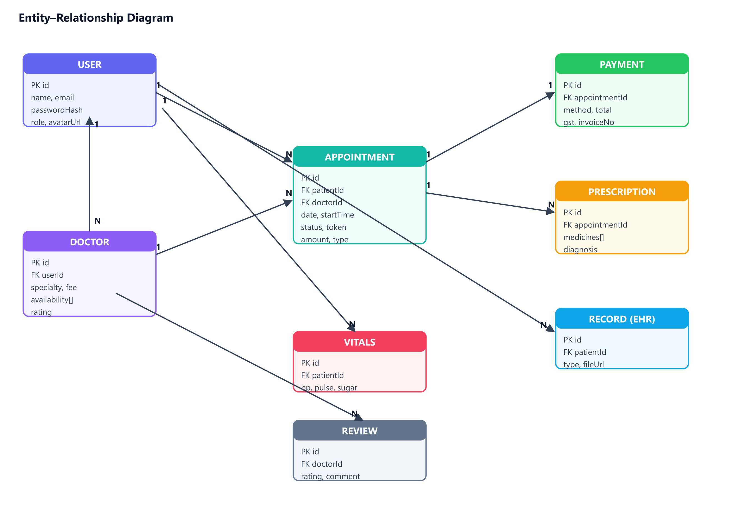
Fig 4.3 Entity–Relationship Diagram

4.4 Data Flow Diagrams
The context-level DFD (Level 0) shows the system as a single process exchanging data with the four external entities. The Level 1 DFD decomposes the system into its major processes and data stores.
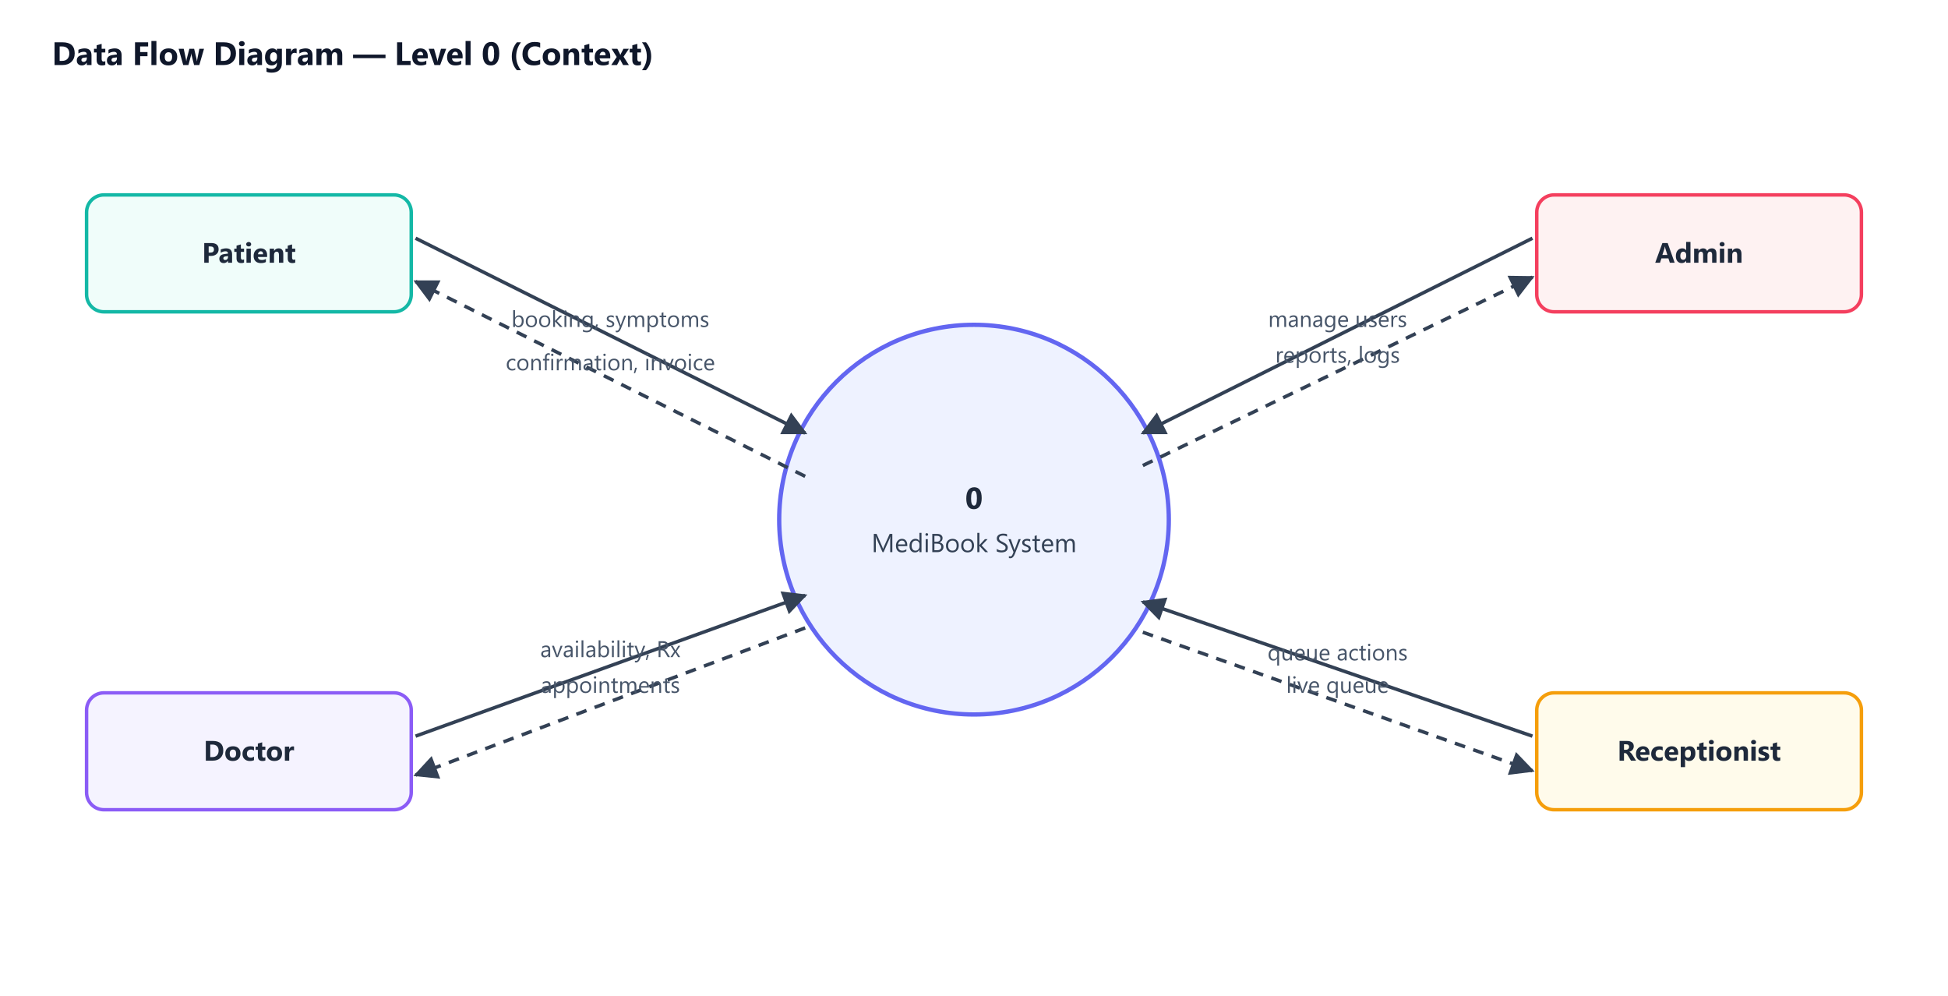
Fig 4.4 Data Flow Diagram — Level 0 (Context)
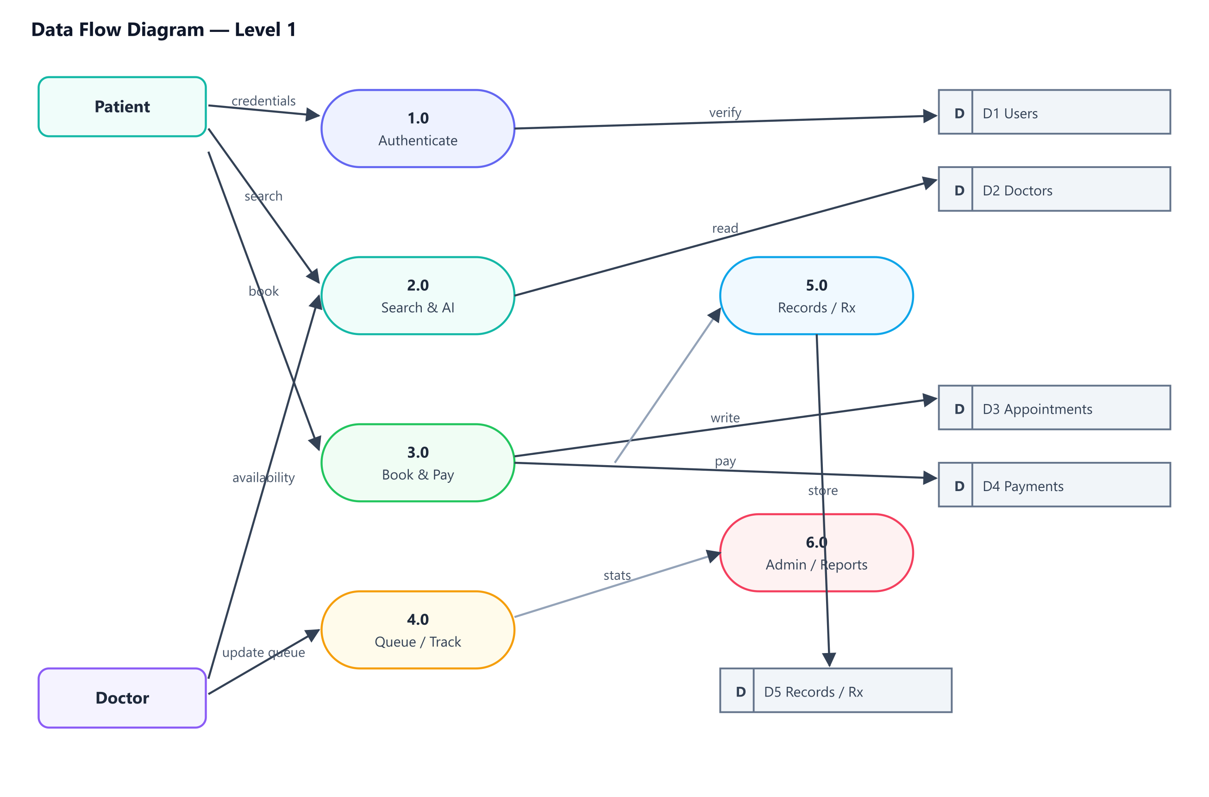
Fig 4.5 Data Flow Diagram — Level 1

4.5 Sequence Diagram
The sequence diagram below illustrates the pay-first booking flow: the client obtains a price quote, processes payment, and only then creates the appointment, which the server validates and persists before returning a token.
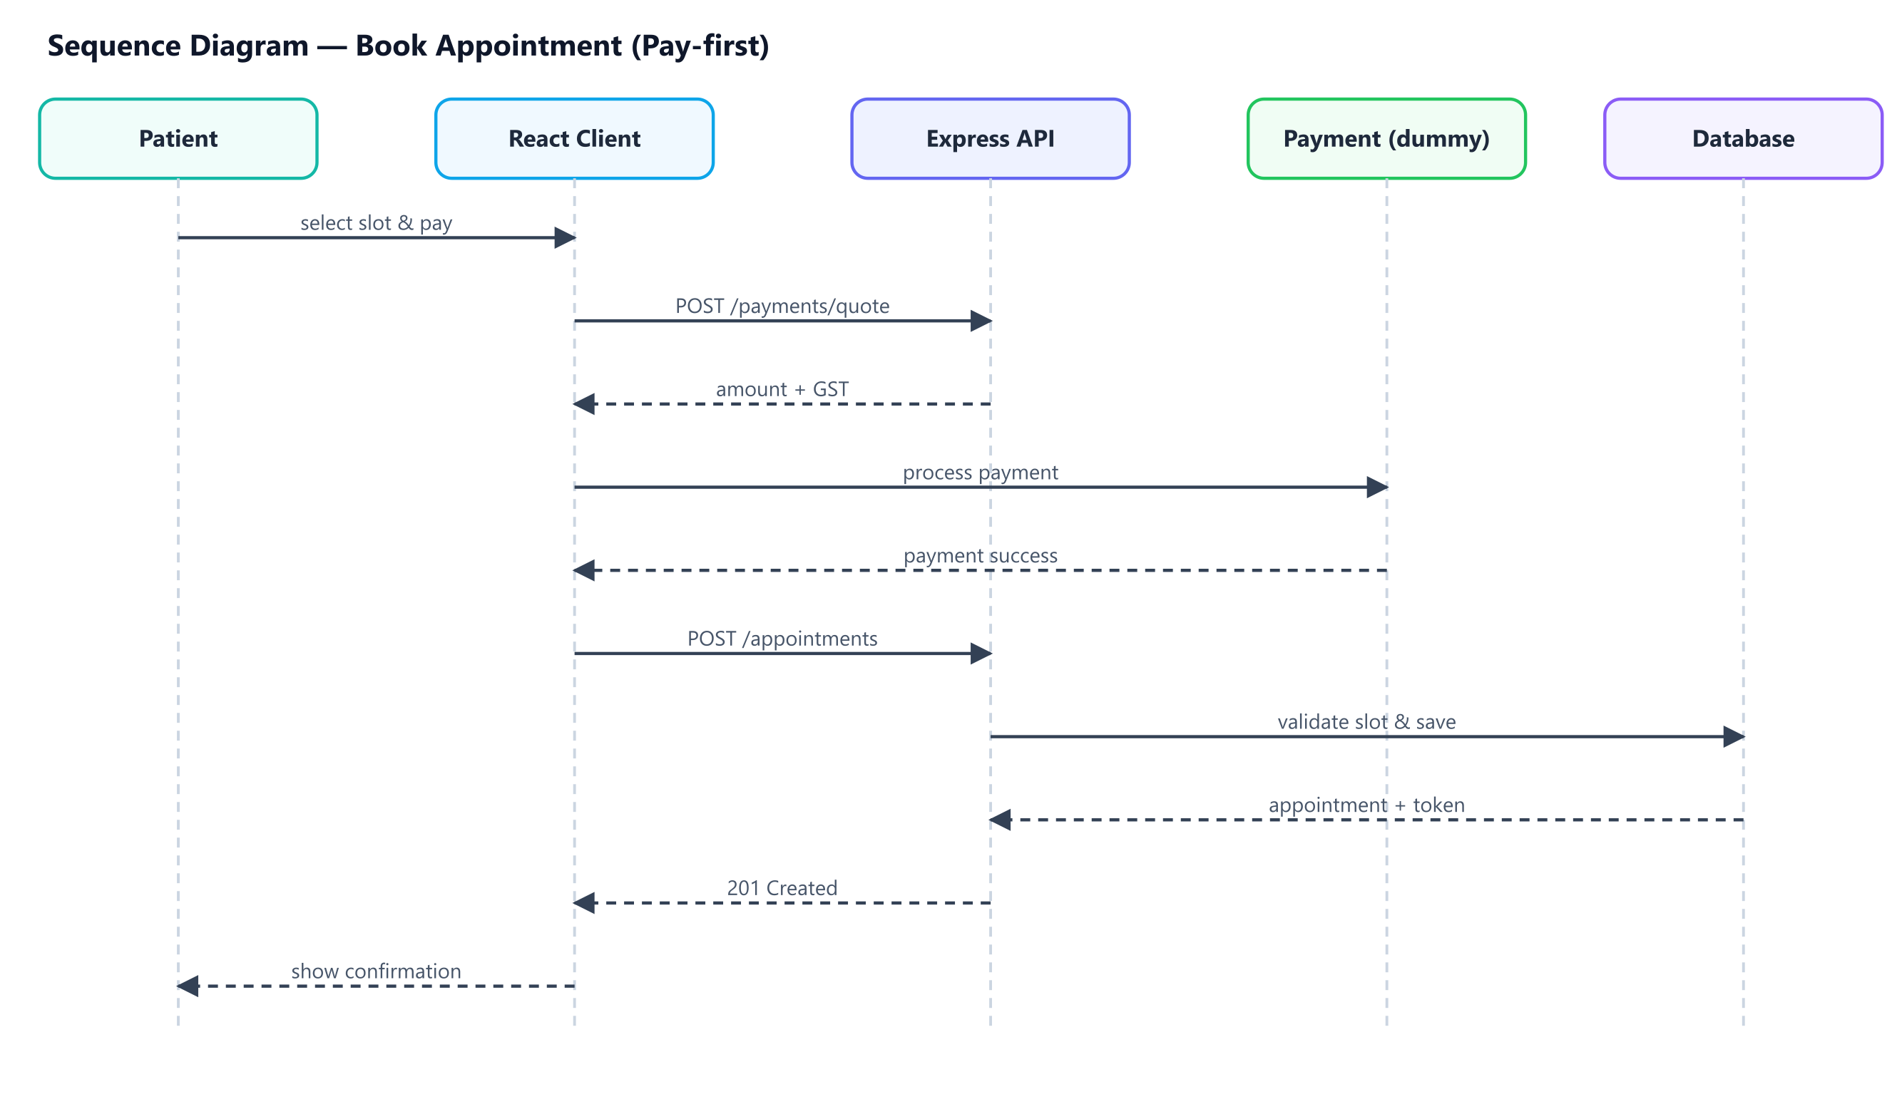
Fig 4.6 Sequence Diagram — Book Appointment

4.6 Class / Module Diagram
The backend is organised around a generic Repository abstraction that both the File and Mongo adapters implement (realisation). Controllers depend on repositories and services such as the Payment service and the Symptom engine.
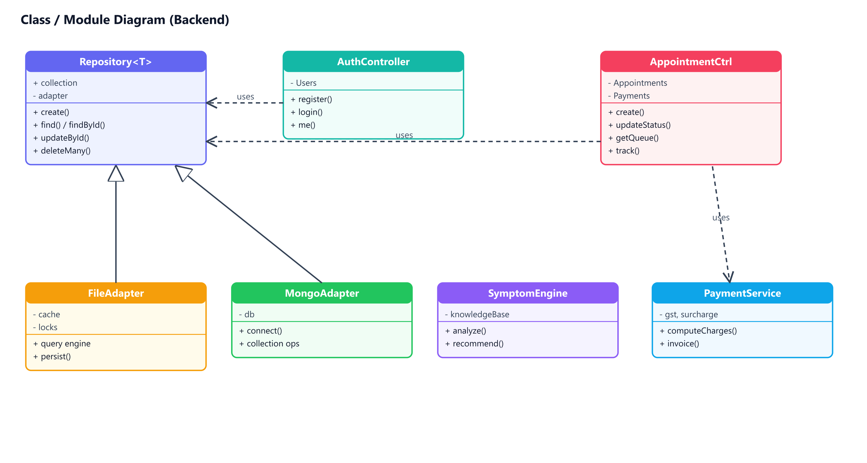
Fig 4.7 Class / Module Diagram

4.7 Activity Flow — Booking
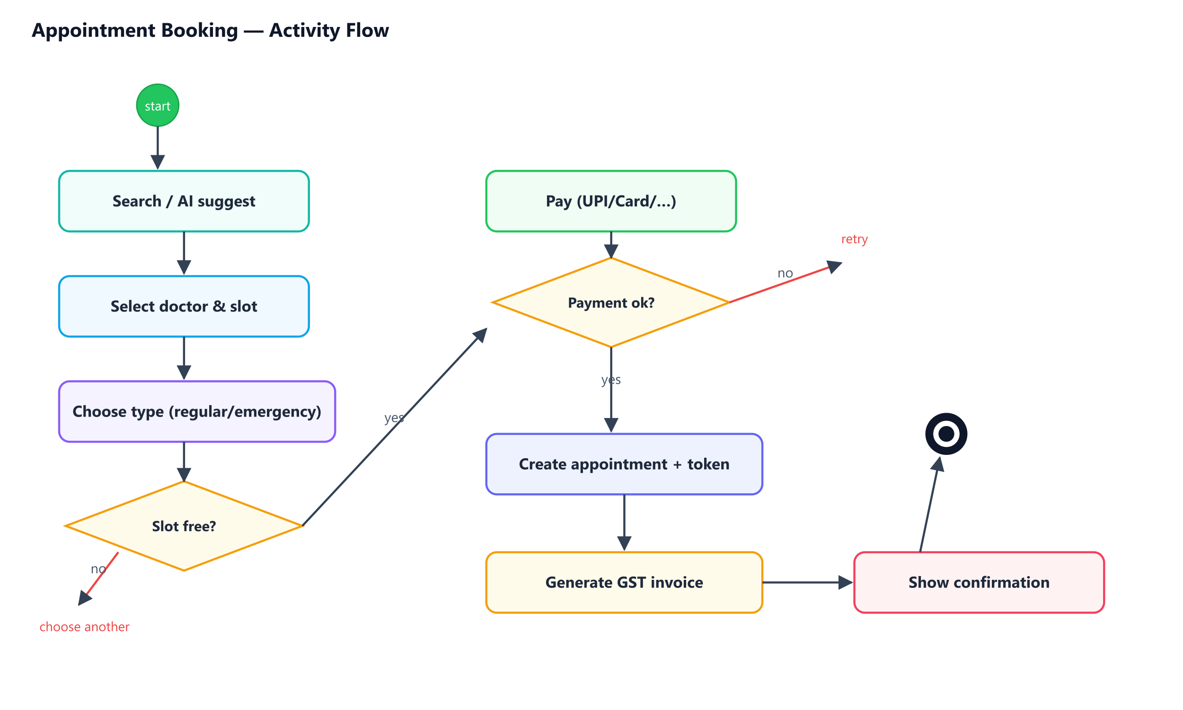
Fig 4.8 Activity Flow — Appointment Booking

4.8 Database Design
The following tables summarise the main collections and their key fields. The same logical schema applies to both the file store and MongoDB.

4.8.1 users
Field | Type | Description
id | String (PK) | Unique identifier
name / email | String | Account holder name and unique email
passwordHash | String | bcrypt hash of the password
role | Enum | patient / doctor / receptionist / admin
avatarUrl, phone, gender | String | Profile details
status | Enum | active / disabled

4.8.2 doctors
Field | Type | Description
id | String (PK) | Unique identifier
userId | String (FK) | Linked user account
specialty, qualifications | String | Professional details
consultationFee, experienceYears | Number | Fee and experience
availability[], breaks[], blockedDates[] | Array | Schedule configuration
rating, ratingCount, status | Mixed | Rating and approval status

4.8.3 appointments
Field | Type | Description
id | String (PK) | Unique identifier
patientId, doctorId | String (FK) | Participants
date, startTime, endTime | String | Scheduled slot
type | Enum | regular / emergency
status, trackStatus, token | Mixed | Lifecycle & queue token
amount, paymentId, invoiceNo | Mixed | Billing references

4.8.4 Other collections
Collection | Purpose
payments | Transactions with fee, GST, total, method, invoice number
prescriptions | Diagnosis, vitals, medicines[], advice, signature
records | EHR uploads: type, file URL, OCR text
vitals | BP, pulse, weight, sugar, SpO₂ over time
reviews | Doctor ratings and comments
leaves | Doctor leave requests and approvals
auditlogs | Who changed what and when

Chapter 5: Implementation

5.1 Development Methodology
The project was developed using an iterative, incremental approach. Core functionality (authentication, booking) was built first, followed by role workspaces, advanced features (AI checker, payments, queue), and finally UI polish, analytics and internationalisation. Each increment was verified end-to-end before moving on.

5.2 Project Structure
The codebase is split into a client (React + Vite) and a server (Express). The server is layered into configuration, database adapters, repositories, controllers, routes, middleware and utilities. The client is organised into API modules, reusable components, contexts, pages and a shared CSS design system.

5.3 Pluggable Storage Layer
A key implementation highlight is the storage abstraction. A common repository interface exposes create, find, findById, updateById and deleteMany. The file adapter implements an in-memory-cached JSON store with a small MongoDB-style query engine, while the Mongo adapter maps the same operations to the native driver. The active driver is selected at runtime from a single environment variable, so no application code changes when switching databases.

5.4 Authentication & Authorisation
Passwords are hashed with bcrypt. On login, a signed JWT is issued and stored client-side; an Axios interceptor attaches it to requests and gracefully signs the user out on expiry. Middleware authenticates the token and authorises requests by role, ensuring, for example, that only doctors can write prescriptions and only administrators can manage users.

5.5 AI Symptom Checker
The symptom checker is a rule-based triage engine backed by a curated knowledge base that maps symptoms to likely conditions, a recommended specialist, an urgency level and home-care advice. A scoring function then recommends the best-matched doctors based on rating, experience, success rate, budget, language, location and the patient’s history.

5.6 Payments, Queue & Prescriptions
Booking is pay-first: the client obtains a price quote (fee + emergency surcharge + GST), simulates payment through a Razorpay-style checkout, and then creates the appointment with a queue token and GST invoice. The live queue board advances patients through booked → waiting → called → in-consultation → completed, with estimated waiting times. Doctors write structured prescriptions that patients can view and print as PDF.

Chapter 6: User Interface (Screenshots)

6.1 Public Website & Authentication
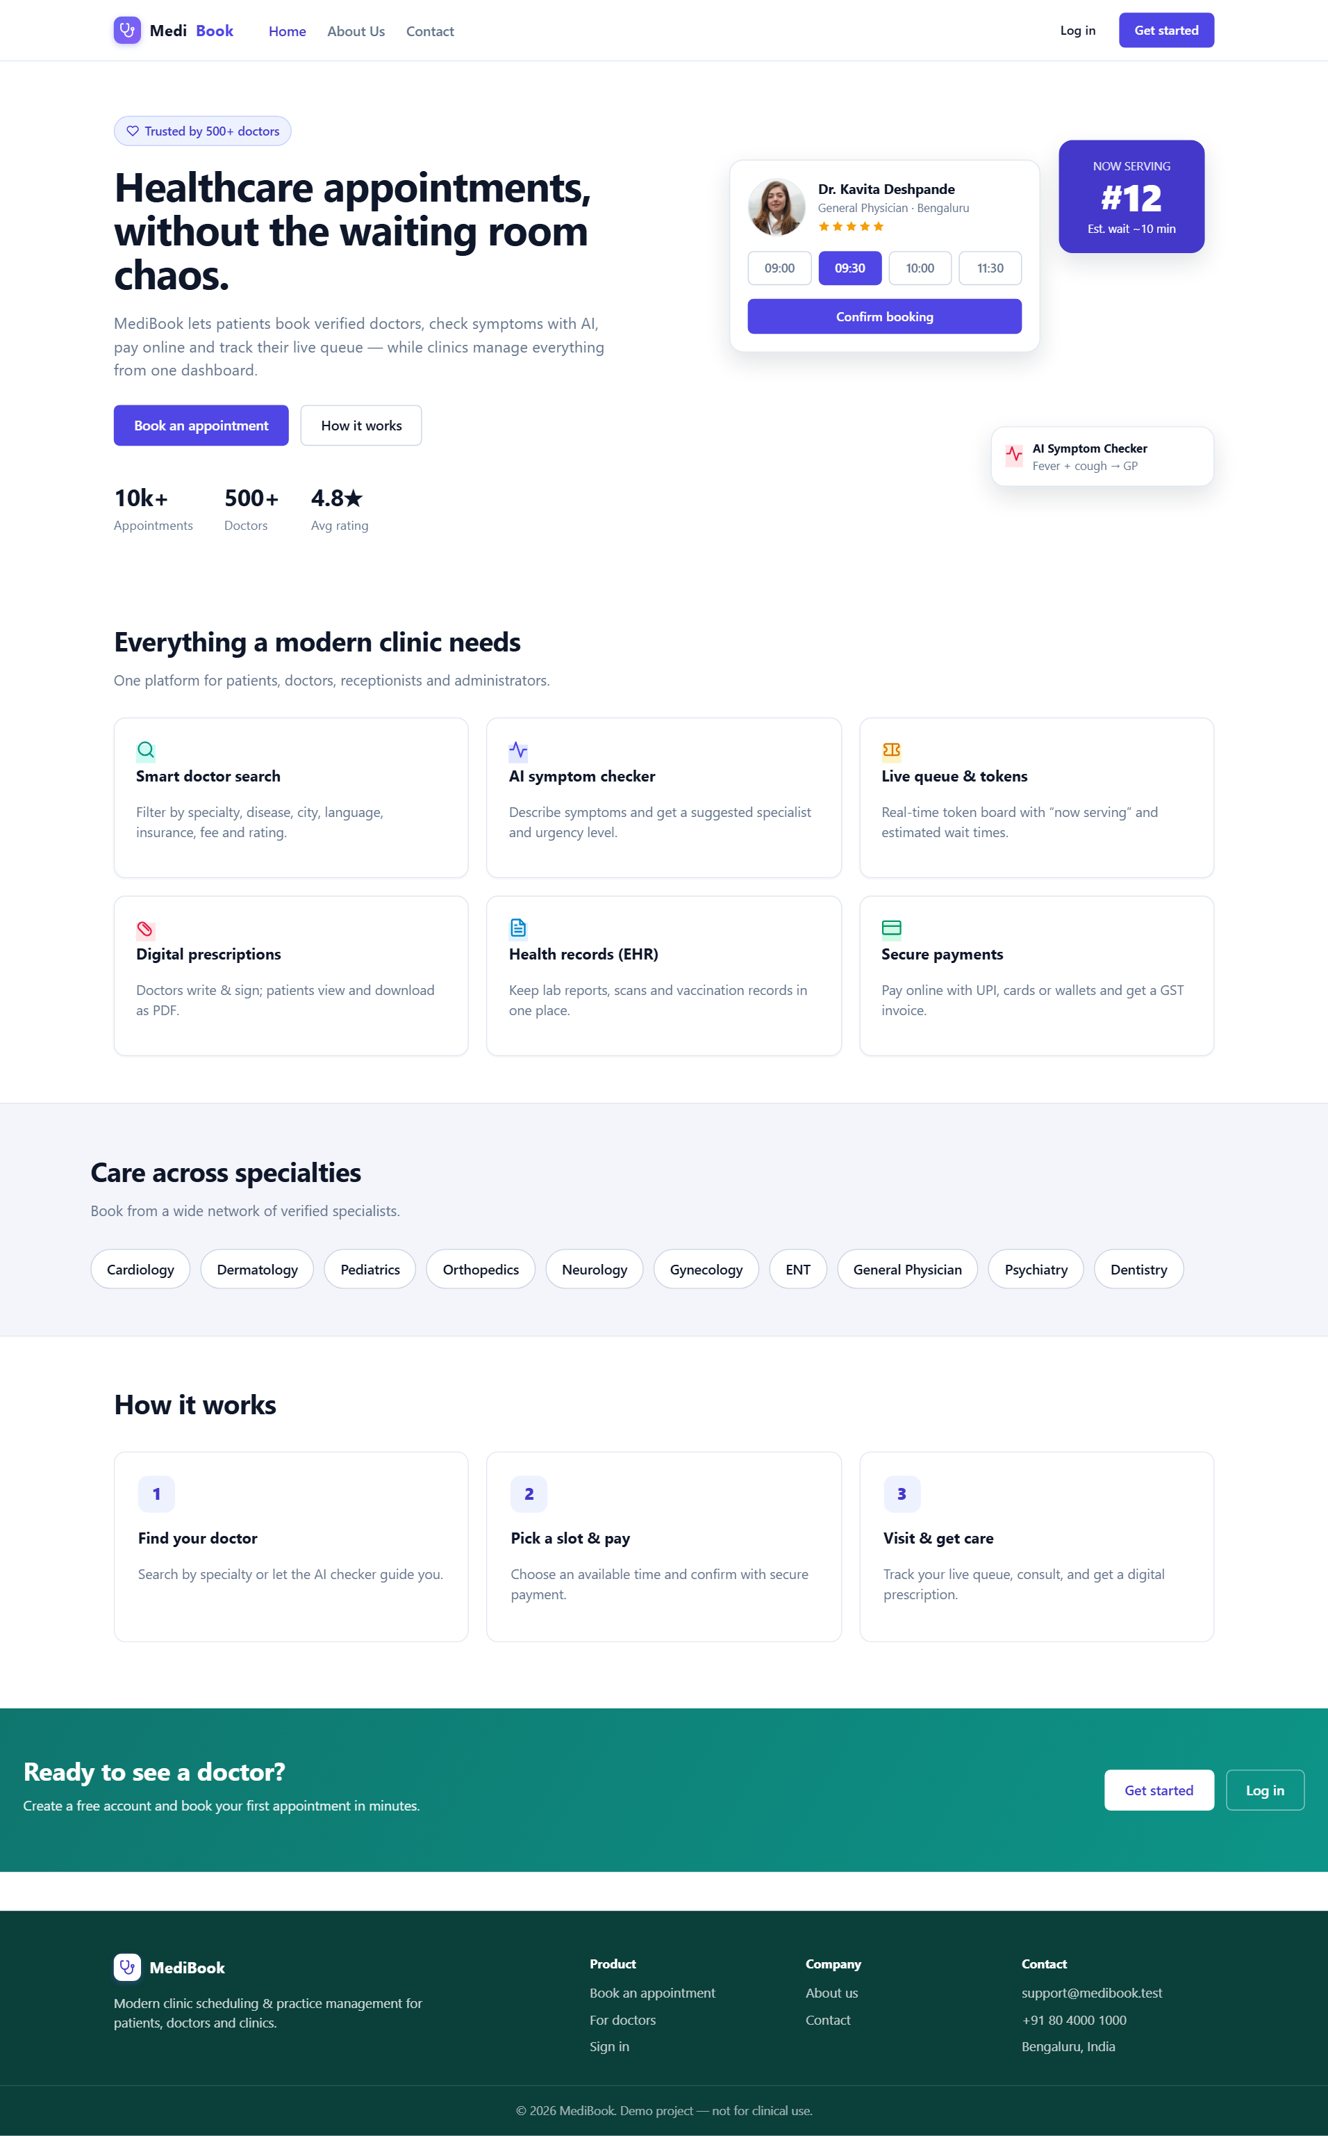
Fig 6.1 Public — Home
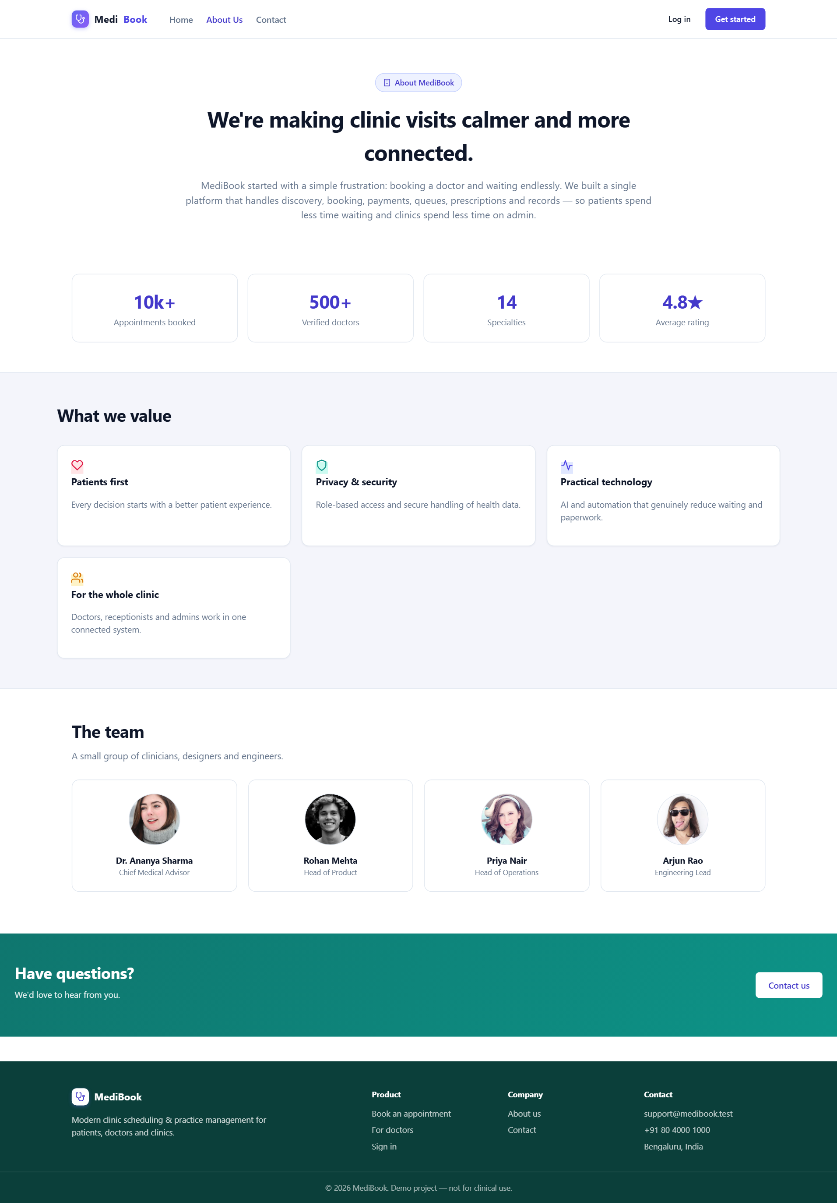
Fig 6.2 Public — About
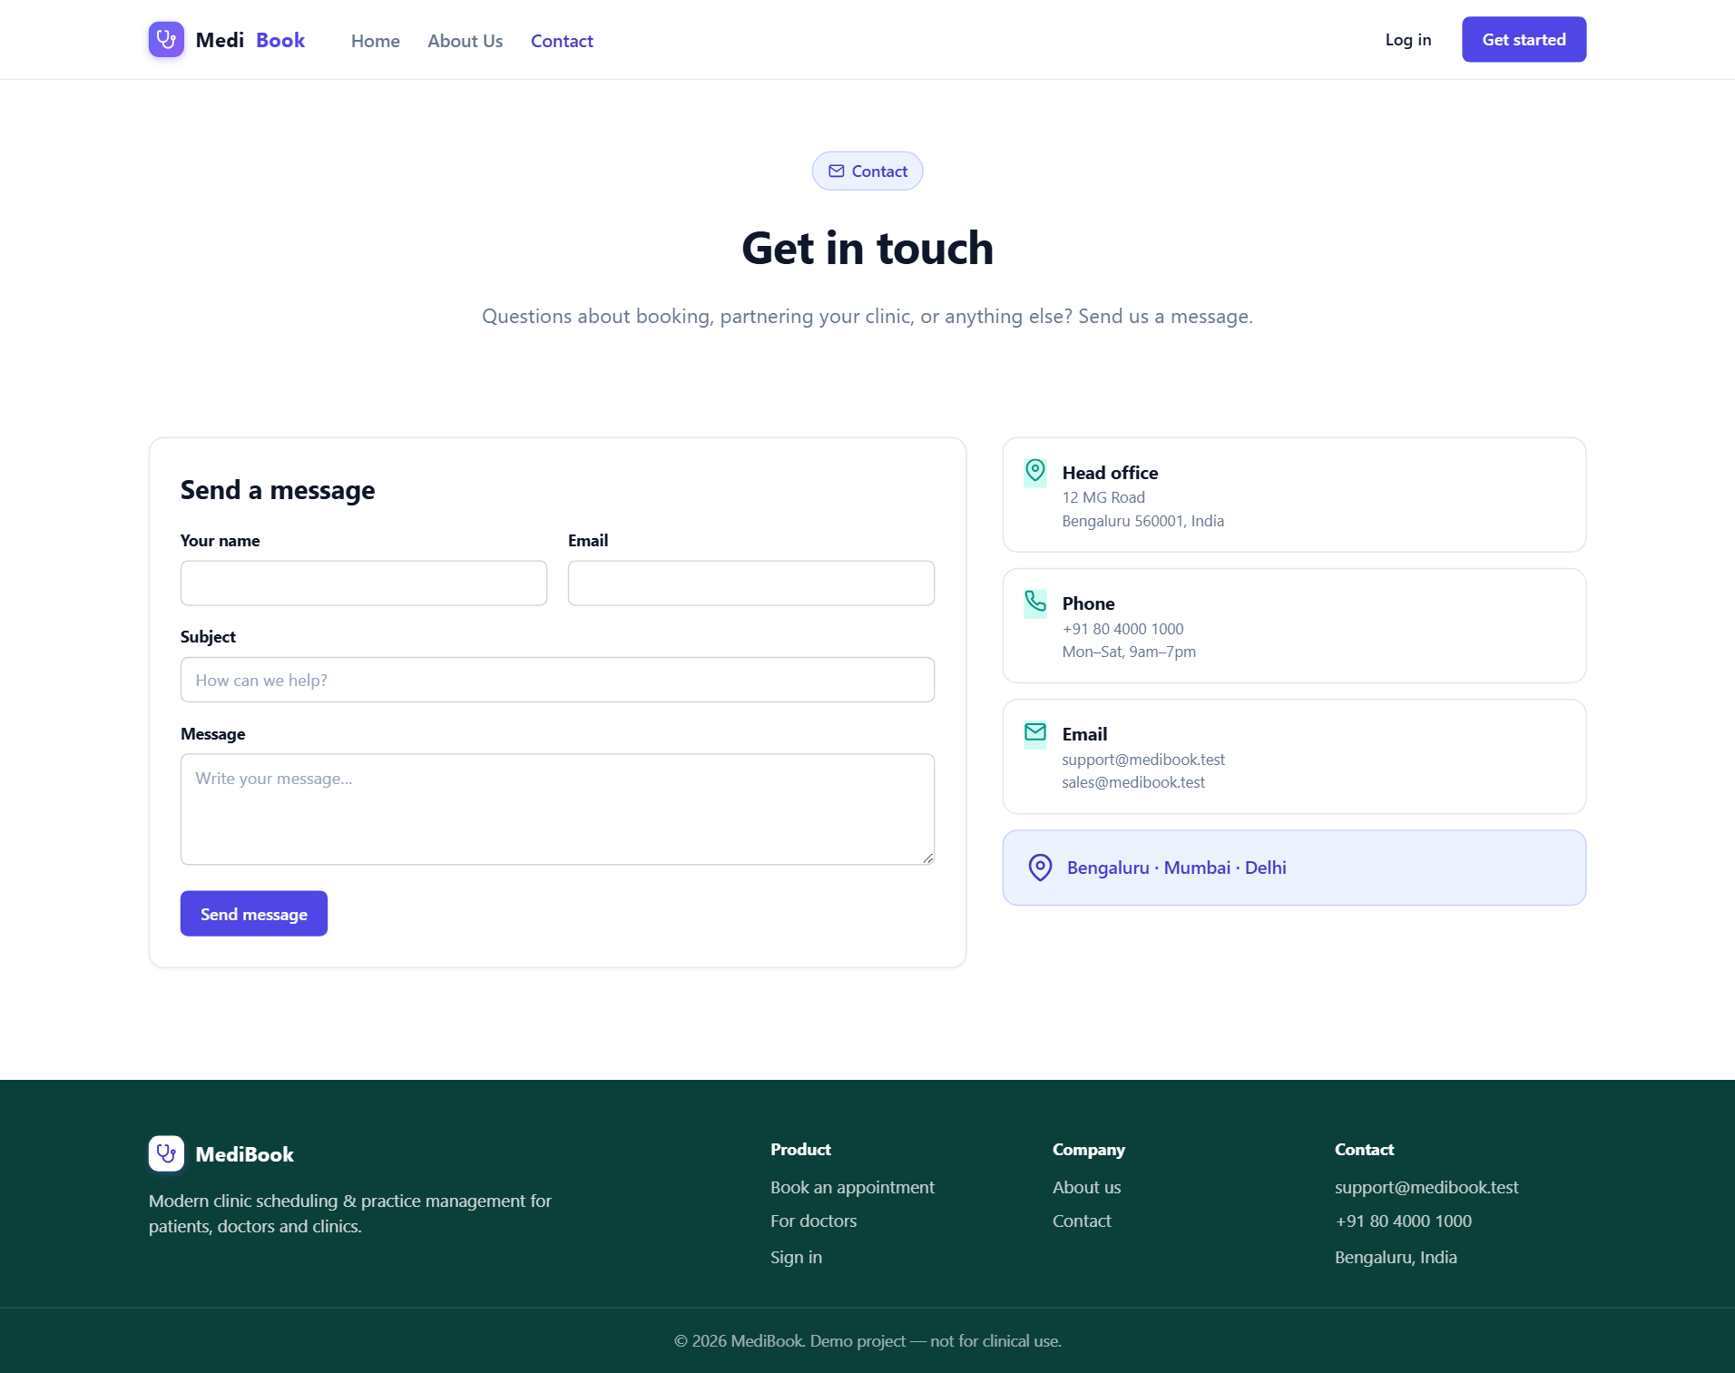
Fig 6.3 Public — Contact
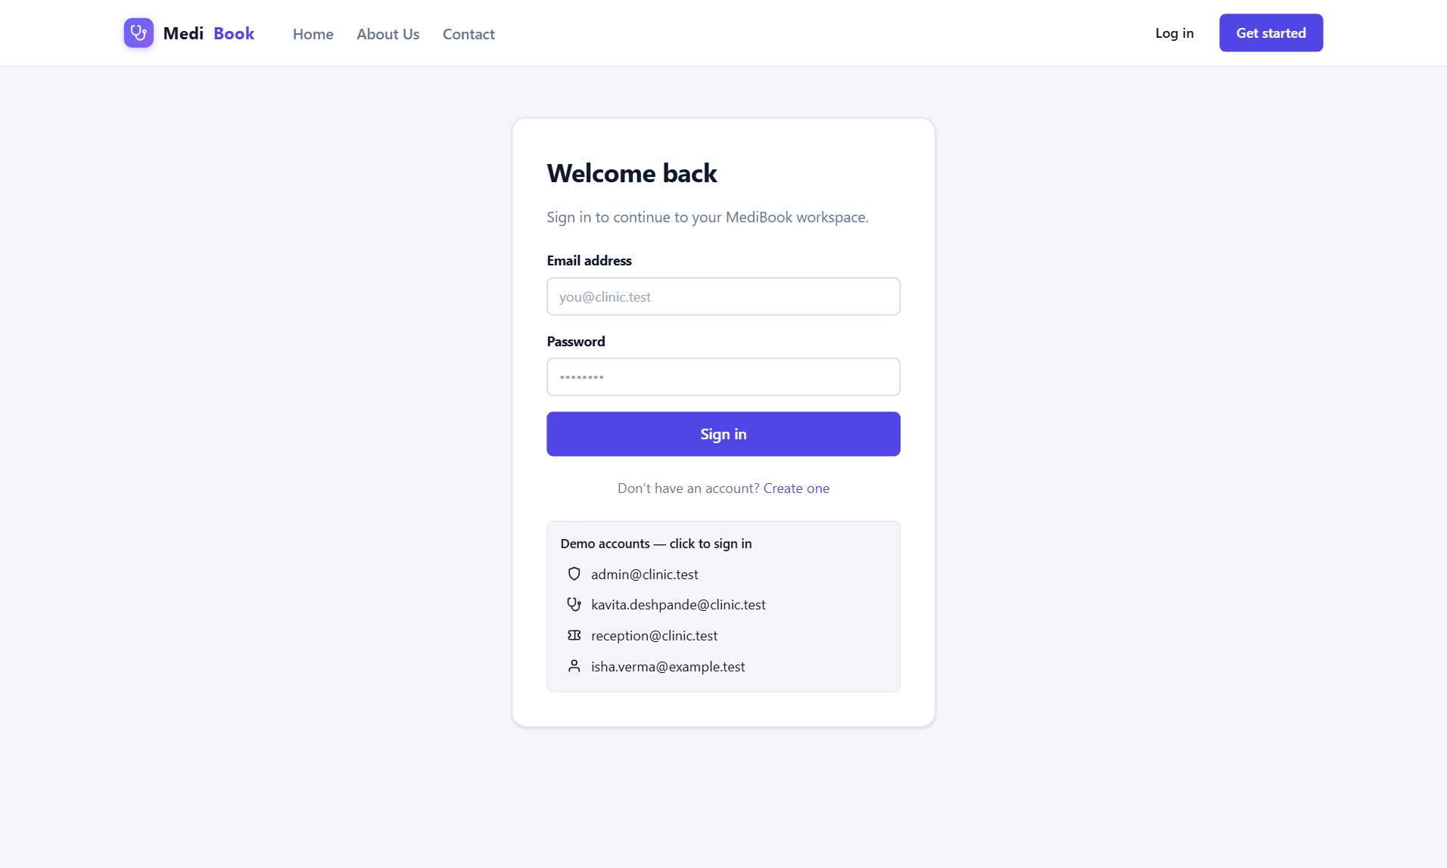
Fig 6.4 Public — Login
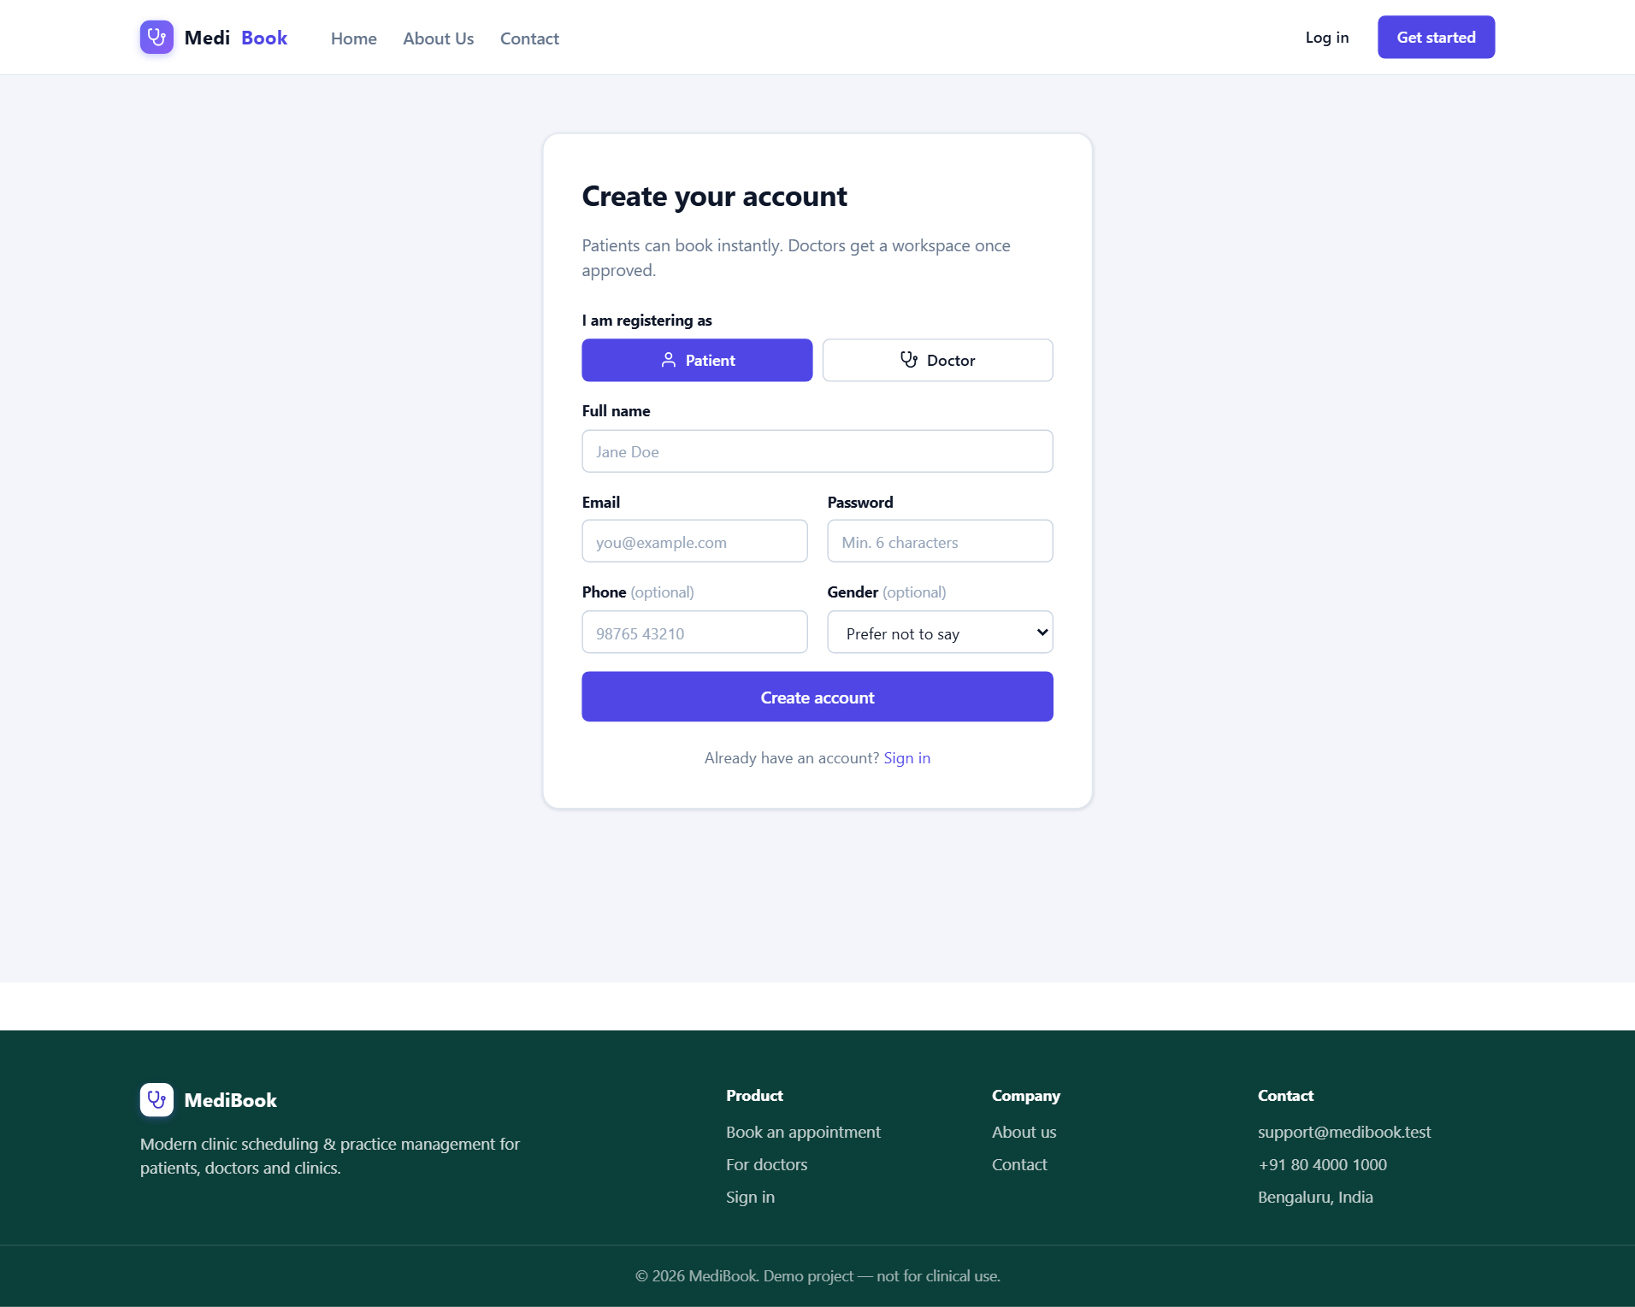
Fig 6.5 Public — Register

6.2 Patient Workspace
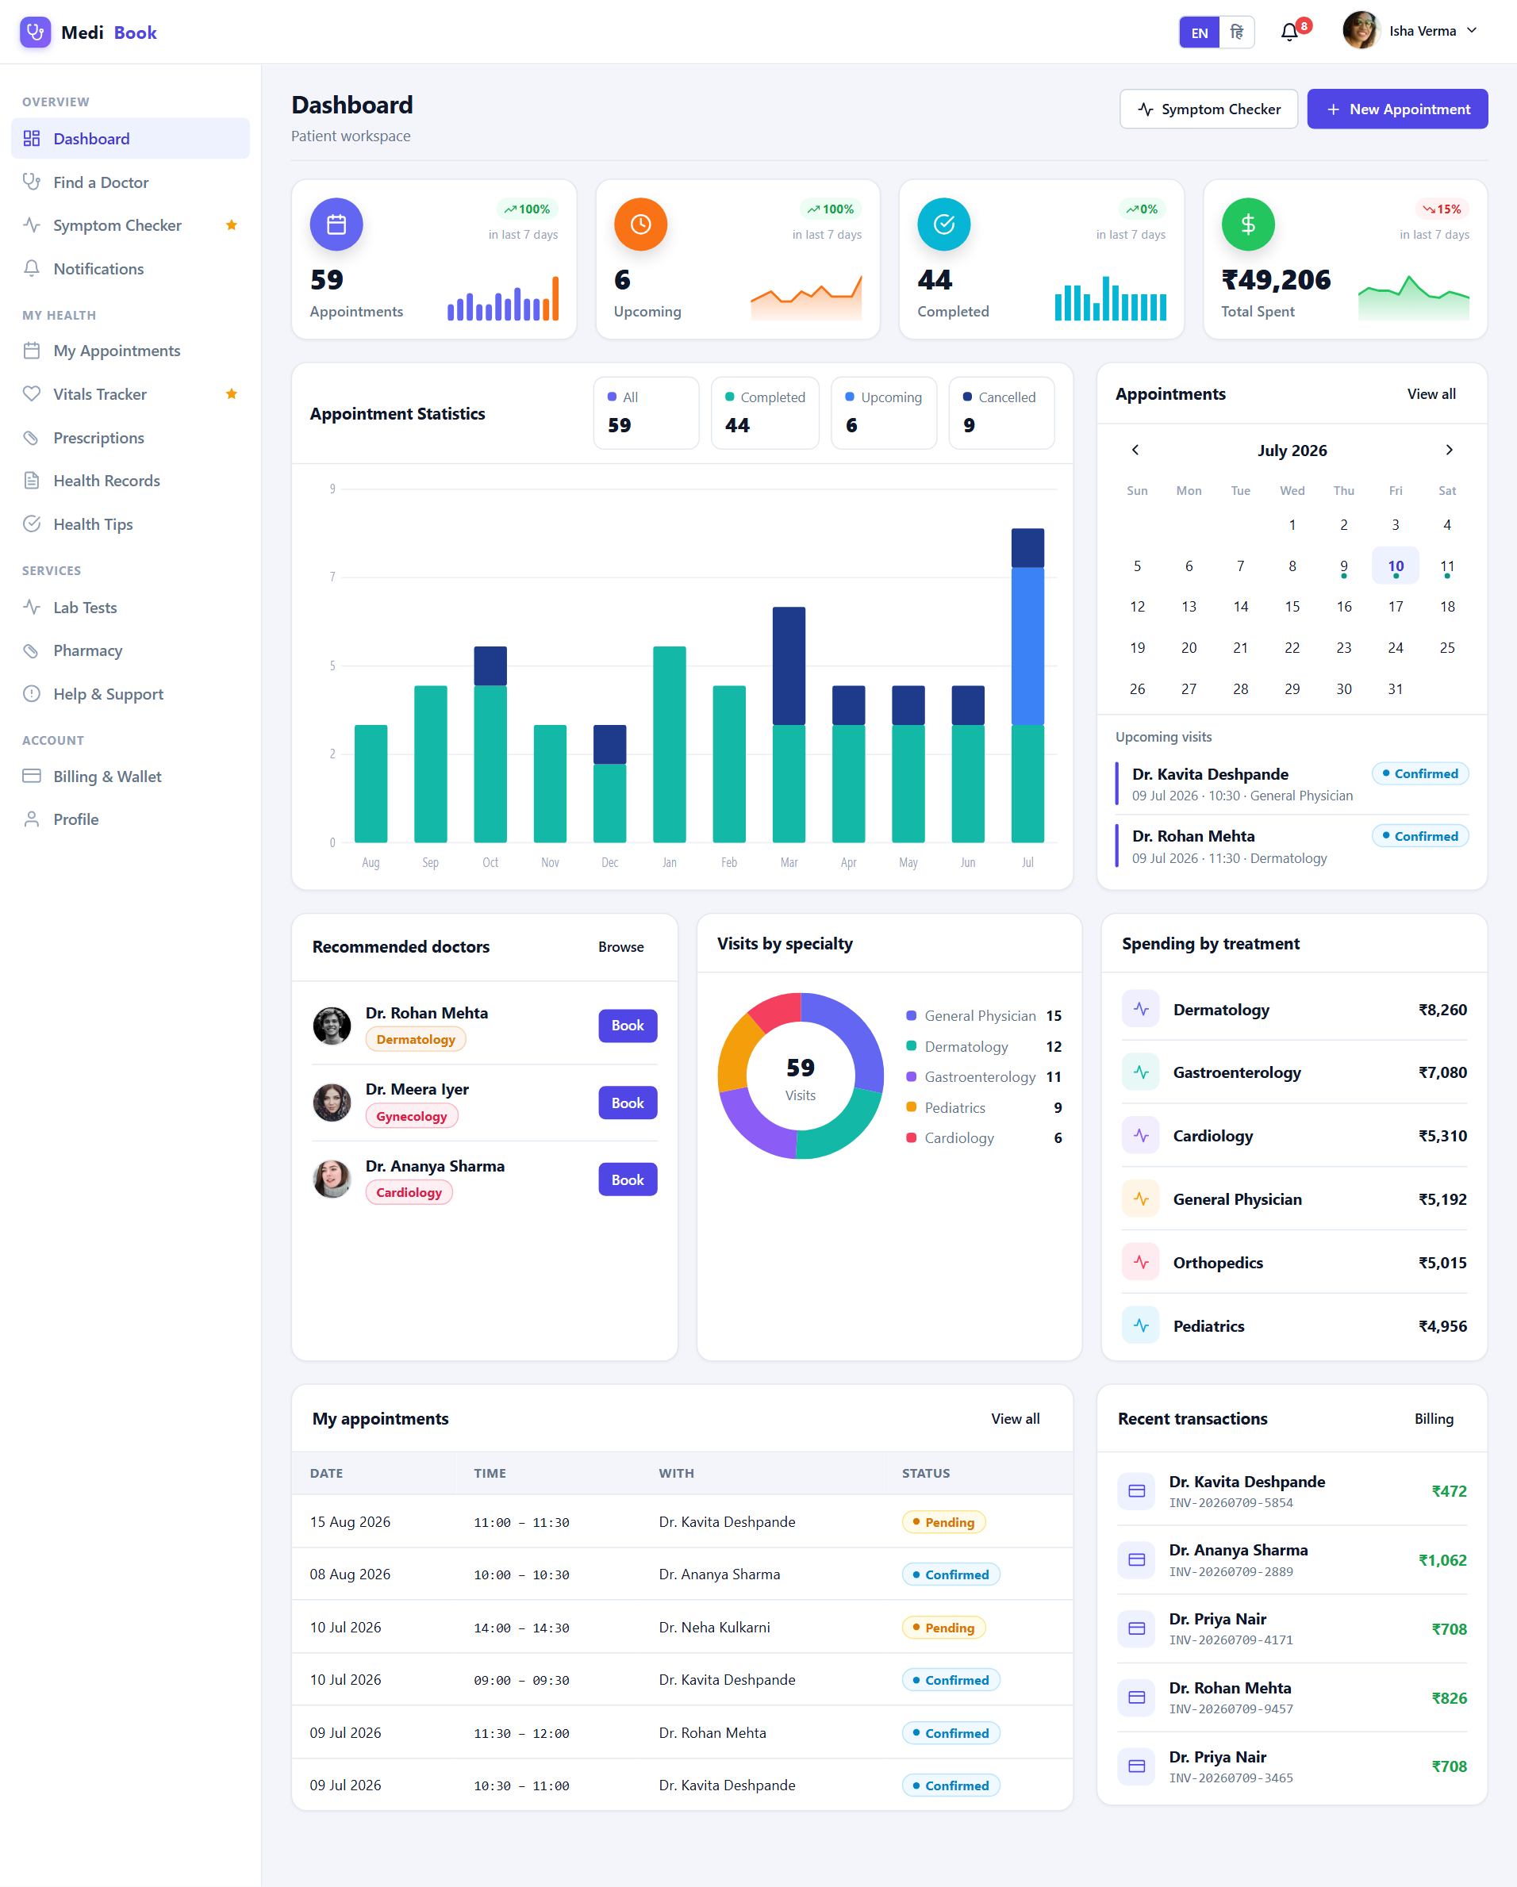
Fig 6.6 Patient — Dashboard
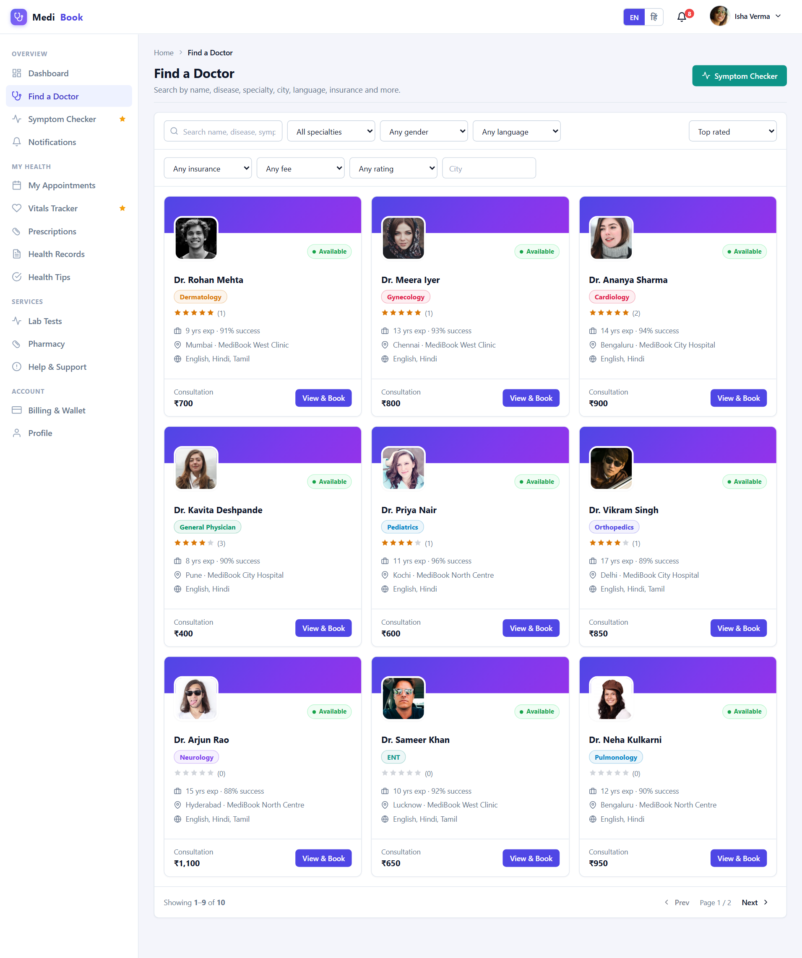
Fig 6.7 Patient — Find Doctor
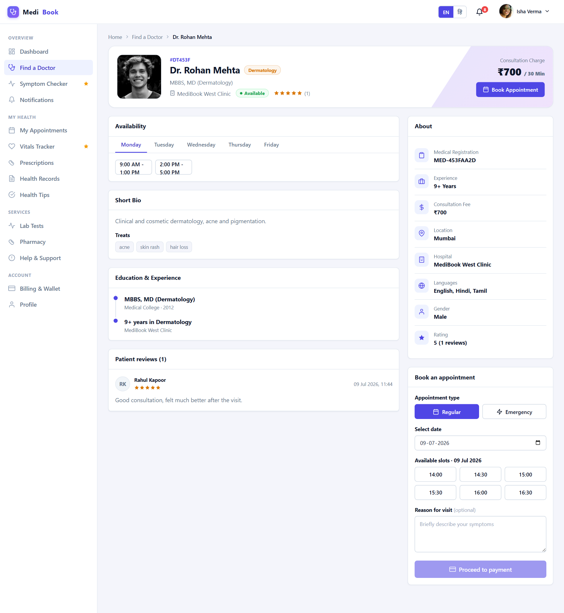
Fig 6.8 Patient — Doctor Detail
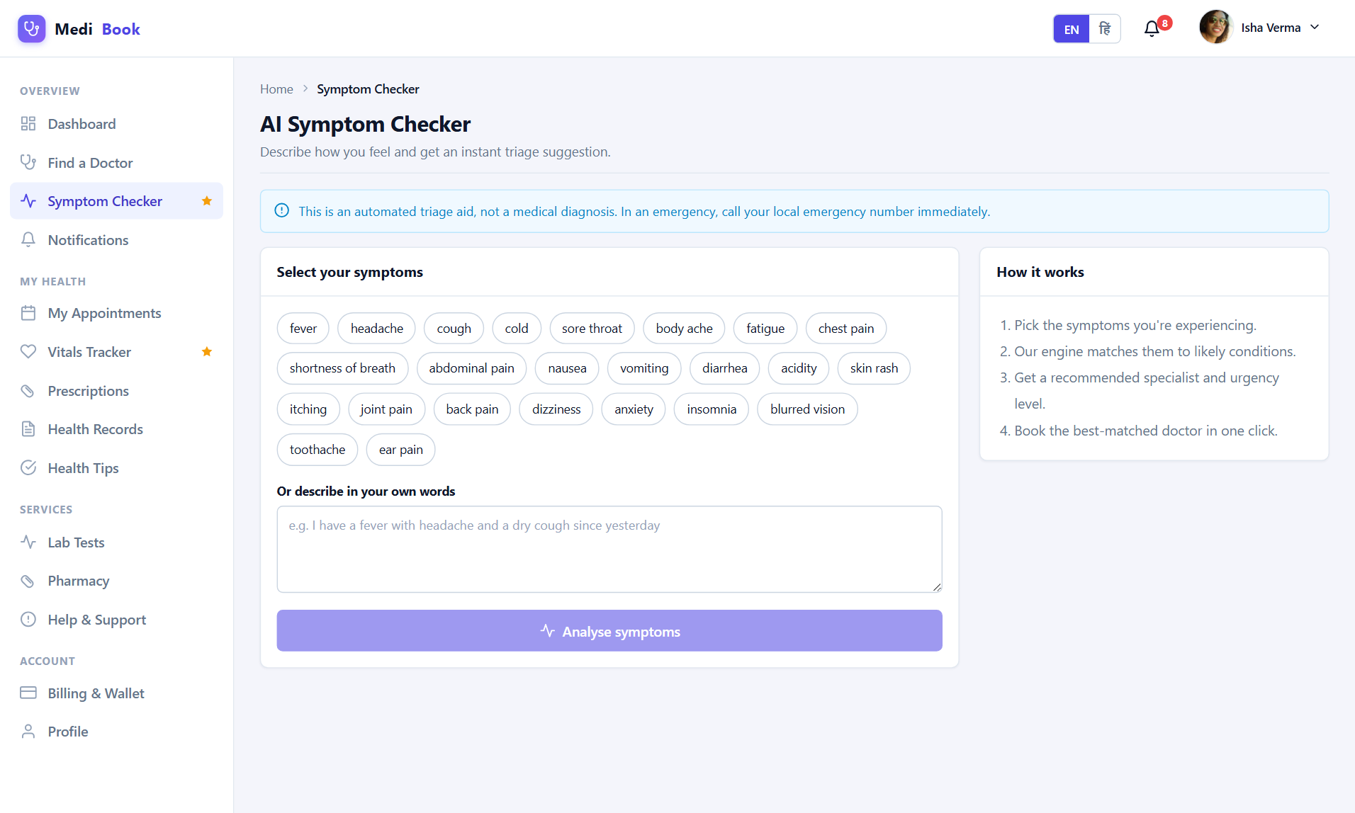
Fig 6.9 Patient — Symptom Checker
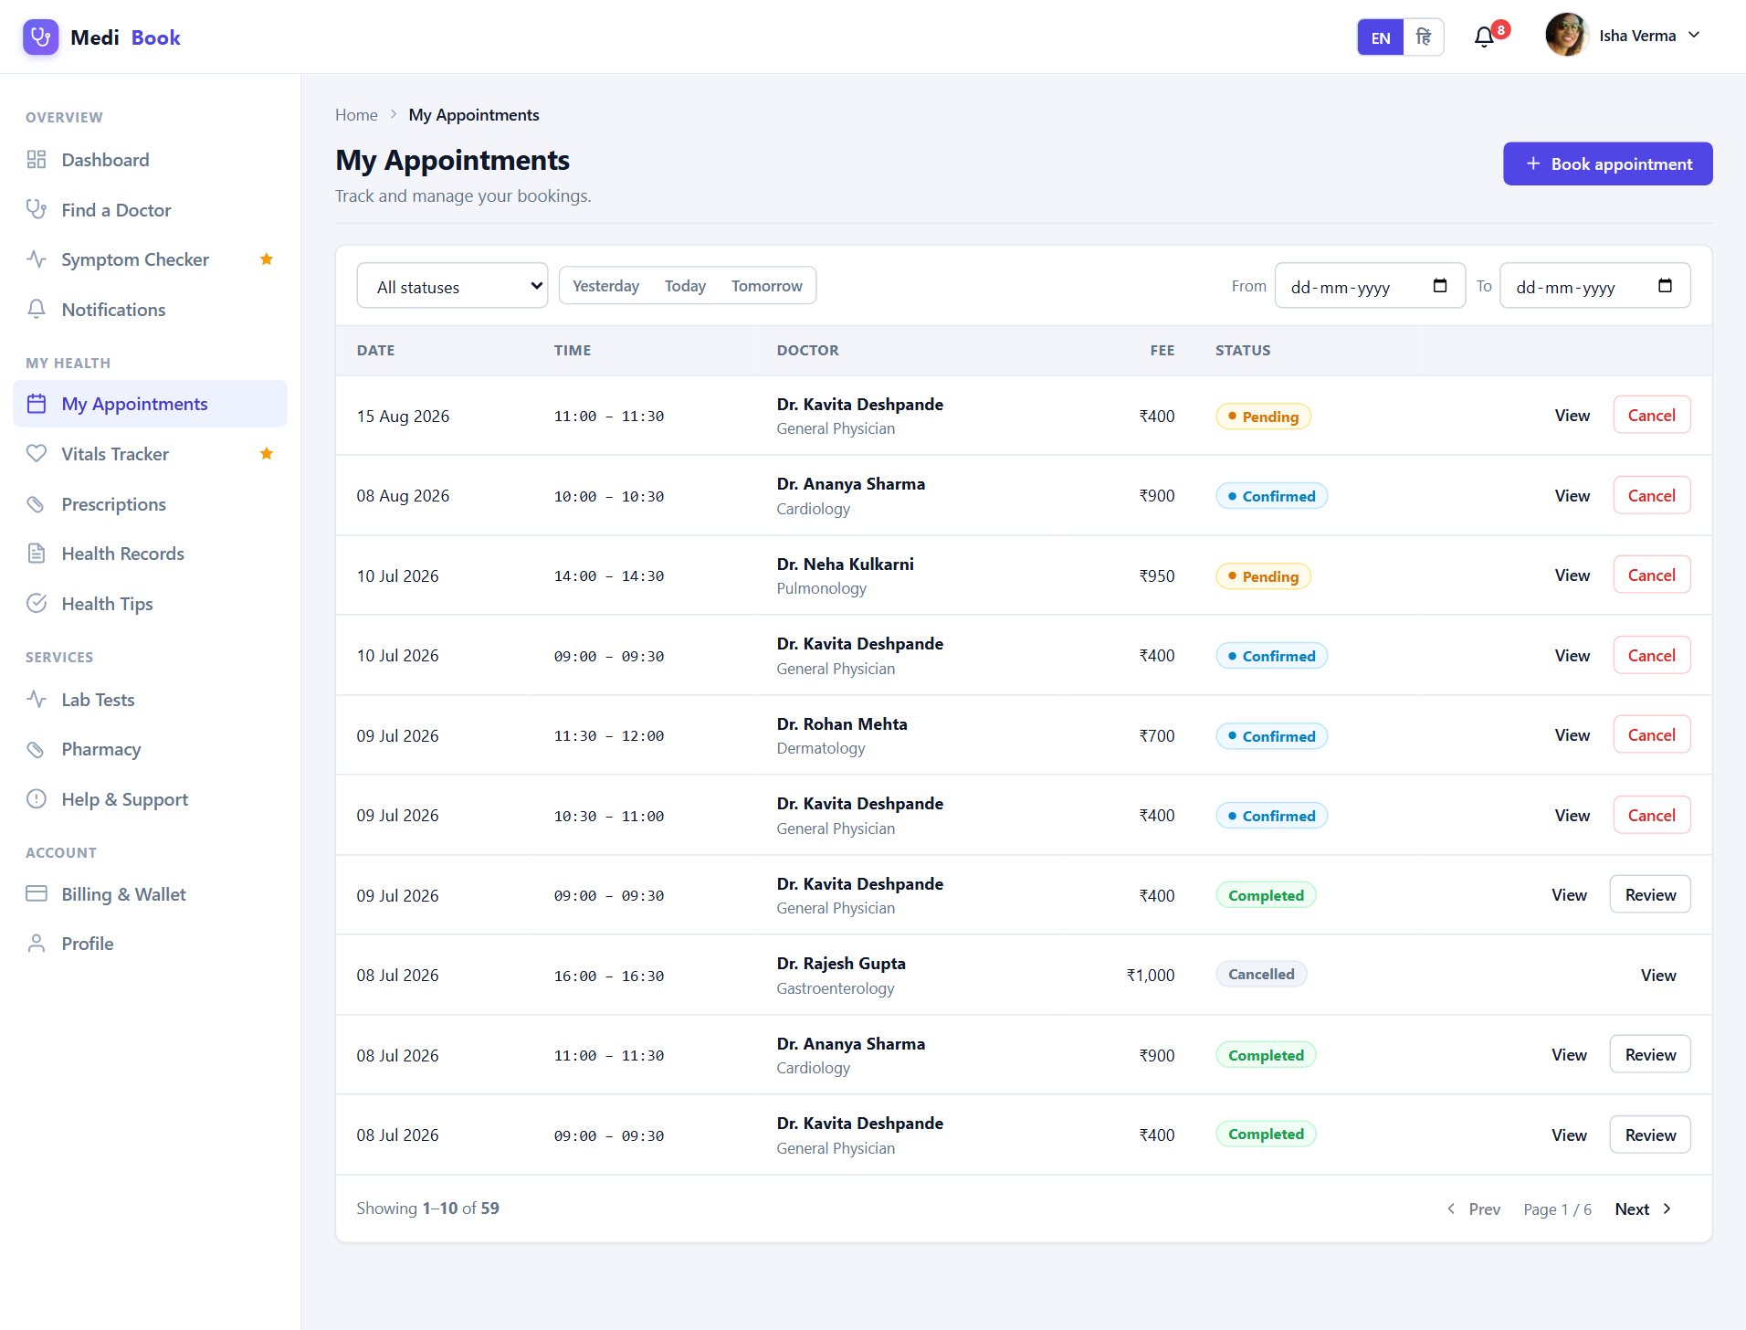
Fig 6.10 Patient — Appointments
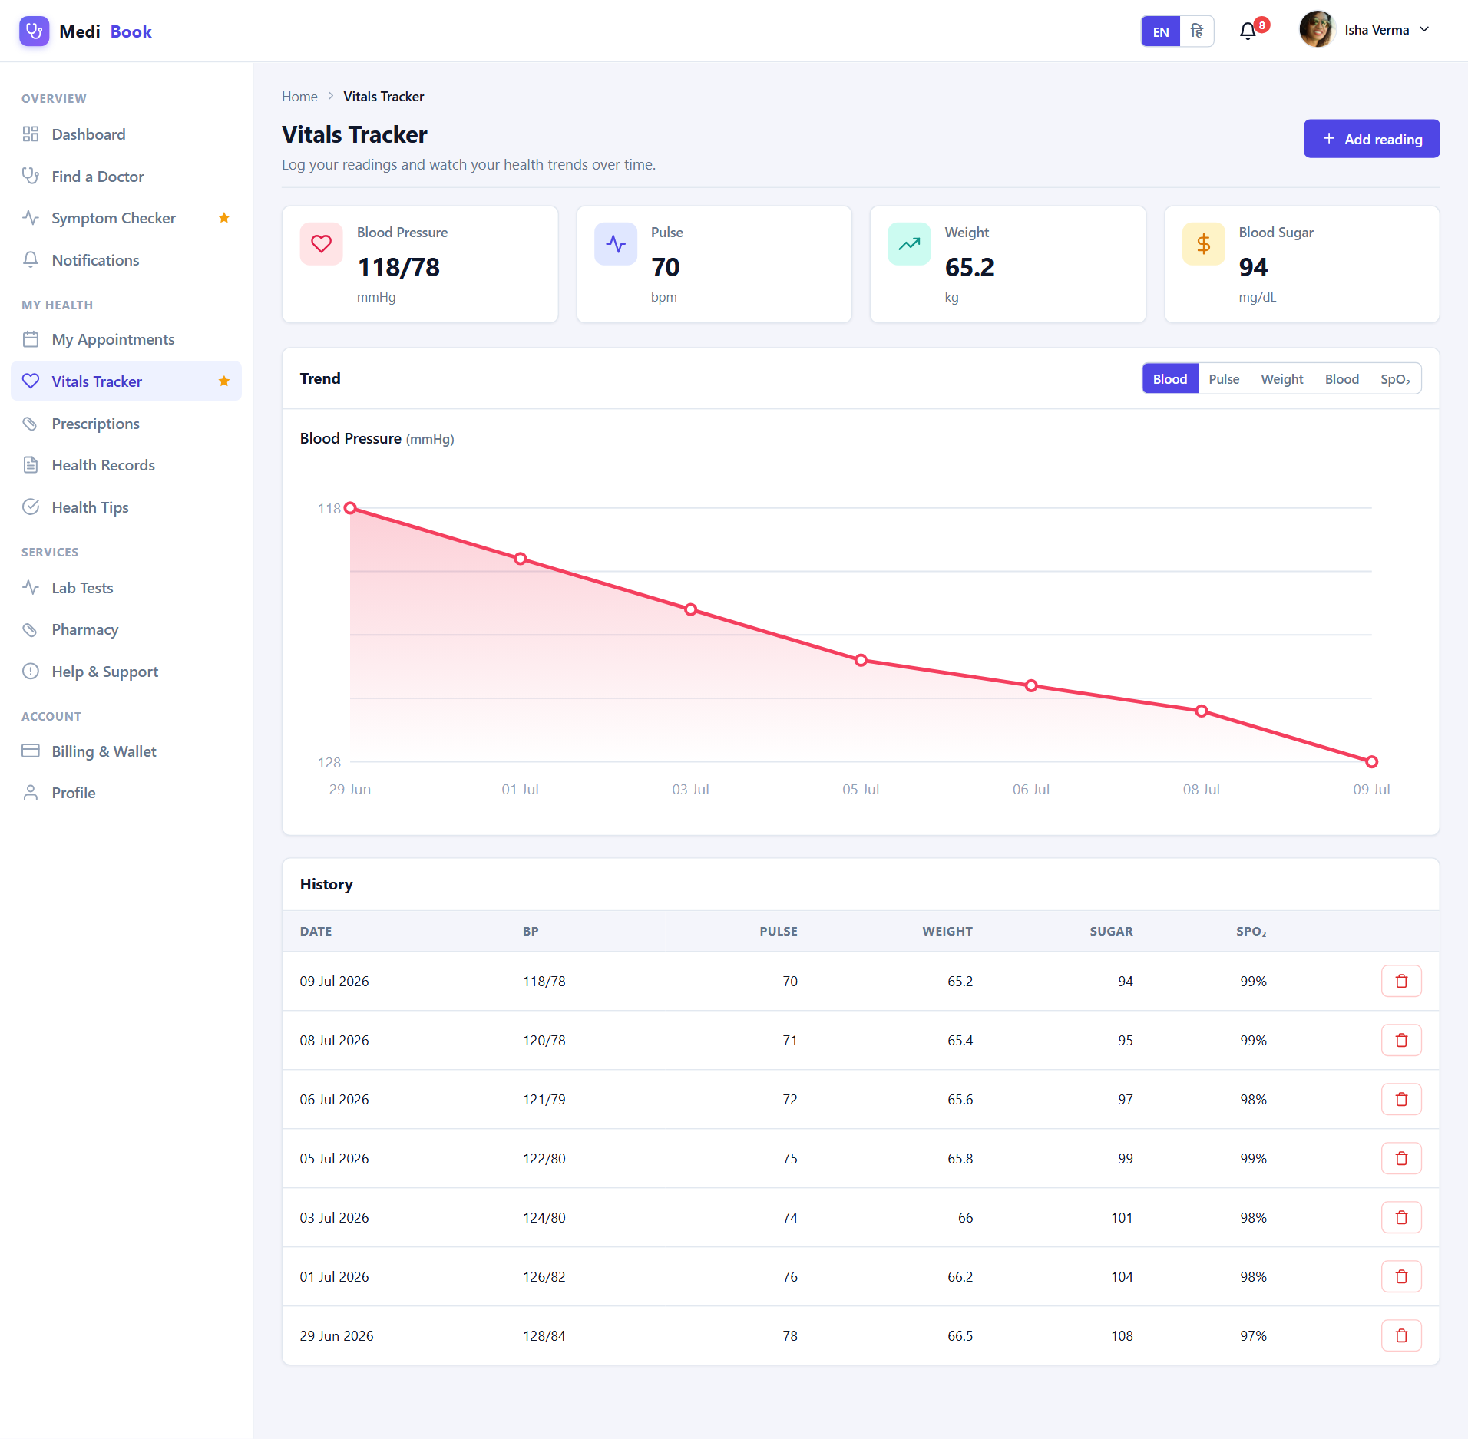
Fig 6.11 Patient — Vitals
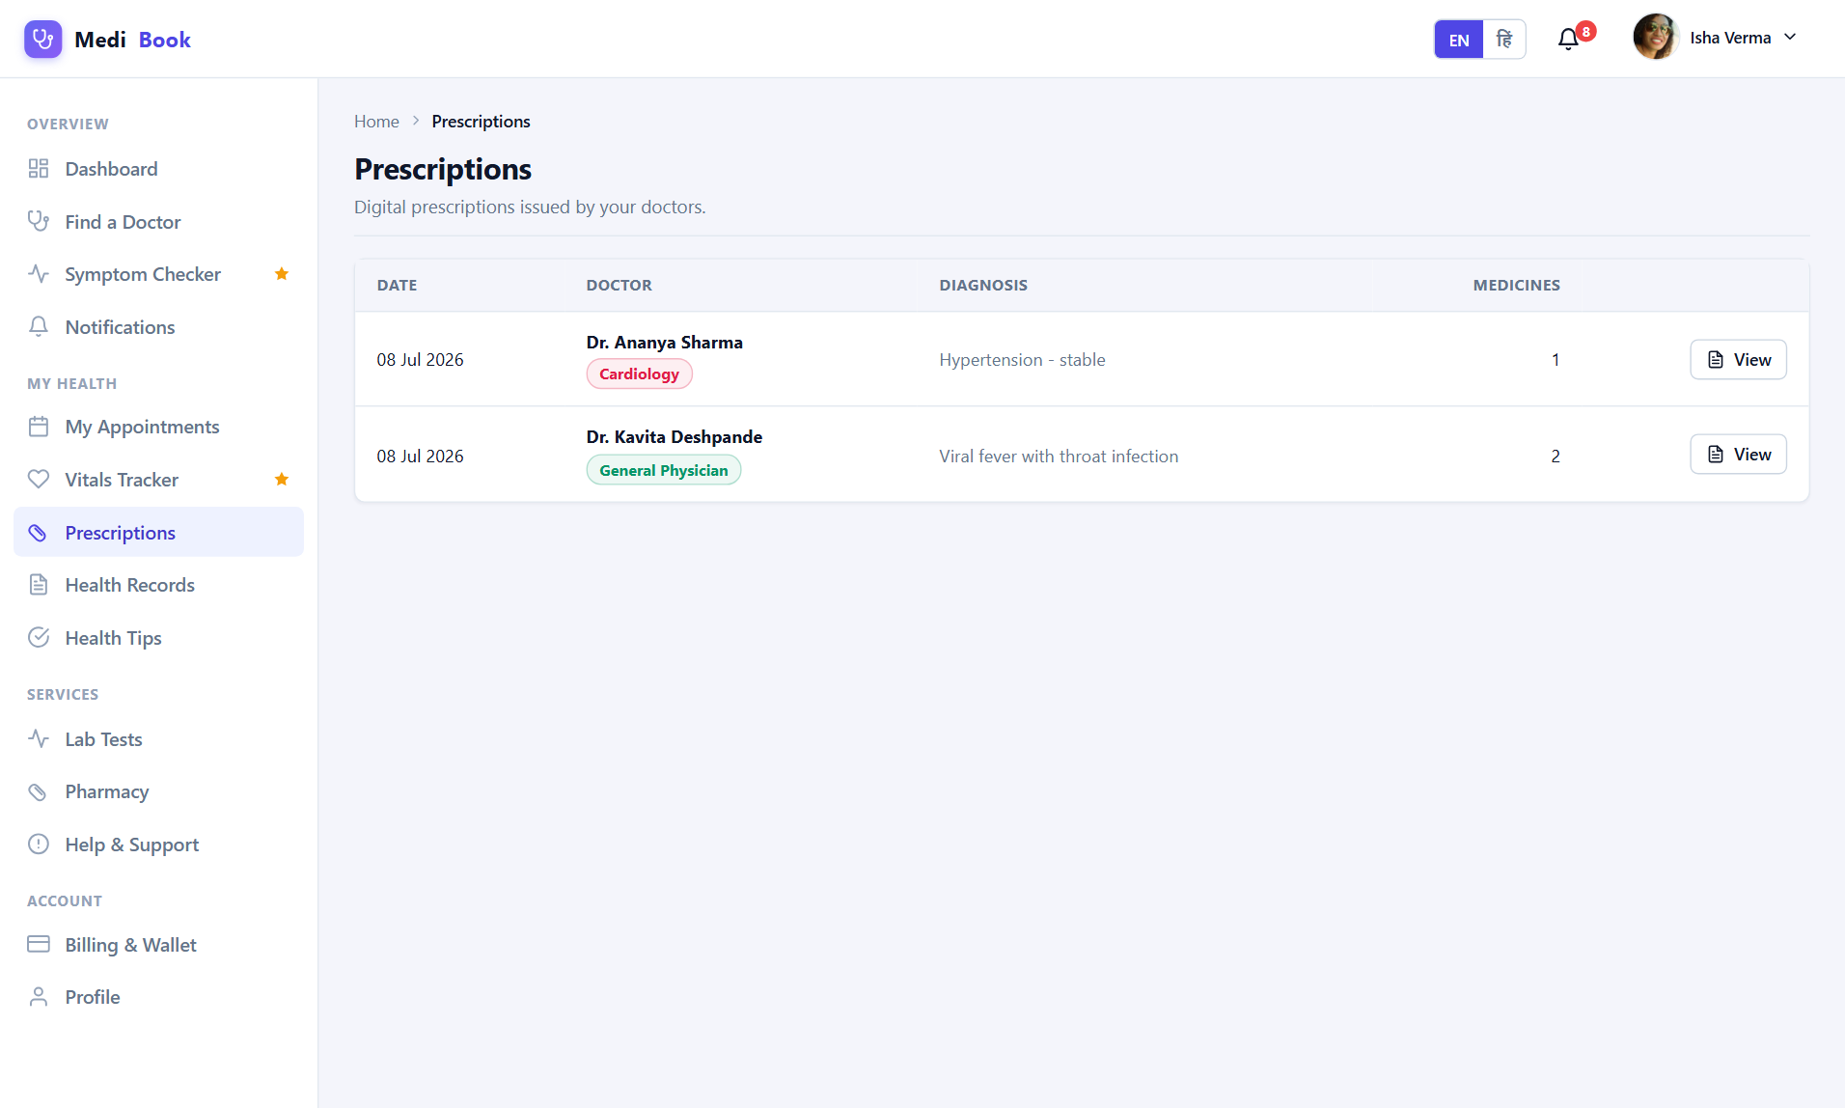
Fig 6.12 Patient — Prescriptions
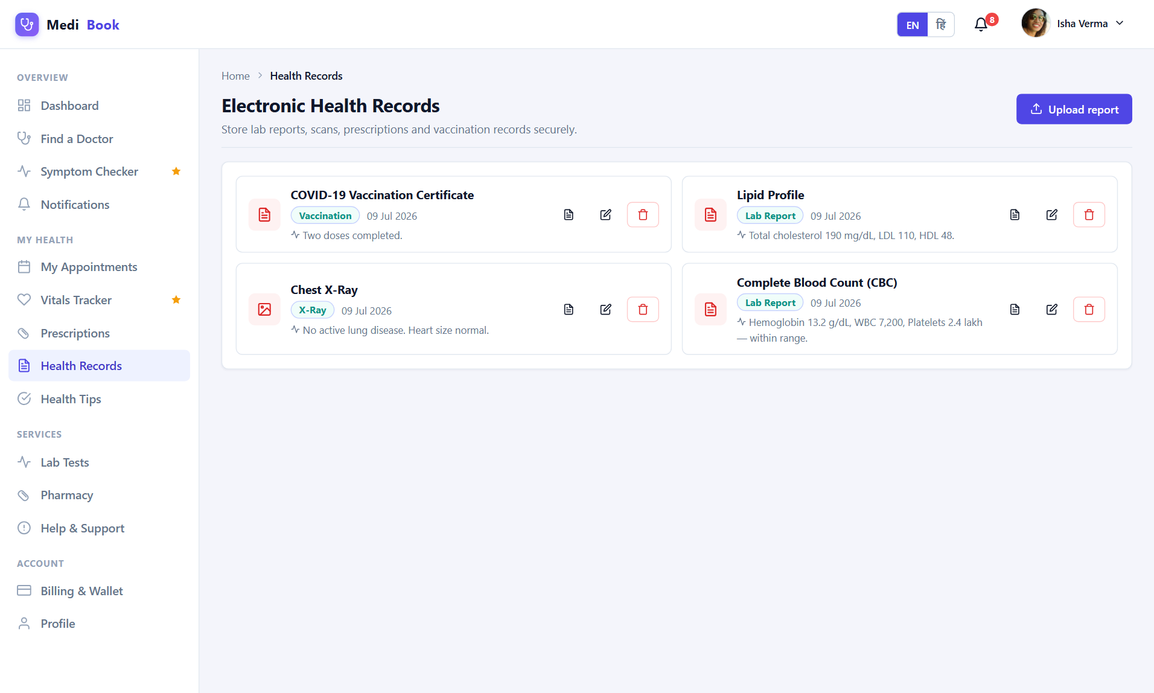
Fig 6.13 Patient — Records
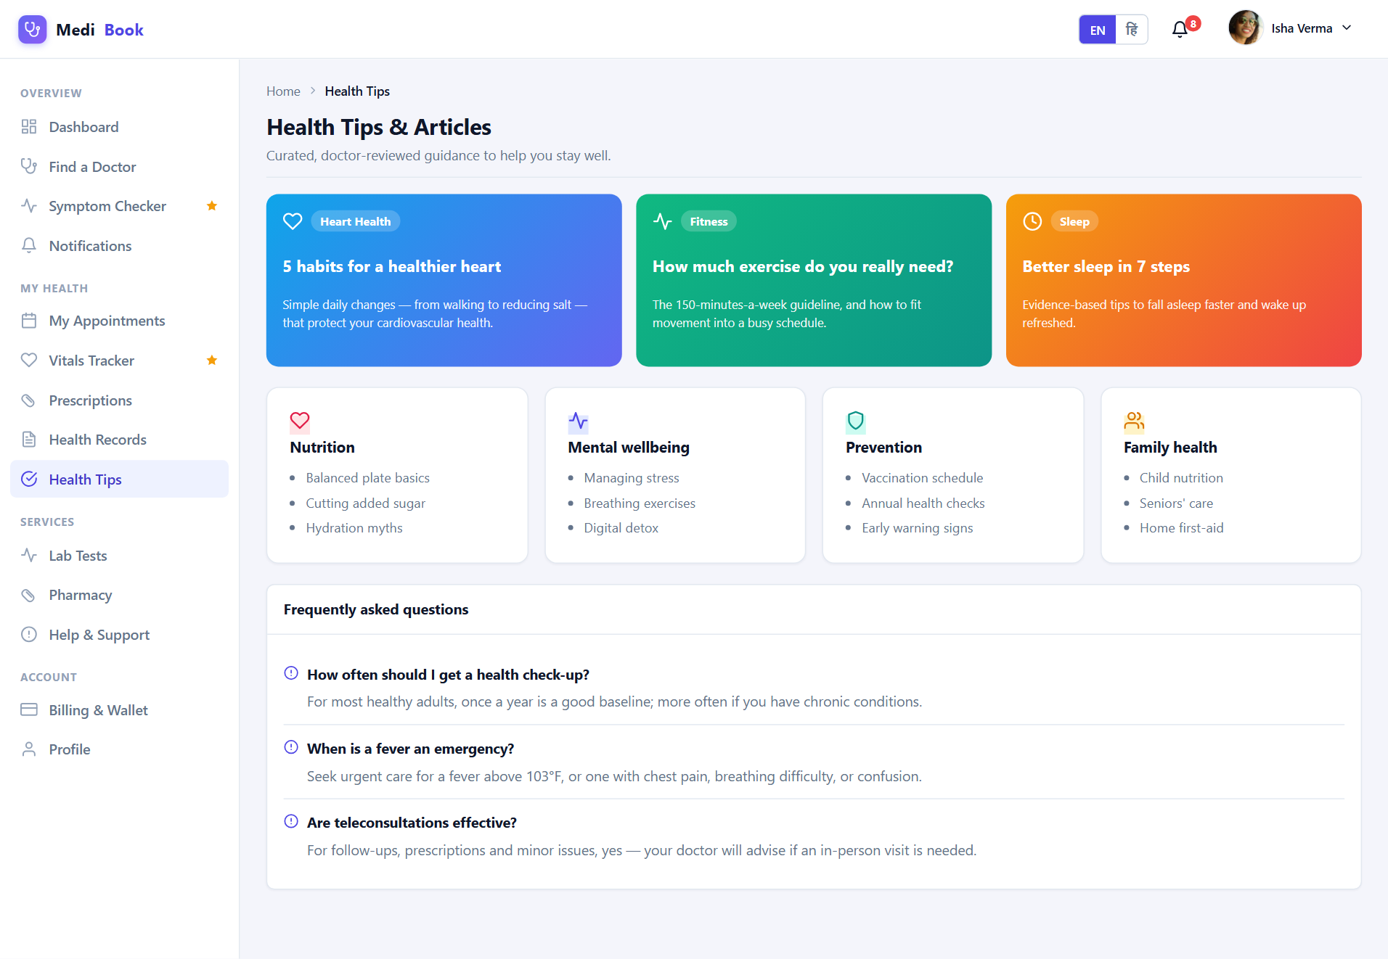
Fig 6.14 Patient — Tips
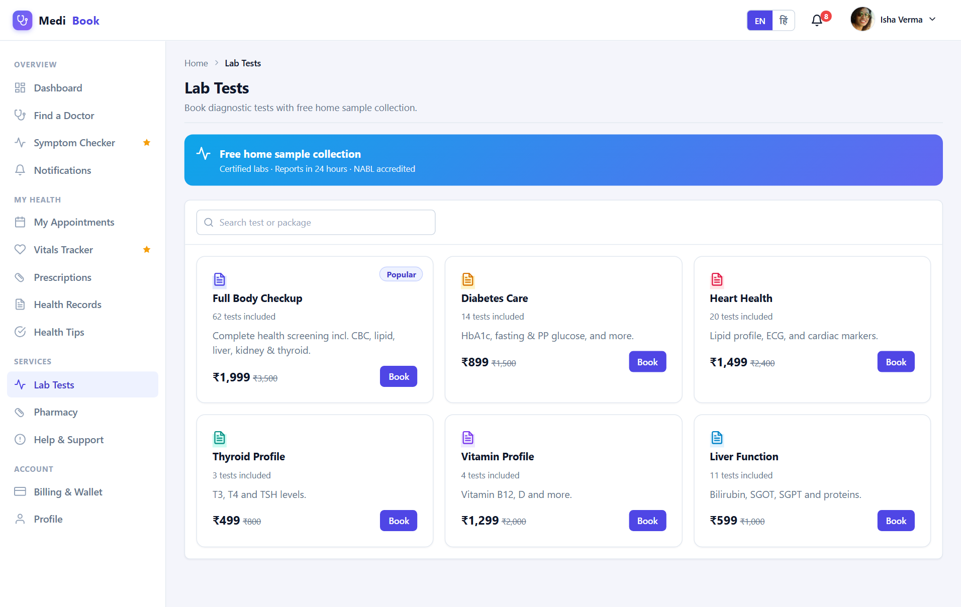
Fig 6.15 Patient — Lab Tests
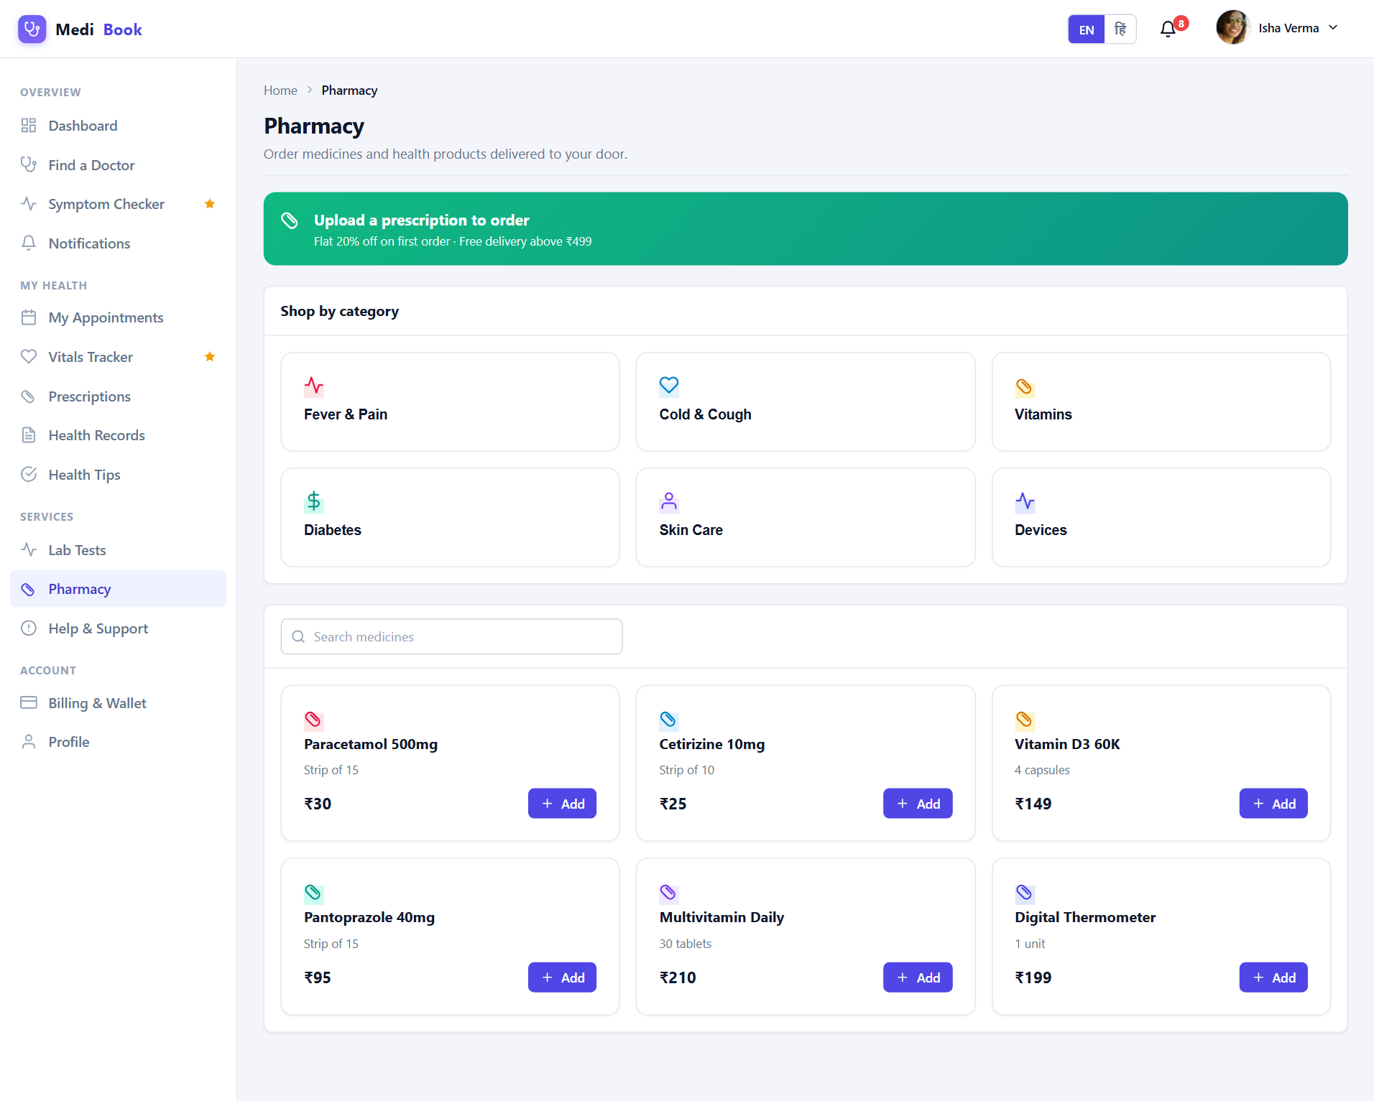
Fig 6.16 Patient — Pharmacy
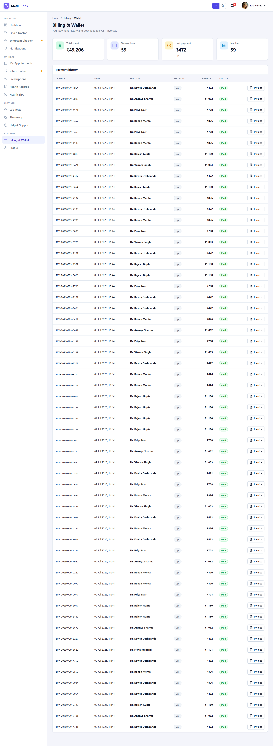
Fig 6.17 Patient — Billing
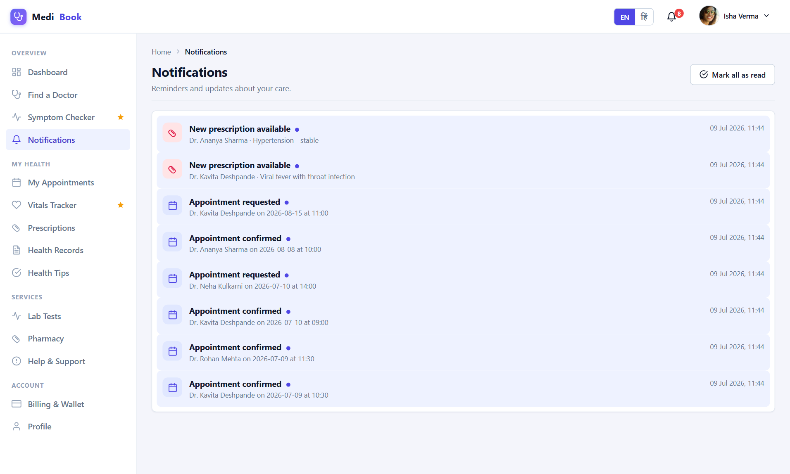
Fig 6.18 Patient — Notifications
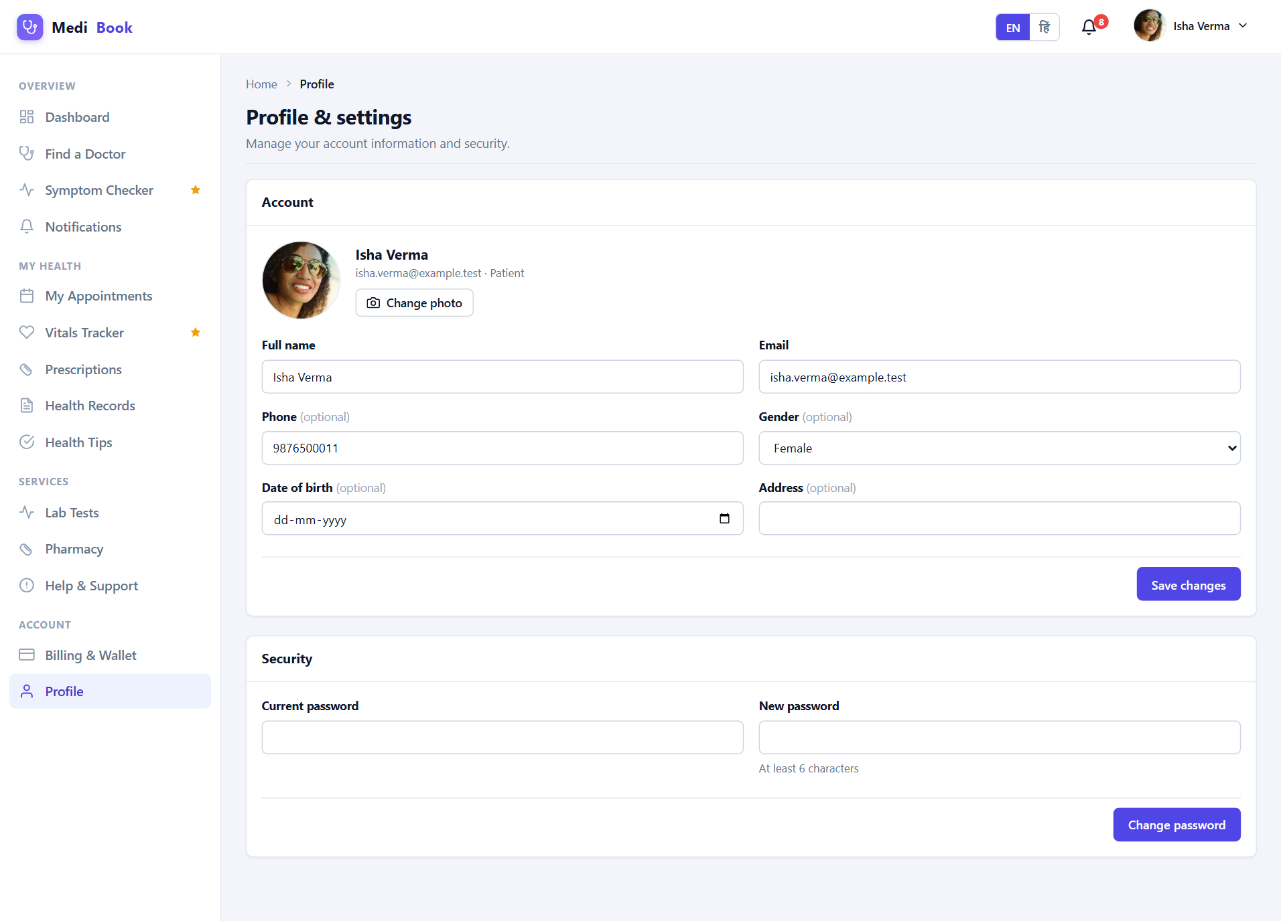
Fig 6.19 Patient — Profile

6.3 Doctor Workspace
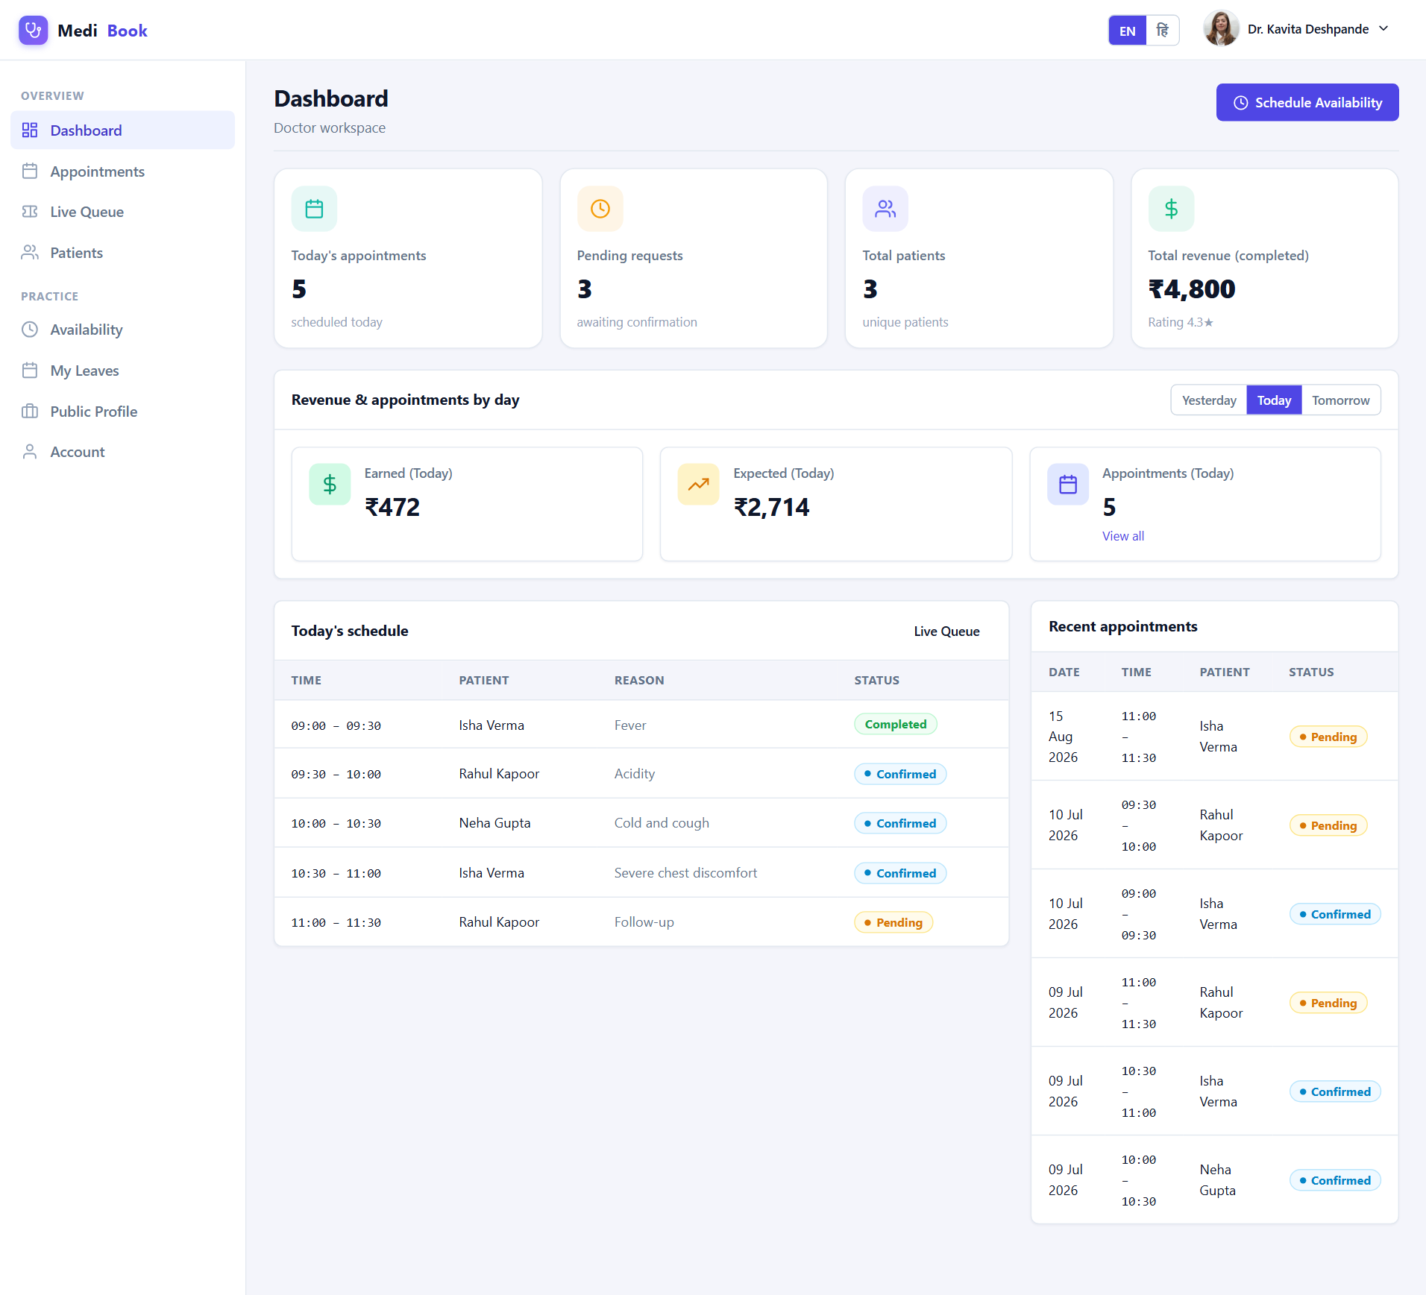
Fig 6.20 Doctor — Dashboard
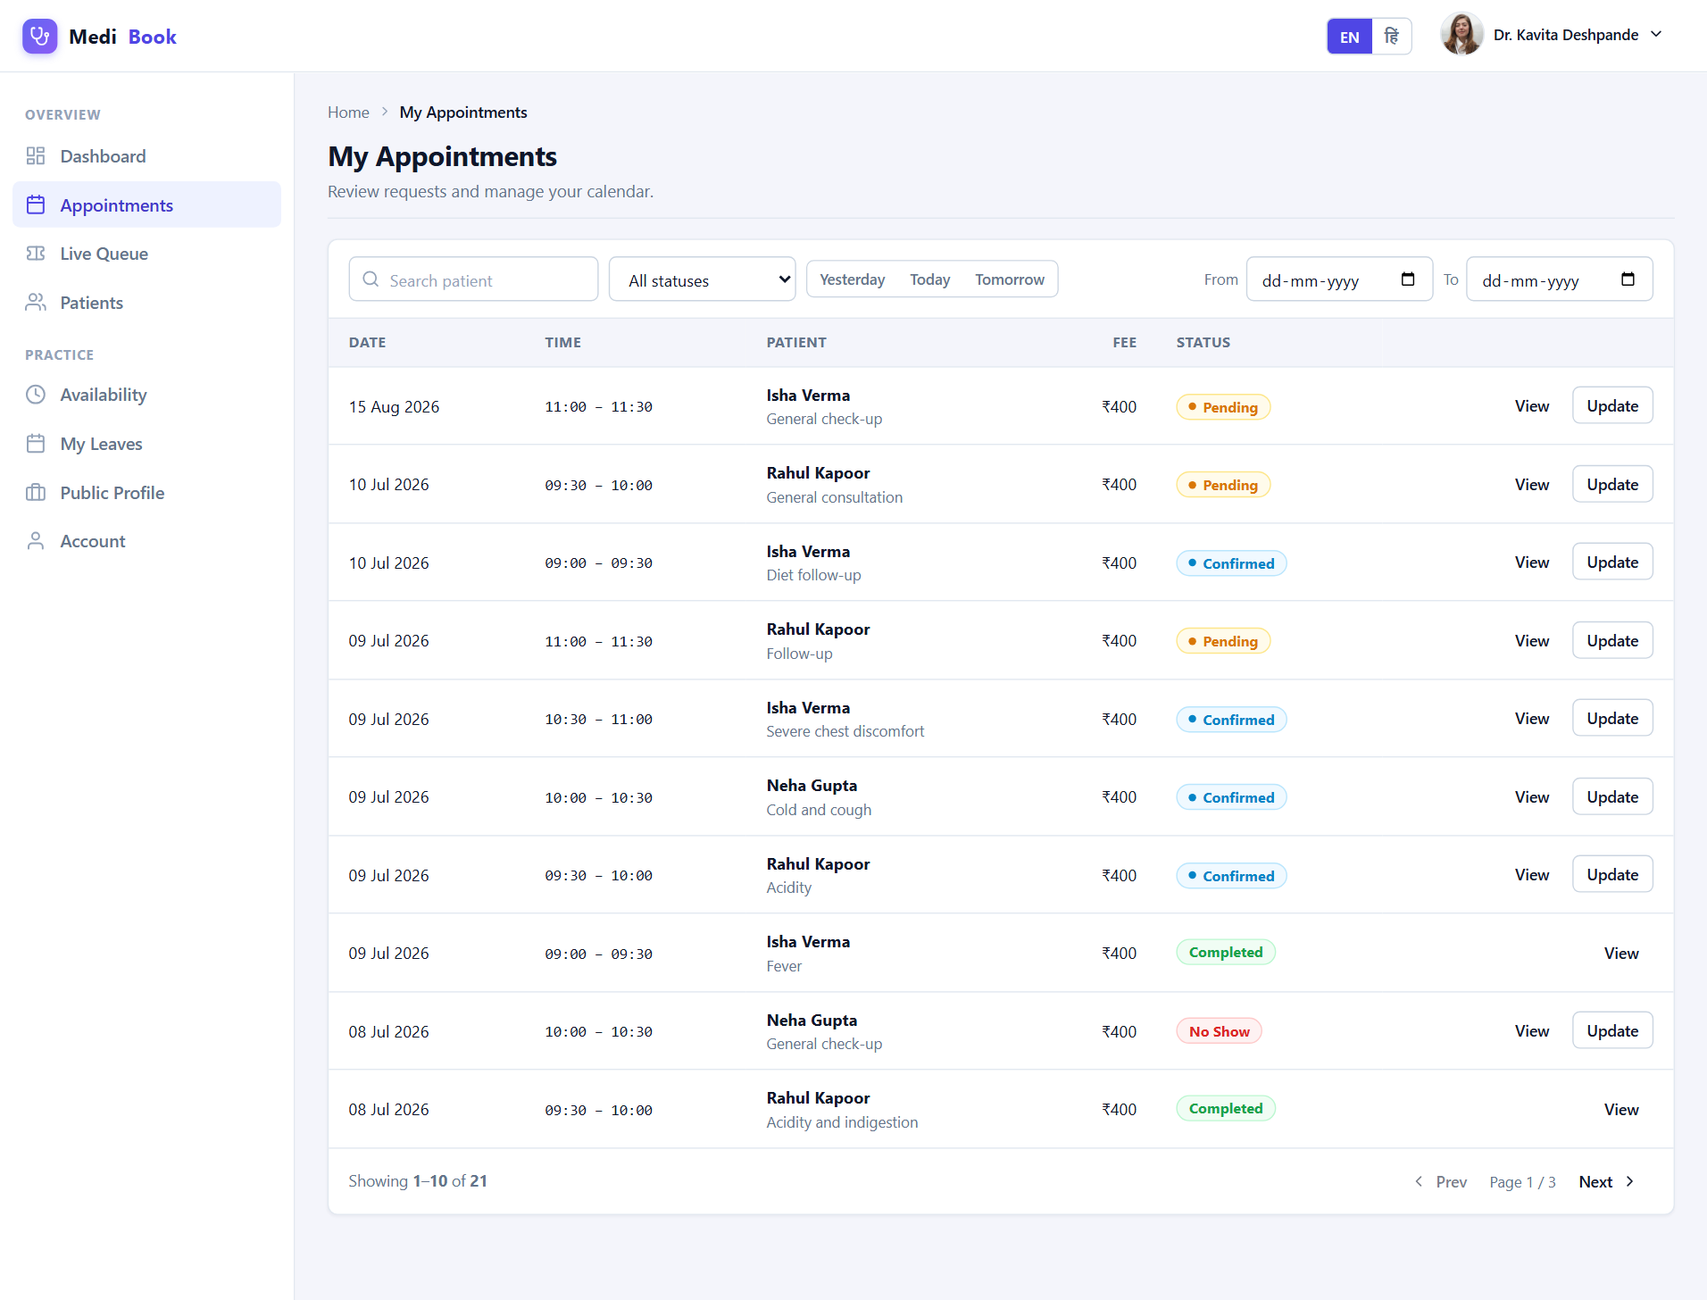
Fig 6.21 Doctor — Appointments
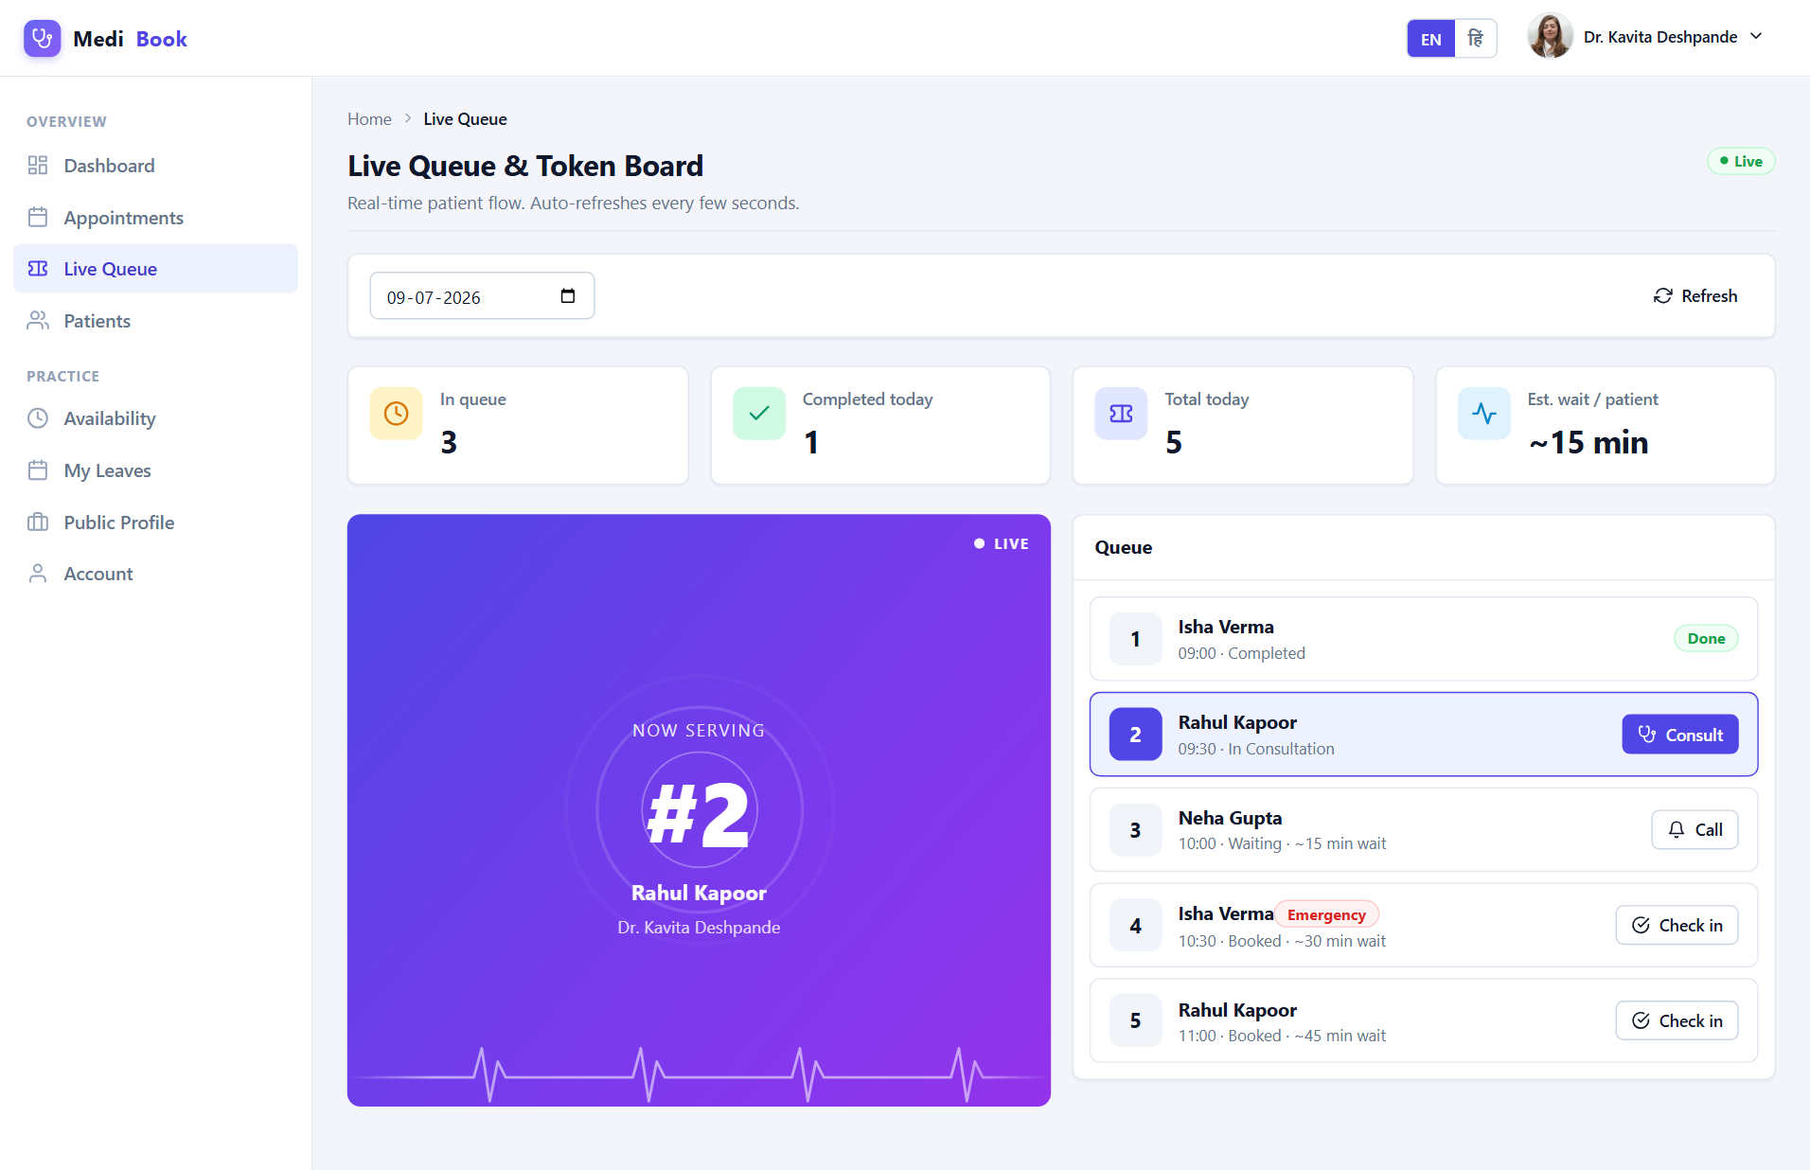
Fig 6.22 Doctor — Queue
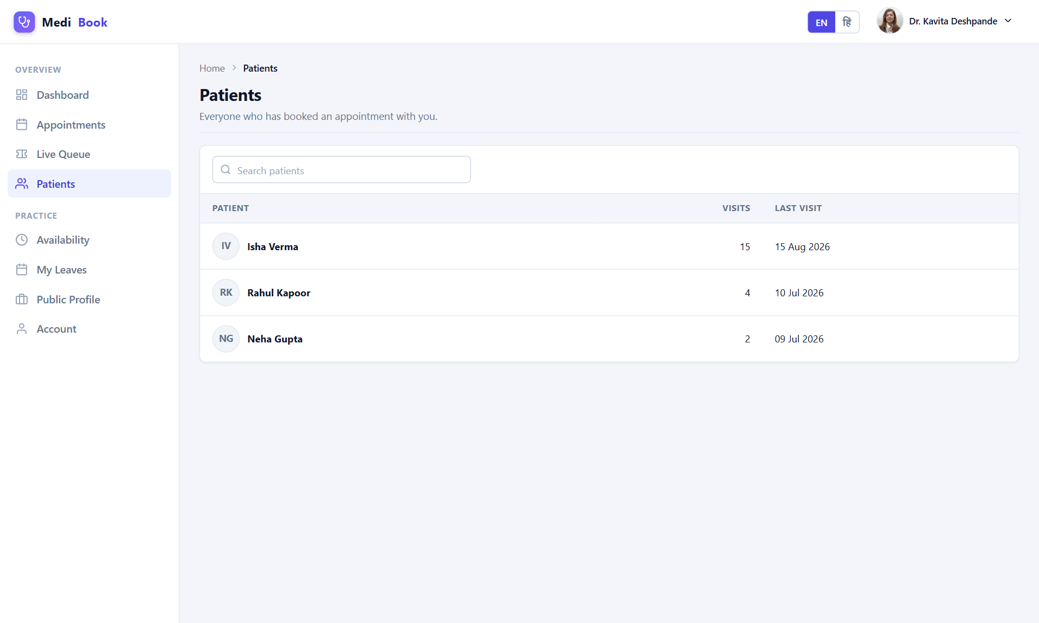
Fig 6.23 Doctor — Patients
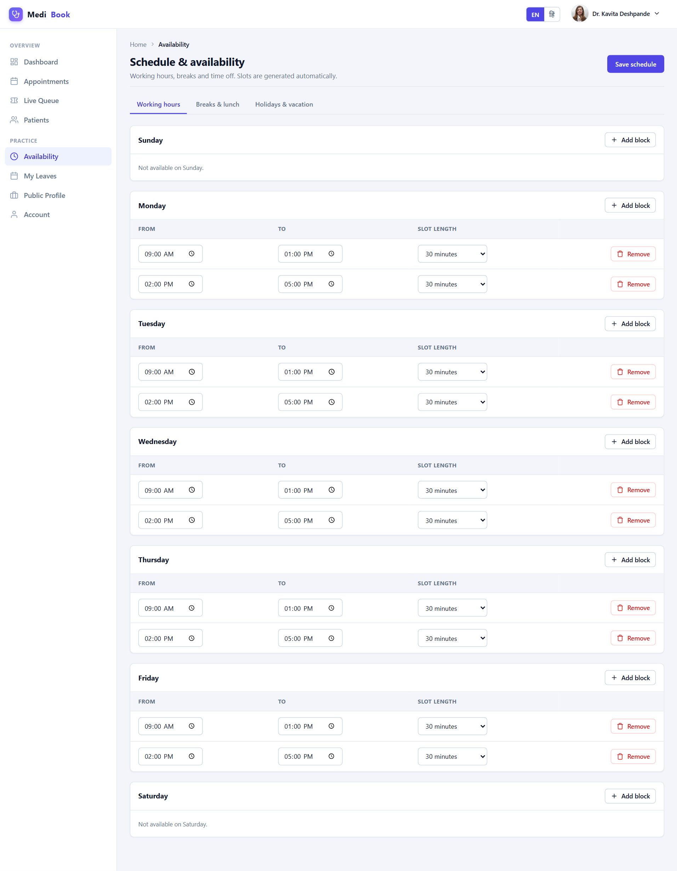
Fig 6.24 Doctor — Schedule
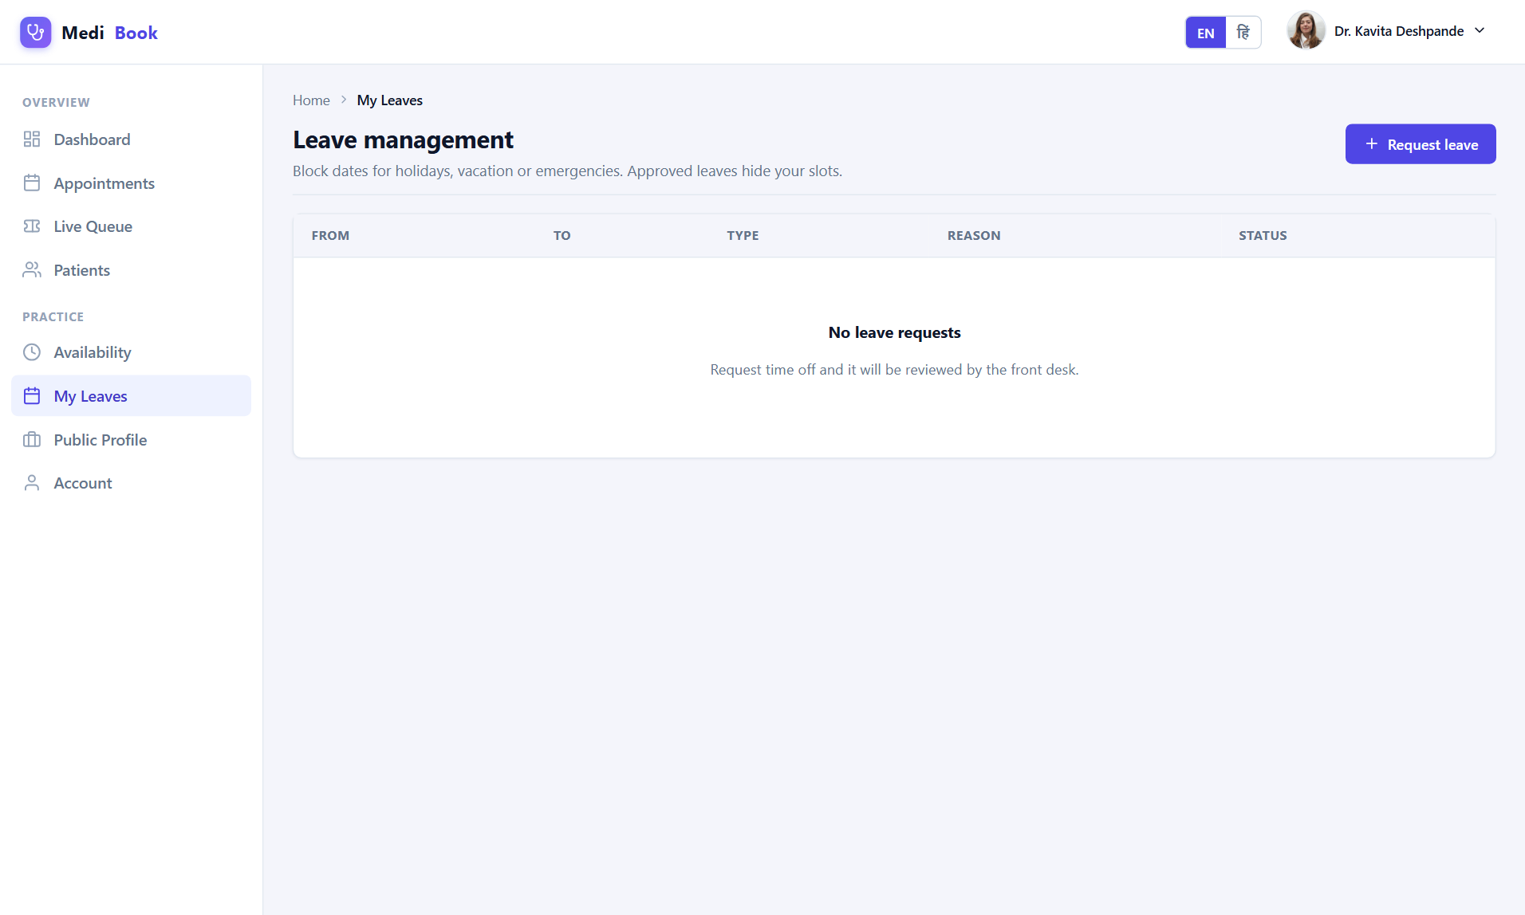
Fig 6.25 Doctor — Leaves
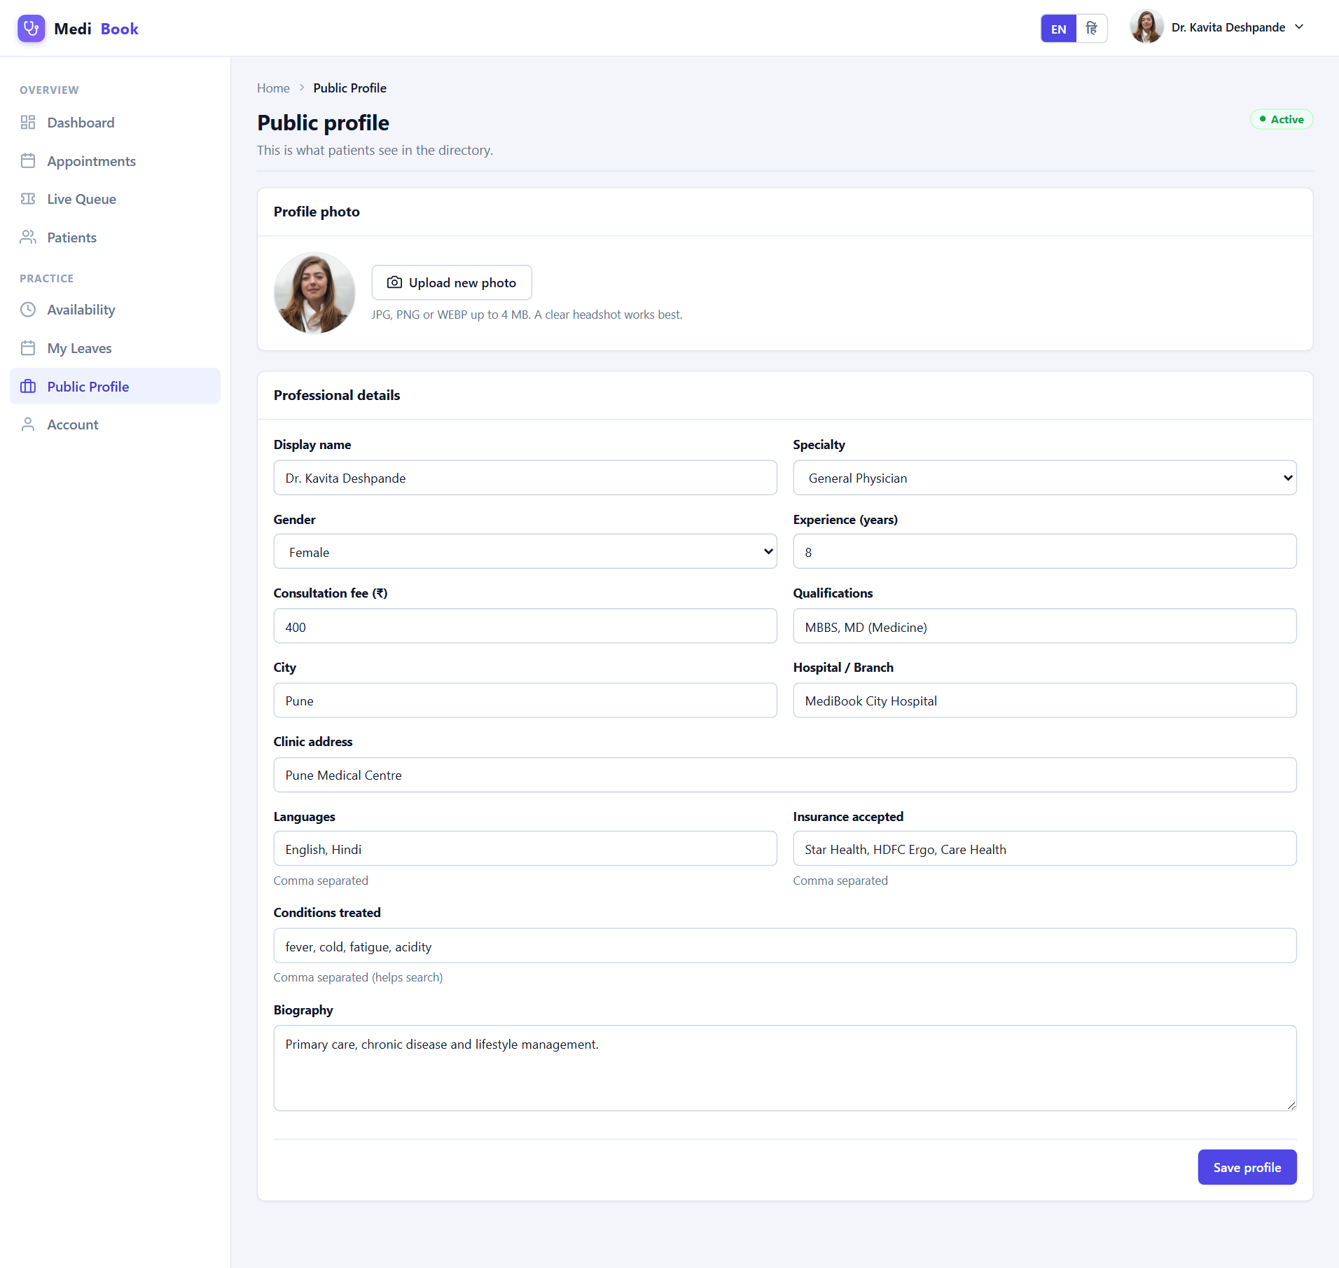
Fig 6.26 Doctor — Public Profile

6.4 Receptionist Workspace
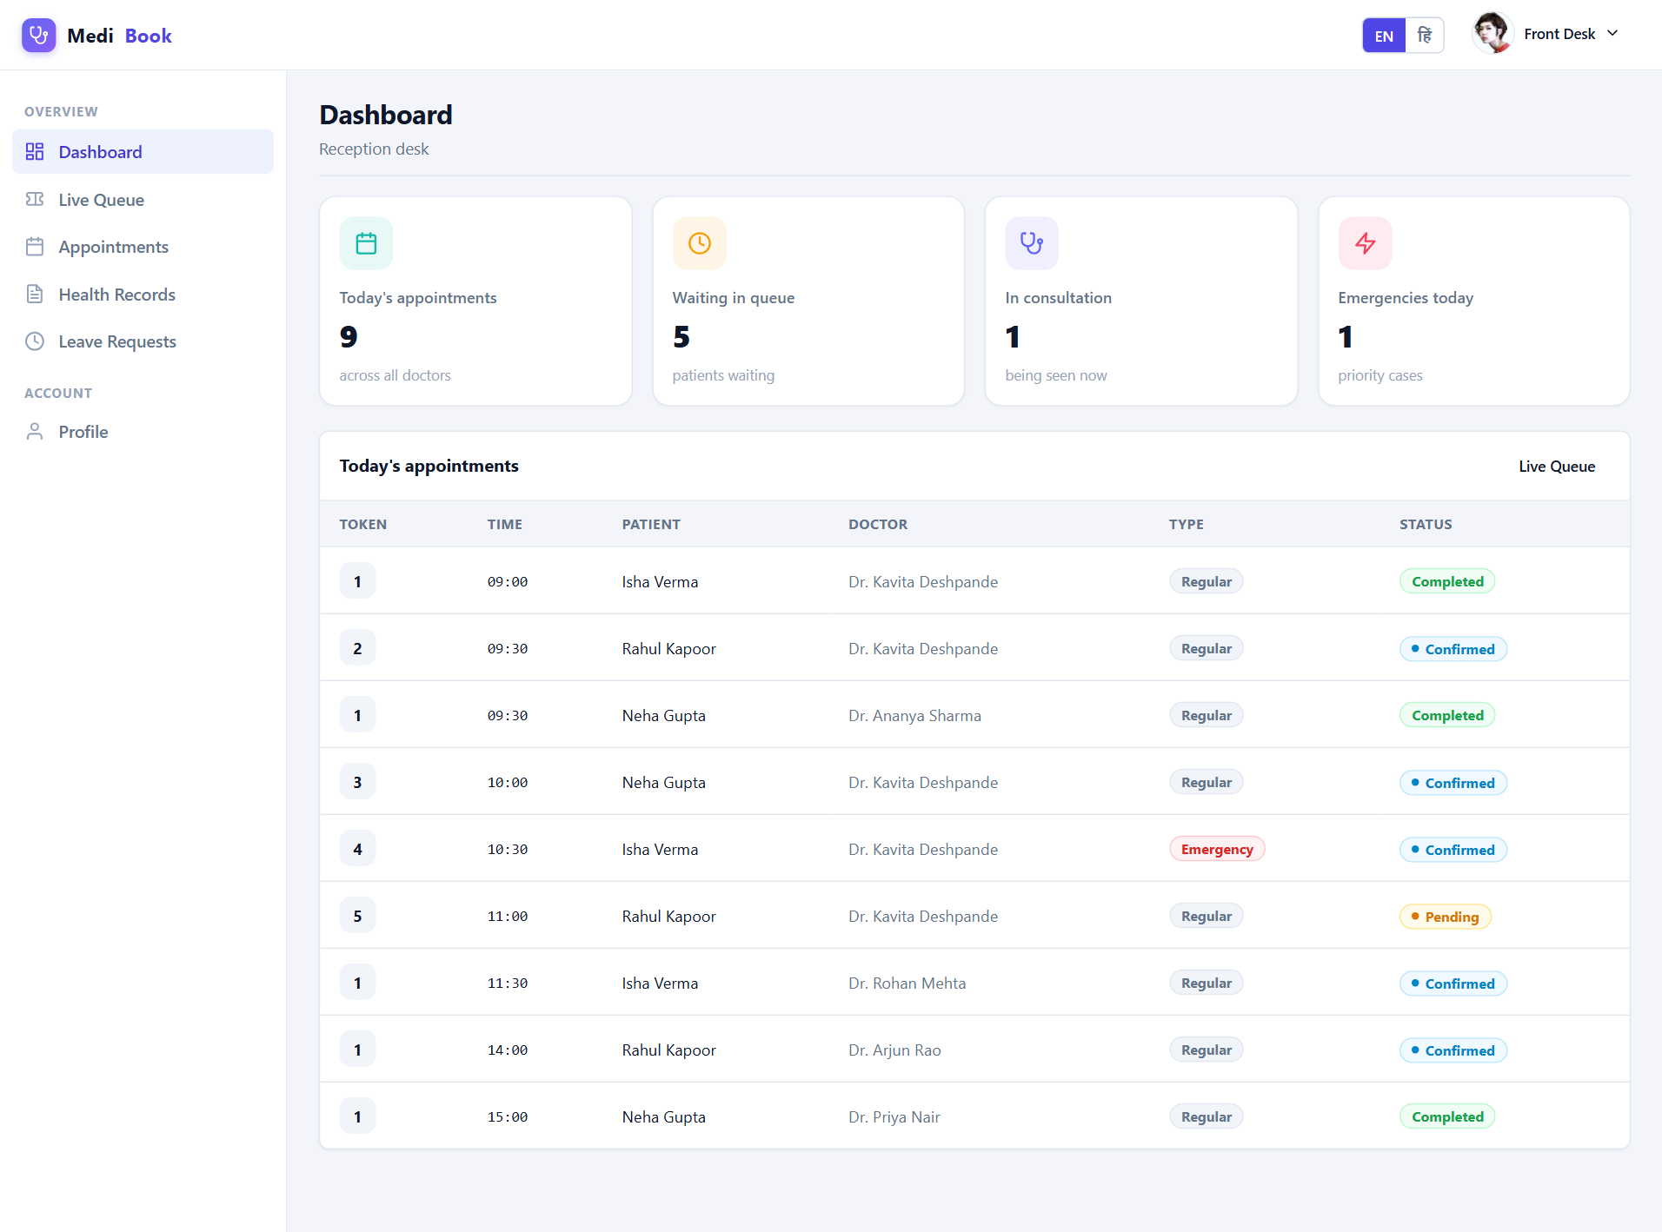
Fig 6.27 Reception — Dashboard
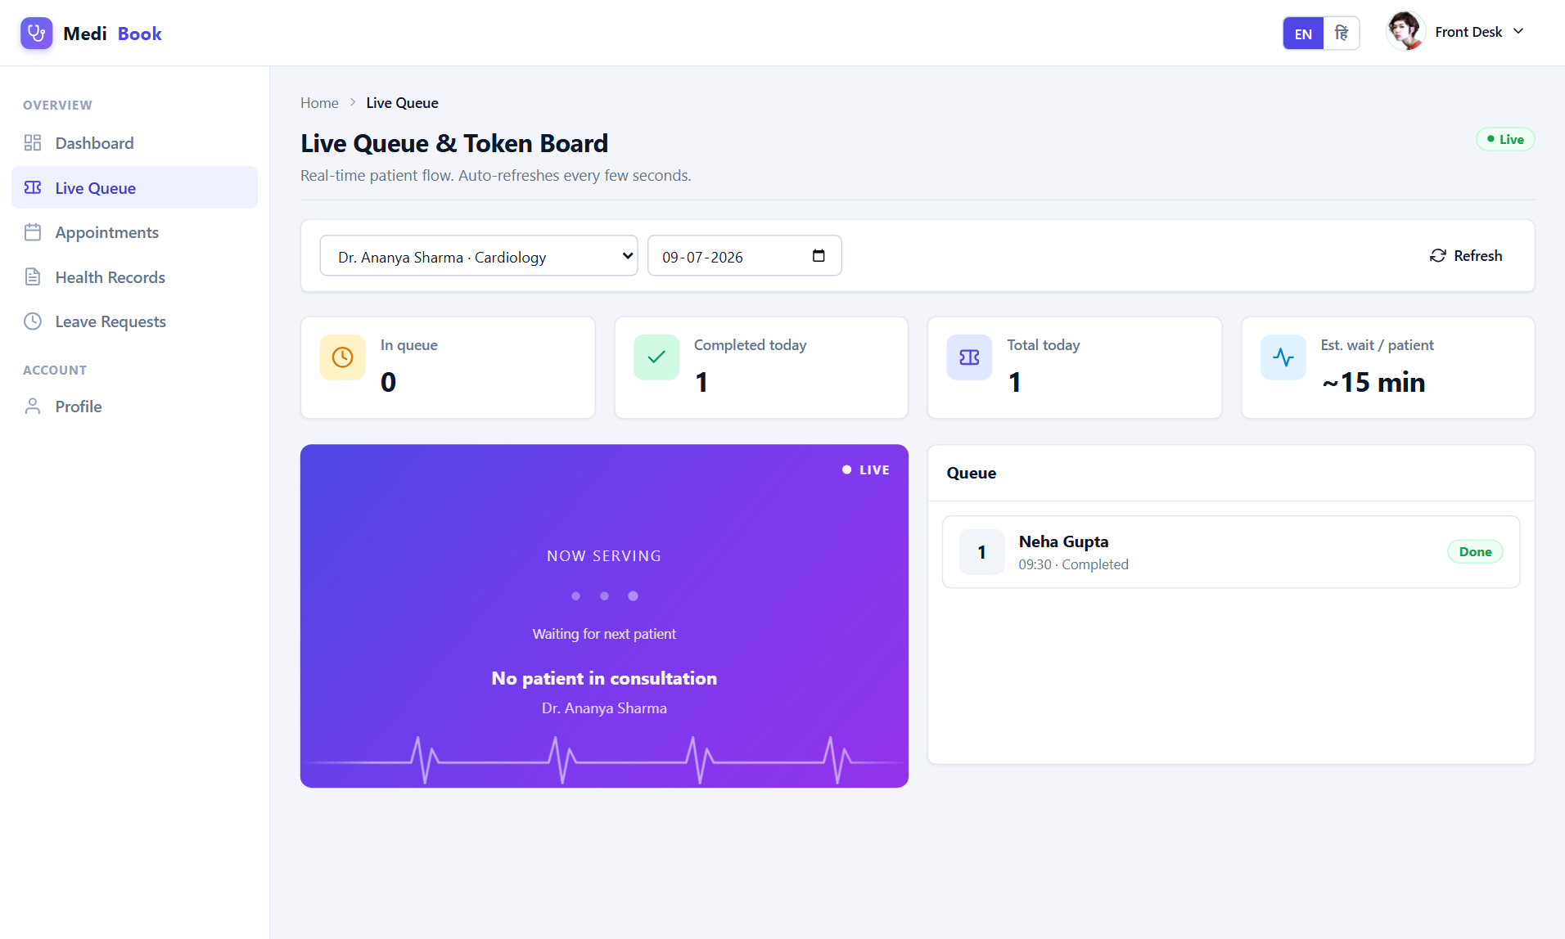
Fig 6.28 Reception — Queue
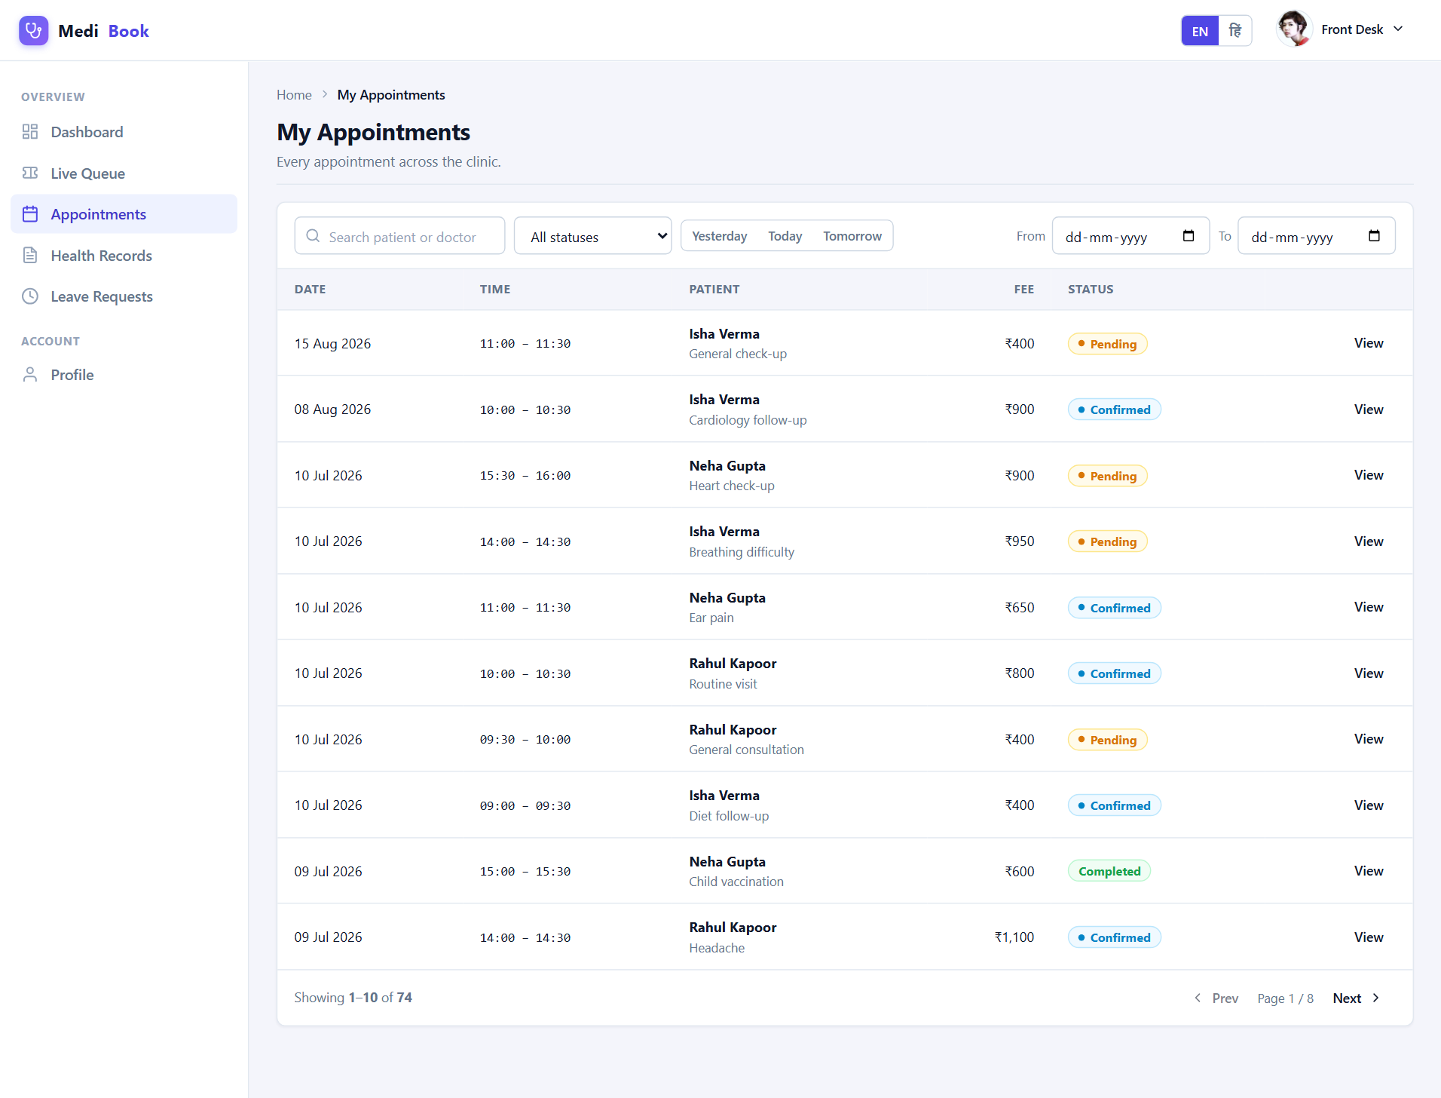
Fig 6.29 Reception — Appointments
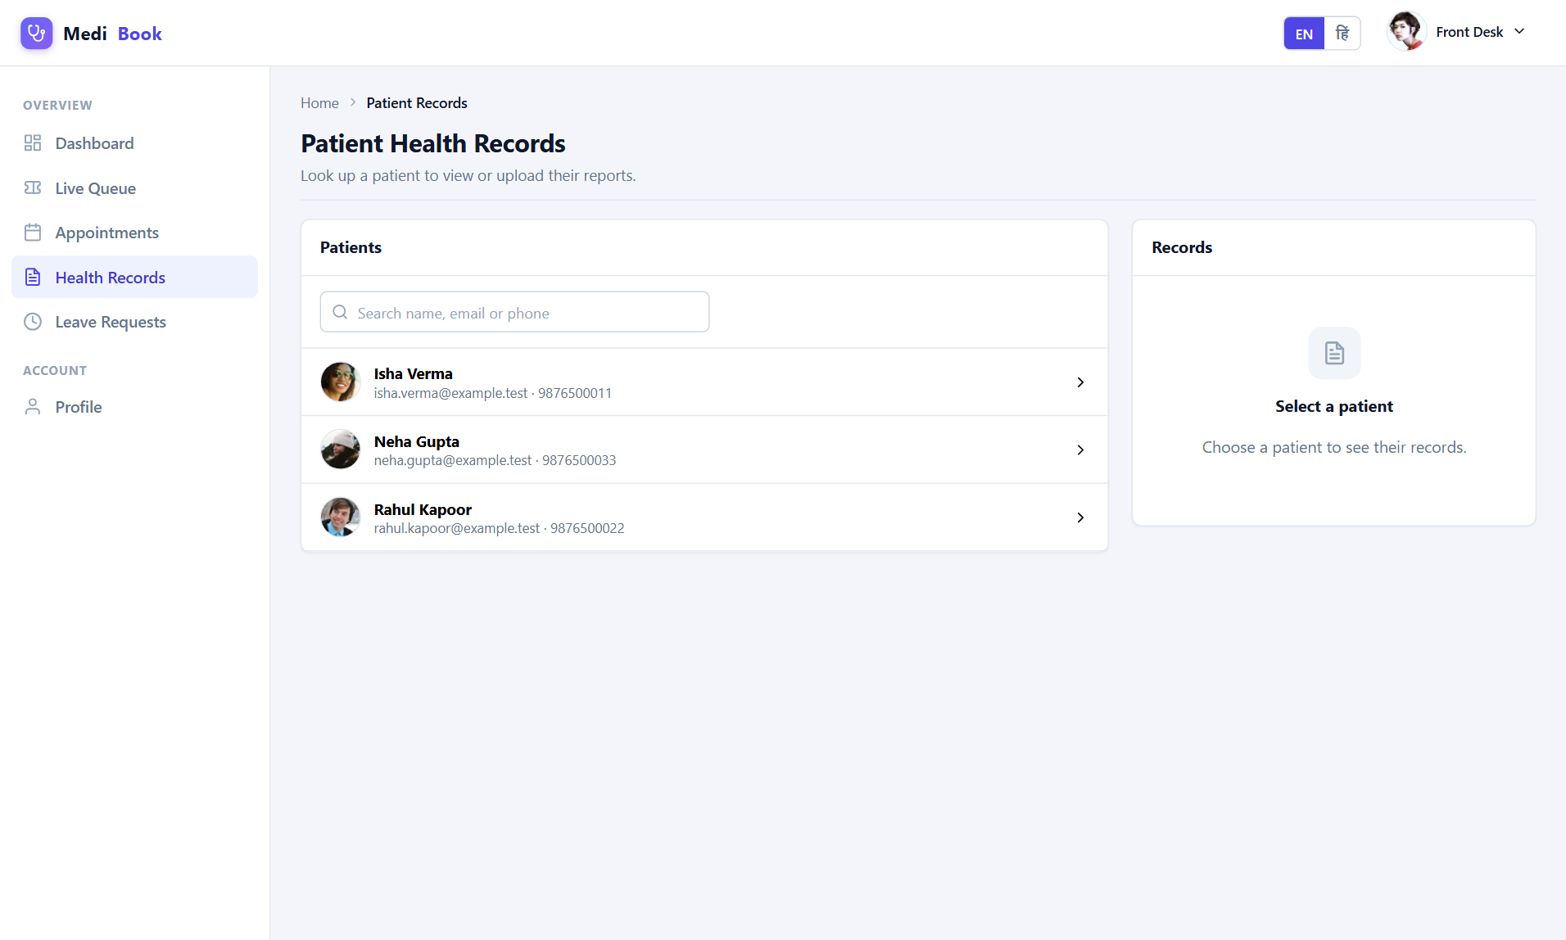
Fig 6.30 Reception — Records
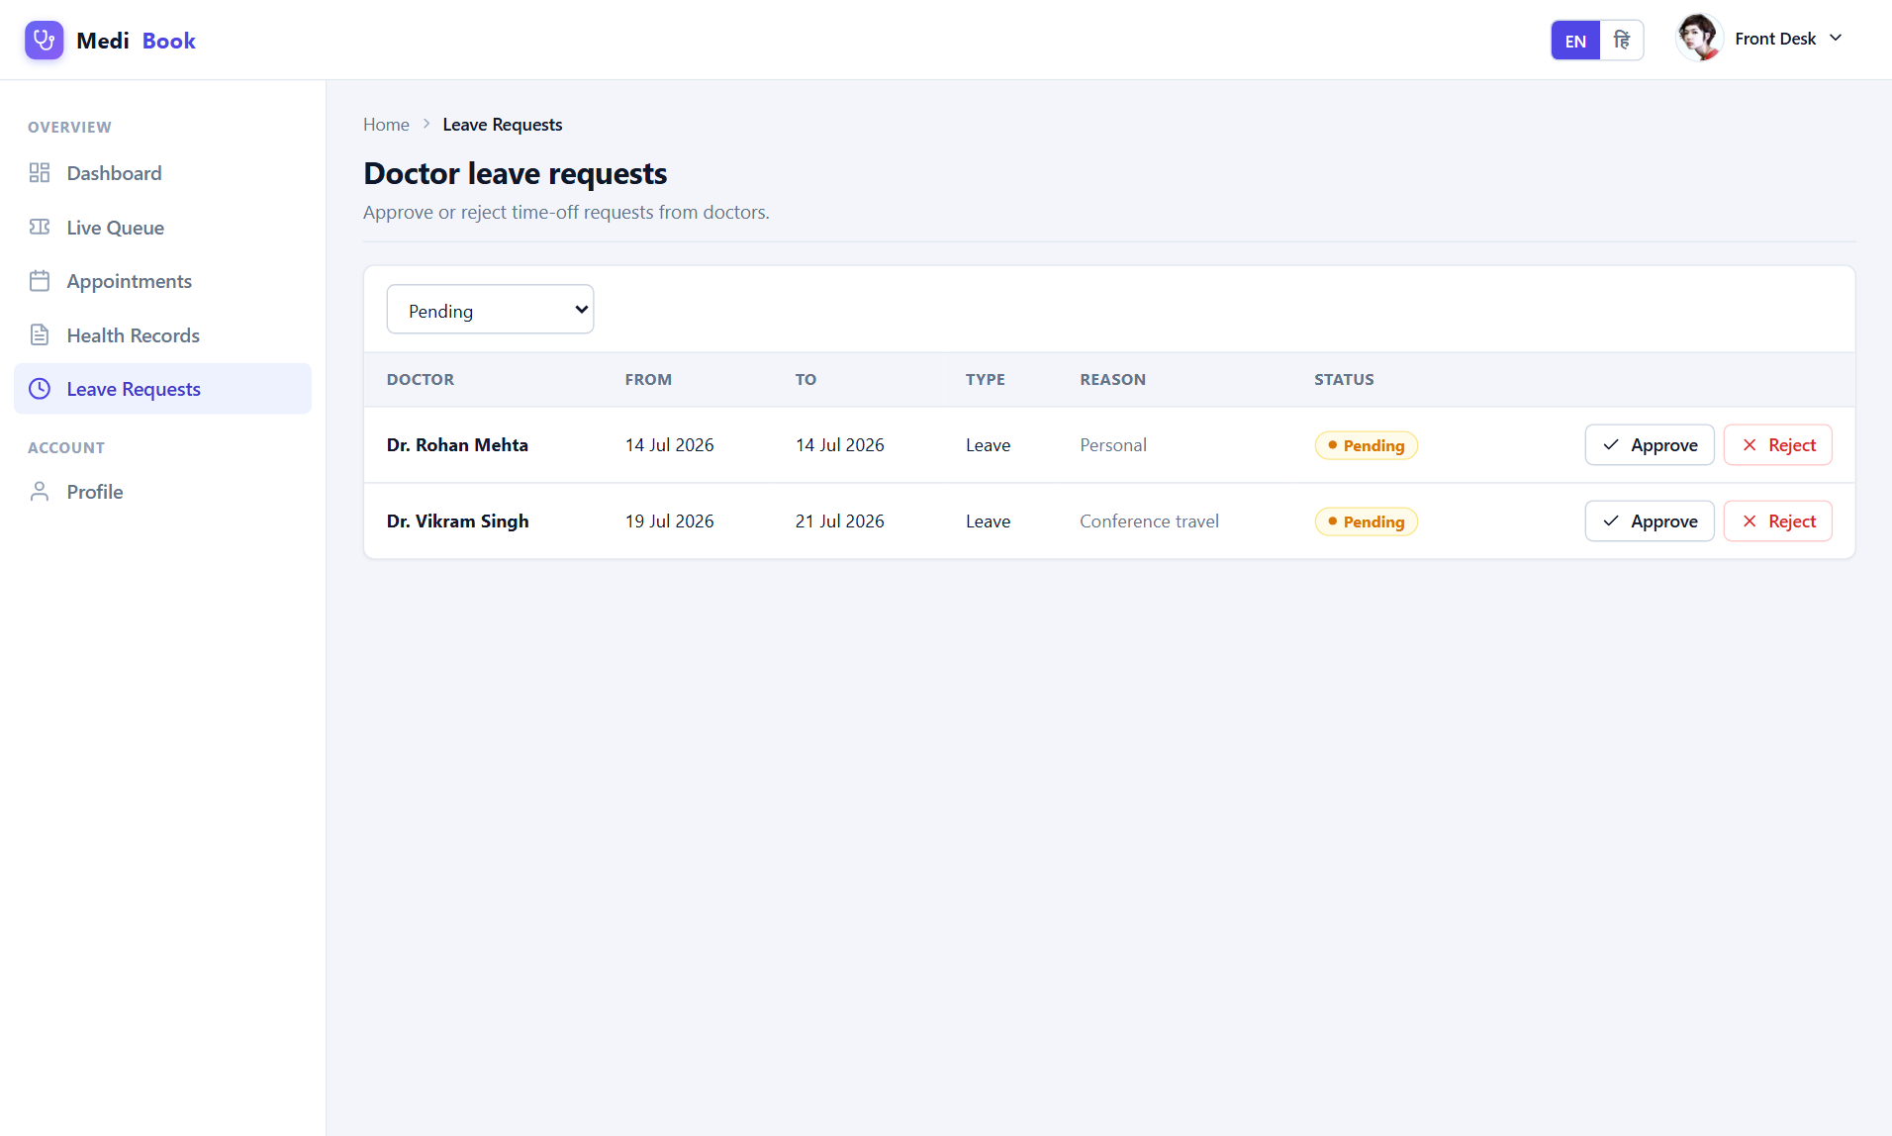
Fig 6.31 Reception — Leaves

6.5 Administrator Workspace
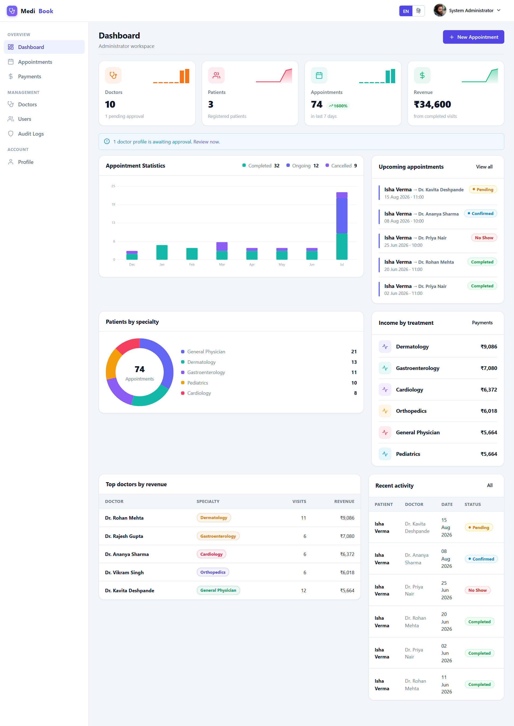
Fig 6.32 Admin — Dashboard
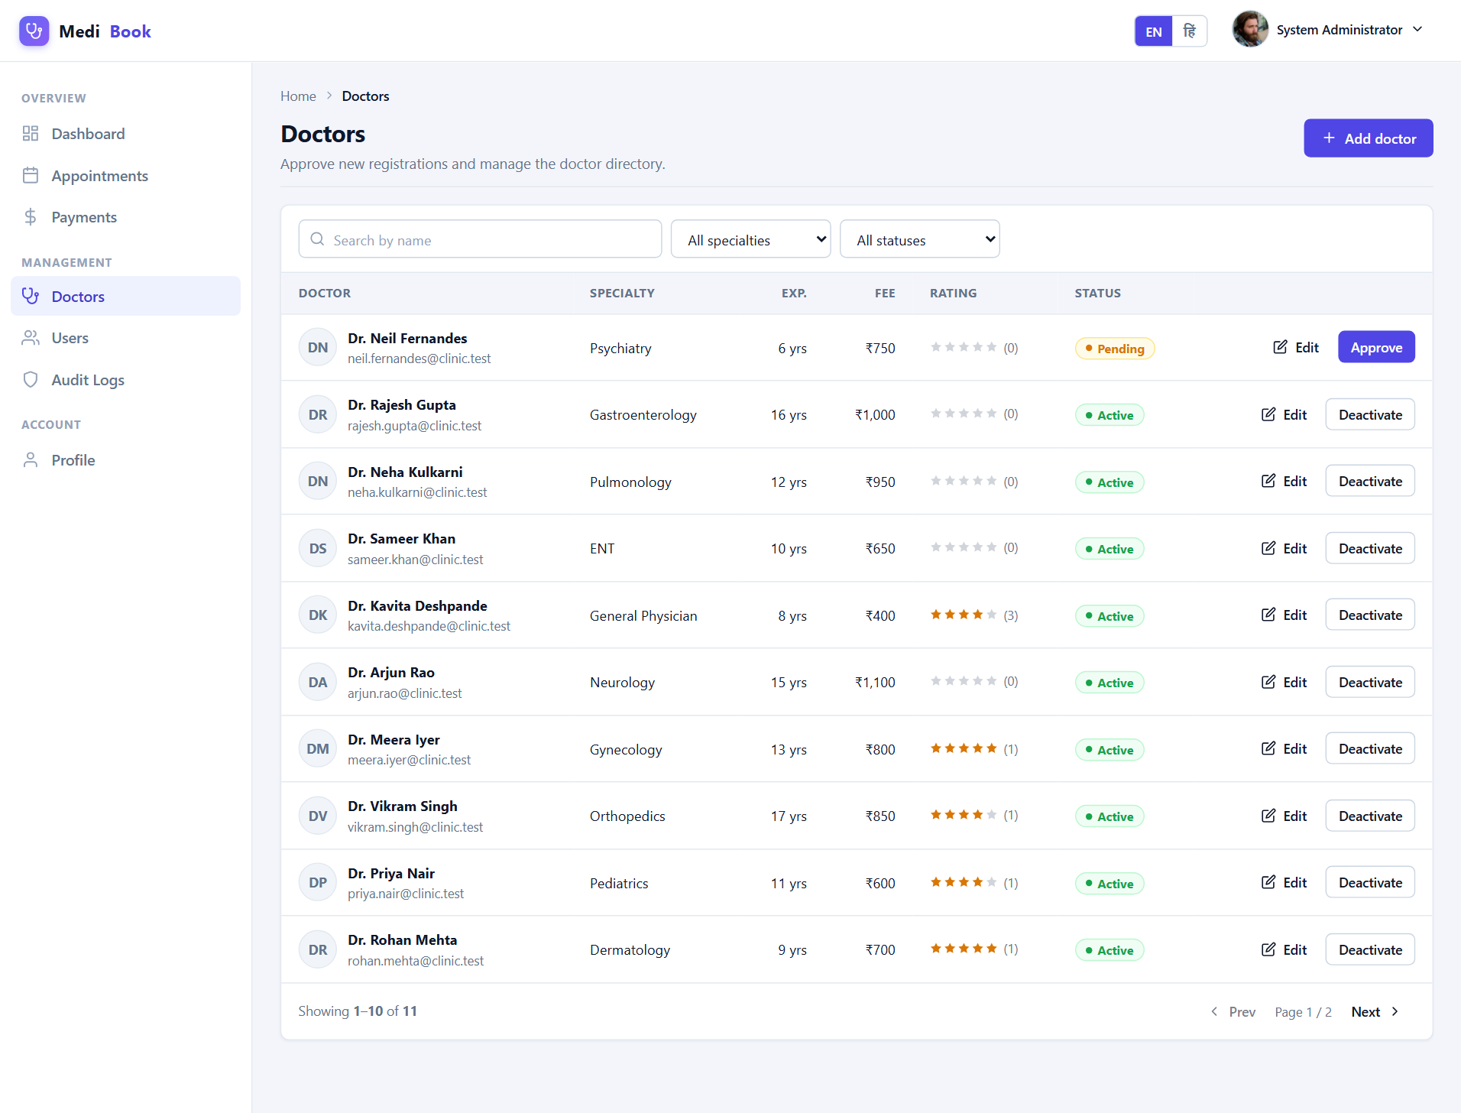
Fig 6.33 Admin — Doctors
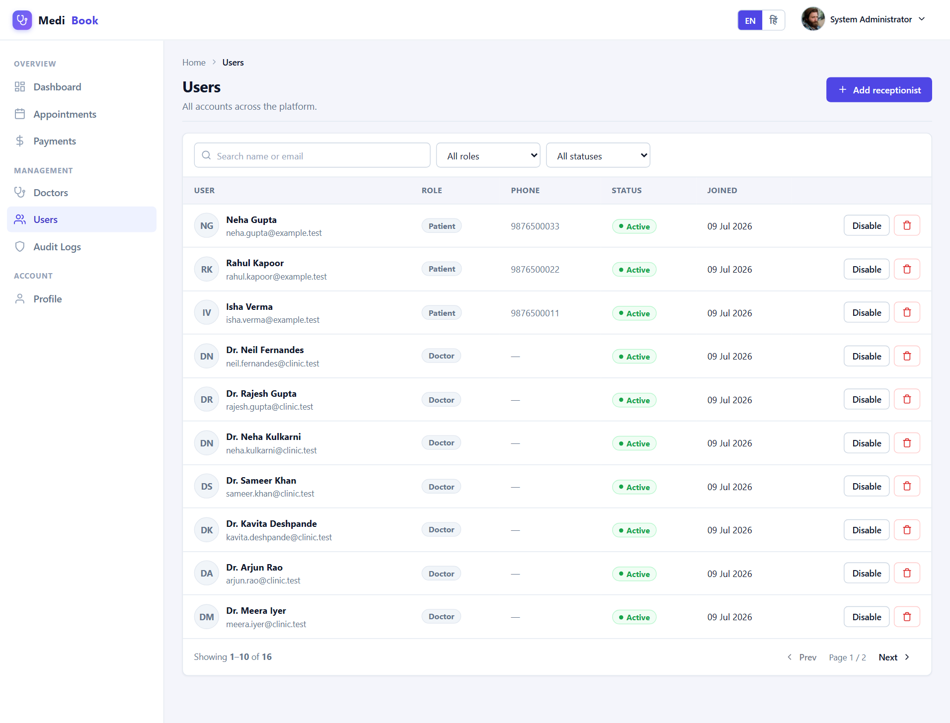
Fig 6.34 Admin — Users
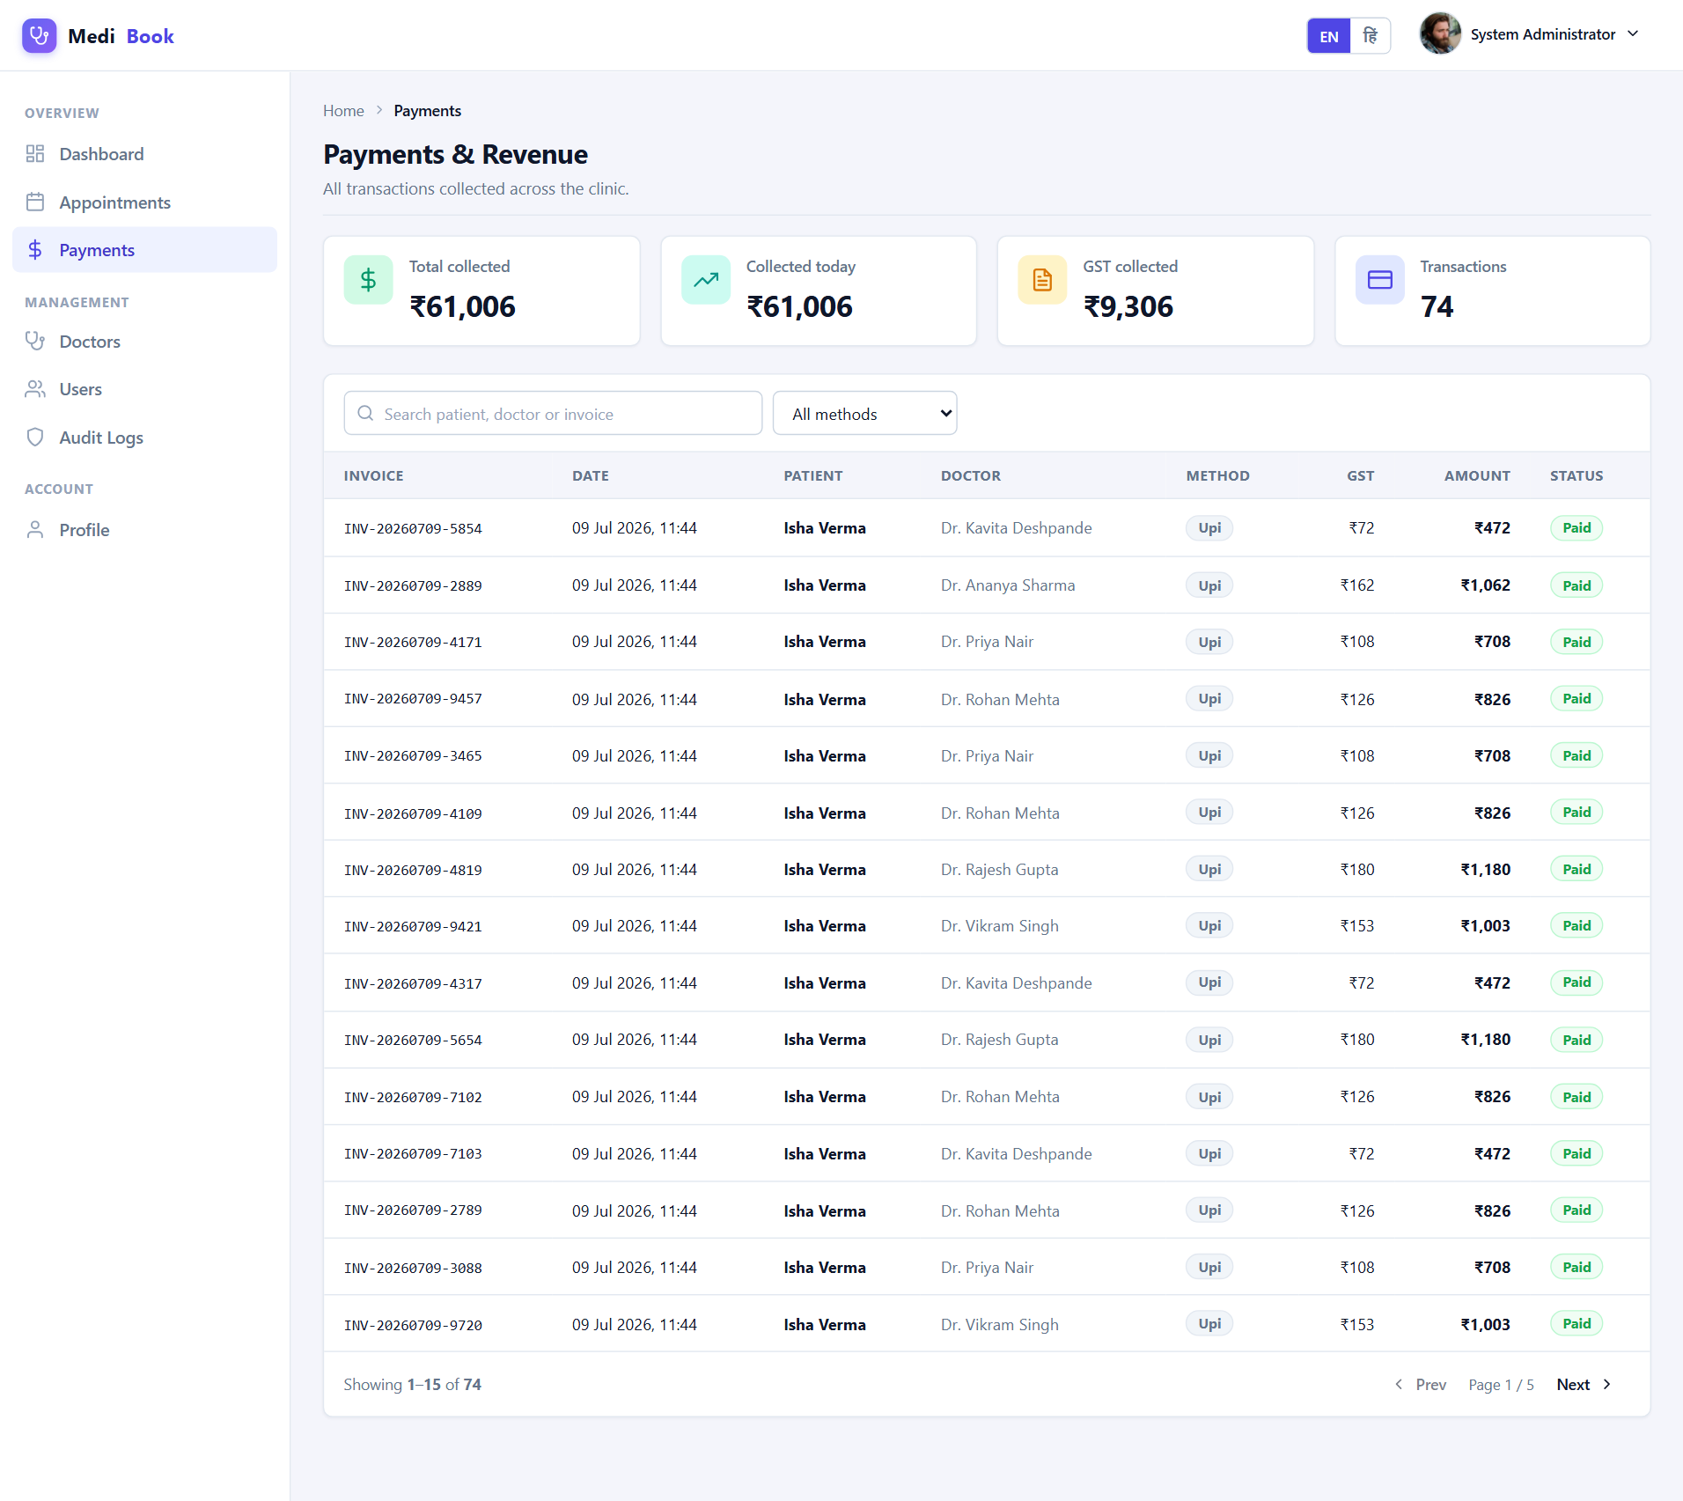
Fig 6.35 Admin — Payments
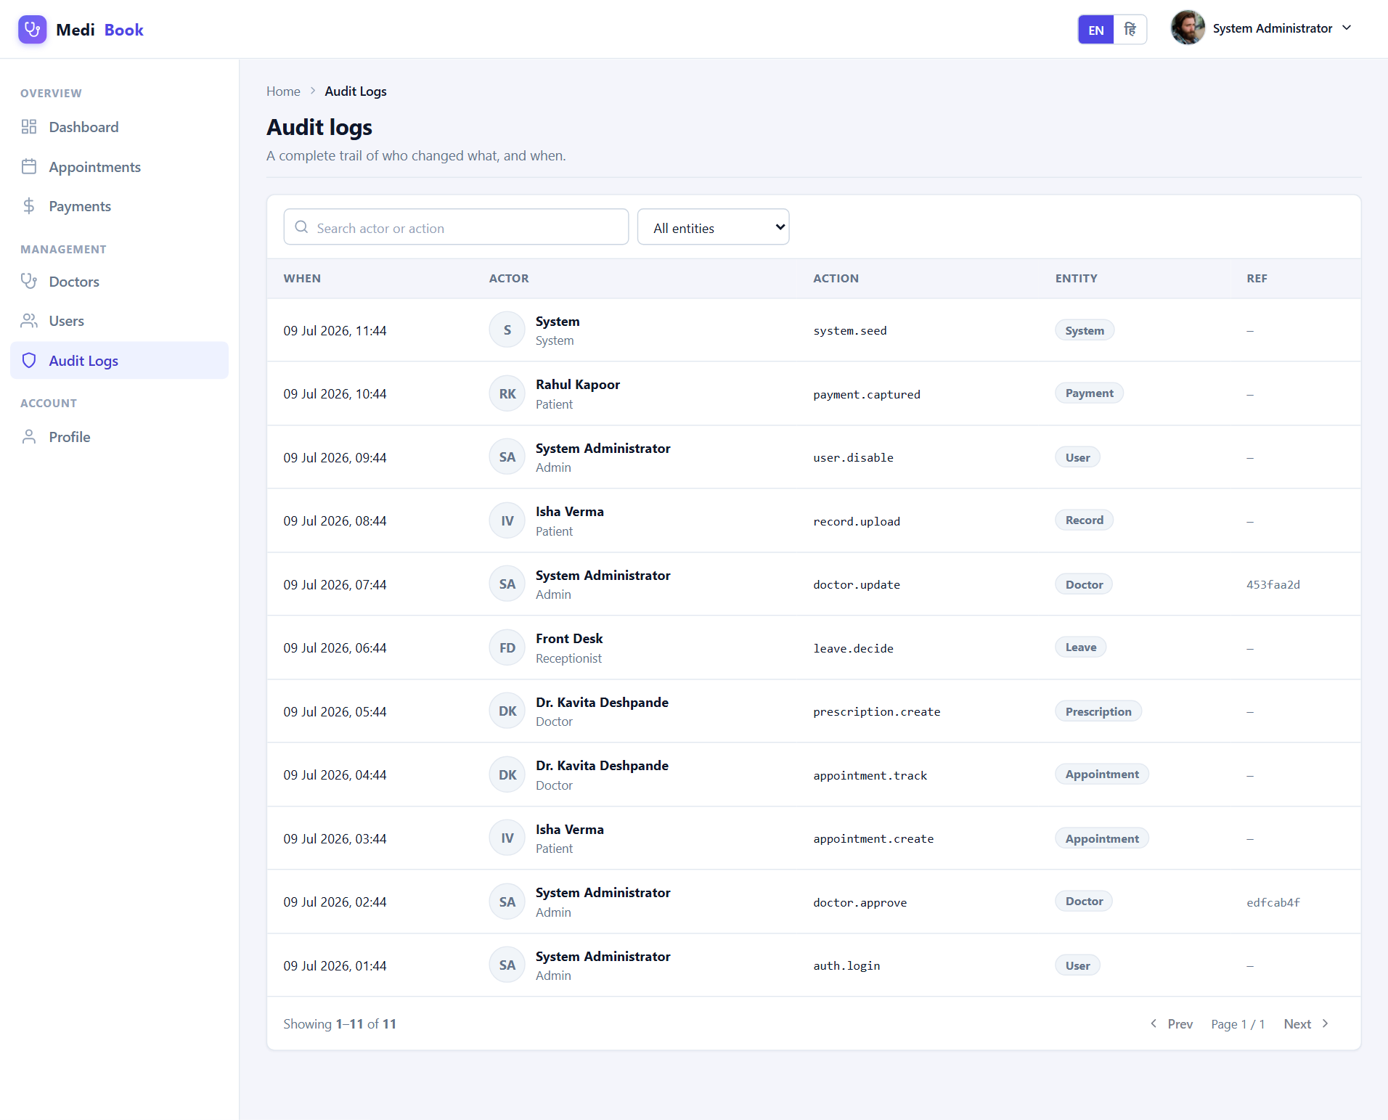
Fig 6.36 Admin — Audit
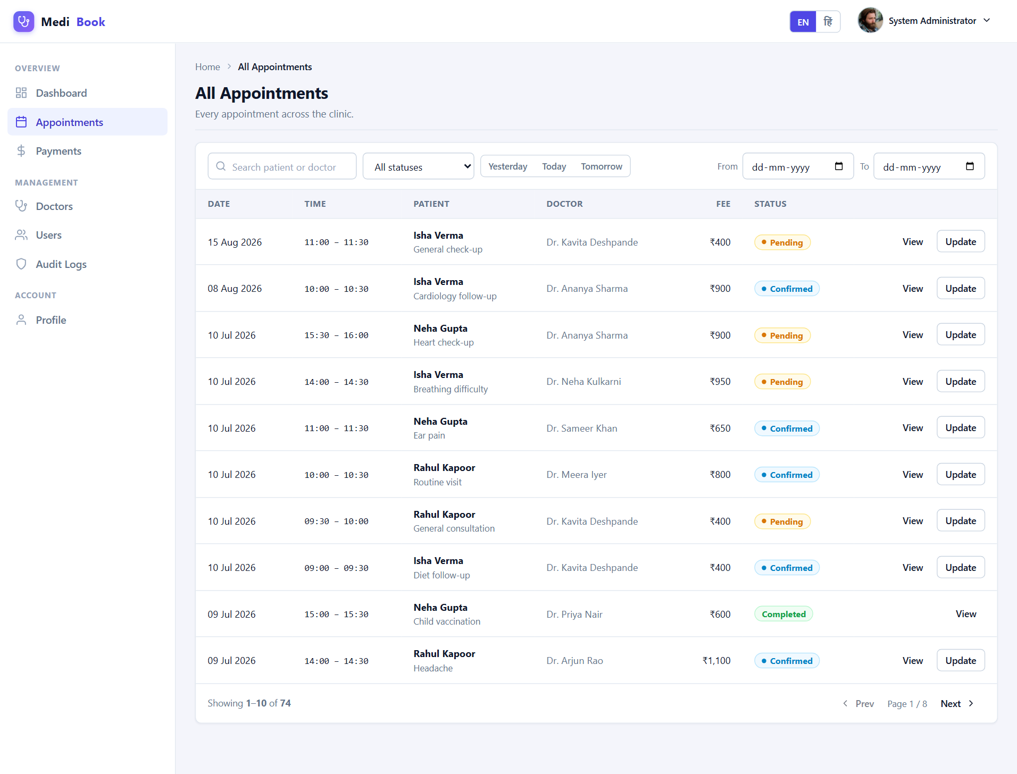
Fig 6.37 Admin — Appointments

Chapter 7: Testing

7.1 Testing Methodology
The application was validated using functional (black-box) testing of each module, integration testing of end-to-end flows (such as pay-first booking), and manual usability testing across screen sizes. API endpoints were exercised directly to confirm correct status codes, validation and authorisation behaviour.

7.2 Test Cases
ID | Test Case | Expected Result | Status
TC-01 | Login with valid credentials | Token issued, redirected to dashboard | Pass
TC-02 | Login with invalid password | Error “Invalid email or password” | Pass
TC-03 | Access /app without token | Redirected to login | Pass
TC-04 | Patient searches doctors by specialty | Filtered list returned | Pass
TC-05 | AI symptom checker with fever+cough | Suggests GP with urgency & advice | Pass
TC-06 | Book an already-taken slot | Rejected with 409 conflict | Pass
TC-07 | Pay-first booking (regular) | Payment → appointment + token + invoice | Pass
TC-08 | Emergency booking surcharge | Fee + surcharge + GST applied | Pass
TC-09 | Doctor writes prescription | Saved & visible to patient | Pass
TC-10 | Queue advance (call → consult → done) | Track status transitions correctly | Pass
TC-11 | Patient views own records only | Cannot access others’ records (403) | Pass
TC-12 | Doctor views own patient records | Allowed only for linked patients | Pass
TC-13 | Admin approves pending doctor | Doctor becomes active/listed | Pass
TC-14 | Mark all notifications as read | Unread count becomes 0 | Pass
TC-15 | Switch language to Hindi | Key UI text switches to Hindi | Pass
TC-16 | Upload EHR report (PDF/image) | File stored and listed | Pass
TC-17 | Cancel upcoming appointment | Status set to cancelled | Pass
TC-18 | Session expiry on stale token | Auto-logout to login screen | Pass
TC-19 | Responsive layout on mobile | Sidebar collapses; content reflows | Pass
TC-20 | Switch DB driver to MongoDB | App runs unchanged on MongoDB | Pass

7.3 Test Summary
All twenty representative test cases passed. Validation errors, authorisation rules, booking conflict prevention and the storage-driver switch behaved as expected, confirming the correctness and robustness of the system.

Chapter 8: Results, Limitations & Future Scope

8.1 Results
The project successfully delivers a complete, role-based clinic management platform. Patients can discover doctors, self-triage, book and pay, and track their live queue; clinics can manage the full operational workflow; and administrators gain real-time analytics. The pluggable storage layer and clean layered architecture demonstrate sound software-engineering practice.

8.2 Limitations
- The payment gateway and OCR extraction are simulated for a self-contained demo.
- Notifications are in-app; SMS/e-mail delivery is not integrated.
- The AI symptom checker is rule-based and is a triage aid, not a medical diagnosis.

8.3 Future Scope
- Integrate a real payment gateway (e.g., Razorpay/Stripe) and SMS/e-mail reminders.
- Add tele-consultation with secure video calling.
- Replace the rule-based triage with a trained ML model and real OCR for reports.
- Native mobile applications and offline support.
- Insurance claims, multi-branch operations and pharmacy fulfilment.

Chapter 9: Conclusion
MediBook demonstrates how a thoughtfully designed, full-stack web application can streamline the entire clinic experience for patients and staff alike. By combining role-based workspaces, real-time queue management, AI-assisted discovery, secure payments and digital health records within a clean, responsive interface, the system addresses the key shortcomings of traditional appointment processes.
Beyond its functionality, the project showcases important engineering principles — a layered architecture, a storage-agnostic data layer, secure authentication and authorisation, input validation, and reusable UI components. The result is a maintainable and extensible codebase that can evolve into a production-grade product with the enhancements outlined in the future scope.

References
- React – A JavaScript library for building user interfaces. https://react.dev
- Node.js Documentation. https://nodejs.org/en/docs
- Express – Fast, unopinionated web framework for Node.js. https://expressjs.com
- MongoDB Manual. https://www.mongodb.com/docs
- JSON Web Tokens (JWT). https://jwt.io
- Vite – Next generation front-end tooling. https://vitejs.dev
- MDN Web Docs. https://developer.mozilla.org
- OWASP Top Ten – Web application security risks. https://owasp.org

Appendix A: How to Run the Project
Prerequisite: Node.js 18+ installed. From the project root, run the following commands:
npm run install:all
cp server/.env.example server/.env
npm run seed
npm run dev
Then open the URL printed by Vite (usually http://localhost:5173). To use MongoDB instead of the file store, set DB_DRIVER=mongo and MONGODB_URI in server/.env, then re-seed and run.

Demo Accounts
Role | Email
Administrator | admin@clinic.test
Receptionist | reception@clinic.test
Doctor | kavita.deshpande@clinic.test
Patient | isha.verma@example.test
(All demo accounts share the same password configured during seeding.)

