**Sales Analysis Project**

Introduction

This project involves the analysis of a sales dataset using PostgreSQL and Python. The objective was to uncover insights, identify trends, and visualize results to aid in business decision-making.

Data Pipeline

1. Data was imported into a PostgreSQL database where SQL queries were used for data cleaning and transformation.  
2. The processed data was exported and analyzed further using Python.  
3. Key insights were visualized using Matplotlib.

Key Insights

1. Monthly Revenue Trends

The monthly revenue trends analysis revealed steady growth in revenue, with an average monthly growth rate of 13%. The visualization below shows the monthly revenue trends.

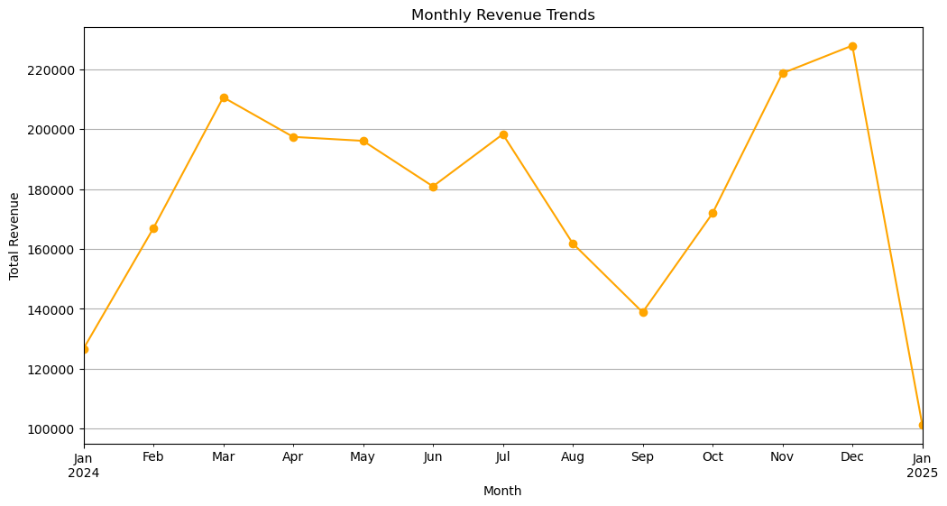

2. Revenue by Region

The North region generated the highest revenue, contributing $1.2M annually. The South region had the lowest performance, indicating potential for improvement. The bar chart below illustrates the revenue distribution by region.

3. Top Customers

The top 10 customers contributed 30% of the total revenue. This highlights the importance of maintaining strong relationships with key accounts. The chart below shows the revenue generated by the top 10 customers.

4. Revenue by Product

Smartphones contributed 45% of the total revenue, making it the highest-performing product. The bar chart below shows the revenue distribution across products.

**Tools and Skills**

Tools: PostgreSQL, Python, Jupyter Notebook, Matplotlib  
Skills: Data Cleaning, SQL Queries, Data Visualization, Exploratory Data Analysis

**Conclusion**

This project demonstrates the ability to manage and analyze data, extract actionable insights, and present findings visually. These skills are essential for driving business decisions and optimizing performance.