RESEARCH REFERENCE
Predicting solution absorbance and colour
from volume and concentration
Internal briefing for drafting a research paper
Prepared from the project notebooks, saved models, and comparison tables. 30 September 2026.
How to use this document
This is a factual brief of what the project actually did, with the numbers that are in the notebooks and saved model files. It is written so a teammate can lift the methods, results, and limitations into a manuscript. It is not a finished paper. Sections marked “Laboratory details still required” must be completed by the people who ran the experiments. Do not invent an analyte name, concentration unit, instrument, or replicate structure that is not in the laboratory records.

1. What the project is
The project trains supervised regression models on a small laboratory workbook and serves the chosen models in a web app. Given a sample’s volume and concentration, the system predicts absorbance at a fixed wavelength, then predicts the solution colour as red, green, and blue channel values and converts those values to a hexadecimal colour.
Two prediction tasks are defined.
- Absorbance regression. Inputs are volume (mL) and concentration, or concentration alone. The target is measured absorbance.
- Colour regression. Inputs are the same experimental variables plus the absorbance predicted by the first model. The targets are the three RGB channels (0–255). A hex colour is obtained by rounding and clipping each channel.
Colour is treated as regression, not as classification of hex strings. That choice keeps the output continuous and comparable to the photographed colour, and it avoids treating each distinct hex code as a separate class on only 90 usable rows.
The colour model is deliberately trained on predicted absorbance rather than on the measured absorbance. At deployment the measured absorbance is not available; only volume and concentration are. Training on the first model’s prediction makes the second stage match the way the app will actually be used.
1.1 Working title options
- Machine-learning prediction of absorbance and solution colour from volume and concentration at 640 nm.
- A two-stage regressor for absorbance and RGB colour: comparing linear and nonlinear models with and without volume.
- How much does sample volume add beyond concentration when predicting absorbance and photographed colour?
Replace the generic wording with the analyte, matrix, and instrument once those are confirmed from the laboratory notebook.
1.2 Draft abstract
A laboratory workbook of solution measurements at 640 nm was used to test whether volume and concentration can predict absorbance and photographed colour. After removal of incomplete rows and one absorbance value of 52, 90 of 101 rows remained. Absorbance ranged from 0.09 to 2.00. Concentration and absorbance were strongly associated (Pearson r = 0.914). Volume was only weakly associated with absorbance (r = −0.139). An 80/20 split (72 training rows, 18 test rows; random seed 42) was used for every model. Nine regressors were compared in a two-stage design: absorbance was predicted first, and that prediction was then used, with the experimental inputs, to predict RGB colour. Each comparison was repeated with volume included and with concentration alone. With volume, support vector regression gave the lowest absorbance error on the test set (MAE 0.057, RMSE 0.072, R² 0.981). Colour was much harder: the best same-algorithm colour R² with volume was 0.286 (random forest). The deployed system therefore uses support vector regression for absorbance and a random forest for colour, with the forest trained on the support-vector absorbance predictions (test colour MAE 16.2 RGB units, R² 0.271). Dropping volume raised absorbance error for every nonlinear model and lowered the deployed absorbance R² from 0.981 to 0.929. The colour models remain too weak for quantitative colour matching. The split is a single hold-out on a small, unbalanced design, so these rankings should be treated as internal evidence, not as an externally validated assay.
Word count of the draft abstract: about 230 words. Tighten it once the chemical system is named, and add one sentence on why the measurement matters.
2. Scientific question
The analysis answers four questions.
- Can absorbance at 640 nm be predicted from concentration, and does adding sample volume improve that prediction?
- Can the photographed colour, stored as RGB, be predicted from the same inputs once a predicted absorbance is available?
- Which of nine standard regressors is most accurate for each target, under the same split?
- Is a model accurate enough to put behind a simple predictor that a user can query with volume and concentration?
A physical reading of the first question follows the Beer–Lambert relation: absorbance is proportional to concentration and to optical path length when the absorber, wavelength, and matrix are fixed. If every row was measured in the same cuvette, volume should not act as path length. A gain from volume would then mean that the volume label carries some other experimental information (a different dilution series, a different concentration window, or a preparation effect). The workbook does not record which of those is true. That distinction belongs in the discussion, and it depends on the laboratory protocol.
3. Data
3.1 Source file
All modelling uses chem_excel_final.xlsx, sheet Sheet1, as loaded in chemistry_ml_project.ipynb. The file has 101 rows. Columns were renamed in the notebook to a stable set: an unused leading column, a volume label (name), concentration (conc), wavelength in nm (wl_nm), absorbance (abs), a photo flag, hex colour, R, G, B, and HSL.
Wavelength is 640 nm on every non-missing row. It was not used as a feature because it does not vary. HSL was stored but not used as a target. The photo column was not used.
3.2 Cleaning
A row was kept only when all of the following were present and valid.
- Volume label could be parsed to a number in millilitres (for example, “5ml” to 5.0).
- Concentration and absorbance were numeric.
- Hex colour matched # followed by six hexadecimal digits, after conversion to upper case.
- R, G, and B were numeric.
Ten rows failed those checks, mostly because colour fields were blank. One further row had absorbance equal to 52 at 5 mL and concentration 0.8, with an otherwise ordinary dark hex colour. That value is far outside the rest of the absorbance range (0.09 to 2.00) and was removed as a recording error so that it would not dominate the fit. Ninety rows remained.
3.3 What the 90 rows look like
Volumes present are 1, 2, 3, 4, and 5 mL. The design is not balanced: 5 mL has 29 rows and 1 mL has 10. Concentration ranges also differ by volume, so volume and concentration are partly tied together.
Table 1. Usable rows by volume label, with the concentration range recorded in that group.
Volume | Rows | Concentration minimum | Concentration maximum
1 mL | 10 | 1.00 | 10.00
2 mL | 12 | 0.50 | 6.00
3 mL | 20 | 0.30 | 6.00
4 mL | 19 | 0.25 | 4.75
5 mL | 29 | 0.60 | 6.40
All usable rows | 90 | 0.25 | 10.00

Table 2. Summary of the cleaned modelling table (n = 90).
Variable | Mean | SD | Minimum | Median | Maximum
Absorbance | 1.140 | 0.572 | 0.090 | 1.120 | 2.000
Concentration | 3.418 | 2.018 | 0.250 | 3.275 | 10.000
Volume (mL) | 3.50 | 1.36 | 1 | 4 | 5
R (0–255) | 41.8 | 53.6 | 0 | 6.5 | 189
G (0–255) | 153.0 | 30.5 | 15 | 159 | 191
B (0–255) | 179.7 | 36.9 | 23 | 191 | 208

The red channel is much more variable than green or blue, and its median is only 6.5. Many solutions are therefore blue-green in the recorded RGB, with red often near zero. That imbalance matters later: red is the colour channel the models fit worst.
The concentration column has no unit in the workbook. The paper must state the unit (for example mol/L, mg/L, or % w/v) from the experimental record. Until then, report it only as “concentration as recorded”.
3.4 Association among the inputs and absorbance
On the 90 cleaned rows, Pearson correlation between absorbance and concentration is 0.914. Correlation between absorbance and volume is −0.139, and between concentration and volume is −0.192. Concentration already carries most of the linear signal in absorbance. Volume is a weak linear correlate, which is why a later gain from volume, where it appears, is a nonlinear or design effect rather than a strong straight-line effect.
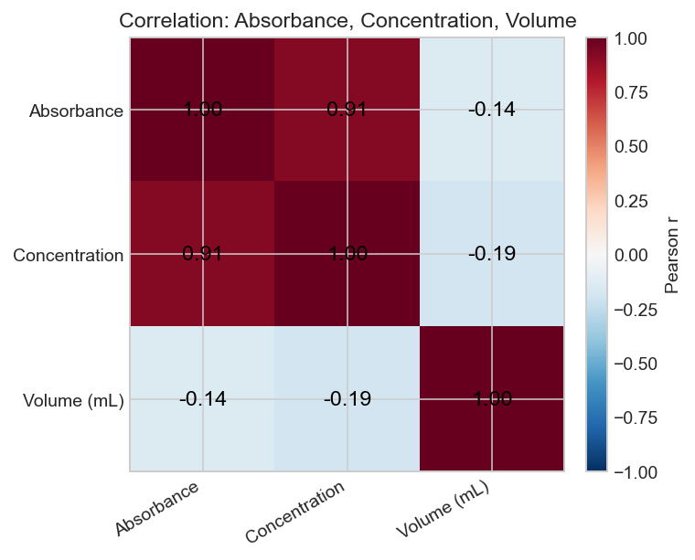
Figure 1. Pearson correlations on the cleaned data (n = 90). Values in the figure are rounded to two decimals; the text uses three.
4. Methods
4.1 Split
Rows were split once with scikit-learn train_test_split, test_size 0.2, random_state 42, with shuffling left on. That gives 72 training rows and 18 test rows. The same seed was used for the with-volume and without-volume experiments, so both settings are scored on the same 18 solutions. No cross-validation, nested tuning, or external batch was run.
4.2 Two-stage targets
Stage 1 predicts absorbance.
- With volume: features are volume_ml and conc.
- Without volume: the only feature is conc.
Stage 2 predicts R, G, and B together.
- With volume: features are volume_ml, conc, and the Stage-1 absorbance prediction.
- Without volume: features are conc and the Stage-1 absorbance prediction.
The absorbance prediction used in Stage 2 is produced by the same algorithm that was just fit for Stage 1, except in the deployed hybrid described in Section 6. Training-set predictions of absorbance are used when fitting the colour model; test-set predictions are used when scoring it. Measured absorbance is not given to the colour model.
Multi-output models wrap the base regressor in MultiOutputRegressor, which fits one model per RGB channel. Predicted channels are clipped to 0–255 and rounded to integers before they are shown as a colour. Metrics below are computed on the unclipped continuous predictions, as returned by the scikit-learn scorers in the notebook.
4.3 Algorithms
Nine regressors were fit under identical splits. Hyperparameters were fixed in advance. They were not tuned on the test set, and they were not chosen by cross-validation. Defaults apply wherever a value is not listed.
Table 3. Regressors in the comparison. Software: Python 3.12.10, scikit-learn 1.5.1.
Algorithm | Settings used
Linear regression | Ordinary least squares, no scaling
Ridge | StandardScaler, then Ridge with alpha = 1.0
k-nearest neighbours | StandardScaler, then k = 5, uniform weights
Decision tree | min_samples_leaf = 2, random_state = 42
Random forest | 400 trees, min_samples_leaf = 2, random_state = 42
Extra trees | 400 trees, min_samples_leaf = 2, random_state = 42
Gradient boosting | scikit-learn defaults, random_state = 42
HistGradientBoosting | scikit-learn defaults, random_state = 42
Support vector regression | StandardScaler, then RBF kernel, C = 10, epsilon = 0.05, gamma = scale

The colour-stage random forest that is saved for the app uses 500 trees rather than 400, with the same leaf size and seed. That difference is stated again in Section 6 so the comparison table and the deployed model are not described as identical.
4.4 Metrics
Every model is scored on the 18 held-out rows with three metrics.
- Mean absolute error (MAE). Average absolute miss. For absorbance this is in absorbance units. For colour it is in RGB units (0–255), averaged across channels and test rows.
- Root mean squared error (RMSE). Same units, with larger misses weighted more heavily.
- Coefficient of determination (R²). Fraction of test-set variance explained. A value near 1 is a close fit. A value near 0 is no better than predicting the test-set mean. A negative value is worse than that mean.
For colour, the notebook also reports per-channel MAE and R² for the original random-forest pair. Those channel scores are in Section 5.2. The nine-algorithm table reports only the overall multi-output scores.
4.5 What was not done
- No k-fold or repeated cross-validation.
- No hyperparameter search.
- No confidence intervals or prediction intervals.
- No grouping of the split by volume, so some volumes can be over-represented in the 18 test rows by chance.
- No external solutions measured after the workbook was frozen.
- Wavelength, HSL, and the photo flag were not modelled.
5. Results
5.1 Absorbance, nine algorithms
With volume and concentration, eight of the nine models reach a test R² above 0.87. The two linear models sit at the bottom of that group. Support vector regression is the most accurate (MAE 0.057, RMSE 0.072, R² 0.981), followed by gradient boosting (MAE 0.059, RMSE 0.080, R² 0.976). Removing volume hurts every model. The drop is small for linear regression (R² 0.879 to 0.878) and large for gradient boosting (0.976 to 0.862) and extra trees (0.963 to 0.879). Support vector regression remains the best concentration-only model (R² 0.929), but its MAE roughly doubles, from 0.057 to 0.116.
Table 4. Held-out absorbance metrics. Sorted by R² with volume. Lower MAE and RMSE are better; higher R² is better.
Algorithm | MAE with vol. | RMSE with | R² with | MAE no vol. | RMSE no vol. | R² no vol. | R² gain
SVR | 0.057 | 0.072 | 0.981 | 0.116 | 0.138 | 0.929 | +0.052
Gradient boosting | 0.059 | 0.080 | 0.976 | 0.151 | 0.193 | 0.862 | +0.114
Extra trees | 0.077 | 0.099 | 0.963 | 0.140 | 0.180 | 0.879 | +0.084
k-NN (k = 5) | 0.086 | 0.121 | 0.945 | 0.130 | 0.163 | 0.901 | +0.044
Random forest | 0.111 | 0.129 | 0.939 | 0.144 | 0.180 | 0.880 | +0.058
Decision tree | 0.111 | 0.131 | 0.936 | 0.147 | 0.186 | 0.872 | +0.064
HistGradientBoosting | 0.151 | 0.179 | 0.881 | 0.175 | 0.200 | 0.852 | +0.029
Linear regression | 0.143 | 0.180 | 0.879 | 0.141 | 0.181 | 0.878 | +0.001
Ridge | 0.144 | 0.181 | 0.878 | 0.142 | 0.182 | 0.877 | +0.001

R² gain is the with-volume R² minus the without-volume R². Full unrounded values are in artifacts/multi_model_comparison.csv. Figures in this table are rounded to three decimals, so a gain may differ by 0.001 from a subtraction of the displayed R² values.
The linear models barely change when volume is removed. That matches the weak Pearson correlation. The tree and kernel models use volume anyway, and they lose accuracy without it. Because the concentration window is different at each volume (Table 1), part of that gain may be the model learning which concentration range a volume label belongs to, rather than learning a path-length effect. The paper should not claim a physical volume mechanism unless the protocol supports it.
5.2 Colour, nine algorithms
Colour R² values are an order of magnitude weaker than absorbance R² values. With volume, the best overall colour R² is 0.286 (random forest, MAE 17.0). Without volume, extra trees is the best of this table (R² 0.323, MAE 17.9), and several linear and kernel models fall to an R² at or below zero. A negative R² means the predictions are worse, on this test set, than always guessing the mean colour.
Table 5. Held-out colour metrics. Each colour model uses that algorithm’s own absorbance predictions. Sorted by R² with volume.
Algorithm | MAE with vol. | RMSE with | R² with | MAE no vol. | RMSE no vol. | R² no vol.
Random forest | 17.00 | 32.58 | 0.286 | 20.16 | 35.43 | 0.182
Extra trees | 17.55 | 34.31 | 0.234 | 17.94 | 32.64 | 0.323
Decision tree | 17.09 | 32.67 | 0.229 | 18.21 | 33.51 | 0.249
Gradient boosting | 17.01 | 35.16 | 0.187 | 20.08 | 36.39 | 0.131
k-NN (k = 5) | 18.43 | 39.27 | 0.069 | 19.51 | 35.36 | 0.213
SVR | 18.70 | 39.30 | 0.076 | 19.43 | 40.68 | −0.004
HistGradientBoosting | 22.02 | 39.59 | 0.037 | 23.39 | 39.04 | 0.051
Ridge | 22.49 | 39.64 | 0.030 | 25.20 | 41.31 | −0.062
Linear regression | 22.53 | 39.67 | 0.028 | 25.18 | 41.32 | −0.062

An MAE of about 17 on a 0–255 channel is a moderate absolute miss, but the R² stays low because much of the green and blue variation is small (Table 2) and is not a smooth function of concentration. Support vector regression, which is the best absorbance model, is a poor colour model (R² 0.076 with volume). That is why the deployed app does not use one algorithm for both stages.
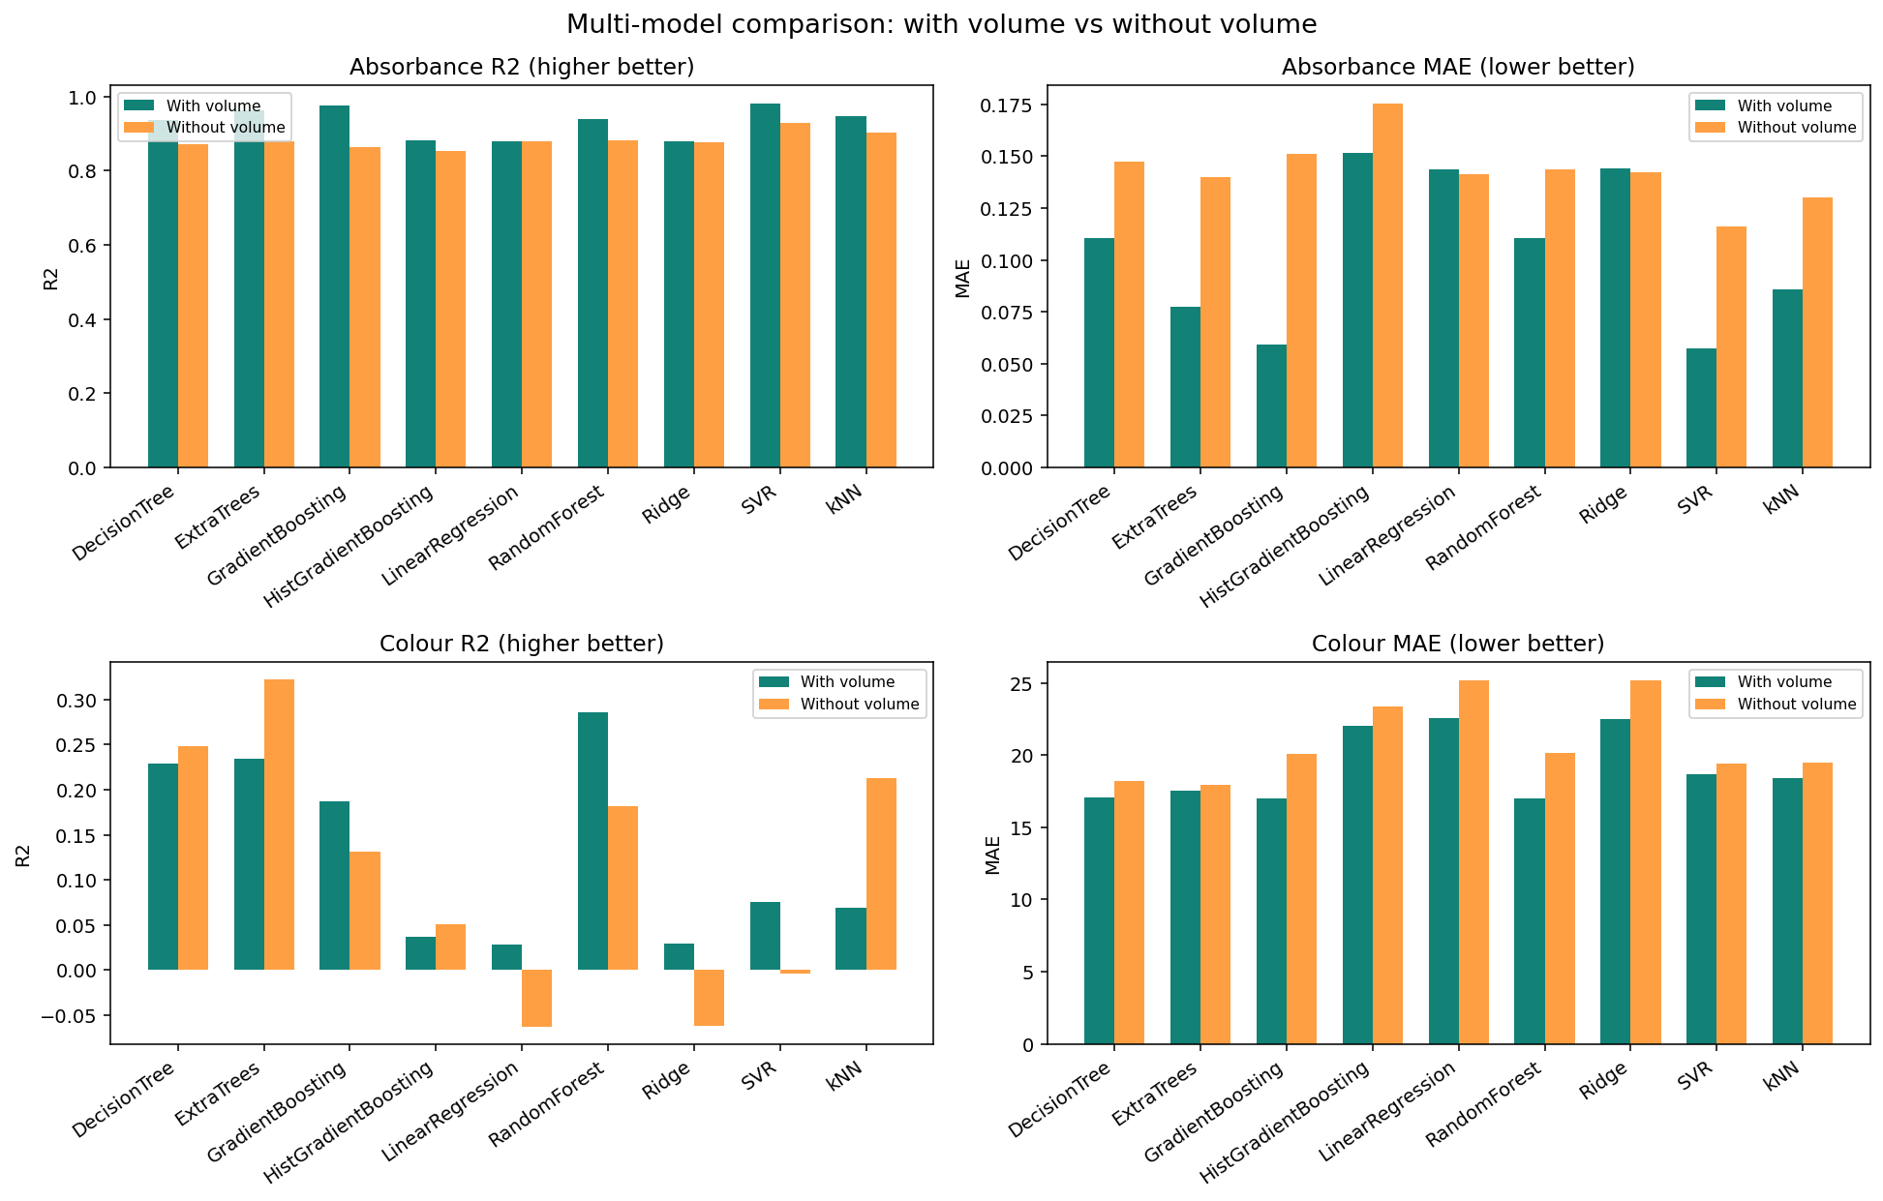
Figure 2. Test MAE and R² for all nine algorithms, with volume (teal) and without volume (orange). Absorbance R² is high across the board; colour R² is not. Source: chemistry_ml_project.ipynb, saved as artifacts/multi_model_comparison.png.
5.3 Original random-forest pair, including colour by channel
Before the nine-algorithm comparison, the notebook trained a random-forest pair and saved per-channel colour scores. Those forests are the numbers in Figures 3 and 4. They are not the deployed models. The absorbance forest used 400 trees. The colour forest used 500 trees and was trained on that forest’s absorbance predictions, not on support-vector predictions.
Table 6. Original random-forest pair on the same 18-row test set.
Setting | Target | MAE | RMSE | R²
With volume | Absorbance | 0.111 | 0.129 | 0.939
Without volume | Absorbance | 0.144 | 0.180 | 0.880
With volume | Colour, overall | 17.03 | 32.65 | 0.282
Without volume | Colour, overall | 20.22 | 35.65 | 0.171

Table 7. Colour error by channel for that same random-forest pair.
Channel | MAE with volume | R² with volume | MAE without volume | R² without volume
R | 21.04 | −0.018 | 24.29 | −0.116
G | 14.96 | 0.292 | 16.71 | 0.269
B | 15.09 | 0.571 | 19.65 | 0.361

Blue is the only channel with a clearly useful R². Green is modest. Red is not predicted: its R² is slightly negative even when volume is included. Any claim about “predicting colour” should say that the model mainly tracks the blue channel and does not recover red.
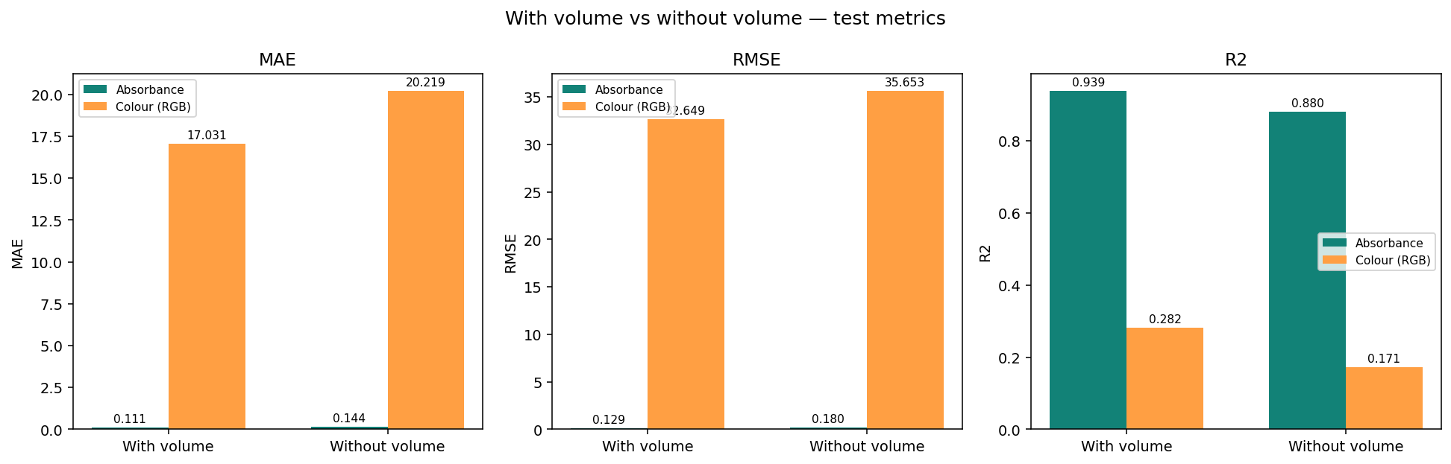
Figure 3. Test metrics for the original random-forest pair only. Absorbance bars are small on the MAE and RMSE panels because they are in absorbance units, while colour error is in RGB units. Do not read the bar heights as a direct comparison of the two tasks.
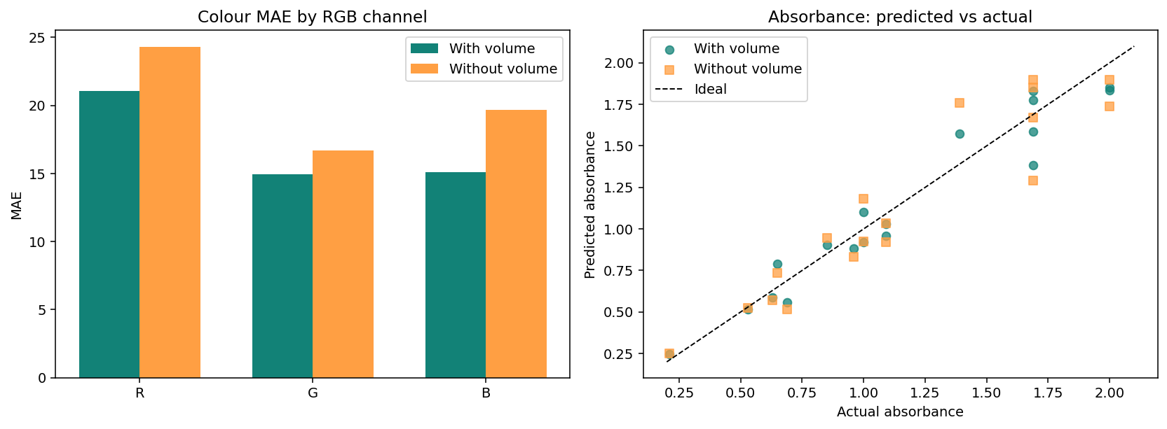
Figure 4. Left: colour MAE by channel for the original random-forest pair. Right: predicted versus measured absorbance on the 18 test rows. The dashed line is perfect agreement.
5.4 Worked examples
These are single queries of the original random-forest pair, included so the paper can show what a prediction looks like. They are not test-set scores.
Table 8. Example queries from the notebook. Hex colours are the rounded RGB values.
Inputs | Predicted absorbance | Predicted RGB | Hex
3.0 mL, concentration 1.5 | 0.557 | (99, 163, 192) | #63A3C0
Concentration 1.5 only | 0.517 | (104, 184, 190) | #68B8BE

6. Models chosen for the app
The Streamlit app (web_app.py) does not serve the single best algorithm for both tasks. The saved metadata records the reason: support vector regression had the best absorbance R², while support vector regression for colour was weak, so colour uses a random forest trained on the support-vector absorbance predictions.
Table 9. Deployed artifacts and the test metrics stored in the model metadata.
Variant | Absorbance model | Colour model | Abs. MAE | Abs. RMSE | Abs. R² | Colour MAE | Colour R²
Volume + concentration | SVR | Random forest | 0.057 | 0.072 | 0.981 | 16.23 | 0.271
Concentration only | SVR | Random forest | 0.116 | 0.138 | 0.929 | 20.39 | 0.138

Deployed absorbance model: StandardScaler followed by SVR with an RBF kernel, C = 10, epsilon = 0.05, gamma = “scale”. Deployed colour model: MultiOutputRegressor of RandomForestRegressor with 500 trees, min_samples_leaf = 2, random_state = 42. Colour RMSE on the same test rows is 33.08 with volume and 36.27 without. A support-vector colour model was scored only as a reference and was not deployed (R² 0.076 with volume; R² −0.004 without).
The colour MAE of 16.23 in Table 9 is not the same number as the random-forest colour MAE of 17.00 in Table 5. Table 5 trains the colour forest on random-forest absorbance predictions. Table 9 trains it on support-vector absorbance predictions. Both use the same 18 test rows. Quote Table 9 when describing the app, and Table 4 and Table 5 when describing the algorithm comparison.
Saved files:
- artifacts/absorbance_model.joblib and colour_model_rgb.joblib, with model_metadata.joblib.
- artifacts/absorbance_model_no_volume.joblib and colour_model_rgb_no_volume.joblib, with model_metadata_no_volume.joblib.
- Random-forest backup files are also in artifacts/. They are not what the app loads.
The app asks for volume in mL and concentration, or concentration alone. It predicts absorbance, then RGB, clips each channel to 0–255, rounds to an integer, and draws the hex colour. If a volume is outside 1–5 mL, the app warns that the prediction is outside the training range. Known training labels stored with the model are 1ml, 2ml, 3ml, 4ml, and 5ml.
7. A second colour path that should not be mixed in
comparisons.xlsx and comparisons_plots_replicate.ipynb are a separate charting exercise. That notebook does not train the models above. It reads absorbance values that are already stored as “actual” and “predicted”, plots them against concentration for each volume, and builds a predicted colour by interpolating measured colours along absorbance. Those interpolated colours are not the RGB model’s colours. If a figure from that notebook is used in the paper, the caption must say that the colour was looked up from absorbance, not predicted by the colour regressor.
8. Points worth making in the discussion
- Absorbance is predictable. An R² of 0.98 on the hold-out, with an MAE of 0.06 against a response that spans 0.09 to 2.00, is a close fit for this workbook. The strong concentration correlation (r = 0.914) explains most of it. Nonlinear models, especially SVR and gradient boosting, pick up the rest when volume is available.
- Volume is not required for a usable linear absorbance model, and it is required for the best nonlinear ones. State both facts. The linear R² barely moves (0.879 versus 0.878). The best nonlinear R² moves from 0.981 to 0.929, and gradient boosting moves from 0.976 to 0.862.
- Do not over-interpret volume. The series are unbalanced, concentration ranges differ by volume, and volume correlates weakly with both absorbance and concentration. A methods paragraph should describe how each volume series was prepared. Without that, “volume improves prediction” is a statistical result, not a Beer–Lambert result.
- Colour is not solved. Overall R² stays below 0.33 in every setting that was tried. Red is effectively unpredictable in the channel-wise random-forest scores. The honest conclusion is that photographed RGB, as recorded here, is a noisy target. Possible reasons to discuss, if the lab can support them: lighting and camera white balance, sampling a single pixel or region, solutions that are optically similar in green and blue, and the decision to predict colour from a predicted absorbance rather than from a spectrum.
- One algorithm should not be forced to do both jobs. SVR wins absorbance and loses colour. The hybrid in the app is a direct consequence of Table 4 and Table 5, not a preference for complexity.
- Eighteen test rows is a thin basis for ranking nine models. A difference of a few thousandths in R² can swap neighbours. The gap between SVR (0.981) and linear regression (0.879) on absorbance is large enough to discuss. The gap between random forest, extra trees, and decision tree on colour is not.
- The app is a demonstration of the fitted functions. It is not a validated analytical method. The manuscript should not describe it as a replacement for a spectrophotometer.
9. Limitations to include, not to hide
- Sample size. 90 rows after cleaning, 18 in the test set, one split, one seed.
- No cross-validation and no tuning. The SVR settings (C = 10, epsilon = 0.05) and the tree sizes were chosen up front. A search could change the ranking, especially among the tree models.
- Possible leakage of experimental structure. If several rows are repeated preparations of the same solution, a random split lets near-duplicates fall on both sides. The workbook does not label replicates, so this could not be checked.
- One discarded absorbance of 52. If that value was real, removing it changes the scientific claim. The surrounding colour (#081018) looks like a dark solution, which makes a typo the more plausible reading, but the lab should confirm the original sheet.
- Fixed wavelength. Nothing in these models says how the solution behaves at any wavelength other than 640 nm.
- Colour metrics are not perceptual. MAE in RGB is not a CIE ΔE. Two colours with the same RGB error can look different, and the reverse is also true. If the paper makes a visual claim, compute a perceptual difference on the test set.
- No uncertainty. The app returns a point prediction. A user cannot see whether 0.55 and 0.62 are distinguishable under this model.
- Extrapolation. Volumes outside 1–5 mL, and concentrations outside the ranges in Table 1, are not supported. Tree models will flatten; the RBF support-vector model can move more freely and should not be trusted there either.
- Software lock. Scores were produced with scikit-learn 1.5.1. A later version can change histogram-gradient boosting and, less often, forest numerics. Pin the version in the paper.
10. Laboratory details still required
Do not submit until this list is filled from the experimental record
The code and the workbook do not contain the identity of the solution, the concentration unit, the instrument, the path length, the camera setup, or whether rows are replicates. Those facts change the introduction, the methods, and what “volume” means. Leave them blank in the draft rather than guessing.

Table 10. Facts the modelling files cannot supply.
Item the paper needs | What the project files show | Who should fill it
Analyte and matrix | Not named | Experimental lead
Concentration unit and how standards were prepared | A numeric column only | Experimental lead
What the volume label means | Parsed from strings 1ml–5ml | Experimental lead
Cuvette path length and spectrophotometer | Wavelength fixed at 640 nm | Experimental lead
Blank and what absorbance is referenced to | Unused blank column, all empty in the sample rows inspected | Experimental lead
How RGB and hex were read from photos | Columns exist; method does not | Experimental lead
Replicates versus independent solutions | Not labelled | Experimental lead
Why one absorbance equals 52 | Removed as an outlier | Check the original sheet
Ethics, safety, or instrument calibration statement | Not in the repository | Authors
Literature this result should sit against | Not reviewed in the notebooks | Authors

11. Suggested manuscript outline
A short empirical paper can follow this order. Each line points at the section of this brief that already holds the numbers.
- Introduction. Why predicting absorbance and colour from preparation variables would help. Beer–Lambert in one paragraph. Gap: small tabular lab sets, colour as a noisy image-derived target. End with the four questions in Section 2.
- Materials. Analyte, preparation, instrument, path length, camera. Then the workbook description in Section 3, including the 101-to-90 cleaning rule and Table 1.
- Statistical methods. Section 4, almost as written. Name the software versions. State that hyperparameters were not tuned.
- Results. Figure 1, then Table 4 and Table 5, then the channel breakdown in Table 7, then the deployed hybrid in Table 9. One paragraph each.
- Discussion. Section 8, after the laboratory protocol is known. Lead with absorbance success, then the volume caveat, then the colour failure.
- Conclusion. Absorbance can be predicted closely from concentration, and more closely when volume is included, on this internal split. Recorded RGB colour cannot be predicted well enough for quantitative use. The app illustrates the absorbance model and should not be described as an analytical method.
Figures worth including, in this order:
- Figure 1, correlation heatmap (already saved).
- A line plot of absorbance versus concentration, one line per volume. The notebook draws this; export it at publication resolution.
- Figure 2, the nine-algorithm comparison.
- Figure 4, predicted versus measured absorbance, ideally redrawn for the deployed SVR rather than the original forest.
- A small strip of actual versus predicted colour swatches on the test rows, with RGB MAE printed under each pair. This figure does not exist yet and would make the colour result honest and visible.
Tables worth including: Table 1, Table 4, Table 5, Table 7, and Table 9.
12. Reproducibility map
Table 11. Files a co-author needs.
File | Role
chem_excel_final.xlsx | Source measurements
chemistry_ml_project.ipynb | Cleaning, models, metrics, saved artifacts
chem_excel_eda.ipynb | Earlier exploratory plots; not required for the reported scores
artifacts/multi_model_comparison.csv | Full unrounded comparison table
artifacts/model_metadata.joblib | Deployed with-volume features, algorithms, and test metrics
artifacts/model_metadata_no_volume.joblib | Same, for the concentration-only variant
web_app.py | Streamlit app that loads the joblib files
requirements.txt | joblib, numpy, pandas, scikit-learn, streamlit, openpyxl
comparisons.xlsx | Separate actual-versus-predicted sheet; not the training table
comparisons_plots_replicate.ipynb | Charts from that sheet; colour there is interpolated

To regenerate the models and scores, install the requirements, open chemistry_ml_project.ipynb, and run all cells. To open the app, run streamlit run web_app.py from the project folder. Plotting notebooks also import matplotlib; the comparison notebook additionally uses seaborn or plotly in the exploratory file.
Notebook environment recorded in the file: Python 3.12.10. Metric-producing environment checked while writing this brief: scikit-learn 1.5.1.
13. Sentences that are safe to reuse
The following statements match the files. They can be edited for journal style. They should not be widened beyond a single 80/20 split of this workbook.
- Of 101 recorded rows, 90 had a parseable volume, numeric concentration and absorbance, a valid hex colour, and numeric RGB channels, after exclusion of one absorbance value of 52.
- All retained measurements were taken at 640 nm. Wavelength was constant and was not used as a predictor.
- On the cleaned data, absorbance was strongly correlated with concentration (Pearson r = 0.914) and weakly correlated with volume (r = −0.139).
- Models were compared on one shuffled hold-out of 18 rows (random seed 42). Hyperparameters were fixed before seeing test scores.
- With volume included, support vector regression predicted held-out absorbance with MAE 0.057, RMSE 0.072, and R² 0.981.
- The same support vector model without volume had MAE 0.116, RMSE 0.138, and R² 0.929.
- No colour model in the nine-algorithm comparison exceeded an R² of 0.33. The deployed colour model, a random forest on support-vector absorbance predictions, reached R² 0.271 (MAE 16.2) with volume and R² 0.138 (MAE 20.4) without it.
- In the channel-wise random-forest scores, blue was partially predictable (R² 0.57 with volume), green less so (R² 0.29), and red was not (R² −0.02).
14. Sentences to avoid
- “The model replaces spectrophotometry.” It does not. It interpolates this workbook.
- “Volume is the optical path length.” That has not been established.
- “Colour is predicted accurately.” The R² values say otherwise.
- “SVR is universally best.” It is best for absorbance in this comparison. It is poor for colour.
- “Results were cross-validated.” They were not.
- Quoting the random-forest colour MAE of 17.0 as the app’s error. The app’s stored colour MAE is 16.2, from a different absorbance input. Use the number that matches the claim.
End of reference. Questions about a number in this brief should be checked against chemistry_ml_project.ipynb and artifacts/multi_model_comparison.csv before they are copied into a manuscript.
15. Full accounting of the workbook
This section records every column, every missing-value count, and the difference between the exploratory notebook and the modelling notebook. The two notebooks do not clean the file the same way. A paper that cites “the dataset” has to say which filter it means.
15.1 Columns as stored in chem_excel_final.xlsx
The file has one sheet, Sheet1, and 101 rows by 11 columns. The first column has no name in Excel, so pandas reads it as Unnamed: 0. The modelling notebook renames that column to blank. It is empty on 100 of the 101 rows and is never used.
Table 12. Columns, missing counts on all 101 rows, and whether any model uses them.
Excel column | Notebook name | Missing rows | Role
Unnamed: 0 | blank | 100 | Unused. Empty on almost every row.
name | name, then volume_label | 8 | Volume label such as 5ml. Parsed to volume_ml.
conc | conc | 8 | Concentration. Numeric. Unit not recorded.
wl(nm) | wl_nm | 8 | Wavelength. 640 nm wherever it is filled. Not a feature.
abs | abs | 8 | Absorbance. Target of stage 1.
photos | photos | 99 | Text flag. Two rows say Picture. Unused.
HEX | hex | 10 | Colour as #RRGGBB. Required for a modelling row.
R | r | 10 | Red channel, 0–255. Colour target.
G | g | 10 | Green channel, 0–255. Colour target.
B | b | 10 | Blue channel, 0–255. Colour target.
HSL | hsl | 10 | Hue, saturation, lightness text. Stored, never modelled.

Eight rows are empty across name, concentration, wavelength, and absorbance. Those eight empty rows are also exact duplicates of one another, which is why a full-row duplicate count on the raw file is 7 (eight copies, one of which is the first). Hex, R, G, B, and HSL are missing on those eight rows and on two further rows. Those two further rows are 5 mL at concentrations 0.2 and 0.4, with absorbances 0.08 and 0.14, and the photos cell set to Picture. They have no colour, so the colour model cannot use them. The photos column is Picture on only those two rows and blank on the other 99.
Row accounting for the modelling table: 101 rows in the file; 8 empty; 2 measured rows with no hex colour; 1 row with hex colour but absorbance 52 (5 mL, concentration 0.8, hex #081018). 101 − 8 − 2 − 1 = 90 rows used to train and test. The value 52 is the only absorbance above 10. The next highest absorbance in the file is 2.00.
15.2 How volume is parsed
The modelling notebook builds volume_label by stripping spaces from name, then volume_ml by taking the first number in that string with the regular expression (\d+(?:\.\d+)?). The labels that survive cleaning are exactly 1ml, 2ml, 3ml, 4ml, and 5ml, which become 1, 2, 3, 4, and 5. A label without a number would be dropped. None of the non-empty labels lacked a number.
15.3 Hex check, and how hex is produced at prediction time
A stored hex value is kept only if, after conversion to upper case, it matches # followed by exactly six characters from 0–9 and A–F. Short codes, missing hashes, and blank cells fail. R, G, and B must also be numeric on the same row. The models do not predict the hex string. They predict three continuous channel values. The app and the notebook then clip each value to the closed interval from 0 to 255, round to the nearest integer, and format the integers as #RRGGBB.
15.4 Absorbance within each volume, on the 90 modelling rows
Mean absorbance is not the same at every volume. The 1 mL series sits higher (mean 1.31) than the 4 mL series (mean 0.98). The 5 mL mean is 1.11. That pattern is descriptive. It is not, by itself, evidence that volume is a path length, because the concentration windows also differ (Table 1).
Table 13. Absorbance by volume label on the 90 modelling rows.
Volume | Rows | Minimum | Mean | Median | Maximum
1ml | 10 | 0.36 | 1.31 | 1.41 | 2.00
2ml | 12 | 0.26 | 1.26 | 1.30 | 2.00
3ml | 20 | 0.15 | 1.18 | 1.23 | 2.00
4ml | 19 | 0.09 | 0.98 | 0.92 | 2.00
5ml | 29 | 0.21 | 1.11 | 1.09 | 2.00

The cleaned table contains 89 distinct hex colours in 90 rows, so almost every solution was stored as its own colour, and 84 distinct HSL strings. HSL is a second encoding of the same photographed colour. It was not used as an input or as a target. An example stored HSL value is hsl(199, 25%, 9%), paired in the sheet with hex #121A1E.
16. Exploratory notebook, in full
chem_excel_eda.ipynb is a separate exploration. It does not train models, does not save artifacts, and does not apply the absorbance ≤ 10 rule or the hex rule. Its summary cell at the end is still a blank template (main observations, data-quality concerns, next steps). The findings below are what that notebook computes, plus the counts measured from the same file.
- Libraries: numpy, pandas, matplotlib, seaborn, and plotly. Warnings are silenced. Seaborn theme is whitegrid. Figure size default is 10 by 5 inches. Plotly is imported. The executed cells that produce the static figures use seaborn and matplotlib.
- Load: chem_excel_final.xlsx, first sheet only. Printed shape is (101, 11). Printed columns are Unnamed: 0, name, conc, wl(nm), abs, photos, HEX, R, G, B, HSL.
- Cleaning inside this notebook: count duplicate rows, drop exact duplicate rows, then try to convert object columns to numbers when at least 80% of the non-missing values parse as numbers. Name, HEX, photos, and HSL stay as text because they do not meet that test.
- After that drop, the seven extra empty rows are gone. The absorbance value 52 is still in the frame, and so are rows that have no colour. Histograms and box plots in this notebook therefore still show that extreme absorbance.
- Univariate plots: a histogram and a box plot for every numeric column the notebook sees, which are conc, wl(nm), abs, R, G, and B. Wavelength is a spike at 640. The absorbance box plot is dominated by 52 if that row has not been removed.
- Bivariate plots: a scatter of absorbance against concentration, and a seaborn pair-style view of the numeric columns. These are exploratory pictures, not test-set diagnostics.
- Categorical bars: the notebook plots the top categories of object columns, which on this file are the volume labels, the hex codes, the HSL strings, and the photo flag.
The modelling notebook later draws its own absorbance-versus-concentration lines, one line per volume, and a three-variable Pearson heatmap (Figure 1). Those two figures, not the generic EDA histograms, are the ones worth putting in a paper. The EDA notebook is the place a co-author can see missingness and the outlier before the modelling filter.
Do not merge the two cleaning stories
The exploratory notebook drops exact duplicate rows and keeps the absorbance of 52. The modelling notebook keeps non-duplicate measured rows, drops rows without a valid hex or RGB, and drops absorbance above 10. Quote n = 90 only for model metrics. Quote n = 101 for the raw file.

17. The comparison workbook, row by row of method
comparisons.xlsx is not the training table. comparisons_plots_replicate.ipynb reads it with openpyxl, data_only=True, so it sees cached calculated values rather than formulas. The first sheet is used. The header row does not carry column names that the notebook trusts. The notebook reads fixed positions: volume, concentration, wavelength, actual absorbance, actual colour, and predicted absorbance.
Volume labels are not repeated on every row in the sheet. The notebook remembers the last non-empty volume and applies it to the following rows until the next label. It stops when it meets a volume cell equal to the text Total Error. A row is kept when concentration, actual absorbance, and predicted absorbance are all numbers. Colour may be missing. That rule produced 93 rows: 10 at 1 mL, 12 at 2 mL, 20 at 3 mL, 19 at 4 mL, and 32 at 5 mL. None of those 93 actual absorbance values is 52. The same 5 mL, concentration 0.8, colour #081018 row is stored as absorbance 52 in chem_excel_final.xlsx and as absorbance 0.52 in comparisons.xlsx, where the sheet’s own prediction is 0.28. The modelling filter removed it because 52 is above 10. The comparison sheet kept the 0.52 value. That is the most important data-quality note in the project: one row disagrees by a factor of one hundred between the two workbooks, and the training set currently omits it. The laboratory record should say which value was measured. The 5 mL count is 32 in the comparison extract and 29 in the modelling table. The three-row gap is that disputed row plus the two 5 mL rows that have absorbance but no hex colour (concentrations 0.2 and 0.4).
For each volume the notebook plots actual absorbance and the sheet’s predicted absorbance against concentration, and prints the mean absolute error. Colours on the plot are #1f77b4 for actual and #ff7f0e for predicted. The figure is five stacked panels, about 15 by 24 inches.
Table 14. Error of the predicted absorbance already stored in comparisons.xlsx. These are not the deployed support-vector errors.
Volume | Rows | Mean absolute error | Largest absolute error
1ml | 10 | 0.115 | 0.27
2ml | 12 | 0.383 | 1.71
3ml | 20 | 0.097 | 0.40
4ml | 19 | 0.087 | 0.44
5ml | 32 | 0.073 | 0.24
All extracted rows | 93 | 0.125 | 1.71

Across the 93 rows the mean absolute error is 0.125 and the root mean squared error is 0.230. The 2 mL average is pulled up by one row: concentration 0.50, actual absorbance 0.26, sheet prediction 1.97, absolute error 1.71, stored colour #9A9185. The next largest misses are 4 mL at concentration 0.25 (actual 0.09, sheet prediction 0.53) and 3 mL at concentration 0.30 (actual 0.15, sheet prediction 0.55).
Those sheet predictions are not the current deployed model. On the same 93 rows, the mean absolute gap between the sheet’s predicted absorbance and a fresh prediction from the saved support-vector model is 0.115, and the largest gap is 1.660. The largest gap is that same 2 mL, concentration 0.50 row: the sheet says 1.97 and the saved support-vector model says about 0.310. Use Table 4, Table 5, and Table 9 for the models in this project. Use Table 14 only to describe the older numbers embedded in comparisons.xlsx.
17.1 How that notebook invents a predicted colour
It does not call the RGB model. It builds a piecewise-linear colour map in matplotlib from the pairs of actual absorbance and actual hex colour, after dropping duplicate absorbance anchors and keeping the first colour at each absorbance. Each anchor is placed on a 0-to-1 scale between the smallest and largest actual absorbance. LinearSegmentedColormap interpolates between those anchors with 256 steps. The sheet’s predicted absorbance is passed through that map and converted back to hex. If every absorbance were identical, the function would return the single anchor colour; that case does not arise here.
The notebook then draws a small table of example swatches: up to three rows sampled from each volume, random_state 42, showing volume, concentration, actual absorbance, actual colour, predicted absorbance, and the interpolated colour. Because the sample is random within each volume, those particular swatches are illustrations. They are not a test-set score.
18. What the saved colour forest uses
The deployed colour model is three random forests, one per channel, wrapped by MultiOutputRegressor. Each forest has 500 trees, min_samples_leaf = 2, and random_state = 42. scikit-learn’s impurity-based feature importance, on the with-volume model, is below. Importance is the share of split improvement attributed to each input. The three shares in a row sum to 1. They are not causal effects, and they are not the support-vector model’s importances. Support vector regression with an RBF kernel does not produce this kind of score. The saved absorbance model has 31 support vectors.
Table 15. Impurity importance in the deployed with-volume colour forests. Features are volume, concentration, and the support-vector absorbance prediction.
Channel | Volume | Concentration | Predicted absorbance
R | 0.092 | 0.231 | 0.677
G | 0.094 | 0.369 | 0.537
B | 0.243 | 0.446 | 0.311

For red and green, the predicted absorbance takes more than half of the importance. For blue, concentration is the largest share (0.446), then predicted absorbance (0.311), then volume (0.243). Volume is the smallest share for red and green (about 0.09). That can sit beside the earlier result that volume still changes absorbance error a great deal: volume may act mostly by changing the absorbance prediction, which the colour model then reads, rather than by splitting the colour trees directly.
19. Queries of the deployed models
Section 5.4 quoted the original random-forest pair. The app loads the support-vector absorbance model and the colour forest trained on that model’s predictions. The same style of query, run on the saved joblib files, is below. Hex values are the clipped and rounded channels. These are demonstrations, not hold-out scores.
Table 16. Deployed volume-and-concentration model.
Volume | Concentration | Predicted absorbance | Predicted RGB | Hex
1.0 mL | 1.00 | 0.410 | (135, 162, 148) | #87A294
2.0 mL | 0.50 | 0.310 | (152, 138, 126) | #988A7E
3.0 mL | 1.50 | 0.662 | (62, 167, 192) | #3EA7C0
4.0 mL | 2.00 | 0.706 | (51, 176, 193) | #33B0C1
5.0 mL | 0.60 | 0.311 | (147, 132, 113) | #938471
5.0 mL | 6.40 | 1.976 | (16, 127, 182) | #107FB6

Table 17. Deployed concentration-only model, one query.
Volume | Concentration | Predicted absorbance | Predicted RGB | Hex
none | 1.50 | 0.563 | (98, 183, 191) | #62B7BF

At 3.0 mL and concentration 1.5, the deployed model predicts absorbance 0.662 and colour (62, 167, 192), hex #3EA7C0. The original random-forest pair, at the same inputs, predicted absorbance 0.557 and colour (99, 163, 192), hex #63A3C0. Both can appear in a lab note. Only Table 16 is what the app returns for the volume-and-concentration choice. Concentration 1.5 with volume omitted returns absorbance 0.563 and colour (98, 183, 191), hex #62B7BF.
20. The web application, control by control
web_app.py is a Streamlit page titled Chemistry Predictor in the browser tab, with a flask emoji, centered layout. The heading on the page is Chemistry Color Predictor. The subtitle is: Predict absorbance and resulting solution color from volume and/or concentration.
- A horizontal radio button labelled Model offers two choices: Volume + concentration, and Concentration only (no volume). The help text tells the user which pair of files each choice loads.
- Models are loaded with joblib and cached with st.cache_resource. The cache key includes the string svr_abs_v1 so that replacing the joblib files refreshes the cache. If either model file is missing, the page stops and asks for the training notebook to be run.
- Metadata is optional. When model_metadata.joblib is present, the page reads volume labels, parses numbers out of them, and treats the minimum and maximum as the recommended range. For the saved with-volume metadata that range is 1.00 to 5.00 mL. The default volume shown in the box is 3.00, clipped into that range. The default concentration is 1.50.
- Volume + concentration shows two number boxes side by side. Volume is labelled Volume (mL), minimum 0, step 0.1, two decimal places. Concentration has the same step and format and the same minimum of 0. A caption under volume states the recommended range.
- Concentration only hides the volume box and shows one concentration box, with the caption: This model ignores volume and uses concentration only.
- The form button is labelled Predict. Before the user presses it, the page already runs a prediction on the defaults, so a colour is visible on first load. Pressing Predict reruns with the typed values.
- Prediction order: build a one-row table of the selected features; call the absorbance model; append that prediction as abs_pred; call the colour model; clip each channel to 0–255; round to an integer; format hex.
- If the chosen volume is outside the metadata range, a warning says the prediction may be less reliable. The page still returns a number. It does not refuse the query.
- The result block shows Predicted absorbance to four decimal places, Predicted RGB as three integers, and a full-width swatch filled with the hex colour and labelled with that hex code.
- A caption reports the algorithm names stored in metadata. For the current files those names are SVR for absorbance and RandomForest for colour. Another caption lists the training volume labels, or, for the concentration-only model, states that volume was not used.
Visual styling is custom CSS, not the default Streamlit theme. The page background is a warm off-white with two soft colour washes. The title uses the Google font DM Serif Display in a dark teal (#0E4D64). Body labels use Space Grotesk. The card has a light border, a 20-pixel radius, and a shadow. The Predict button is a teal gradient (#128277 to #15a48f) with white text. None of that styling changes the numbers.
requirements.txt lists joblib, numpy, pandas, scikit-learn, streamlit, and openpyxl. The notebooks also import matplotlib. The exploratory notebook imports seaborn and plotly. The comparison notebook imports seaborn. Those plotting libraries are not in requirements.txt. A co-author who only installs that file can run the app and the metric cells, and will need the extra packages to redraw the figures.
21. Every artifact file
Table 18. Contents of the artifacts folder and what the app actually loads.
File | What it is
absorbance_model.joblib | Deployed with-volume absorbance model. StandardScaler + SVR. The app loads this.
colour_model_rgb.joblib | Deployed with-volume colour model. Multi-output random forest, 500 trees. The app loads this.
model_metadata.joblib | Features, algorithms, clean-row count (90), volume labels, and the test metrics in Table 9.
absorbance_model_no_volume.joblib | Deployed concentration-only SVR. The app loads this for the second radio choice.
colour_model_rgb_no_volume.joblib | Deployed concentration-only colour forest. The app loads this with the row above.
model_metadata_no_volume.joblib | Same kind of metadata, uses_volume false, and the concentration-only test metrics.
absorbance_model_randomforest_backup.joblib | Earlier with-volume random-forest absorbance model. The app does not load it.
colour_model_rgb_randomforest_backup.joblib | Matching colour-forest backup. The app does not load it.
absorbance_model_no_volume_randomforest_backup.joblib | Concentration-only forest backup. Not loaded.
colour_model_rgb_no_volume_randomforest_backup.joblib | Concentration-only colour backup. Not loaded.
multi_model_comparison.csv | All 36 metric rows: 9 algorithms × 2 volume settings × 2 targets.
multi_model_comparison.png | Figure 2.
correlation_heatmap.png | Figure 1.
metrics_comparison.png | Figure 3. Original random-forest pair only.
metrics_comparison_detail.png | Figure 4. Channel MAE and the forest absorbance scatter.

Metadata for the with-volume model also stores a short note: absorbance uses SVR because it had the best absorbance R², and colour uses a random forest trained on those SVR predictions because SVR colour was weak. The same note is stored for the concentration-only metadata. Feature lists stored with the with-volume model are [volume_ml, conc] for absorbance and [volume_ml, conc, abs_pred] for colour. The concentration-only lists are [conc] and [conc, abs_pred].
22. Notebook cells that save models more than once
chemistry_ml_project.ipynb contains two nearly identical cells that save the with-volume joblib files. The first writes abs_feature_cols, color_feature_cols, clean_rows, and volume_labels. The second writes feature_cols, clean_rows, and volume_labels, and would overwrite the metadata if it were the last cell run. The metadata file on disk today matches the later hybrid training: it names SVR and RandomForest and stores test metrics. Whoever re-runs the notebook should run the hybrid save after the older random-forest save, or delete the older save cell, or the app will start describing the wrong algorithm.
There is also an interactive predictor at the bottom of the modelling notebook, built with ipywidgets: a volume box defaulting to 3.0, a concentration box defaulting to 1.5, and a Predict button. It calls the predict_sample function defined next to the original random-forest training, not a fresh load of the joblib files. If those forest objects are still in memory, the widget shows forest predictions. The Streamlit app shows the saved SVR-plus-forest predictions. The notebook prints a warning that VS Code must have widget rendering on, or the user will only see the text VBox(...).
23. Train, score, and serve, as a single sequence
- Read chem_excel_final.xlsx with openpyxl through pandas. Rename the 11 columns.
- Parse volume. Coerce concentration, absorbance, and RGB to numbers. Upper-case the hex code and test the six-digit pattern.
- Keep rows that pass every check and have absorbance at most 10. Reset the index. n = 90.
- Draw absorbance against concentration by volume. Compute the Pearson matrix of absorbance, concentration, and volume. Save the heatmap.
- Split volume and concentration, absorbance, and RGB together, 80/20, seed 42. Fit the random-forest absorbance model (400 trees) and the colour forest (500 trees) on its predictions. Print MAE, RMSE, and R², including per channel.
- Repeat with concentration alone, same seed, so the 18 test solutions match. Print the with-versus-without comparison and save the bar charts.
- Fit the nine-algorithm zoo twice, with and without volume. For each algorithm, fit absorbance, then fit a multi-output copy of the same algorithm on that algorithm’s absorbance predictions. Write multi_model_comparison.csv and the four-panel figure.
- Replace the deployed absorbance model with the scaled SVR. Refit the 500-tree colour forest on the SVR’s training predictions. Score both on the same 18 rows. Write the six joblib files the app loads, including metadata.
- Serve them from web_app.py. The user never supplies absorbance or a photograph.
24. Analyses that were not run
A complete paper often includes the items below. They are absent from the notebooks, so this brief does not invent their results. If a co-author adds one, it should be labelled as new work.
- No k-fold, repeated split, or grouped split by volume.
- No search over C, epsilon, tree count, or neighbour count.
- No prediction interval and no residual plot for the deployed SVR. Figure 4 is the original forest.
- No formal test that the with-volume model is better than the concentration-only model. The R² gaps are descriptive on 18 rows.
- No CIE ΔE or other perceptual colour distance.
- No calibration curve, blank subtraction study, or path-length measurement in the code.
- No literature search and no named analyte.
- The exploratory notebook’s closing summary was never filled in.
25. Additional sentences that match the files
- Eight of the 101 spreadsheet rows are empty, and those empty rows account for the duplicate-row count. Two further rows, 5 mL at concentrations 0.2 and 0.4, have absorbance but no hex colour.
- The photos column is filled only on those two rows, with the word Picture.
- On the 90 modelling rows, mean absorbance is 1.31 at 1 mL, 0.98 at 4 mL, and 1.11 at 5 mL. There are 89 distinct hex colours, so colour almost never repeats.
- The comparison sheet’s stored predictions disagree with the deployed support-vector model by 0.115 absorbance units on average, and by 1.66 on the worst row.
- In the deployed colour forest, predicted absorbance is the largest impurity importance for red (0.677) and green (0.537). Concentration is the largest for blue (0.446).
- The saved absorbance SVR uses 31 support vectors.
- At 3 mL and concentration 1.5 the app’s volume-and-concentration model returns absorbance 0.662 and hex #3EA7C0.
- The 5 mL, concentration 0.8 row is absorbance 52 in the training workbook and absorbance 0.52 in comparisons.xlsx. The training filter drops it. The comparison sheet keeps 0.52.
End of the expanded reference. Sections 1 to 14 are the paper-facing brief. Sections 15 to 25 are the remaining project detail: the raw sheet, the exploratory notebook, the comparison workbook, the colour-forest importances, the deployed queries, the app controls, the artifact list, and the analyses that were not done.

