Student Performance Analysis
A Data Analytics Study of Social, Economic and Educational Factors

Research Question
“What social, economic and educational factors are associated with differences in student academic performance?”

Prepared by Harsh Raj
AICTE | IBM SkillsBuild Data Analytics with AI Internship 2026
September 2026

1. Abstract
This project examines the relationship between selected social, economic and educational factors and student academic performance using the Student Performance Factors dataset. The analysis combines data cleaning, exploratory data analysis (EDA), visualization and multiple linear regression. The dataset contains 6,607 student observations and 20 variables. The analysis identifies positive associations between exam scores and attendance, study hours, tutoring sessions, physical activity and several family- and education-related characteristics. A multiple linear regression model produced an R-squared of 0.691. The findings are interpreted as associations rather than causal effects because the dataset is observational.

2. Introduction
Academic performance can be associated with a range of student, family and educational conditions. Data analytics provides a way to examine these relationships systematically by combining descriptive statistics, visual analysis and statistical modelling. This project applies an exploratory data analysis workflow to investigate differences in student Exam Score across behavioural, educational, social and economic characteristics.

3. Objectives
- Examine patterns in student academic performance using descriptive statistics and visualizations.
- Study the association between attendance and Exam Score.
- Study the association between study hours and Exam Score.
- Examine differences in Exam Score across access to resources, parental involvement, family income and parental education.
- Use multiple linear regression to examine these associations while controlling for several observed characteristics simultaneously.
- Translate the analytical results into observations, hypotheses and practical recommendations while avoiding unsupported causal claims.

4. Dataset Description
The project uses the Student Performance Factors dataset by Ayesha Saher, obtained from Kaggle. The dataset used in the analysis contains 6,607 rows and 20 columns. The dependent variable is Exam_Score. The dataset includes numerical variables such as Hours_Studied, Attendance, Previous_Scores, Tutoring_Sessions and Physical_Activity, along with categorical variables covering parental involvement, access to resources, motivation, family income, parental education, school type and other student characteristics.
Dataset source: https://www.kaggle.com/datasets/ayeshaseherr/student-performance

5. Data Cleaning and Preparation
The raw dataset was checked for dimensions, data types, missing values and duplicate records. There were no duplicate rows. Missing values were present in Teacher_Quality (78), Parental_Education_Level (90) and Distance_from_Home (67). Because these variables are categorical, missing values were filled using the mode of the corresponding variable. After cleaning, the dataset contained 6,607 observations and no missing values.
One potential data-quality anomaly was identified in Exam_Score: one observation had a value of 101. A sensitivity check showed that the mean Exam Score was 67.236 with this observation and 67.231 after excluding it, a difference of only 0.005 points. The observation was therefore retained and documented as a potential anomaly.

6. Exploratory Data Analysis

6.1 Attendance and Exam Score
Question: Is attendance associated with differences in student academic performance?
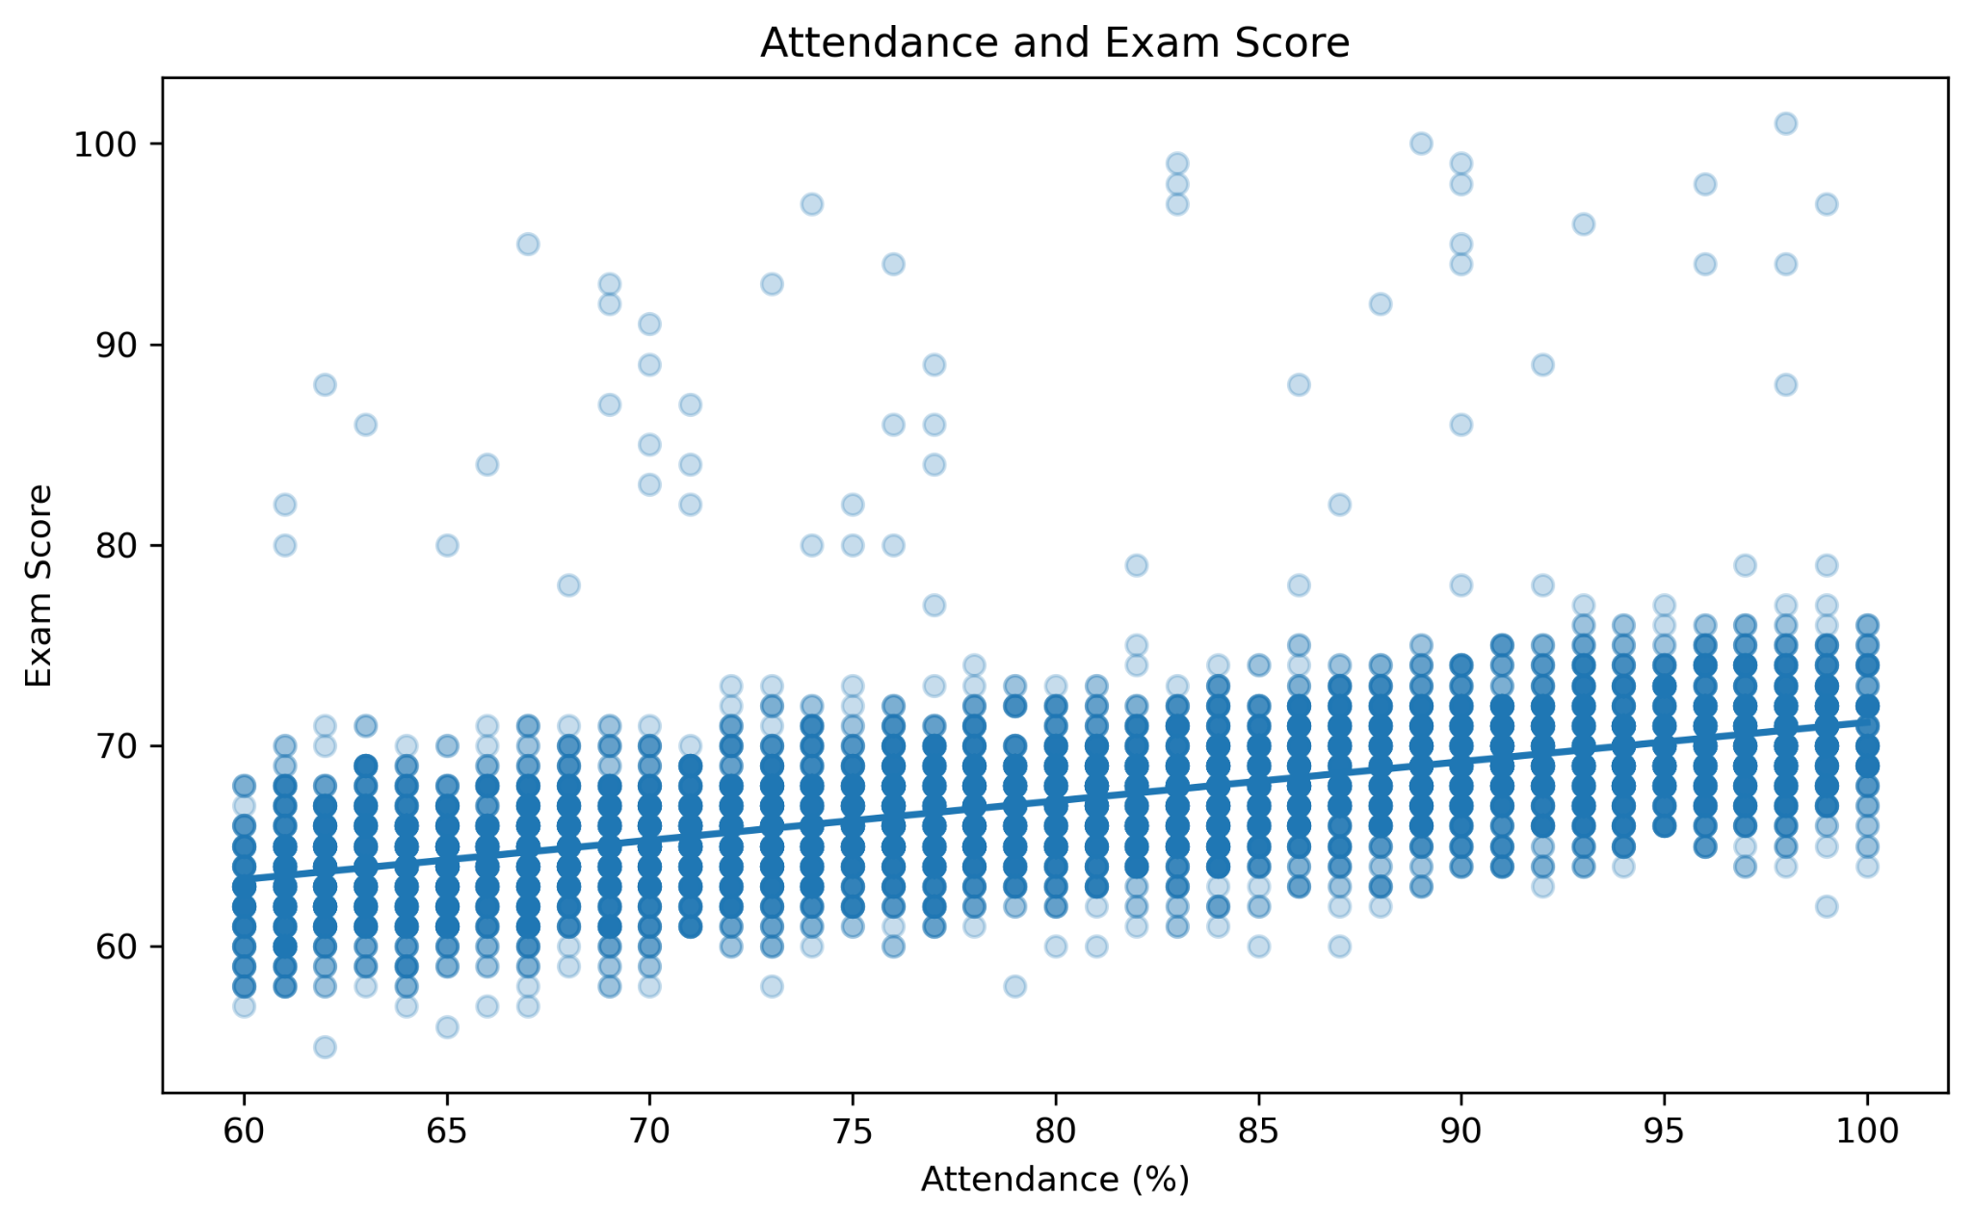
Figure 1. Attendance and Exam Score
What the visualization shows: The visualization shows a clear upward trend in Exam Score as attendance increases. The correlation between Attendance and Exam_Score is 0.581. Average Exam Score increased from 64.21 among students with 60–69% attendance to 70.14 among students with 90–100% attendance.
Answer: The dataset shows a moderate positive association between attendance and exam scores. This does not establish that attendance itself causes higher scores.

6.2 Study Hours and Exam Score
Question: Is the amount of time students spend studying associated with academic performance?
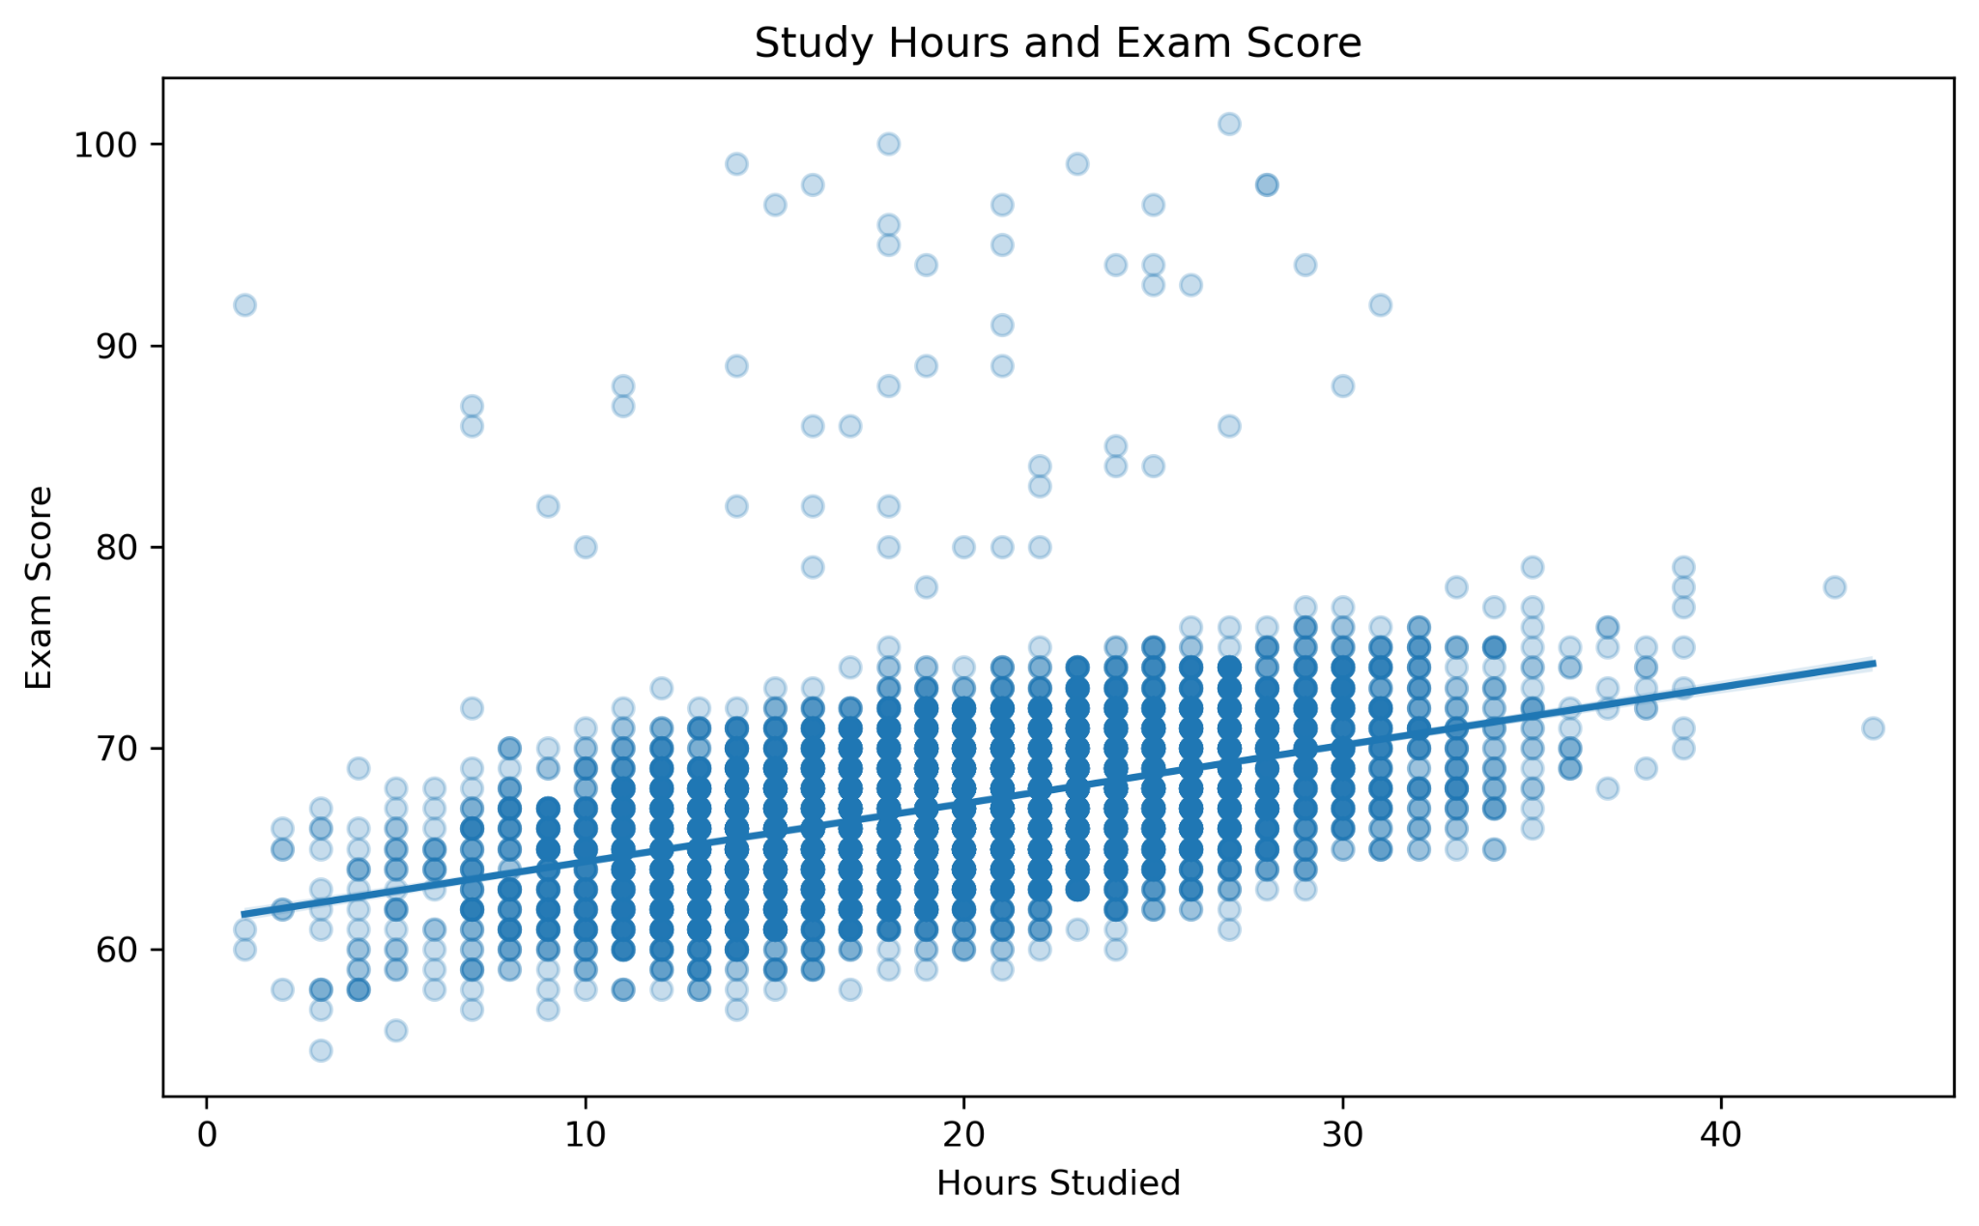
Figure 2. Study Hours and Exam Score
What the visualization shows: The correlation between Hours_Studied and Exam_Score is 0.445. Average Exam Score increased from 63.82 among students reporting 1–9 study hours to 70.88 among those reporting 30–44 hours.
Answer: Higher reported study time is associated with higher average exam scores in this dataset. The relationship should be interpreted as an association rather than a causal effect.

6.3 Access to Educational Resources
Question: Is access to educational resources associated with student performance?
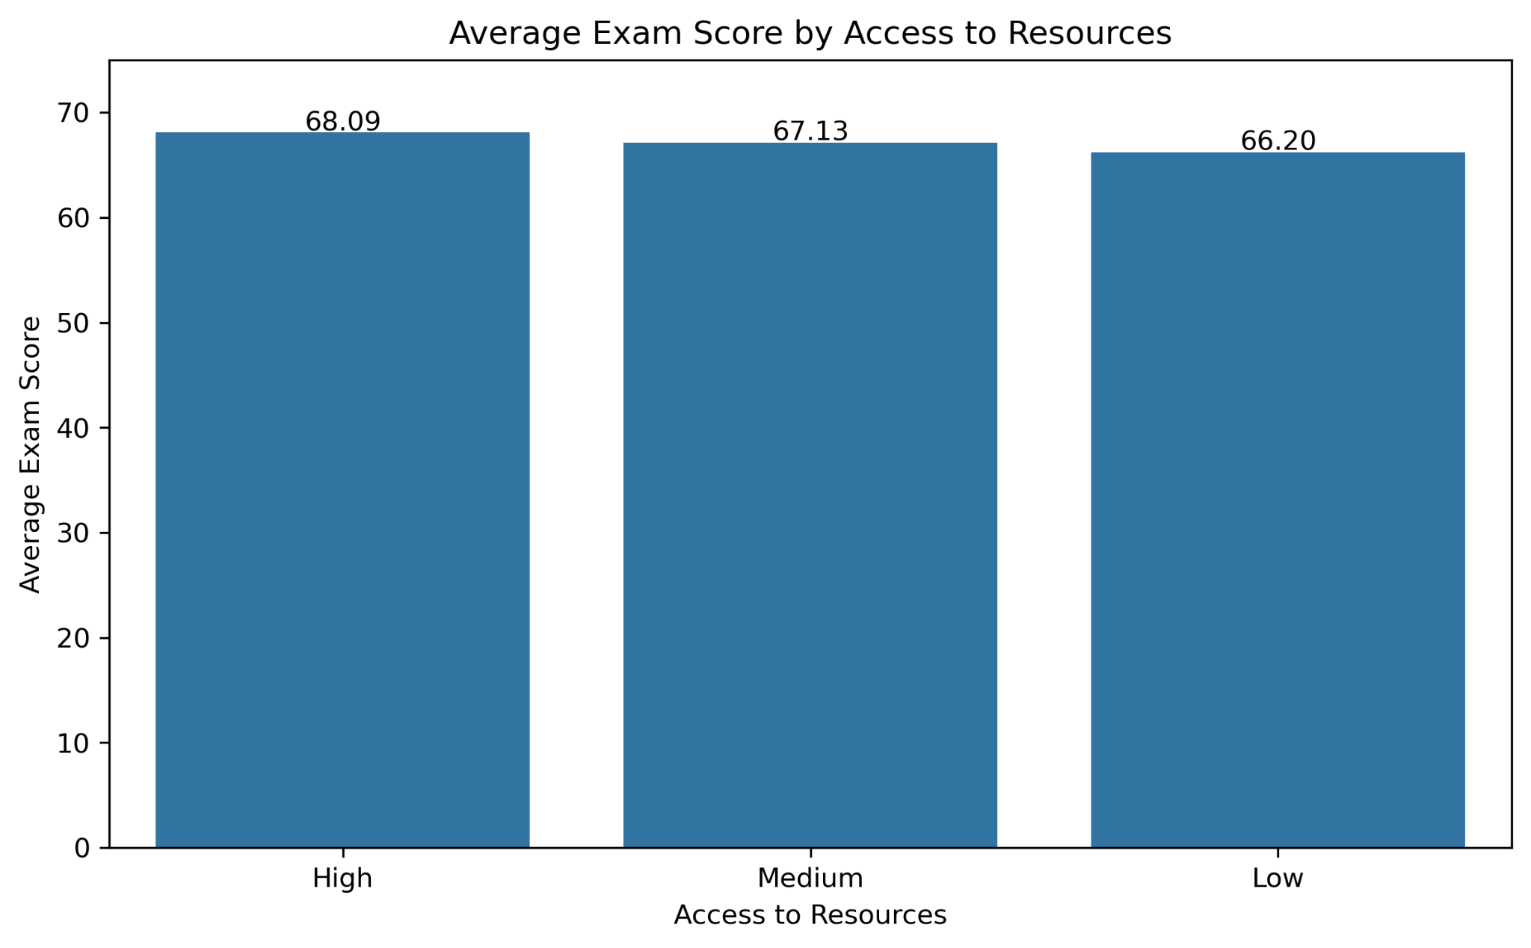
Figure 3. Average Exam Score by Access to Resources
What the visualization shows: Average Exam Score was 68.09 for the High access group, 67.13 for the Medium group and 66.20 for the Low group. The difference between High and Low access groups was approximately 1.89 points.
Answer: Students reporting greater access to educational resources have higher average exam scores in this dataset.

6.4 Parental Involvement
Question: How is parental involvement associated with academic performance?
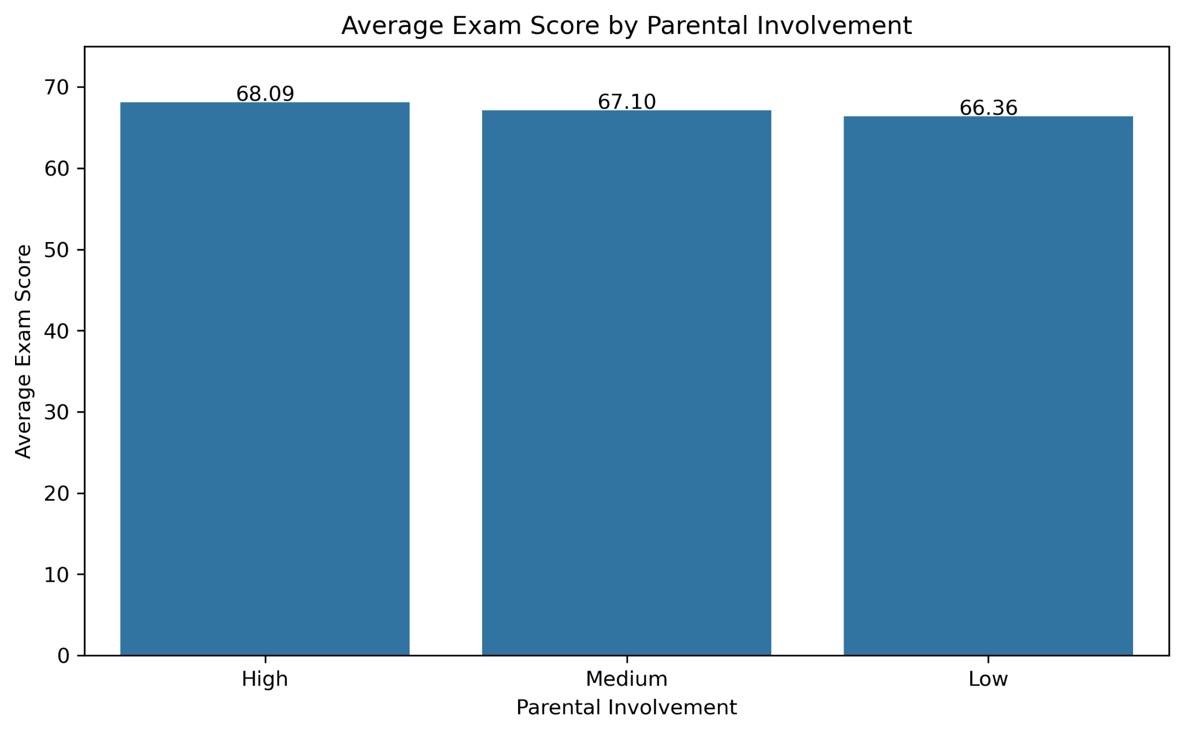
Figure 4. Average Exam Score by Parental Involvement
What the visualization shows: Average Exam Score was 68.09 for High parental involvement, 67.10 for Medium involvement and 66.36 for Low involvement. The difference between the High and Low groups was approximately 1.73 points.
Answer: Higher parental involvement is associated with higher average exam scores in the dataset.

6.5 Family Income
Question: Is family income associated with differences in academic performance?
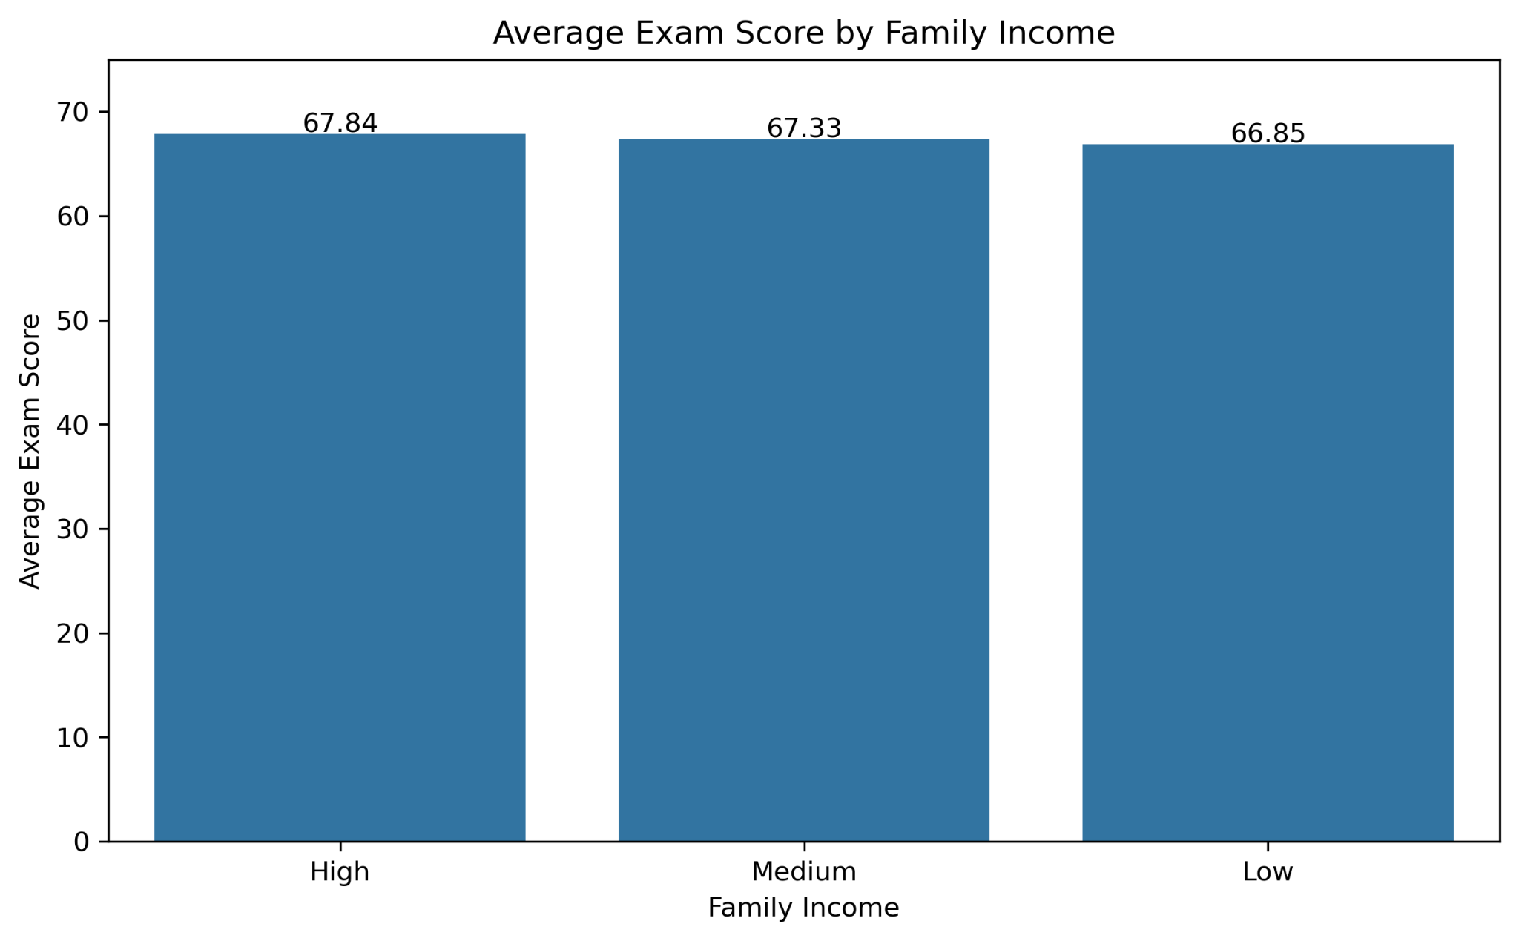
Figure 5. Average Exam Score by Family Income
What the visualization shows: Average Exam Score was 67.84 for High family income, 67.33 for Medium income and 66.85 for Low income. The difference between High and Low income groups was approximately 0.99 points.
Answer: The dataset shows a relatively small positive association between family income category and average Exam Score.

6.6 Parental Education
Question: How is parental education associated with student performance?
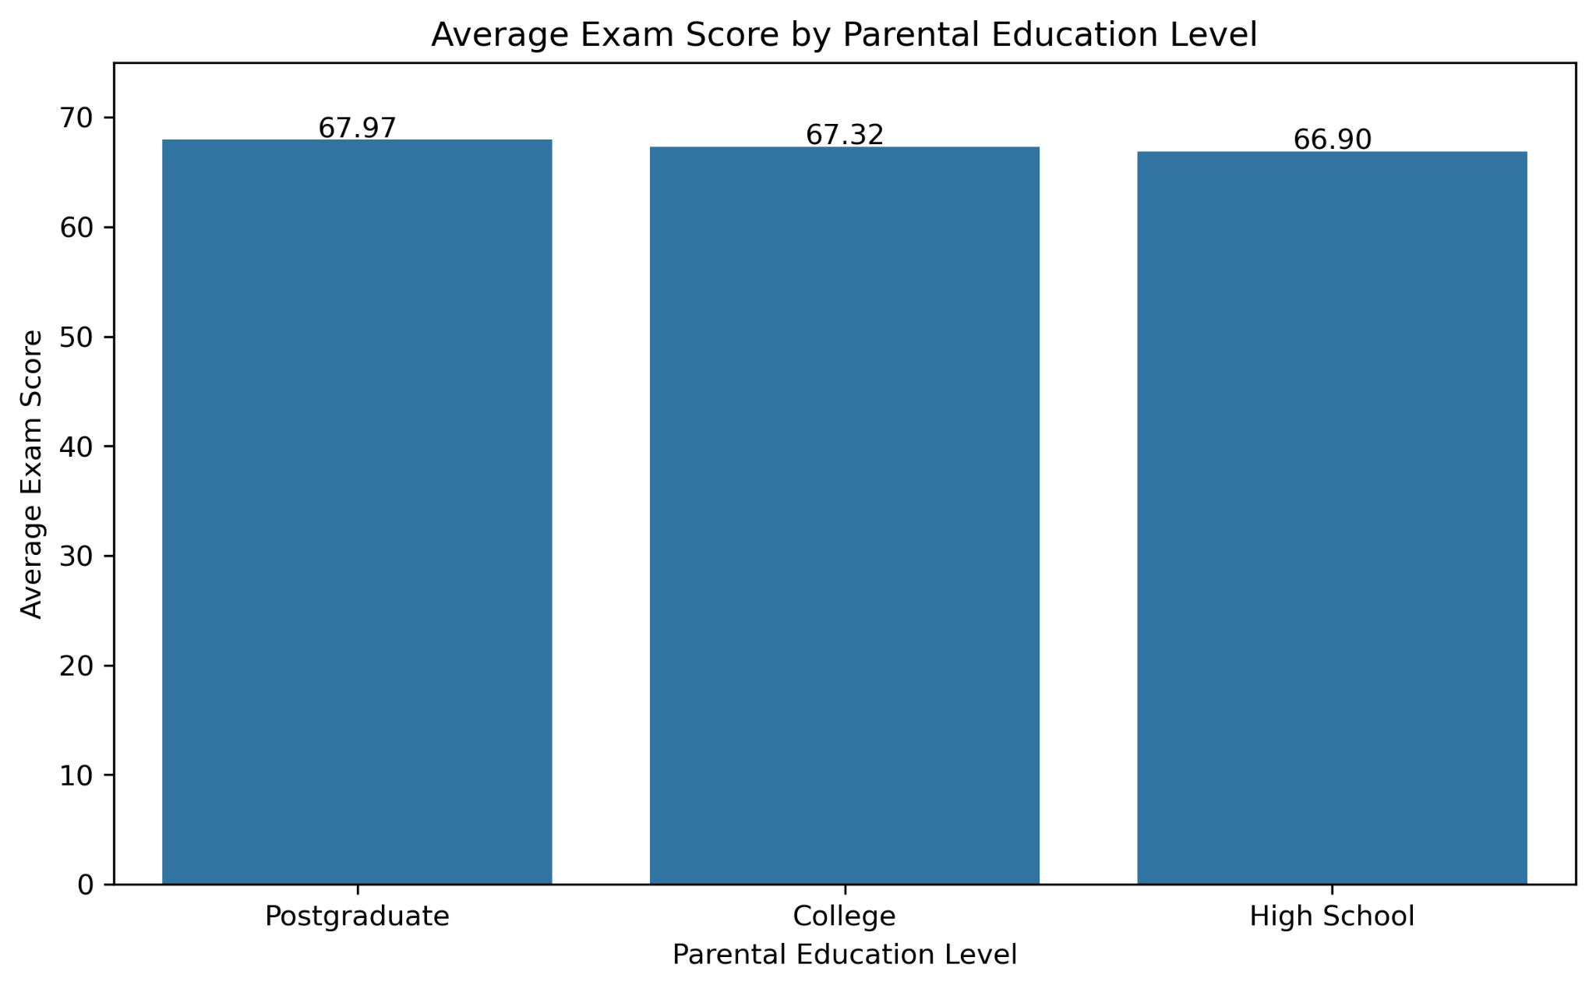
Figure 6. Average Exam Score by Parental Education Level
What the visualization shows: Average Exam Score was 67.97 for the Postgraduate group, 67.32 for College and 66.90 for High School. The difference between Postgraduate and High School groups was approximately 1.07 points.
Answer: Higher parental education levels are associated with somewhat higher average exam scores in this dataset.

7. Multiple Linear Regression
A multiple linear regression model was used to examine whether the observed relationships remained when several numerical and categorical predictors were considered simultaneously. The numerical predictors were Attendance, Hours_Studied, Previous_Scores, Tutoring_Sessions and Physical_Activity. Categorical predictors included Family_Income, Parental_Education_Level, Access_to_Resources, Parental_Involvement and Motivation_Level.
The model produced an R-squared of 0.691 and an adjusted R-squared of 0.690. Thus, approximately 69.1% of the observed variation in Exam Score is explained by the variables included in the model. The overall F-test was statistically significant (p < 0.001).

7.1 Regression Coefficients
All included predictors had p-values below 0.001 in the OLS model. Positive coefficients were observed for Attendance (0.199), Hours_Studied (0.295), Previous_Scores (0.049), Tutoring_Sessions (0.498), and Physical_Activity (0.177). Several categorical predictors also showed statistically significant differences relative to their omitted reference categories. For example, the coefficient for Access_to_Resources_Low was -2.036, while the coefficient for Parental_Involvement_Low was -2.016.
Categorical coefficients represent differences relative to the corresponding reference category. The coefficients should not be interpreted as causal effects, and coefficient magnitudes across variables with different units should not be treated as a simple importance ranking.

7.2 Regression Diagnostics
Variance Inflation Factor (VIF) values ranged from 1.00 to 1.86, providing no indication of substantial multicollinearity among the predictors. The mean regression residual was approximately zero. However, the residual plot showed a subset of observations with large positive residuals, indicating that the linear model does not fully capture the distribution of Exam Score for all students.
The regression was fitted and evaluated on the same observations, so its R-squared and mean absolute error should not be presented as out-of-sample predictive performance. The model is used here primarily as an explanatory association model.

8. Key Observations
- Attendance has a moderate positive association with Exam Score, with average scores increasing from 64.21 to 70.14 across the lowest and highest attendance groups examined.
- Study hours show a positive association with Exam Score, with students reporting 30–44 hours averaging 7.06 points more than students reporting 1–9 hours.
- Access to educational resources and parental involvement both show noticeable group differences in average Exam Score.
- Family income and parental education show smaller differences in average Exam Score than attendance and study hours.
- The multiple regression model explains 69.1% of the observed variation in Exam Score, while VIF values between 1.00 and 1.86 indicate no substantial multicollinearity.

9. Key Insights
- Student academic performance is associated with both behavioural factors and broader social and educational characteristics.
- Attendance and study time display clear positive relationships with Exam Score in the dataset.
- Access to educational resources and parental involvement are associated with differences in average performance even when viewed alongside other student characteristics in the regression model.
- Economic and parental educational characteristics show statistically significant associations, although their simple group-average differences are relatively modest.
- The combined regression model suggests that academic performance is related to multiple factors simultaneously rather than to a single characteristic.

10. Hypotheses for Further Investigation
- Higher student attendance may be associated with higher academic performance.
- Greater study time may be associated with higher academic performance after accounting for other observed student and family characteristics.
- Differences in social, economic and educational conditions—such as access to resources, parental involvement, family income and parental education—may be associated with differences in academic performance.

11. Recommendations
- Schools could monitor attendance patterns and provide appropriate academic support to students with persistently low attendance.
- Educational programmes could identify students with limited access to learning resources and consider targeted support where appropriate.
- Schools and families could consider structured study support, tutoring opportunities and appropriate parental engagement as components of broader academic-support programmes.
These recommendations are based on observed associations and should not be interpreted as evidence that the proposed interventions will necessarily cause higher exam scores.

12. Limitations
- The analysis is observational and therefore cannot establish causality.
- The dataset contains one Exam Score value of 101, which appears inconsistent with a conventional 0–100 scoring scale; it was retained after a sensitivity check because its effect on the mean was negligible.
- The residual diagnostics indicate that the linear model does not capture all patterns in the outcome distribution.
- The regression model was evaluated on the same observations used for fitting and therefore is not an out-of-sample prediction assessment.
- The dataset represents the variables and population contained in the source data; findings should not automatically be generalized to all students or educational systems.

13. Conclusion
This analysis examined social, economic and educational factors associated with differences in student academic performance. The EDA showed positive associations between Exam Score and attendance, study hours, access to educational resources and parental involvement. Family income and parental education also showed smaller differences in average scores. The multiple linear regression model explained 69.1% of the observed variation in Exam Score, with all included predictors statistically significant in the OLS specification. Overall, the results suggest that student performance is associated with a combination of academic behaviour, educational resources and family-related characteristics. Because the data are observational and the regression diagnostics show limitations, the findings should be treated as evidence of association and as a basis for further investigation rather than causal conclusions.

14. Technologies Used
- Python
- Spyder
- Pandas
- NumPy
- Matplotlib
- Seaborn
- Scikit-learn
- Statsmodels

15. References
Saher, A. Student Performance Factors Dataset. Kaggle.
https://www.kaggle.com/datasets/ayeshaseherr/student-performance
IBM SkillsBuild / AICTE Data Analytics with AI Internship learning materials.

