**Experiment -1.1**

**Student Name: HARSH RAJ SINGH UID: 22BDO10006**

**Branch: CSE(DEVOPS) Section/Group:22BCD-1/A**

**Semester: 4TH Date of Performance: 17/01/2024**

**Subject Name:GIT AND GITHUB Subject Code: 22CSH-293**

**1. Aim/Overview of the practical:**. Install Git and creating repository

**2. Software used:** Git Bash and Github.

**3. Hardware Used:** Computer system.

**4. Steps for experiment:**

**For Installation of Git :**

**1.** Download Git for windows from chrome.



**2.**  Click on windows and go for 64 bit installer.

**3.** Click on install

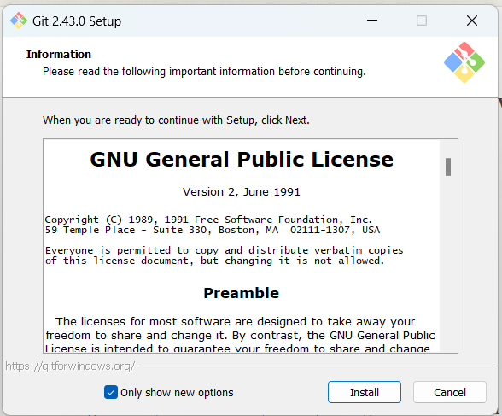

**4.** Select the location for installation for the git.

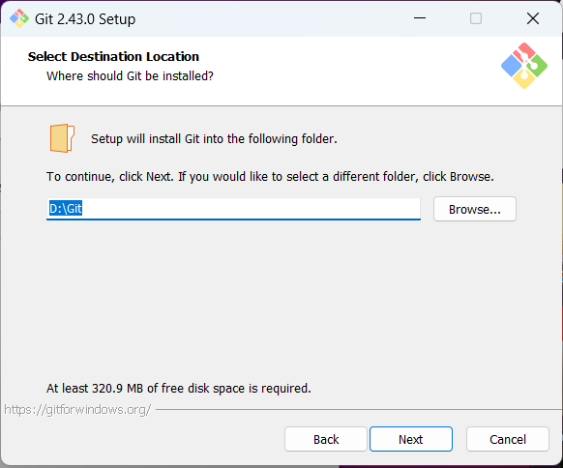

**6.** Click on next for all default settings.

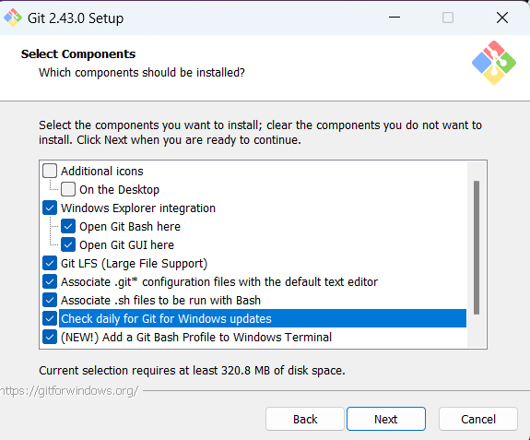 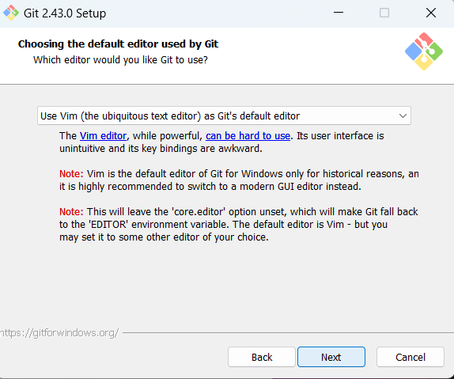

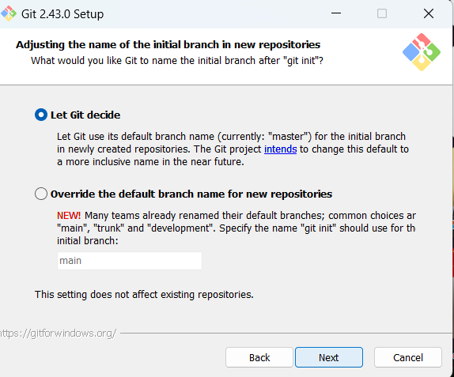 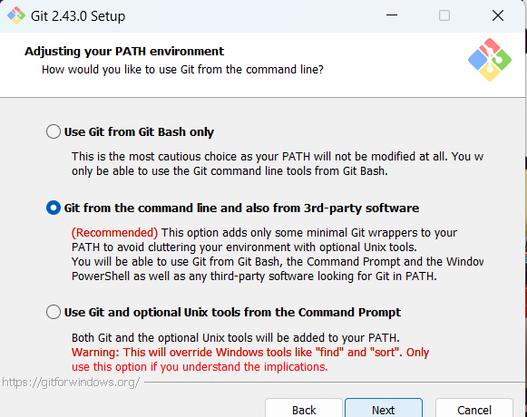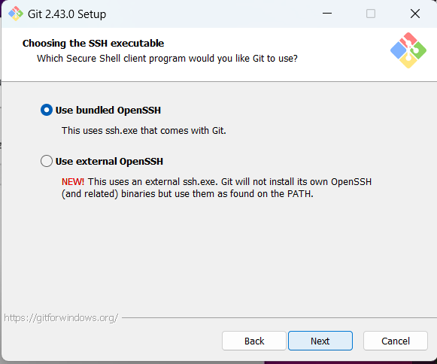 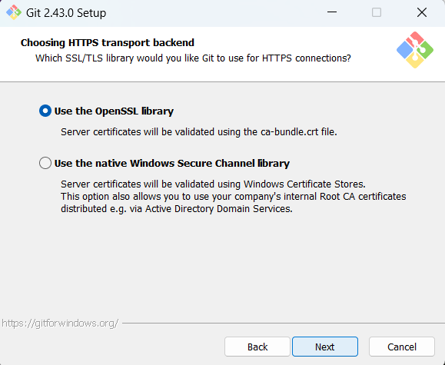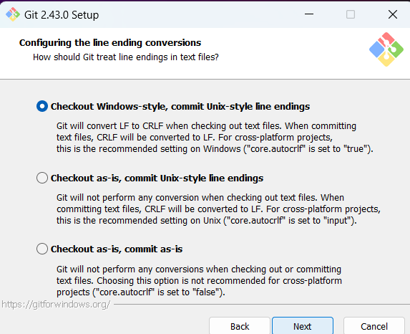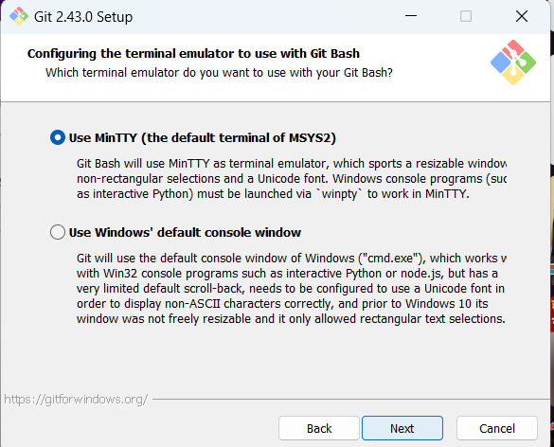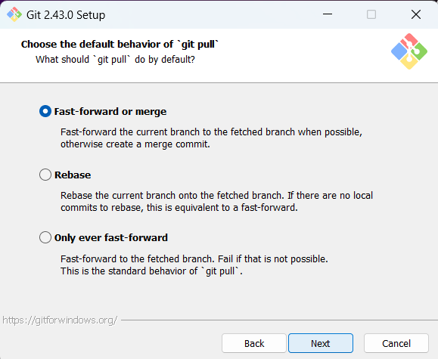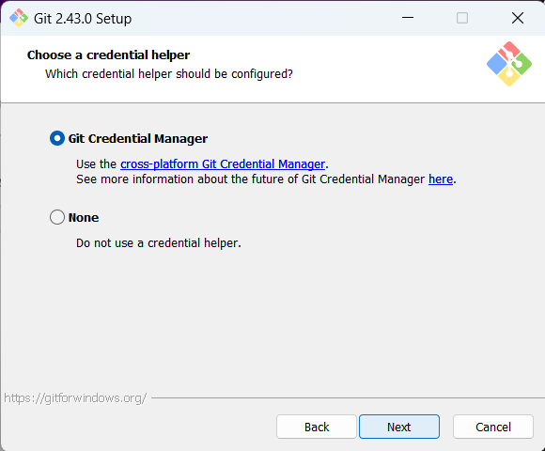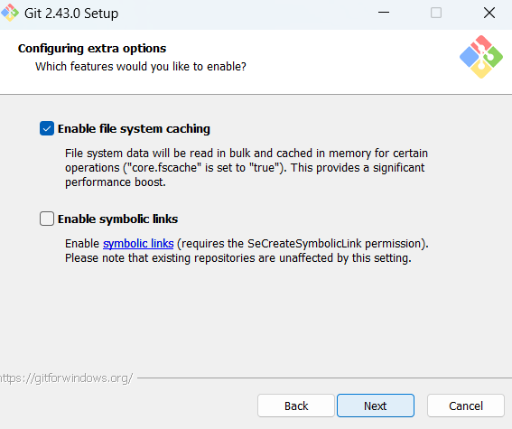

**7.** Click on Finish after successful completing the installation.

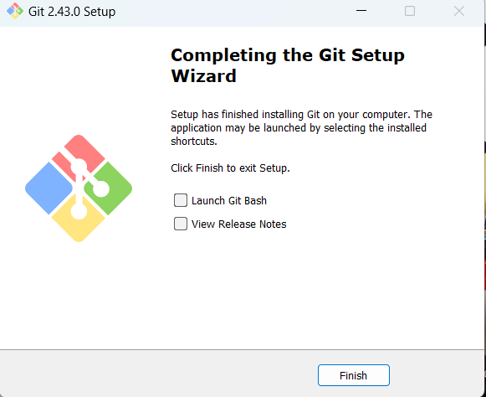

**8.** To verify git is installed in system or not follow these steps.

Go to CMD-> type *“git”*

It will give version and description regarding Git

**Creation Of Account on Github**

Follow these steps to create acoount on Github

1. Type Github on google.
2. Go for signup.
3. Login with email.
4. Give password.
5. Accept condition and fill necessary information like username DOB and more.
6. After completing formation of github account page will look like

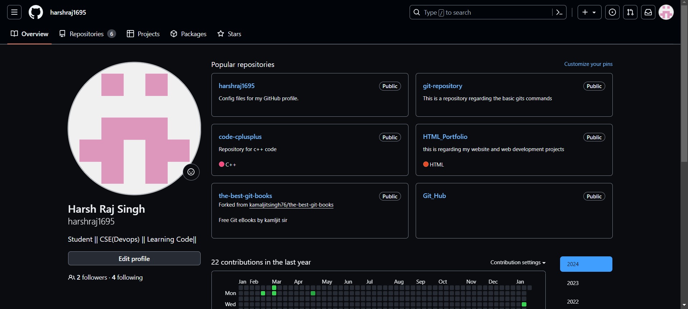

**Creating repository on Github**

Goto github account -> Repositories -> New -> Name the Repository ->write Description(optional) -> Public(to access openly) ->Add a README file(Details of Project) -> add .gitignore - > License(none)-> click “Create Repository”

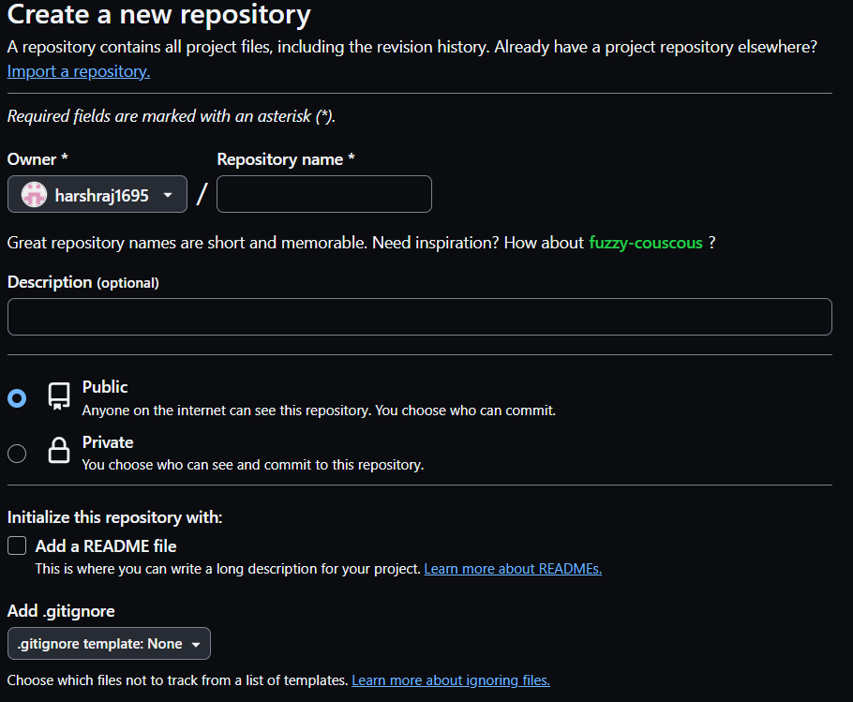

**Configuration of Git And Github:**

To configure Git and Github we have to write some commands in Git Bash which we enlist our username and email in git.

**Steps: For username**

Type code:- *git config --global user.name “*harshraj1695*”*

**For email**

Type code:- *git config --global user.email* [*singhharshraj215@gmail.com*](mailto:singhharshraj215@gmail.com)

**To verify**

Type code:-*git config --list*

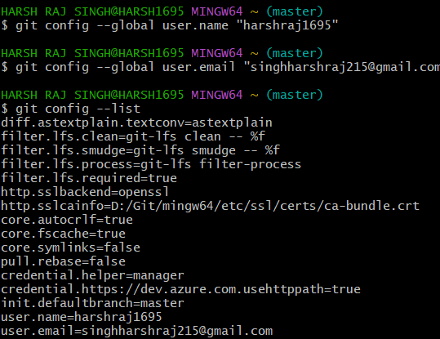

**For cloning the repository:**

Use Command

*git clone* [*https://github.com/harshraj1695/Git_Hub.git*](https://github.com/harshraj1695/Git_Hub.git)

*Note: link is of the HTTPS*

Press enter.

**Some useful command**

cd- Change the directory

touch- it is used to create file.

ls- used to print no of files in repository.

pwd- used to print the current working directory.

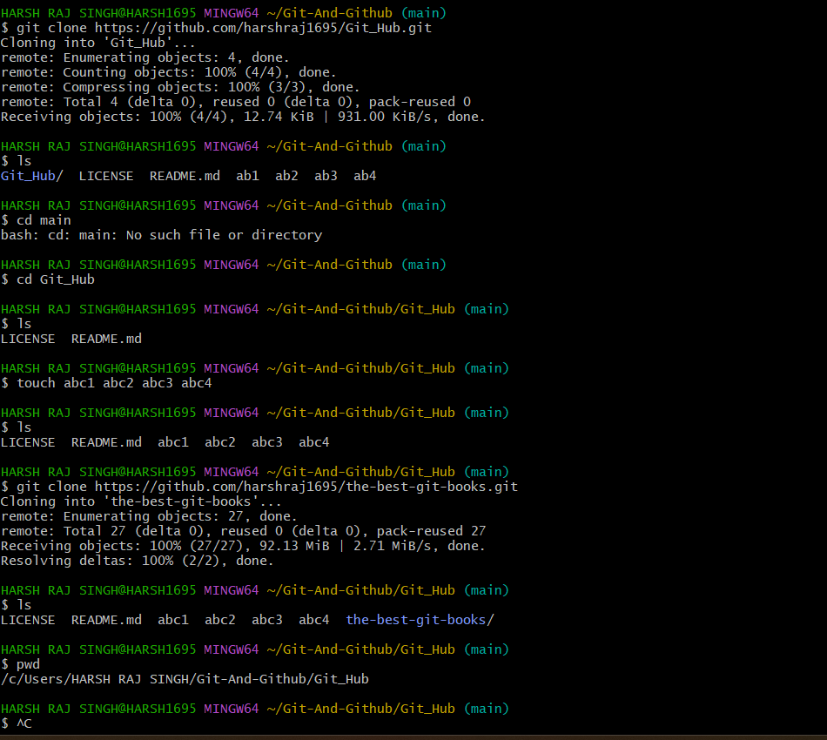

**5. Result/Output/Writing Summary:**

In this experiment we installed git, configured it with our GitHub account and write some commands such as clone to pull remote repository to our local machine, cd, touch, ls, pwd.

**Learning outcomes (What I have learnt):**

**1.** Learnt how to install git.

**2.** Learnt how to configure git with GitHub account.

**3.** Learnt about some basic commands such as cd and cat.

**4.** Learnt using git clone command.

**5.** Also learnt how to add and commit updates to the GitHub account.

**Evaluation Grid (To be created as per the SOP and Assessment guidelines by the faculty):**

|  |  |  |  |
| --- | --- | --- | --- |
| Sr. No. | Parameters | Marks Obtained | Maximum Marks |
| 1. |  |  |  |
| 2. |  |  |  |
| 3. |  |  |  |
|  |  |  |  |