**Experiment -3.3**

**Student Name: HARSH RAJ SINGH UID: 22BDO10006**

**Branch: CSE(DEVOPS) Section/Group:22BCD-1/A**

**Semester: 4TH Date of Performance: 03/04/2024**

**Subject Name:GIT AND GITHUB Subject Code: 22CSH-293**

**1. Aim/Overview of the practical:. Work with your history in Git.**

**2.Software used: Git Bash and Github.**

**3. Hardware Used: Computer system.**

**4. Steps for experiment:**

1. Create a file on local device and open that folder with Git Bash.

2. Create a repository on Github with Exp8 name and copy the http link.

3. Now open the file “abc.c” using “vi filename” and edit the file

**4.** Now add and commit the file using “git add .” and “git commit -m”messaage””

**5.** Repeat step 3 and 4 for multiple time to have multiple commits.

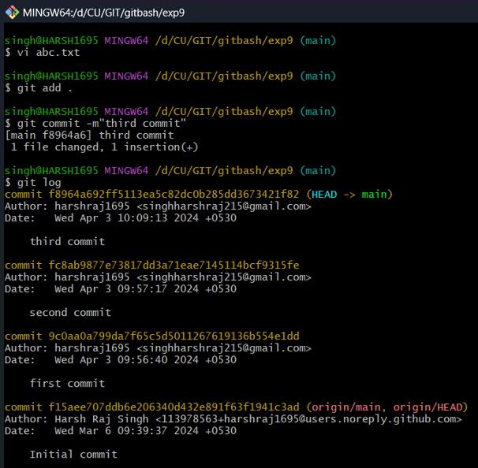

**6.** Now again edit the file and stage thst edit and instead of making a new commit amend the previous commit by “git commit --amend ”

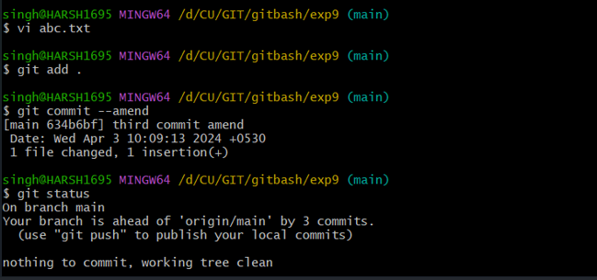

**7.** realize the commit by using “git log ”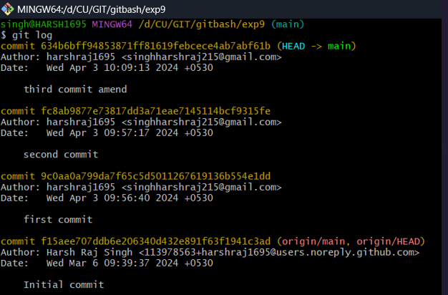

**8.**  Now make a new branch and go to that branch and make changes in the file using “git checkout -b nope”.

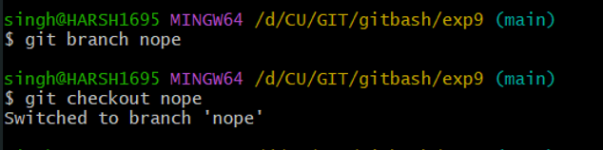

**9.**  Now make few commits in this branch.

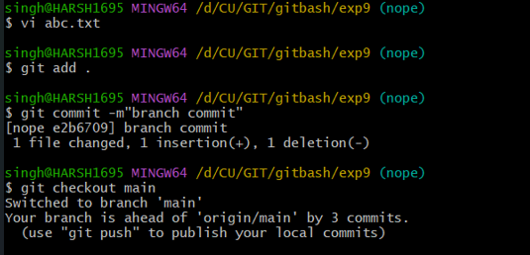

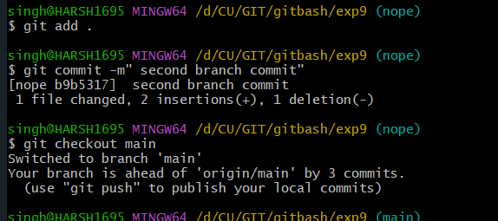

**10.**  Now make to main branch and rebase the changes to main branch.

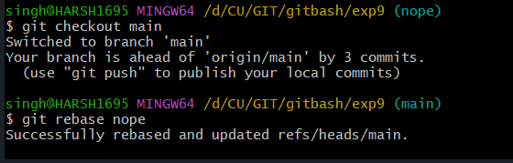

**11.**  Realise these changes usig git log to analyse the commit history.

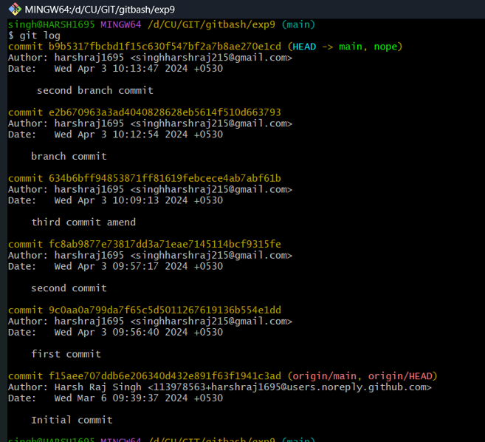

**12.** Again make a new branch make commit in this branch also.

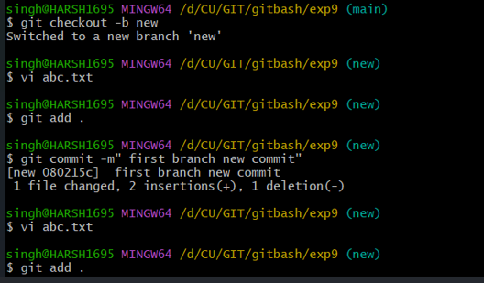

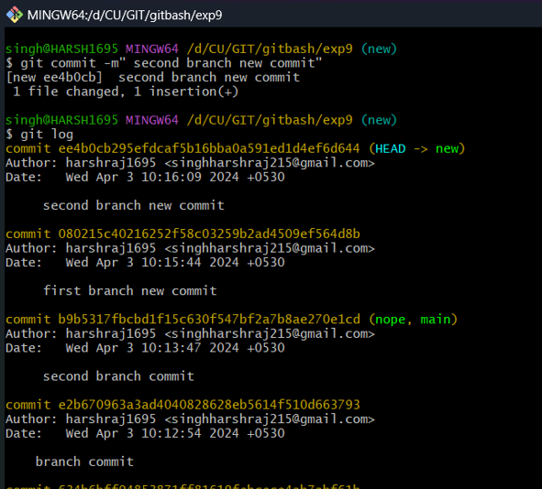

**13.**  Now merge these changes into main and rebase the head to 4 commits.

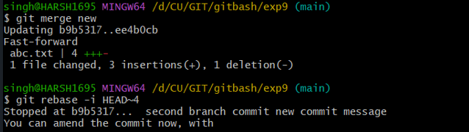

This will open a prompt and makes changes whatever you want to make.

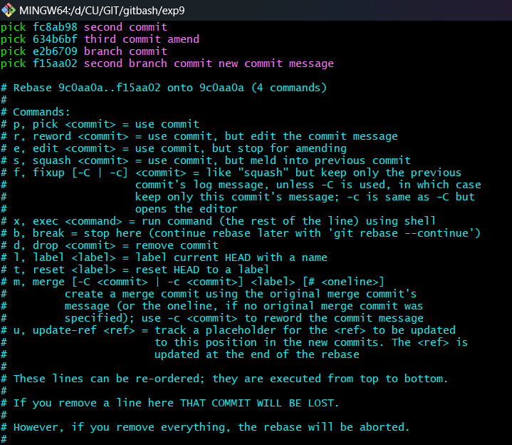

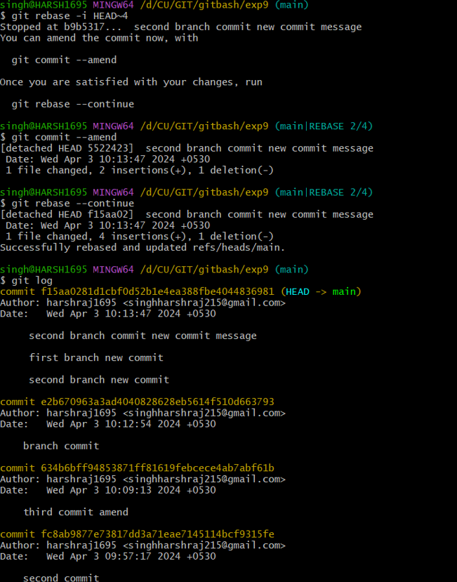**5. Result/Output/Writing Summary:**

In this experiment we have learn about rebase and methods of rebase.

**Learning outcomes (What I have learnt):**

1. Learnt the difference between reset and revert.

2. Learnt how to make the reset

3. Learnt about type of rebase.

4. Learnt about interactive rebase.

5. Also learnt about commands of rebase.

**Evaluation Grid (To be created as per the SOP and Assessment guidelines by the faculty):**

|  |  |  |  |
| --- | --- | --- | --- |
| **Sr. No.** | **Parameters** | **Marks Obtained** | **Maximum Marks** |
| **1.** |  |  |  |
| **2.** |  |  |  |
| **3.** |  |  |  |
|  |  |  |  |