**Experiment -1.1**

**Student Name: HARSH RAJ SINGH UID: 22BDO10006**

**Branch: CSE(DEVOPS) Section/Group:22BCD-1/A**

**Semester: 4TH Date of Performance: 07/02/2024**

**Subject Name:GIT AND GITHUB Subject Code: 22CSH-293**

**1. Aim/Overview of the practical:**. Editing a file and committing changes on github.

**2. Software used:** Git Bash and Github.

**3. Hardware Used:** Computer system.

**4. Steps for experiment:**

**1.** Create a file on local device and open that folder with Git Bash.

**2.** Create a repository on Github with exp4 name and copy the http link.

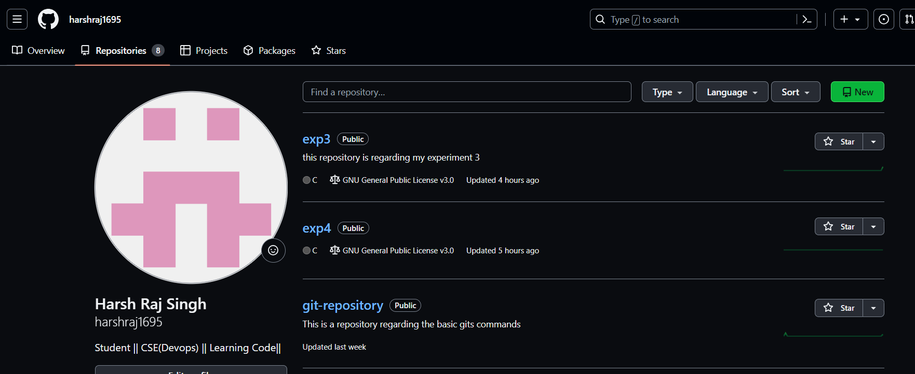

**3.** Make clone of the repository using  *“git clone http link”*

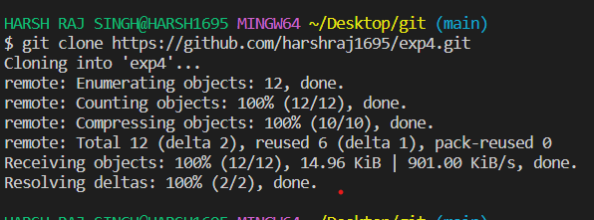

**4.** Change the current working directory using **“cd”** command: *“cd exp4”*

**5.** Create and edit a file using **“vi filename”** command: *“vi abc.c”*

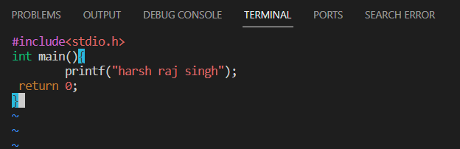

**6.** Add the file using **“git add “** command

**7.** Commit the file using **“git commit -m”message””** command.

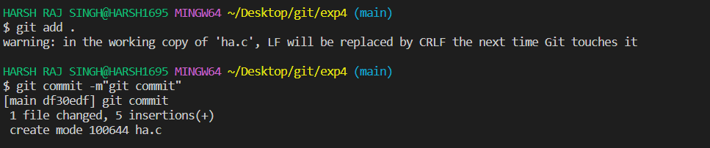

**8.** Push the file into the remote repository using **“git push origin main”** command.

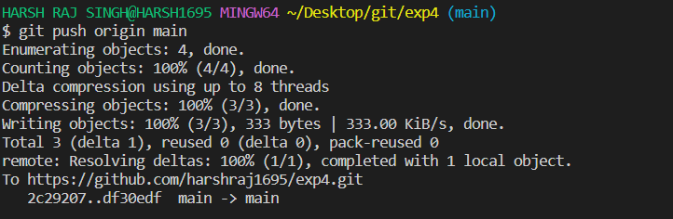

**9.** Go to the remote repository and verify the changes.

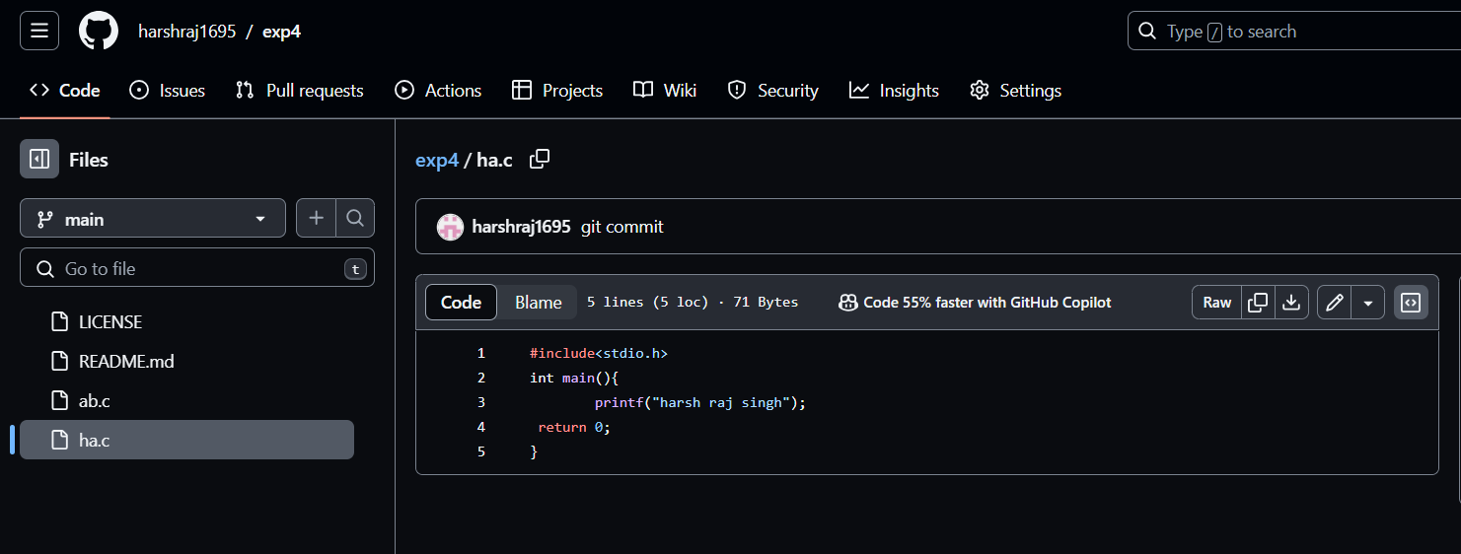

**10.** do changes in the remote repository file and commit the changes.

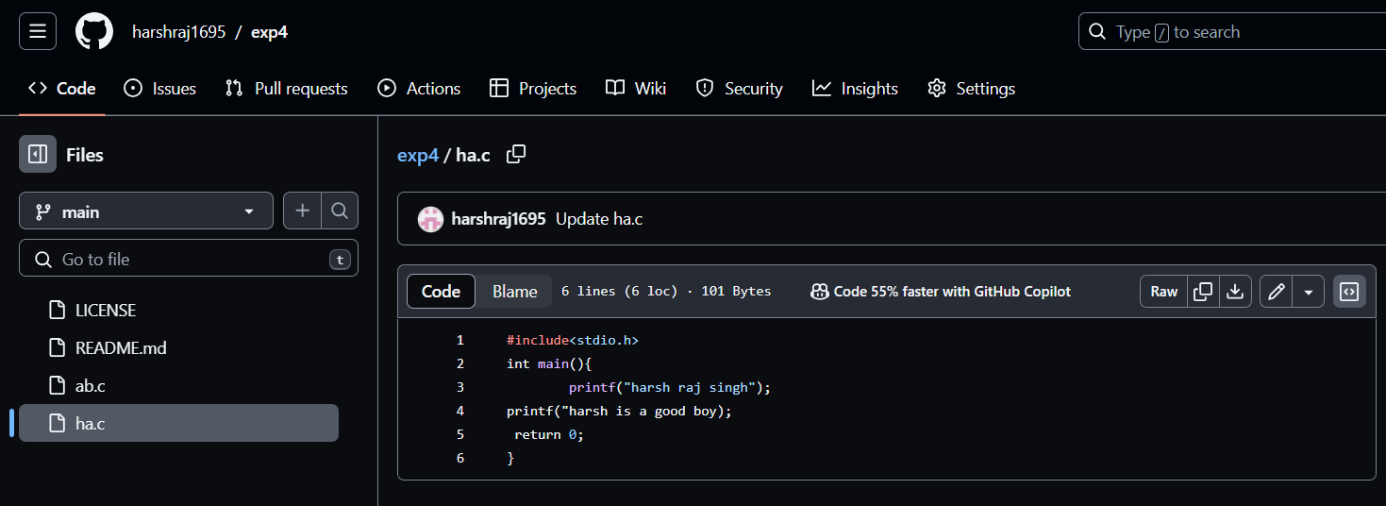

**11.** Pull the changes done in the remote repository by **“git pull origin main”**

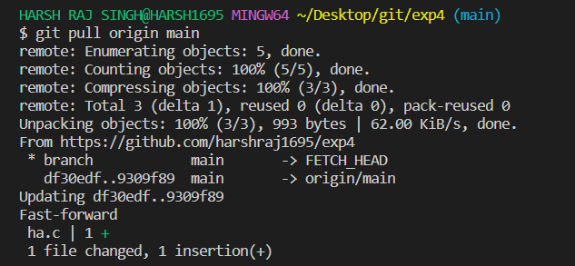

**12.** verify the change by opening the file with **“vi ha.c”**

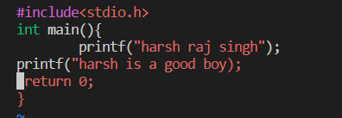

**13.** Now create a branch by **“git checkout -b nope”**

**14.** Edit the file in the branch by **“vi ha.c”**

**15.** go to main branch and merge the branch by **“git merge nope”**

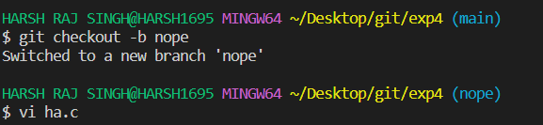

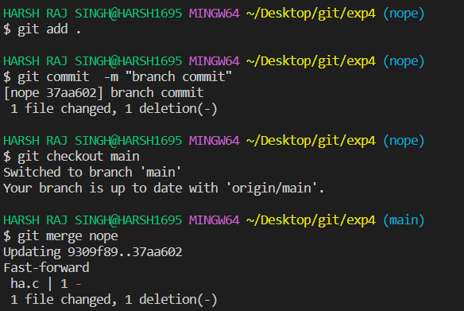

**16.** Now push the two main and nope branch by **“git push branch_name”.**.

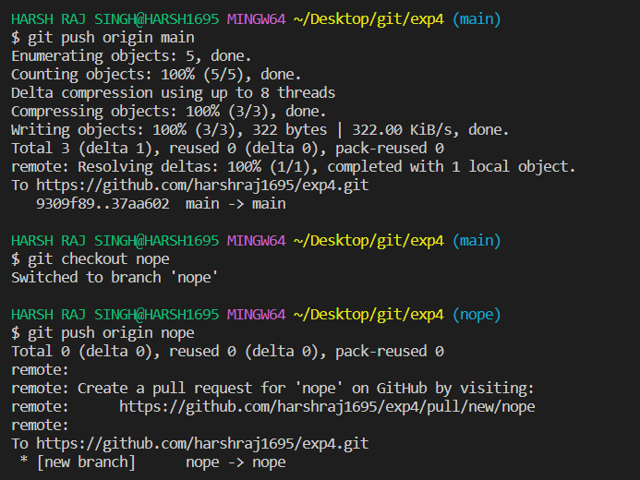

**17.** verify the pushed branch on github.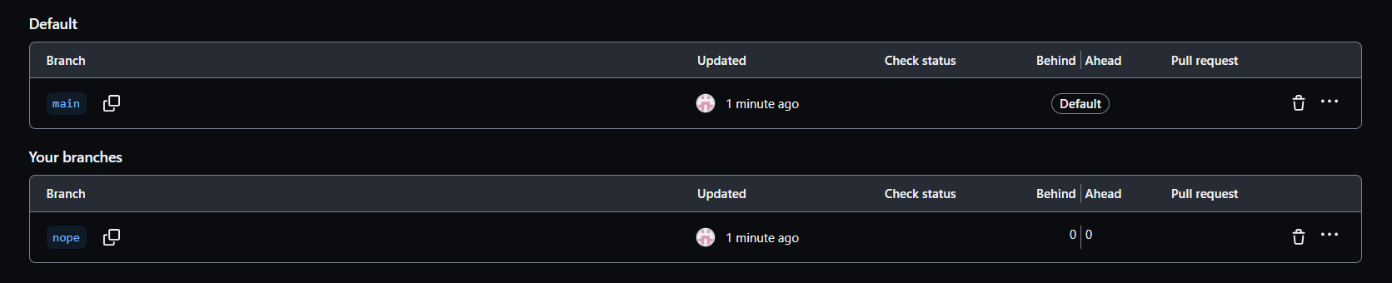

**18.** Verify the merge content of file on Github.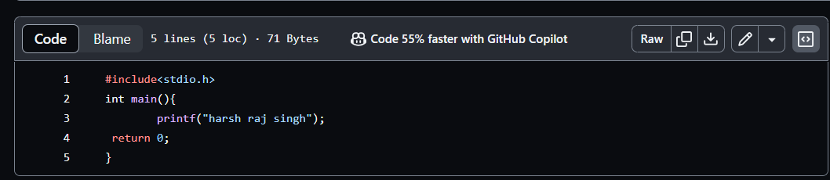

**19.** Now editing the file on github with the branch nope

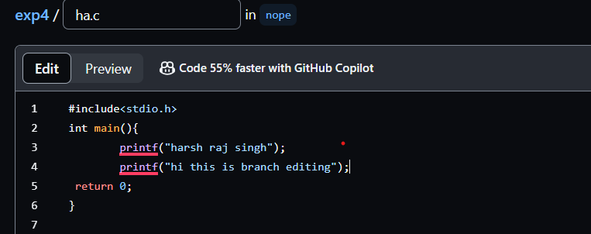

**20.** Create a branch on the github and edit the file and commit the change.

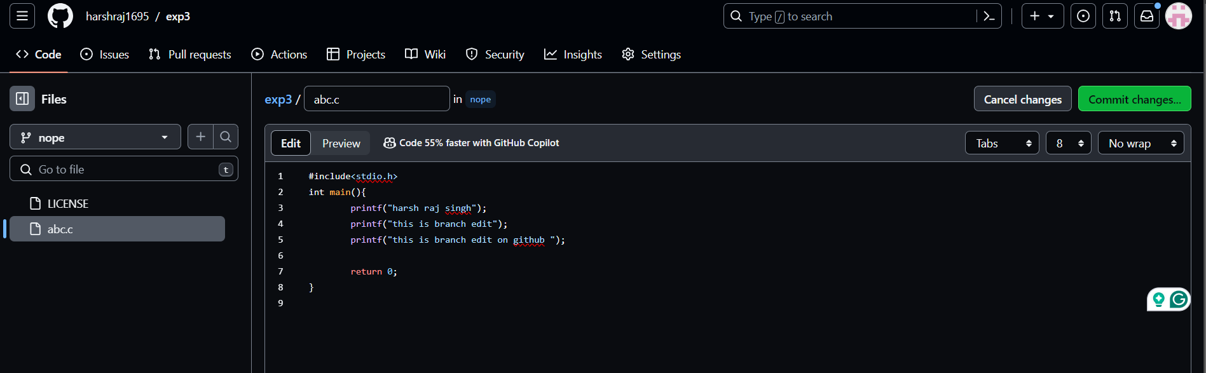

**21.** Commit the changes on the remote repository on the Github.

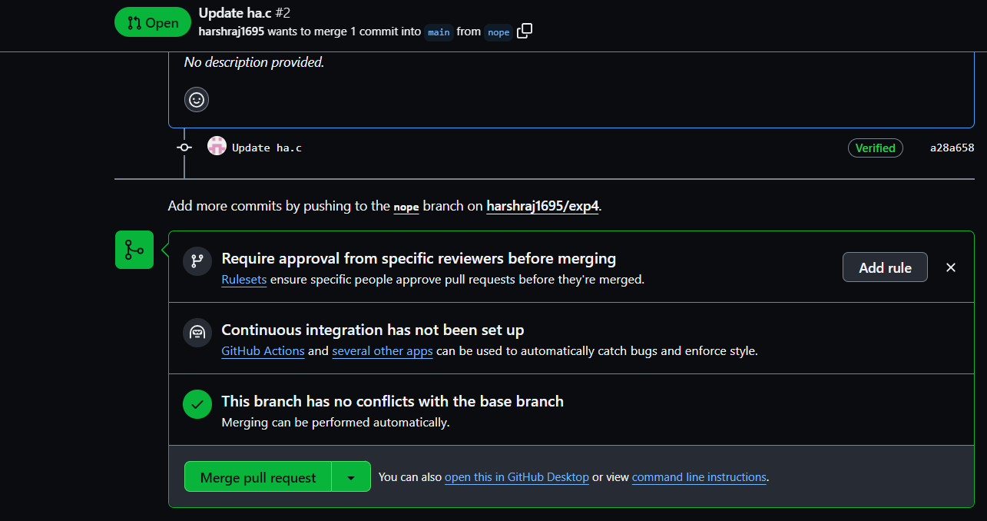

**22.** Pull the changes in the local machine using **“git pull origin main”**.

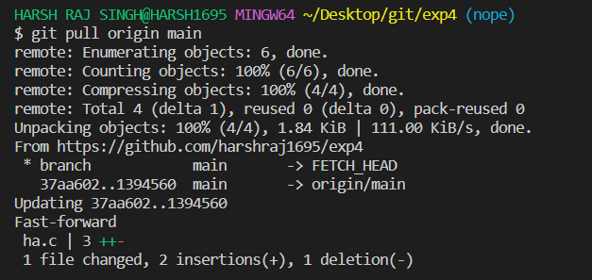

**23.** Verify the changes on the local machine by **“vi ha.c”**

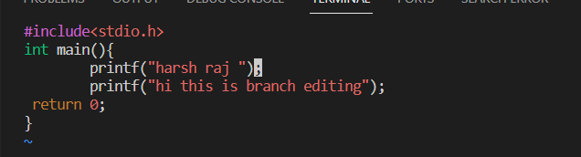

**5. Result/Output/Writing Summary:**

In this experiment we have learn about making a pull request on both github and git bash for local as well as remote servers. We have also gone through the changes pull request command.

**Learning outcomes (What I have learnt):**

**1.** Learnt the difference between git merge and pull request.

**2.** Learnt how to make the merge request on github and git bash.

**3.** Learnt about editing the files.

**4.** Learnt how to delete a branch in github and bash.

**5.** Also learnt about comparing the merged files.

**Evaluation Grid (To be created as per the SOP and Assessment guidelines by the faculty):**

|  |  |  |  |
| --- | --- | --- | --- |
| Sr. No. | Parameters | Marks Obtained | Maximum Marks |
| 1. |  |  |  |
| 2. |  |  |  |
| 3. |  |  |  |
|  |  |  |  |