Experiment -2.3

# Student Name: HARSH RAJ SINGH UID: 22BDO10006

**Branch: CSE(DEVOPS) Section/Group:22BCD-1/A**

# Semester: 4TH Date of Performance: 28/02/2024

**Subject Name:GIT AND GITHUB Subject Code: 22CSH-293**

1. **Aim/Overview of the practical:**. Creation of Forks on GitHub
2. **Software used:** Git Bash and Github.
3. **Hardware Used:** Computer system.

# Steps for experiment:

* 1. Go to the the github website and visit the repository you want to fork.

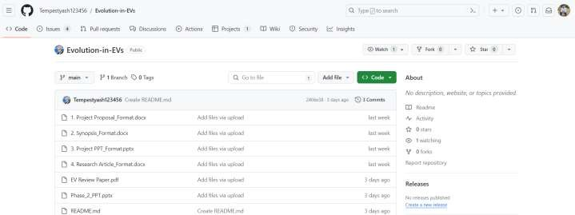

* 1. Click on create fork to create the fork on to your profile.

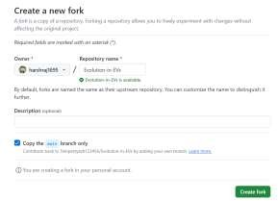

* 1. Now copy the http link of the repository.

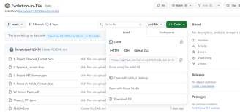

* 1. Clone the git repository and change the working directory through “cd repo_name”

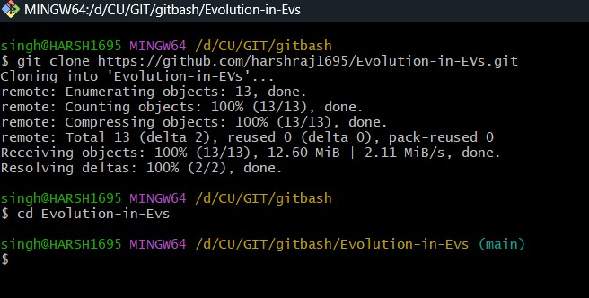

* 1. Edit the file using “vi filename”.

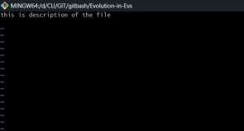

**5.** Now add and commit the file and push the changes to main using “git add .”, “git commit - m”commit message ””, and “git push origin main”.

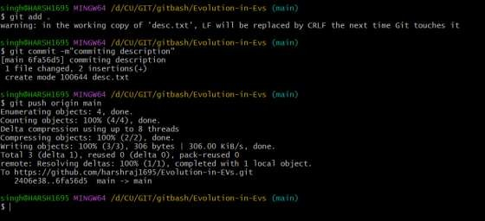

**6.**  Now add remote upstream to the repo from where it is being forked.

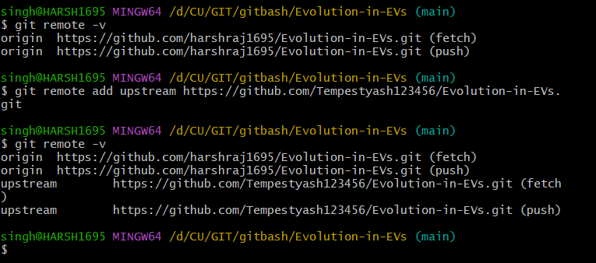

# Result/Output/Writing Summary:

In this experiment we have learnt about forking a repository and making local copy of that forked repository and after making changes how to push those changes in github.

# Learning outcomes (What I have learnt):

* 1. Learnt the difference between forking.
  2. Learnt how to make the clone.
  3. Learnt about editing the files.
  4. Learnt how to delete a branch in github and bash.
  5. Also learnt about comparing the merged files.

**Evaluation Grid (To be created as per the SOP and Assessment guidelines by the faculty):**

|  |  |  |  |
| --- | --- | --- | --- |
| Sr. No. | Parameters | Marks Obtained | Maximum Marks |
| 1. |  |  |  |
| 2. |  |  |  |
| 3. |  |  |  |
|  |  |  |  |