**Experiment -2.3**

**Student Name: HARSH RAJ SINGH UID: 22BDO10006**

**Branch: CSE(DEVOPS) Section/Group:22BCD-1/A**

**Semester: 4TH Date of Performance: 28/02/2024**

**Subject Name:GIT AND GITHUB Subject Code: 22CSH-293**

**1. Aim/Overview of the practical:**. Git Merge Conflicts and resolving Git merge conflicts

**2. Software used:** Git Bash and Github.

**3. Hardware Used:** Computer system.

**4. Steps for experiment:**

**A: On Git Bash:-**

**1.** Create a file on local device and open that folder with Git Bash.

**2.** Create a repository on Github with ExpGit name and copy the http link.

**3.** Now open the file using “vi filename” and edit the file.

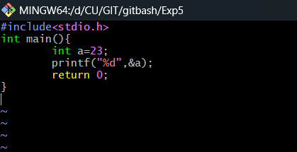

**4.** Now add and commit the file using “git add .” and “git commit -m”messaage””.

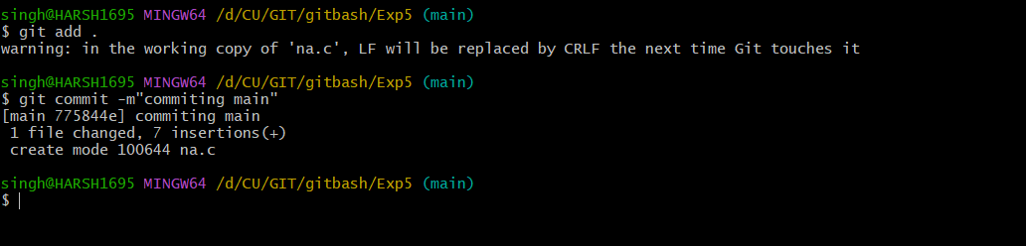

**5.** Now create a branch and edit the file in that branch using “git checkout -b name ” and “vi file”.

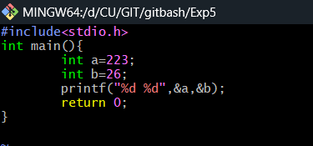

**6.** Now add and commit this file and move to main .

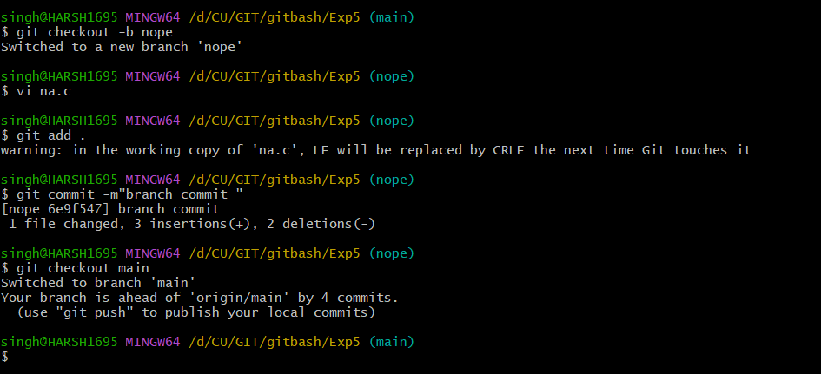

**6.** Now show the difference using “git diff main nope” and merge the file with fast forward using “git merge –no-ff branch_name”.

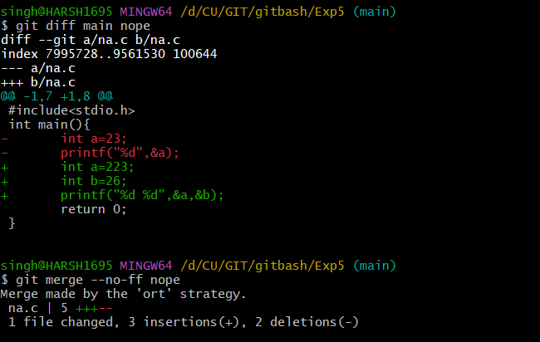

**Note:** ort is 3way commit and specify the commit message

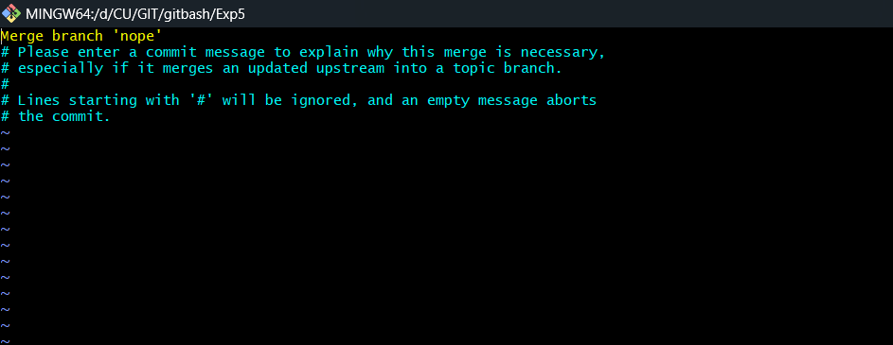

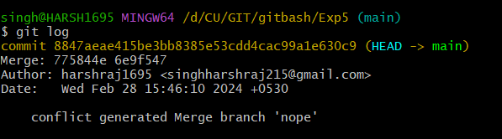

**B: On Git Hub:-**

1. Go to Github and create a branch name nope.

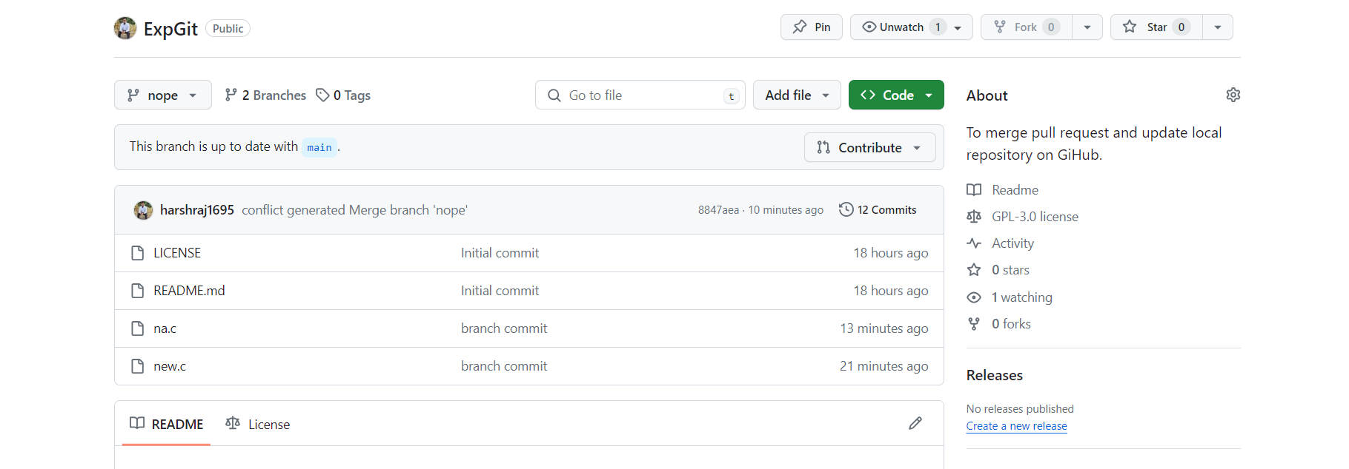

1. Now edit the file and do the changes.

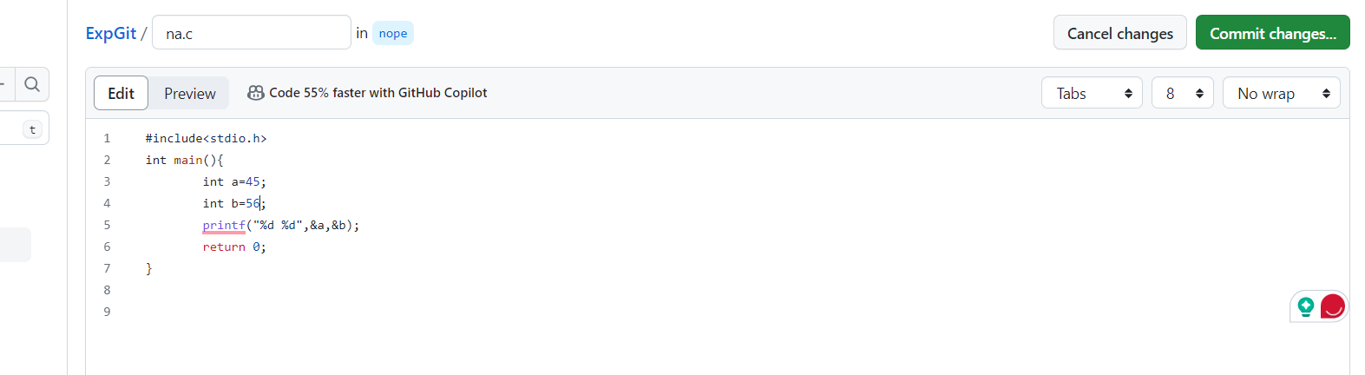

1. Commit the changes on the github.
2. Click on compare and pull.

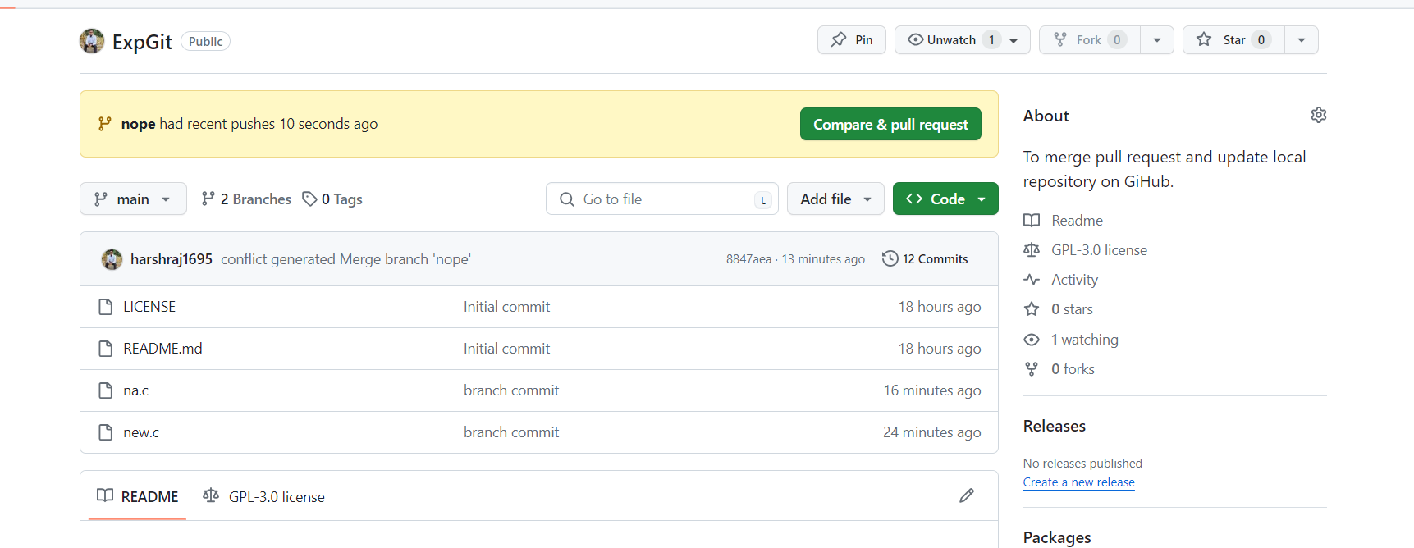

1. Click on create pull request.

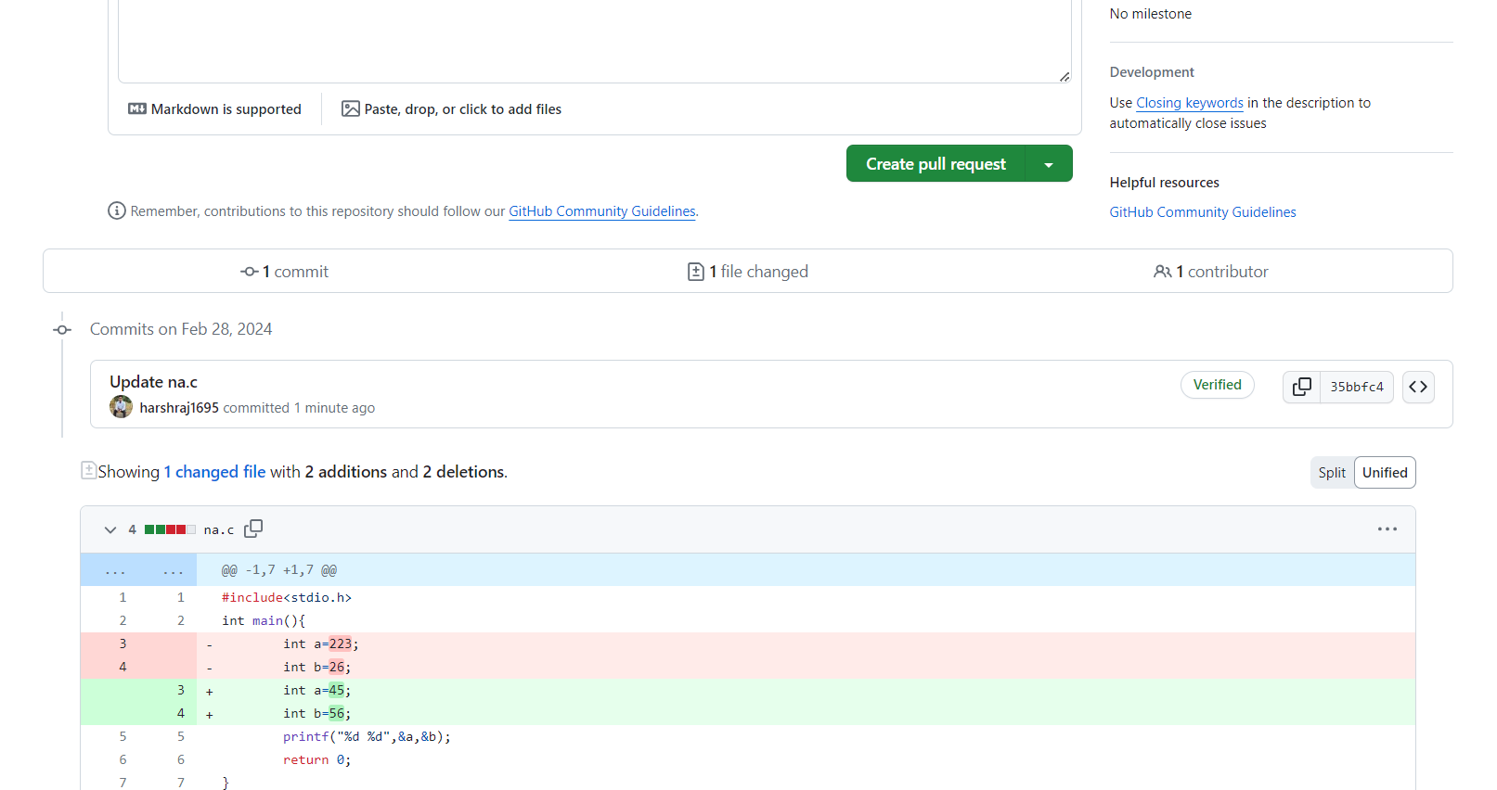

1. Click on merge pull request and after merging delete the Branch by click on delete branch option.

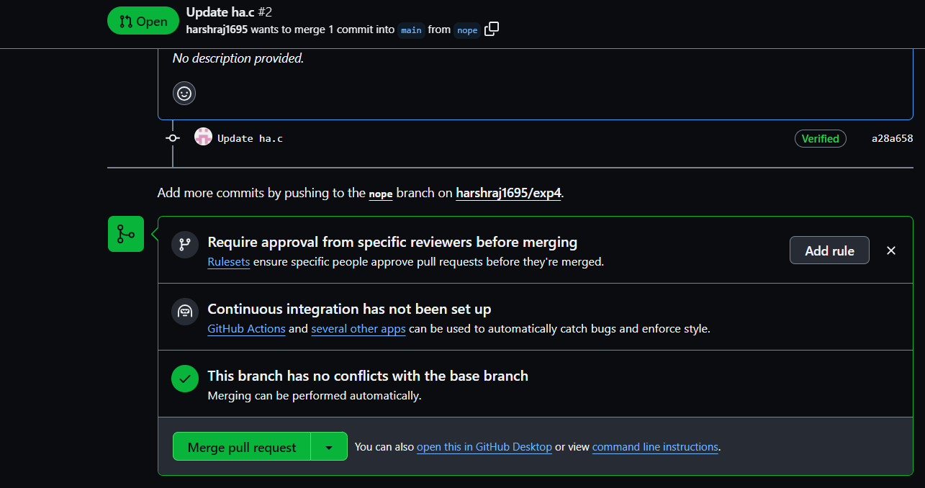

1. Verify the changes on github.

**5. Result/Output/Writing Summary:**

In this experiment we have learn about merge and merge conflict arries due to merging.

**Learning outcomes (What I have learnt):**

**1.** Learnt the difference between git merge and pull request.

**2.** Learnt how to make the merge

**3.** Learnt about type of merging.

**4.** Learnt about merge conflict.

**5.** Also learnt about ort merging.

**Evaluation Grid (To be created as per the SOP and Assessment guidelines by the faculty):**

|  |  |  |  |
| --- | --- | --- | --- |
| Sr. No. | Parameters | Marks Obtained | Maximum Marks |
| 1. |  |  |  |
| 2. |  |  |  |
| 3. |  |  |  |
|  |  |  |  |