**Experiment -3.1**

**Student Name: HARSH RAJ SINGH UID: 22BDO10006**

**Branch: CSE(DEVOPS) Section/Group:22BCD-1/A**

**Semester: 4TH Date of Performance: 06/03/2024**

**Subject Name:GIT AND GITHUB Subject Code: 22CSH-293**

**1. Aim/Overview of the practical:. Compare the changes in the Git Repository.**

**2. Software used: Git Bash and Github.**

**3. Hardware Used: Computer system.**

**4. Steps for experiment:**

1. Create a file on local device and open that folder with Git Bash.

2. Create a repository on Github with Exp8 name and copy the http link.

3. Now open the file “has.c” using “vi filename” and edit the file**.**

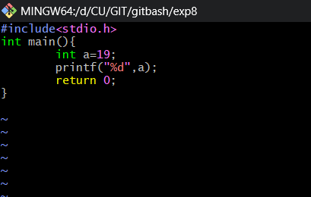

**4.** Now add and commit the file using “git add .” and “git commit -m”messaage””.

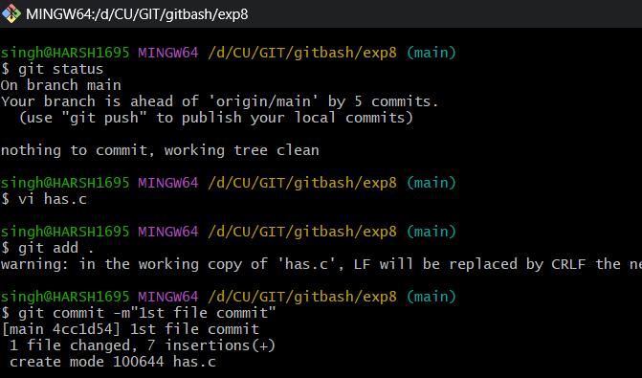

**5.** Now open the file “two.c” using “vi filename” and edit the file.

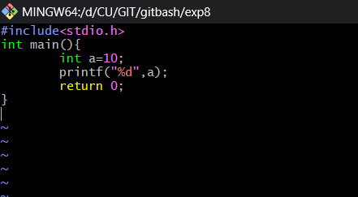

**6.** Now add and commit this file.

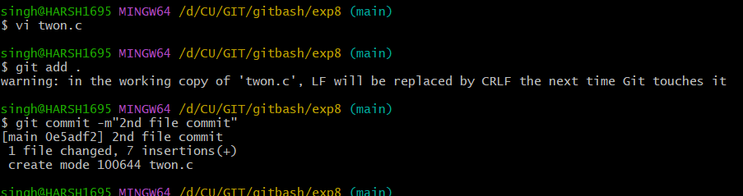

**6.** Now show the git log and draw git diff using “git diff hash1 hash2”

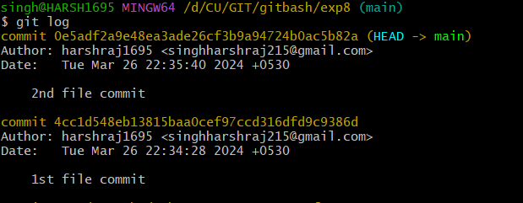

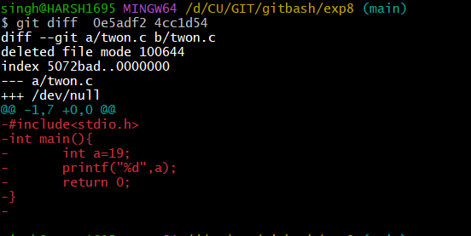

**7.** Now edit the file and don’t add this file to staging area and use git diff.

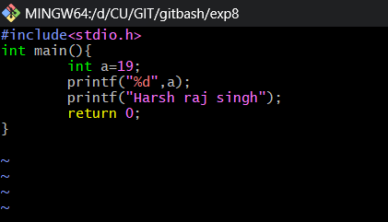

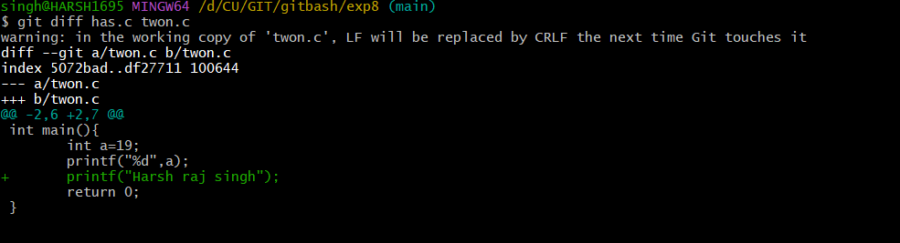

**8.** Now create a branch using “git branch nope” or “git checkout -b nope”.

**9.** Now edit file and add it to stagging area and commit this file ising “git add .” and “git commit -m”message””.

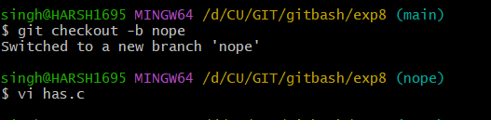

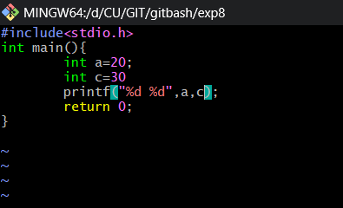

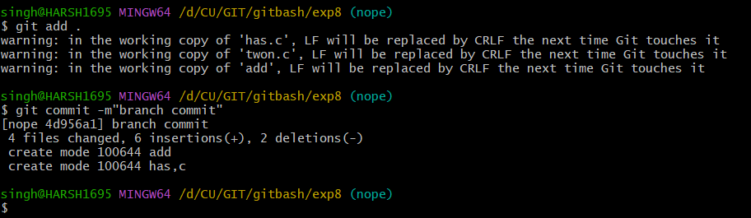

**9.** Now Move to main branch by “git checkout main” and run the git diff command .

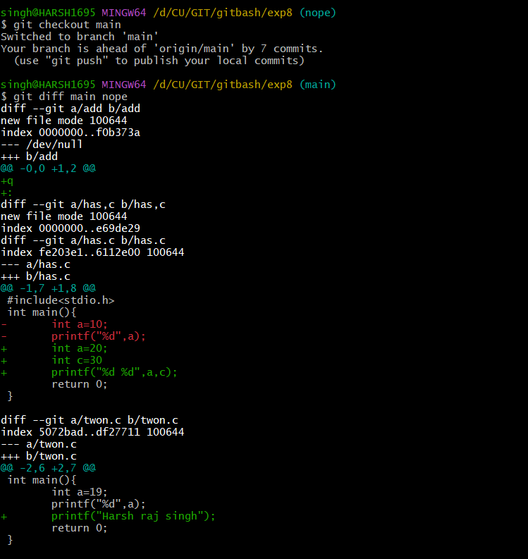

**5. Result/Output/Writing Summary:**

In this experiment we have learn about diff and associated commands with git diff.

**Learning outcomes (What I have learnt):**

1. Learnt the difference between git merge and pull request.

2. Learnt how to make the merge

3. Learnt about type of merging.

4. Learnt about merge conflict.

5. Also learnt about ort merging.

**Evaluation Grid (To be created as per the SOP and Assessment guidelines by the faculty):**

|  |  |  |  |
| --- | --- | --- | --- |
| **Sr. No.** | **Parameters** | **Marks Obtained** | **Maximum Marks** |
| **1.** |  |  |  |
| **2.** |  |  |  |
| **3.** |  |  |  |
|  |  |  |  |