**Experiment -3.2**

**Student Name: HARSH RAJ SINGH UID: 22BDO10006**

**Branch: CSE(DEVOPS) Section/Group:22BCD-1/A**

**Semester: 4TH Date of Performance: 03/04/2024**

**Subject Name:GIT AND GITHUB Subject Code: 22CSH-293**

**1. Aim/Overview of the practical:. Understanding the various reset modes in GitHub. 2.Software used: Git Bash and Github.**

**3. Hardware Used: Computer system.**

**4. Steps for experiment:**

1. Create a file on local device and open that folder with Git Bash.

2. Create a repository on Github with Exp8 name and copy the http link.

3. Now open the file “abc.c” using “vi filename” and edit the file**.**

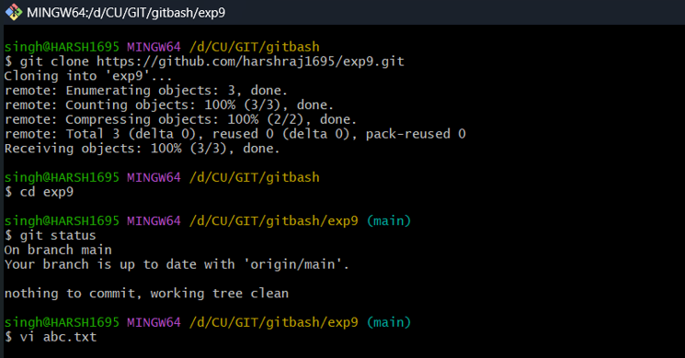

**4.** Now add and commit the file using “git add .” and “git commit -m”messaage””.

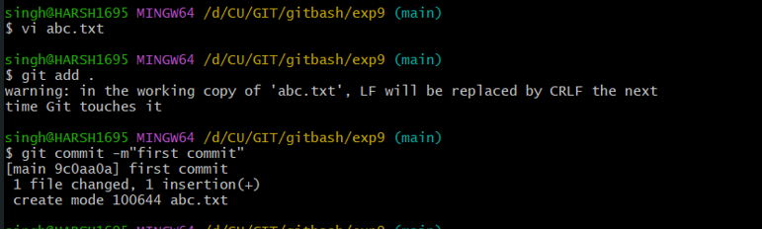

**5.** Repeat step 3 and 4 for multiple time to have multiple commits.

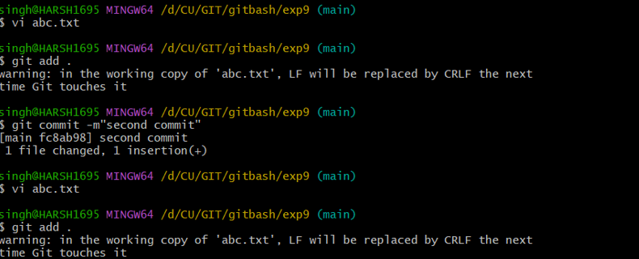

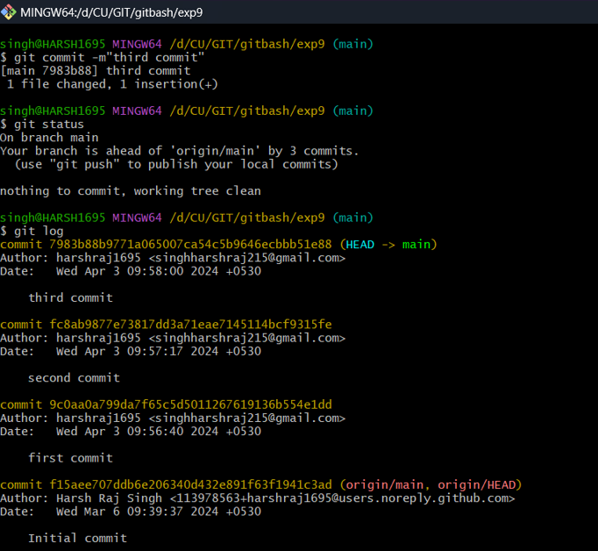

**6.** Now perform soft rest by “git reset –soft Head~1” which will bring head to previous commit and bring the commit to stagging area.

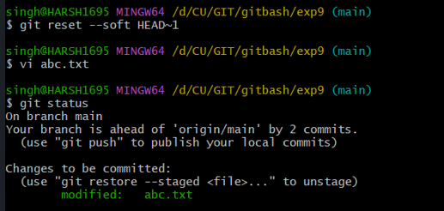

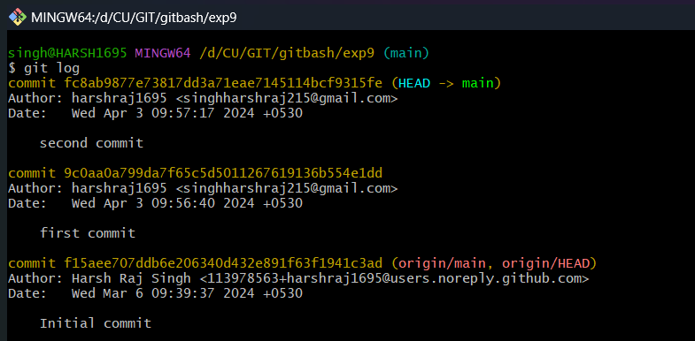

**7.** Now perform soft rest by “git reset -–mixed Head~1” which will bring head to previous commit and unstage the file which be result in untrack file.

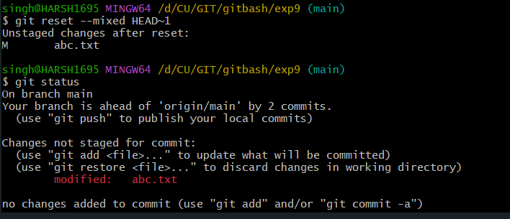

**8.**  Now perform soft rest by “git reset -–hard Head~1” which will bring head to previous commit and without affecting the file formet and remove all changes done in commit.

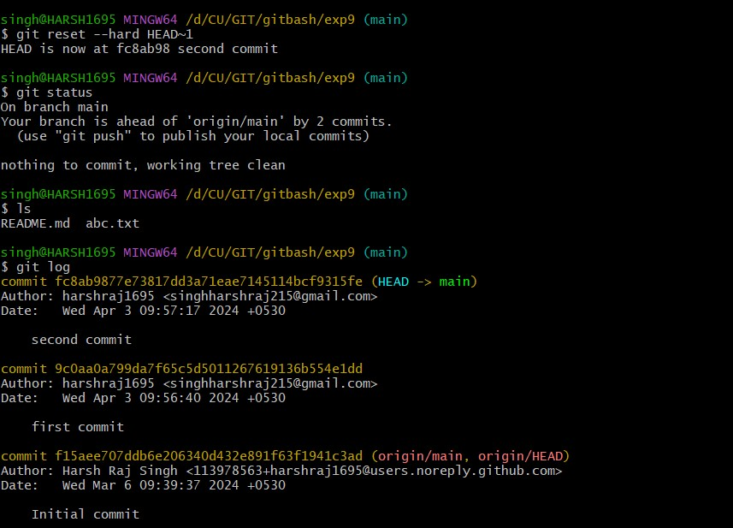

**5. Result/Output/Writing Summary:**

In this experiment we have learn about reset and types of reset.

**Learning outcomes (What I have learnt):**

1. Learnt the difference between reset and revert.

2. Learnt how to make the reset

3. Learnt about type of reset.

4. Learnt about soft reset.

5. Also learnt about mixed and hard reset.

**Evaluation Grid (To be created as per the SOP and Assessment guidelines by the faculty):**

|  |  |  |  |
| --- | --- | --- | --- |
| **Sr. No.** | **Parameters** | **Marks Obtained** | **Maximum Marks** |
| **1.** |  |  |  |
| **2.** |  |  |  |
| **3.** |  |  |  |
|  |  |  |  |