**Experiment -1.2**

**Student Name: HARSH RAJ SINGH UID: 22BDO10006**

**Branch: CSE(DEVOPS) Section/Group:22BCD-1/A**

**Semester: 4TH Date of Performance: 24/01/2024**

**Subject Name: GIT AND GITHUB Subject Code: 22CSH-293**

**1. Aim/Overview of the practical:**. Creating branches with GitHub

**2. Software used:** Git Bash and Github.

**3. Hardware Used:** Computer system.

**4. Steps for experiment:**

**For Creating branch on GitHub :**

**1.** Login to your github profile on Chrome.

**2.**  Click on the repository where you want to do branching.

**3.** Click on add file to add a new file.

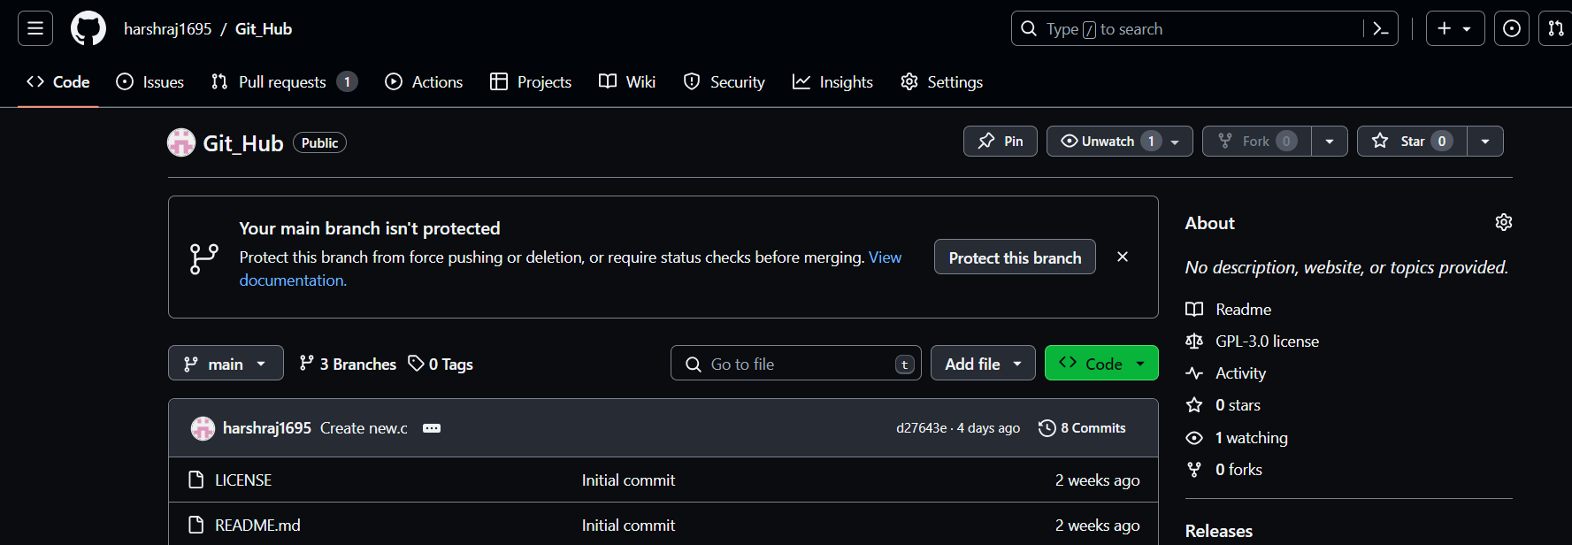

**4.** Give this file a name “**this.c”** and add linear search code in it.

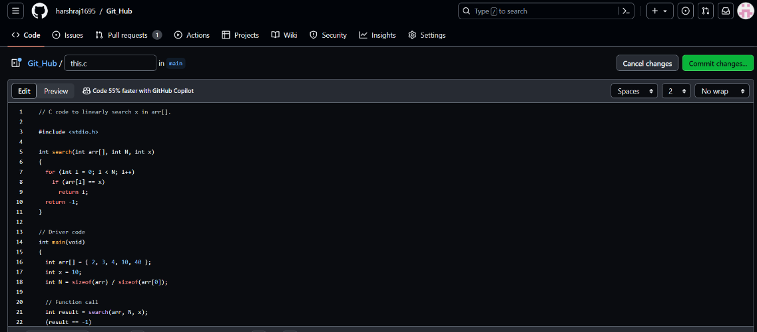

**6.** Click on **“commit changes”** button to commit the change.

**7.** Provide **“commit message”** and **“ Extented description”** abd than click **“commit changes”**

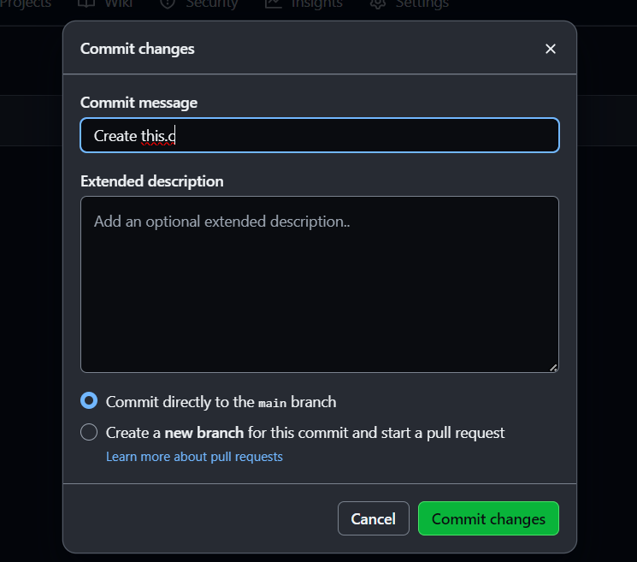

**8.** Now go on that file click on branch **“main”**.

**9.** Type a new branch name **“br.c”** and click **“Create branch br.c from main”**

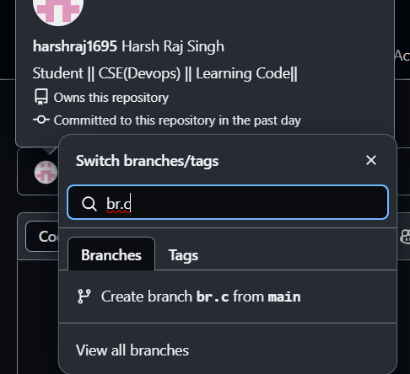

**10.** Click on the **“edit”**  button and edit the code.

**11.** Ater editing click on **“commit changes “** to commit the changes.

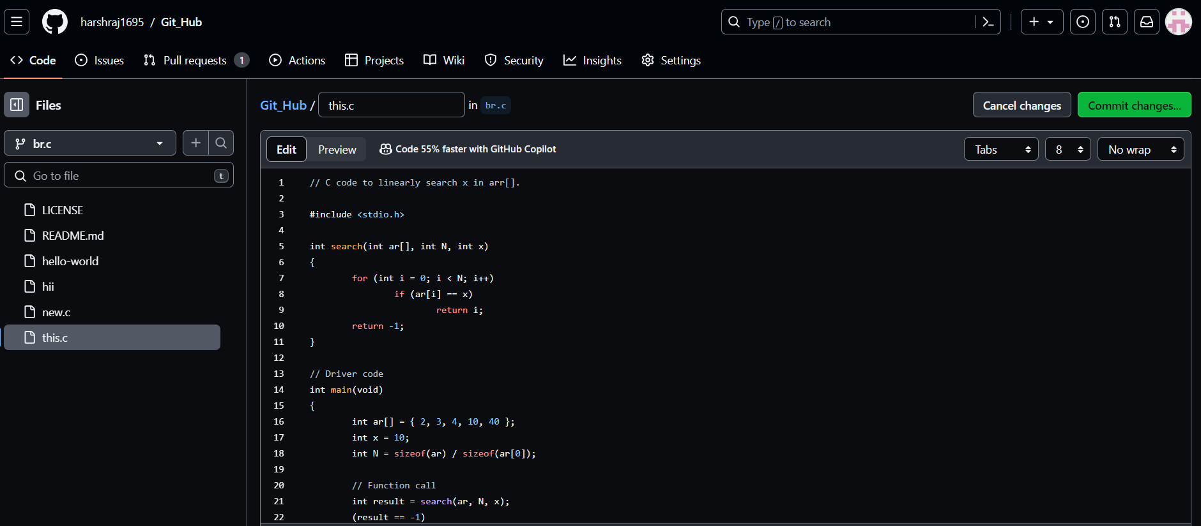

**12.** Add **“Commit message”** And  **“Extended description”** and than click on **“commit changes”**

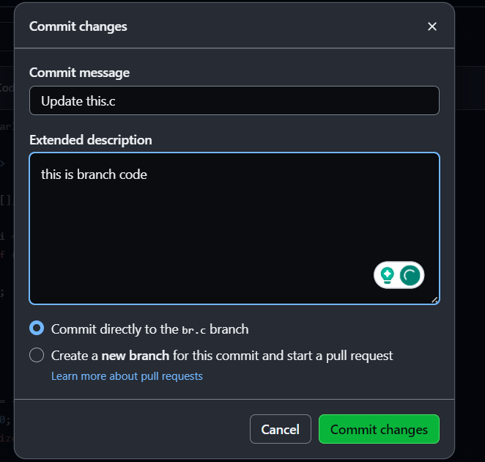

**13.** After commiting the changes go to **“parent repository”** and click on **“compare nad pull request”.**

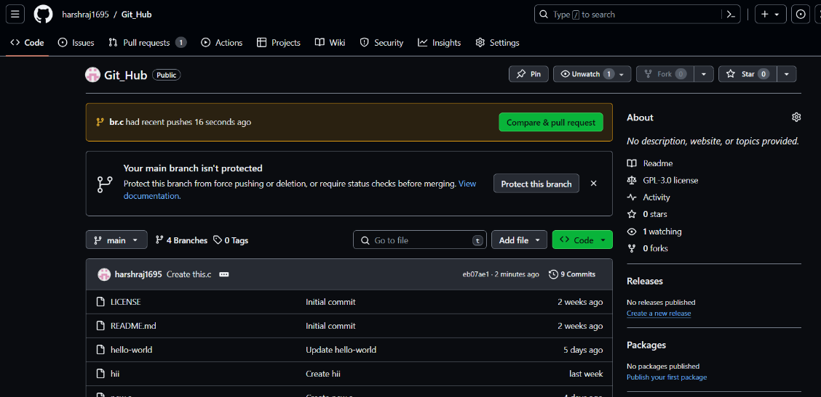

**14.** Compare the code in two modes.

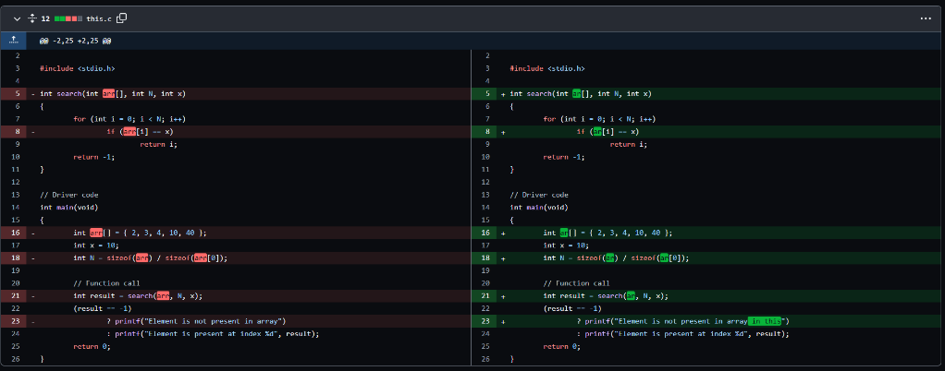

**15.** Click on **“Create pull request”** And add **“title and description to code”**

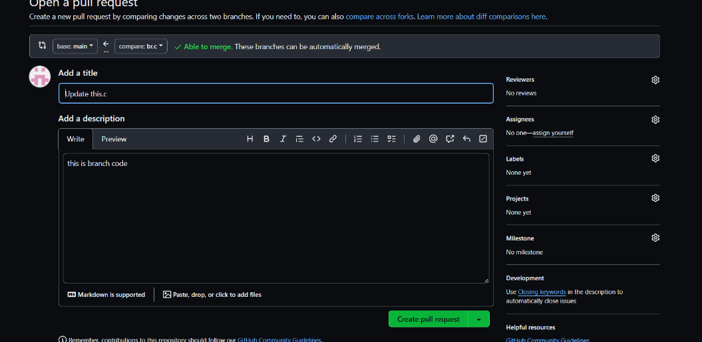

**16.** Click on **“Merge pull request”**

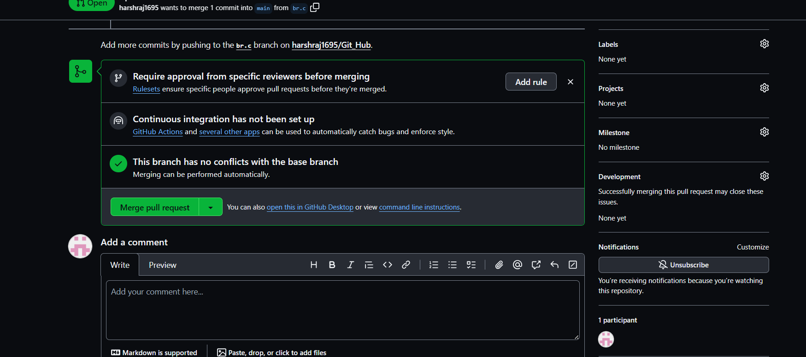

**17.** After Merging the code Click on **“Delete branch”** if you wish to delete the branch.

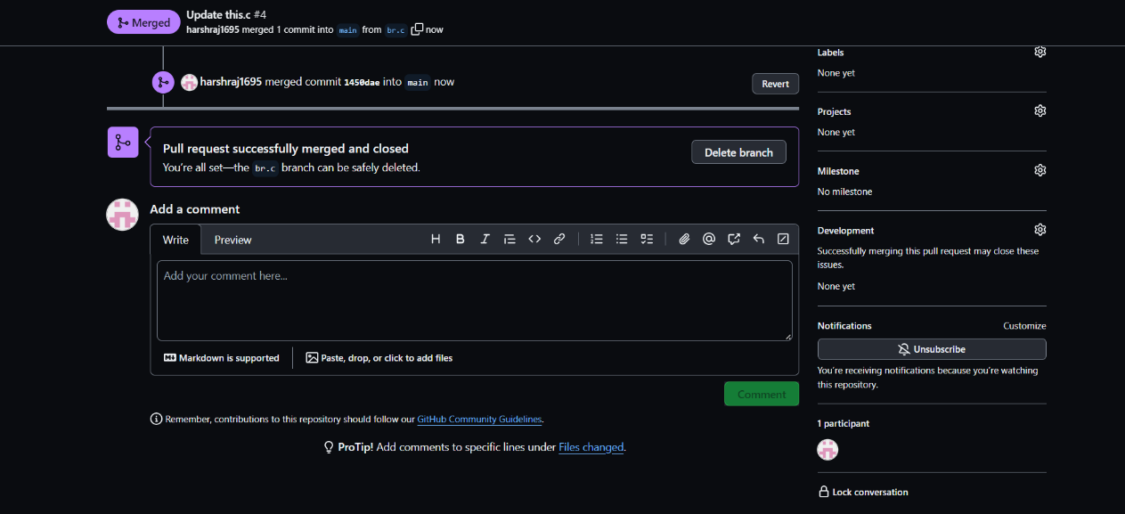

**From Creating Branch On GitBash:**

**1.** Create a new folder naming **“git”** on dextop.

**2.** Initialize the git using *“git init”*  command.

**3.** Create a new file using *“vi command”* Eg **“vi harsh.txt”**

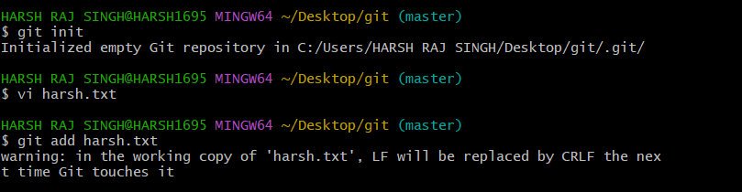

**4.** Edit file and add content to it.



**5.** Put the file in staging area using *“git add (file name)”* Eg **“git add harsh.txt”**

**6.** Commit this file using *“git commit -m “message””*

**7.** Create a new branch using code *“git checkout -b branch_name”*

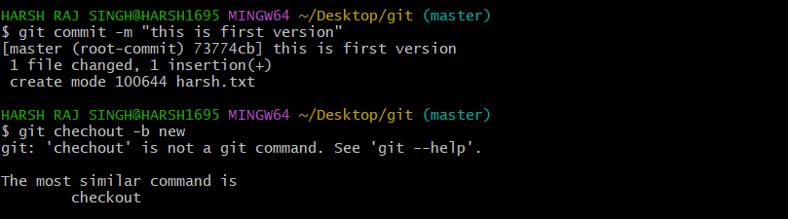

**8.** Open and Edit file using *“vi file name”*  and add content to it.

**9.** Put the file in staging area using *“git add (file name)”* Eg **“git add harsh.txt”**

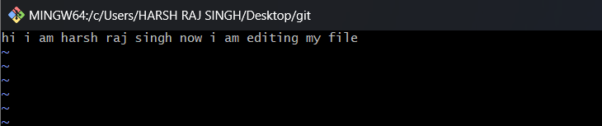

**10.** Commit this file using *“git commit -m “message””*

**11.** Move to master branch using *“git checkout master”*

**12.** Merge the branch using code *“ git merge new”*

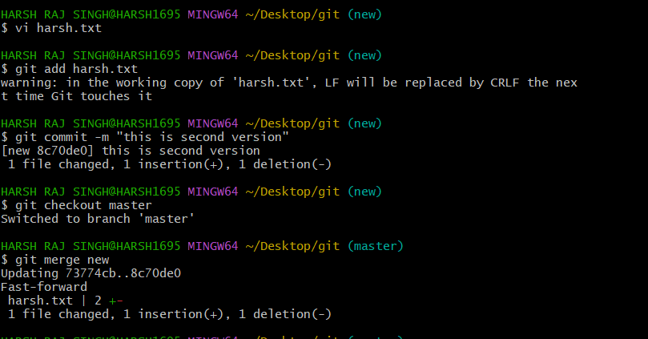

**13.** Show the status of file using *“git status”.*

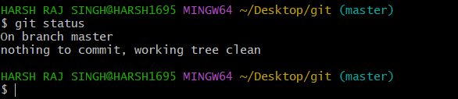

**5. Result/Output/Writing Summary:**

In this experiment we have created a branch on a file in the repository using GitHub and Gitbash. We have merge this branch with the parent main branch.

**Learning outcomes (What I have learnt):**

**1.** Learnt About branching.

**2.** Learnt how to create branch using github.

**3.** Learnt how to create branch using gitbash .

**4.** Learnt how to merge the two branches.

**5.** Also learnt how to differ these two files.

**Evaluation Grid (To be created as per the SOP and Assessment guidelines by the faculty):**

|  |  |  |  |
| --- | --- | --- | --- |
| Sr. No. | Parameters | Marks Obtained | Maximum Marks |
| 1. |  |  |  |
| 2. |  |  |  |
| 3. |  |  |  |
|  |  |  |  |