**Experiment -1.1**

**Student Name: HARSH RAJ SINGH UID: 22BDO10006**

**Branch: CSE(DEVOPS) Section/Group:22BCD-1/A**

**Semester: 4TH Date of Performance: 31/01/2024**

**Subject Name:GIT AND GITHUB Subject Code: 22CSH-293**

**1. Aim/Overview of the practical:**. To create and explore Pull request

**2. Software used:** Git Bash and Github.

**3. Hardware Used:** Computer system.

**4. Steps for experiment:**

**For Branch Making And Making a Pull Request:**

**1.** Create a file on local device and open that folder with Git Bash.

**2.** Create a repository on Github with exp3 name and copy the http link.

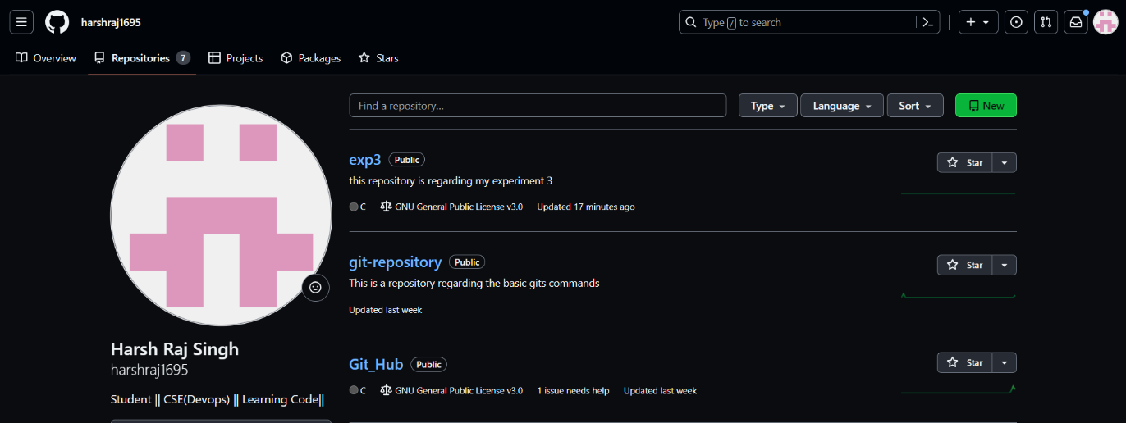

**3.** Make clone of the repository using  *“git clone http link”*

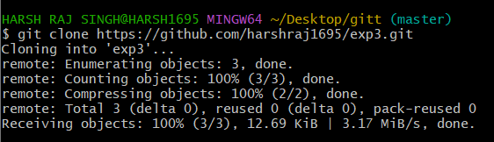

**4.** Change the current working directory using **“cd”** command: *“cd exp3”*

**5.** Create and edit a file using **“vi filename”** command: *“vi abc.c”*

**6.** Add the file using **“git add “** command

**7.** Commit the file using **“git commit -m”message””** command.

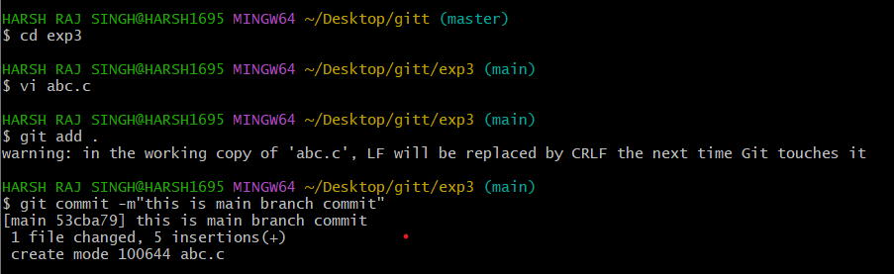

**8.** Push the file into the remote repository using **“git push origin main”** command.

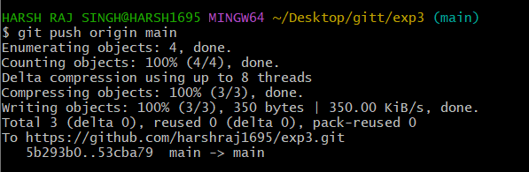

**9.** Create a new branch and move to that branch using **“git checkout -b branch name”**

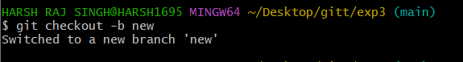

**10.** Open the same file and start editing the file using **“vi file name”** Command

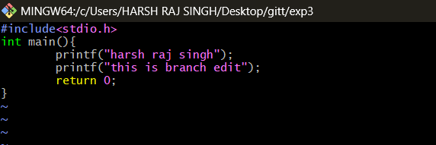

**11.** Add the file to the stagging area using **“git add.”** Command.

**12.** Make a Commit to the file using **“git commit -m”message””**

**13.** Make a push using the **“git push origin branch name”**

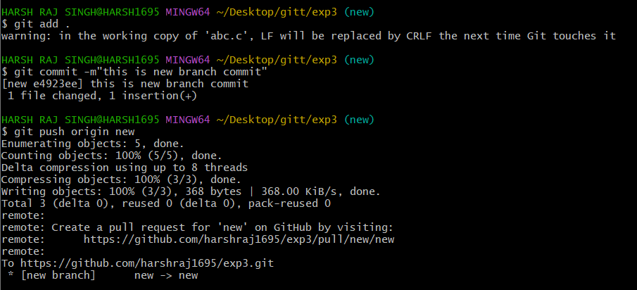

**14.** Now make compare and pull request on Github.

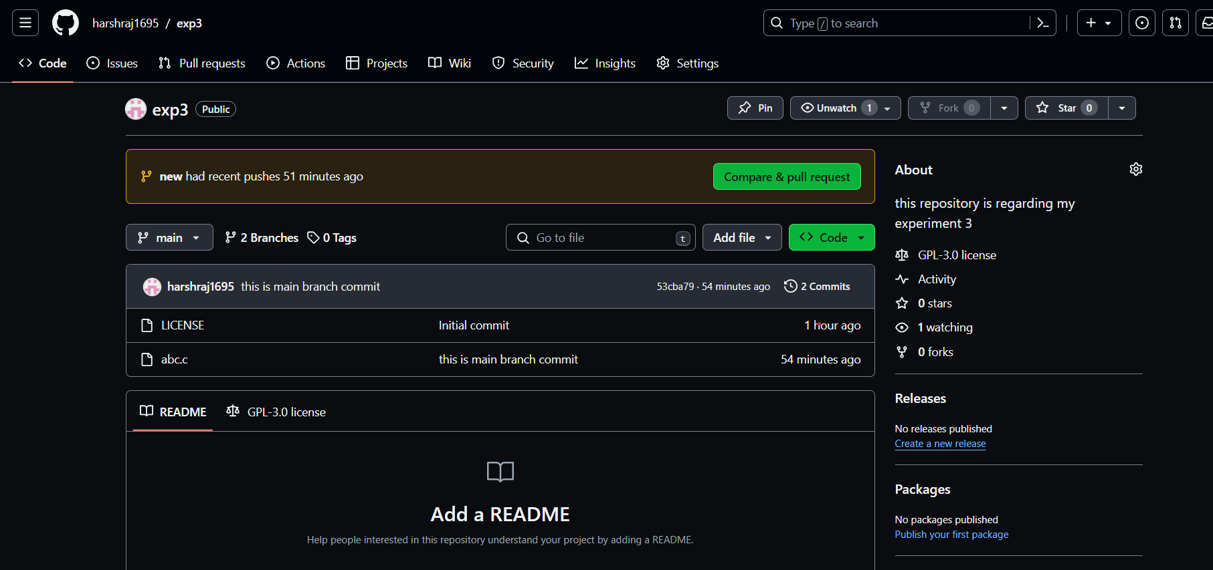

**15.** Compare the change done in the branches.

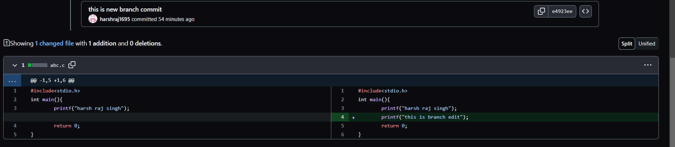

**16.** Create a pull request on github and do the merge pull request.

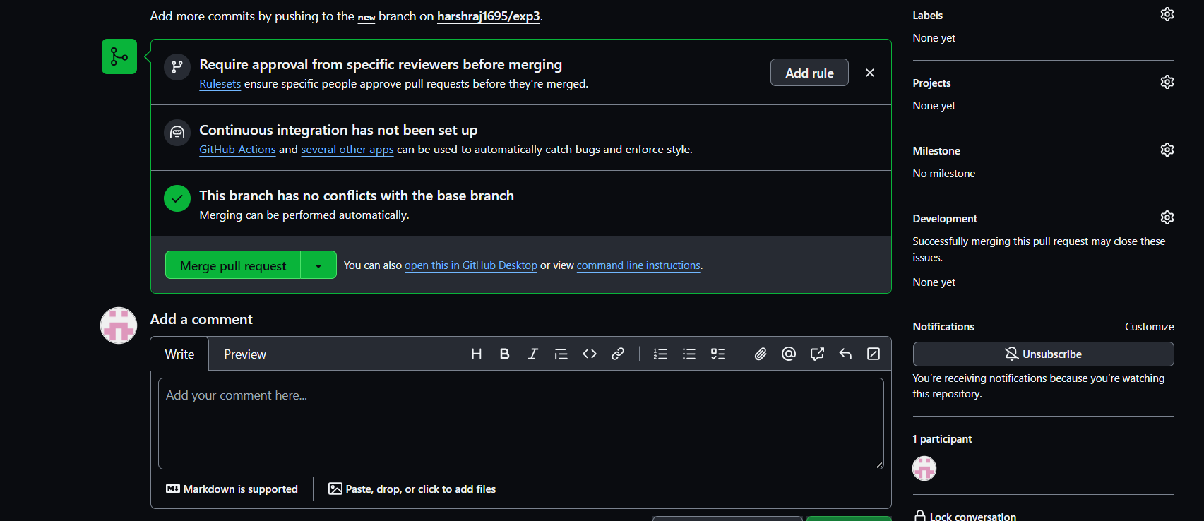

**17.** Delete the branch using delete branch on github.

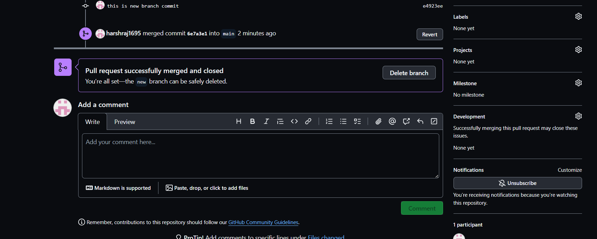

**18.** Create a branch on the github and edit the file and commit the change.

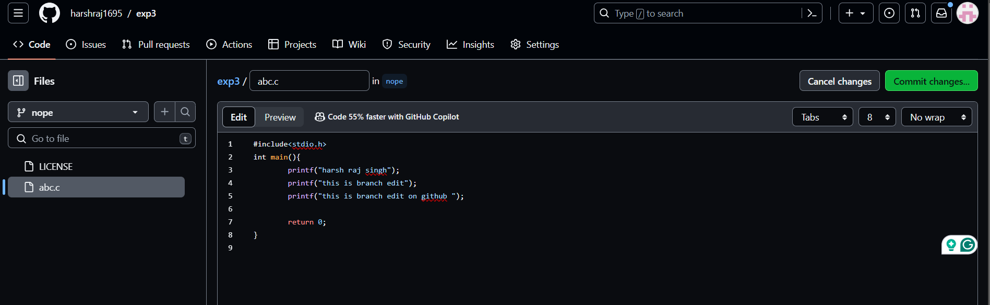

**19.** Now make compare and pull request on Github

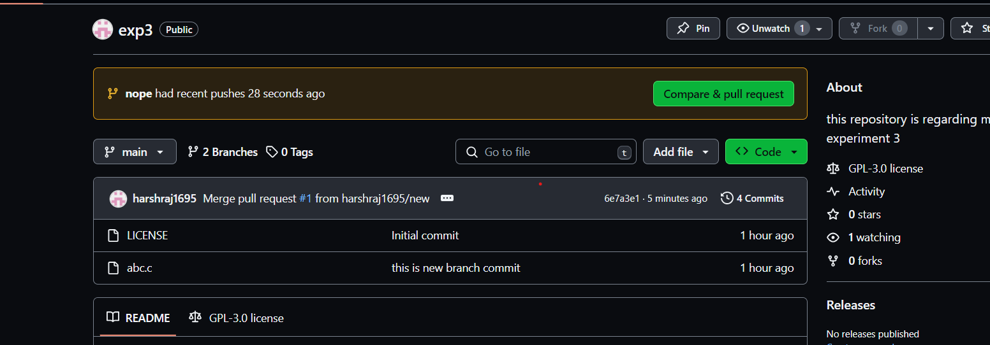

**20.** Compare the change done in the branches.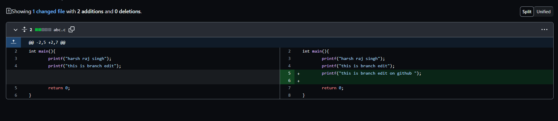

**21.** Create a pull request on github and do the merge pull request.

**22.** Delete the branch using delete branch on github.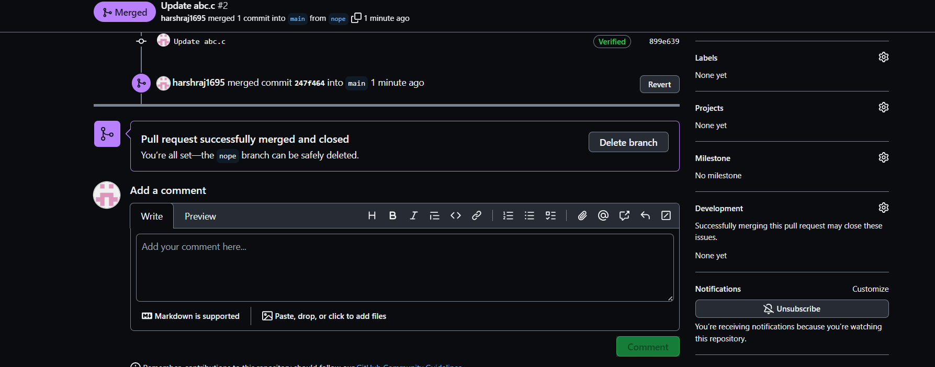

**22.** Go to the Gitbash and fetch the changes using *“git fetch command”*

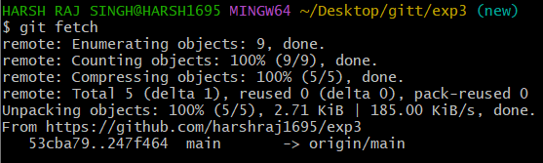

**23.** Carefully examine the changes in the file after fetch command.



**24.** Now do a pull request using command *“git pull origin main”* and examine the changes.

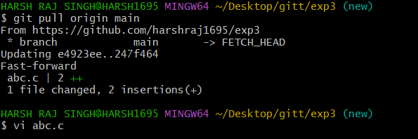

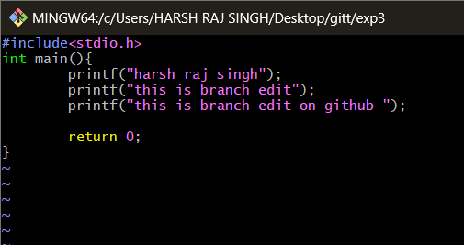

**5. Result/Output/Writing Summary:**

In this experiment we have learn about making a pull request on both github and git bash for local as well as remote servers. We have also gone through the chages made by merge and pull request command.

**Learning outcomes (What I have learnt):**

**1.** Learnt the difference between git merge and pull request.

**2.** Learnt how to make the merge request on github and git bash.

**3.** Learnt about editing the files.

**4.** Learnt how to delete a branch in github and bash.

**5.** Also learnt about comparing the merged files.

**Evaluation Grid (To be created as per the SOP and Assessment guidelines by the faculty):**

|  |  |  |  |
| --- | --- | --- | --- |
| Sr. No. | Parameters | Marks Obtained | Maximum Marks |
| 1. |  |  |  |
| 2. |  |  |  |
| 3. |  |  |  |
|  |  |  |  |