**Hands - on Breadboard and Multimeter**

**Circuit Diagram**

**BREADBOARD**

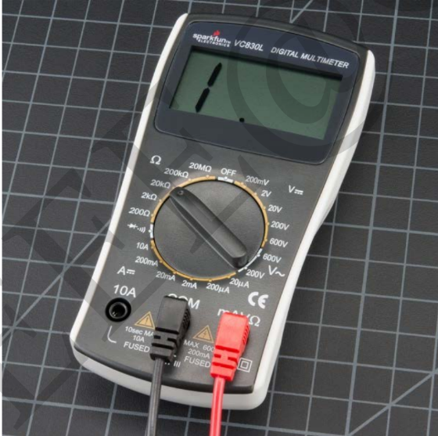

**Digital Multimeter**

**Theory**

**Concepts Used**

**What is a breadboard?**

**A breadboard is a rectangular plastic board with a bunch of tiny holes in it. These holes let you easily insert electronic components to prototype (meaning to build and test an early version of)an electronic circuit, like this one with a battery, switch, resistor, and an LED (light-emitting diode).**

**Technically, these breadboards are called solderless breadboards because they do not require soldering to make connections. Soldering (pronounced SAW-der-ing) is a method where electronic components are joined together by melting a special type of metal called solder.Electronic components can be soldered directly together, but more commonly they are soldered onto printed circuit boards (PCBs). PCBs are what you will see if you take the cover off many electronic devices, like a computer or cell phone. Frequently, engineers will use solderless breadboards to prototype and test a circuit before building the final, permanent design on a PCB. This image shows the same circuit (battery, switch, resistor, and LED) built three different ways: on a solderless breadboard (left), with the components soldered directly together (middle), and on a printed circuit board (right).**

**What is Digital Multimeter?**

The display usually has four digits and the ability to display a negative sign. A few multimeters have illuminated displays for better viewing in low light situations.The selection knob allows the user to set the multimeter to read different things such as milliamps (mA) of current, voltage (V) and resistance (Ω). COM stands for common and is almost always connected to Ground or ‘-’ of a circuit. The COM probe is conventionally black but there is no difference between the red probe and black probe other than color. 10A is the special port used when measuring large currents (greater than 200mA). mAVΩ is the port that the red probe is conventionally plugged in to. This port allows the measurement of current (up to 200mA), voltage (V), and resistance (Ω).

1. Interfacing with the breadboard and multimeter.
2. Concept of multimeter.

**Precautions**

1. Don’t make the connection loose.
2. Before giving power to the circuit make sure that the circuit is good.

**Learning Outcomes**

1. **We learn that how current flow in the breadboard.**
2. **We also learn that how to use the digital multimeter for measuring current and voltage.**