VIT Bhopal University
VITyarthi E-Learning Platform
Digital Literacy Portfolio
CSE0001 – Digital Literacy
Project Report

Name | HARSH RAJPUT
Registration No. | 25BEY10012
Branch | E-COMMERCE TECHNOLOGY
Year | First Year B.Tech
Course Code | CSE0001
Course Title | Digital Literacy
Date of Submission | 24 March 2026

Introduction

This project report documents my work as a Student Digital Ambassador for the CSE0001 – Digital Literacy course at VIT Bhopal University. The Digital Literacy Portfolio is designed to help first-year B.Tech students like me develop essential skills for navigating the digital world — from building a professional online presence to communicating safely and responsibly online.
The project is organized into five tasks, each mapping to one module of the course. Over the course of this assignment, I worked through creating a visual infographic, setting up professional online profiles, exploring coding and collaboration platforms, drafting professional emails, and researching cybercrime awareness. All my work is collected in a single public GitHub repository, which is itself part of the deliverable.
No prior coding experience was required, and all tools used are free and browser-based — making this project accessible to every student regardless of their technical background. This report documents each task with observations, reflections, and key learnings.

Task 1 – Digital Literacy Awareness Infographic

Module 1 | 20 Marks

What I Made
For Task 1, I created a one-page Digital Literacy Awareness Infographic using Canva (canva.com), a free, browser-based design tool that requires no prior design experience. The infographic is titled 'Be Digitally Smart' and is structured as a visually engaging single-page layout using icons, colour blocks, and concise text.
The infographic covers three key topics:
- What Digital Literacy is — defined as the ability to find, evaluate, create, and communicate information using digital technologies responsibly.
- Safe Internet Practices — including using strong passwords, avoiding suspicious links, keeping software updated, and being careful about sharing personal information online.
- Professional Online Presence — explaining the importance of maintaining a clean, professional digital footprint on platforms like LinkedIn and GitHub, which employers and internship coordinators actively check.
The final design was exported as a PNG file and uploaded to the task-1-presentation/ folder of my GitHub repository. A shareable Canva link is also included in the README.

Reflection
Using Canva was straightforward as the drag-and-drop interface made it easy to arrange elements. The most interesting part was realising how much meaning can be communicated through colour and icons alone — text-heavy slides lose the audience quickly. The most challenging part was deciding which information to include and which to leave out, since a one-page format forces prioritisation. I found myself cutting nearly half of my original draft to keep the design clean and readable.

Task 2 – Student Digital Portfolio

Module 2 | 20 Marks

Platforms Set Up
For Task 2, I created and configured professional profiles on three platforms: GitHub, LinkedIn, and Kaggle. Screenshots of each profile are saved in the task-2-portfolio/ folder of my repository.
- GitHub (github.com) — I created a profile README repository (named after my GitHub username) containing my name, branch, year of study, and a short paragraph about what I hope to learn during my B.Tech. GitHub is primarily used by developers to host code, collaborate on open-source projects, and showcase technical work. It is the most widely used platform for software portfolios.
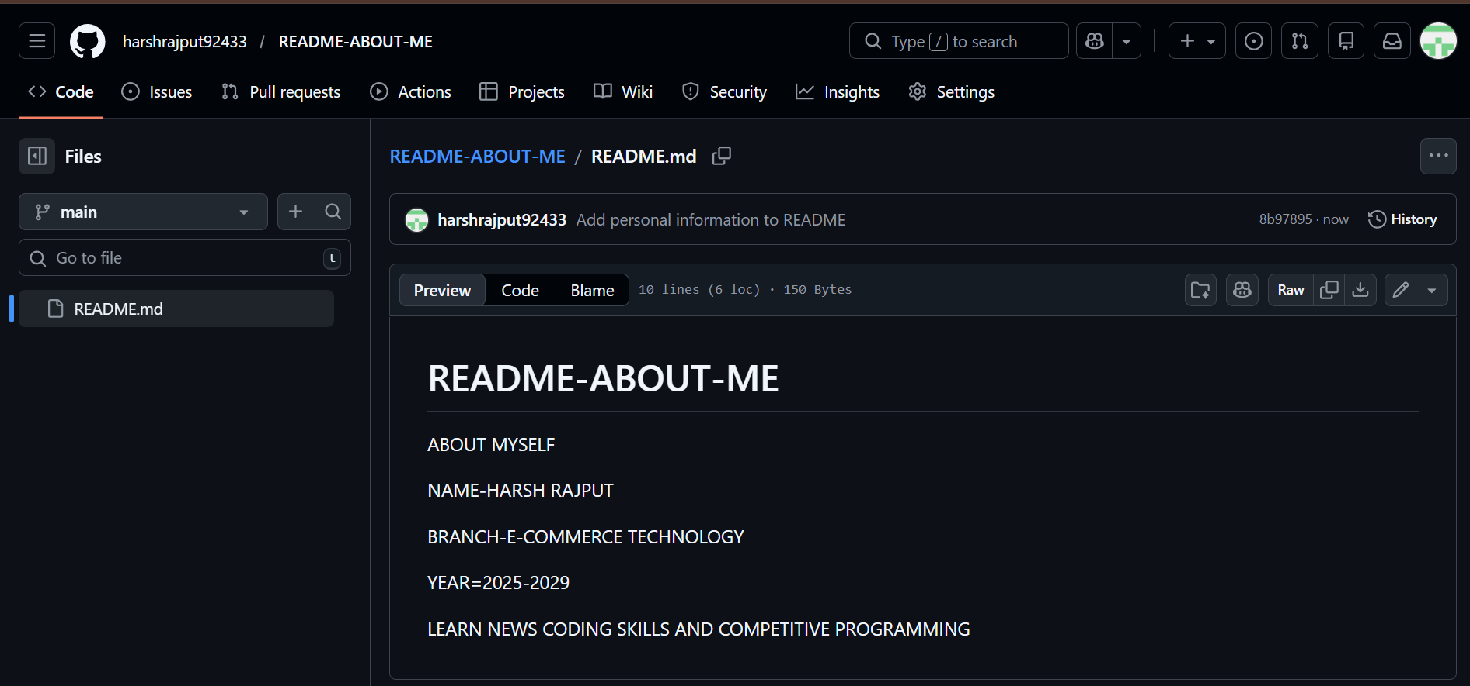
- LinkedIn (linkedin.com) — I filled in my Education section with my current degree (B.Tech), institution (VIT Bhopal University), and expected graduation year. LinkedIn is a professional networking platform used to connect with industry professionals, discover internship and job opportunities, and build a career-oriented online identity.
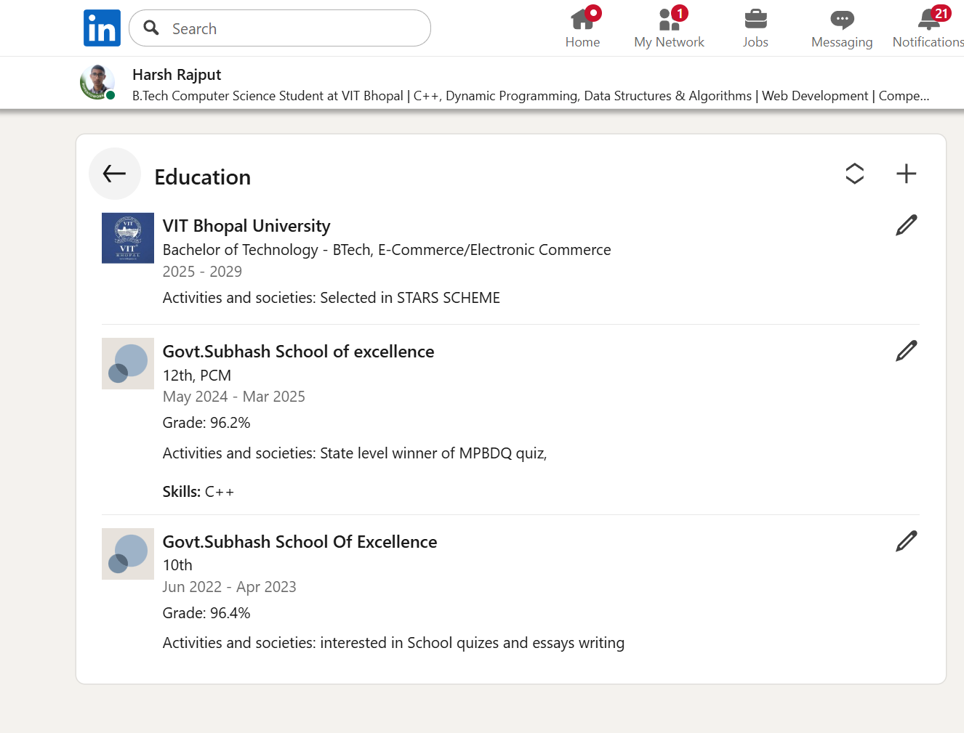
- Kaggle (kaggle.com) — I created an account on Kaggle, a data science and machine learning community. Kaggle hosts datasets, competitions, and notebooks. Even as a first-year student, having an account allows me to explore datasets and follow learning paths in Python and data analysis.
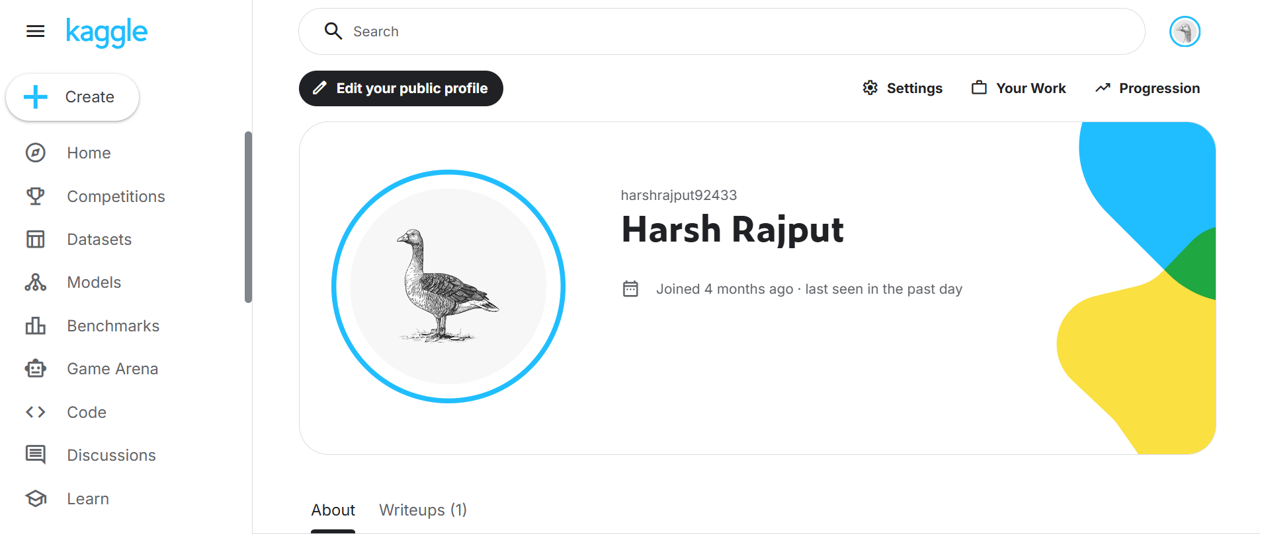

Future Plans
Over the next four years, I plan to use GitHub to version-control all my coding projects and contribute to open-source repositories, LinkedIn to document internships, projects, and achievements as I progress, and Kaggle to participate in beginner-level data science competitions once I build Python proficiency. Setting up these profiles now — even minimally — means I will have a digital footprint that grows organically throughout my degree rather than scrambling to build one in my final year.

Task 3 – Coding & Collaboration Platforms

Module 3 | 20 Marks

Part A – Coding Practice (HackerRank)
I created an account on HackerRank (hackerrank.com) and completed the 'Solve Me First' beginner challenge in the Problem Solving domain. This challenge involves reading two integers and printing their sum — a simple but complete introduction to reading input and producing output in a programming language. I chose to solve it using Python. A screenshot of the completed challenge and the score is saved in task-3-platforms/.

Part B – Google Forms Collaboration
I created a Digital Literacy Awareness Quiz using Google Forms (forms.google.com) with exactly 5 questions designed to test basic digital literacy knowledge among first-year students. The quiz includes:
- Q1 (Multiple Choice): What does 'Digital Literacy' mean?
- Q2 (Multiple Choice): Which of the following is a safe internet practice?
- Q3 (Multiple Choice): Which platform is best suited for showcasing coding projects?
- Q4 (Multiple Choice): What should you do if you receive a suspicious email asking for your password?
- Q5 (Short Answer): Name one habit you will change to improve your digital safety.
The form is linked to a Google Sheet that automatically collects responses. Both the form and the response sheet screenshot are saved in task-3-platforms/. The Google Form link is also shared in the repository README so batchmates can actually take the quiz.

Reflection
Both tools were easy to use and browser-based. HackerRank immediately gave me a sense of what competitive programming looks like, and completing even a simple challenge felt rewarding. The Google Forms exercise was particularly useful — I had used forms before to fill in surveys, but designing one yourself requires thinking about question clarity, answer options, and flow. These skills will be directly useful academically: Google Forms can be used for peer feedback, quizzes, and project surveys throughout my degree.

Task 4 – Professional Email & Etiquette Guide

Module 4 | 20 Marks

Part A – Professional Email Drafts

Email 1: Request for Assignment Deadline Extension
Email 1 — Request for Assignment Deadline Extension
Subject: Request for Extension – Laws of Inference Assignment Submission
Dear Professor Omprakash Hari,
I hope this email finds you well. I am Harsh Rajput, a first-year B.Tech student (Reg. No. 25BEY10012) from your Discrete Mathematics class.
I am writing to respectfully request a short extension of 2–3 days for the Laws of Inference Assignment due on [original due date]. Due to a medical issue, I have been unable to complete the assignment to the standard I would like to submit.
I have completed approximately 60% of the work and am committed to submitting a complete and quality submission by [31 march 2026]. I take full responsibility for managing my time better going forward.
Thank you for considering my request. Please let me know if you require any documentation or further details.
Yours sincerely,
Harsh Rajput
25BEY10012
| B.Tech [E-COMMERCE TECHNOLOGY] | First Year
harsh.25bey10012@vitbhopal.ac.in

Email 2: Internship Inquiry to a Company
Email 2 — Internship Inquiry to a Company
Subject: Enquiry Regarding Summer Internship Opportunities – B.Tech CSE Student
Dear Hiring Team,
I am Harsh Rajput, a first-year B.Tech student majoring in Computer Science and Engineering at VIT Bhopal University. I am writing to express my interest in summer internship opportunities at GOOGLE INDIA for the upcoming vacation period (May–June 2026).
I am particularly drawn to GOOGLE INDIA] because of your work in software development and your reputation for mentoring student interns. I am eager to apply my academic knowledge in a professional environment and contribute meaningfully to your team, even at an early stage of my education.
I would be grateful if you could share information about any open internship positions or application procedures. I am available to discuss my background further at your convenience.
Thank you for your time and consideration.
Yours sincerely,
Harsh Rajput
25BEY10012 | B.Tech CSE | VIT Bhopal University
harsh.rajput2025@vitbhopal.ac.in
https://www.linkedin.com/in/harsh-rajput-8237ba386/

Part B – Social Media Do's and Don'ts
The following checklist is for responsible social media use as a college student. A standalone file (social-media-checklist.md) is also included in task-4-email-etiquette/.
Do's
- Keep your profile picture and bio professional — employers and college staff may view your profiles.
- Think before you post — ask yourself if you would be comfortable with your professor or future employer seeing it.
- Use privacy settings to control who sees your personal content.
- Credit original creators when sharing others' work or ideas.
- Use social media to share academic achievements, projects, and helpful resources.
Don'ts
- Don't share personal information like your address, phone number, or financial details publicly.
- Don't post anything offensive, discriminatory, or hurtful — even as a joke.
- Don't engage with or share unverified news and rumours.
- Don't use social media to vent about college, professors, or classmates.
- Don't share login credentials or click links from unknown accounts, even in DMs.

Communication Scenario & Key Learnings
In 2023, a college student in India posted a casual complaint about a faculty member's teaching style on a public Instagram story. The post went viral in the college community, leading to a formal complaint being raised against the student. What began as a moment of frustration ended with academic consequences and a damaged relationship with the faculty. This could have been avoided by either addressing the concern directly with the professor, or using the college's official feedback mechanism. The key lesson is that digital platforms amplify reach beyond what we expect — a 'close friends' story or a private venting post can always be screenshotted and shared.

Task 5 – Cybercrime Awareness Case Study & Prevention Guide

Module 5 | 20 Marks

Part A – Case Study: UPI / Online Payment Fraud
UPI (Unified Payments Interface) fraud is one of the most common cybercrimes targeting college students and young adults in India. This case study describes a realistic scenario based on widely reported patterns.
Scenario: A second-year engineering student in Pune received a WhatsApp message from an unknown number claiming to be from the 'VIT Scholarship Cell.' The message stated that a scholarship amount of Rs. 8,000 had been approved and that the student needed to accept it by scanning a QR code. Excited and in need of money, the student scanned the code using Google Pay. Instead of receiving money, Rs. 8,000 was debited from their account. When they tried to contact the sender, the number was blocked.
How it happened (step-by-step):
- The attacker identified the target — a first-year student active on college social media groups.
- They crafted a convincing message using official-sounding terminology ('Scholarship Cell') and a plausible amount.
- The student was sent a QR code — in UPI, scanning a QR code is a payment action, not a receipt action. The fraudster exploited this confusion.
- Once the QR code was scanned and the student entered their UPI PIN, the money was immediately transferred out.
- The attacker blocked the victim and disappeared.
Who is targeted: Students, first-time UPI users, people in financial need, and anyone unfamiliar with how payment QR codes work.
Consequences: Financial loss (often non-recoverable immediately), emotional distress, and loss of trust in digital payments. In some cases, victims delay reporting, reducing the chance of recovery.
Source: Pattern based on documented cases reported by the Cyber Crime Coordination Centre (I4C) and news coverage by The Hindu and NDTV (2022–2024).

Part B – Stay Safe Online: Prevention Checklist
The following checklist (also available as prevention-checklist.md in task-5-cybercrime/) provides 8 actionable tips for college students in India:
- Never scan a QR code to 'receive' money — in UPI, QR codes are for sending money, not receiving it. Anyone asking you to scan to collect a payment is attempting fraud.
- Never share your UPI PIN, OTP, or bank password with anyone — not even someone claiming to be from your bank, college, or government.
- Verify scholarship or job offers by calling the official institution number before taking any action online.
- Use two-factor authentication (2FA) on all important accounts — email, social media, and banking apps.
- Do not click links in WhatsApp or SMS messages from unknown numbers, especially those promising prizes, jobs, or financial benefits.
- Keep your phone's OS and apps updated — security patches fix known vulnerabilities that fraudsters exploit.
- Use strong, unique passwords for different accounts. Consider using a password manager.
- Lock your SIM card with a PIN so that even if your phone is stolen, fraudsters cannot carry out SIM swap attacks.
Reporting Channels:
- National Cyber Crime Portal: cybercrime.gov.in — Report online financial fraud, cyberbullying, and other cybercrimes.
- Cyber Crime Helpline: 1930 (24x7) — Call immediately if you have lost money to online fraud; early reporting improves recovery chances.

Reflection
What surprised me most while researching this topic was how sophisticated the social engineering tactics are — the fraudsters do not need technical hacking skills. They rely entirely on exploiting trust, urgency, and a lack of awareness about how payment systems work. The QR code confusion (most people assume scanning = receiving) is a particularly effective trap because it exploits a genuine gap in digital literacy. One habit I will personally change as a result of this task is to always verify any financial request through an official channel before acting — no matter how legitimate it looks. I will also remind family members about UPI QR code safety, since they are equally if not more vulnerable.

Conclusion

This Digital Literacy Portfolio has been one of the most practically useful assignments I have completed in my first semester. Rather than being an abstract exercise, each task required me to actually set up real accounts, create real resources, and engage with real platforms that I will continue to use throughout my career. The five tasks collectively taught me that digital literacy is not about knowing how to use apps — it is about using them responsibly, professionally, and safely.
The most impactful realisations from this project were: that my digital footprint already exists and I need to manage it intentionally (Task 2); that most cybercrime relies on exploiting confusion rather than technical skills (Task 5); and that professional communication is a learnable skill that can be improved with practice (Task 4). I am grateful for an assignment that makes these lessons concrete rather than theoretical.

References

- Canva – canva.com (Tool used for Task 1 infographic)
- GitHub – github.com (Platform used for Task 2 portfolio and repository hosting)
- LinkedIn – linkedin.com (Platform used for Task 2 professional profile)
- Kaggle – kaggle.com (Platform used for Task 2 data science profile)
- HackerRank – hackerrank.com (Platform used for Task 3 coding challenge)
- Google Forms – forms.google.com (Tool used for Task 3 collaboration quiz)
- National Cyber Crime Portal – cybercrime.gov.in (Referenced in Task 5)
- Cyber Crime Helpline 1930 – Government of India (Referenced in Task 5)
- 'UPI Fraud: How scammers exploit QR codes' – NDTV Tech (2023) (Informing Task 5 case study)
- Indian Cyber Crime Coordination Centre (I4C) – MHA, Government of India (Referenced for fraud pattern data in Task 5)

