Name : HARSHRAJSINH ZALA  
Reg no :22BCE2238

All About Not A Number (NaN)

CODE :

const prompt = require('prompt-sync')()

let x = prompt("Enter a number: ");

if(isNaN(x)){

console.log("its not a number");

}

else{

console.log("its a valid number");

}

OUTPUT : 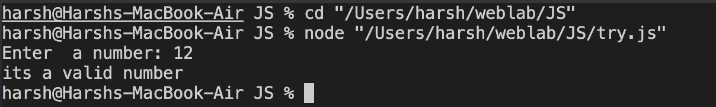

AGE :  
CODE :

const prompt = require('prompt-sync')()

let x = prompt("Enter a number: ");

if(x>120 || x<0){

if(isNaN){

console.log("its not a valid age");

}

}

OUTPUT :

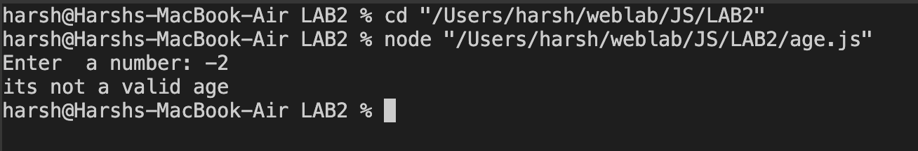

USES OF NAN

When converting char to int or else

Illegal math expressions

Infinity /infinity

Arithmetic operations involving a NaN

Relational operators

NaN is never equal to another NaN

CODE :

const prompt = require('prompt-sync')()

let x=12;

console.log("x is "+x);

let y=Math.sqrt(-1);

console.log("y is "+y);

let i = Infinity/Infinity;

console.log(i);

let z=7\*NaN;

console.log("z is "+z);

if(7>NaN){

console.log("TRUE");

}

else{

console.log("Relation Operators with NaN are always FALSE");

}

if(NaN == NaN){

console.log("nan == nan are always equal")

}

else{

console.log("nan == nan are always unequal")

}

if(NaN != NaN){

console.log("they are equal")

}

else{

console.log("nan == nan are always unequal")

}

Output ; 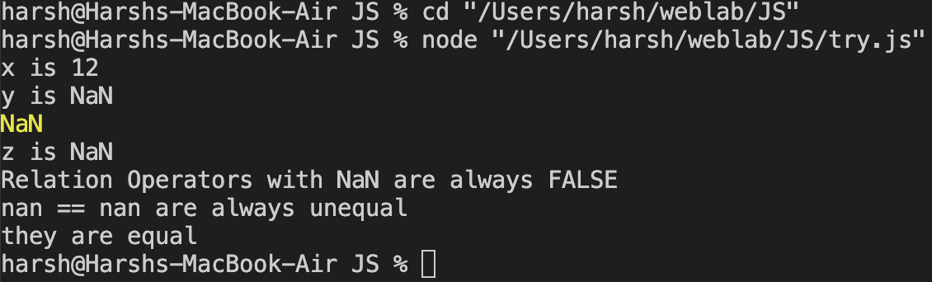

ARRAY in JAVA SCRIPT :

CODE :

const prompt = require('prompt-sync')()

//declaration of arrays using const

//cannot redeclare or reinitialise

const subjects = ["java","python","DAA","OS"];

{

const subjects= ["java","python","DAA","OS"];

console.log(subjects[0]);

}

console.log(subjects[1]);

//also declaring and assigning should be done at the same time

// const sub;

// sub= ["java","python","DAA","OS"]; // NOT ALLOWED

//method 2 to declare array

const sub = [];

sub[0] = "java";

sub[1] = "s1";

console.log(sub[1]);

//method 3

const s = new Array("szero","sone","stwo");

console.log(typeof(s));

//method to check if an array

if(Array.isArray(sub)){

console.log("ITs an Array using instance of Array.isArray ");

}

else{

console.log("not an array");

}

//method 2 to check if an array

if(sub instanceof Array){

console.log("ITs an Array using instance of");

}

else{

console.log("not an array");

}

OUTPUT :

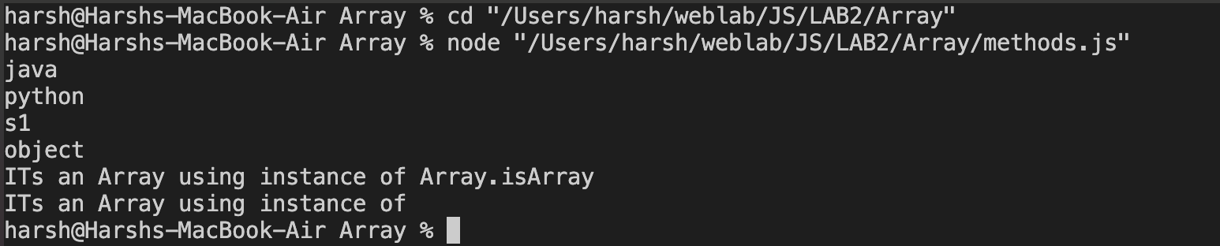

ARRAY METHODS IN JAVASCRIPT :

CODE :

//Array methods

let subjects = ["java", "os", "python"];

for (i in subjects) {

console.log(subjects[i]);

}

//LENGTH

console.log(subjects.length);

//toString

let res = subjects.toString();

console.log(res);

//PUSH POP

subjects.push("PUSHED");

console.log(subjects);

console.log(subjects.pop());

//JOIN

let x = subjects.join("|");

console.log(x);

console.log("\n");

//SHift and Unshift QUEUE can be made using PUSH POP SHIFT UNSHIFT

subjects.shift();

console.log(subjects);

subjects.unshift("UNSHIFT");

console.log(subjects);

//CONCAT

{

const s = ["java", "os", "python"];

const u1 = ["t1", "t2"];

const u2 = ["t11", "t22"];

const result = s.concat(u1, u2);

console.log(result);

}

OUTPUT:

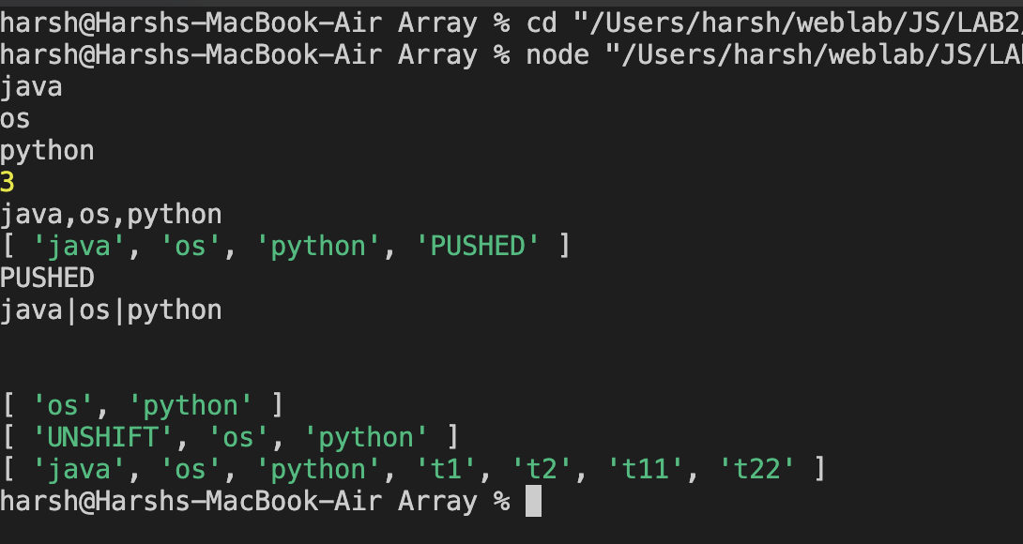

SOME MORE METHODS  
CODE :

//copywithin

//to copy within the array from the array itself

{

const sub = ["java", "python", "os", "networks"];

sub.copyWithin(1, 0);

console.log(sub);

}

{ //using range

const sub = ["java", "python", "os", "networks","hello","why"];

sub.copyWithin(4,0,3);

console.log(sub);

}

//SLICE AND SPLICE

{

const sub = ["java", "python", "os", "networks"];

const res =sub.slice(1,3); //ending index not included and returns an array

console.log(res);

const res2 = sub.slice(1); //from index 1 to end

console.log(res2);

}

//SPLICE --> remove/add any number of elements from an index

{

const sub = ["java", "python", "os", "networks","why","Hello"];

let res = sub.splice(1,2); //splice(start index , how many elements)

console.log(res);

sub.splice(1,0,"physics","chemistry");

console.log(sub);

sub.splice(4,2,"physics","chemistry");

console.log(sub);

}

OUTPUT :

