NAME : HARSHRAJSINH ZALA

REG : 22BCE2238

ARRAY METHODS SESSION 2

CODE :

//Array methods Session 2

//filter ,map,foreach,some,every,reduce

const x = [2, 2, 4, 6, 7];

const st = ["java", "python", "os", "network"];

//for each value in teh array we will invoke a function

//Intro to functions

function display(x, y) {

return x \* y;

}

let result = display(3, 2);

console.log(result);

//FILTER Method is used for filtering the values inside the array ....

//return type is array

console.log("\nFilter method");

console.log(`original array: ${x}`);

console.log(x);

const res = x.filter(filterfunction);

function filterfunction(value, index, array) {

return value > 2

}

console.log(`Filtering values greater than 2: ${res}`);

const res2 = st.filter(filterfunction2);

function filterfunction2(value) {

return value.includes("java");

}

console.log(`Filtering values having JAVA: ${res2}`);

//foreach

{

console.log("for each method");

const x = [2, 3, 4, 5, 6];

x.forEach(testfunction);

function testfunction(value, index, array) {

console.log(`${value}-->${index}`);

}

console.log();

}

//map

{

console.log("map function");

const x = [2, 3, 4, 5, 6];

console.log(`original array : ${x}`);

const res = x.map(mapfunction);

function mapfunction(value){

return value\*2;

}

console.log(`mapped to \*2 : ${res}`);

}

//Reduce : reduce the array to a single value

{

console.log("\nReduce function");

const x = [1,1,1,1,1];

let res = x.reduce(sumfunction,10);

function sumfunction(total,value,index,array){

return total+=value

}

console.log(res);

}

//EVERY: when every value in the array satisfies a condition then returns true and false otherwise

{

const x = [2,9,3,5,6];

let res = x.every(checkfunc);

function checkfunc(value,index,array){

return value>1;

}

console.log("every mehthod checking if every val >1: ");

console.log(res);

}

//some

{

const x = [2,9,3,5,6];

let res = x.some(checkfunc);

function checkfunc(value,index,array){

return value>50;

}

console.log("some method checking if some val>50: ");

console.log(res);

}

//Sort

{

const sub = ["cat","jar","orange","Apple"]

sub.sort();

console.log(sub);

//numeric sort doesnt work with .sort make a function to make it work

console.log("numeric sort using function");

const x = [56,33,21,456,723,44]

x.sort(mysort)

function mysort(x,y){

return x-y;

}

console.log(x);

x.sort(mysortde)

function mysortde(x,y){

return y-x;

}

console.log(x);

//or use reverse

console.log("reversing using .reverse():");

x.reverse();

console.log(x);

}

OUTPUT :

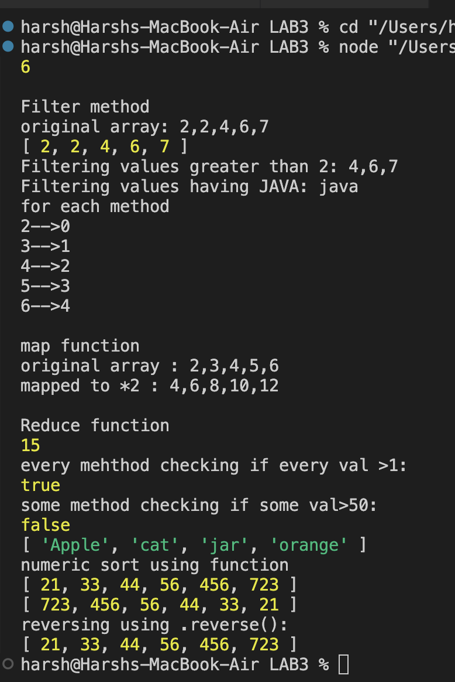

DATA TYPES IN JS :

CODE :

let x = 10.5;

let n = BigInt(9888888888888888888888);

//string

let k = 'Harsh';

//boolean

let result = true;

//null

let j = null;

if(null){

console.log("null is true");

}

else{

console.log("null is always false");

}

{

console.log("UNDEFINED");

let x;

if(x ==undefined){

console.log("assign some value for x");

}

console.log("type of x is "+typeof(x));

console.log();

}

//obj

{

console.log("OBJECT :");

const st = {

reg:"22BCE2238",address:"vellore",branch:"BCE"

}

console.log(st["reg"]);

console.log("type of student is: "+typeof(st));

console.log();

}

//Symbol

{

console.log("Symbol: ");

let mysymbol = Symbol();

let mysecsymbol = Symbol();

if(mysymbol == mysecsymbol){

console.log("they are equal");

}

else{

console.log("they are not equal");

}

const st = {

[Symbol()]:"22BCE2238",address:"vellore",branch:"BCE"

}

for(let j in st){

console.log(st[j]);

}

}

OUTPUT :

