NAME : HARSHRAJSINH ZALA

REG : 22BCE2238

QUESTION :

To check the register number of a user and print the school

CODE :

let x="22BCE2238"

let y=x.substring(2,5)

switch(y){

case 'BCE':

console.log('School is SCOPE')

break;

case 'BEE':

console.log('School is SENSE')

break;

case 'BIT':

console.log('School is SCORE')

break;

case 'BEM':

console.log('School is SCHEME')

break;

}

OUTPUT :

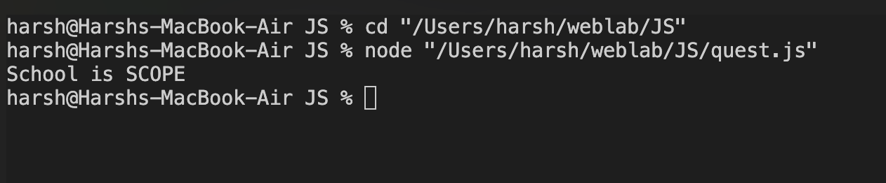

String Methods

LOCALE COMPARE METHODS   
CODE :

let x ='a'

let y ='b'

console.log(x.localeCompare(y));

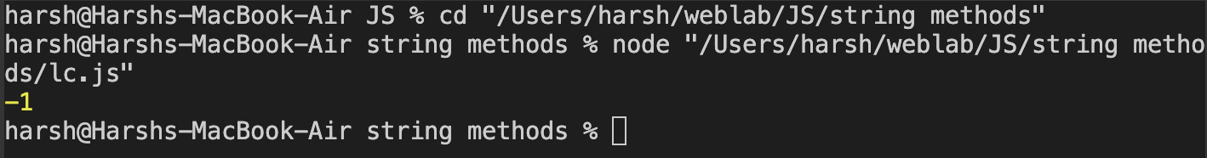

Char at :

Code :

let x = 'Harshraj'

console.log(x.charAt(2));

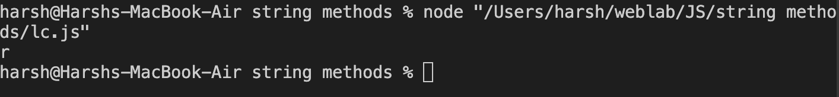

Concat :

let x = 'Harshraj '

console.log(x.concat('Zala'));

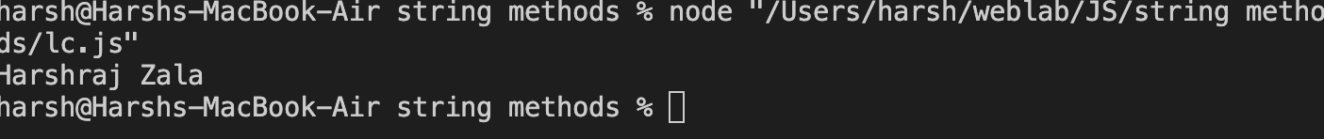

Includes :

let x = 'I am learning javaScript'

console.log(x.includes("learning"));



Ends with :

let x = 'I am Learning javaScript'

console.log(x.endsWith('ipt'));

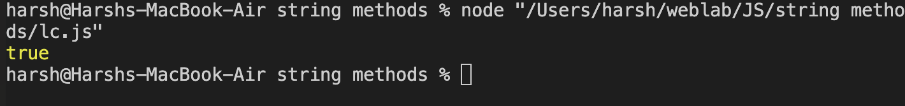

Starts with :

let x = 'Learning javaScript'

console.log(x.startsWith('Learn'));

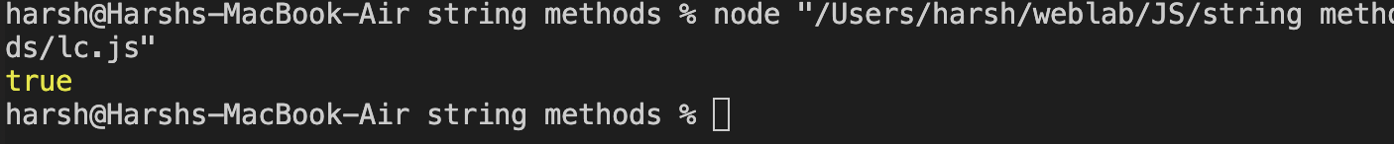

Index of :

let x = 'I am learning javaScript'

console.log(x.indexOf("learning"));

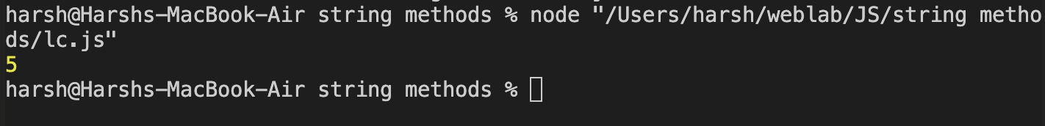

Lastindex :

let x = 'I am learning learning javaScript'

console.log(x.lastIndexOf("learning"));

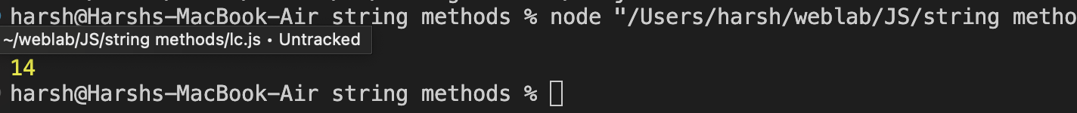

LENGTH :

let x = 'Harsh'

console.log(x.length);

Repeat :

let x = 'Harsh'

console.log(x.repeat(3));

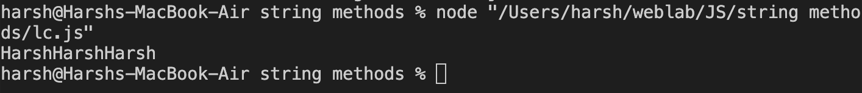

REPLACE :

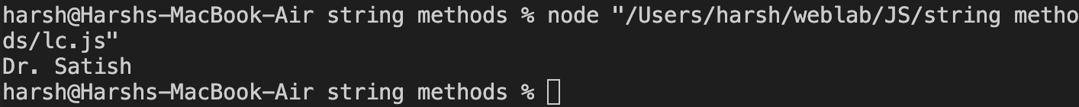

Slice :

let x = 'harshraj is a good boy'

console.log(x.slice(2,5));

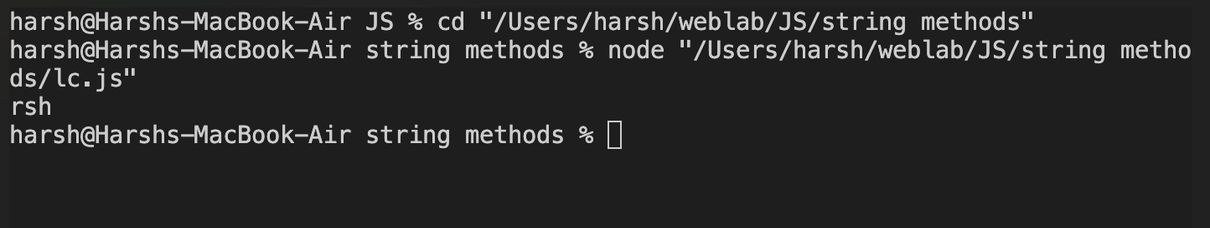

REPLACE METHOD :

let x = 'Mr Harshraj'

console.log(x.replace('Mr','Dr'));

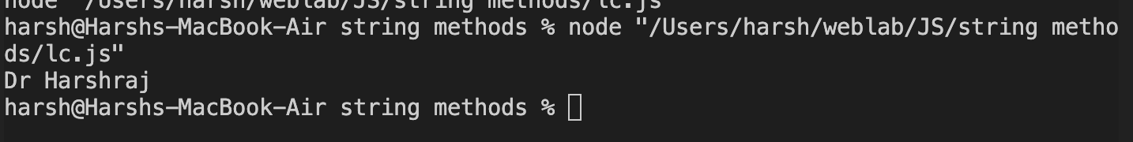

SPLIT :

let x = 'Harshraj is learning javascript'

const k = x.split(" ");

for(let i of k)

{

console.log(i);

}

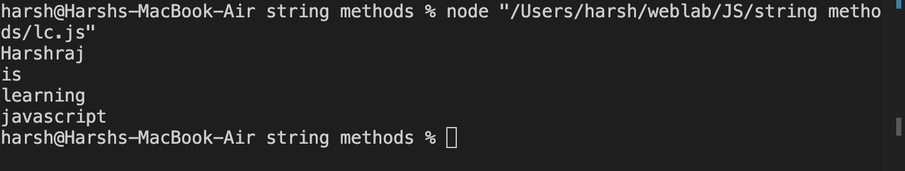

MIX :

let x ="Harshraj"

console.log(x.substring(1,4));

console.log(x.toLowerCase());

console.log(x.toUpperCase());

console.log(x.trim());

